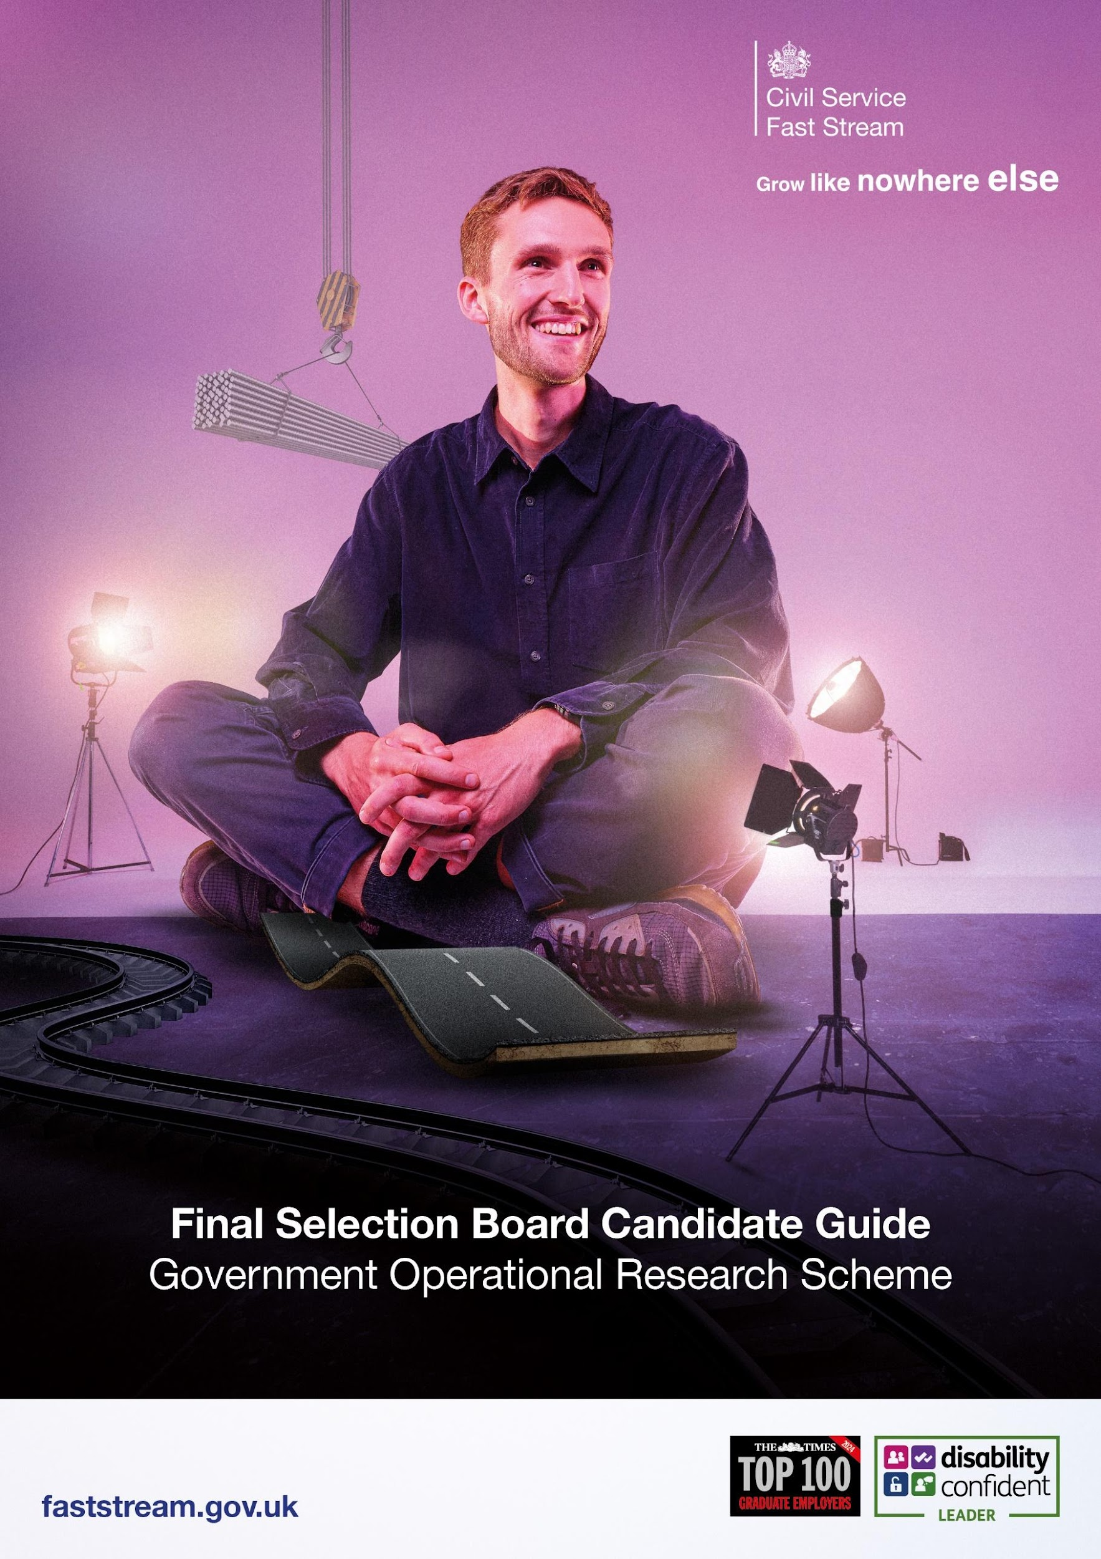

Congratulations on passing the Fast Stream Assessment Centre!

What is GORS looking for?
GORS is the Government Operational Research Service, an umbrella organisation which supports and champions Operational Research across Government. We have over 1400 members in 30 Central Government Departments and Agencies who provide Operational Research analysis and advice on policy and operational issues.

GORS takes a broad view of what is meant by Operational Research (OR): it is activity to help civil servants and Ministers take better decisions or manage more effectively, using whatever analytical, technical and consultancy skills are useful to get the job done. Formal techniques and analysis are used alongside softer OR skills. Critical knowledge and skills are:

Analytical Skills
All fast streamers, whether for the Analytical or other Fast Stream schemes, are required to have good analytical and problem-solving skills. The distinction for OR analysts is that these skills are required to a greater degree. We are looking for people who can rigorously and systematically identify all the factors involved in a problem situation, identify what sort of questions are worth asking to help move forward and what sort of data or analysis could be done to answer them, identify interconnections, spot patterns in data and suggest possible hypotheses; and who can not only suggest all these things but actually then put them into practice, collecting data, analysing it and understanding the implications of answers.

Technical Knowledge
All OR analysts should have a basic ‘toolkit’ of techniques and methodologies that they can apply if needed, including statistical, IT and classical OR techniques. However, GORS does not require new entrants to already have these techniques. We are looking for highly numerate people who have the technical ability to construct some sort of mathematical or logical model, to deal with uncertainty in data, and rapidly to acquire any additional technical knowledge that might be useful for a requirement

Consultancy Skills
All fast streamers are required to have strong skills for working with others and OR fast streamers are no exception. In addition, there is a group of people with whom OR fast streamers will have a relationship: ‘clients’, those who need the analysis and who have responsibility for taking the final decision informed by the analysis provided. OR analysts require skills in communication, responsiveness and integrity, in order to ensure they play an impartial and useful role.

Overview of ORAC
The Operational Research Assessment Centre (ORAC) will be a virtual assessment process to explore how well you are likely to perform as an Operational Research Analyst in Government. It tests three broad competencies:

- Analytical problem solving
- Technical knowledge
- Consultancy and associated personal skills

We are looking for candidates who can perform well across all three of these areas as well as the Fast Stream competencies.

The ORAC will consist of four exercises. Some of them will require you to do some preparation in advance. Others require no advance preparation apart from understanding what their purpose is. The four exercises are:

The Problem Structuring Test (PST): 60 minutes
The Analytical Exercise (AE): 75 minutes
The Technical Presentation (TP): 15 minutes to prepare and 5 minutes presentation plus Q&A
The Interview: 30 minutes

How to prepare
It will not be possible to prepare in advance for some of the assessments. However, we do describe in this document what you can expect from each stage of the ORAC assessment process.
The main area of preparation relates to the Technical Presentation, for which you should complete some research on one of the following Operational Research techniques:

- System Dynamics
- Discrete Event Simulation (DES)
- Bayesian Networks
- Multi-Criteria Decision Analysis (MCDA)

In the Technical Presentation you will be asked to apply your research to an analytical problem.

If you do not have an OR background but do have a reasonably numerate background, you should be able to get adequately comfortable with the principles of the technique, how you would apply it and why/when it is appropriate to use it, with around 10 hours of study. You are recommended not just to read up about the technique, but also to try one or two practical exercises. If you do have an OR background you may nevertheless wish to revise the relevant techniques.

ORAC

Each candidate will complete the same exercises which are outlined as follows:

Analytic Exercise
The purpose of the Analytical Exercise is to give you a chance to show your analytical and modelling skills in practice. It will be based on an application area from a government department, using realistic data with examples of real problems that need to be addressed. There will be three parts: first, giving you the opportunity to study the data and consider what it is telling you, then asking you to specify a model or set of algorithms for addressing a particular problem and finally giving you a further problem and asking you to find and interpret the answers using data and methods provided.

You will be allowed 75 minutes for the Analytical Exercise.

Problem Structuring Test
The purpose of the exercise is to give you a chance to show how you go about tackling a high-level problem that is presented to you. You will be provided with a brief description of a public service problem and a high-level statement of requirement, e.g. to evaluate an initiative, or to design a means of improving the situation, or to understand how things might change in future. Examples of public services include:

- Provision of passports
- A policy concern such as traffic congestion

You will be asked to tackle this in four parts, with 60 minutes for the whole exercise. Within that, each part has a recommended time attached. This is partly to avoid you spending too long on parts that will not earn many marks and partly to encourage you to cover the whole question.

Technical Presentation
The Technical Presentation is designed to test your understanding of a specific OR technique. On the day on of the interview, you will be given a set of related questions and asked to choose one to address using one of four specified OR techniques:

- System Dynamics
- Discrete Event Simulation (DES)
- Bayesian Networks
- Multi-Criteria Decision Analysis (MCDA)

You will be allowed 15 minutes to prepare a 5 minute presentation. You must not prepare any visual aids, but any paper notes made during this time can be used during the presentation.

When you join the interview, you will be asked to give the presentation first. This will be followed by a series of follow-up questions, which are structured to enable you to show the extent of your understanding of a technique and how it can be used in practice. You will be assessed separately on the quality of the presentation in terms of its clarity, the way you deliver it and the depth of your understanding of the technique. You may also be asked about quality assurance and working with clients.

Interview
The interview enables you to talk about the skills acquired from your educational qualifications and any postgraduate experience, and your reasons for wanting to become a Government OR analyst. It will last 30 minutes. No prior preparation is necessary, but you may want to remind yourself of what you have studied, why it is relevant to GORS work, and be ready to talk about examples of your experience (whether academic or work-based) in relevant areas.

The assessors will be looking for evidence that you have some relevant experience (this does not have to be in OR, but may be in numerate disciplines relevant to OR), that you have a reasonable understanding of what will be required of you as a Government OR analyst, and that you are motivated toward OR and the public sector as a career.

What happens on the virtual ORACs?

The virtual ORACs will be administered in two parts. Candidates will complete the two written tests: Analytical Exercise (AE) and Problem Structuring Test (PST) on a separate day from their Technical Presentation (TP) and Interview.

Part 1
The two written tests will be administered by the Fast Stream Operations team via a secure digital platform, and they will also be the timekeepers for both exercises. Candidates will be given access for the Problem Structuring Test (PST) prior to the start time. Candidates will then have 60 minutes to complete the PST exercise. At the end of the 60 minutes candidates will return their answers to the fast stream by following the instructions provided.

There will be a 20 minute break before the Fast Stream Operations team allow candidates access to the Analytical Exercise (AE). Similarly, candidates will receive the AE prior to the start time. Candidates will then have 75 minutes to complete the AE exercise. At the end of the 75 minutes candidates will return their answers to the Fast Stream Operations by following the instructions provided.

Part 2
Candidates will be invited to the Interview on a separate day to the written exercises. The interview will be conducted virtually, and candidates will receive joining instructions once they have been booked onto an interview slot. Prior to joining the interview, candidates will have 15 minutes to prepare for the 5 minute Technical Presentation (TP). After the 15 minutes preparation time

candidates will join the virtual interview and the first half of the interview will focus on the TP: 5 minutes presentation followed by questions on the presentation, and the second half will comprise the interview (30 minutes).

What happens next?
We aim to let you know within two weeks whether you have been successful. You will be informed by the “Scheme Progress” page on the Fast Stream website when you log in.
Finally, we want to take this opportunity to congratulate you on getting to this point, in what has been a very competitive assessment process. We wish you every success at the ORAC and look forward to meeting you soon.

Mithu Norris
GORS Central Management Unit

