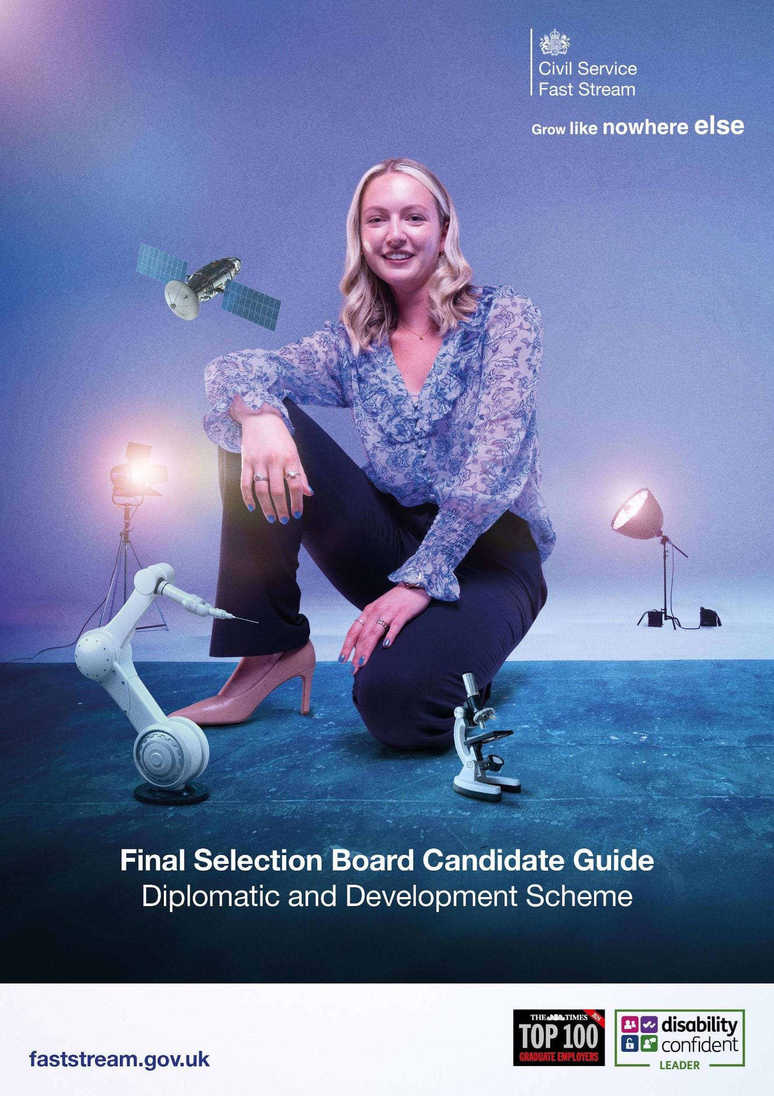

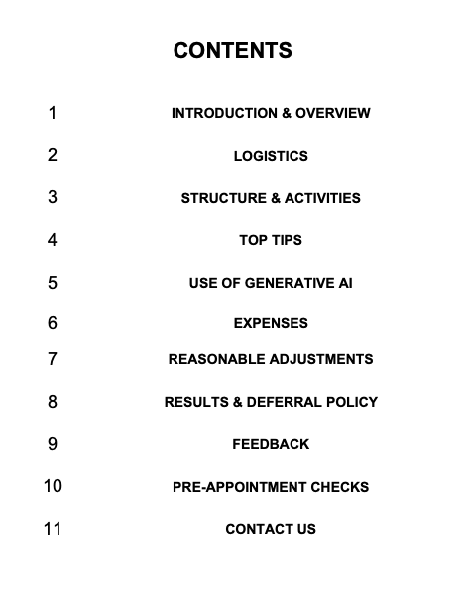

1. INTRODUCTION & OVERVIEW

Congratulations on passing the Fast Stream Assessment Centre (FSAC). You have now reached the Final Selection Board (FSB) for the Diplomatic and Development (DD) Fast Stream. This is the final stage of the recruitment process for candidates who have achieved sufficiently high scores through the process and demonstrated the motivation, resilience, and capability required for a career in the Foreign, Commonwealth and Development Office (FCDO). A career in the FCDO is both rewarding and demanding - it requires resilience, adaptability, and a genuine commitment to public service. The challenges you may face, whether navigating complex international issues or responding to global crises, should not be underestimated.

The FCDO is embarking on an ambitious and far-reaching transformation programme, known as FCDO2030. This initiative is designed to ensure the organisation remains agile, effective, and resilient in an increasingly complex and fast-changing global environment. Through this transformation, the FCDO is reimagining how it operates - modernising its systems and processes, strengthening the delivery of world-class policy, and enhancing its ability to project influence and deliver impact on the international stage. FCDO2030 is not just about structural change, it is about building a future-ready organisation that can anticipate challenges, seize opportunities, and continue to serve the UK’s interests globally with excellence and innovation. As part of this journey, the FCDO is seeking to recruit DD Fast Streamers who are not only adaptable to change but eager to contribute to it. This is a unique opportunity to be part of a forward-looking organisation that is redefining its role on the world stage.

We are seeking individuals who bring intellectual curiosity, a global outlook, and a deep interest in the shifting dynamics of international affairs. Fast Streamers will be expected to think critically, act with integrity, and embrace innovation. As part of the refocused Fast Stream programme, successful candidates will be equipped with the skills and experiences needed to lead in a rapidly evolving global landscape.

Candidates are asked to keep the details of the FSB secure and not to breach confidentiality by divulging information to others including prospective or actual candidates for the FCDO.

2. LOGISTICS

For the first time in five years, the FSB is returning to in-person interviews. This marks a significant shift in the recruitment process, reflecting the FCDO’s commitment to meaningful engagement and the importance of face-to-face interaction in assessing candidates for such a high-profile and globally oriented career path. In-person FSBs allow the FCDO to better evaluate the interpersonal skills, presence, and judgement that are essential for success in diplomatic and development roles. The return to this format underscores the seriousness of the career and the high standards expected of those who represent the UK on the international stage.

Your FSB will be held in FCDO’s headquarters in Westminster, London. Annex A contains a map and directions for getting to the venue for your FSB.

The postal address is:

Foreign, Commonwealth and Development Office
King Charles Street
London
SW1A 2AH

The FCDO will be holding FSBs on selected dates in January and February. The date and time of your specific FSB will be confirmed and communicated by the Fast Stream and Emerging Talent (FSET) team at the Cabinet Office.

On the day of your FSB, you are required to arrive 15 minutes prior to your allocated start time. On arrival, please report to the FCDO Reception and inform them that you are attending the Fast Stream recruitment interviews. A member of the FCDO Fast Stream Team will meet you in reception and escort you to the FSB assessment area. Prior to starting your FSB, you will have a welcome briefing where you will be talked through the timetable for your FSB, explain how FSB operates and provide the opportunity to ask any questions you have. If you are running late, or cannot attend due to ill health, please contact us on Fast.Stream@fcdo.gov.uk.

On the day of your FSB, you must bring your UK Passport. Your passport will be used to confirm that the individual completing the FSB is the person we were expecting. If you do not have a valid Passport, you will need to provide an alternative form of photo ID (i.e. driving licence).

Water facilities will be available throughout the event, but please note, the FCDO has a target of eliminating avoidable single-use plastics from our global operations. We would therefore strongly advise bringing a reusable drinks bottle.

FCDO Staff will be on hand throughout the FSB assessment, so please feel free to ask them any questions you have, either about FSB, the Fast Stream or working for the FCDO in general.

3. STRUCTURE & ACTIVITIES

Your FSB interview will last up to 60 minutes. During the interview, all candidates will be asked a core set of questions focused on assessing suitability for the DD Fast Stream:

Motivation
Behavioural Based: Leadership
Behavioural Based: Communicating & influencing
Behavioural Based: Engaging Internationally
Behavioural Based: Demonstrating Resilience

Assessors may ask additional follow-up questions related to the core set of questions if they require further clarification or elaboration on any of the points you have provided. These supplementary questions are intended to ensure a full understanding of your responses and to give you the opportunity to provide any additional context or detail that

may strengthen your answers.

For the motivation-based questions, they are designed to explore your curiosity about the work of the FCDO and your interest in the DD Fast Stream. We will be keen to understand what drives you to apply, and how your expectations align with the unique opportunities and challenges of the Fast Stream programme.

The behavioural questions will be linked to different work-based scenarios that will be sent to you via e-mail 24 hours before your FSB. These scenarios are designed to assess how you might approach real-life FCDO challenges. An example of a work-based scenario is:
You are developing a digital communications strategy aimed at promoting the FCDO’s consular services. These services provide vital support to British nationals who encounter difficulties while living or travelling abroad - ranging from lost passports and medical emergencies to legal issues and crisis situations. The strategy will focus on raising awareness of the help available and encouraging individuals to proactively engage with consular guidance before and during their time overseas.

The primary objective of the campaign is to increase visibility and understanding of consular support among British citizens. Many people are unaware of the breadth of assistance the FCDO can offer, especially in times of distress. By highlighting real-life scenarios, sharing testimonials, and providing clear, accessible information, the campaign will aim to build trust and ensure that individuals know where to turn when they need help. It will also promote preventative measures, such as travel registration and insurance advice, to reduce risk and improve outcomes. To achieve this, the campaign must reach a diverse and geographically dispersed audience. This includes tourists, expatriates, business travellers, students, and those visiting friends and family abroad.

Each scenario will be paired to a specific behaviour that has been highlighted on the above table. For example, the above example work-based scenario could be matched to the communicating and influencing behaviour. A potential question could be:

What considerations should be given when communicating to a broad range of individuals?

Please note that your knowledge of the subject matter presented in each work-based scenario will not be assessed. The purpose is to gain insight into your approach to problem-solving and decision-making. The focus will be on understanding your thought process, how you analyse information, and the key behaviours and skills you consider essential for successfully navigating each scenario.

Each candidate will be assessed by a panel of experienced and impartial FCDO officers. You will be assessed against the Civil Service Success Profiles Framework and International Competencies (See Annex B).

The assessors will be looking for a well-rounded performance across all aspects assessed. We do not expect candidates to excel in everything assessed and score top marks in each aspect. If you do less well in some of the aspects assessed, provided you

meet the minimum standard, you may still be successful.

Prior to attending your FSAC, you provided written responses on motivation and a skills self-reflection exercise specific to the DD Fast Stream. These written responses form an important part of the overall assessment process and will be considered alongside your performance at the FSB interview when determining your suitability for the scheme. This ensures a holistic evaluation of both your aspirations and the skills you bring to the programme.

4. TOP TIPS

During your FSB, it is important that you:

· Stay Calm and Embrace the Experience: Try to stay relaxed and approach the day with curiosity and confidence. This is an opportunity to showcase your strengths and learn more about yourself. A calm mindset helps you think clearly and perform at your best.

· Be Authentically You: Don’t try to fit a mold. The assessors are looking for genuine individuals who bring their own perspectives and qualities. Authenticity is far more compelling than trying to be what you think they want.

· Speak Up and Show Your Thinking: Assessors can only evaluate what you say and do. Make your thought process visible - explain your reasoning, contribute actively, and don’t be afraid to ask questions. They’re not trying to catch you out; they’re rooting for you to succeed.

· Focus on Your Own Performance: You’re not in competition with others. Everyone is assessed against the same independent criteria. Concentrate on doing your personal best rather than comparing yourself to others.

· Adopt a Positive Mindset: Go into the FSB with optimism and self-belief. A positive attitude can help you stay resilient, engage more fully, and make a stronger impression.

· Prepare, But Don’t Over-Rehearse: Familiarise yourself with the format and expectations but avoid scripting your responses. Flexibility and responsiveness are key qualities being assessed.

· Reflect and Learn: Whatever the outcome, treat the experience as a valuable learning opportunity. Reflect on what went well and what you might do differently next time.

5. USE OF GENERATIVE AI

While candidates can use Gen AI tools, such as ChatGPT, to prepare for the process, it is crucial that you do not use these tools during the actual FSB interview. The goal is to ensure that responses are genuine and reflect your own abilities and potential fit for the D&D Fast Stream scheme. This ensures a fair and level playing field for all candidates and helps maintain the integrity of the selection process. Remember, integrity and honesty are core parts of the Civil Service Code, and the values of the organisation you

are seeking to join.

It is essential that all responses during your FSB interview accurately represent your own thoughts, ideas, and abilities. This authenticity is crucial to determine if you are a good fit for the scheme. Where AI use is suspected during the FSB interview, it will affect your application and your chances of being successful. Trust in your preparation and abilities. The selection process is an opportunity to showcase your true self and capabilities.

6. EXPENSES

Fast Stream candidates will be able to claim reasonable actual travel and accommodation expenses incurred when travelling to the FCDO headquarters for the FSB. All expenses must be reasonable, necessary, and proportionate to the purpose of the FSB. Allowable expenses include:

· Travel Expenses: Candidates may claim reimbursement for standard-class travel to and from the FCDO headquarters for the FSB, up to a maximum of £200. Please note the following restrictions:

o Only travel within the UK can be expensed. Travel from overseas cannot be expensed.
o Public transport must be used. Air travel within the UK should only be used if there is no alternative.
o Expenses for taxis will only be reimbursed if the candidate can demonstrate that no public transport was available.

Pre-approval for travel from the FCDO Fast Stream Team is not required, provided all arrangements demonstrate value for money and adhere to the above agreed travel guidelines.

· Accommodation Expenses: Candidates may claim reimbursement for one night’s accommodation, up to a maximum of £250, where same-day travel to the FSB is impractical. Accommodation may be provided under the following circumstances:

o Cannot reasonably complete a round trip to the interview location within the hours of 7:00am–7:00pm without excessive fatigue or disruption.
o One-way travel time exceeds 2.5 hours, or the total round-trip travel exceeds 5 hours.
o The interview is scheduled early in the morning or late in the afternoon, making same day travel impractical.

Pre-approval for accommodation from the FCDO Fast Stream Team is required in all cases. Candidates must provide a short business case explaining why overnight accommodation is necessary, demonstrating value for money and compliance with accommodation guidelines. Requests should be submitted to fast.stream@fcdo.gov.uk and will be processed within two working days.

Candidates are responsible for arranging and initially paying for their own travel and accommodation. The amount can then be claimed back via the FCDO Fast Stream

expense process. All bookings should be made with consideration for cost-effectiveness and practicality. The FCDO reserves the right to reject claims that do not meet the criteria outlined above. Detailed guidance on the claims process will be provided by the FCDO Fast Stream Team closer to the time.

7. REASONABLE ADJUSTMENTS

We want all candidates to be able to perform to the best of their ability. Under the disability provisions of the Equality Act 2010, the FCDO is legally required to make reasonable adjustments where a provision, criterion or practice applied by the FCDO places a disabled candidate at a substantial disadvantage compared with a candidate who is not disabled.

If you have requested reasonable adjustments during earlier stages of the recruitment process, this information will be shared with the FCDO to put in place for your FSB. The FCDO will always endeavour to implement any reasonable adjustments, but in some circumstances it may not be reasonable to implement an adjustment. Please note that the onus is on you, as the candidate, to request reasonable adjustments.

In some exceptional circumstances, we might need to consult one of the FCDO's professional disability advisers to ensure that we are providing the correct adjustments for you. If you fall into this category, then the FCDO will contact you directly to discuss your specific requirements.

If you have any questions about reasonable adjustments during the FSB, please contact the FCDO Fast Stream Team (email: Fast.Stream@fcdo.gov.uk).

8. RESULTS & DEFERRAL POLICY

We will aim to set an initial high pass mark in February 2026. The pass mark will be kept under review and slowly lowered as more candidates come through and sit the FSB. The final pass mark for the FSB will be set by the end of March 2026 at the latest. Candidates will receive their results periodically and not all at the same time.

If you are successful, we will look to start your onboarding journey immediately. The Cabinet Office Fast Stream Team and the FCDO Fast Stream Team will be responsible for different stages of your onboarding journey. The projected start date will be late September/early October 2026.

If you are unsuccessful, the FCDO will update your status on the Fast Stream portal, and you will automatically proceed with your next Fast Stream scheme option if applicable.

As the number of DD Fast Streamers recruited each year is relatively small, the FCDO do not generally approve deferral requests except in exceptional circumstances. Deferral requests are considered on a case-by-case basis.

9. FEEDBACK

All candidates receive a feedback report on their performance at the FSB. You do not need to request this individually. The objective is to issue all feedback by the end of April. The feedback will offer an overview of your strengths and areas for development demonstrated at the FSB. This could prove useful both if you are unsuccessful this year but wish to re-apply for the Fast Stream in the future and, if you are successful, as a guide to your next developmental steps.

10. PRE-APPOINTMENT CHECKS

Candidates who are successful at FSB will be made a provisional job offer to join the FCDO, subject to successfully obtaining Developed Vetting (DV) security clearance. The onboarding process can be lengthy. Before we can even start the DV security clearance, pre-employment checks will need to be completed to verify your identity, right to work in the UK and a Criminal Record Check. You will need to produce certain documents to complete the pre-employment checks. Annex C sets out the documentation required. We would strongly recommend that you get these documents ready ahead of time to ensure that pre-employment checks are completed in a prompt manner and avoid delays.

Once these checks are completed, you will proceed with the DV security clearance process. Decisions are taken based on the Vetting Decision Framework, and each case is different, but we have no reason to expect many refusals – a study by Cabinet Office found that less than 1% of those applying for DV were refused. The length of DV clearance process will vary as it is dependent on everyone’s personal circumstances, so it is essential that we start the DV process as promptly as possible. Details about security clearances within the Civil Service can be found at: https://www.gov.uk/government/publications/united-kingdom-security-vetting-clearance-levels/national-security-vetting-clearance-levels

11. CONTACT US

We would be happy to talk to you if you have any questions relating to the FCDO or the FSB process. Please feel free to contact a member of the FCDO Fast Stream Team at Fast.Stream@fcdo.gov.uk

Good luck with your FSB.

Richard

Richard Everingham
FCDO Fast Stream Team

Annex A – Guide to King Charles Street

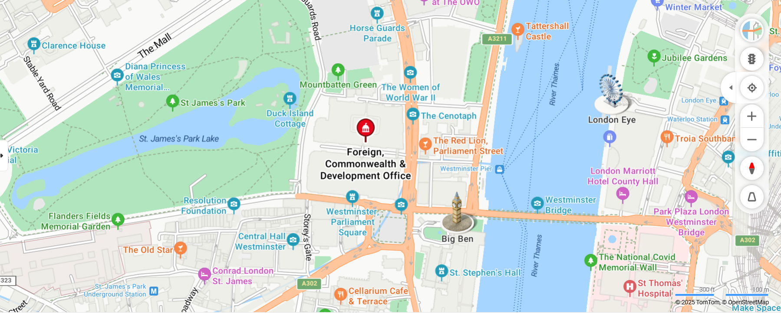

Getting to and from King Charles Street

Train: There are three main line train stations within easy access to KCS:

- London Charing Cross is about 10 mins walk and is the terminus of the Southeastern Main Lines to Dover via Ashford and Hastings via Tunbridge Wells. It is connected to Charing Cross Underground station and is near to Embankment Underground station.

- London Victoria Station is about 20 mins walk. It is the terminus of the Brighton Main Line to Gatwick Airport and Brighton and the Chatham Main Line to Ramsgate and Dover via Chatham. It is connected to Victoria Underground station

- London Waterloo Station is about 20 mins walk. It is the terminus of the South-West Main Line to Weymouth via Southampton, the West of England main line to Exeter via Salisbury, and several commuter services around west and south-west London, Surrey, Hampshire and Berkshire. It is connected to Waterloo Underground Station and is adjacent to Waterloo East station on the South-Eastern Main Line.

Other mainline train stations like London King’s Cross station and St Pancras station are within travel distance to KCS but may require public transport.

London Underground: There are several underground stations within easy access to KCS. The commonly used are:

- Westminster Underground Station is about a 3-minute walk. It is served by the Circle, District and Jubilee lines.

- Embankment Underground Station is about a 10-minute walk. It is served by the Bakerloo, Circle, District and Northern lines.

- Victoria Underground Station is about 20 mins walk. It is served by the Circle, District and Victoria lines.

Buses: There are various bus routes that stop in the Westminster area. These include 9 (Aldwych/Hammersmith), 15 (Blackwall/Charing Cross), 24 (Grosvenor Road/Hampstead Heath), 87 (Towards Wandsworth Plain/ Aldwych), 88 (Parliament Hill Fields/Omnibus Clapham), 91 (Tottenham Lane/Trafalgar Square), 139 (Golders Green/Waterloo) and 176 (Penge/Tottenham Court Road).

Car: There is no parking for motor vehicles in KCS. Access and parking are now restricted to essential service vehicles only. If you want to drive to KCS, then you will need to identify local parking facilities.

Cycling: KCS has bicycle parking capacity of 170 spaces. Bike parking is intended to be used by FCDO staff who are actively commuting daily. Cycles should not be left in the Quad space for long periods of time, and generally not overnight and across weekends. Cycle parking is provided on a first come / first served basis.
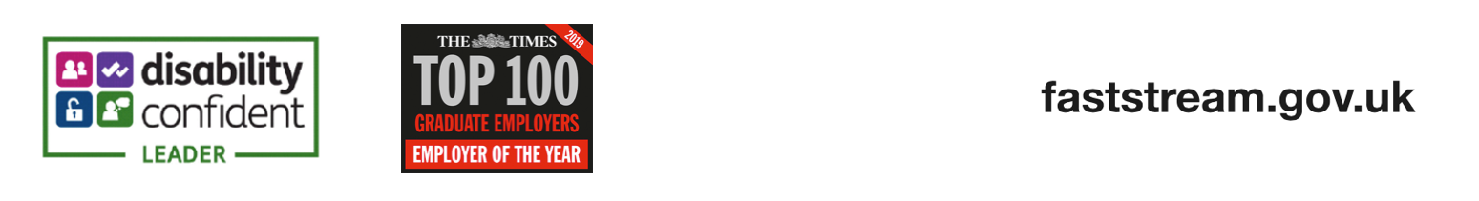
Annex B – FCDO International Competencies

Engaging Internationally

Effectiveness in this area is about leading internationally, engaging our staff, contacts and international partners to help deliver UK Government objectives. For all staff it’s about understanding UK Government aims in the wider UK and international context and developing productive relationships with those external contacts and partners to help deliver UK objectives. All staff are aware of cultural sensitivities in their area of responsibility. Staff build up negotiating expertise through the grades and champion and use language skills where appropriate to deepen impact.

Effective Behaviour  People who are effective are likely to…… | Ineffective Behaviour  People who are ineffective are likely to……
Represent and advance UK interests and policies. Use knowledge of UK governance, political culture and His Majesty’s Government (HMG) context to add to credibility | Lose credibility and ability to influence due to lack of knowledge of UK agenda and context
Build and maintain cooperative and productive relationships with an effective range of external contacts. Use the network professionally and sensitively to the benefit of the UK | Be passive in identifying and engaging effective wider stakeholder groups and therefore lacks influence and the wider UK perspective
Have a working knowledge of country context and local sensitivities and encourage staff to develop this knowledge. When appropriate, can speak and use a language/s with a high level of proficiency | Not take account of and weigh up changes which may impact on their role and staff. Be reluctant to develop appropriate language skills to increase impact
Negotiate effectively combining logic and reason with interpersonal sensitivity. Seek to create solutions offering mutual benefits. Anticipate problems and be able to respond to the unexpected | Unconvincing in negotiation or when challenged. Overly dominant or diffident in discussions
Set a good example by working positively in diverse teams and living up to UK Government values | Not model a positive approach in a very diverse environment. Ignore UK Government values

Demonstrating Resilience

This is about helping our people to build resilience in international roles, supporting their ability to adapt to working in difficult and varied international environments; and to bounce back from crises and setbacks in these contexts. Individuals need to be aware of the impact they have on themselves and on others, and show support for others with a pragmatic attitude, perseverance and resolve. Individuals should be able to manage in a wide variety of circumstances and locations and, with appropriate support, to recover from challenges and setbacks. For leadership roles this competence would also include leading a culture of support, while promoting a proper regard for employee safety, health and well-being.

Effective Behaviour  People who are effective are likely to…… | Ineffective Behaviour  People who are ineffective are likely to……
Ensure they manage their people to play to their strengths and have high awareness of their own and others’ impact. | Fail to realise the full impact of work on their individual team members, leading to them feeling unsupported.
Coach others within the team to think about how they manage through challenges or setbacks in an international context, and develop as a result, bouncing back. | Inactive in supporting their team to develop and become more self-aware. Unaware of their impact on others.
Have well developed awareness of own strengths and limitations and the impact of this on their work and their colleagues. Manage this in various challenging or ambiguous international scenarios and across their department and more widely. | Lack awareness of their limitations, leading to poor judgement and sub-optimal decisions.
Demonstrate an ability to learn, adapt and change behaviours, striving for continuous improvement across their department and more widely. | Rely on limited responses and an inflexible personal style regardless of the changing environment.

Annex C – Pre-employment Checks

If you are successful, you will receive detailed information about what happens next – including the pre-employment check process. Before we can even start the DV security clearance, pre-employment checks will need to be completed to verify your identity, right to work in the UK and a Criminal Record Check.

All successful candidates must provide 3 documents for their pre-employment checks as follows:

- One primary identity document: This must be a valid British Passport for the DD Fast Stream. Individuals need to be a British citizen (or hold dual nationality) to join the FCDO.

- One trusted Government document: This can be a Driving Licence Photo Card, Birth Certificate, Marriage/Civil Partnership Certificate, HM Forces identity card, etc.

- One Financial and Social History Document i.e. Endorsed Bank/Building Society document (issued within last 3 months), Mortgage Statement (issued within last 12 months), P45 or P60 (issued within last 12 months), Council Tax Statement (issued within last 12 months), etc. The document must be an original hardcopy and electronic versions from a banking app, for example, will not be accepted.

All documents MUST show your current address. The documents will need to be uploaded electronically via the CS Jobs website, into your IDVT (identity document validation technology) profile - a link will be sent to you to access the portal with your confirmation of formal job offer.

