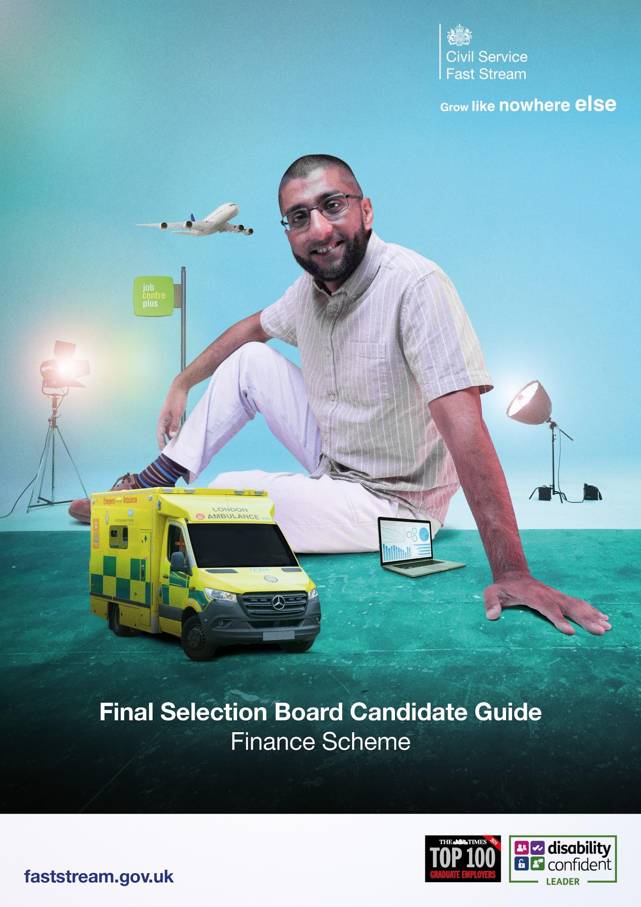

Congratulations on passing your Fast Stream Assessment Centre (FSAC)!

You have been invited to attend a virtual Final Selection Board (FSB) for the Finance Fast Stream.

This guide will take you through the next steps on how to prepare for the meeting and what to
expect.

Prior to your interview, you may find it useful to consider some examples that you could use to
provide evidence in the areas listed below Government Finance Function - GOV.UK

Our interviewers will be looking to find out:
● More about you
● Your motivations for joining the Government Finance Function and career aspirations.
● What you already know about public sector finance in Government

Useful Information:
- The format will be a virtual video interview lasting around 30 mins long.
- We will be using MS Teams to conduct the interview and have listed some useful IT tips below
- We recommend having some paper and pens available.
- You should wear what you would during an in-person assessment centre and what makes you feel comfortable.
- Sit somewhere with a strong Wi-Fi connection and somewhere you will not be distracted. This will help you focus on your performance on the day.
- Download the latest version of one of the internet browsers listed below. We
recommend Google Chrome for the best user experience.
- Make sure you can be seen in front of the camera.
- Have a laptop charger or plug socket nearby to plug in your computer if required.
- Have a fully charged mobile phone on hand in case you experience connectivity issues on the day. The Fast Stream team may have to ring you to resolve the issue.
- If you require reasonable adjustments, please submit a ticket to re-request your adjustments for the FSB. We will implement the necessary adjustment required to ensure you can fully participate on the day.
- You will need access to your email inbox throughout the day to receive your FSB schedule and virtual URL room links.
- Plan ahead and turn your computer on early so you are ready for the assessment centre to start on time.
- Read this guide carefully. It sets the scene for the day.

IT Checks:

Here is an IT checklist to consider:
- We will be using MS Teams to communicate with you on the day, and a modern internet browser is required for MS Teams to run.
- We recommended downloading and using the current version of one of the browsers listed below:
  - Google Chrome Browser
  - Mozilla Firefox
  - Microsoft Edge
  - Apple Safari
- For best user experience, Google Chrome is highly recommended
- Internet Explorer is not supported
- Please check that your microphone and webcam are working
- Ensure that your laptop or computer has a strong WiFi connection. On the day if you have disconnected from the internet, we might need to contact you via phone, so if possible please have a mobile phone available and fully charged.

AI Software:
- Due to the increased usage of AI tools during interviews we want to clarify what is and is not accepted during your Final Selection Board.
- Acceptable use – Researching information on the Civil Service & Finance Fast Stream before your interview, asking for interview tips or sample responses for practice.
- Unacceptable use – Any use of AI during your live virtual interview to produce answers to the questions.
- If we suspect you are using AI at any point, we will stop the interview, and your Fast Stream application may be terminated.

We will aim to provide feedback after the interview following the notification of your outcome of
your final selection board.

If you have any questions on the process, please email GFA@HMTreasury.gov.uk

Good luck with your interview.

