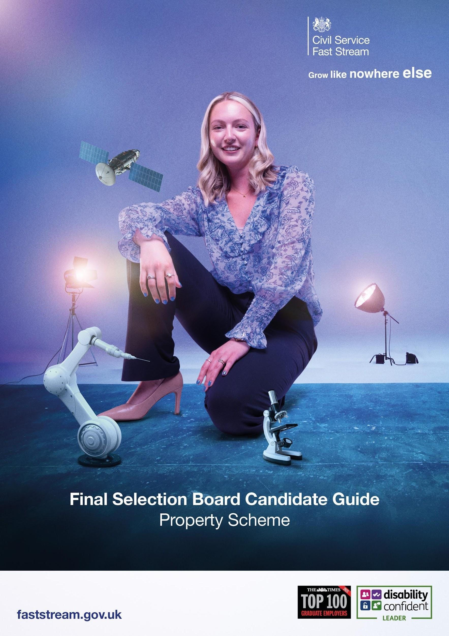

Congratulations on getting this far in what has been a demanding assessment process! We are delighted to invite you to attend a Final Selection Board (FSB) for the Property Fast Stream scheme. The FSB will take the format of a recorded video interview and can last up to 40 minutes. Please inform us if you have any reasonable adjustment requirements so that we can allocate you additional time as needed by contacting us at faststream.applicationsupport@cabinetoffice.gov.uk.

Process

You will receive an email containing your video interview invite link from VidCruiter on the date of your FSB. We are keen to find out more about you and your motivations for joining the Property Fast Stream scheme in particular. You will be asked a number of questions and your answers will be recorded through your webcam. This will be viewed later by our team of property assessors. We have provided details of the FSB via email but you can also view the date of your FSB on your Home Page. For your information, the FSB date displayed on your Home Page is the date you will receive an invitation to commence your FSB video interview which you must complete within 7 days. Please ensure no-reply@hiringplatform.co.uk is in your “safe” or “contacts” list so it doesn’t get identified as either junk or spam. If you do not receive the email please contact us at faststream.applicationsupport@cabinetoffice.gov.uk.

Once you have commenced your video interview, please use the “need help” icon at the bottom of the screen on the platform if you are experiencing any technical difficulties. For your video interview we recommend that you are somewhere quiet and where you won’t be interrupted, with a strong wifi signal. Please be aware you will need to ensure your camera and microphone is working for the video interview.

We will also be asking you to complete an additional information form so we can obtain more information about you and your route of entry. Your responses to the questions will not be assessed, they will be used to ensure we place you into the best placement possible should you be successful for the scheme and to gain high level insight into who has applied for the scheme.

To help you prepare for the FSB, please watch the below video for useful help and guidance:

https://www.youtube.com/watch?v=jm-BPj7vSok

Interview Questions

The questions will aim to find out:

- More about you, and your interest of working within Government Property
- Your motivations for joining the Property Fast Stream and the Civil Service
- Your key skills that will help you to successfully complete the property scheme
- Your aspirations for your future career

Prior to your interview, you may find it useful to consider some examples that you could use to provide evidence in the areas listed above. Please note, we do not have the ability to ask you any prompts or follow-up questions therefore please ensure you have provided a full answer before moving on to the next question.

Presentation

In addition to the above, we will ask you to deliver a short 8 minute verbal presentation on the property related question provided below:

“What elements of the government property strategy are the most important to you and how would you go about implementing them?”

To help you prepare, please access the government property strategy here. We will be looking for well thought out ideas as well as your personal view on the strategy areas. We will also be assessing your presentation skills therefore please do not read from a script. Please note, you will not have the ability to present any slides therefore you will need to provide a verbal presentation only.

Throughout your presentation and interview questions, please refrain from using ChatGPT or any other AI software. This ensures a fair and level playing field for all candidates and helps maintain the integrity of the selection process. Integrity and honesty are core parts of the Civil Service Code. It is essential that all responses accurately represent your own thoughts, ideas, and abilities. Where AI use is suspected during the interview, it will affect your application.
Please see guidance for more information on appropriate and inappropriate use here.

Outcome

The central FSET Team will inform you of the outcome of your video interview as early as possible via the scheme progress page of the website.

Good luck with your interview!
Property Fast Stream Team

FAQs

- How many places are on offer? We have 26 places available on the 2026 Property Fast Stream.
- When am I likely to know the outcome of the video interview? We will be assessing candidates until approximately the end of March. Most candidates will find out their result within 4 weeks of their interview, but in some cases it could take longer.
- I do not have a degree (or property degree) - will that count against me? No - we are looking for the best candidates, not for candidates with specific degrees.
- When will the scheme begin? The Scheme will begin in September 2026.
- Do I get to choose which department I will work in? Unfortunately we cannot take personal preferences into account. We will aim to rotate you into a different department that will be able to support the qualification and professional accreditation route you are undertaking. As a scheme, we aim to ensure you are able to achieve your accreditation in a timely manner which takes precedence during our placement matching process. In some cases, you may have to remain or return to the same department depending on what experience they are able to offer.
- When will I know which department I will be working in? You will be notified which department you will be working in around 8 weeks before your starting date.
- Will I spend all my time in the same department? No, the scheme has been designed for you to get the widest possible experience. We would expect you to gain experience in at least 3 different government departments over the 4 years.
- What will my first placement look like? What experience will I gain on the Property Fast Stream? What you will do in your first placement will depend on the qualification and professional accreditation you are trying to obtain. So for example, if you are undertaking a Real Estate MSc or undertaking the RICS APC, you will be in an estates, construction or surveying role. If you are undertaking a Level 6 Diploma in Workplace or undertaking IWFM accreditation, you will be in an Facilities Management or workplace role. Your subsequent placements will be designed to have a different focus, but one still relevant to the qualification/accreditation.

- Will I have to relocate? Can I choose where to be based? All fast streamers should expect to work in more than one part of the UK. Most Fast Streamers spend at least one posting in a new geographical area. This will apply equally whether you start off in London, in a devolved administration (e.g.Scottish or Welsh Government), or another region. There are cases when your personal circumstances mean you may be less able to relocate for a posting. In these situations, we will work with you to understand your needs and take these into account when selecting your first and subsequent postings.
- What are the qualifications/professional accreditation I can take? This will depend on your entry route, i.e. Property degree candidates - depending on your degree, we will support your professional accreditation journey with either RICS or IWFM. Non-property degree candidates - we will offer the chance to take an MSc in Real Estate/Construction Management or Level 6 Diploma in Workplace management. Non-degree (existing Civil Servants) - we will offer you the chance to take a Level 6 Diploma in Workplace management.
- Why can’t non-degree Civil Servants undertake an RICS Qualification? Unfortunately there isn’t a non-degree qualification available that can lead to membership with RICS.
- Can I undertake the RICS APC or IWFM professional accreditation on the Fast Stream? If you have a property degree that is accredited by either RICS or IWFM, during the Fast Stream we will assist you in your journey to membership of the body that accredited your degree.
- What does the RICS APC involve? The RICS APC involves gaining experience in a number of competencies over a 2-year period. At the end of the process, you write a 1,500 summary of your experience; undertake a 3,000 word case study and sit a 1 hour interview. If you pass these, you will become a member of RICS. For more information please visit www.rics.org
- What does the IWFM Accreditation process involve? Over a 2-year period, you will record your experience against a range of competencies. At the end of the process, you must write a summary of how you have demonstrated the required competencies and submit a CV. This will then be assessed by an IWFM assessor panel.
- What is the pay/grade? For the duration of the fast stream, you will be on a Fast Stream pay grade. The starting pay will be circa £31,554 per annum which increases incrementally across the 4 years subject to you completing certain performance standards.
- Will there be any pay progression? Pay increases will be subject to an annual pay review that is conducted between the Civil Service and the government. Pay increases will be in line with Cabinet Office agreements, not the department you are working in.

