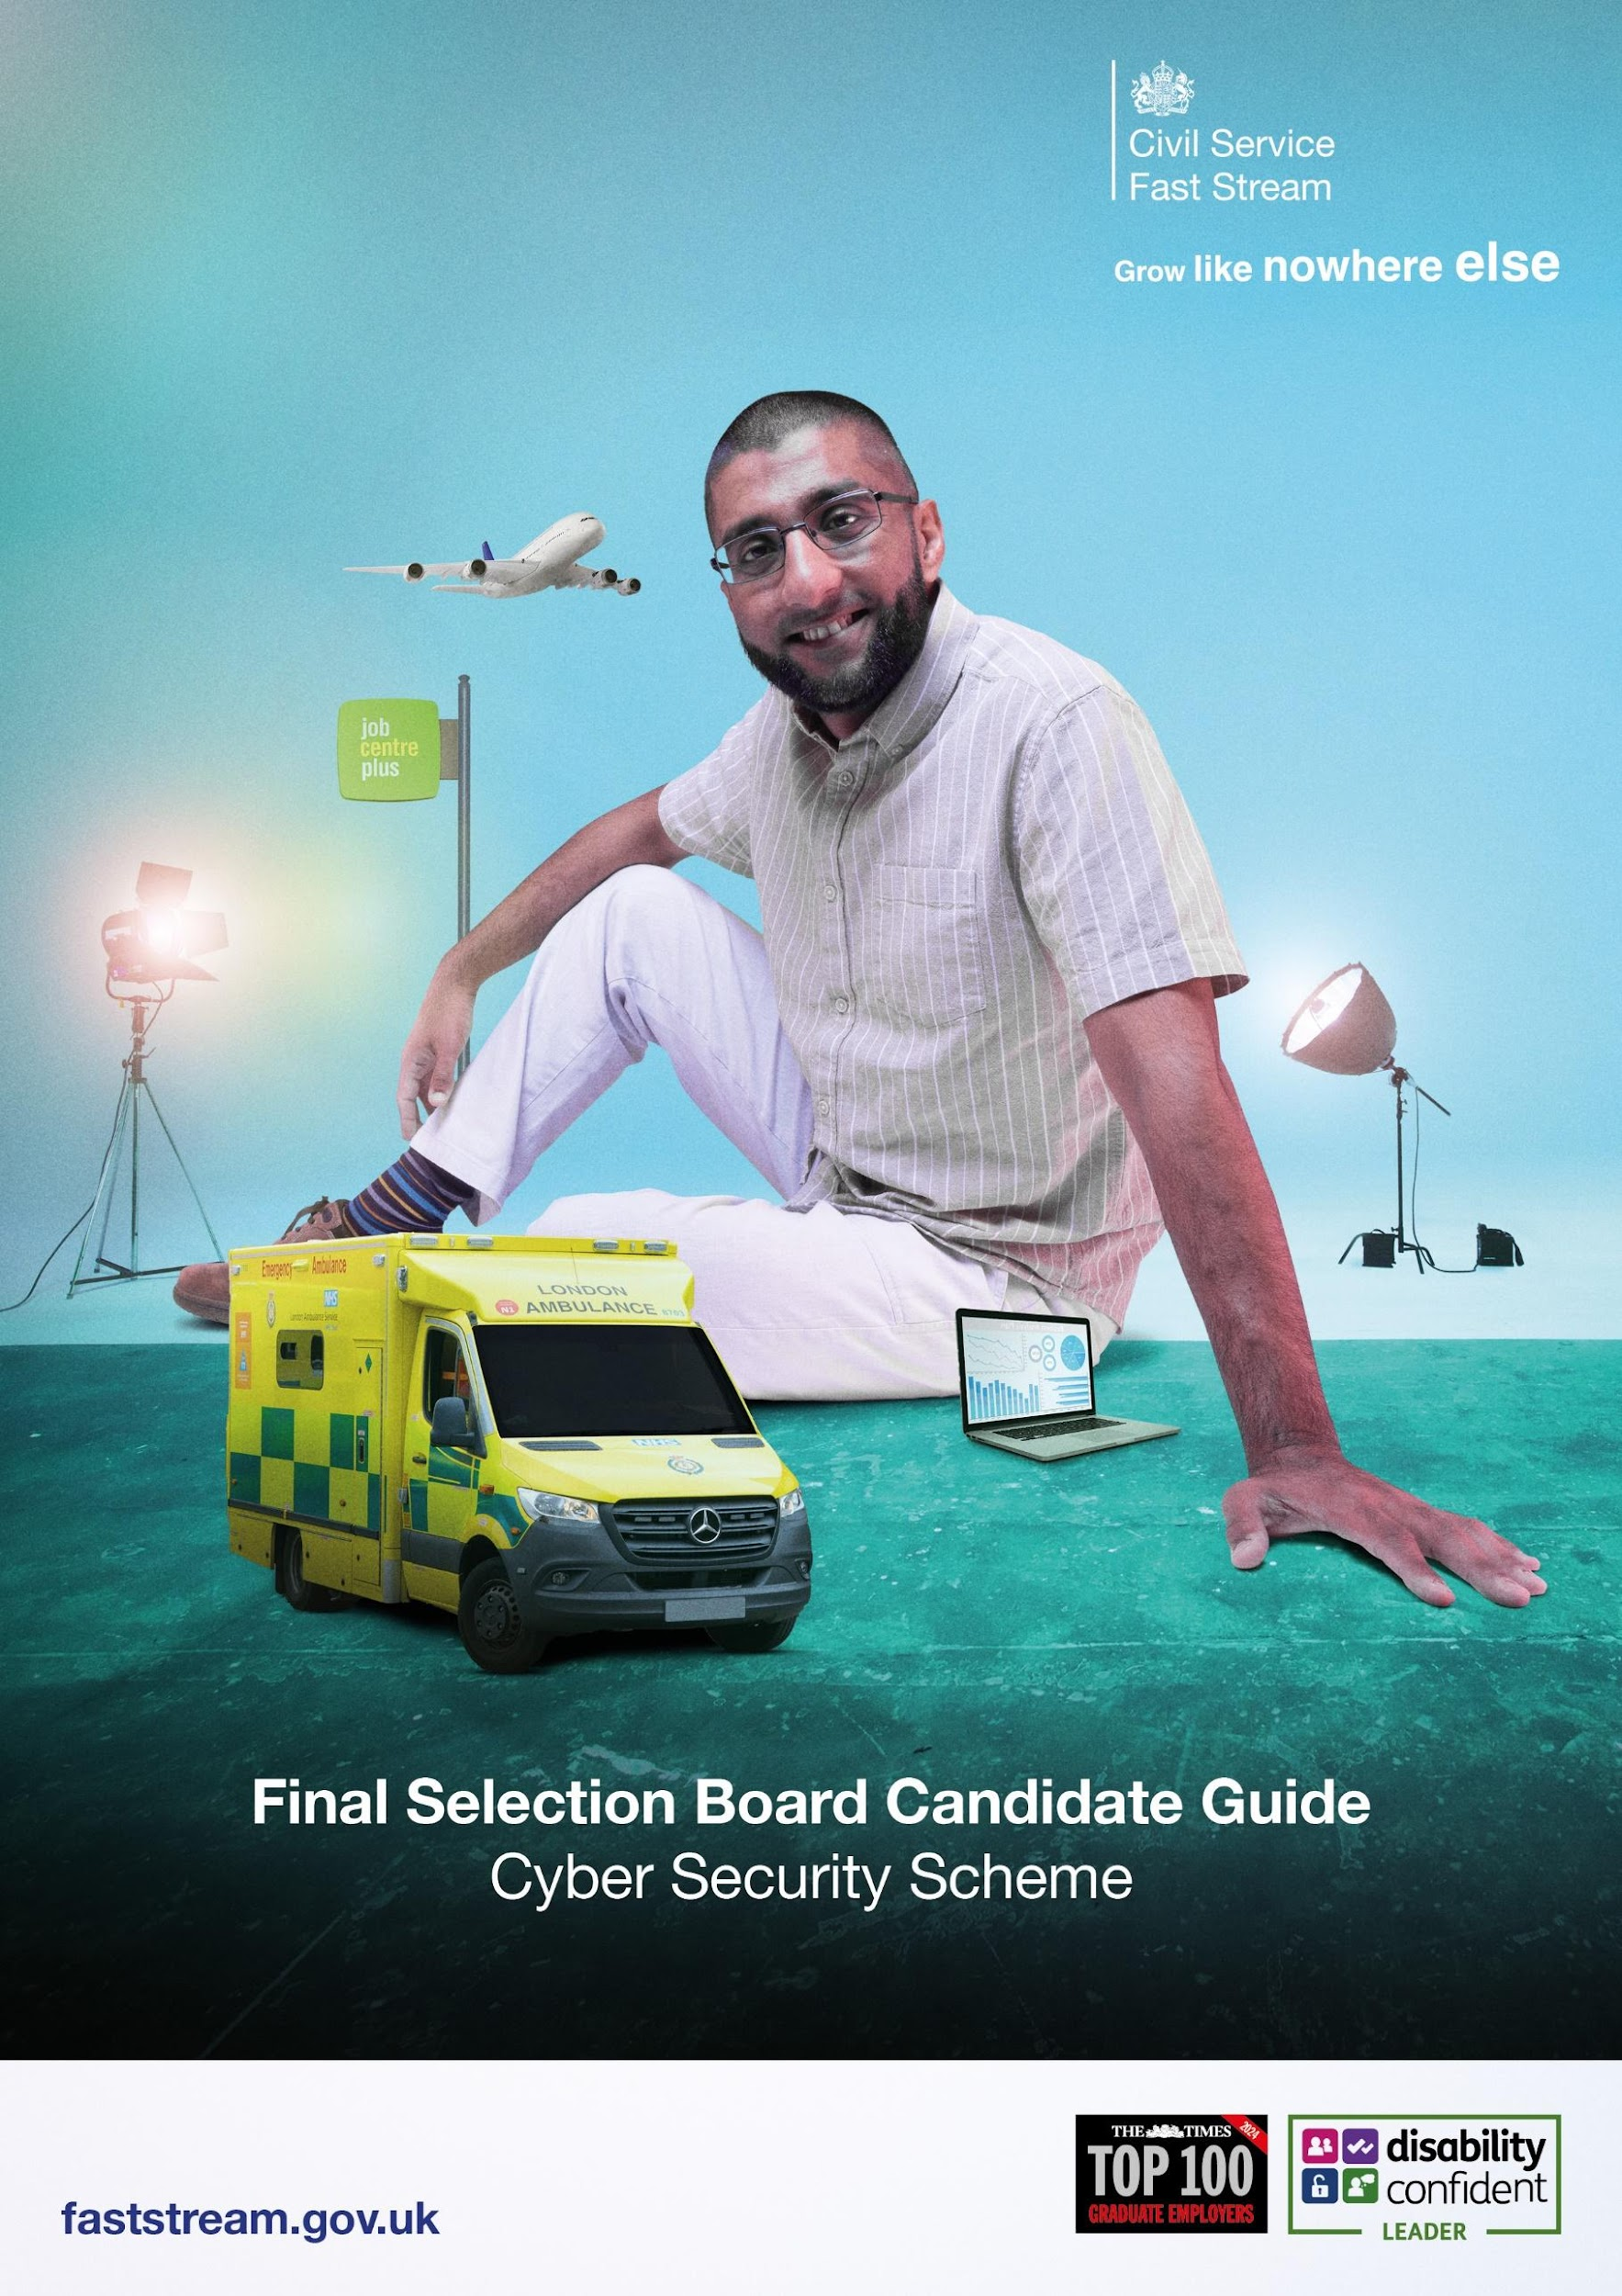

Congratulations on getting this far in what has been a demanding assessment process.

This guide will take you through the last step in the Fast Stream application process which is the Cyber Fast Stream Final Selection Board (FSB).

Next Steps

You will be invited to a Final Selection Board (FSB) interview which will be held virtually on Google Meets. You will receive your invitation via the Fast Stream website, as you have done for earlier stages of the assessment process. You will also receive a calendar invitation containing joining instructions from the Government Security Profession (GSP): talentschemes.gsp@cabinetoffice.gov.uk 24-48 hours before your interview date. Please ensure this email address is in your “safe” or “contacts,” so it does not get identified as either junk or spam. This invitation will be sent to the email address you supplied on your additional information form.

ID Checks

Photo ID will be needed at the beginning of your interview, in the form of a
- valid UK Passport,
- or a valid UK Driving Licence (or provisional licence).

You will need to present this ID to your camera. Photos or copies of your ID cannot be accepted. Please ensure that the photo and the name on the passport are visible. Your ID is used to confirm that the individual completing the FSB is the person we were expecting.

FSB Interview

Your FSB interview will last approximately 30 minutes and consist of 1 presentation (no slides) and 2 questions.

The interview will consist of questions assessing;
- Presentation (no slides) 5-10mins: What are some of the current trends or significant threats in cyber security that you believe professionals should be aware of?
- You will be asked a further 2 questions to allow the panel to assess your motivation and awareness in relation to your application for the Cyber Security Fast Stream programme.

The FSB is based on your capability and potential. Previous employment in cyber security is not required to be successful. You may draw upon any area of your life including work, academic studies, personal projects or volunteering.

It may be helpful to refresh your understanding of the:
- Civil Service Values- https://www.gov.uk/government/organisations/government-security-profession
- Cyber Fast Stream https://www.civil-service-careers.gov.uk/professions/working-in-security/

The FSB is an opportunity for you to ask questions about the Cyber Security Fast Stream programme and Security Profession. If you have any questions before/after your interview, please submit a ticket and a member of the Fast Stream Operations Team will get back to you.

TOP TIPS

Before your interview, it is important that you:

- Ensure you are in a quiet space, free of distractions and won’t be disturbed, and unless agreed as a part of any reasonable adjustments, you should not have anyone else in the room.
- Try to use a plain background or minimise any distractions (try the blur background function on Google Meet)
- Read the information on this pack thoroughly and any supporting information mentioned.
- Ensure you have your ID to hand when you join your interview.
- Have a drink of water nearby.
- Looking into your camera helps create ‘virtual eye contact’
- Remember that the assessors are not looking for a specific ‘type’ of person or specific experience. We want you to bring your authentic self to your FSB.
- Feel free to have notes with you during the interview. But try not to read from these throughout.
- You should wear what you would during an in-person assessment centre and what makes you feel comfortable.
- Download the latest version of one of the internet browsers listed below. We recommend Google Chrome for the best user experience.
- Have a laptop charger or plug socket nearby to plug in your computer if required.
- Check your microphone and webcam are working properly.
- Please ensure that you join the meeting promptly using the email address that you received the invite to, please do not forward the invite on to a further email address, as this may cause access issues.

Reasonable adjustments

If you require reasonable adjustments, please submit a ticket and a member of the Fast Stream Operations Team will get back to you. We will always endeavour to implement any reasonable adjustments. However, in some circumstances it may not be reasonable to make the adjustment.

As the candidate, it is your responsibility to request reasonable adjustments prior to your interview.

Good Luck with your interview!



