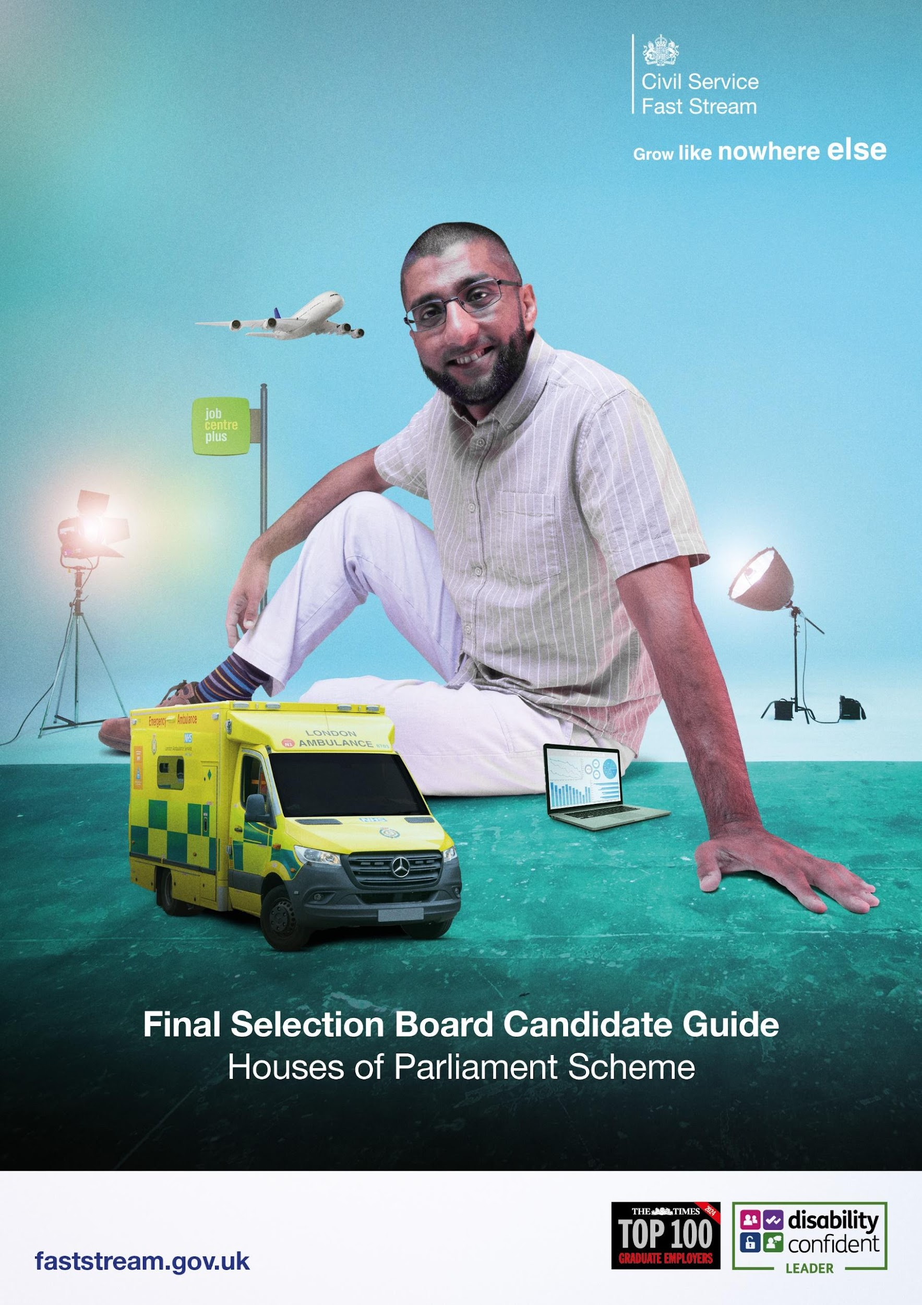

Introduction

Congratulations on passing the Fast Stream Assessment Centre!

The Houses of Parliament Final Selection Board (FSB) is the final assessment for candidates who have achieved sufficiently high scores at the Fast Stream Assessment Centre (FSAC) and have shown enthusiasm for a career in the Houses of Parliament.

Successful candidates will be offered a place on the House of Commons Graduate Development Programme.

The interview

When you attend the FSB, you will be asked to complete a panel interview. The interview will last approximately 40 minutes, and will be assessed by the following panel:

- Elizabeth Hunt, Director of Restoration & Renewal Boards and Groups and Senior Adviser, Clerk Development Programme, House of Commons (Chair);
- Sara Elkhawad, Head of Clerk Early Career Development, House of Commons;
- Ian Bradshaw, Secretary to the Independent Expert Panel, House of Commons;
- Anna Murphy, Head of Procedure, House of Lords.

We will send interview questions in advance of the interview stage to give you the maximum opportunity for presenting your best answers to the questions. Please note there may also be supplementary questions and follow up questions arising from your answers which you will not be provided in advance of the interview.

We will be assessing you against the following criteria:

- Written and oral communication skills;
- Ability to provide impartial advice;
- Ability to use the most appropriate techniques to influence or persuade others;
- Ability to acquire knowledge rapidly in unfamiliar areas;
- Understanding of how to research and organise information from a range of sources and use it to draw conclusions and make evidence-based decisions;
- Ability to get on with people from all walks of life and the skills to build and maintain effective working relationships; and
- Planning and organisational skills, with demonstrable experience of planning and prioritising your own work to meet strict deadlines.

During your final interview, try to:
- Stay relaxed and be yourself;
- Remember that the panel can only give credit for what you say – they want you to do well and are not trying to trip you up; and
- When giving examples in your answers to interview questions, it can be helpful to use the “STAR” method to help you structure your answers:
S – situation: Describe the situation you were in, the issue or the problem you were trying to solve.
T – task: What was the task that you needed to do to deal with the situation?
A – action: What did you do? And importantly, how did you do it?
R – result: What was the outcome of your action[s]?
We are most interested in hearing what you did, how you did it and why (the “action” part in STAR)

Logistics

The FSB is expected to be held in the week commencing 16 March 2026. It will be conducted online using Microsoft Teams. You should not come to Parliament. You will be provided with a link to join the Microsoft Teams meeting and given instructions for when to join.

You should make sure you download Microsoft Teams and familiarise yourself with it in advance of your interview.

If you are successful at the FSB, you will be contacted by HR and will be offered a position in the House of Commons, subject to security checks.

At this stage you will be asked to provide the following documents via email in pdf format:

- Proof of identification: passport, or full birth certificate and NI number;
- Proof of address: for example, a utility bill or bank statement that is less than three months old, or a driving licence;
- Evidence of your right to work in the UK. If you’re a British or Irish citizen, you can prove your right to work in the UK with either of the following:
  - a British passport
  - an Irish passport or passport card
If you’re not a British or Irish citizen, you can prove your right to work with a share code; and
- An original copy of your degree certificate if you have already graduated.

The Houses of Parliament Graduate Development Programme is not a centrally managed scheme and we do not participate in any of the following partner programmes: Entrepreneur First; Frontline; Lead First; Police Now; TeachFirst; Think Ahead; and Year Here.

Reasonable adjustments

It is important that we are able to make appropriate arrangements or adjustments where necessary in order to ensure a full and equal participation in the selection process. If you require reasonable adjustments and you require one at your FSB, please submit a ticket and a member of the team will get back to you.

If you require special arrangements for the interview and haven’t informed the Civil Service, or if you would like to discuss arrangements ahead of the interview, please call 020 7219 5570/5973 to speak to an HR adviser confidentially about how we can meet your needs.

Contact us

We’d be happy to talk to you if you have any questions relating to the House of Commons or the FSB process. Please feel free to contact an HR adviser on 020 7219 5570/5973 or recruitment@parliament.uk.

We also offer candidates the opportunity to take part in a virtual drop-in with the scheme lead from the House of Commons. This will provide you with an opportunity ahead of the process to answer any questions you have about working in the House of Commons. If you are successful, we will offer you a buddy who can answer questions prior to your arrival. If you would like to take part in a virtual drop-in, please email Sara Elkhawad (elkhawads@parliament.uk).

We look forward to meeting you at the FSB.

Elizabeth Hunt Sara Elkhawad
Director of R&R Boards and Groups, Head of Clerk Early Career Development
House of Commons House of Commons

