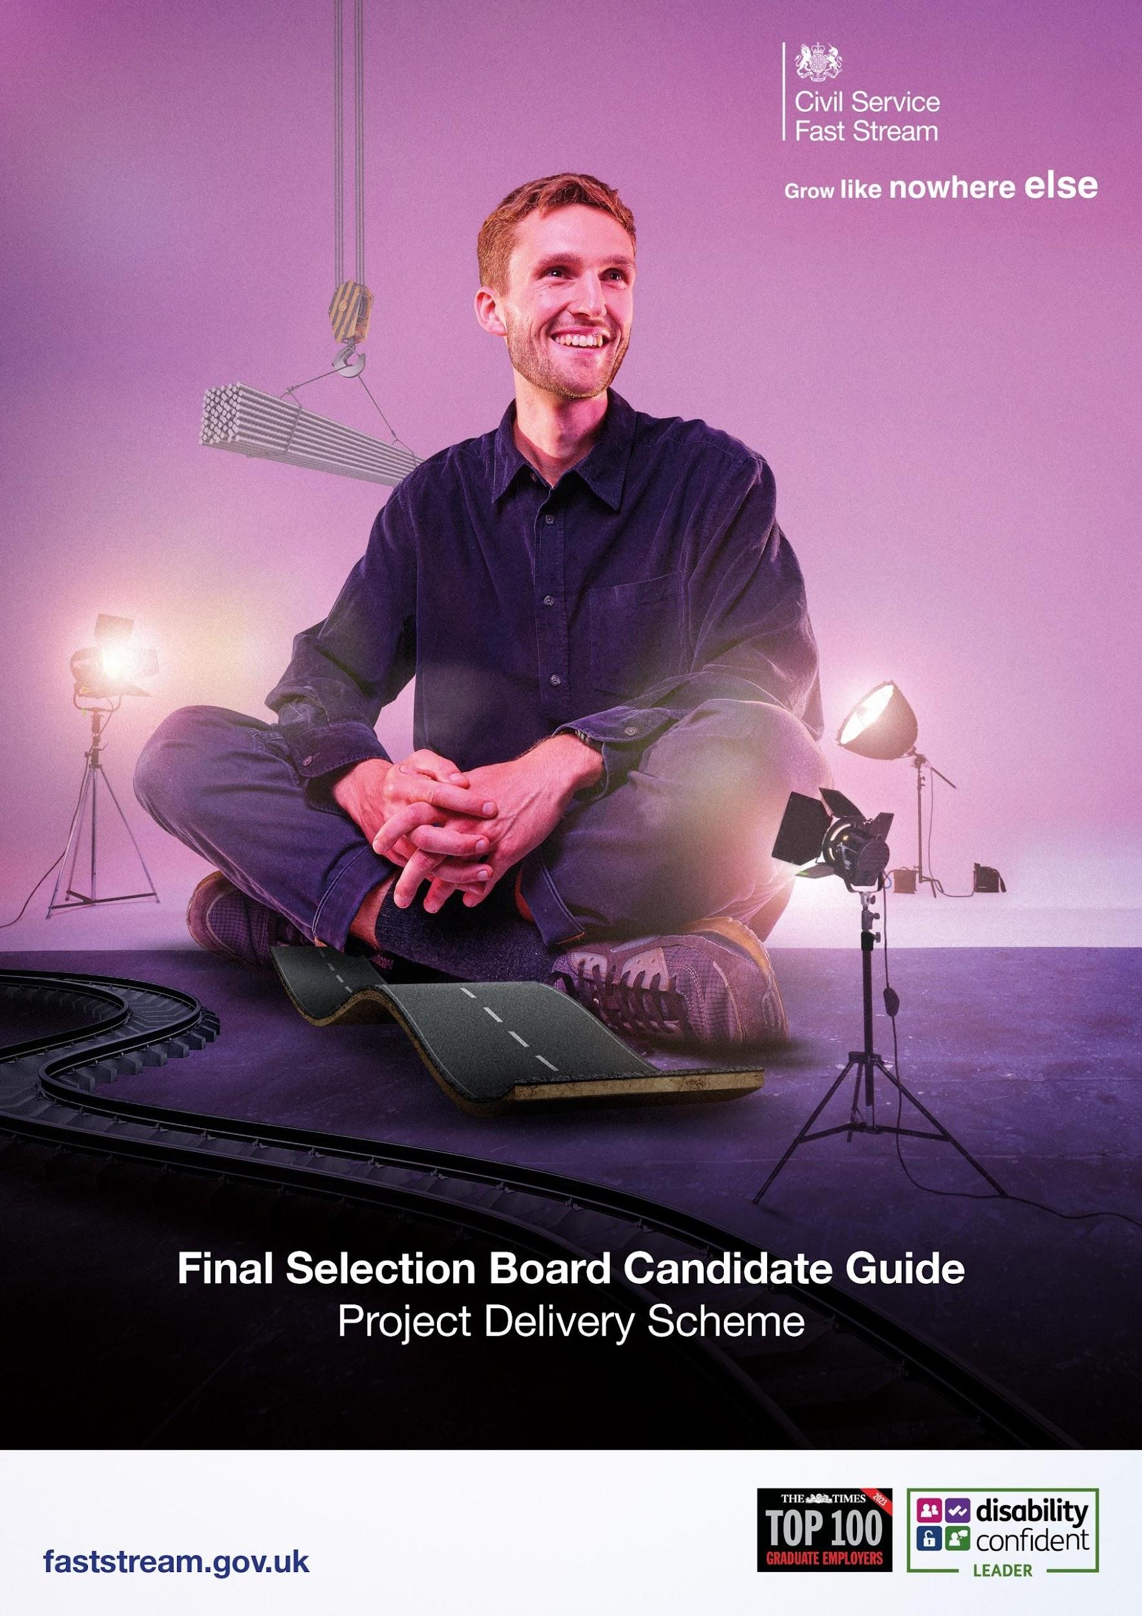

Congratulations on getting this far in what has been a demanding assessment process.
The Project Delivery Final Selection Board (FSB) will take the format of a video interview. It will last approximately 20 to 30 minutes, however please don’t be alarmed if it is either longer or shorter.
You will receive your invite via the Fast Stream website, as you have done for previous stages of the assessment process.
The Project Delivery Final Selection Board will take place via Microsoft Teams.
In addition to your invitation via the Fast Stream website, you will also receive a calendar invite to the event from: pdfaststream@faststream.civilservice.gov.uk 5 – 7 days before the event if you have accepted the invitation on the portal. Please ensure this email address is in your “safe” or “contacts” list so it doesn’t get identified as either junk or spam.
This invite will be sent to the email address you supplied in your additional information form. You do not need to have a Microsoft Teams account to use Microsoft Teams.
On the day, you will need to click on the link contained within the invite at the time of your interview. Once you’ve clicked, you will progress to a google calendar page where you will need to click the MS teams link again. Once you’ve completed that step, you should be directed to the MS teams page, where you can input your full name and select ‘join meeting’.
You will be joined in the meeting by two project delivery interviewers who will deliver your interview.
Please ensure that you join the meeting promptly using the email address that you received the invite to, please do not forward the invite on to a further email address, as this may cause access issues.
If you plan to use a mobile or tablet, you will need to download the Microsoft Teams app prior to your interview. You will need to ensure you have microphone and camera functionality for your interview.
For your interview we recommend that you are somewhere quiet and where you won’t be interrupted, with a strong Wi-Fi signal. We’d also suggest you have your mobile phone to hand (on silent), should our interviewers need to contact you for any reason on the day.

Please be aware you will need to ensure your camera is working for the interview. If your interviewers aren’t able to see you, then we will need to reschedule your interview.

Our interviewers will be looking to find out:
- More about you
- Your motivations for joining the Project Delivery profession
- What you know about project delivery in Government
- What basic knowledge you have about project management (note: professional experience of project management is not required if successful - you can draw upon life experiences where you have shown project management skills. This may be in your work, academic or personal life).
Prior to your interview, you may find it useful to consider some examples that you could use to provide evidence in the areas listed above.

Please note that as part of your FSB, we will be scoring the Project Delivery question from the ‘extra information’ form that you will have already completed. We will inform you of the outcome of your final interview as early as possible via the scheme progress page of the website.

The Project Delivery Fast Stream is committed to providing feedback to all who undertake our Final Selection Board where you are sitting the interview as your first preference scheme. This feedback will usually be provided within 20 working days following notification of the outcome of your final selection board. This will be sent to the email address you provided in your ‘extra information’ form.

Finally, we would remind you that you should not use any Generative AI (Gen AI) tools during your Final Selection Board. Fast Stream guidance on the use of Gen AI can be found here.

Good luck with your interview.
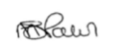
Michelle Palin

