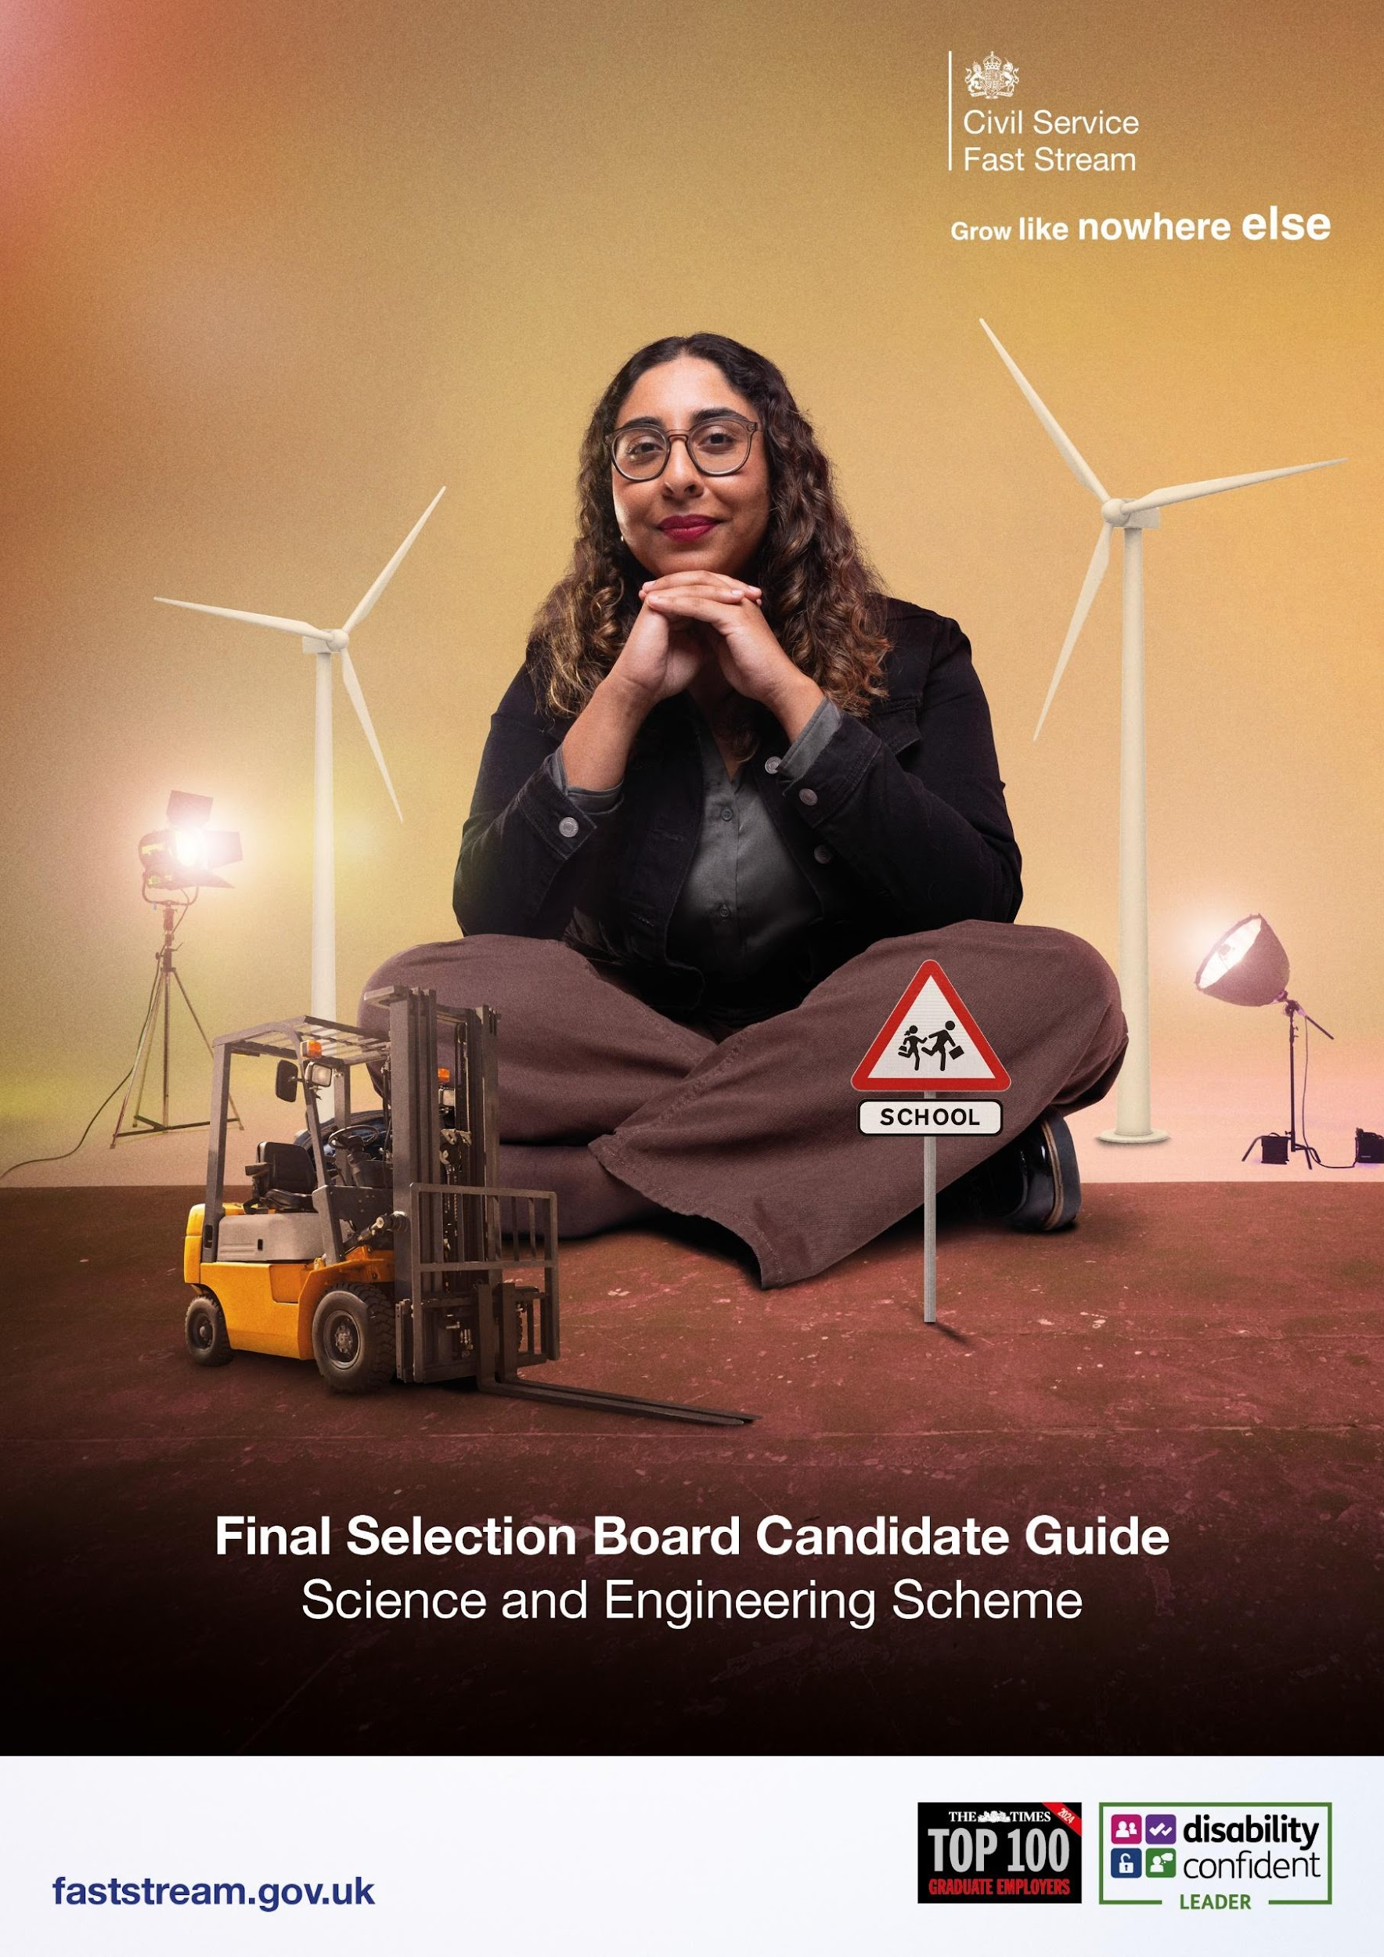

Congratulations on passing the Fast Stream Assessment Centre (FSAC)!

This guide will take you through the next step - the Science & Engineering (S&E) Final Selection Board (FSB).
Read this guide carefully. It sets the scene for the day.

Useful Information
IT Checks
Now that the entire S&E FSB takes place online, there are some logistical IT checks you will want to get right from the get-go. This should prevent any unwanted surprises on the day.
Here is an IT checklist to consider:
- We will be using Google Meet to communicate with you on the day and a modern internet browser is required for Google Meet to run.
- We recommend using the current version of one of the browsers listed below:
- Google Chrome Browser Download the latest version
- Mozilla Firefox. Download the latest version
- Microsoft Edge. Download the latest version
- Apple Safari.
- For the best user experience at FSB Google Chrome is highly recommended.
- Internet Explorer is not supported.
- More information on Google Meet can be found on the Google Meet Help Centre.
- Check your microphone and webcam are working.
- Ensure your laptop or computer has a strong WiFi connection. On the day if you’re disconnected from the internet, we might need to contact you via phone, if possible, please have a mobile device available and fully charged.
Read the Briefing Email
You will receive a briefing email from your dedicated test administrator the day before your event (around 15.30). This will include some key information you need to consider, such as:
- The name and contact details of your test administrator.
- Key instructions about emailing in your Photographic ID ahead of the S&E FSB.
- The URL virtual meeting room link you will need to click on to access the S&E FSB on the day.
- If you have not received the email before 16.00, please check your junk or spam folder. If it is not in there, please submit a ticket, to let them know.
Other useful Information:
- We recommend having some paper and pens available.
- You should wear what you would during an in-person assessment centre and what makes you feel comfortable.
- Make sure you can be seen in front of the camera.
- Plan ahead and turn your computer on early so you are ready for the assessment centre to start on time. If you join S&E FSB late, it is highly unlikely you will be able to take part on the day.
- Ensure your computer is plugged in and receiving power.
- If you require a reasonable adjustment at your FSB, please submit a ticket and a member of the team will get back to you. We will implement the necessary adjustments required to ensure you can fully participate on the day.
- You will be completing a written exercise in Microsoft Word and will be sent the template on the day of your assessment.
- You will need access to your email inbox throughout the day to receive your FSB schedule, exercise material and virtual URL room links.
- Get a good night’s sleep before the event.
Please submit a ticket if you have any queries, and a member of the Fast Stream team will get back to you.
Attending the Virtual S&E FSB
On the day
Specific events start and end times will be communicated in your invite.
To join the S&E FSB, you need to click the URL Google meeting room link previously sent to you in your briefing email. Please note these rooms will remain locked until the event begins.
You will then be placed into a virtual meeting room with your test administrator and other candidates in your group. You will have to have your microphone and camera switched on so the team can communicate with you and complete the registration stage. The team will brief you on the running of your assessment and give you access to your schedule and the virtual assessment centre platform.
It is from the virtual meeting room that you will complete your exercise preparation, and this will be timed by your test administrator.
Please be reassured your test administrator is there to help and guide you through the process. It is important to have your phone on hand in case you lose connection, and we need to contact you offline.
If you have done everything you can beforehand to ensure a good WiFi connection and you are still disconnected from the internet, please do not worry as these things happen and the team will work with you to find a solution.
Below are some useful tips to consider when attending S&E FSB:
- Stay relaxed, be yourself and try to enjoy the day.
- Remember that assessors can only give credit for what you say and do. They are not trying to trip you up; they want you to do well and show what you are capable of.
- Remember that you are not competing with others in your group. You are all being assessed against an independent standard.
- Go into each exercise with a positive frame of mind.
- Read the exercise instructions and follow them carefully. If you are unsure of something, ask before the exercise begins. Don’t feel embarrassed about doing so.
How is the Science and Engineering FSB structured?
The FSB consists of a:
- Written exercise – 90 Minutes
- Oral presentation – 10 Minutes
- Interview – 50 Minutes
In total your assessment will last 2 hours and 30 minutes.

Written Exercise
The Final Selection Board will start with your written exercise. Using a range of information provided to you on the day via email, you will be asked to develop a briefing.
The way you approach the issue at hand may reflect your particular area of scientific or engineering expertise, but no information, other than that provided, should be quoted in your briefing. In the 90 minutes, you will also need to prepare an oral presentation, which must not exceed five minutes, on the options and recommendations laid out in your briefing note. There is an additional five minutes for any follow up questions the panel may wish to ask. You will need a sheet of paper to make notes if you wish.
The written exercise and the oral presentation will be assessed against the following GSE Technical skills which are shown in the GSE Career Framework. Please familiarise yourself with the GSE Career Framework by clicking on the link.
- Communicating science & engineering (S&E) for government - Communicating science and engineering - (Page 15)
- Communicating science & engineering (S&E) for government - Providing and handling evidence - (Page 15)
- Broad Thinking - Technical adaptability - (Page 18)

Oral Presentation
The oral presentation will be a summary of your answers to the written exercise and is designed to test your oral communication skills, in particular your ability to support ministerial decision making in a technical area. You will be instructed to prepare your presentation so that it can be understood in isolation, as the interview will not have access to your written exercise/answers. The interview panel will also ask you follow-up questions based on the presentation you deliver.

Interview
Your Oral Presentation will be followed by an interview lasting 50 minutes. You will be interviewed by a panel of 2 or 3. At least 1 panel member will have a substantial science or engineering background.
Your interview questions will be based on the first 4 GSE Technical skills taken from the GSE Career Framework which have been highlighted below. The interview questions are also designed to explore your interests, strengths and motivation for joining the Science and Engineering Fast Stream therefore your interview will consist of behaviour questions and strength-based questions.
Technical questions – will be based on the 4 skills below -
- Building and applying knowledge - (page 13 & 14)
- Communicating science and engineering for government - (page 15)
- Developing science and engineering capability (page 16)
- Technical oversight and management (page 17)
There are no right or wrong answers, and the questions are designed to allow you to explore a range of examples of your achievements so that we can get a rounded picture of you.
Prior to attending the FSB, you may find it useful to consider some examples that you could use in the interview to provide evidence against the skill areas listed above.
You should use the STAR method (Situation, Task, Action, Result) to structure the examples you give to questions.
- Situation - the situation you had to deal with.
- Task - the task/tasks you were specifically given to do.
- Action - the action/actions you took.
- Result - what happened as a result of your action/actions and what you learned from the experience.
When using STAR, remember:
- you can use examples from work, home or volunteering.
- keep examples short and to the point.
- be prepared to answer follow-up questions about the examples you give.
Example of an interview question and STAR response – Tell me about a time when you have shown leadership skills?
Situation - In my previous digital marketing job, the company wanted to get more people to sign up to a newsletter which was not receiving a lot of attention.
Task - My job was to find a way of getting more people to sign up.
Action - I organised a meeting with other important members of the marketing team to come up with creative ideas, and I led the social media campaign to generate interest in the revamped newsletter.
Result - over a period of 3 months, there was a 25% increase in sign-ups to the newsletter and the approach I took was used by the management team in other departments.

Strength based questions
Preparing for Strength based questions –
- Research the employer. Learn about the company's core values and culture.
- Get to know your strengths.
- Analyse your employment history
- Be authentic and confident.
Remember In an interview, a strength is assessed not just by what you say, but how you say it.

What happens after your Final Selection Board
You will be informed as soon as possible after all the FSBs have finished as to whether you have been successful by visiting the Scheme Progress page of your Fast Stream website in the usual way.
After the final selection board, you will receive detailed feedback on how you performed in the written exercise, oral presentation and interview. You will receive a summary of your strengths and areas for further development in each of these exercises. Feedback will be emailed to you in the weeks after the final selection board.
Finally, we would like to congratulate you for getting this far and wish you good luck at your final selection board.

