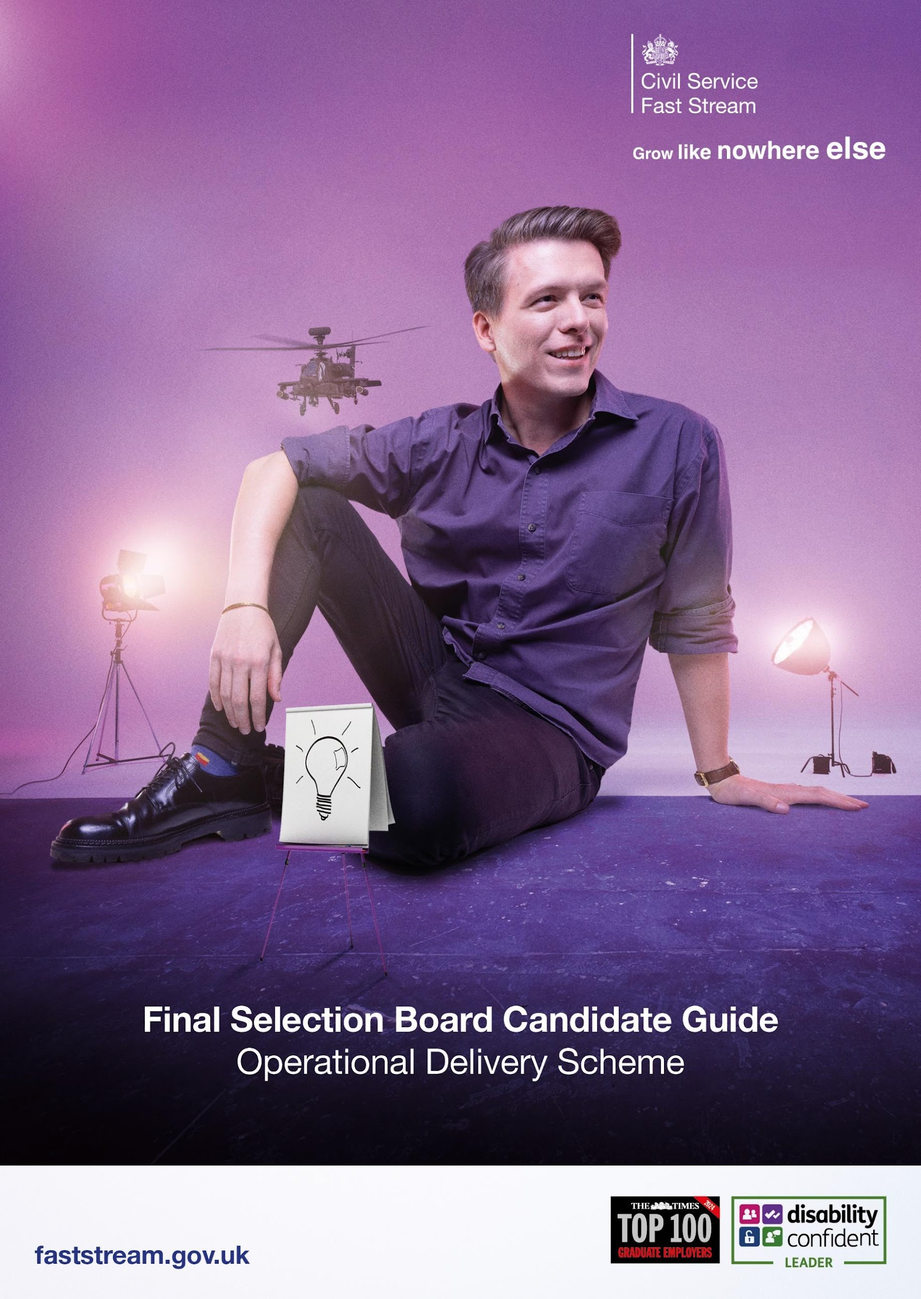

This guide will take you through the last step in the Fast Stream application process which is the Operational Delivery Final Selection Board (FSB).

Next Steps
You will be invited to an FSB interview which will be held virtually via MS Teams. You will receive your invitation via the Fast Stream website, as you have done for earlier stages of the assessment process. You will also receive a calendar invitation containing joining instructions from the Operational Delivery Profession (OPD) Team: operationaldeliveryfaststream.centralodp@hmrc.gov.uk 24-48 hours before your interview date. Please ensure this email address is in your “safe” or “contacts” list, so it does not get identified as either junk or spam. This invitation will be sent to the email address you supplied on your additional information form.

If you need reasonable adjustments for your FSB, please submit a ticket and a member of the team will get back to you.

If you need any adjustments beyond this, please use this email to contact the ODP Team: operationaldeliveryfaststream.centralodp@hmrc.gov.uk

Here’s an IT checklist to consider:

- Make sure you download and test the Microsoft Teams app prior to your interview including camera, microphone and sound.
- When joining the MS Teams call you will simply need to click on the ‘Join meeting’ link contained within the invitation at the time of your interview.
- Please ensure that you join the meeting using the email address that you received the invitation to. Please do not forward the invite on to a further email address as this will cause access issues.
- For your interview we recommend that you are somewhere quiet and where you will not be interrupted, with your device plugged in or a charger nearby, and strong Wi-Fi signal.
- We would also suggest you have your mobile phone to hand on the day, should our interviewers need to contact you before the interview for any reason.
- Please be aware you will need to ensure your camera is working for the interview. If your interviewers cannot see you, we will need to reschedule your interview.

ID Checks
Photo ID will be needed at the beginning of your interview, in the form of a valid UK Passport, or a valid UK Driving Licence (or provisional licence). You will need to present this ID to your camera. Photos or copies of your ID cannot be accepted. Please ensure that the photo and the name on the passport are visible.

Your ID is used to confirm that the individual completing the FSB is the person we were expecting. Once these checks have been conducted the record of the ID details are deleted and not retained by the ODP Team. If you do not have a valid Passport or Driver's License and you are unable to provide a formal photo ID, then please provide us with an electronic copy of your birth certificate and a headshot. The headshot photo can be taken on your computer, phone or other electronic device and should be provided to operationaldeliveryfaststream.centralodp@hmrc.gov.uk 48 hours before your interview.

FSB Interview

Your FSB interview will last approximately 30 - 45 minutes and consist of 6 assessed questions. Before the interview starts you will be asked a warm-up question. The warm-up question is not assessed.

The questions will aim to find out:
- Your motivations for joining the Operational Delivery Profession and Operational Delivery Fast Stream, and your values and working style that you would bring.
- What you already know about operational delivery, the Profession and front-line services,
- Your career aspirations and how the Operational Delivery Fast Stream fits into these.

The FSB is based on your capability and potential. Previous experience of operational delivery is not required to be successful. You may draw upon any area of your life including work, academic studies, volunteering or personal life.

It may be helpful to refresh your understanding of the:
- Civil Service Values- https://www.gov.uk/government/organisations/civil-service-operational-delivery-profession
- The Operational Delivery Fast Stream - https://www.faststream.gov.uk/operational-delivery/index.html
- Government Operational Delivery profession- https://www.gov.uk/government/organisations/civil-service-operational-delivery-profession?_ga=2.243310662.2101119483.1702048135-193194499.1699366069

Note:
Some information may reference the Government Operational Delivery Profession Team. This is a central unit based within HMRC, who support personal development and career progression for Operational Delivery professionals, by providing qualifications, events and resources to harness people’s potential. This central team does not make up the entirety of the Operational Delivery Profession.

The FSB is an opportunity for you to ask questions about the Operational
Delivery Fast Stream scheme and Operational Delivery Profession. Those who are
interviewing you are part of the profession with direct operational delivery
experience. Any questions that they are unable to answer during your interview, they will take them away and the ODP Team will respond to you via email with an answer.

TOP TIPS

Before your interview, it is important that you:
- Ensure you are in a quiet space, free of distractions and won’t be disturbed, and unless agreed as a part of any reasonable adjustments, you should not have anyone else in the room.
- Try to use a plain background or minimise any distractions (the blur background function on MS Teams is handy here.)
- Read the information on this pack thoroughly and any supporting information mentioned.
- Complete the IT check list.
- Ensure you have your ID to hand when you join your interview.
- Have a drink of water nearby.
- Looking into your camera helps create ‘virtual eye contact’.
- Remember that the assessors are not looking for a specific ‘type’ of person or specific experience. We want you to bring your authentic self to your FSB.
- Feel free to have notes with you during the interview. But try not to read from these throughout.

Reasonable adjustments
We want all candidates to be able to perform to the best of their ability. Under the disability provisions of the Equality Act 2010, the Operational Delivery Profession (ODP) is legally required to make reasonable adjustments if you feel this applies to you, please contact the OPD Team (email: operationaldeliveryfaststream.centralodp@hmrc.gov.uk). Please also contact the Fast Stream Recruitment Operations team by submitting a ticket to inform them of any adjustments that you may require at your FSB. The ODP Team will always endeavour to implement any reasonable adjustments. However, in some circumstances it may not be reasonable to make the adjustment.

Please note that the onus is on you, as the candidate, to request reasonable adjustments prior to your interview.

Outcomes

We will inform you of the outcome of your FSB interview as early as possible via the
‘Scheme progress’ page of the Fast Stream website. Candidates will receive their results periodically and not all at the same time. Feedback will usually be provided within 30 working days following notification of the outcome of your FSB, but this may take longer due to the level of work undertaken by the OPD Team during this time. This will be sent to the email address you provided during the initial application process. If you do not receive feedback beyond the 30 working days, please email operationaldeliveryfaststream.centralodp@hmrc.gov.uk

If you are successful, the Cabinet Office Fast Stream team will contact you by email to begin the onboarding process. The projected start date will be September 2025 or October 2025, please ensure that you can meet this start date as delayed starts beyond October 2025 cannot be accommodated.

Please note that all offers will be subject to passing the relevant security background checks. If you are unsuccessful, the Cabinet Office Fast Stream team will update your status on the Fast Stream portal, and you will automatically proceed with your next Fast Stream scheme choice if applicable.

Location

Please keep in mind the locations available for the Operational Delivery Fast Stream do not include Central London. In 2025 and beyond the Operational Delivery Fast Stream scheme is open UK-wide, excluding Central London as a continued commitment to move roles out of Whitehall. Central London is defined in the London Government Act (1963) and includes the boroughs of:

- Camden
- Greenwich
- Hackney
- Hammersmith and Fulham
- Islington
- Kensington and Chelsea
- Lambeth
- Lewisham
- Southwark
- Tower Hamlets

- Wandsworth
- Westminster
- And City of London.

Note:
While the Operational Delivery Fast Stream is open UK-wide this may not guarantee we can offer a role in your region or local area. This is because roles on the Fast Stream schemes work on a bid process and rely on a suitable bid or role being made available in your region by Government departments.

If you have any concerns about the above information, please contact the Fast Stream team by submitting a ticket, or emailing the ODP Team on operationaldeliveryfaststream.centralodp@hmrc.gov.uk. For example, if you don’t have access to Microsoft Teams, or a quiet place to take your assessments.

Good luck with your interview!
