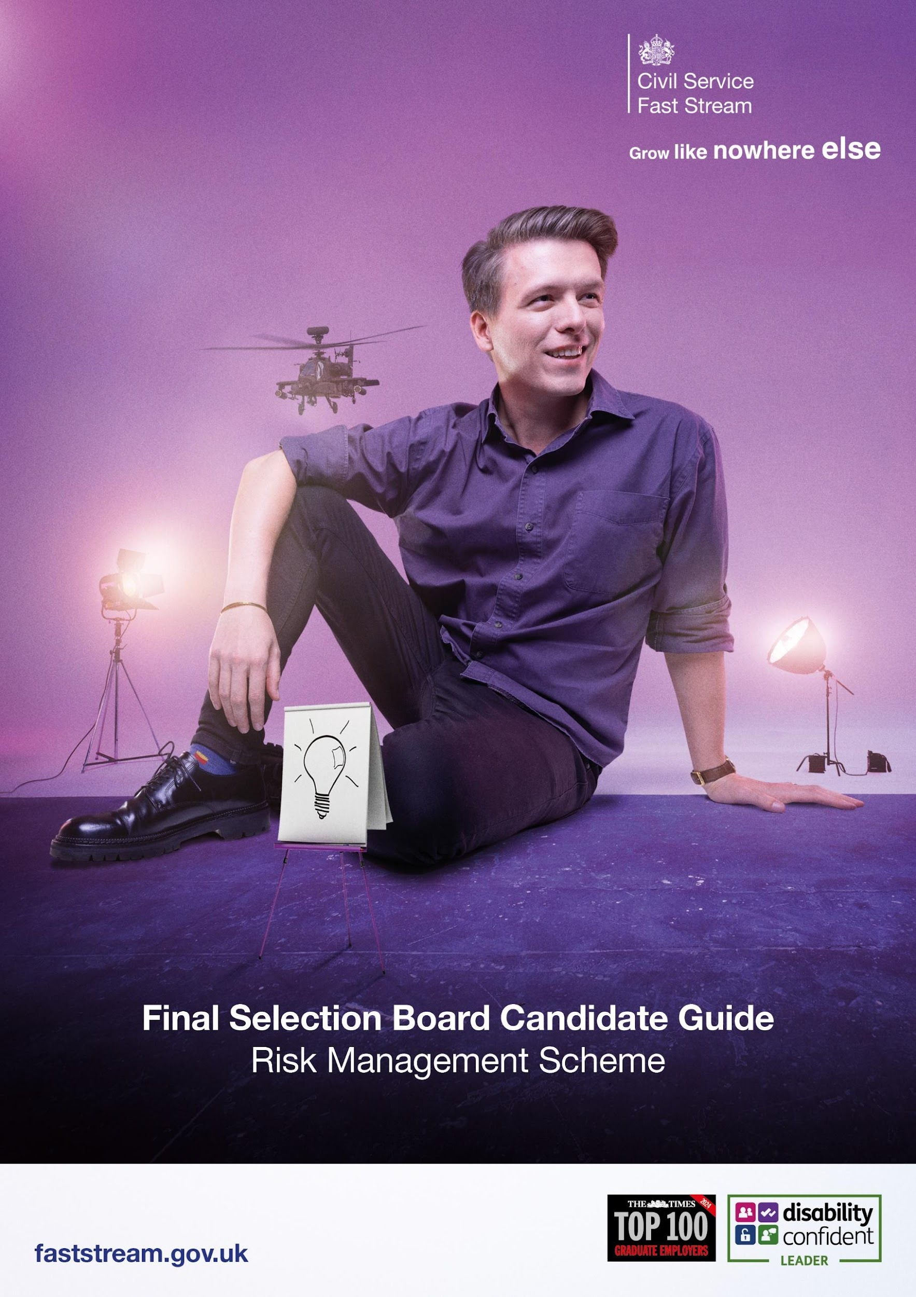

Congratulations on your success in getting this far in our demanding assessment process. We are delighted you are showing such an interest in helping advance the management of risk in government.

You have been invited to attend a virtual Final Selection Board (FSB) interview for the Risk Management Fast Stream. This guide will take you through the next steps on how to prepare for the meeting and what to expect.

Our interviewers will be looking to find out:
- More about you
- Your motivations for joining the Government Risk Profession
- What you already know about risk management

Please note whilst professional experience in risk management is not necessary, you will be expected to demonstrate an understanding of risk management and its application.

You should also be aware that as part of the FSB, we will be referring to the risk management question from the ‘extra information’ form that you already completed. We will inform you of the outcome of your final interview as early as possible via the scheme progress page of the website.

Useful Information:
- The format will be a virtual video interview lasting around 45 mins.
- We will be using MS Teams to conduct the interview and have listed some useful IT tips below
- We recommend also having some paper and pens available.
- There is no dress code, per se – you should wear business casual clothing.
- Have a laptop charger or plug socket nearby to plug in your computer if required.
- If you require reasonable adjustments, please submit a ticket to re-request your adjustments for the FSB. We will implement the necessary adjustments required to ensure you can fully participate on the day.
- You will need access to your email inbox throughout the day to receive your FSB schedule and virtual URL room links.
- Plan ahead and turn your computer on early so you are ready for the assessment centre to start on time.

IT Checks

Here is an IT checklist to consider:
- We will be using MS Teams to communicate with you on the day, and a modern internet browser is required for MS Teams to run.
- We recommended downloading and using the current version of one of the browsers listed below:

  - Google Chrome Browser
  - Mozilla Firefox
  - Microsoft Edge
  - Apple Safari
- For the best user experience, Google Chrome is highly recommended
- Internet Explorer is not supported
- Please check that your microphone and webcam are working
- Ensure that your laptop or computer has a strong WiFi connection. On the day if you have disconnected from the internet, we might need to contact you via phone, if possible, please have a mobile phone available and fully charged.

The Risk Management Fast Stream is committed to providing feedback to all candidates who undertake our FSB where you are sitting the interview as your first preference scheme. This feedback will usually be provided by e-mail following notification of the outcome of your FSB.

Good luck with your interview.

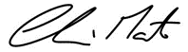

Clive Martin
Head of the Government Risk Profession

