Master Thesis: Research Proposal
Examining Scarcity channel of Quantitative Easing
15 January 2022 | Hubert Mrugala

1. Motivation and institutional setting
Scarcity channel is one of the least studied effects of central bank large asset purchases. It is plausible that quantitative easing programs, by decreasing the supply of Treasuries, increase scarcity of these securities in the market, especially in the repo market. There has been some research done on scarcity channel by determining relationship between central bank asset purchases and special repo rates (Arrata et al., 2018; D'amico et al., 2014). The authors of both papers use a very detailed repo data to test the hypothesis of a central bank induced collateral shortage, however they don’t take into the account the mechanics of the collateral intermediation complex. Jank et al. (2020) look into the dynamics of the shadow banking system in the and link the re-use rate of collateral to the supply of collateral and repo rates in the Euro area. Nevertheless, there still is no evidence of the scarcity channel in US Treasury repo market, that considers off-balance sheet collateral creation. This research would investigate effects of quantitative easing in the US on the Treasury General Collateral repo rate, with the help of bank’s repledgedable collateral data that represents augmented “supply” of repo collateral endogenously created by the banking system itself.

2. Research design and the data
The idea is to use test causality with a simple OLS regression. The depended variable would be the overnight GC Treasury repo rate in one of three possible forms: a) repo rate in first-difference form, b) fed funds upper target less repo rate, c) collateral spread, i.e. repo rate less unsecured rate, as in Nyborg and Rosel (2019).
While Nyborg (2019) asks the question of what makes collateral spread to narrow and why does it often turn negative? Here, the main question is: does the central bank create a shortage of the Treasury collateral by lowering the supply of Treasury securities. Collateral supply problems could be identified by observing widening in (positive) collateral spread.
Dependent variables would include:
- amount of all U.S. Treasury Securities held at the Fed,
- nominal value of US marketable debt (bills + notes + bonds),
- amount of collateral received, that is permitted to be repledged by biggest dealer banks,
- some macro controls, for instance the ones laid out in Nyborg (2019).
“Collateral permitted to be repledged” is a variable that reflects to what extend the shadow banking system creates artificial, off-balance sheet collateral by rehypothecating already pledged collateral (Singh 2017). It is available in notes of 10-Q reports of G-SIB banks, but unfortunately, only on quarterly basis. Including repledgeable collateral data may be challenging for the reason that it forces to use quarterly data which may create a sample that may just be too small. Jank (2020) showed that increases repo rate volatility follows increases in collateral re-use rates, so it is possible to increase the frequency of the data to month-by-month data by using repo rate volatility as a proxy for bank’s repledgeable collateral numbers.
Observations would be taken from the period of 2008-2021. Repo data is available online from DTCC. Fed’s balance sheet (weekly) data and US Treasury debt (monthly) data are also available online for free. An OLS specification would, for example, look like this:
collateral_spread_{t} = β₀ + β₁ ΔFed’s_Treasuries_{t} + β₂ ΔUS_Debt_{t} + β₃ ΔRepledgeable_Collateral_{t} + γ Controls_{i,t}.
There are many variables that could also be included, like dummies for regulatory changes, most notably the supplementary leverage ratio, or the notional amount of Treasuries lent by the Fed though the standing overnight reverse repo facility.
Collateral scarcity was very visible in 2021. T-bills were in high demand and repo rates plunged to almost the sub-zero level. It is quite possible that the ultra-high QE that was a response to the pandemic contributed a lot to this T-bill scarcity. Proposed research would also analyze repo/collateral dynamics of 2020-21 in very detail.

References

1. W. Arrata, B. Nguyen, I. Rahmouni-Rousseau, and M. Vari. The scarcity effect of
quantitative easing on repo rates:. IMF Working Papers, 18(258):1, 2018.
2. S. D'Amico, R. Fan, and Y. Kitsul. The scarcity vale of treasury collateral: Repo market
effects of security-specific supply and demand factors. SSRN Electronic Journal, 2013.
3. K. G. Nyborg. Repo rates and the collateral spread puzzle. SSRN Electronic Journal,
2019.
4. K. G. Nyborg and C. Rösler. Repo rates and the collateral spread: Evidence. SSRN
Electronic Journal, 2019.
5. M. M. Singh. Collateral Reuse and Balance Sheet Space. IMF Working Papers 2017/113, International Monetary Fund, May 2017.

Appendix A: The data
Figure 1. Fed’s holdings of Treasuries (blue), ON RRP standing facility sales of Treasuries (orange) and Goldman Sachs’ off-balance sheet collateral (green).
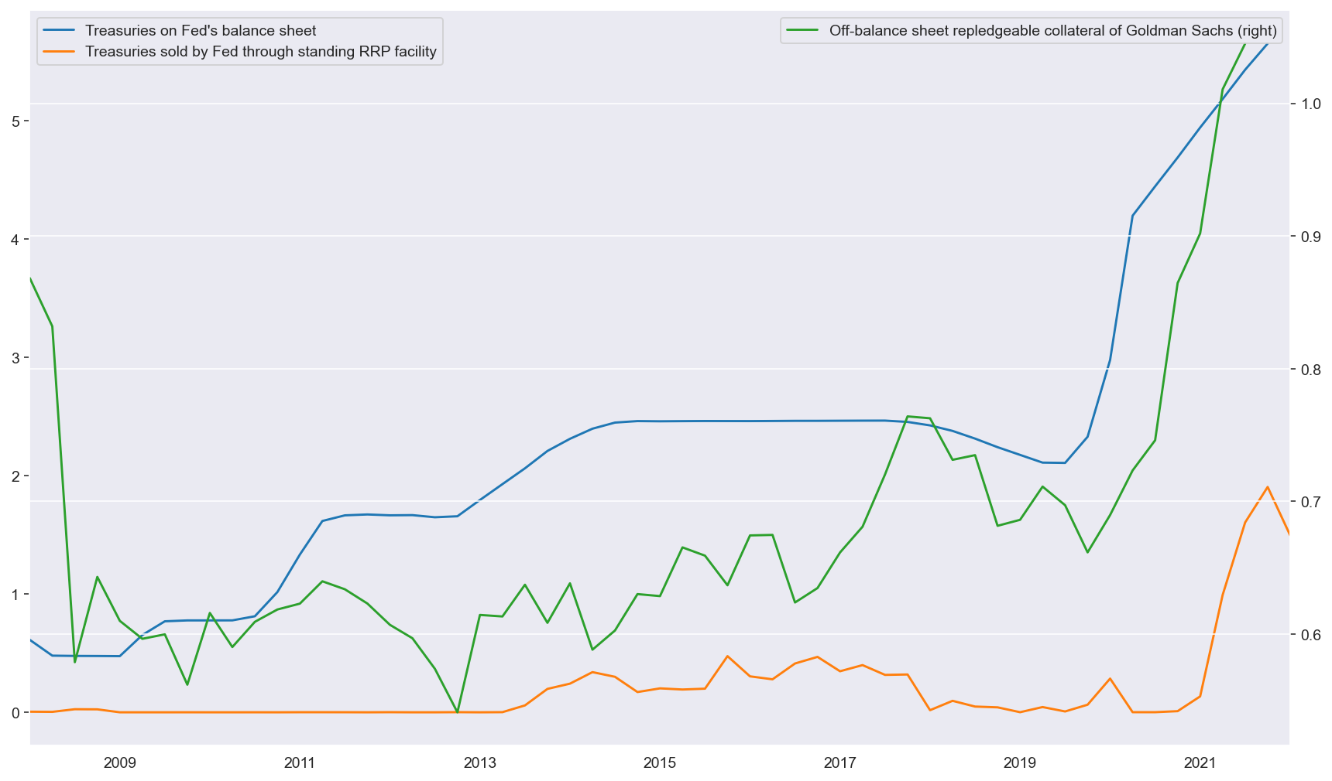
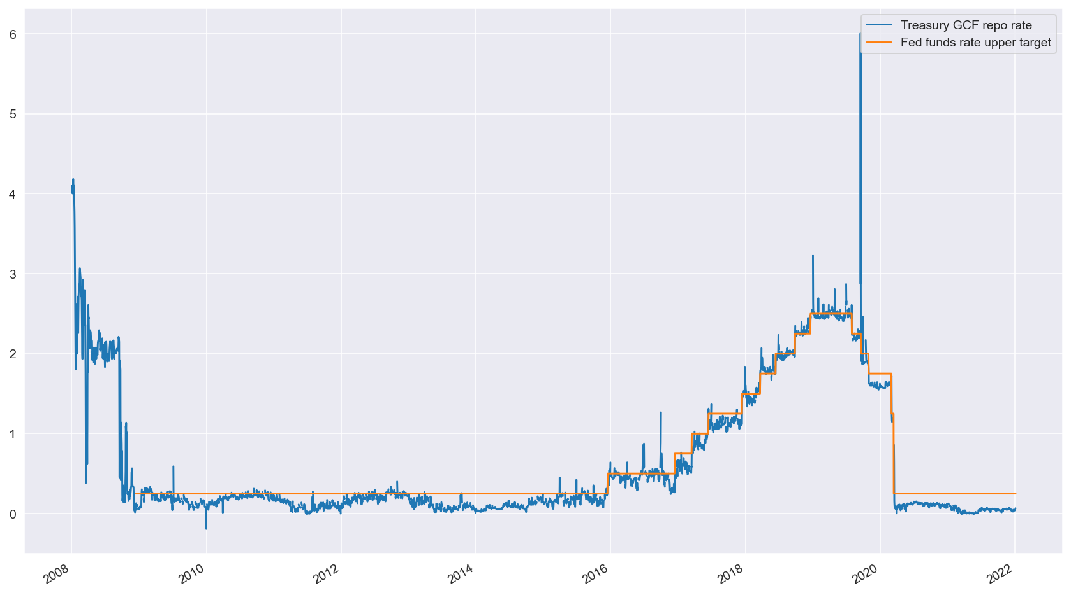
Figure 2. Treasury GCF repo rate (blue) and Fed funds upper target (orange).
Figure 3. Collateral spread, i.e. effective fed funds rate less Treasury GCF repo rate.
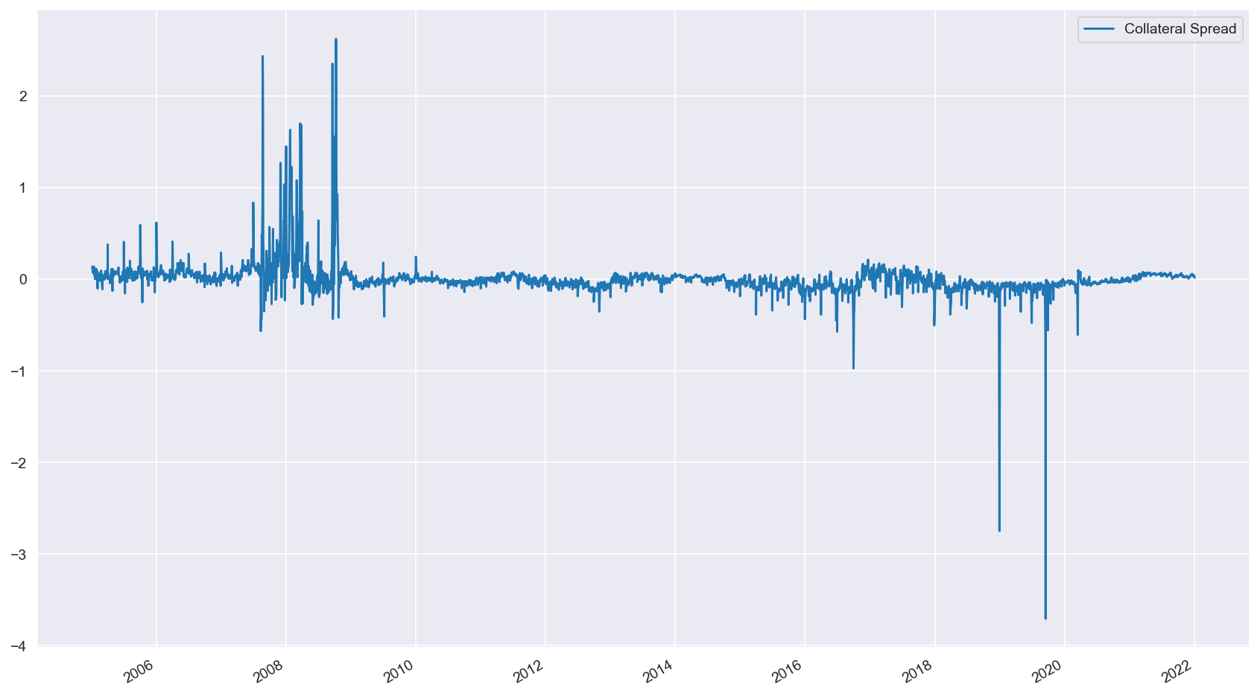

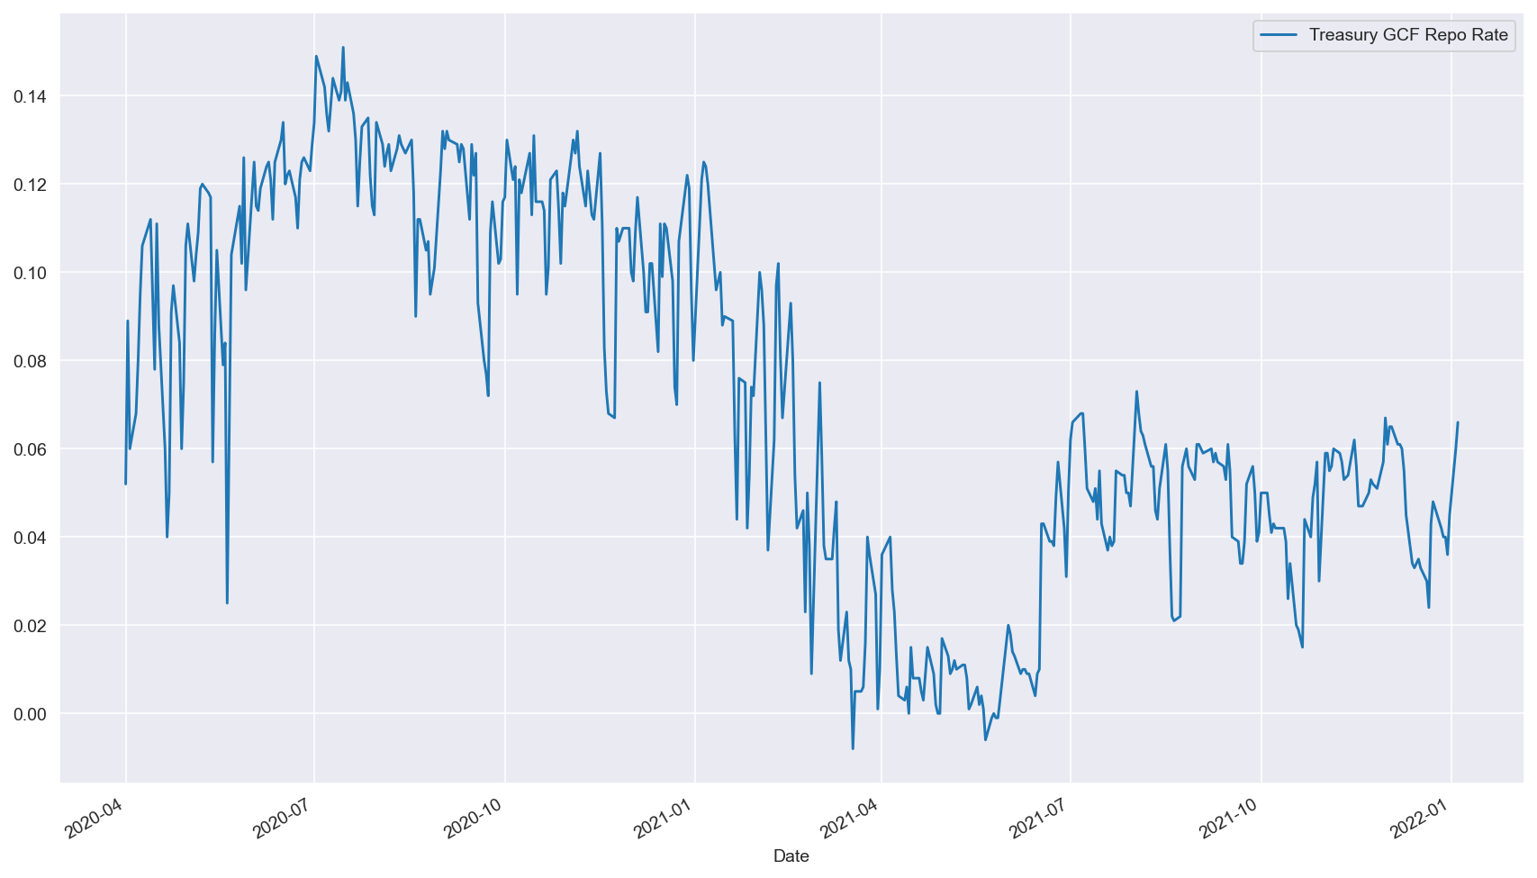
Figure 4. From mid-2020, the repo rate was trending downwards to zero until the Fed opened 5 bps ON RRP facility.

In the case of repo rates alone, differencing is needed to make the time-series stationary.
Some banks that can be included: JP Morgan, Goldman Sachs, Morgan Stanley, Wells Fargo, BNY Mellon, State Street Bank, HSBC, Credit Suisse, Nomura, MUFG. Unfortunately Bank of America, Citi and UBS report those numbers only annually.
Re-use rate is usually defined as the ratio of collateral from all sources to the primary collateral (that has not been reused).

