First Let’s Import all certificates and keys
Navigate to System>Cert. Manager
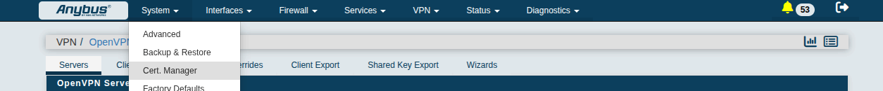
Select CAs so we can import the Certificate Authority
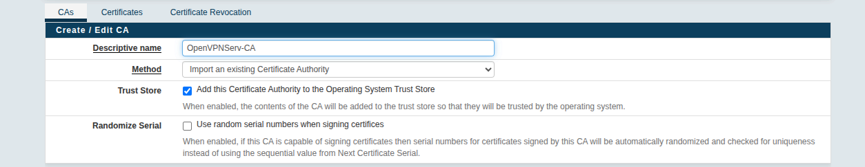
Click Edit/Add
Descriptive Name can be whatever the user/customer chooses
Method = ‘Import an Existing Certificate Authority
Trust Store, Add this certificate Authority to the Operating System Trust Store = Yes
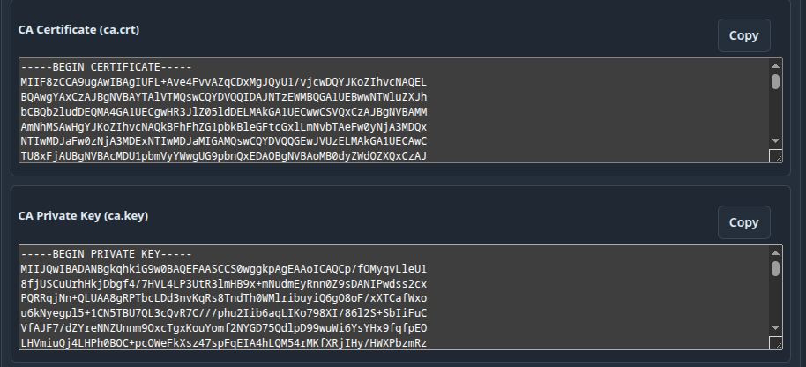
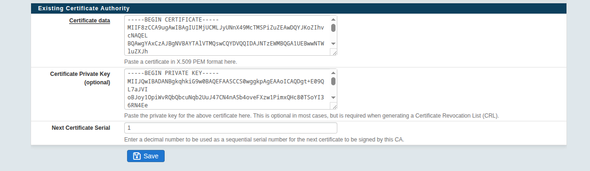
Click Copy for CA Certificate, Paste in Certificate Data
Click Copy for CA Private Key, Paste in Certificate Private Key
Then Click Save
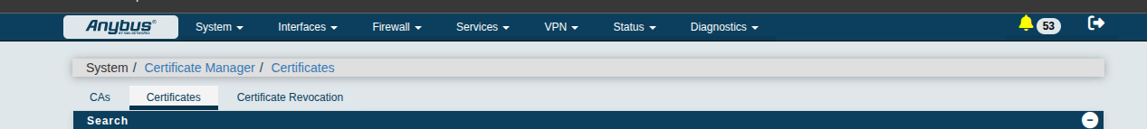
Now let’s go to Certificates so we can import the Server Cert and Key
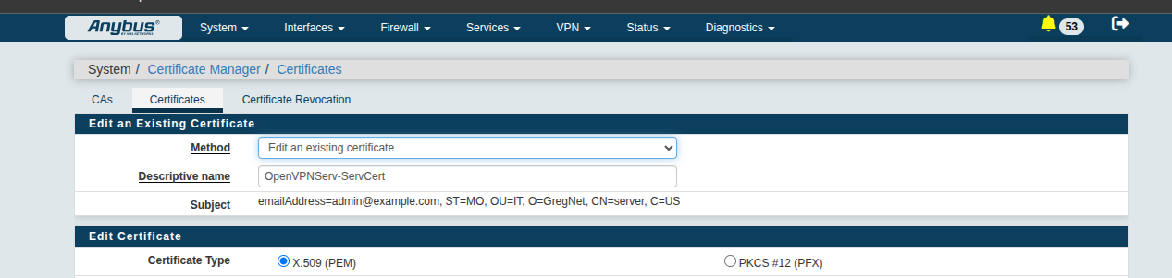
Method = Import/Edit and existing certificate
Descriptive Name = can be whatever the user/customer wants
Certificate Type = x.509 (PEM)

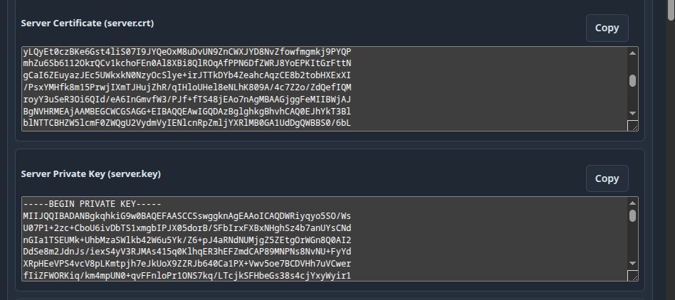
Click Copy for Server Certificate, Paste in Certificate Data
Click Copy for Server Private Key, Paste in Server Private Key

Then Click Save

Finally let’s go to Certificate Revocation to import the CRL.pem file

In the dropdown select your import Certificate Authority then click Add

Descriptive Name can be whatever the user/customer likes

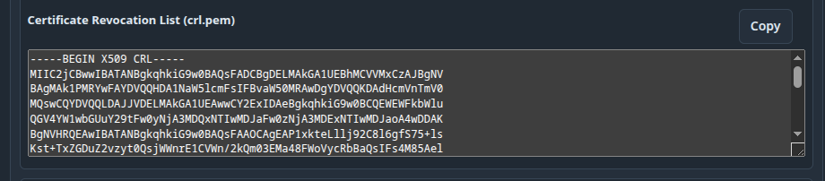
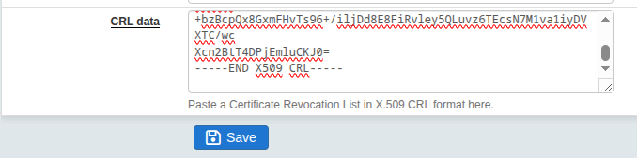
Click Copy for the Certificate Revocation List and paste it in the CRL data field, then click Save

Now we can create the OpenVPN server in the Anybus Defender Web GUI
Navigate toe VPN>OpenVPN
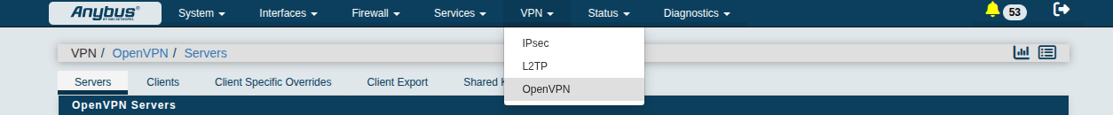
Select Servers Tab then click Add

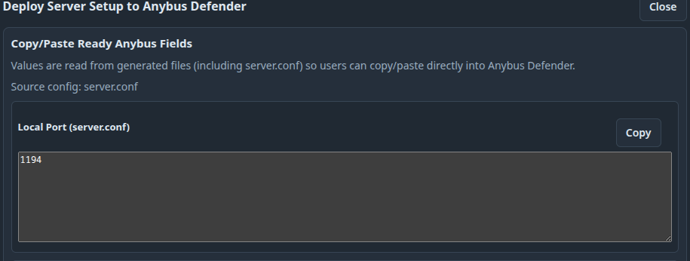
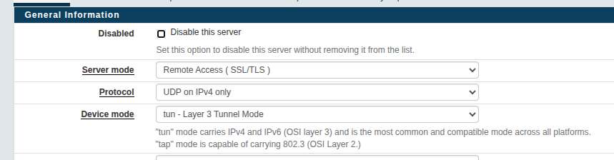
Server Mode = Remote Access (SSL/TLS)
Protocol = should come from our utility when generated
Device Mode = tun is default, we shouldn’t ever need to use tap

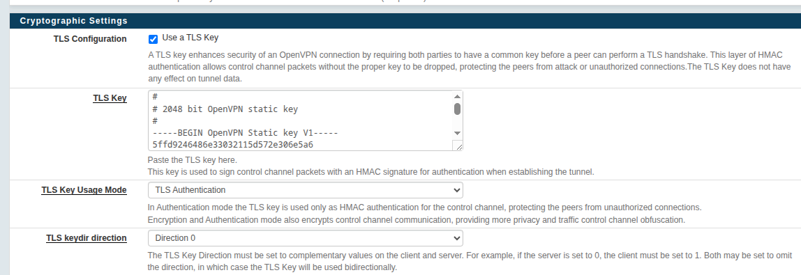
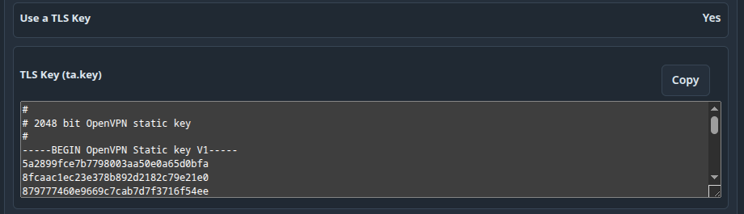
TLS Configuration = Use a TLS key = Yes
Click copy for the TLS Key data and paste it in the TLS Key field in the Anybus Defender Web GUI
TLS Key Usage Mode = TLS Authentication
TLS keydir direction = Server Always uses 0, clients always use 1

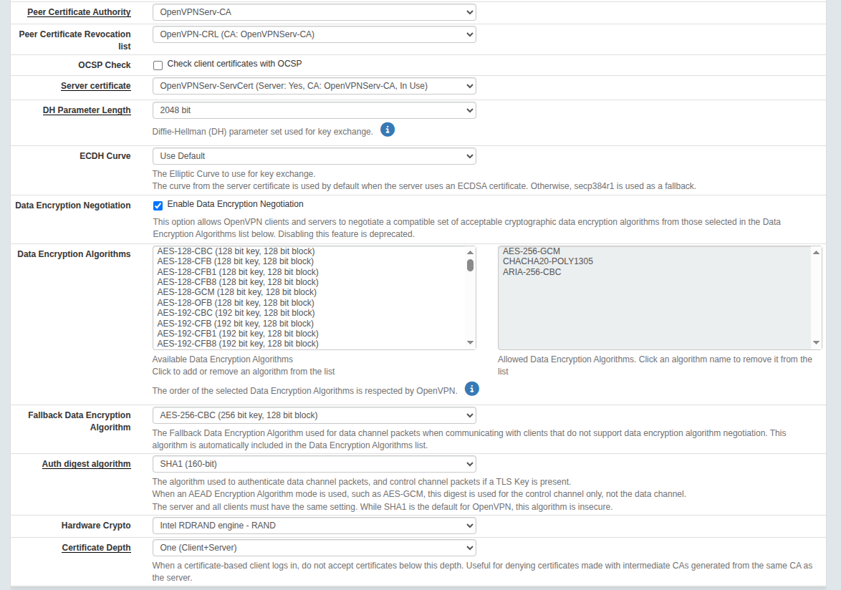
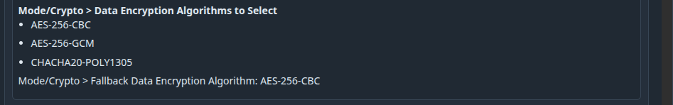
Peer Certificate Authority = Select your imported Certificate Authority from the Dropdown
Peer Certificate Revocation List = Select your imported CRL from the dropdown
Data Encryption Algorithms = Use EZOpenVPNToolkitGUI provided
Same with Fallback Data Encryption Algorithm
Since we do not specify Auth Digest in the setup for EZ-OpenVPN-Toolkit-GUI we should use the OpenVPN default of SHA1 (160-bit)
Hardware Crypto = Not needed but you can specify Intel RDRAND engine if your device supports it
Certificate Depth = One

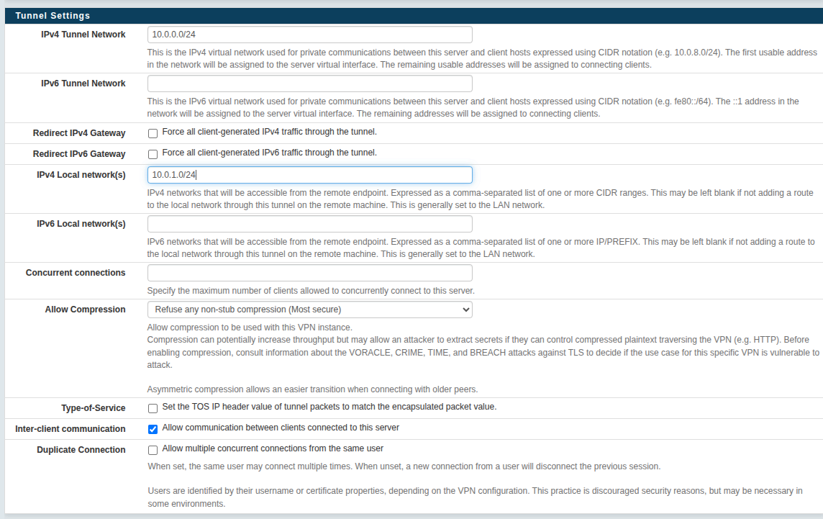
We should add this section to the EZ-OpenVPN-Tookit-GUI Anybus Defender help modal as well
IPv4 Tunnel Network = Provided by EZ-OpenVPN-Toolkit-GUI
IPv6 Tunnel Network = N/A
Redirect IPv4/IPv6 Gateway = No, we don’t want OpenVPN clients to use the OpenVPN tunnel for their default Gateway.
IPv4 Local Network = Should be Provided by EZ-OpenVPN-Toolkit-GUI
IPv6 Local Network = N/A
Concurrent Connections = This is for the user/customer to specify, default is blank
Allow Compression = No
Inter-Client Communication = Yes
Duplicate Connection = No we do not need to allow multiple connections for the same clients
This section can all be left as default, just make sure Topology = Subnet

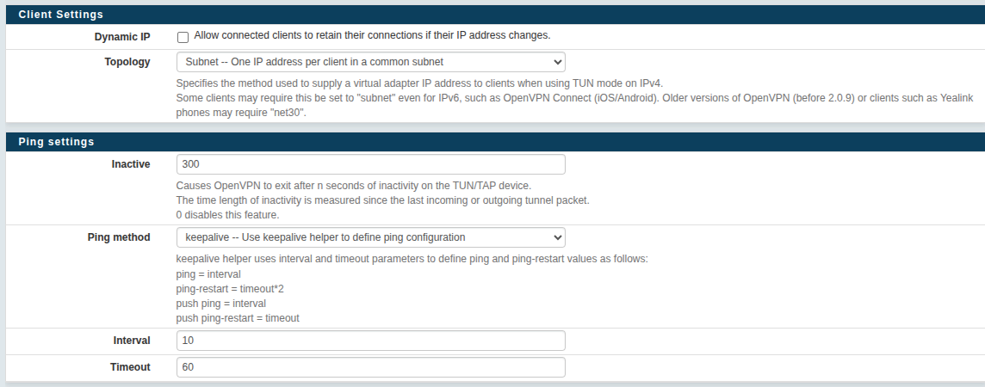
same with this section
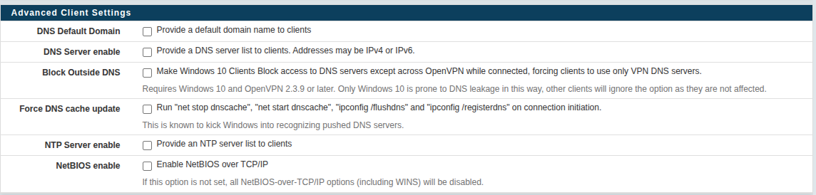
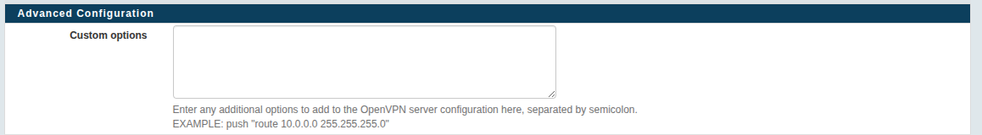
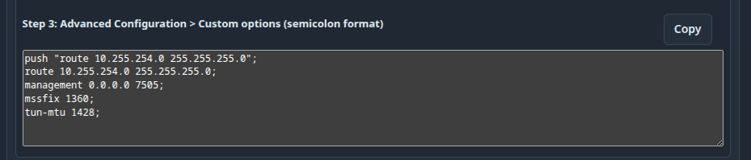
We just need to click copy from the EZ-OpenVPN-Toolkit-GUI Anybus Defender help modal and paste them in the Advanced Configuration > Custom Option field

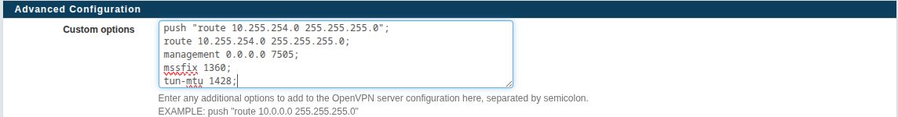
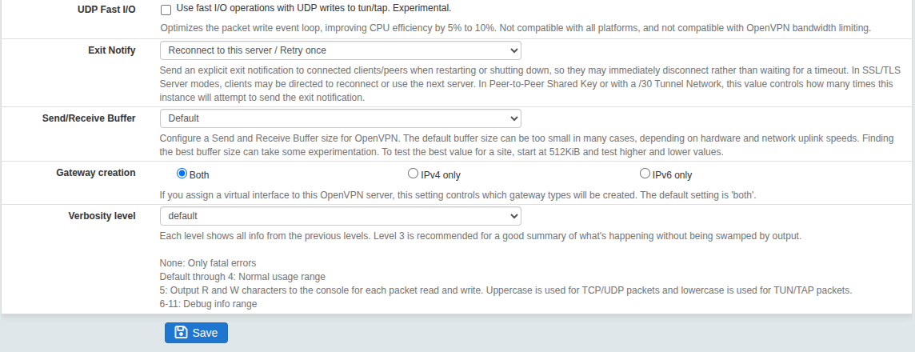
This last section can also be default then just click Save

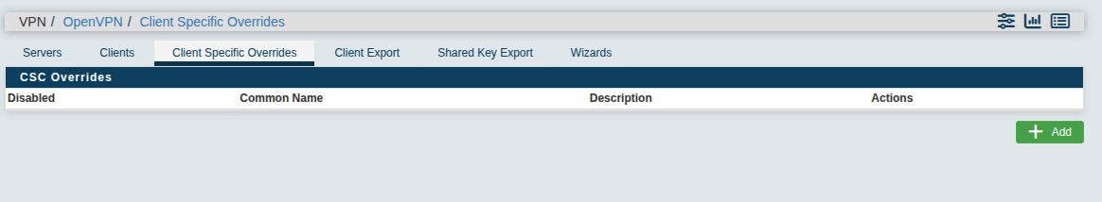
Now since we can’t upload the ccd folder and files into the anybus defender we have to specify each client with their own Client Specific Override. Under VPN>OpenVPN>Client Specific Overrides click Add
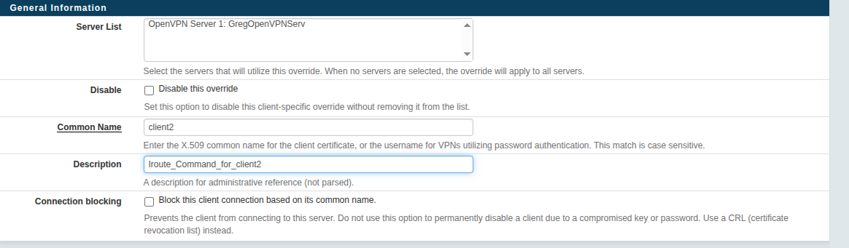
Make sure the OpenVPN server you created is in the Server List
Common Name = Client name (This should be provided by EZ-OpenVPN-Toolkit-GUI)
Description = Whatever the customer/user needs

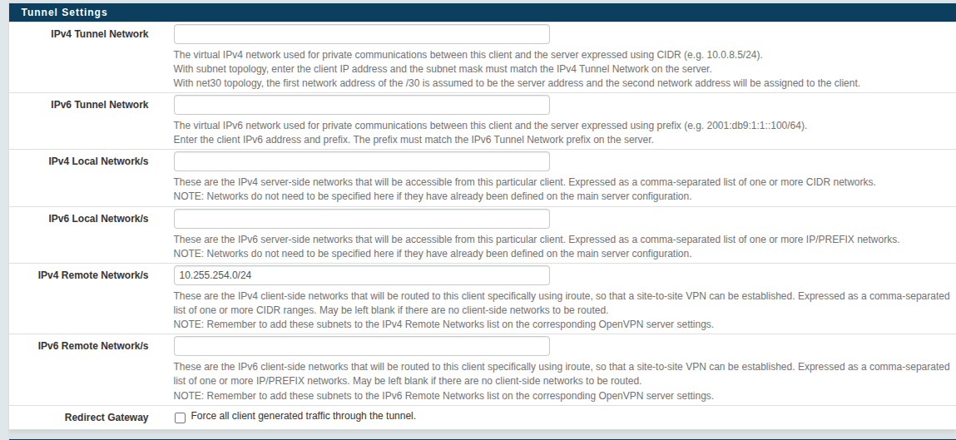
You only need to specify the Local Private Subnet for this client in this section

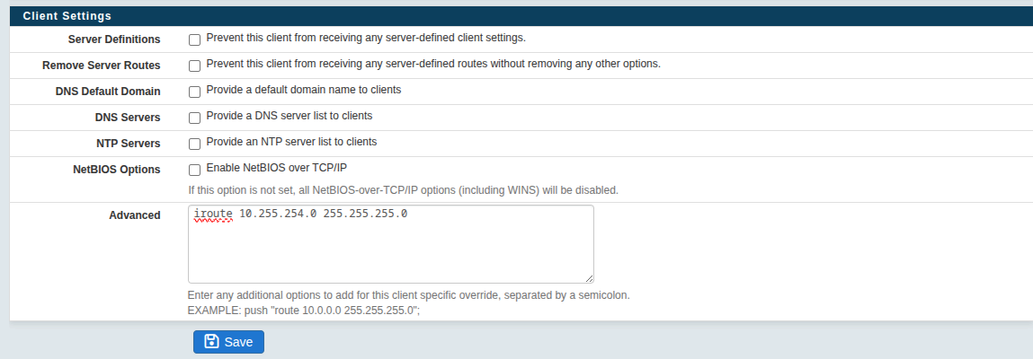
then in the advanced field is where we put the iroute command. Then click save. This will tell the server running on the Anybus Defender and other clients, what subnet this client has for it’s network. and it will prevent the OpenVPN server from ‘pushing’ this client its own route.
It is also a good idea to add some firewall rules for the anybus defender under Firewall>Rules

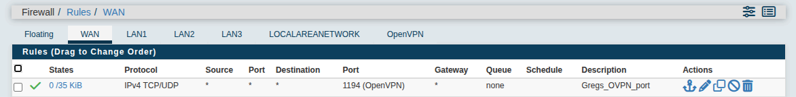
Under Firewall>Rules>WAN Make sure the port you chose for the OpenVPN server is allowed.

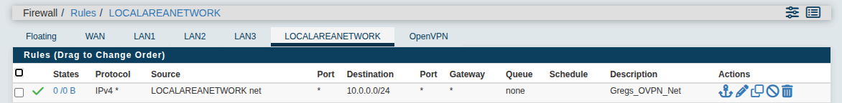
Under Firewall>Rules>LAN ( I setup ethernet ports 1-3 for the LocalAreaNetwork) make sure the OpenVPN tunnel network is allowed to talk to the LAN network

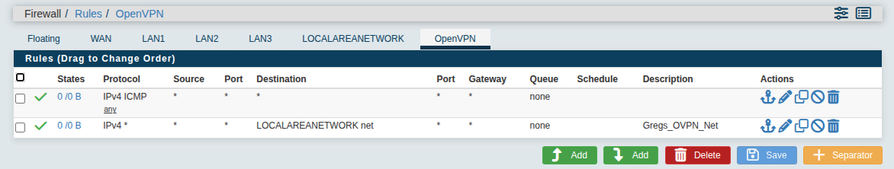
Under Firewall>Rules>OpenVPN make sure the LAN (LocalAreaNetwork in my case) can communicate with the OpenVPN tunnel network.

