USER MANUAL
Industrial Certificate Assistant
for Crimson 3.2 Devices
Guided SSL/TLS management, certificate generation, trust installation, and FlexEdge deployment
Software | Industrial Certificate Assistant 0.3.0 and Crimson 3.2
Validated on | FlexEdge DA70, Crimson 3.2.1055.0, System Web Server TCP port 4443
Audience | Customers, integrators, and technical-support personnel

Purpose
This manual explains how to create, request, import, validate, and deploy SSL/TLS certificates for the Crimson 3.2 System Web Server. It includes the built-in Crimson trust method and a fully tested customer-managed PKI workflow using Industrial Certificate Assistant.
Expected warning: Before the C3.2 Root Certificate is trusted, Chrome may display “Your connection is not private” with NET::ERR_CERT_AUTHORITY_INVALID. This is expected during initial setup.

Before you begin
- Connect the PC to a network interface that can reach the Crimson 3.2 device.
- Know the device IP address or its .local hostname.
- Use an account with permission to install certificates on the PC.
- Confirm the PC and device clocks are correct; certificate validation depends on accurate time.
- These instructions show Windows certificate installation. Linux and centrally managed enterprise devices use different trust-store procedures.

Industrial Certificate Assistant Overview
The application presents four guided workflows. Select the workflow that matches the customer’s certificate source and deployment requirements.
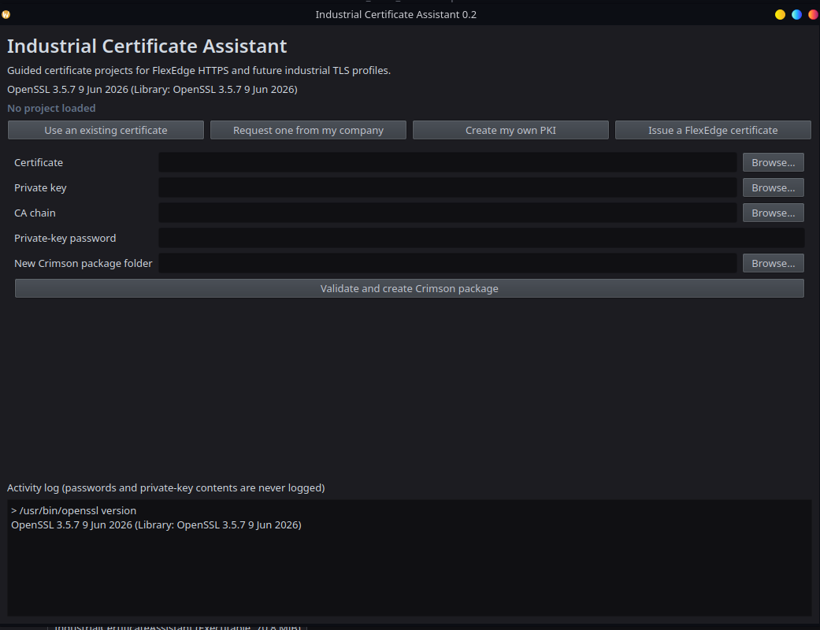
Figure 1 - Use an existing certificate to validate a certificate, private key, and CA chain and create a Crimson-ready package.
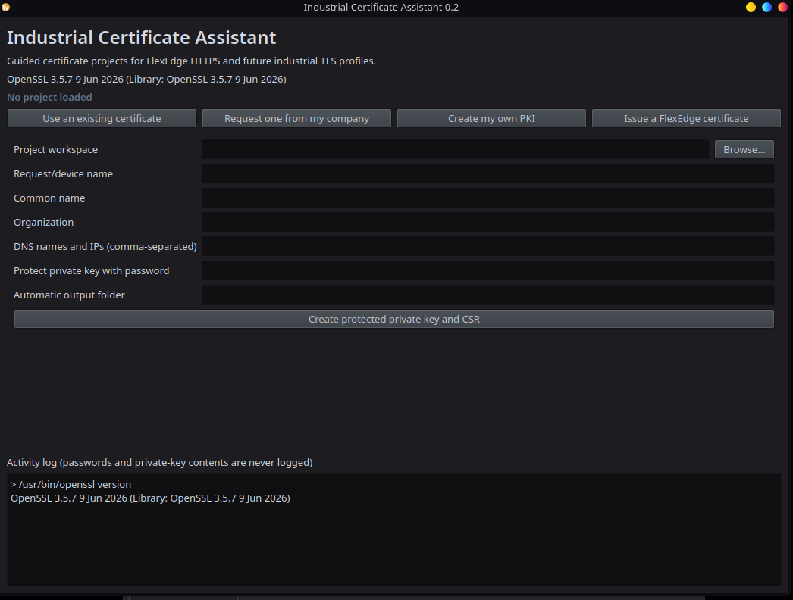
Figure 2 - Request one from my company creates a protected or passwordless private key and CSR for a corporate CA.

Workflow selection
Workflow | Purpose
Use an existing certificate | Validate an existing server certificate and key and assemble a Crimson package.
Request one from my company | Generate a local key and CSR for an enterprise or corporate CA.
Create my own PKI | Create a root CA, issuing CA, project folders, and trust installers.
Issue a FlexEdge certificate | Issue a device certificate and produce fullchain.pem and the complete deployment package.
Password choice: Version 0.3.0 supports encrypted or passwordless CA, CSR, and FlexEdge private keys. Encryption is selected by default. Passwordless operation requires an explicit risk confirmation.

Option 1 - Trust the C3.2 Root Certificate

Step 1 - Open the Crimson 3.2 System Web Server
In a supported browser, enter the device address followed by port 4443. For example:
https://10.255.254.4:4443
Address matching: Use the same IP address or hostname that the device certificate was created to represent. Crimson’s automatically generated certificate normally includes the unit’s private IP addresses and .local name.

Step 2 - Continue past the initial browser warning
The first connection may show a privacy warning because the PC does not yet trust the C3.2 Root Certificate.
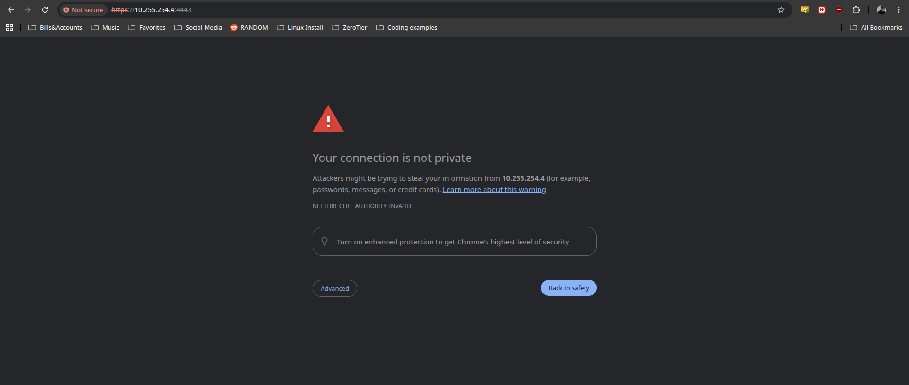
Figure 3 - Expected Chrome warning before the Crimson root certificate is installed.
- Select Advanced.
- Select Proceed to [device address] (unsafe). This bypass is temporary and is used only to reach the certificate download link.

Step 3 - Download the C3.2 Root Certificate
At the Crimson 3.2 login page, locate the C3.2 Root Certificate link below the Log On button and download the certificate to the PC. The link is available before authentication.
Important: Download only the public C3.2 Root Certificate. No private key is required or exposed by this process.

Step 4 - Confirm access to the System Web Server
After continuing through the warning and signing in, the System Web Server home page should appear. This confirms that the device and HTTPS service on port 4443 are reachable.
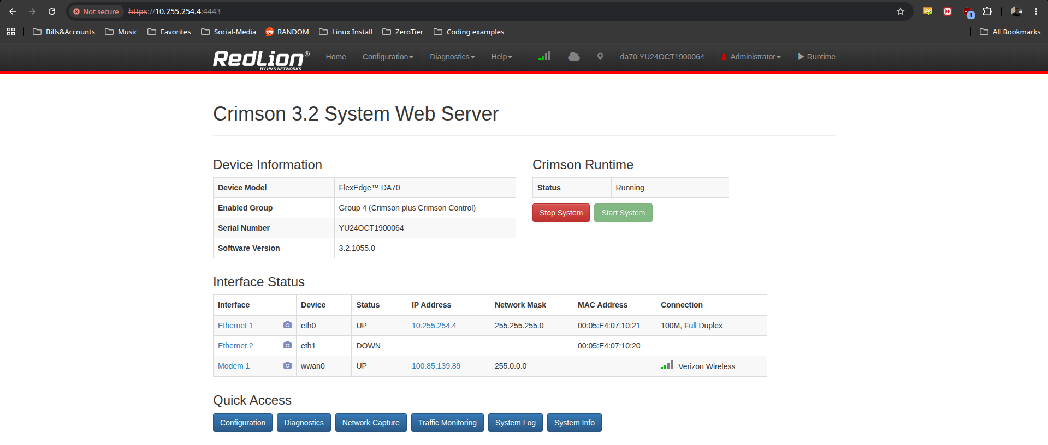
Figure 4 - Crimson 3.2 System Web Server reached through HTTPS on port 4443.

Step 5 - Install the certificate in Windows
- Open the downloaded C3.2 Root Certificate file.
- Select Install Certificate.
- Choose Local Machine when the certificate should be trusted by all users of the PC. Administrator approval may be required. Choose Current User only when trust should apply to your account.
- Select Place all certificates in the following store.
- Select Browse, choose Trusted Root Certification Authorities, and select OK.
- Select Next, review the destination, and select Finish.
- Accept the Windows security warning only after confirming that the certificate came directly from the intended Crimson 3.2 device.

Step 6 - Restart the browser and verify
- Close every browser window. If necessary, end any remaining browser processes.
- Reopen the browser and return to the same device address on port 4443.
- Confirm that the privacy warning no longer appears and that the browser reports a secure HTTPS connection.
- Open the browser’s certificate information and confirm that the certificate is valid for the address entered.

Verification checklist
- The System Web Server opens at https://[device-address]:4443.
- The browser no longer reports NET::ERR_CERT_AUTHORITY_INVALID.
- The certificate is within its valid date range.
- The IP address or hostname entered in the browser appears in the certificate’s Subject Alternative Name list.
- The certificate chain terminates at the trusted C3.2 Root Certificate.

Troubleshooting
Browser message | What to check
CERT_AUTHORITY_INVALID | Confirm the C3.2 Root Certificate was installed in Trusted Root Certification Authorities, then fully restart the browser.
CERT_COMMON_NAME_INVALID | Use an IP address or hostname included in the device certificate. Check for a typing error or an address that was added after the certificate was generated.
CERT_DATE_INVALID | Correct the time, date, and time zone on both the PC and the Crimson device.
Warning remains after installation | Confirm the certificate was placed in the intended user or machine store. Enterprise policy or a browser-specific trust store may also apply.

Security notes
- Install a root certificate only when it was obtained directly from a device or source you trust.
- The default C3.2 Root Certificate is constrained to private IP addresses and names ending in .local.
- Option 1 is convenient for isolated or locally administered systems. Organizations that manage their own enterprise PKI may prefer a server certificate signed by their corporate CA.

Option 2 - Use a Customer-Managed Certificate
Use this option when the organization wants the FlexEdge to present an HTTPS server certificate issued by its own certificate authority. The certificate can be issued by an existing corporate CA or by a dedicated industrial-device PKI created with Industrial Certificate Assistant.
Recommended enterprise approach: Generate the private key and certificate signing request locally, then have the organization’s existing CA sign the request. The private key remains with the FlexEdge administrator and is never sent to the CA.

Choose an issuance path
Path | Use when | Result
A - Corporate CA | The customer already operates Microsoft AD CS or another enterprise CA. | A CSR and encrypted private key are created locally; the CA returns the signed certificate and chain.
B - Dedicated local PKI | The site needs an independent certificate hierarchy for industrial devices. | A protected root CA, intermediate CA, and FlexEdge server certificate are created.

Required certificate properties
- The certificate must be an end-entity server certificate, not a CA certificate.
- Extended Key Usage must include TLS Web Server Authentication (serverAuth).
- Key Usage should include Digital Signature and, for an RSA certificate, Key Encipherment.
- The Subject Alternative Name extension must include every DNS name and IP address used to open the device.
- The certificate and private key must be PEM encoded and must form a matching pair.
- The certificate must be within its validity period, and the PC and FlexEdge clocks must be correct.

Before generating the certificate
Record every address that administrators may use. For the example device in this guide, the IP address is 10.255.254.4. A typical Subject Alternative Name list could be:
10.255.254.4, flexedge01.local, flexedge01.company.local
Do not omit the IP address: If users open https://10.255.254.4:4443, the certificate must contain 10.255.254.4 as an IP Subject Alternative Name. Adding it only as a Common Name is not sufficient.

Path A - Request a Certificate from a Corporate CA

Step A1 - Generate the private key and CSR
Open Industrial Certificate Assistant and select Request one from my company. Complete the fields as follows:
Application field | Value
Common name | Primary DNS name for the FlexEdge, such as flexedge01.company.local
Organization | Customer’s organization name
DNS names and IPs | Comma-separated list of every address used to reach the device
Protect private key with password | Strong password that will later be entered in Crimson
Output folder | Secure folder dedicated to this FlexEdge
Select Create private key and CSR. The application creates private-key.pem and request.csr.pem.
Protect the private key: Do not email or upload private-key.pem to the certificate authority. Submit only request.csr.pem. Retain the private-key password securely.

Step A2 - Submit the CSR
- Submit request.csr.pem through the organization’s approved certificate-request process.
- Request a TLS Web Server Authentication certificate.
- Confirm the issuing CA preserves all requested DNS and IP Subject Alternative Names.
- Obtain the signed server certificate and the issuing intermediate CA certificate or complete CA chain in PEM format.

Step A3 - Validate the returned certificate
In Industrial Certificate Assistant, select Use an existing certificate. Choose the returned server certificate, private-key.pem, and the CA chain. Enter the private-key password and select Validate certificate package.
Do not continue until the application confirms that the certificate and private key match and that the certificate chain verifies successfully.

Path B - Create a Dedicated Industrial PKI

Step B1 - Create the root and intermediate CAs
Open Industrial Certificate Assistant and select Create my own PKI. Choose a new workspace and enter the organization and DNS suffix. Keep CA-key encryption enabled and enter a password, or clear the encryption checkbox and complete the passwordless risk confirmation. Select Create PKI project.
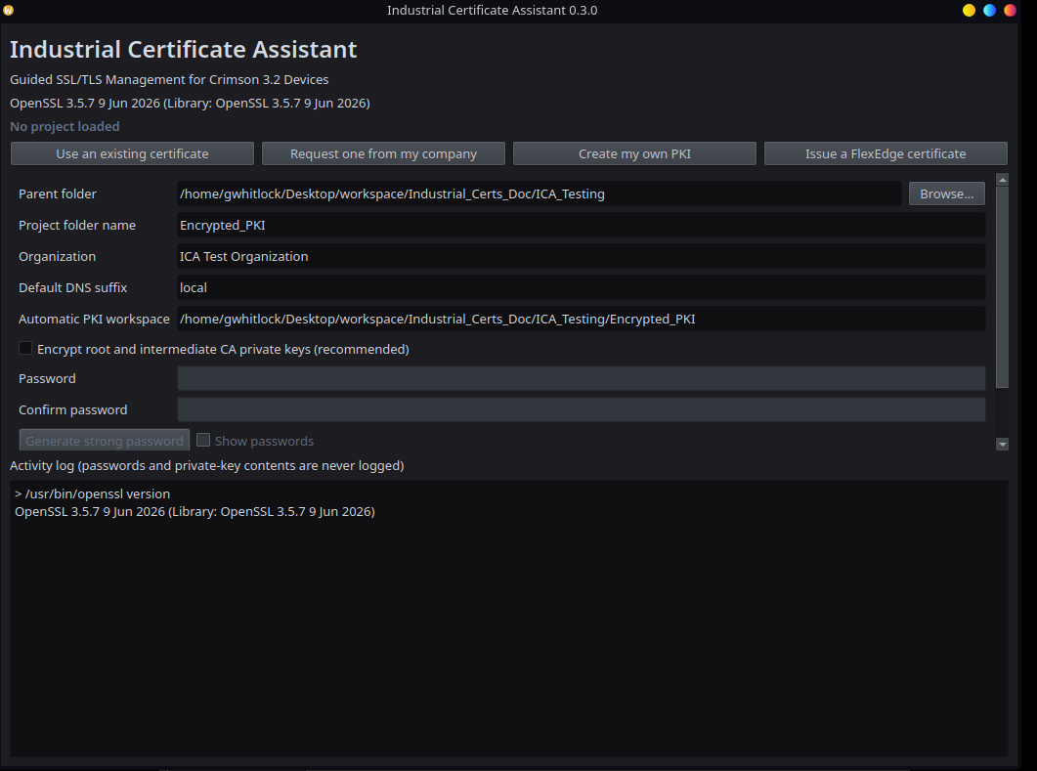
Figure 5 - Completed PKI project fields with CA-key encryption disabled for the validated passwordless test.
CA custody: Back up the PKI workspace securely and keep the root CA offline whenever it is not required. Anyone who obtains an unencrypted CA key—or an encrypted CA key and its password—can issue certificates trusted by that CA.

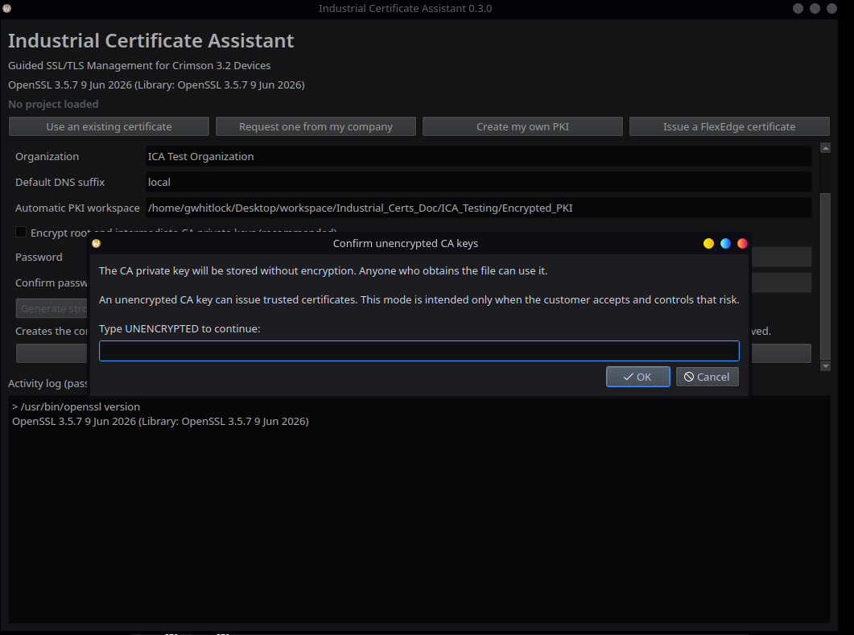
Figure 6 - Typed confirmation required before creating unencrypted CA private keys.

Step B1 result
After generation, the application loads the project and records whether the CA keys are encrypted. Passwords are never written to project metadata.
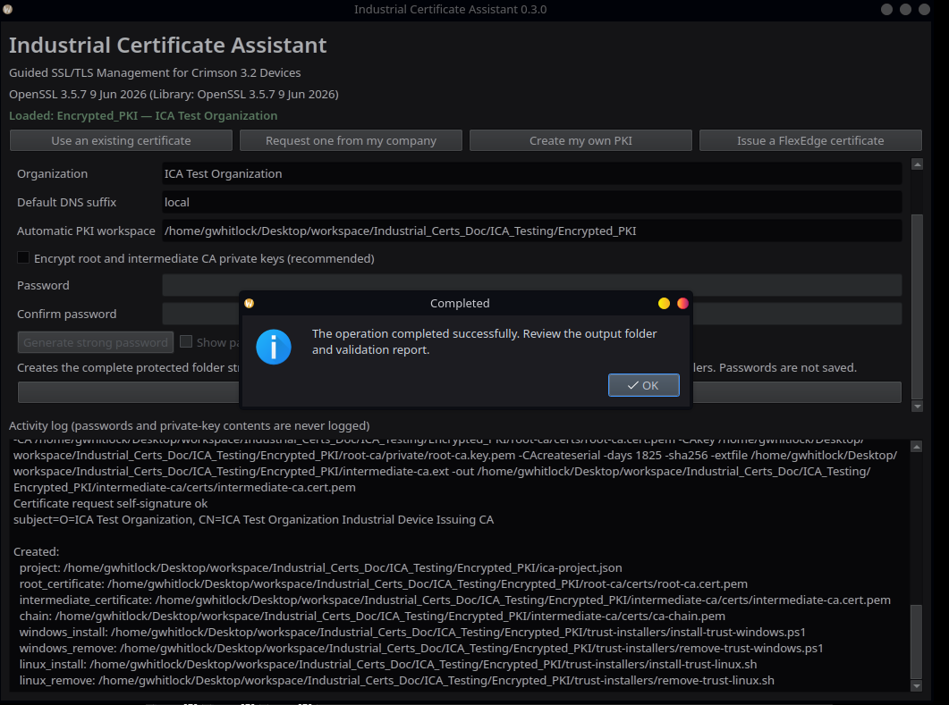
Figure 7 - Successful passwordless PKI project creation.
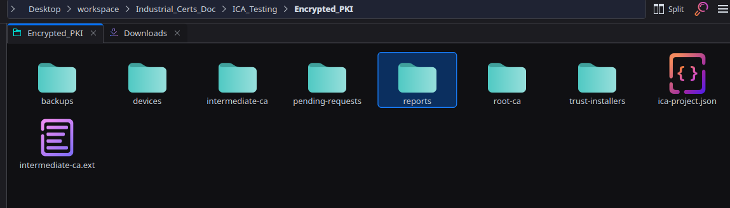
Figure 8 - Automatically created project folders and ica-project.json.

Step B2 - Issue the FlexEdge server certificate
Select Issue a FlexEdge certificate and complete these fields:
Application field | Value
PKI workspace | Workspace created in Step B1
Common name | Primary FlexEdge DNS name
Organization | Customer or site organization name
DNS names and IPs | Every address used to open the System Web Server
CA password | Password protecting the intermediate CA key
New private-key password | Password that will later be entered in Crimson
Output folder | Secure folder dedicated to this FlexEdge
Select Issue complete FlexEdge HTTPS package. The application creates certificate.pem, private-key.pem, fullchain.pem, ca-chain.pem, CA certificates, request.csr.pem, certificate-report.txt, and trust installers.
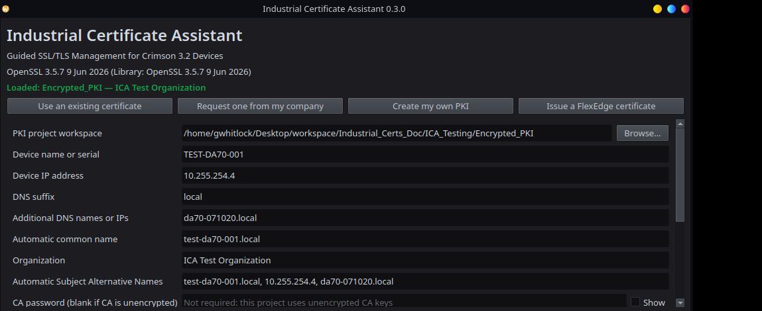
Figure 9 - FlexEdge identity, IP address, DNS suffix, and SAN values are derived from the loaded project.
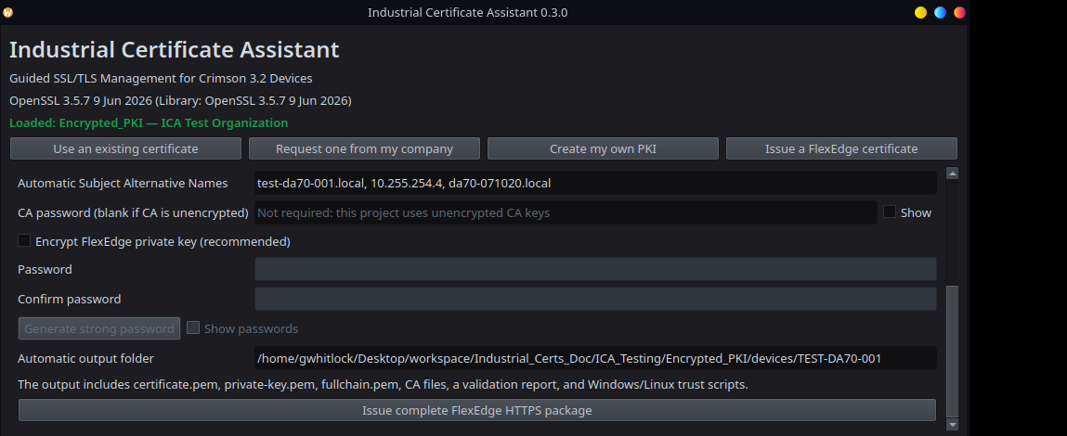
Figure 10 - Passwordless CA status, optional FlexEdge-key encryption, and automatic device output folder.
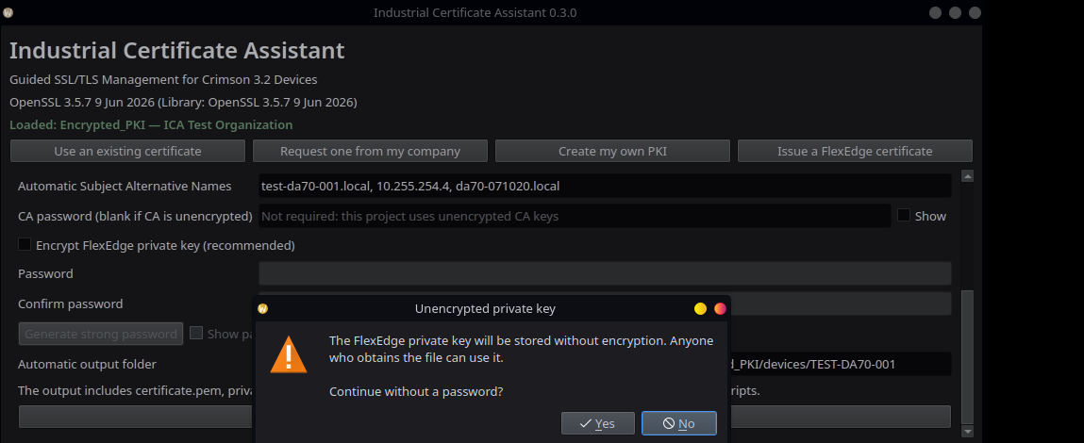
Figure 11 - Confirmation required before issuing an unencrypted FlexEdge private key.
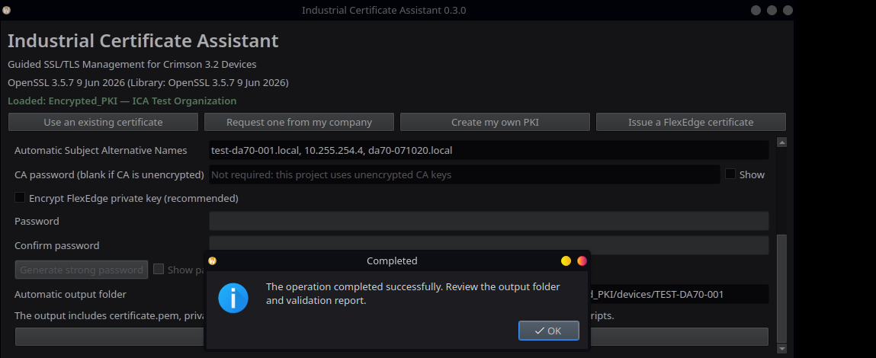
Figure 12 - Successful FlexEdge package generation.
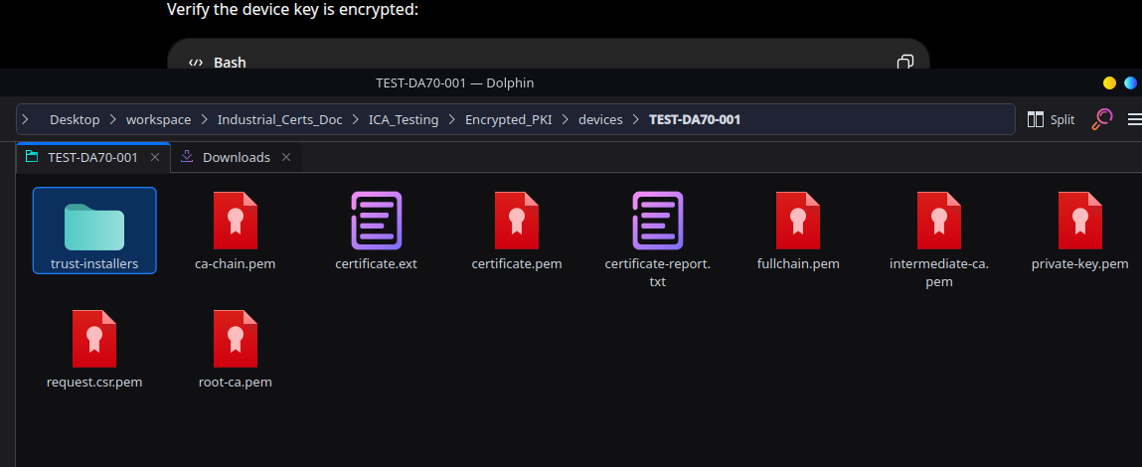
Figure 13 - Generated device package, including fullchain.pem, validation report, and trust installers.

Step B3 - Distribute the root certificate
The public root certificate is located at root-ca/certs/root-ca.cert.pem inside the PKI workspace. Install that public certificate on administrator PCs through the organization’s approved trust-distribution process. Never distribute root-ca.key.pem or intermediate-ca.key.pem.

Install the Customer-Managed Certificate in Crimson 3.2

Step 1 - Prepare the server certificate chain
The certificate presented by the FlexEdge should include the server certificate followed by the issuing intermediate certificate. If the CA returned separate PEM files, create fullchain.pem in this order:
- FlexEdge server certificate
- Issuing intermediate CA certificate
Do not normally append the root CA certificate to the server chain. The root belongs in the client’s trusted root store.

Step 2 - Open the System Web Server
Open https://[device-address]:4443. Until the new certificate is installed, use the temporary Advanced > Proceed method from Option 1 if the browser does not yet trust the existing Crimson certificate.

Step 3 - Configure the default device certificate
- Sign in to the Crimson 3.2 System Web Server.
- Open Configuration and navigate to System Configuration > Network Identity > Naming.
- Set Default Cert to Specified Below.
- For Cert File, select fullchain.pem. If no intermediate CA is used, select certificate.pem.
- For Key File, select private-key.pem.
- Enter the private-key password in Key Password.
- Save or commit the System Configuration changes.
- Confirm that the editor status returns to UNCHANGED.
- Open System Information and select Restart System. Testing confirmed that the System Web Server does not begin presenting the new identity until after a restart.
Private-key handling: Transfer private-key.pem only to the intended FlexEdge and only through an approved secure method. Do not retain unneeded copies on shared workstations or support-ticket systems.

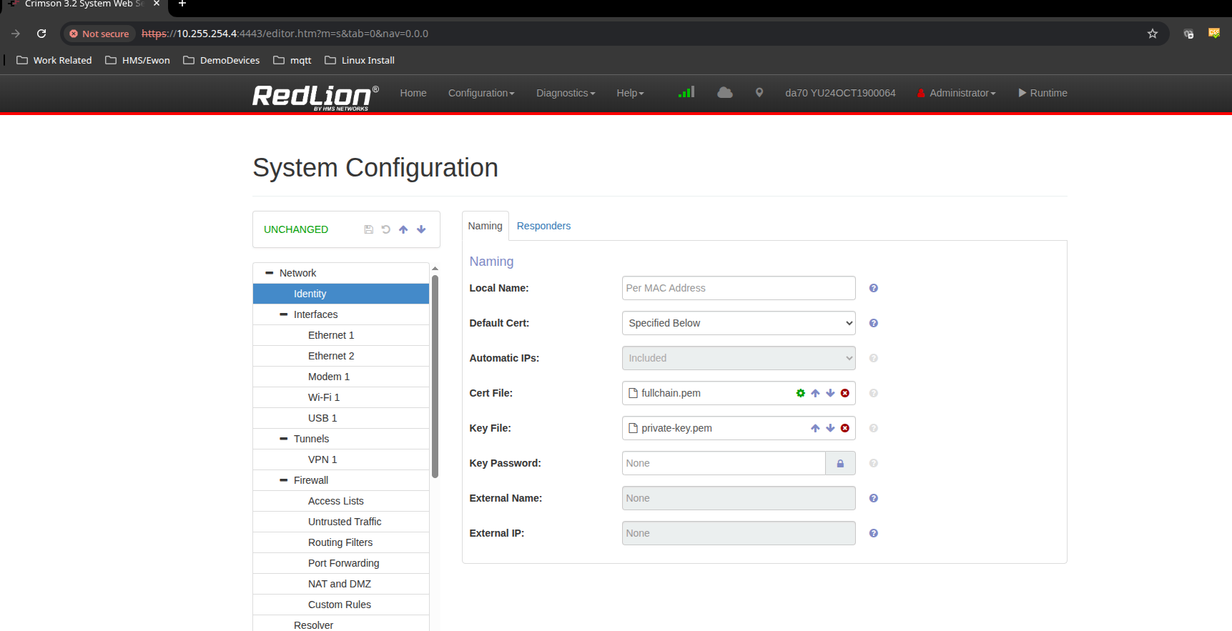
Figure 14 - Tested Crimson configuration: Specified Below, fullchain.pem, private-key.pem, and no password for a passwordless device key.
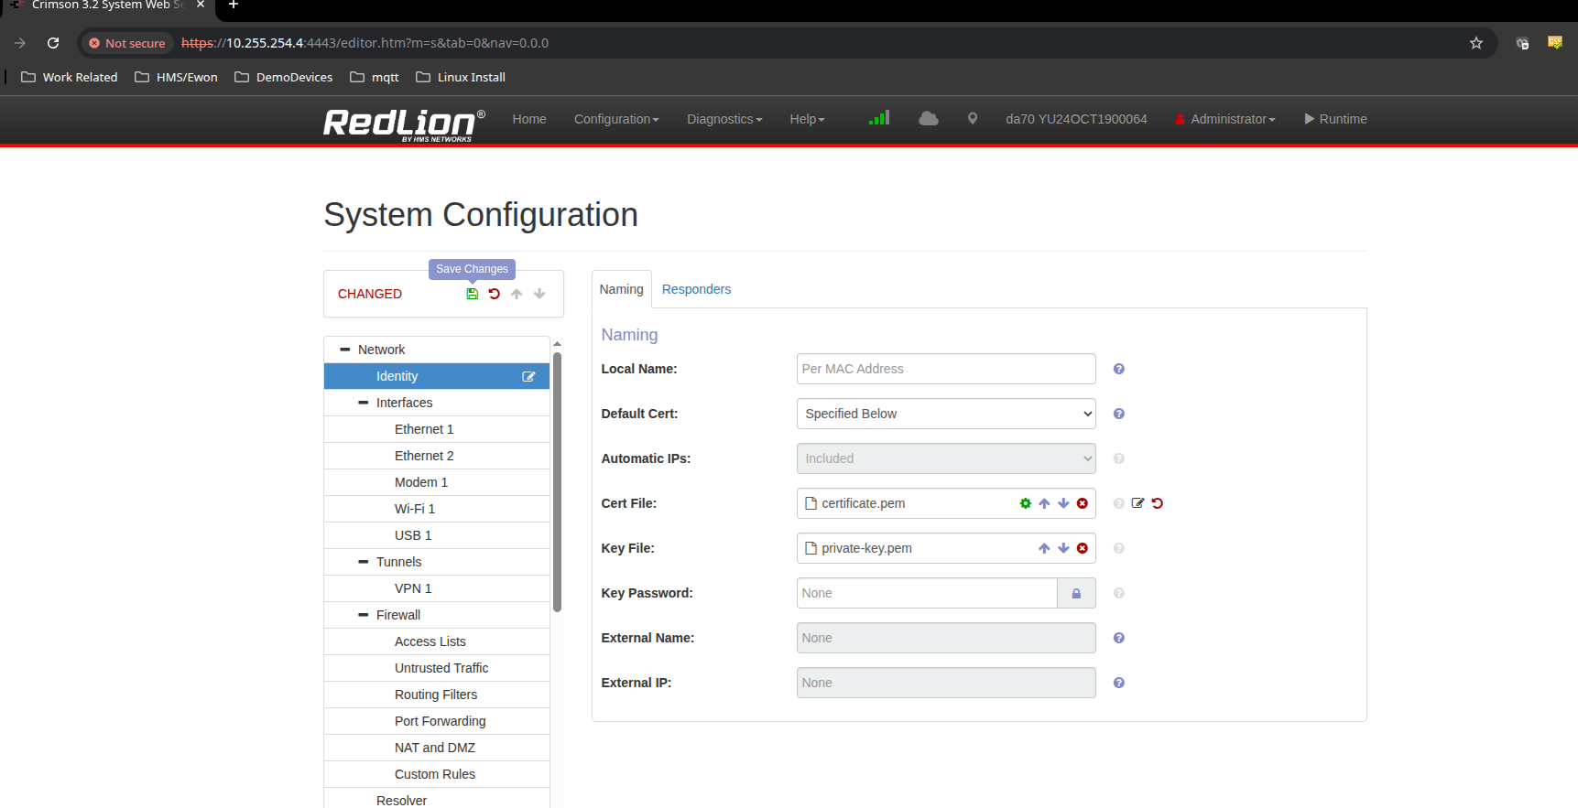
Figure 15 - Save Changes must be selected before restarting the FlexEdge.

Step 4 - Establish trust on administrator PCs
For a corporate CA, the organization may already distribute the required root and intermediate certificates. For a dedicated PKI, install root-ca.cert.pem in Trusted Root Certification Authorities and, when required, install the intermediate certificate in Intermediate Certification Authorities.

Verify Option 2
- Fully close and reopen the browser.
- Open the exact device IP address or DNS name included in the certificate, followed by :4443.
- Confirm the browser no longer displays a privacy warning.
- Inspect the presented certificate and verify its subject, issuer, validity period, and Subject Alternative Names.
- Confirm the certificate chain reaches the expected customer or corporate root CA.

Validated FlexEdge results
The tested DA70 accepted fullchain.pem, served the server and intermediate certificates, validated the IP SAN for 10.255.254.4, and completed a TLS 1.3 handshake with OpenSSL verification code 0.
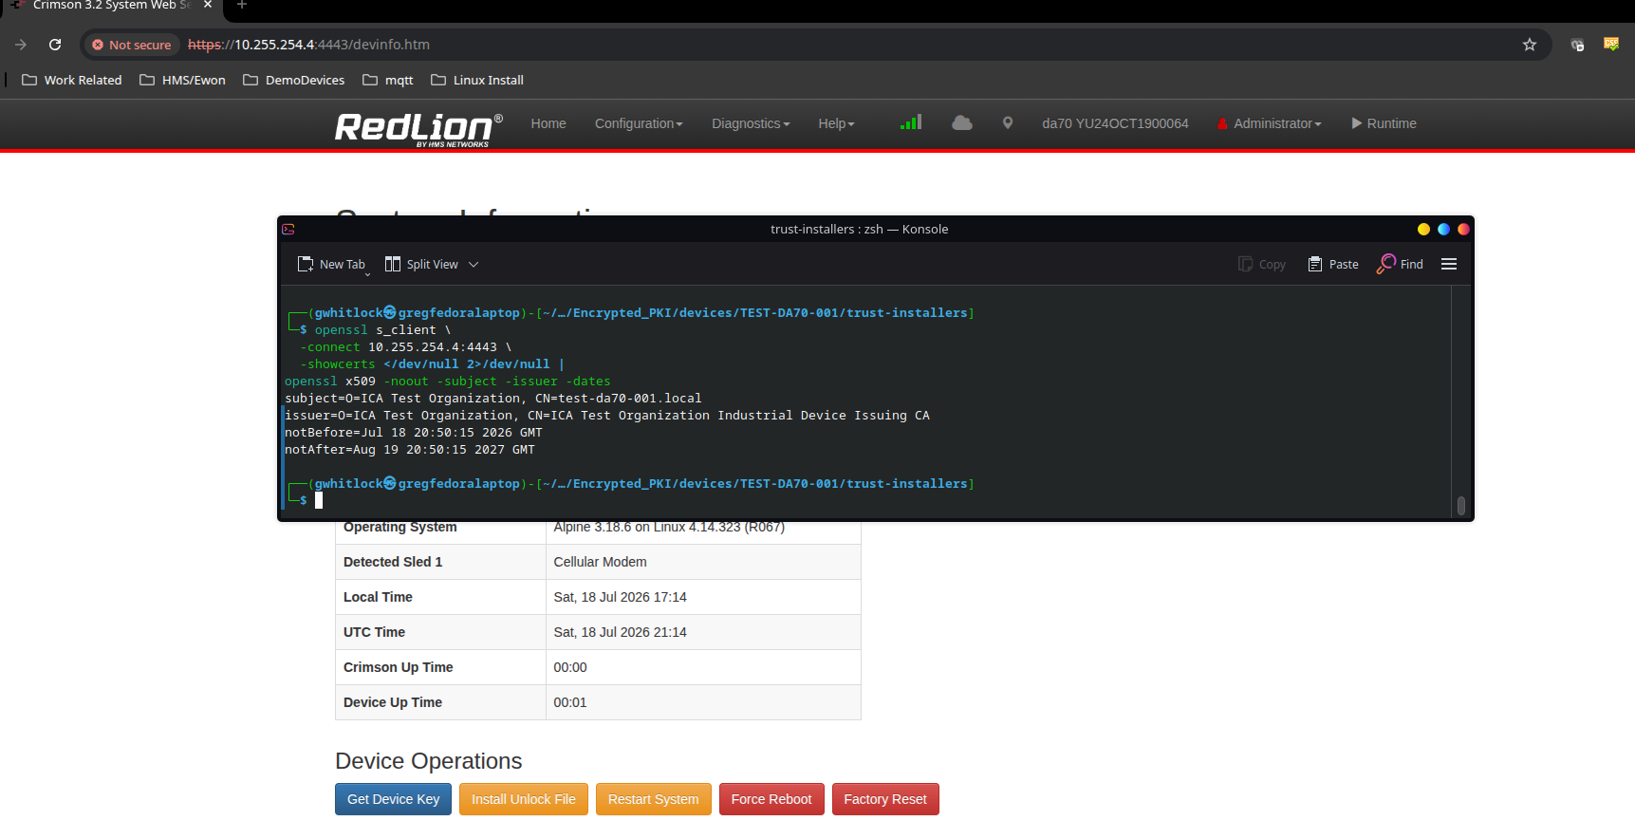
Figure 16 - After Restart System, the FlexEdge presents the certificate issued by the Industrial Device Issuing CA.
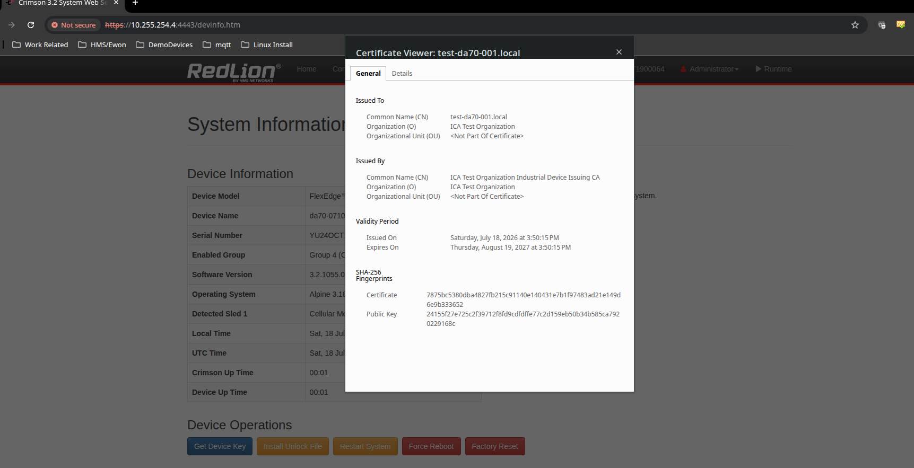
Figure 17 - Crimson certificate viewer showing the customer-managed subject, issuer, and validity period.

Trusted browser result
Install the generated public root CA using the trust installer, completely restart the browser, and reopen the exact IP address or DNS name included in the certificate. The login page’s Download the C3.2 Root Certificate link remains present, but it refers to Crimson’s built-in root and is not used for the custom-PKI workflow.
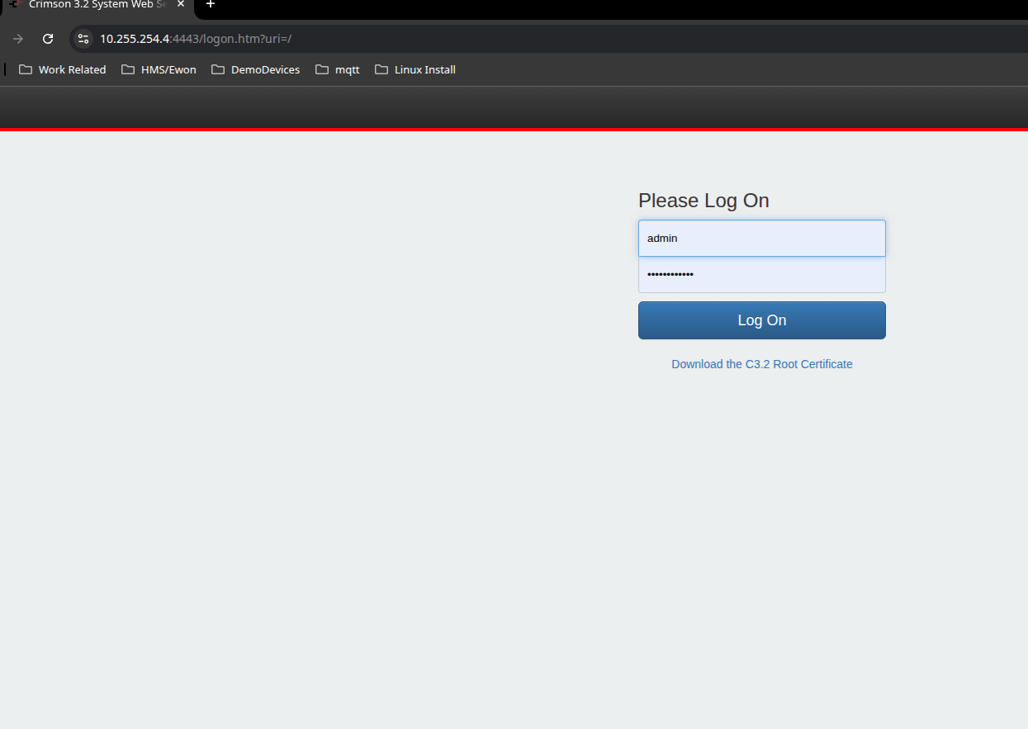
Figure 18 - Trusted Crimson login page with no certificate warning.
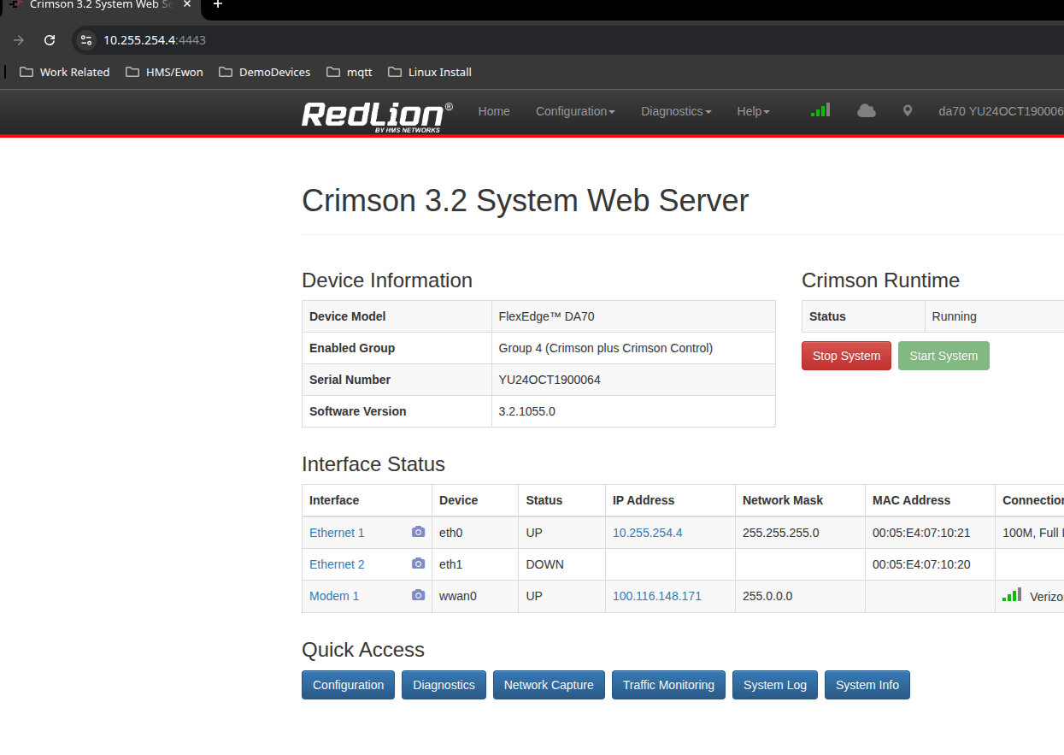
Figure 19 - Crimson 3.2 System Web Server operating normally after custom-certificate deployment.

Option 2 troubleshooting
Symptom | Likely cause and corrective action
Crimson rejects the private key | Confirm the file is PEM encoded, the password is correct, and the key matches the certificate. Revalidate the package in Industrial Certificate Assistant.
Authority invalid | Install the correct root CA on the PC and confirm the FlexEdge is serving the intermediate CA certificate in fullchain.pem.
Name mismatch | Regenerate or reissue the certificate with the exact IP address or hostname in Subject Alternative Name.
Date invalid | Correct the clocks and verify the certificate’s Not Before and Not After dates.
Old certificate still appears | Commit the configuration, restart the applicable service or device, then fully restart the browser to clear cached TLS sessions.

Completion checklist
- The private key matches the installed server certificate.
- Every administrator-facing IP address and DNS name appears as a Subject Alternative Name.
- The FlexEdge supplies the server certificate and required intermediate certificate.
- Administrator PCs trust the correct root CA.
- The System Web Server opens securely on TCP port 4443.
- Save Changes was completed and the FlexEdge was restarted after selecting the new identity.
- CA and device private keys are backed up, access-controlled, and excluded from tickets and email.

