Industrial Certificate Assistant for Crimson 3.2 Devices
Guided SSL/TLS management, certificate generation, trust installation, and FlexEdge deployment
Software | Industrial Certificate Assistant 0.7.0 and Crimson 3.2
Validated on | FlexEdge DA70, Crimson 3.2.1055.0, System Web Server TCP port 4443
Audience | Customers, integrators, and technical-support personnel

Purpose
This manual explains how to create, request, import, validate, and deploy SSL/TLS certificates for the Crimson 3.2 System Web Server. It includes the built-in Crimson trust method, a workflow for packaging an existing certificate, private key, and CA chain, and a fully tested customer-managed PKI workflow using Industrial Certificate Assistant.
Expected warning: Before the C3.2 Root Certificate is trusted, Chrome may display “Your connection is not private” with NET::ERR_CERT_AUTHORITY_INVALID. This is expected during initial setup.

Before you begin
- Connect the PC to a network interface that can reach the Crimson 3.2 device.
- Know the device IP address or its .local hostname.
- Use an account with permission to install certificates on the PC.
- Confirm the PC and device clocks are correct; certificate validation depends on accurate time.
- These instructions show Windows certificate installation. Linux and centrally managed enterprise devices use different trust-store procedures.

Industrial Certificate Assistant Overview
The application presents four guided workflows. Select the workflow that matches the customer’s certificate source and deployment requirements. Use Import Existing Certificate when the customer already has a matching certificate, private key, and CA chain from another CA or PKI tool.
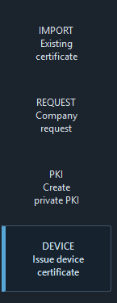

Figure 2 - Request one from my company creates a protected or passwordless private key and CSR for a corporate CA.

Workflow selection
Workflow | Purpose
IMPORT Existing Certificate | Validate an existing server certificate and key and assemble a crimson package.
Request one from my company | Generate a local key and CSR for an enterprise or corporate CA.
Create my own PKI | Create a root CA, issuing CA, project folders, and trust installers.
Issue a Crimson 3.2 device certificate | Issue a device certificate and produce fullchain.pem and the complete deployment package.
Password choice: Version 0.7.0 supports encrypted or passwordless CA, CSR, and FlexEdge private keys. Encryption is selected by default. Passwordless operation requires an explicit risk confirmation.

Option 1 - Trust the C3.2 Root Certificate

Step 1 - Open the Crimson 3.2 System Web Server
In a supported browser, enter the device address followed by port 4443. For example:
https://10.255.254.4:4443
Address matching: Use the same IP address or hostname that the device certificate was created to represent. Crimson’s automatically generated certificate normally includes the unit’s private IP addresses and .local name.

Step 2 - Continue past the initial browser warning
The first connection may show a privacy warning because the PC does not yet trust the C3.2 Root Certificate.
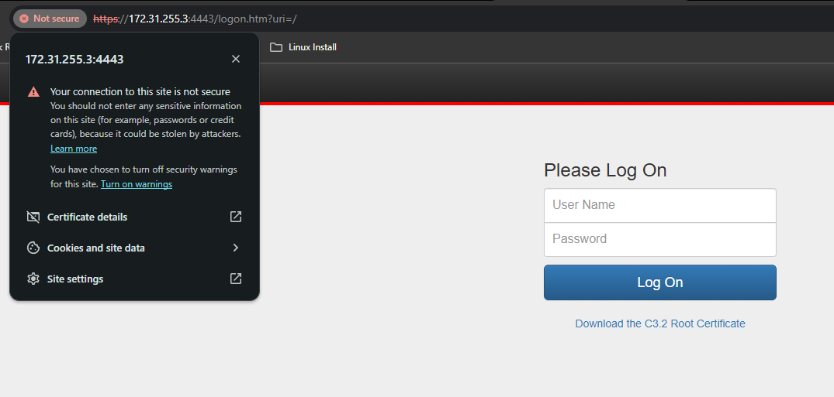
Figure 3 - Expected Chrome warning before the Crimson root certificate is installed.

Select Advanced.
Select Proceed to [device address] (unsafe). This bypass is temporary and is used only to reach the certificate download link.
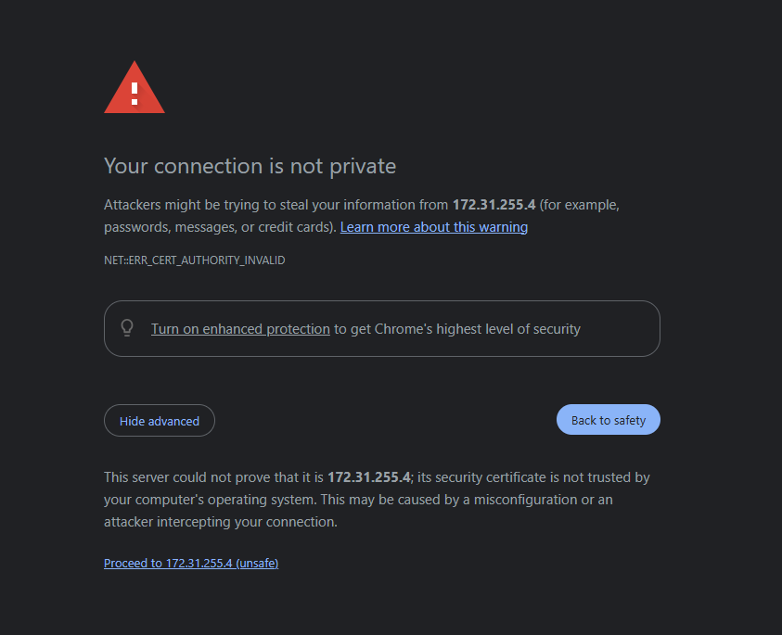

Step 3 - Download the C3.2 Root Certificate
At the Crimson 3.2 login page, locate the C3.2 Root Certificate link below the Log On button and download the certificate to the PC. The link is available before authentication.
Important: Download only the public C3.2 Root Certificate. No private key is required or exposed by this process.

Step 4 - Install the certificate in Windows
Open the downloaded C3.2 Root Certificate file.
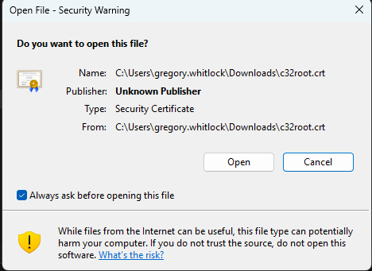
Select Install Certificate.
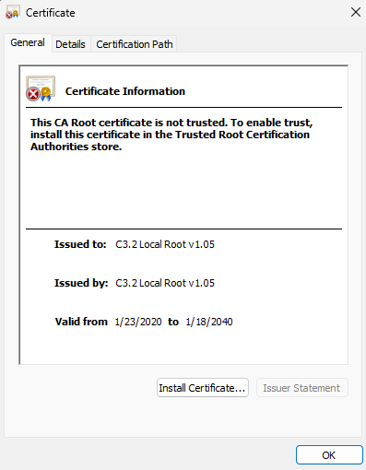
Choose Local Machine when the certificate should be trusted by all users of the PC. Administrator approval may be required. Choose Current User only when trust should apply to your account.
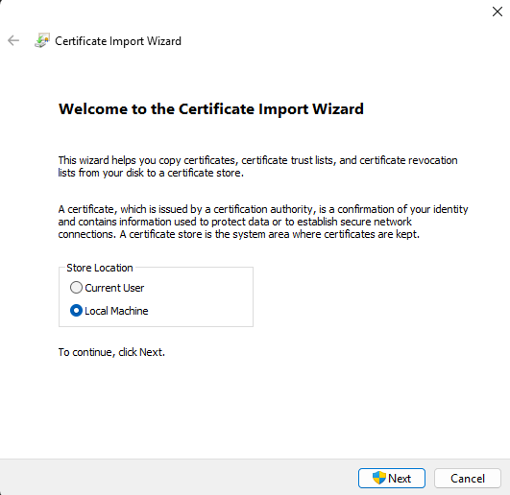
Select Place all certificates in the following store.
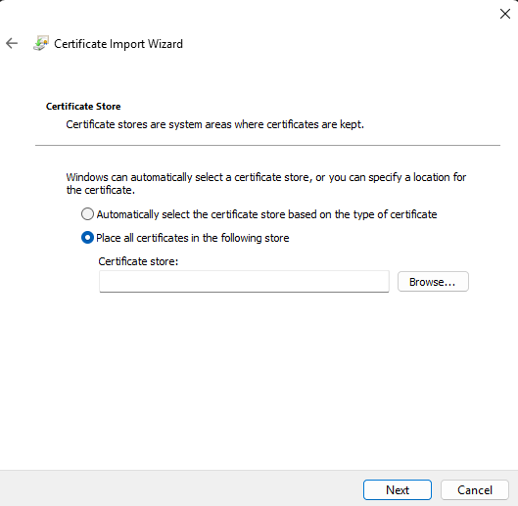
Select Browse, choose Trusted Root Certification Authorities, and select OK.
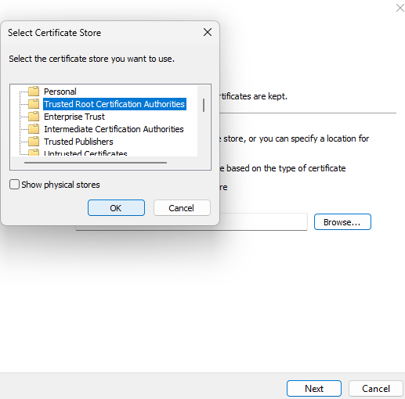
Select Next, review the destination, and select Finish.
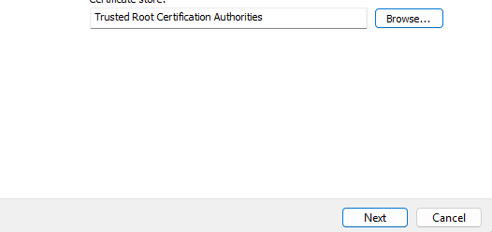
Accept the Windows security warning only after confirming that the certificate came directly from the intended Crimson 3.2 device.

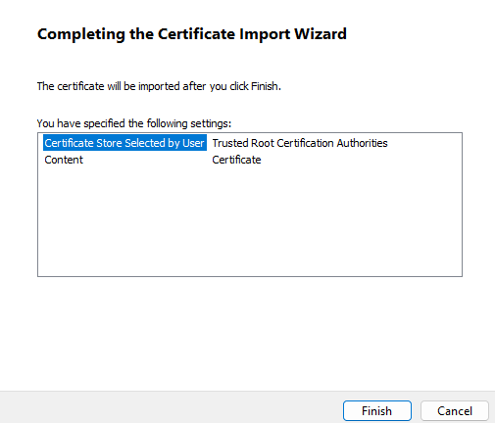

Step 5 - Restart the browser and verify
Close every browser window. If necessary, end any remaining browser processes.
Reopen the browser and return to the same device address on port 4443.
Confirm that the privacy warning no longer appears and that the browser reports a secure HTTPS connection.
Open the browser’s certificate information and confirm that the certificate is valid for the address entered.

Verification checklist
The System Web Server opens at https://[device-address]:4443.
The browser no longer reports NET::ERR_CERT_AUTHORITY_INVALID.
The certificate is within its valid date range.
The IP address or hostname entered in the browser appears in the certificate’s Subject Alternative Name list.
The certificate chain terminates at the trusted C3.2 Root Certificate.

Troubleshooting
Browser message | What to check
CERT_AUTHORITY_INVALID | Confirm the C3.2 Root Certificate was installed in Trusted Root Certification Authorities, then fully restart the browser.
CERT_COMMON_NAME_INVALID | Use an IP address or hostname included in the device certificate. Check for a typing error or an address that was added after the certificate was generated.
CERT_DATE_INVALID | Correct the time, date, and time zone on both the PC and the Crimson device.
Warning remains after installation | Confirm the certificate was placed in the intended user or machine store. Enterprise policy or a browser-specific trust store may also apply.

Security notes
Install a root certificate only when it was obtained directly from a device or source you trust.
The default C3.2 Root Certificate is constrained to private IP addresses and names ending in .local. Option 1 is convenient for isolated or locally administered systems. Organizations that manage their own enterprise PKI may prefer a server certificate signed by their corporate CA.

Option 2 - Use a Customer-Managed Certificate
Use this option when the organization wants FlexEdge to present an HTTPS server certificate issued by its own certificate authority. This workflow is for certificates the customer already has or receives from another CA, and it can be issued by an existing corporate CA or by a dedicated industrial-device PKI created with Industrial Certificate Assistant.
Recommended enterprise approach: Generate the private key and certificate signing request locally, then have the organization’s existing CA sign the request. The private key remains with the FlexEdge administrator and is never sent to the CA.

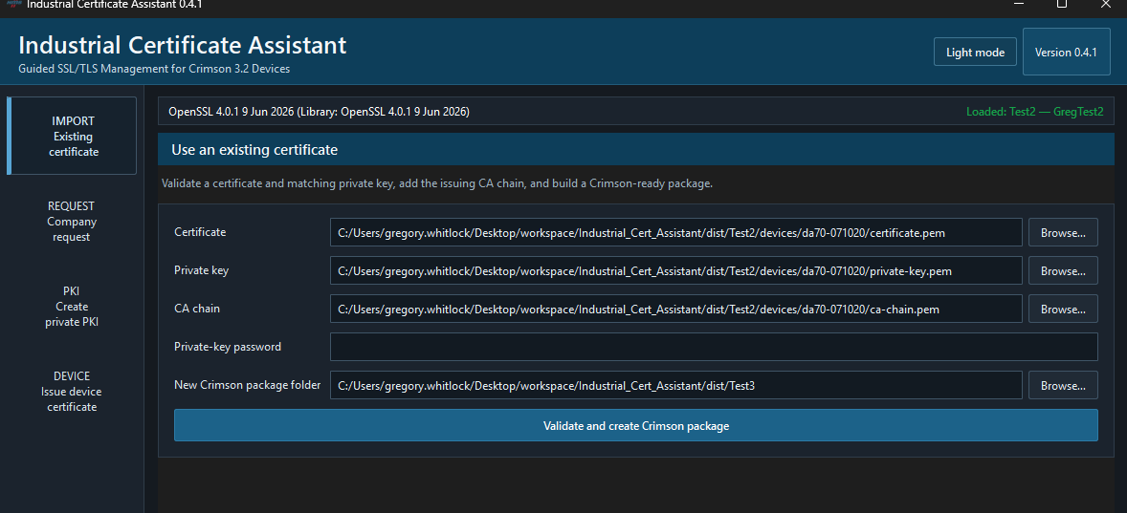

Choose an issuance path
Path | Use when | Result
A - Corporate CA | The customer already operates Microsoft AD CS or another enterprise CA. | A CSR and encrypted private key are created locally; the CA returns the signed certificate and chain.
B - Dedicated local PKI | The site needs an independent certificate hierarchy for industrial devices. | A protected root CA, intermediate CA, and FlexEdge server certificate are created.

Required certificate properties
The certificate must be an end-entity server certificate, not a CA certificate.
Extended Key Usage must include TLS Web Server Authentication (serverAuth).
Key Usage should include Digital Signature and, for an RSA certificate, Key Encipherment.
The Subject Alternative Name extension must include every DNS name and IP address used to open the device.
The certificate and private key must be PEM encoded and must form a matching pair.
The certificate must be within its validity period, and the PC and FlexEdge clocks must be correct.

Before generating the certificate
Record every address that administrators may use. For the example device in this guide, the IP address is 10.255.254.4. An example Subject Alternative Name list could be:
10.255.254.4, da50-08ffcf
Do not omit the IP address: If users open https://10.255.254.4:4443, the certificate must contain 10.255.254.4 as an IP Subject Alternative Name. Adding it only as a Common Name is not sufficient.

Path A - Request a Certificate from a Corporate CA

Step A1 - Generate the private key and CSR
Open Industrial Certificate Assistant and select Request one from my company. Complete the fields as follows:
Application field | Value
Common name | Primary DNS name for the FlexEdge, such as flexedge01.company.local
Organization | Customer’s organization name
DNS names and IPs | Comma-separated list of every address used to reach the device
Protect private key with password | Strong password that will later be entered in Crimson
Output folder | Secure folder dedicated to this FlexEdge
Select Create private key and CSR. The application creates private-key.pem and request.csr.pem.
Protect the private key: Do not email or upload private-key.pem to the certificate authority. Submit only request.csr.pem. Retain the private-key password securely.

Step A2 - Submit the CSR
- Submit request.csr.pem through the organization’s approved certificate-request process.
- Request a TLS Web Server Authentication certificate.
- Confirm the issuing CA preserves all requested DNS and IP Subject Alternative Names.
- Obtain the signed server certificate and the issuing intermediate CA certificate or complete CA chain in PEM format.

Step A3 - Validate the returned certificate
In Industrial Certificate Assistant, use Import Existing Certificate when the customer already has a matching server certificate, private key, and CA chain. Choose the certificate, private key, and CA chain files from that package, then enter the private-key password only if the private key is encrypted and select Validate and create Crimson package.
Do not continue until the application confirms that the certificate and private key match and that the certificate chain verifies successfully.
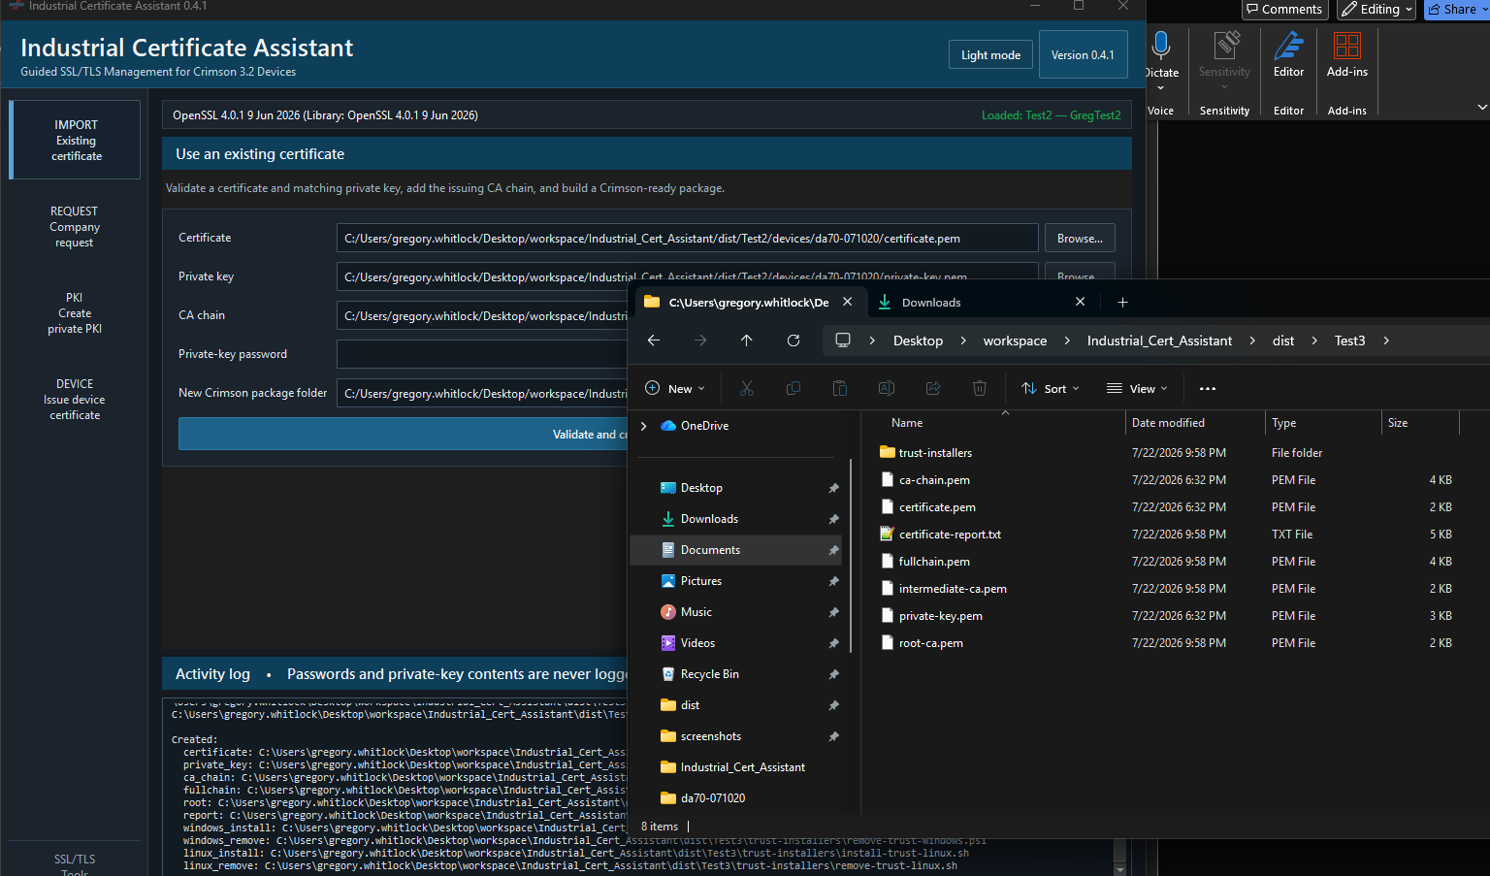

Path B - Create a Dedicated Industrial PKI

Step B1 - Create the root and intermediate CAs
Open Industrial Certificate Assistant and select Create my own PKI. Choose a new workspace and enter the organization and DNS suffix. Keep CA-key encryption enabled and enter a password or clear the encryption checkbox and complete the passwordless risk confirmation. Select Create PKI project.
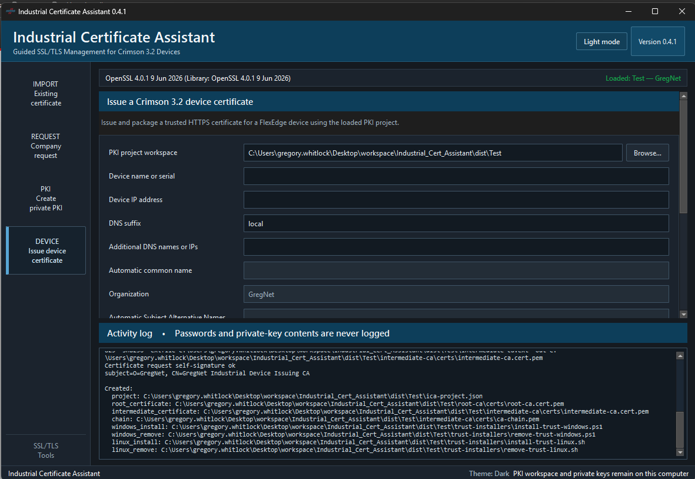
Figure 5 - Completed PKI project fields with CA-key encryption disabled for the validated passwordless test.
CA custody: Back up the PKI workspace securely and keep the root CA offline whenever it is not required. Anyone who obtains an unencrypted CA key—or an encrypted CA key and its password—can issue certificates trusted by that CA.

Step B2 - Issue device certificate
Select Issue a device certificate and complete these fields:
Application field | Value
PKI workspace | Workspace created in Step B1
Common name | See Below
Organization | Customer or site organization name
DNS names and IPs | Every address used to open the System Web Server
CA password | Password protecting the intermediate CA key
Output folder | Secure folder dedicated to this FlexEdge

Common name can either be retrieved from the System Configuration page, or can be set by the user under Configuration>System Configuration>Network>Identity>Local Name
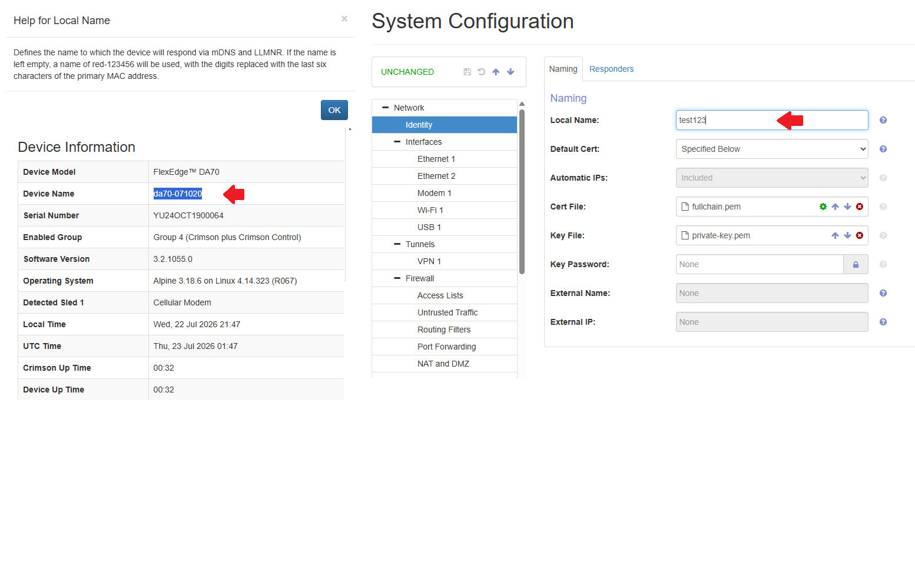
Select Issue complete FlexEdge HTTPS package. The application creates certificate.pem, private-key.pem, fullchain.pem, ca-chain.pem, CA certificates, request.csr.pem, certificate-report.txt, and trust installers.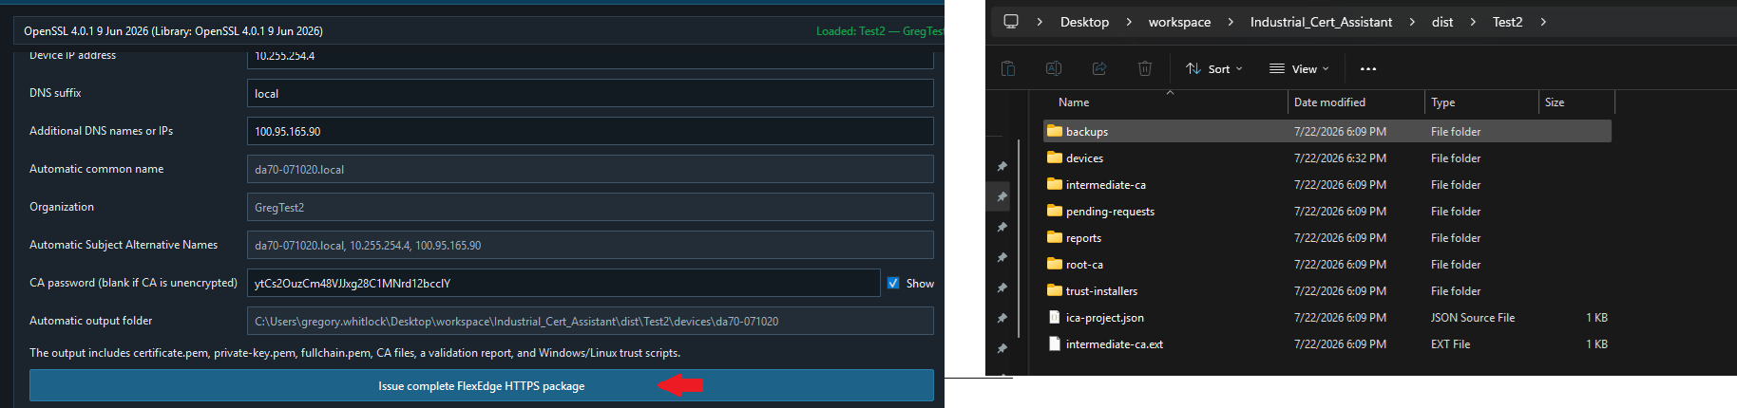

Step B3 - Distribute the root certificate
The public root certificate can be installed in your PC by running the installation scripts found in
the project root/trust installers directory.
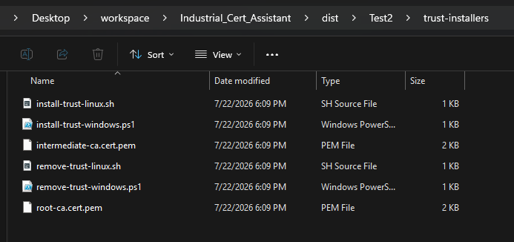
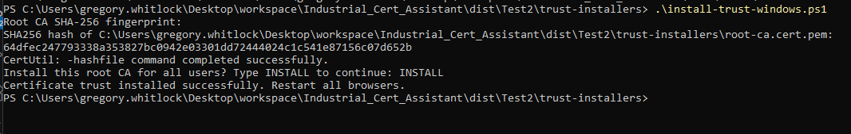
Example of successful install on Windows

Install the Customer-Managed Certificate in Crimson 3.2

Step 1 - Open the System Web Server
Open https://[device-address]:4443. Until the new certificate is installed, use the temporary Advanced > Proceed method from Option 1 if the browser does not yet trust the existing Crimson certificate.
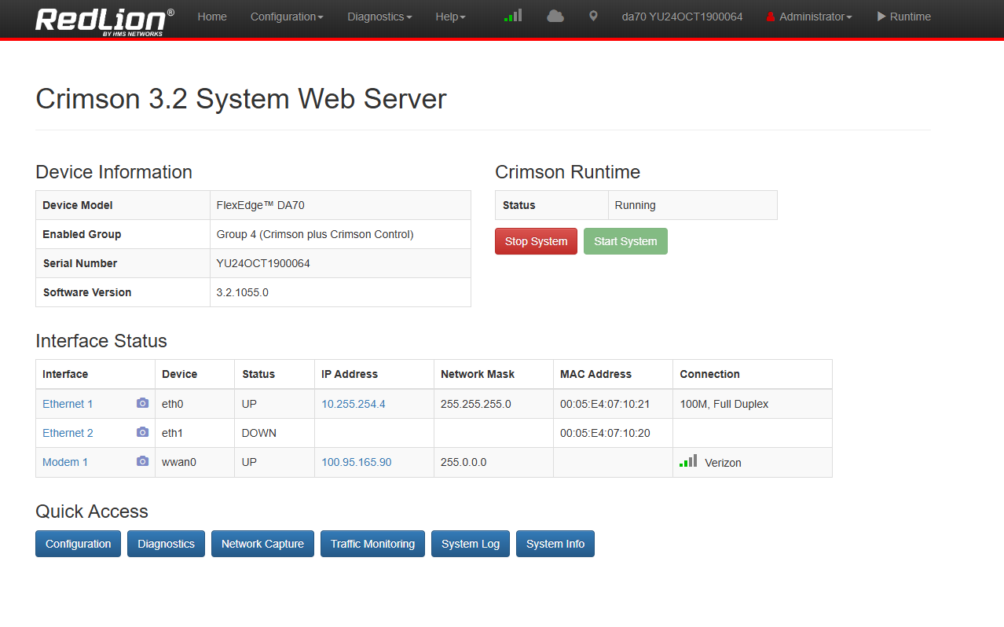

Step 2 - Configure the default device certificate
Navigate to Configuration>System>Network>Identity page
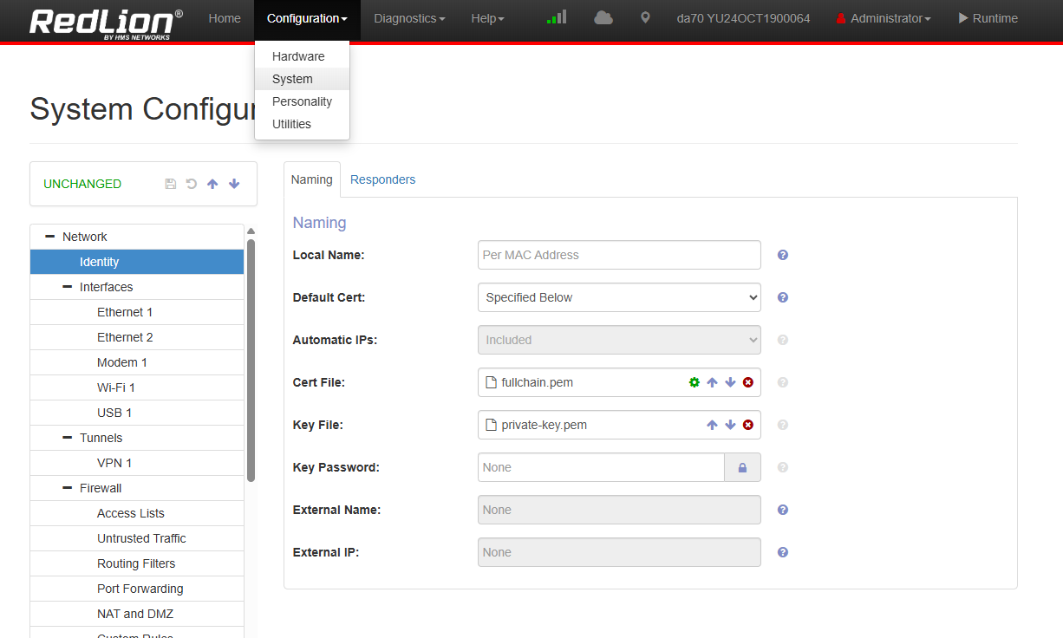
Change dropdown for Default Cert: to Specified Below
Click the Up arrow next to Cert File: and select fullchain.pem found in [project root]\[devices]\[device name folder]\
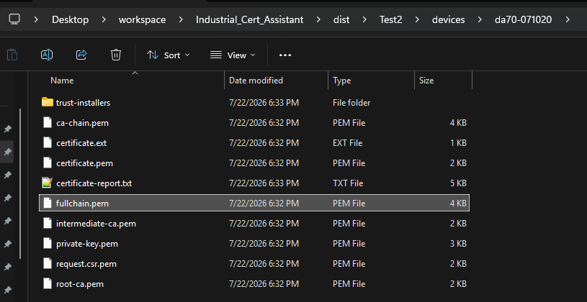
Click the Up arrow next to Key File: and select private-key.pem ound in [project root]\[devices]\[device name folder]\
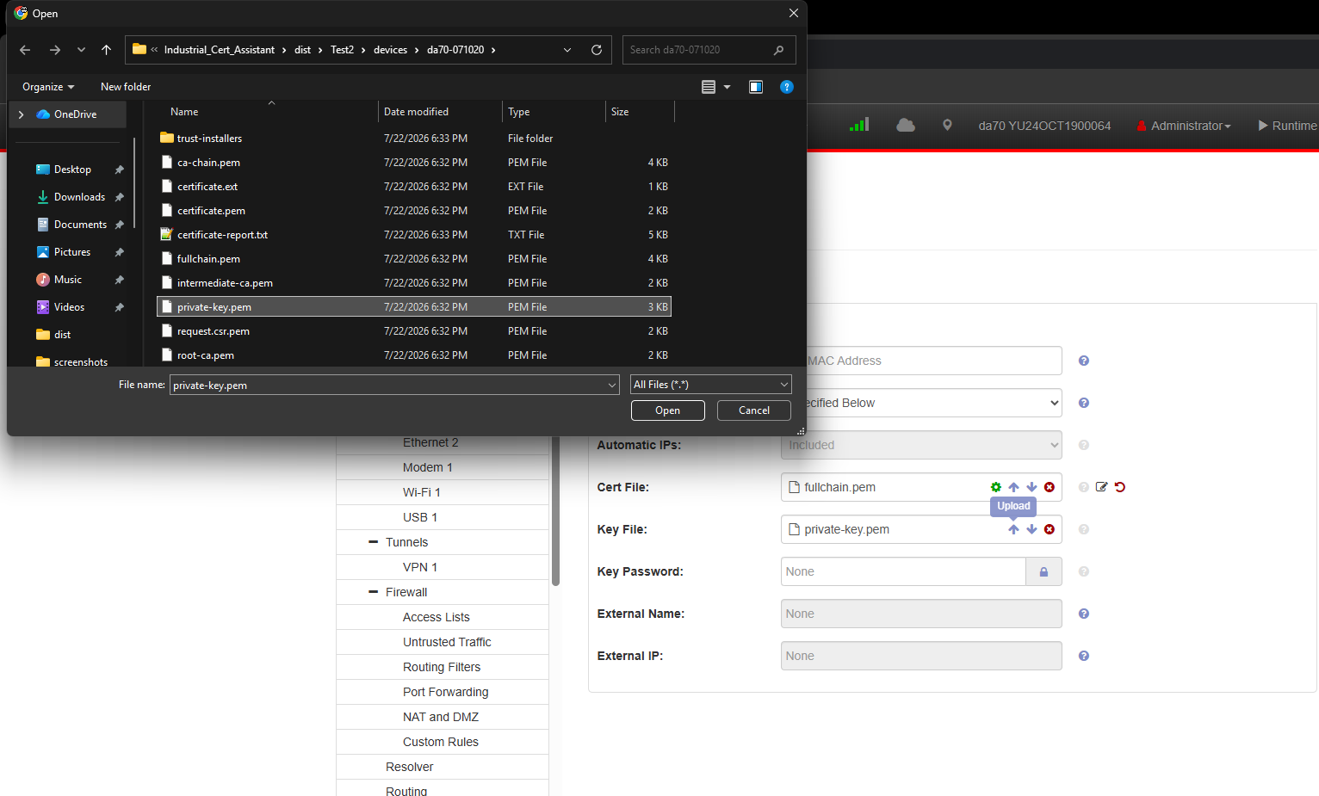
Private-key handling: Transfer private-key.pem only to the intended FlexEdge and only through an approved secure method. Do not retain unneeded copies on shared workstations or support-ticket systems.
Save the Configuration: Click on the Save Icon (looks like a floppy disk)
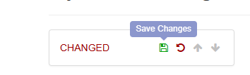
Click ‘OK’ on the confirmation pop-up
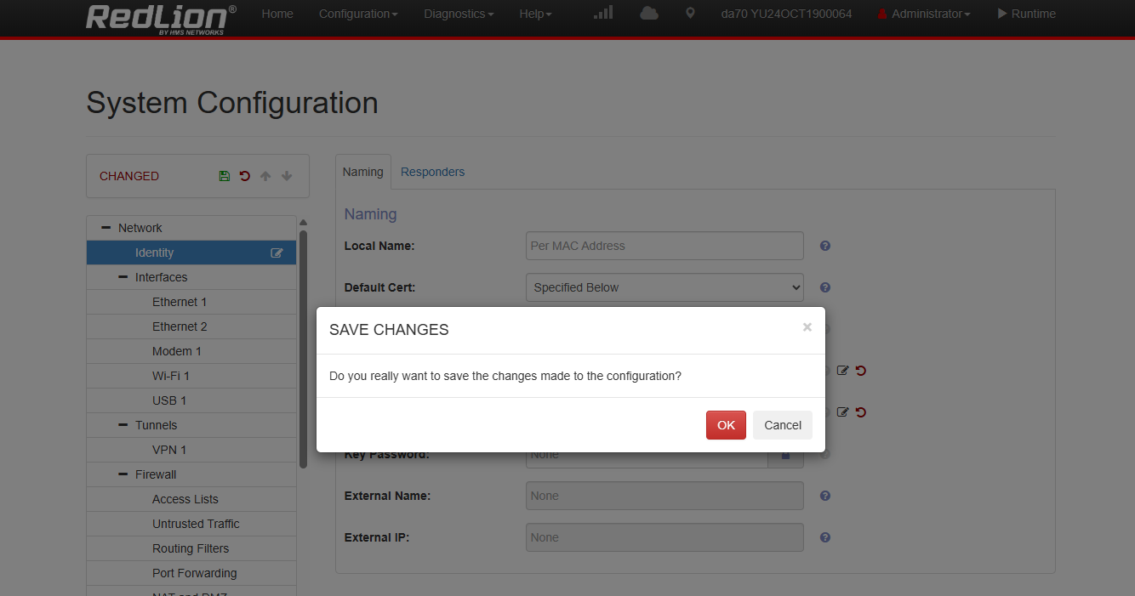
Pay attention to the serial number in the top row of the configuration page, you may notice it change to red. Once it changes back to grey the save process is complete.
If you work with Crimson 3.2 database files you can make sure these changes are save to your crimson 3.2 database by following this procedure
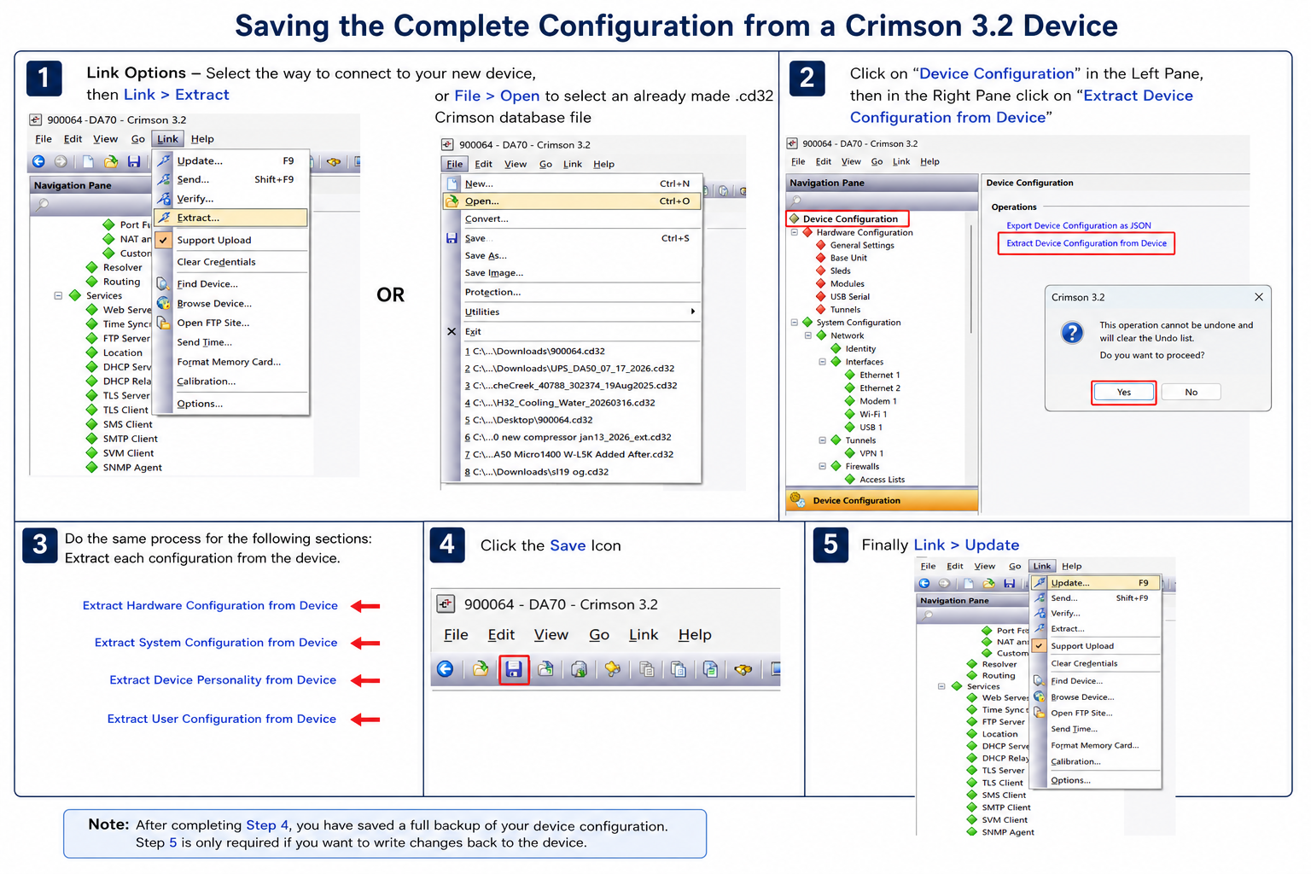

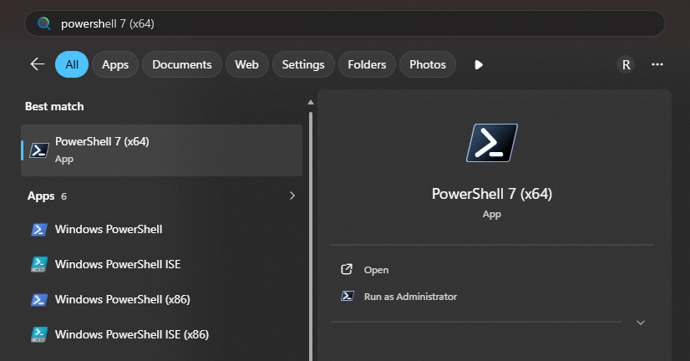
Figure 15 - Save Changes must be selected before restarting the FlexEdge.

Verify Option 2
- Fully close and reopen the browser.
- Open the exact device IP address or DNS name included in the certificate, followed by :4443.
- Confirm the browser no longer displays a privacy warning.
- Inspect the presented certificate and verify its subject, issuer, validity period, and Subject Alternative Names.
- Confirm the certificate chain reaches the expected customer or corporate root CA.

Trusted browser result
Install the generated public root CA using the trust installer, completely restart the browser, and reopen the exact IP address or DNS name included in the certificate. The login page’s Download the C3.2 Root Certificate link remains present, but it refers to Crimson’s built-in root and is not used for the custom-PKI workflow.
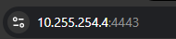
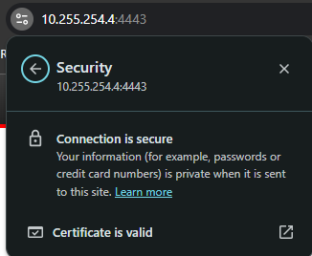

Option 2 troubleshooting
Symptom | Likely cause and corrective action
Authority invalid | Install the correct root CA on the PC and confirm FlexEdge is serving the intermediate CA certificate in fullchain.pem.  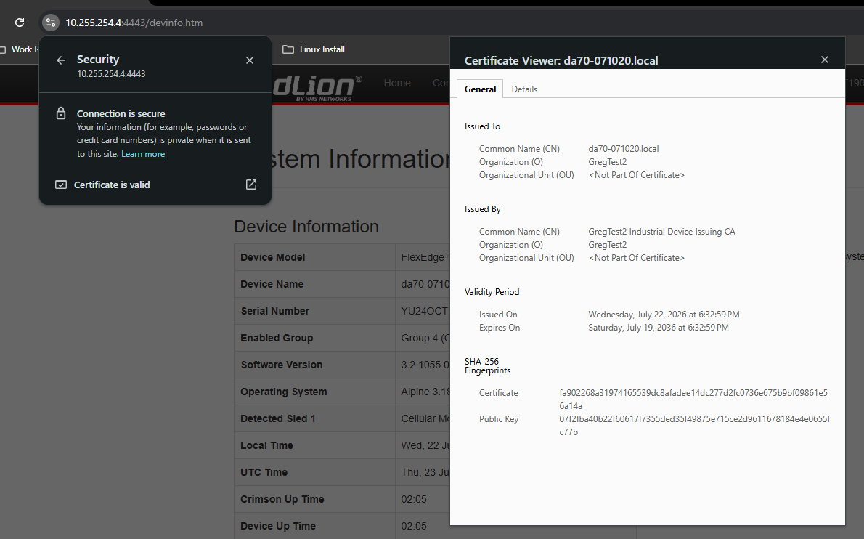
Name mismatch | Regenerate or reissue the certificate with the exact IP address or hostname in Subject Alternative Name.
Date invalid | Correct the clocks and verify the certificate’s Not Before and Not After dates.
Old certificate still appears | Commit the configuration, restart the applicable service or device, then fully restart the browser to clear cached TLS sessions.

Completion checklist
The private key matches the installed server certificate.
Every administrator-facing IP address and DNS name appears as a Subject Alternative Name.
FlexEdge supplies the server certificate and required intermediate certificate.
Administrator PCs trust the correct root CA.
The System Web Server opens securely on TCP port 4443.
Save Changes was completed and the FlexEdge was restarted after selecting the new identity.
CA and device private keys are backed up, access-controlled, and excluded from tickets and email.

Appendix A - Validated MQTT, Node-RED, InfluxDB, and Dashboard Deployment
This appendix records the end-to-end deployment validated on GregPubServ with a Red Lion FlexEdge DA70A. It extends the certificate workflows in this manual from HTTPS identity management to MQTT mutual TLS, telemetry collection, time-series storage, dashboard visualization, and controlled Internet publication.
Validated reference: Fedora 44, Mosquitto 2.1.2, Node-RED 5.0.4, Node.js 24, InfluxDB 2.9.1, FlowFuse Dashboard 2.0, Caddy 2.11.4, Crimson 3.2, and Industrial Certificate Assistant 0.7.0.

A.1 Reference architecture
Component | Validated address or role | Exposure
FlexEdge DA70A | 10.255.254.4; MQTT client YU24OCT1900064 | Routes through the VPN
VPN tunnel | 10.0.0.0/24; server-side internal address 10.0.1.1 | Private transport
Mosquitto | ethersloth4.duckdns.org:8883 | Public MQTT over mutual TLS
Node-RED editor | http://10.0.1.1:1880 | VPN/internal only
InfluxDB | http://127.0.0.1:8086 | Loopback only
Public dashboard | https://ethersloth4.duckdns.org/dashboard/ | HTTPS through Caddy

Security boundary: Port 1883 was used only for the initial routed-VPN test and was later removed. Production telemetry uses port 8883 with broker and client certificates. The Node-RED editor and InfluxDB API remain off the public interface.

A.2 Confirm plaintext MQTT over the routed VPN
Before introducing certificates, verify basic routing and payload structure. Bind the temporary listener to the internal server address, not to all interfaces:
# /etc/mosquitto/mosquitto.conf (temporary test only)
listener 1883 10.0.1.1
protocol mqtt
allow_anonymous true
Permit only the routed device/VPN sources in the firewalld internal zone, restart Mosquitto, and subscribe from the server:
sudo systemctl restart mosquitto
mosquitto_sub -h 10.0.1.1 -p 1883 -t 'gregpubserv/da70a/#' -v
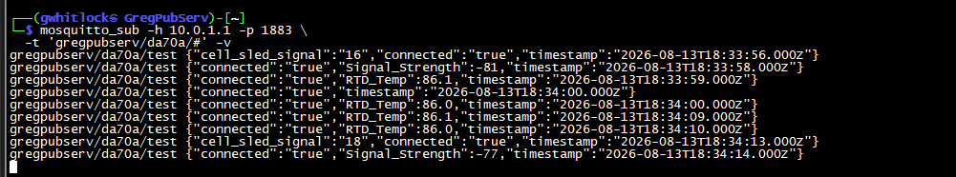
Figure A-1 - Successful DA70A telemetry on the temporary VPN-only MQTT listener.

A.3 Create the private PKI in ICA 0.7.0
- Open Create private PKI and select the Server TLS profile.
- Use ECDSA P-256 with SHA-256 unless a customer compatibility requirement dictates otherwise.
- Choose a protected project folder and enter the organization name. Encrypt CA private keys for production deployments.
- Create the PKI project and preserve the generated trust installers and CA chain.
Private-key handling: Do not place root or intermediate CA private keys on Mosquitto, the FlexEdge, Node-RED, support tickets, shared folders, or email. Back them up separately with access controls.

A.4 Issue the Mosquitto broker certificate
In Issue protocol certificate, select MQTT Broker and complete the package as follows:
Field | Validated value
Device/Broker name | GregPubServ MQTT broker
Primary DNS name | ethersloth4.duckdns.org
Primary IP address | 172.105.43.198 (optional when clients use DNS)
Mutual TLS | Enabled; require a client certificate
Validity | 397 days in the validated test

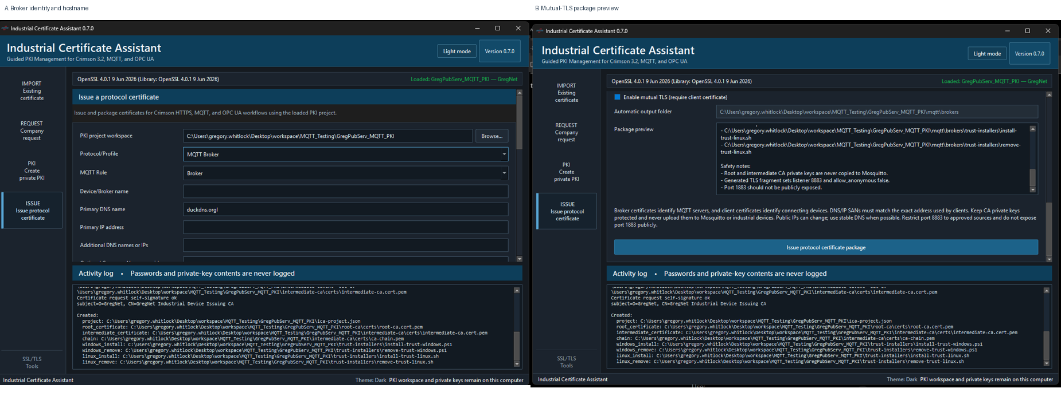
Figure A-2 - ICA 0.7.0 broker identity fields and mutual-TLS package preview.
Name validation: Every client should connect using ethersloth4.duckdns.org. A certificate issued only for that DNS name will not validate when a client connects to 172.105.43.198 directly.

A.5 Install the Mosquitto TLS listener
Transfer the public chain, broker full chain, broker private key, and generated Mosquitto fragment to GregPubServ. Install them with restrictive ownership:
sudo install -d -o root -g mosquitto -m 0750 /etc/mosquitto/certs /etc/mosquitto/conf.d
sudo install -o root -g mosquitto -m 0644 ca-chain.pem broker-fullchain.pem /etc/mosquitto/certs/
sudo install -o root -g mosquitto -m 0640 broker-private-key.pem /etc/mosquitto/certs/
sudo restorecon -RFv /etc/mosquitto
Load the listener from /etc/mosquitto/conf.d/mqtt-tls.conf:
listener 8883
protocol mqtt
cafile /etc/mosquitto/certs/ca-chain.pem
certfile /etc/mosquitto/certs/broker-fullchain.pem
keyfile /etc/mosquitto/certs/broker-private-key.pem
require_certificate true
use_identity_as_username true
allow_anonymous false
Ensure the main configuration contains include_dir /etc/mosquitto/conf.d. Validate using the version-appropriate switch, then restart:
sudo mosquitto -c /etc/mosquitto/mosquitto.conf --test-config
sudo systemctl restart mosquitto
sudo ss -ltnp | grep ':8883'

A.6 Issue and validate MQTT client certificates
Issue separate MQTT Client/Device identities for the DA70A and Node-RED. Use unique common names and client IDs so the broker log and future ACLs can distinguish them.
Client | Certificate common name | MQTT client ID
FlexEdge DA70A | YU24OCT1900064 | YU24OCT1900064
Node-RED | NodeRED_GregPubServ | NodeRED_GregPubServ

Validate each package before deployment:
openssl verify -CAfile ca-chain.pem client-certificate.pem
openssl pkey -in client-private-key.pem -check -noout
openssl x509 -in client-certificate.pem -noout -subject -issuer -ext extendedKeyUsage
- The chain must verify successfully.
- The private key must report as valid.
- Extended Key Usage must include TLS Web Client Authentication.
SAN behavior: ICA 0.7.0 requires at least one Subject Alternative Name. For a local client identity, use a stable device DNS name or an appropriate IP identity. The broker still identifies the client from its certificate common name when use_identity_as_username is enabled.

A.7 Test mutual TLS before configuring Crimson
openssl s_client -connect ethersloth4.duckdns.org:8883 -servername ethersloth4.duckdns.org -verify_hostname ethersloth4.duckdns.org -verify_return_error -CAfile ca-chain.pem -cert client-certificate.pem -key client-private-key.pem </dev/null
A successful test reports Verification: OK, the verified peer name, and the negotiated TLS version/cipher. Then test MQTT framing with mosquitto_sub using the same CA, certificate, and key.

A.8 Configure the FlexEdge DA70A for MQTT mutual TLS
In Crimson 3.2, create two reusable certificate objects under Device Configuration > System Configuration > Security:
- Trusted Cert: import root-ca.pem and label it GregNet_MQTT_CA.
- Identity Cert: import client-fullchain.pem with the matching client private key and label it DA70A_MQTT_Client.
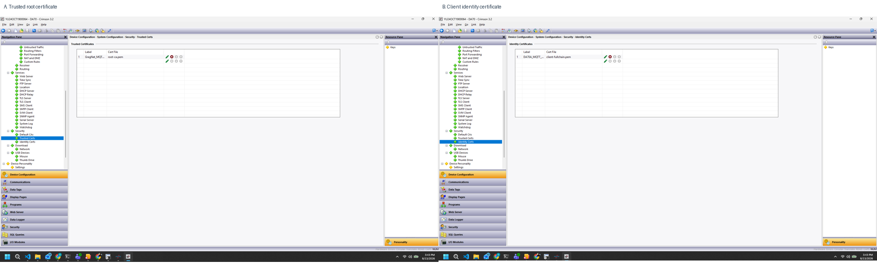
Figure A-3 - Crimson trusted CA and client identity certificate objects.
Configure Communications > Services > Generic MQTT:
Setting | Validated value
Host Name 1 | ethersloth4.duckdns.org
Client ID | YU24OCT1900064
Publication Topic | gregpubserv/da70a/test
Subscription Topic | gregpubserv/da70a/write
Transport / Port | TLS / 8883
Client Certificate | DA70A_MQTT_Client
Server Validation | GregNet_MQTT_CA
Server Cert Checks | Check Everything
Send Interface | Ethernet 1 in the validated routed-VPN design

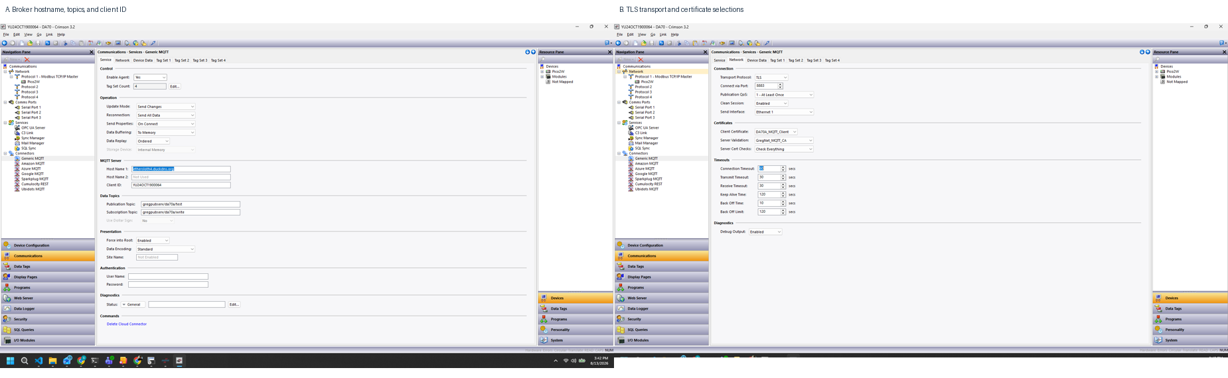
Figure A-4 - Crimson Generic MQTT service and TLS network settings.
Clock requirement: Certificate validation depends on accurate UTC time. Confirm the DA70A time source before diagnosing TLS failures.

A.9 Confirm the DA70A connection at the broker
Follow the Mosquitto journal while downloading the Crimson configuration:
sudo journalctl -u mosquitto -f
The validated DA70A connection produced a broker record equivalent to:
New client connected ... as YU24OCT1900064 (p4, c1, k120, u'YU24OCT1900064')
Client YU24OCT1900064 negotiated TLSv1.3 cipher TLS_AES_256_GCM_SHA384
Subscribe with a separate authorized client and confirm sparse JSON objects arrive on gregpubserv/da70a/test. The example payloads included RTD_Temp, Pico_Temperature_Raw, Pico_Humidity_Raw, Signal_Strength, cell_sled_signal, cell_sled_addr, connected, and timestamp.

A.10 Install Node-RED as a dedicated service
Install Node.js and Node-RED natively. A container is not required and was deliberately avoided so the existing SVM service remained untouched.
sudo dnf install nodejs24 nodejs24-bin nodejs24-npm nodejs24-npm-bin gcc-c++ make python3
sudo npm install --global node-red@latest
sudo useradd --system --create-home --home-dir /var/lib/node-red --shell /usr/sbin/nologin nodered
Store the Node-RED MQTT client files outside the flow directory and make them readable only by root and the nodered group:
sudo install -d -o root -g nodered -m 0750 /etc/node-red/certs
sudo install -o root -g nodered -m 0644 ca-chain.pem client-fullchain.pem /etc/node-red/certs/
sudo install -o root -g nodered -m 0640 client-private-key.pem /etc/node-red/certs/
sudo restorecon -RFv /etc/node-red /var/lib/node-red
Editor exposure: Bind Node-RED to 10.0.1.1:1880 and protect the editor with adminAuth. Do not open TCP 1880 in the external firewalld zone.

A.11 Configure Node-RED MQTT mutual TLS
Create an MQTT broker configuration with the validated endpoint and enable TLS:
Field | Value
Server | ethersloth4.duckdns.org
Port | 8883
Protocol | MQTT v3.1.1
Client ID | NodeRED_GregPubServ
Certificate | /etc/node-red/certs/client-fullchain.pem
Private Key | /etc/node-red/certs/client-private-key.pem
CA Certificate | /etc/node-red/certs/ca-chain.pem
Verify server certificate | Enabled
Server Name | ethersloth4.duckdns.org

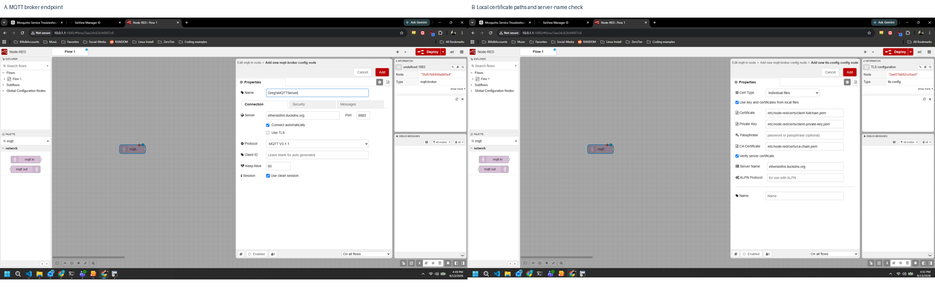
Figure A-5 - Node-RED broker and TLS configuration using local certificate files.
Subscribe to gregpubserv/da70a/#, connect the MQTT input to a Debug node, deploy, and confirm object payloads arrive. Mosquitto should log the NodeRED_GregPubServ certificate identity and a TLS 1.3 cipher.
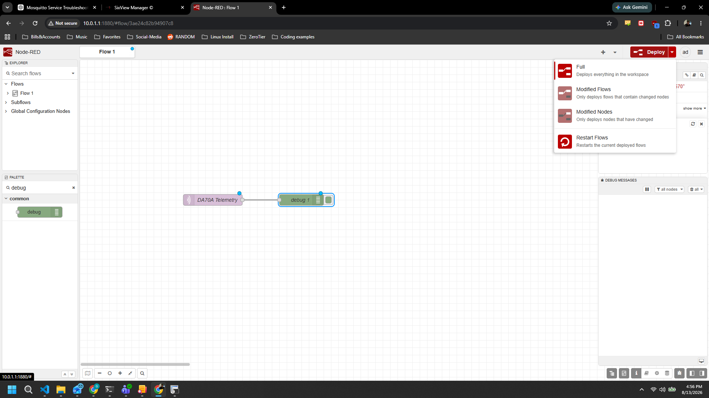
Figure A-6 - Deployed DA70A telemetry flow feeding the Node-RED Debug sidebar.

A.12 Install and isolate InfluxDB
Install InfluxDB 2.x natively and bind it to loopback. This keeps the API reachable by Node-RED without exposing port 8086 publicly.
sudo dnf install --repo=influxdata influxdb2-2.9.1
sudo install -d -m 0755 /etc/systemd/system/influxdb.service.d
# /etc/systemd/system/influxdb.service.d/override.conf
[Service]
Environment=INFLUXD_HTTP_BIND_ADDRESS=127.0.0.1:8086
sudo systemctl daemon-reload
sudo systemctl enable --now influxdb
curl --fail --silent http://127.0.0.1:8086/health | python3 -m json.tool
Create the GregNet organization and da70a_telemetry bucket. Generate a scoped token that can read and write only that bucket, store it in /etc/node-red/influxdb-token with root:nodered ownership and mode 0640, and never place it in screenshots or documentation.
Token test: A successful direct write to /api/v2/write returns HTTP 204. An unauthorized access message in Node-RED means the token, organization, bucket, or permissions do not match.

A.13 Store sparse DA70A telemetry
Install node-red-contrib-influxdb in /var/lib/node-red, restart Node-RED, and configure the InfluxDB 2.0 connection for http://127.0.0.1:8086. Use a Function node to merge each sparse MQTT payload into the latest device state before writing fields to the da70a_telemetry bucket.
- Use a stable measurement such as da70a_telemetry and a device tag such as YU24OCT1900064.
- Write only finite numeric fields; keep timestamps as event time and avoid storing secrets or certificate material.
- Normalize numeric strings before writing so charts do not receive mixed field types.

A.14 Build live and historical dashboards
Install FlowFuse Dashboard 2.0 and create a DA70A Overview page. The validated design includes live cards for connection status, last update, cell sled address, RTD temperature, Pico temperature, Pico humidity, signal strength, and cell sled signal.

Selectable historical range
Replace the fixed Rolling 1-Hour Trends label with a dashboard dropdown. Map each selection to a Flux range and an aggregation interval that limits chart point counts:
Dashboard choice | Flux range | Suggested aggregate window
1 hour | -1h | 30s
8 hours | -8h | 2m
24 hours | -24h | 5m
1 week | -7d | 30m
1 month | -30d | 2h

The range-selection Function node should allow only predefined values, build the Flux query, and send the returned series to separate temperature, humidity, and signal charts. Trigger a default 1-hour query at deployment and provide a manual refresh control.

A.15 Publish only the dashboard through Caddy
Keep Node-RED on 10.0.1.1:1880 and use Caddy on the external interface to proxy only /dashboard and its subpaths. The editor route is not published.
ethersloth4.duckdns.org {
encode zstd gzip
@dashboard path /dashboard /dashboard/*
handle @dashboard {
reverse_proxy 10.0.1.1:1880
}
handle / {
redir /dashboard/ 302
}
handle {
respond "Not Found" 404
}
log
}
Open HTTP and HTTPS in the external zone, validate the configuration, and start Caddy:
sudo firewall-cmd --zone=external --add-service=http --add-service=https
sudo firewall-cmd --zone=external --add-service=http --add-service=https --permanent
sudo firewall-cmd --reload
sudo caddy validate --config /etc/caddy/Caddyfile
sudo systemctl enable --now caddy

A.16 Final verification and hardening checklist
- Mosquitto listens on 8883 and no longer listens on 1883.
- The external zone exposes 8883/tcp, http, and https only as intended; TCP 1880 and 8086 remain closed.
- The DA70A and Node-RED each negotiate TLS and present unique client certificates.
- The broker certificate verifies for ethersloth4.duckdns.org; clients do not connect by raw IP.
- The Node-RED editor is reachable only through the VPN/internal address and requires authentication.
- InfluxDB listens only on 127.0.0.1:8086 and the Node-RED token is bucket-scoped.
- Historical queries return the expected ranges without excessive point counts.
- The public Caddy route serves /dashboard/ and /dashboard/* but returns 404 for editor and unrelated paths.
- Private keys are mode-restricted, backed up securely, and absent from tickets, logs, and screenshots.
- System clocks, certificate expiration dates, service health, and disk use are monitored.

A.17 Diagnostic commands
systemctl is-active mosquitto nodered influxdb caddy
sudo ss -ltnp | grep -E ':(443|8883|1880|8086)\b'
sudo journalctl -u mosquitto -n 80 --no-pager
sudo journalctl -u nodered -n 80 --no-pager
sudo journalctl -u influxdb -n 80 --no-pager
sudo journalctl -u caddy -n 80 --no-pager
curl -I http://ethersloth4.duckdns.org/dashboard/
curl -I https://ethersloth4.duckdns.org/dashboard/

