PES UNIVERSITY, BANGALORE
Department of Computer Science and Engineering

Software Architecture and Design Specification

Hospital Management System

Version 1.0

Prepared by
Navya Suresh (PES1UG24CS904)
Daksha S G (PES1UG24CS137)
Dhruv Swatantramath (PES1UG24CS155)
Gnanasagar H (PES1UG24CS171)

Group Number: 11
PES University, Bangalore
Date created: 02-10-2026

Revision History
Name | Date | Reason For Changes | Version
Navya Suresh (PES1UG24CS904) | 02-10-2026 | Initial draft for Mini-Project Part-1 | 1.0

Approvals
Role | Name | Signature / Date
Architect / Team Lead | Navya Suresh
Course Instructor | Dr. Ashok Kumar Patil (UE24CS341A Software Engineering)

1. Introduction

1.1 Purpose
This document specifies the architecture and design of the Hospital Management System (HMS) v1.0, so that the implementation in Part-2 follows a shared structure and every requirement of the SRS can be traced to a component.

1.2 Scope
Covers user authentication, patient registration and records, appointment booking, clinical records (consultation, prescription, history), billing, reports and administration. Inpatient, pharmacy and laboratory systems are out of scope (see SRS 1.2).

1.3 Audience
Developers, QA engineers, security reviewers, course instructors and the future maintenance team.

1.4 Definitions
HMS, PHI, API, REST, TLS, RBAC, ADR (Architecture Decision Record), STRIDE (Spoofing, Tampering, Repudiation, Information disclosure, Denial of service, Elevation of privilege), DAL (Data Access Layer).

2. Document Overview

2.1 How to use this document
Section 3 gives the architecture: goals, component diagram and descriptions, the chosen pattern, technology stack, traceability to requirements and the security architecture. Section 4 gives the design: UML sequence diagrams, API design, data design, error handling, logging and UX. Decisions are recorded as ADRs in Section 3.5.

2.2 Related Documents
HMS SRS v1.0 (requirements and use cases), HMS Test Plan v1.0 (test cases and traceability).

3. Architecture

3.1 Goals and Constraints
- Goals: protect patient data (SO-1 to SO-4), 99.5% availability from 06:00 to 22:00 (HMS-NF-004), responses within 2-3 s (HMS-NF-001/002), simple to maintain by students and later by hospital IT.
- Constraints: C++17 implementation, open-source libraries only, three-month timeline, DPDP Act 2023 compliance, small team.

3.2 Stakeholders and Concerns
Stakeholder | Concerns
Patients | Privacy of health data, easy booking
Doctors | Speed, correct history and allergy information
Receptionists / Billing | Fast screens, accurate bills
Hospital management / regulators | Compliance, audit trail, reports
Administrator / IT | Easy backup, user management, monitoring
Developers | Modularity, testability

3.3 Component (UML) Diagram
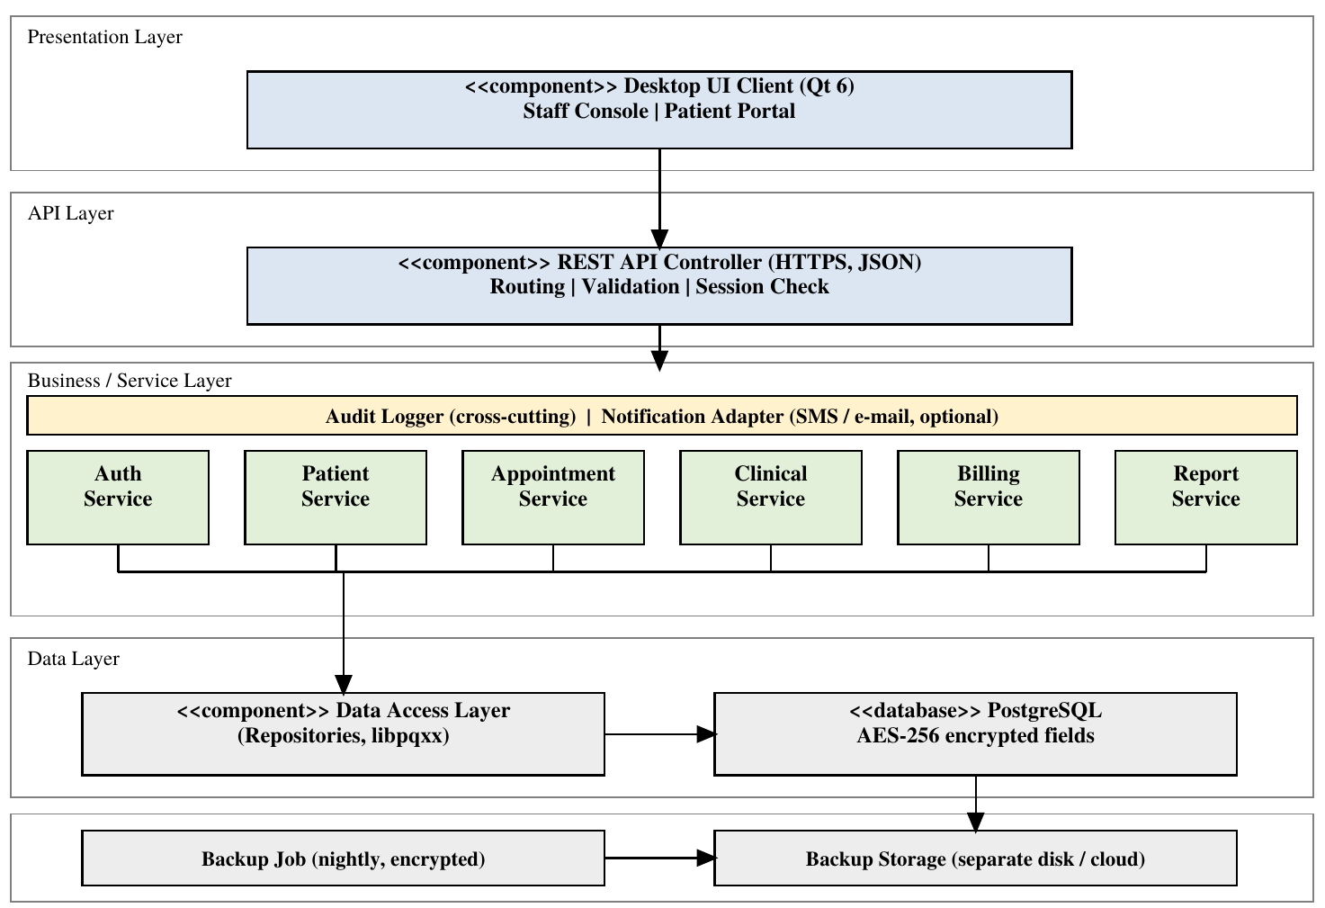
Figure 1. Component diagram of HMS (layered architecture). Arrows show the direction of calls; upper layers call only the layer directly below.

3.4 Component Descriptions
Component | Responsibility
Desktop UI Client (Qt 6) | Staff console and patient portal; collects input, shows results; holds no patient data after logout.
REST API Controller | Terminates HTTPS, routes requests, validates input and session token, checks the role, converts errors to the standard error format.
Auth Service | Login, password hashing and policy, lock-out, session tokens, roles, user management (HMS-F-001 to 003, F-060).
Patient Service | Registration, validation, duplicate check, search, update with history (HMS-F-010 to 014).
Appointment Service | Slot availability, booking, double-booking prevention, reschedule/cancel rules, doctor schedule (HMS-F-020 to 024).
Clinical Service | Visits, diagnoses, prescriptions, allergy check, patient history (HMS-F-030 to 033).
Billing Service | Bill creation and tax calculation, payments, status, receipts (HMS-F-040 to 042).
Report Service | Daily appointment and revenue reports, PDF/CSV export (HMS-F-050).
Audit Logger | Append-only audit records of logins, views and changes (HMS-SEC-005, HMS-F-061).
Notification Adapter | Optional interface for SMS or e-mail reminders; disabled in release 1.0.
Data Access Layer | Repository classes using parameterised libpqxx queries; field-level AES-256 encryption of PHI.
PostgreSQL Database | Stores all persistent data.
Backup Job | Nightly encrypted dump to separate storage; supports restore within 4 hours (HMS-NF-006).

3.5 Chosen Architecture Pattern and Rationale
Layered (n-tier) client-server architecture with presentation, API, service and data layers. Each layer depends only on the one below it, so services can be unit-tested with mock repositories (HMS-NF-008), security checks are concentrated in the API and service layers, and the UI can be changed without touching business rules.
ADR | Decision | Alternatives rejected and reason
ADR-1 | Layered architecture with a modular monolith server | Microservices: too much deployment and network complexity for a small team and a single hospital; MVC desktop-only: no shared data for many users.
ADR-2 | PostgreSQL as the database | SQLite: weak for 200 concurrent users; NoSQL: relational integrity needed for billing and appointments.
ADR-3 | Clients talk to a REST API over HTTPS, never directly to the database | Direct database access: would spread credentials to every client and bypass server-side authorisation (HMS-SEC-007).
ADR-4 | Field-level AES-256 encryption of PHI in the DAL | Disk encryption only: does not protect against a database dump or an over-privileged DB user.

3.6 Technology Stack and Data Stores
Concern | Choice
Language / build | C++17, CMake, GCC 11+ / MSVC 2019+
Client UI | Qt 6 Widgets
HTTP server and JSON | cpp-httplib (with OpenSSL) and nlohmann/json
Database access | PostgreSQL 15 with libpqxx
Cryptography | OpenSSL 3 (TLS, AES-256-GCM), libargon2 (password hashing)
Testing | GoogleTest, gcov/lcov, Postman/Newman, JMeter
Static analysis | clang-tidy, cppcheck

3.7 Risks and Mitigations
Risk | Mitigation
Server or network failure makes HMS unavailable | UPS, nightly backup, documented restore procedure, health-check monitoring
Memory-safety bugs in C++ code | Use RAII and smart pointers, no raw buffers, clang-tidy, sanitizers (ASan/UBSan) in CI
Slow queries with 100,000 patients | Indexes on patient name, phone, appointment (doctor, slot); load test early
Key loss or exposure | Keys kept outside source code in an OS-protected file; documented rotation

3.8 Traceability to Requirements
Component | SRS requirements realised
Auth Service | HMS-F-001, HMS-F-002, HMS-F-003, HMS-F-060, HMS-SEC-001, HMS-SEC-003, HMS-SEC-007
API Controller | HMS-F-003, HMS-NF-003, HMS-SEC-002, HMS-SEC-004, HMS-SEC-007
Patient Service | HMS-F-010, HMS-F-011, HMS-F-012, HMS-F-013, HMS-F-014, HMS-NF-001
Audit Logger | HMS-F-014, HMS-F-061, HMS-SEC-005
Appointment Service | HMS-F-020, HMS-F-021, HMS-F-022, HMS-F-023, HMS-F-024, HMS-NF-002
Clinical Service | HMS-F-030, HMS-F-031, HMS-F-032, HMS-F-033
Billing Service | HMS-F-040, HMS-F-041, HMS-F-042
Report Service | HMS-F-050
Data Access Layer | HMS-NF-001, HMS-NF-003, HMS-SEC-004, HMS-SEC-006
Deployment / Backup Job | HMS-NF-004
Desktop UI Client | HMS-NF-005, HMS-NF-007
Backup Job | HMS-NF-006
All Services | HMS-NF-008

Example: HMS-F-021 (no double booking) is realised by the Appointment Service, checked again by a unique database constraint on (doctor_id, slot_start), and verified by TC-APT-02.

3.9 Security Architecture
Trust boundaries: (1) client to server (untrusted network, protected by TLS 1.2+); (2) API Controller to services (all input validated); (3) services to database (least-privilege database account, encrypted PHI fields); (4) server to backup storage (encrypted dumps).

Threat model (STRIDE)
Threat | Example in HMS | Countermeasure | Req.
Spoofing | Attacker guesses a doctor's password or reuses a token | Argon2id hashed passwords, password policy, lock-out after 5 failures, random 256-bit session tokens, TLS | HMS-F-002, SEC-001, SEC-003
Tampering | Modified API request or SQL injection changes a bill | TLS, server-side validation, parameterised queries, least-privilege DB account, bills locked after payment | SEC-002, SEC-004
Repudiation | User denies changing a prescription | Append-only audit log with user, time, action and record ID | SEC-005
Information disclosure | Receptionist reads diagnoses; DB dump leaks PHI; logs expose data | RBAC and object-level checks, AES-256 field encryption, generic error messages, no PHI or passwords in logs | HMS-F-003, SEC-006, SEC-007
Denial of service | Flood of login or search requests | Rate limiting on login and API, connection limits and timeouts, monitoring, backups | HMS-NF-003, NF-006
Elevation of privilege | Patient calls another patient's record API | Authorisation on every API call on the server (role + ownership), no trust in UI | HMS-F-003, SEC-007

4. Design

4.1 Design Overview
Each service is a C++ class exposing a small interface and depending on repository interfaces (for example IPatientRepository), so that tests can inject mock repositories. Controllers translate JSON to service calls and map exceptions to the standard error format. Domain classes: User, Patient, Doctor, Appointment, Visit, PrescriptionItem, Bill, BillItem, Payment, AuditEntry. A request flows: Client, API Controller (token, role, validation), Service (business rules), Repository (SQL), Audit Logger.

Data design (main tables)
Table | Key columns
users | user_id, username, password_hash, role, active, failed_attempts, locked_until
patients / patient_history | patient_id (PID-nnnnnnnn), name*, dob*, gender, phone*, address*, allergies* (* encrypted fields); history rows keep old values
doctors | doctor_id, user_id, specialty, fee, working hours
appointments | appointment_id, patient_id, doctor_id, slot_start, status; UNIQUE (doctor_id, slot_start) for confirmed rows
visits / prescriptions | visit_id, appointment_id, symptoms*, diagnosis*, notes*; item, dosage, frequency, days, override_reason
bills / bill_items / payments | bill_id, visit_id, subtotal, tax, total, status; item, amount; payment_id, amount, mode, receipt_no
audit_log | audit_id, user_id, role, action, record_id, timestamp, source_ip (insert-only)

4.2 UML Sequence Diagrams

Seq-1: Login (HMS-F-001, F-002, SEC-001, SEC-005)
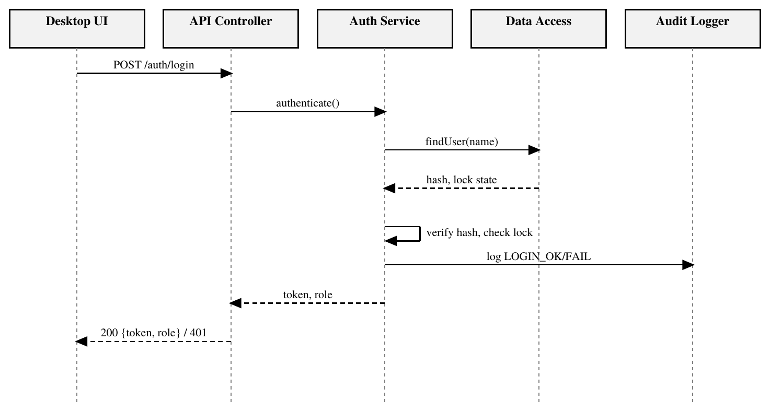
Figure 2. Login sequence. After 5 failures the Auth Service sets locked_until and returns 423 ACCOUNT_LOCKED.

Seq-2: Book appointment (HMS-F-020, F-021, F-022)
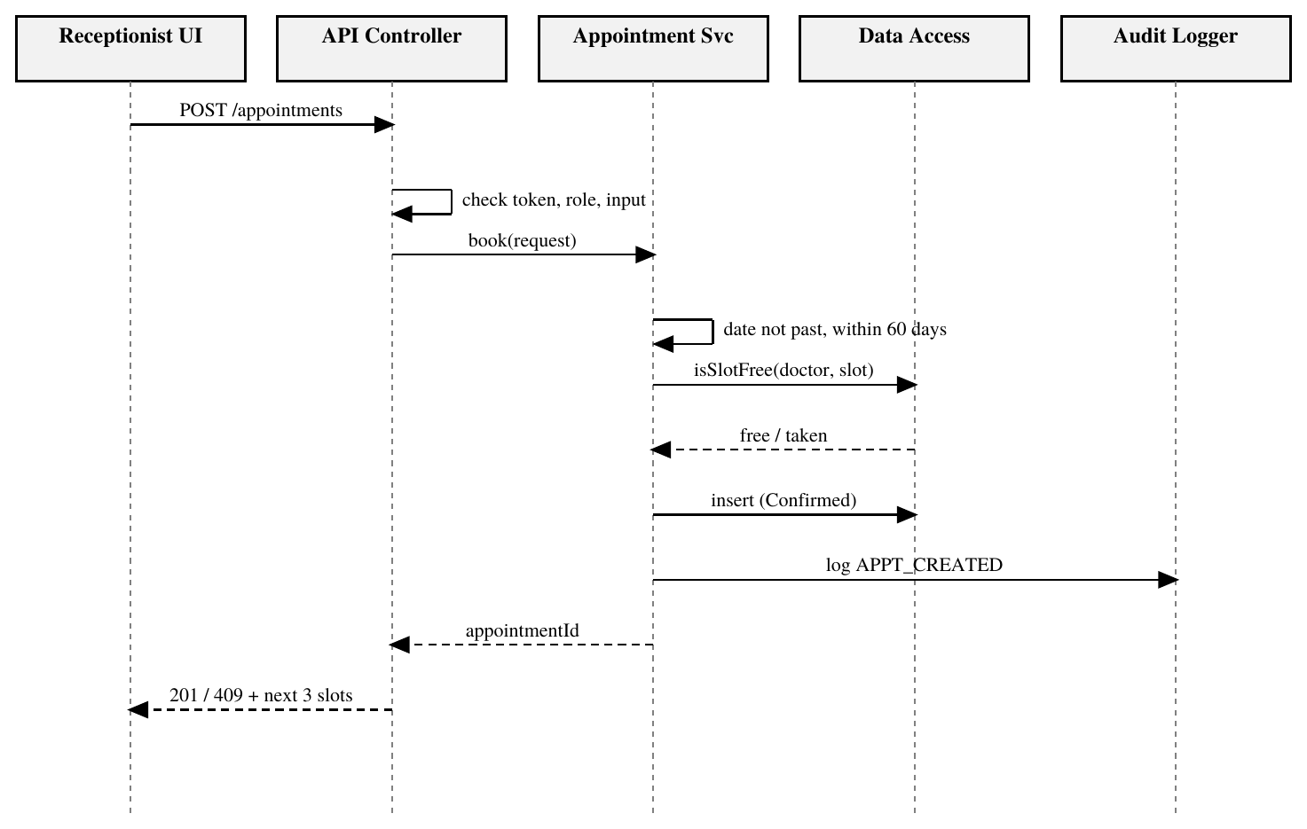
Figure 3. Booking sequence. If the slot is taken, the service returns 409 SLOT_TAKEN with the next 3 free slots; the unique constraint also stops a race between two simultaneous bookings.

Seq-3: Prescribe with allergy check (HMS-F-031, F-032)
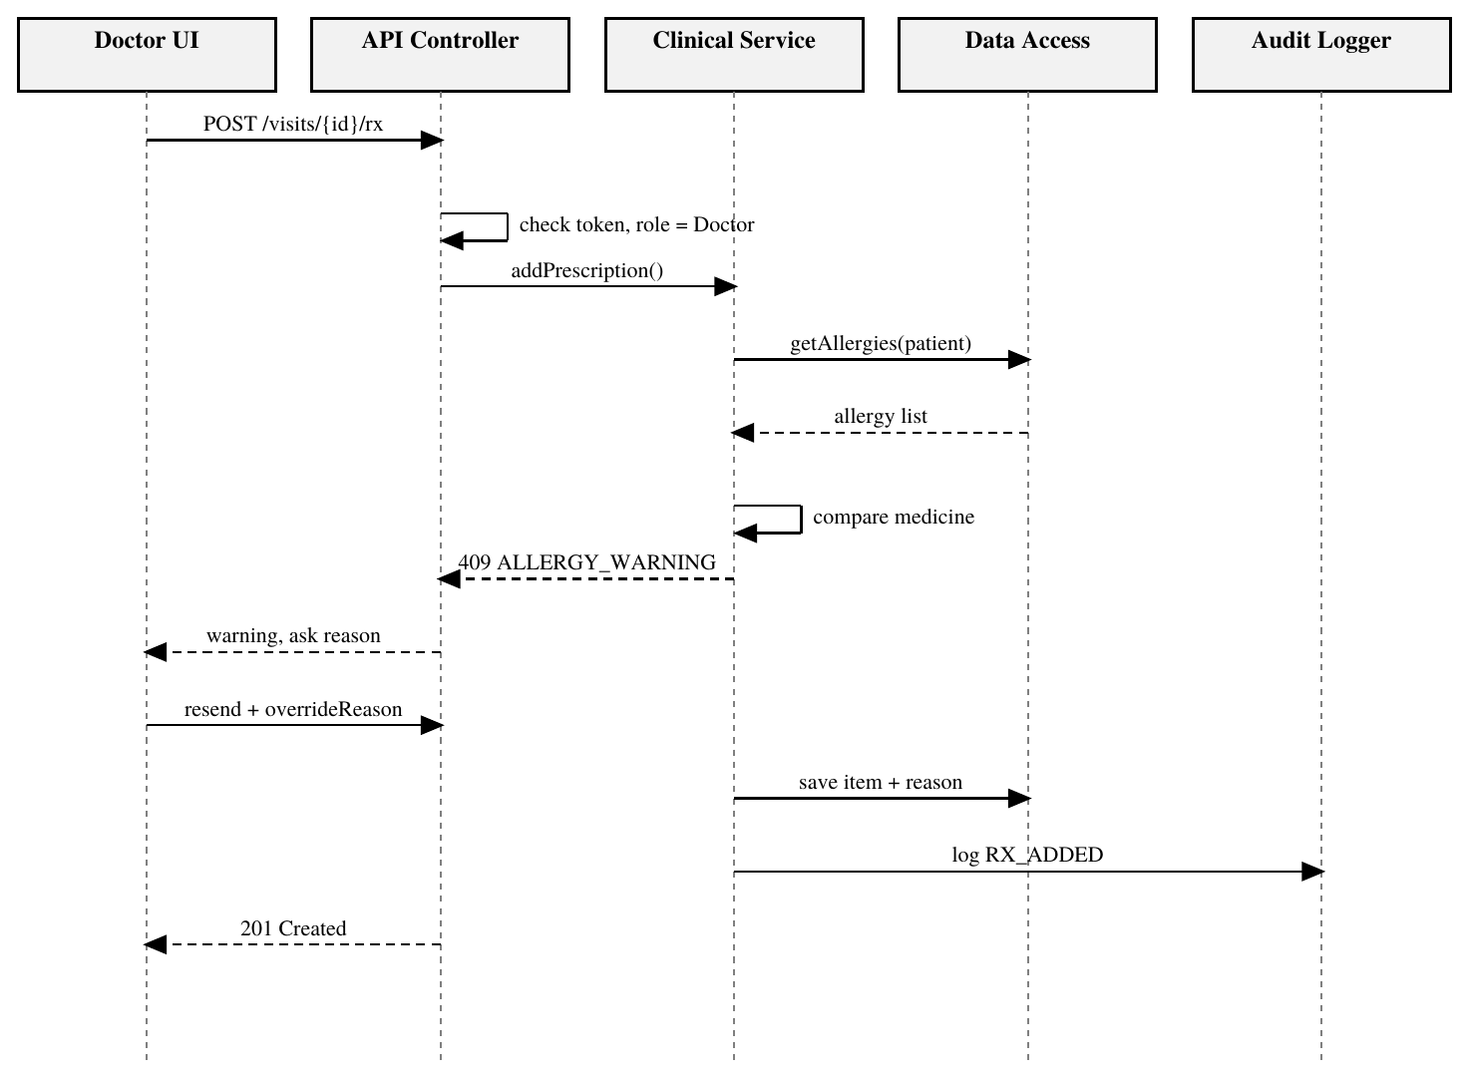
Figure 4. Prescription sequence. The first call is refused when a match is found; the second call with an override reason is saved and audited.

4.3 API Design
Base path /api/v1, JSON over HTTPS. Every endpoint except login needs the header Authorization: Bearer <token>. The API Controller checks role and ownership on each call.
Method and endpoint | Request body / params | Success response | Errors | Roles | Req.
POST /auth/login | {username, password} | 200 {token, role, expiresIn} | 401 INVALID_CREDENTIALS, 423 ACCOUNT_LOCKED | All | F-001, F-002
POST /auth/logout | none | 204 | 401 | All | SEC-003
POST /patients | {name, dob, gender, phone, address, allergies?} | 201 {patientId} | 400 VALIDATION_FAILED (field), 409 DUPLICATE_PATIENT | Receptionist | F-010 to F-012
GET /patients?query= | query: ID, name or phone | 200 [{patientId, name, phone}] | 400, 403 | Receptionist, Doctor | F-013
PUT /patients/{id} | changed fields | 200 {patient} | 400, 403, 404 | Receptionist | F-014
GET /doctors/{id}/slots?date= | date | 200 [{slotStart, free}] | 400, 404 | Receptionist, Patient | F-020
POST /appointments | {patientId, doctorId, slotStart} | 201 {appointmentId, status} | 400 INVALID_DATE, 409 SLOT_TAKEN (+nextSlots) | Receptionist, Patient | F-020 to F-022
PUT /appointments/{id} | {action: cancel|reschedule, newSlot?} | 200 {appointment} | 409 TOO_LATE_TO_CHANGE, 404 | Receptionist, Patient | F-023
GET /doctors/me/schedule?date= | date | 200 [{appointment}] sorted by time | 403 | Doctor | F-024
POST /visits | {appointmentId, symptoms, diagnosis, notes} | 201 {visitId} | 400, 403, 404 | Doctor | F-030
POST /visits/{id}/prescriptions | {medicine, dosage, frequency, days, overrideReason?} | 201 {itemId} | 409 ALLERGY_WARNING, 400, 403 | Doctor | F-031, F-032
GET /patients/{id}/history | none | 200 [{visit, prescriptions}] newest first | 403, 404 | Doctor | F-033
POST /bills | {visitId, items[]} | 201 {billId, subtotal, tax, total} | 400, 404 | Billing Officer | F-040
POST /bills/{id}/payments | {amount, mode} | 201 {receiptNo, status, balance} | 400 OVERPAYMENT, 404 | Billing Officer | F-041, F-042
GET /reports/{type}?from=&to=&format= | type: appointments|revenue; format: pdf|csv | 200 file | 400, 403 | Administrator, Billing Officer | F-050
POST /users, PUT /users/{id} | {username, role, active} | 201 / 200 {user} | 400, 403, 409 | Administrator | F-060
GET /audit?user=&from=&to=&action= | filters | 200 [{auditEntry}] | 403 | Administrator | F-061

Example: POST /api/v1/appointments
Request | { "patientId": "PID-00001234", "doctorId": 7, "slotStart": "2026-10-20T10:00" }
Response 201 | { "appointmentId": "APT-000981", "status": "Confirmed" }
Response 409 | { "error": { "code": "SLOT_TAKEN", "message": "This slot is already booked.", "nextSlots": ["10:30", "11:00", "11:30"] } }

4.4 Error Handling, Logging and Monitoring
All errors use one JSON format: { "error": { "code", "message", "field?", "requestId" } }. The message is plain language and never exposes SQL, stack traces or file paths; the requestId links the response to the server log.
HTTP | Code | When
400 | VALIDATION_FAILED / INVALID_DATE / OVERPAYMENT | Input fails validation (field named in "field")
401 | INVALID_CREDENTIALS / SESSION_EXPIRED | Wrong login or missing, expired or logged-out token
403 | ACCESS_DENIED | Role or ownership check fails
404 | NOT_FOUND | Patient, appointment, visit or bill does not exist
409 | SLOT_TAKEN / DUPLICATE_PATIENT / ALLERGY_WARNING / TOO_LATE_TO_CHANGE | Business rule conflict
423 | ACCOUNT_LOCKED | 5 failed logins, locked for 15 minutes
429 | TOO_MANY_REQUESTS | Rate limit exceeded
500 | INTERNAL_ERROR | Unexpected failure; details only in server log

- Handling: services throw typed exceptions (ValidationError, ConflictError, AuthError); the controller maps them to the table above; database transactions are rolled back on any error.
- Logging: application log (level, time, requestId, component, message) and a separate audit log. Neither stores passwords, tokens or clinical content (HMS-SEC-005).
- Monitoring: health-check endpoint every minute (availability, HMS-NF-004), request failure rate, 95th percentile latency, failed-login count, backup success/failure alert.

4.5 UX Design
- Left-hand menu shows only the functions allowed for the logged-in role.
- Patient search is always one click away (Ctrl+F) and shows results as you type.
- Booking screen shows free slots as a grid so that a receptionist books in three steps (HMS-NF-005).
- Clinical screens always show patient name, ID, age and allergies in a banner.
- Large fonts, high contrast, keyboard-only operation, clear error messages next to fields.

4.6 Open Issues and Next Steps
- How patients receive their first login (in-person activation versus OTP) is to be decided with the hospital.
- Drug-allergy matching uses name matching only; a drug-class database is a possible enhancement.
- Future enhancements: SMS reminders, laboratory integration, mobile patient app, biometric login.
- Part-2: implement services and repositories, write unit tests, run the test cases of the Test Plan.

5. Appendices
5.1 Glossary: see SRS Appendix A and Section 1.4. 5.2 References: IEEE 42010, IEEE 1016, OWASP ASVS 4.0, NIST SP 800-160, DPDP Act 2023, HMS SRS v1.0, HMS Test Plan v1.0. 5.3 Tools: draw.io / PlantUML for diagrams, Postman and Swagger/OpenAPI for the API, CMake, clang-tidy, GoogleTest.

