System Center Operational Reporting Environment (SCORE)

Installation and Configuration

Author: Hugh Scott

Date: 2019/07/03

Version: 1.0.2.0

# Copyright

This document is provided "as-is". Information and views expressed in this document, including URL and other Internet Web site references, may change without notice.

Some examples depicted herein are provided for illustration only and are fictitious. No real association or connection is intended or should be inferred.

This document does not provide you with any legal rights to any intellectual property in any Microsoft product. You may copy and use this document for your internal, reference purposes. You may modify this document for your internal, reference purposes.

© 2018 Microsoft Corporation. All rights reserved.

Microsoft, Active Directory, Bing, BizTalk, Forefront, Hyper-V, Internet Explorer, JScript, SharePoint, Silverlight, SQL Database, SQL Server, Visio, Visual Basic, Visual Studio, Win32, Windows, Windows Azure, Windows Intune, Windows PowerShell, Windows Server, and Windows Vista are trademarks of the Microsoft group of companies. All other trademarks are property of their respective owners.

Contents

Copyright 2

Summary 4

Getting the Latest Management Pack and Documentation 4

Guide History 4

Supported Configurations 4

Before You Begin 4

Pre-Requisites 4

Getting Started 5

Summary of Steps 5

Step Details 5

Download Files 5

Copy the Contents of the Score.Release Folder to the Integration Server 6

Execute the Database Creation Scripts 6

Run the Reports Deployment Script 6

Configure Report Data Sources 7

Import the Management Pack 7

Edit the Configuration File 8

Initial Testing of Extract Scripts 8

Testing Operations Manager Extracts 8

Testing Active Directory Extracts 9

Maintenance 10

Maintaining Configuration File 10

connectionStrings: 11

OperationsManager: 11

settings: 11

ObjectClasses: 11

Groups: 12

Distributed Applications: 12

# Summary

System Center Operational Reporting Environment is a set of PowerShell Scripts, a reporting database, reports and a management pack used to enhance reporting for Operations Manager environments.

## Getting the Latest Management Pack and Documentation

This is a custom management pack written and published exclusively for a Microsoft customer. It’s use in other contexts may not be supported. Updates may not be readily available.

## Guide History

| **Release Date** | **Version** | **Changes** |
| --- | --- | --- |
| July 2019 | 1.0.2.0 | Enhancements to dashboards  Bugfixes for extracts |
| March 2019 | 1.0.0.0 | Original release of this guide |

## Supported Configurations

This management pack requires System Center 2012 R2 Operations Manager or later. In addition, please see the section on Pre-Requisites for a more detailed list of components that must be installed and configured.

# Before You Begin

## Pre-Requisites

* A database hosted on an instance of Microsoft SQL Server 2016 or later.
  + Standard Edition or Enterprise Edition are preferred, although Express Edition should work.
  + It is possible to use the same database instance that is used to host the OperationsManagerDW database.
* An instance of SQL Server 2016 Reporting Services (or later versions).
  + Either Standard Edition or Enterprise Edition will work.
  + DO NOT attempt to use an existing instance of SSRS that is used for SCOM Reports.
  + Administrator may install a SEPARATE instance of SSRS that is hosted on the same server as the SCOM Reporting Server (if there is enough memory)
* An Integration Server used to run PowerShell Scripts with the following features
  + PowerShell Framework 4.0 or later
  + Active Directory PowerShell Cmdlets installed
  + Operations Manager Console installed (in some cases, it may be possible to simply copy the Operations Manager PowerShell cmdlets. This has been tested in environments running Operations Manager 1807.
  + Connectivity to the following services:
    - Active Directory Web Services (port 9389)
    - SQL Server (port 1433 or custom port)
    - Operations Manager Management Server (port 5724)
* Designated Run-As Accounts
  + An account that has access to System Center Operations Manager and is at least a member of the Advanced Operator Role (with global access to objects and groups). This account must also have "Log on Locally" privilege for the Integration Server.
  + An Active Directory account with "Log on Locally" privilege for the Integration Server.
* Other Accounts
  + An Active Directory account for SSRS data sources. The account used for the Operations Manager Data Reader profile may be re-used for this purpose.

# Getting Started

## Summary of Steps

1. Download the most recent version of the files
2. Copy the Score.Relase folder from the downloaded zip to the integration server
3. Execute Database creation scripts
4. Run Reports deployment script
5. Configure report data sources
6. Import Management Pack
7. Edit the Configuration File

## Step Details

### Download Files

Download the most recent version of the files from <https://www.github.com/hmscott4/score>. Select the option to Clone or Download and select Download as Zip.

Extract the contents of the Zip file to a network or other location.

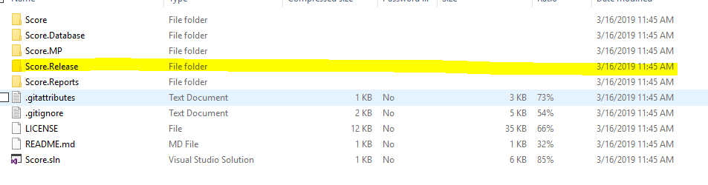

Figure 1. Score.Release Folder

### Copy the Contents of the Score.Release Folder to the Integration Server

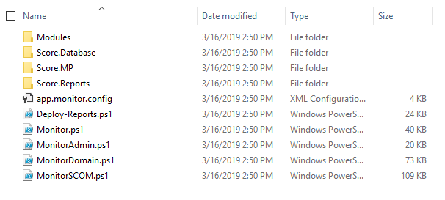

Figure 2. Contents of Score.Release folder

Copy the Contents of the Score.Release Folder to the Integration Server.

***It may be necessary to unblock the files***. Refer to the **Unblock-File** command in PowerShell. An example of the command is presented here:

Get-ChildItem -Path 'E:\Scripts\Score\' -Filter *.ps1 -Recurse | Unblock-File

### Execute the Database Creation Scripts

In the folder Score.Database\_Deployment, open the following SQL scripts in SSMS and execute against the Instance that is designated to host the SCORE reporting database:

1. Script.Deployment.sql
2. Script.DefaultData.sql
3. Script.RolePermissions.sql

For the final script, output the results to Text (**CTRL T)** and then copy/paste the results into a new query window and execute.

### Run the Reports Deployment Script

From an elevated command prompt, run the SSRS-Deploy.ps1 script. You will be prompted for the following Information:

1. Report Server url (this will be in the form http(s)://hostname or http(s)://fqdn.
2. Report Server Instance. The default value is **ReportServer**. If you have installed a named instance of SSRS, you would need to change this value.
3. Reports Folder (default is **SCORE**)
4. Data Sources Folder (default is **SCORE**)
5. Datasets Folder (default is **SCORE**)
6. Initial Deployment (default is **N**, be sure to change to **Y**).
7. If Initial Deployment is set to Y, then the user will be prompted to enter SQL connection information for the following data sources:
   1. Operations Manager
   2. Operations Manager DW
   3. SCORE
8. In Initial Deployment is set to **N**, then the user will be prompted for the following:
   1. Overwrite Data Sources (Y,N) (default is N)
   2. Overwrite Datasets (Y,N) (default is N)
   3. Overwrite Reports (Y,N) (default is Y)

After entering the required information, the script will test connectivity to the Report Server (and, if configured, the data sources). The script will then deploy the objects that the user has selected.

**\*\*\*\* WARNING \*\*\*\***

If the user chooses different destination folders for **Data Sources, Datasets** and **Reports**, it's likely that the deployment will throw some warnings. This configuration is **possible**, but it will require the user to relink some reports to Shared Datasets. Detailed information will be in the output log.

### Configure Report Data Sources

After running the report deployment script, the user will need to manually edit the Report Data Sources and configure user account information for the data source.

1. Open the Report Server Web Console (http(s)://hostname/reports or http(s)://hostname/reports_<instance>
2. Navigate to the deployment folder (/SCORE by default)
3. Select the option to view Hidden Objects
4. For each data source,
   1. Select the ellipsis ("…") and select "Manage"
   2. Select the option to enter credentials
   3. Select the drop-down for "Windows Credentials"
   4. Enter the User Name and Password to be used for reporting (the account used for the Operations Manager Data Reader account is an acceptable choice)

### Import the Management Pack

Import the Management Pack into your SCOM Environment.

Once the Management Pack is imported, you will need to take the following steps:

1. Provision the SCORE OpsMgr Run As Profile.
2. Provision the SCORE Active Directory Run As Profile.
3. Use the included Task to designate/enable the SCORE Integration Server (you will have to provide the path the Script files).
4. Override the SCORE rules to enable them

### Edit the Configuration File

The Configuration File app.monitor.config is responsible for most of the objects that get imported into the SCORE database from Operations Manager. The basic configuration should be sufficient to get started.

Please see the section “Maintaining the Configuration File” for more information on the contents of the file and updating settings.

# Initial Testing of Extract Scripts

SCORE works by extracting data from SCOM and Active Directory into the SCORE database. In order to test the functionality of these scripts and the connectivity from the Integration Server to Operations Manager, Active Directory and the SCORE database, the scripts can be run manually from the Integration Server.

## Testing Operations Manager Extracts

Operations Manager extract are done with the MonitorSCOM.ps1 script. The basic parameters are:

* managementGroup : The name of the management group (case sensitive)
* objectClasses : One of the following
  + WindowsComputer
  + Agent
  + Generic
  + DistApp
  + Group
  + Alert
  + Config
  + TimeZone
* SyncType : Full or Incremental

To test, use the following simple command:

.\MonitorSCOM.ps1 -ManagementGroup <your group> -objectClasses Config,TimeZone -SyncType Full

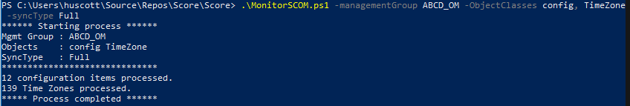

Figure 3. Test Result for MonitorSCOM.ps1

A slightly more advanced command would be:

.\MonitorSCOM.ps1 -ManagementGroup <your group> -objectClasses WindowsComputer, Agent, Generic,DistApp,Group -SyncType Full

At this point, you should start seeing results in the Reports.

## Testing Active Directory Extracts

Active Directory extracts are done using the MonitorDomain.ps1 script. The basic parameters are:

* adDomain : FQDN for Active Directory Domain (myDomain.lcl). NOT a server name.
* adObjectType : One of the following values
  + Forest
  + Domain
  + Site
  + Subnet
  + Computer
  + User
  + Group
  + GroupMember
* SyncType : Full or Incremental

A basic command to test functionality would be:

.\MonitorDomain.ps1 -adDomain <your domain> -adObjectType Forest, Domain -SyncType Full

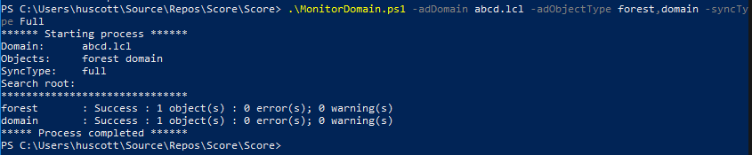

Figure 4. Result of MonitorDomain.ps1 test command

A more advanced command to test functionality would be:

.\MonitorDomain.ps1 -adDomain <your domain> -adObjectType forest,domain,site,subnet,computer -SyncType Full

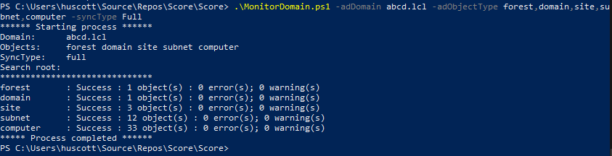

Figure 5. Result for MonitorDomain.ps1

Some Notes about MonitorDomain.ps1 Script:

1. When getting information for **Sites** and **Subnets**, **Forest** must also be specified.
2. While options for Users, Groups and Groupmember are supported, there are no reports configured for these items currently. Also, please note that (depending on the number of objects) these scripts can take quite some time.
3. Remote (untrusted) domains can be accessed with the -Credential switch (enter a valid PSCredential object)
4. Extracts may be scoped to an Organizational Unit using the -adSearchRoot parameter (use format OU=Computers,DC=myDomain,DC=lcl).

Additional Notes (for both MonitorDomain.ps1 and MonitorSCOM.ps1)

1. The SyncType parameter has two options: Full or Incremental.
   1. Full will extract all objects specified.
   2. Incremental will only retrieve objects that have been updated/changed since the last execution of the script.
   3. Due to internal functionality, a Full execution is required periodically (in order to expire/remove objects that have been deleted)
2. See notes and internal documentation for more information.

# Maintenance

## Maintaining Configuration File

The Configuration File contains the following sections (or stanzas):

* connectionStrings
* OperationsManager
* Settings
* ObjectClasses
* Groups
* DistributedApplications

Each section is discussed below:

### connectionStrings:

This section contains a single entry with a connection string to the Central Repository (the SCORE database). This is set during the initial deployment of the solution. If the SCORE database needs to be moved, adjust this value.

### OperationsManager:

This section contains the information necessary to configure an Operations Manager Management group. In *theory*, the application can support multiple Management Groups, however this has **not** been tested.

Administrators can configure more than one management server for the application. Each server will be tried in sequence until a successful connection is established. To temporarily disable a server (without removing it), simply set the Active value to “False”.

### settings:

Ignore this section. It is used for the Monitor.ps1 script, which is not used for SCORE.

### ObjectClasses:

In this section, each ObjectClass that the administrator wants extracted to SCORE is listed. Each entry has three values:

* Name: The name of the ObjectClass in Operations Manager
* genericClass: a “rollup” class for reporting purposes that allows summarization of like objects (for example, see the entries for “Microsoft.Windows.Server.ClusterDisksMonitoring.ClusterDisk” and “Microsoft.Windows.Server.LogicalDisk”. In SCOM, these are distinct classes, but in SCORE, the health can be aggregated to “Windows Logical Disk”.
* Active: If “True” the object will be extracted to SCORE. If “False”, it will not.

### Groups:

In this section, list the Groups that the administrator wants extracted to SCORE. Each entry has the DisplayName for the group and a flag for Active.

### Distributed Applications:

In this section, the administrator can list the Distributed Applications that s/he wants to extract to SCORE. Because distributed applications can have duplicate DisplayNames (thank you SharePoint!), it is necessary to identify Distributed Applications with both the Display Name and the objectID. We could just use the objectID, but then you’d have a heck of a time figuring out what each application is in the configuration file.