System Center Operational Reporting Environment (SCORE)

Reports

Author: Hugh Scott

Date: 2019/07/03

Version: 1.0.2.0

# Copyright

This document is provided "as-is". Information and views expressed in this document, including URL and other Internet Web site references, may change without notice.

Some examples depicted herein are provided for illustration only and are fictitious. No real association or connection is intended or should be inferred.

This document does not provide you with any legal rights to any intellectual property in any Microsoft product. You may copy and use this document for your internal, reference purposes. You may modify this document for your internal, reference purposes.

© 2018 Microsoft Corporation. All rights reserved.

Microsoft, Active Directory, Bing, BizTalk, Forefront, Hyper-V, Internet Explorer, JScript, SharePoint, Silverlight, SQL Database, SQL Server, Visio, Visual Basic, Visual Studio, Win32, Windows, Windows Azure, Windows Intune, Windows PowerShell, Windows Server, and Windows Vista are trademarks of the Microsoft group of companies. All other trademarks are property of their respective owners.

Contents

Copyright 2

# Summary

System Center Operational Reporting Environment is a set of PowerShell Scripts, a reporting database, reports and a management pack used to enhance reporting for Operations Manager environments.

## Getting the Latest Management Pack and Documentation

This is a custom management pack written and published exclusively for a Microsoft customer. It’s use in other contexts may not be supported. Updates may not be readily available.

## Guide History

| **Release Date** | **Version** | **Changes** |
| --- | --- | --- |
| July 2019 | 1.0.2.0 | Enhancements to dashboards  Bugfixes for extracts |
| March 2019 | 1.0.0.0 | Original release of this guide |

## Supported Configurations

This management pack requires System Center 2012 R2 Operations Manager or later. In addition, please see the section on Pre-Requisites for a more detailed list of components that must be installed and configured.

# Reports

## Organization Summary

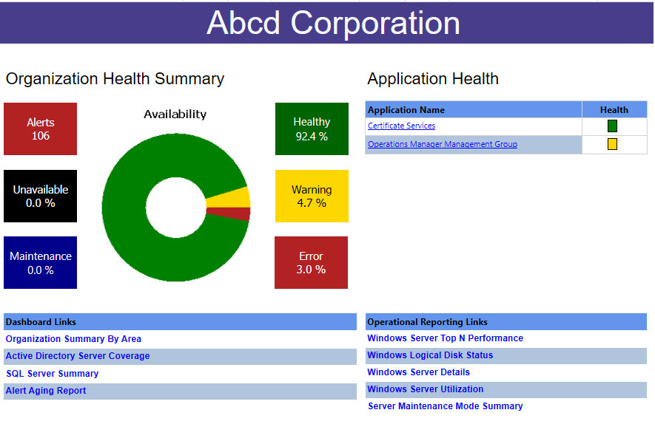

Figure . Organization Summary Report

The **Organization Summary** report is intended to provide a high-level overview of the health of the organization with links to other reports that provide additional insight and detail. It is considered the **home** report or the starting page.

### Organization Health Summary

On the left is the **Organization Health Summary**. This shows current health state (within the last 15 minutes) of objects that are tracked in SCORE. **Not every object in SCOM is tracked in SCORE.** The pie chart allows users to drill through into the Object Health Summary report.

On the right is the **Application Summary**. This shows the current health of Distributed Applications that are tracked in SCORE. **Not ever Distributed Application in SCOM is tracked in SCORE.**

The objects that are tracked in SCORE can be configured in the SCORE configuration file.

There are links to various reports in the spaces below the main report.

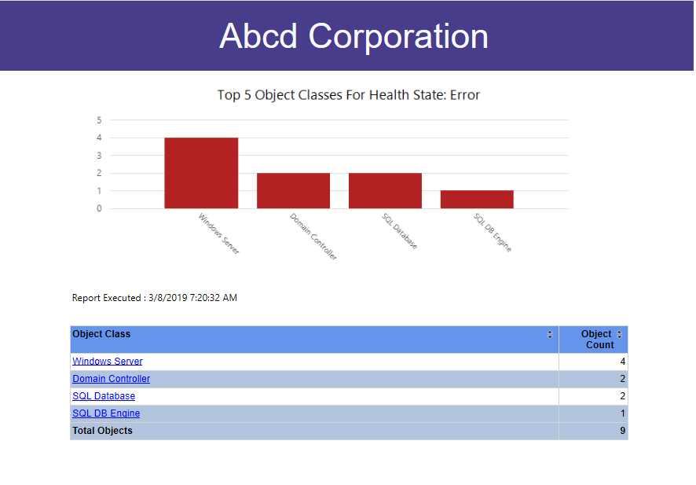

Figure . Object Health Summary by State

## Object Health Summary by Health State

This report is a drill-though from the Organization Summary report. It shows the top five Object Classes for a specific Health State. Only the top 5 Object classes are shown. Users may drill into the chart columns (or the text in the table below) to see the specific objects in each health state.

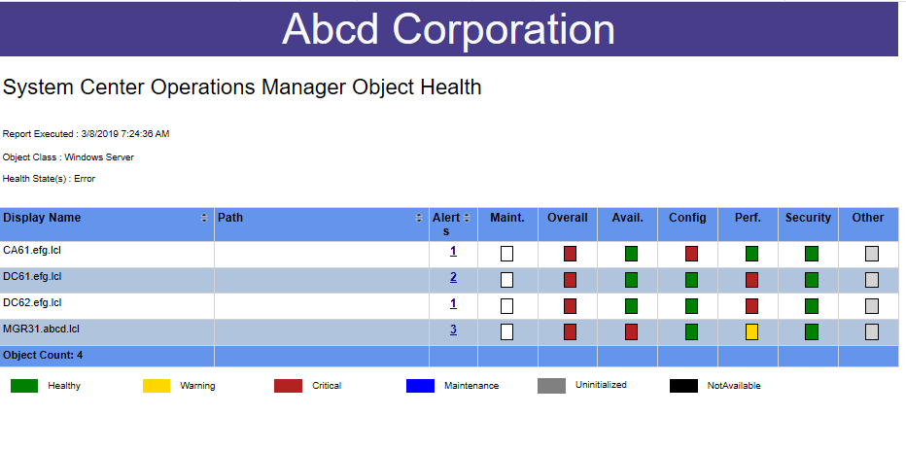

Figure . Object Health State Report

## Object Health State Report

The Object Health State Report is a drill-through report that can be accessed from multiple locations. It displays a listing of objects for a specific Object Class. It can be filtered to display only objects in a specific Health State. Users can see at glance the Overall health for the object and the health for each top-level rollup for the object (Availability, Configuration, Performance and Security). In addition, users can determine if the object is in maintenance mode or not.

Finally, by clicking on the Alerts link, users can drill down to the individual alerts that have been raised for a specific object.

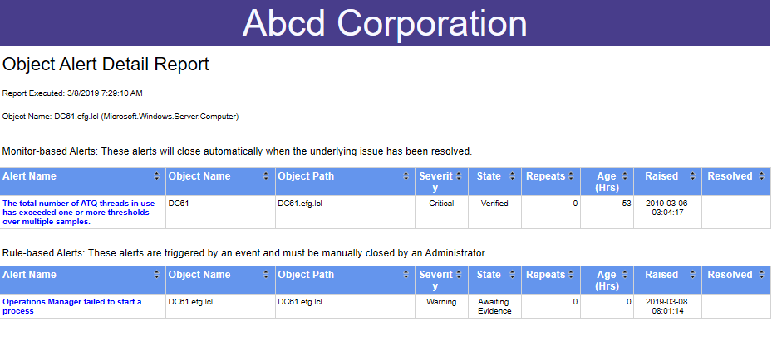

Figure . Object Alert Detail Report

### Object Alert Detail Report

This report allows users to see current alerts that are open for a specific object. The alerts are separated between Rule-based alerts and Monitor-based alerts. This allows administrators to focus on those alerts that are affecting the health of the object (Monitor-based alerts).

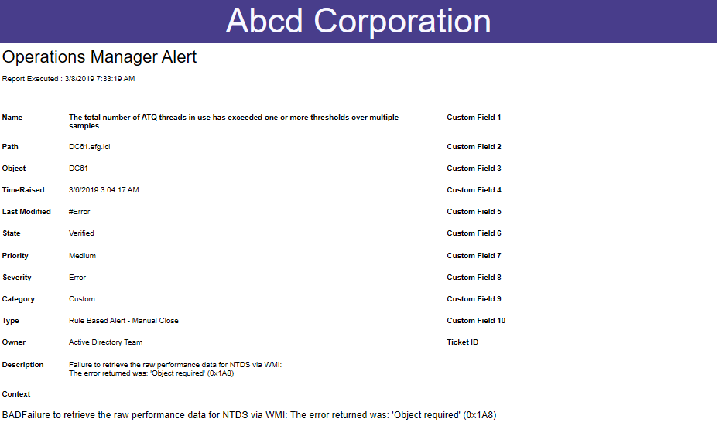

Figure . Alert Detail Report

## Alert Detail Report

This report allows users to view the details for a specific alert, including the description and context information.

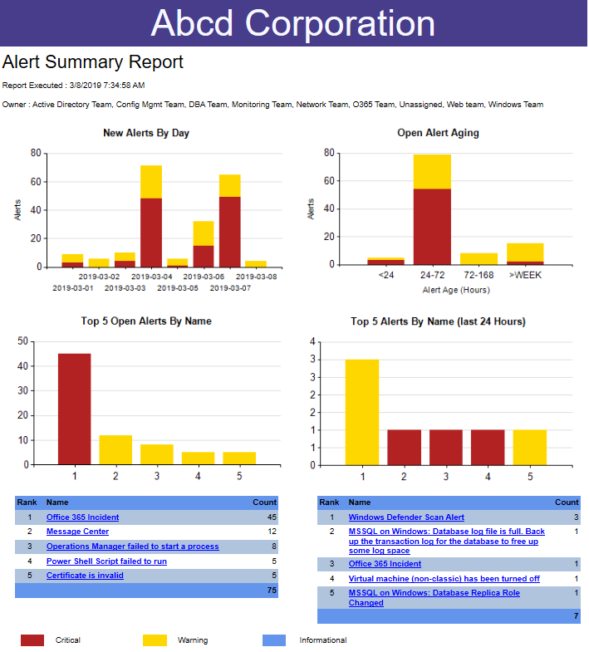

## Alert Summary Report

This report is accessed from the Organization Summary Report (the home page). It is intended to summarize information about currently open alerts. Users may drill-though the chart columns to view details of the underlying alerts.

### Filters

The report can be filtered by Time Zone and By Alert Owner. If the Alert Owner field is not being used, then all alerts will appear as "Unassigned".

### New Alerts by Day

This chart quickly summarizes the number of new alerts triggered each day.

### Open Alert Aging

This chart summarizes open alerts by age. The number and interval for each "bucket" is configurable.

### Top 5 Open Alerts

This chart summarized the top 5 open alerts by alert name.

### Top 5 Alerts by Name (last 24 Hours)

This chart summarizes the Top 5 Alerts by Name over the preceding 24 hours. The current state of the alert does not affect this report, it will included both open and closed alerts.

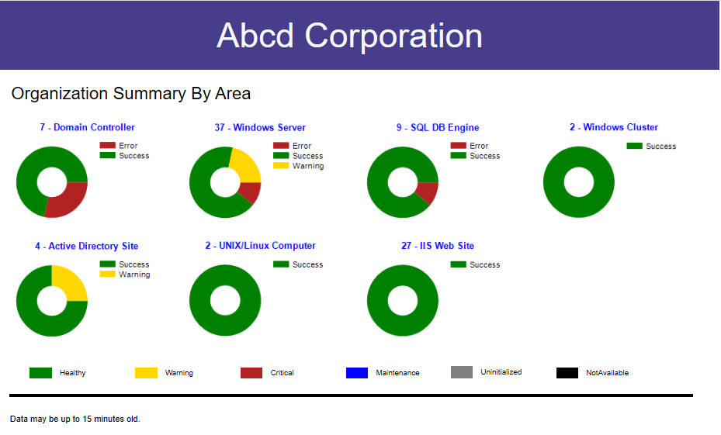

Figure . Organization Summary By Area

## Organization Summary by Area

The Organization Summary by Area dashboard is accessed from the **Organization Summary** report (the home page). It highlights the current health state of selected object classes that the Organization deems important. The list of items displayed (and the sequence in which they are displayed) is configurable.

It is important to note again that SCORE does not track the health of every object in SCOM. Only selected object health states are tracked. The list of objects that are tracked and available for display is configured in the application configuration file.

Each of the pie charts may be drilled-into to display the **Object Health State** report.

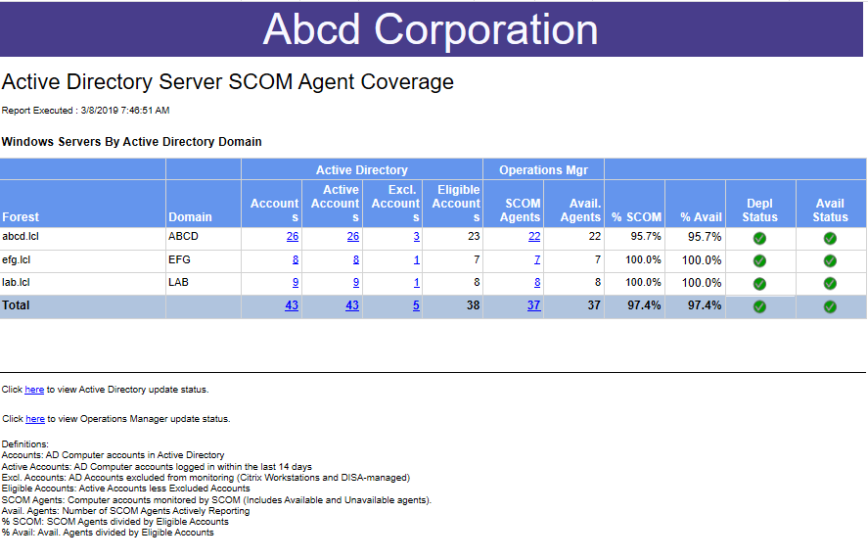

Figure . Active Directory Server Agent Coverage

## Active Directory Server Agent Coverage

This report summarizes the number of computer accounts in Active Directory and compares those accounts with agents that are in Operations Manager. By default, only computer objects with Windows server operating systems are tracked. There is a detailed breakdown and explanation for each column in the report.

In summary, it is possible for administrators to filter out Active Directory accounts which are not intended to have an agent. In addition, only computer accounts which are "active" (have logged in to Active Directory within the last 14 days) are counted as eligible for having an agent.

In addition to checking to see whether an agent is installed, this report will also show agents that are unavailable. An agent may be unavailable if it is shut down, inaccessible from the network or decommissioned.

Each of the columns may be drilled into to obtain more detailed information about the data point.

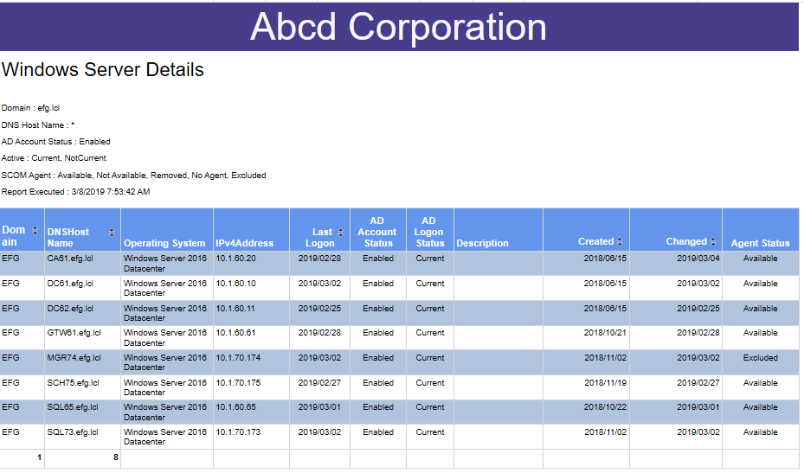

Figure . Windows Server Details

## Windows Server Details

This report can be accessed from multiple locations. It can also be run as a stand-alone report. Potential use-cases for this report:

* Highlight Inactive Computer objects in Active Directory (computer objects that have not logged in for more than 14 days)
* Highlight Computer objects that do not have an agent installed
* Highlight Computer objects that have been disabled (but not yet removed from Active Directory)
* Highlight Computer objects where the Microsoft Monitoring Agent is not available.

## SQL Server Summary Report

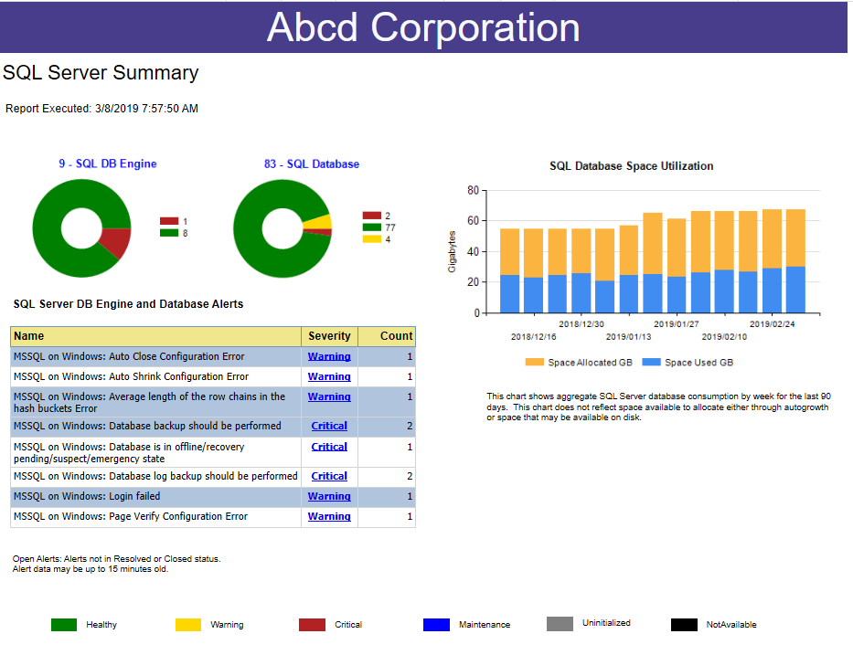

Figure . SQL Server Summary Report

## SQL Server Summary Report

This report may be accessed from a link on the Organization Summary page (the home page).

This report displays the current health state of SQL Server instances and SQL Server databases that are tracked in SCORE. It also displays a listing of alerts.

On the right-side of the page, the report displays the amount of space allocated for SQL Databases in the environment and the amount of space used (as well as the usage trend going back the last 90 days).

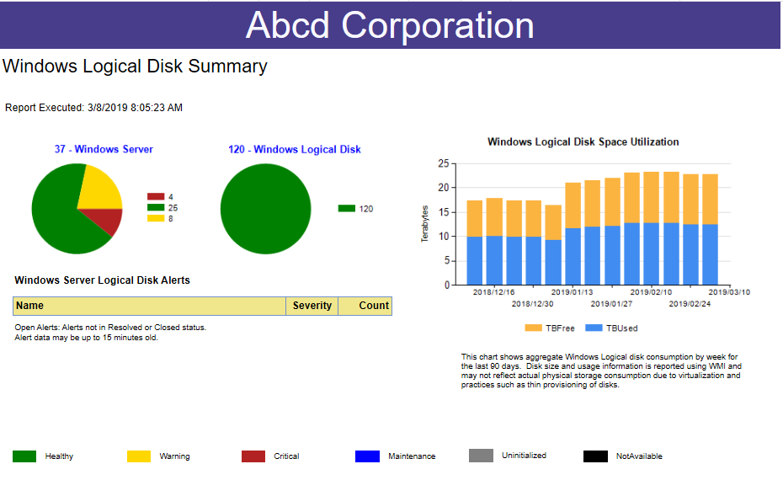

Figure . Windows Logical Disk Summary

## Windows Logical Disk Summary

This report summarizes Windows Logical Disk health for all Windows servers in the environment. It is accessed from the Organization Summary report (the home page report).

In addition, there is a graph showing disk consumption (disk space used and disk space allocated) over time.

Filters: Users may filter the report by System Drive or Non-System Drive (or both).

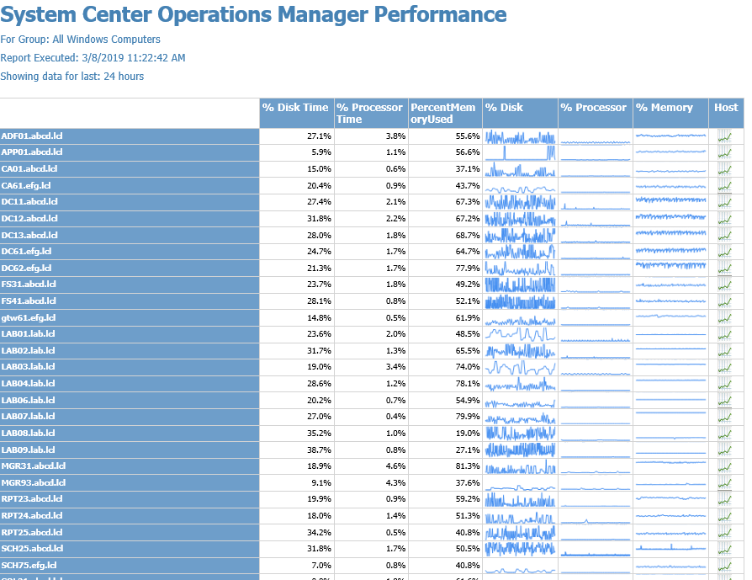

Figure . Windows Server Performance Utilization

## Windows Server Performance Utilization

This report summarizes key performance indicators for Windows Servers.

There is a drill-through enabled for the report which allows users to see more performance indicators for a particular server.

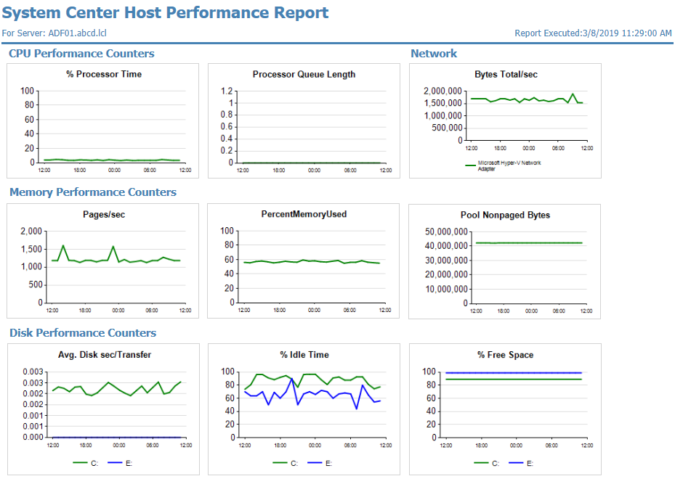

Figure . System Center Host Performance Chart

### System Center Host Performance Chart

This chart summarizes in one page and in graphical format key performance indicators for Windows Servers.

The report includes filters for hostname, date range and time zone.

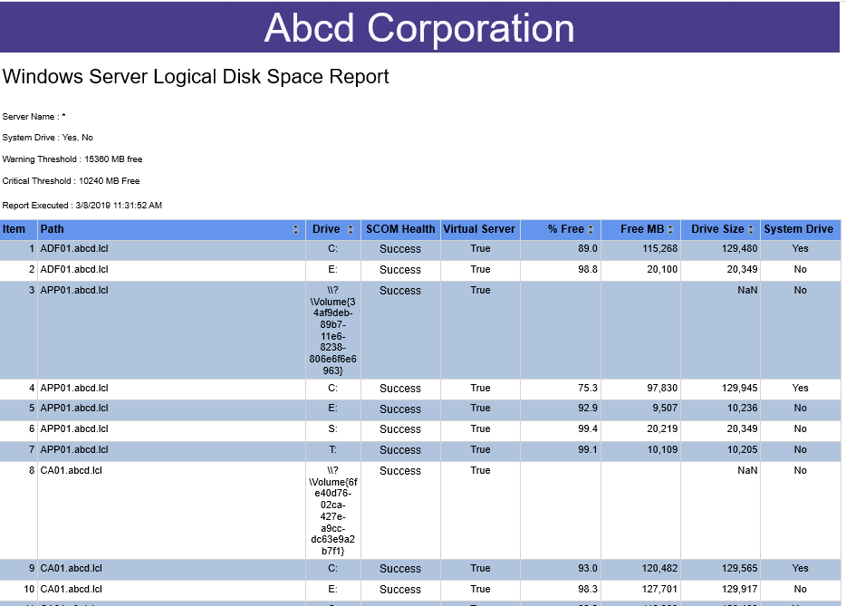

Figure . Windows Server Logical Disk Space Report

### Windows Server Logical Disk Space Report

This report shows detailed logical disk space utilization for all logical disks tracked in SCORE. The report includes parameters which allows users to filter by server name (or partial name), system driver or non-system drive, current health state (in Operations Manager) as well as parameters to highlight drives with set amounts of free space available.

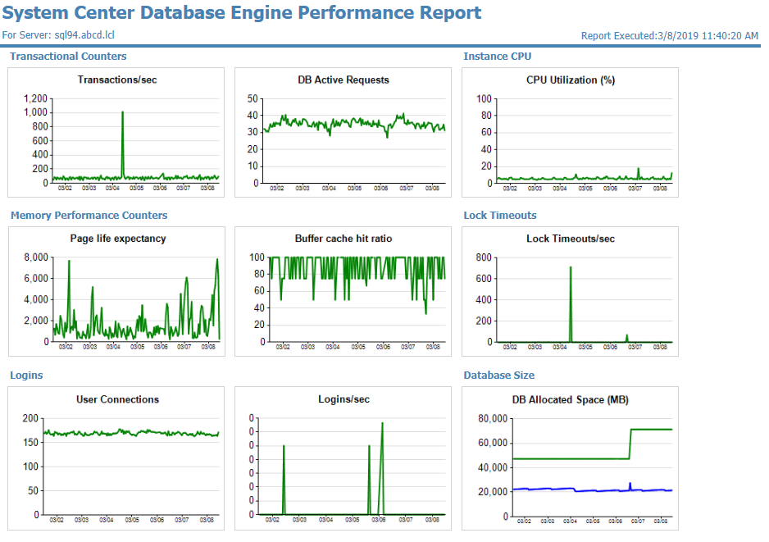

Figure . SQL Server Database Engine Performance Report

### SQL Server Database Engine Performance Report

This report highlights key performance indicators for the SQL Server Database Engine Class. Optionally, users can select to display performance details for databases hosted on the instance.

Importantly, this data is for on-premises databases only; it will not display data for Azure databases.

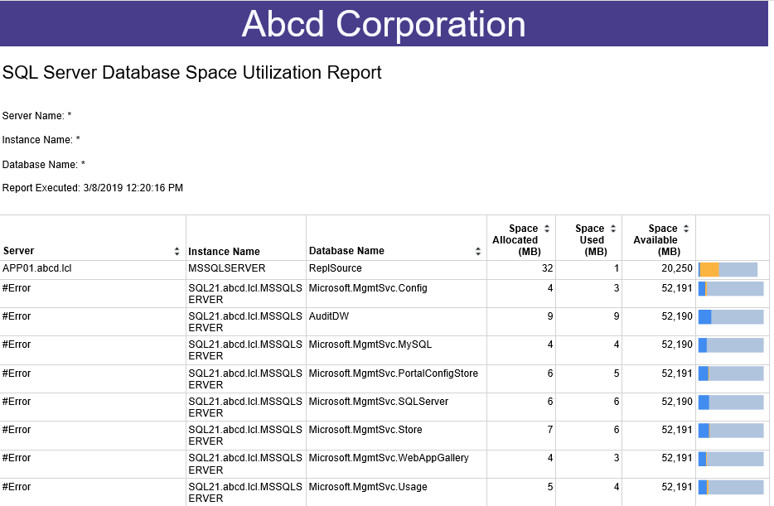

Figure . SQL Server Database Size Report

### SQL Server Database Size Report

This report shows Space Allocated and Space Used for each database that is monitored in Operations Manager and tracked in SCORE. The graphical display of space utilization to the far right is scaled logarithmically.

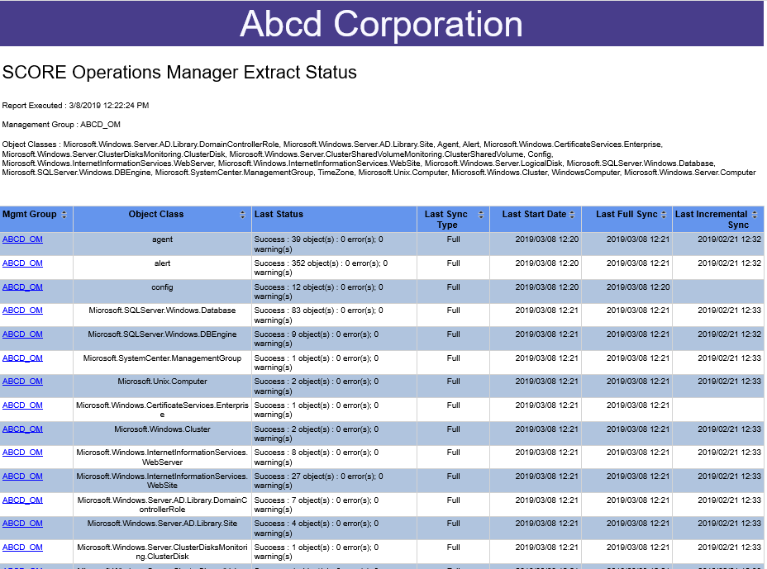

Figure . Operations Manager Extract Status

### System Center Operations Manager Extract Status

This report summarizes the status of extracts from Operations Manager to the SCORE database by Object Class. User can drill into the report by Object Class to see a detailed history of each Object Class.

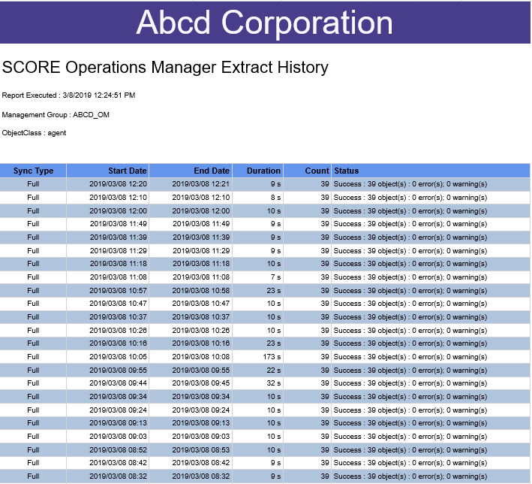

Figure . Operations Manager Extract History Detail

### Operations Manager Extract History Detail Report

This report provides a detailed view of the history of extracts for a specific object class.

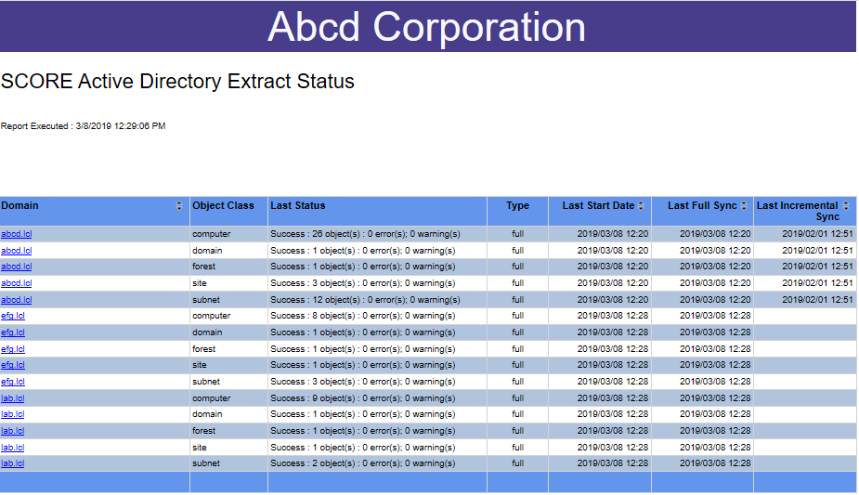

Figure . Active Directory Extract Summary Report

### Active Directory Extract Summary Report

This report summarizes the current state of extracts from Active Directory to SCORE by Object Class. Users may drill into the report to view a detailed history of extracts by Object Class.

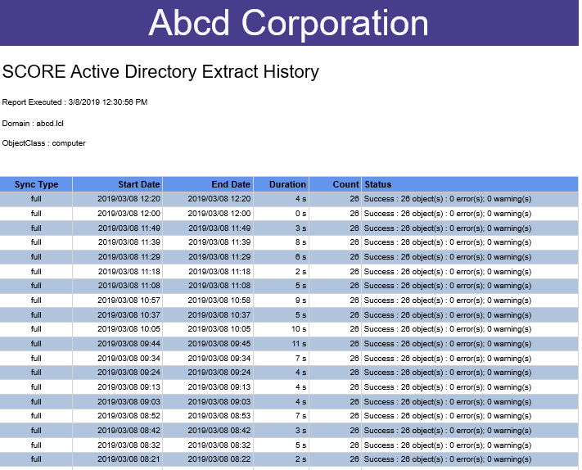

Figure . Active Directory Extract History Detail

### Active Directory Extract History Detail

This report provides a detailed view of extracts from Active Directory to SCOM by Object Class.

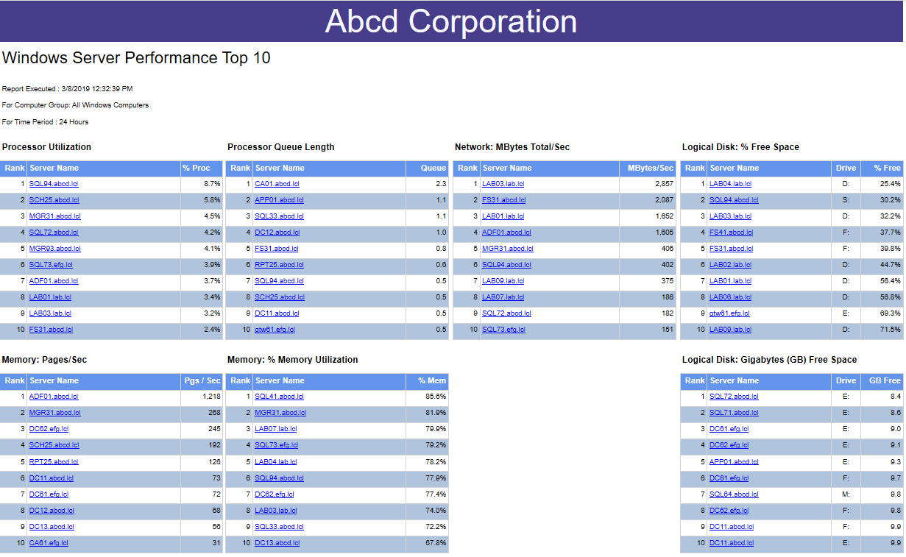

Figure . Windows Server Performance Top 10

### Windows Server Performance Top 10

This report lists the top 10 worst-performing Windows Servers by a variety of performance counters. User may drill into the details for each server to get to the Host Performance Chart.

The report may be filtered by Group (not all groups are scoped to Windows Computers, so some groups may not generate results). The report may also be filtered by time range.

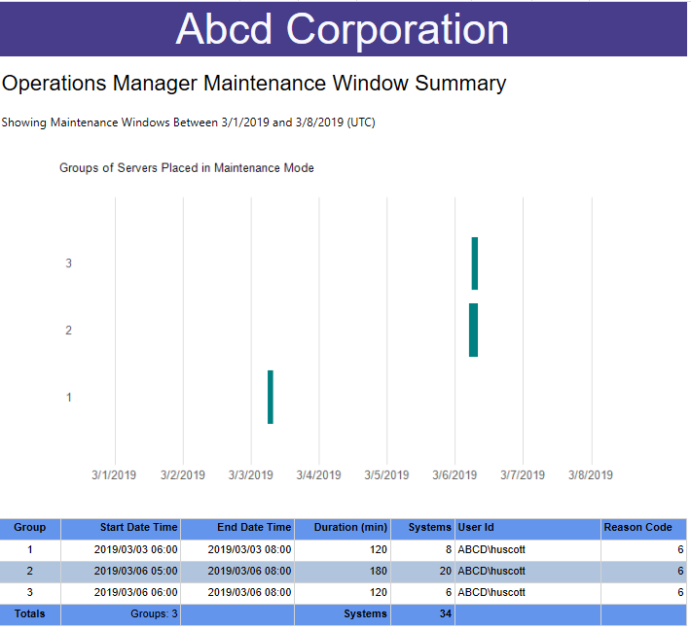

Figure 21. Windows Server Maintenance Mode Summary

### Windows Server Maintenance Mode Summary

This report shows a graphical and tabular summary of schedule maintenance mode windows. This report may be accessed from the Organization Summary report (the home page). The user may click on the horizontal bars in the graph to drill into the details of which objects were placed into maintenance mode.

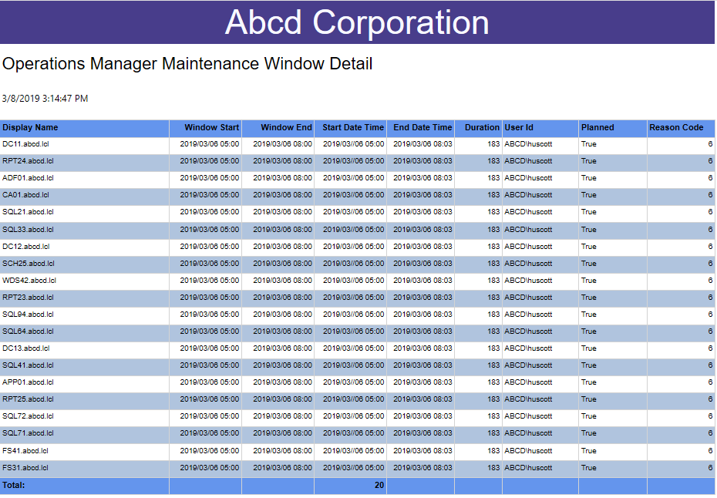

Figure 22. Operations Manager Maintenance Mode Detail

### Operations Manager Maintenance Mode Detail

This report shows the details of which objects were placed into maintenance mode by a particular schedule. Users can see the scheduled start time, the scheduled end time and the actual start and end time for each object placed into maintenance mode.