**Crowdsourcing News Satire**

Comedy is a powerful form of communication. It is used to spread news and political opinions in popular forms.

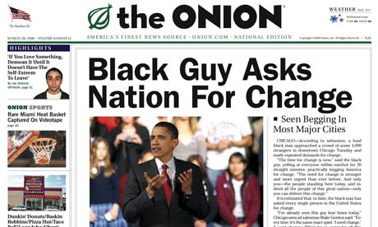 

Although sometimes comedy is mindless entertainment, comedy can be important because comedy is **based in truth**. It is the comedian’s job to find those truths.

Generating humor is a grand challenge in computer science because it is seen as a **hallmark of human intelligence**. Our goal is to build a web site where comedic novices can participate in creating news satire (“fake news”) by reading and analyzing headlines.

Our solution is to **decompose the process of humor** into steps that humans can follow to reliably create news satire on par with The Onion. The steps include:

* **read headlines** carefully for nuance and unexpected angles
* **list basic reactions**: approval, disapproval, doubt, fear, hope, etc.
* **analyze reactions** for a punchline premise*:* tensions, assumptions, inconsistencies, unexpected connections, bias, point-of-view, etc.
* **polish writing** to maximize the impact of the punchline premise. E.g. exaggerate inconsistencies to show hypocrisy.

Our main insight is that comedy does not merely encode information. Comedy is communication, and like all communication it must consider its effect on the listener. To generate comedy, we must **model what the listener is thinking**, feeling, and assuming.

The **larger implications** of this are a) to break down the creative writing process into teachable steps, and b) to explore a novel method of gathering data to train computers to generate and understand intelligent human communication. In the process, we are also encouraging people to read and analyze the news.

|  |  |
| --- | --- |
|  | Lydia B. Chilton – 6th year PhD Student of James Landay (Stanford) and Dan Weld (UW).  8 years of expertise in crowdsourcing and building human-centric systems.  [hmslydia@gmail.com](mailto:hmslydia@gmail.com) |
|  | James A. Landay. Computer Science Professor at Stanford (HCI)  Iterative design, novel interfaces, ubiquitous computing, health, environment, education, “The Diamond Age”  landay@cs.stanford.edu |

**“Fake News”**

1. [Cutbirth, Joe Hale](http://academiccommons.columbia.edu/catalog?f%5Bauthor_facet%5D%5B%5D=Cutbirth,%20Joe%20Hale) (2011). *Satire as Journalism: The Daily Show and American Politics at the Turn of the Twenty-First Century*. Ph.D. Thesis. Columbia University: USA.

**Comedy**

2. Dean, G. (2000) *Step by Step to Stand-Up Comedy* . Portsmouth, NH: Heinemann Drama.

3. Hurley, M.M., Dennett, D.C., Adams, R.B. (2011) *Inside Jokes: Using Humor to Reverse-Engineer the Mind.* Cambridge, MA: MIT Press.

4. Kaplan, S. (2013) *The Hidden Tools of Comedy: The Serious Business of Being Funny.* Studio City, CA: Michael Wiese Productions.

**Crowdsourcing & AI**

5. O'Neill, B. , Riedl, M.O. [Dramatis: A Computational Model of Suspense](http://www.cc.gatech.edu/~riedl/pubs/oneill-aaai14.pdf). *AAAI 2014*,

6. Winston, P.H. 2011. The Strong Story Hypothesis and the Directed Perception Hypothesis. In *Technical Report FS-11-01, Papers from the AAAI Fall Symposium.* AAAI Press.

7. Yu, L., Kittur, N., Kraut, R.E. 2014. *Distributed analogical idea generation: inventing with crowds*. CHI 2014.