Hannah Tarzian

"CS 1632 - DELIVERABLE 6: Static Analysis of the Sieve of Eratosthenes"

https://github.com/hmt17/fictional-sniffle

Summary:

To find the issues dealing with errors or exceptions Findbugs works great because it shows you the line and the problem. It was confusing at first because I downloaded it from a site that gave me the wrong application, but once I had it up and running it was super simple. Checkstyle was easier to install but the error messages were a bit mysterious though, so many times I had to Google what the error correlating with the message was.

The calculateMax() function is where the problem lies. The “throw” to throw an exception wasn’t added, so I wrote three tests to test it passes with a positive number and throws the exception if there’s no number or it’s negative.

Before refactoring:

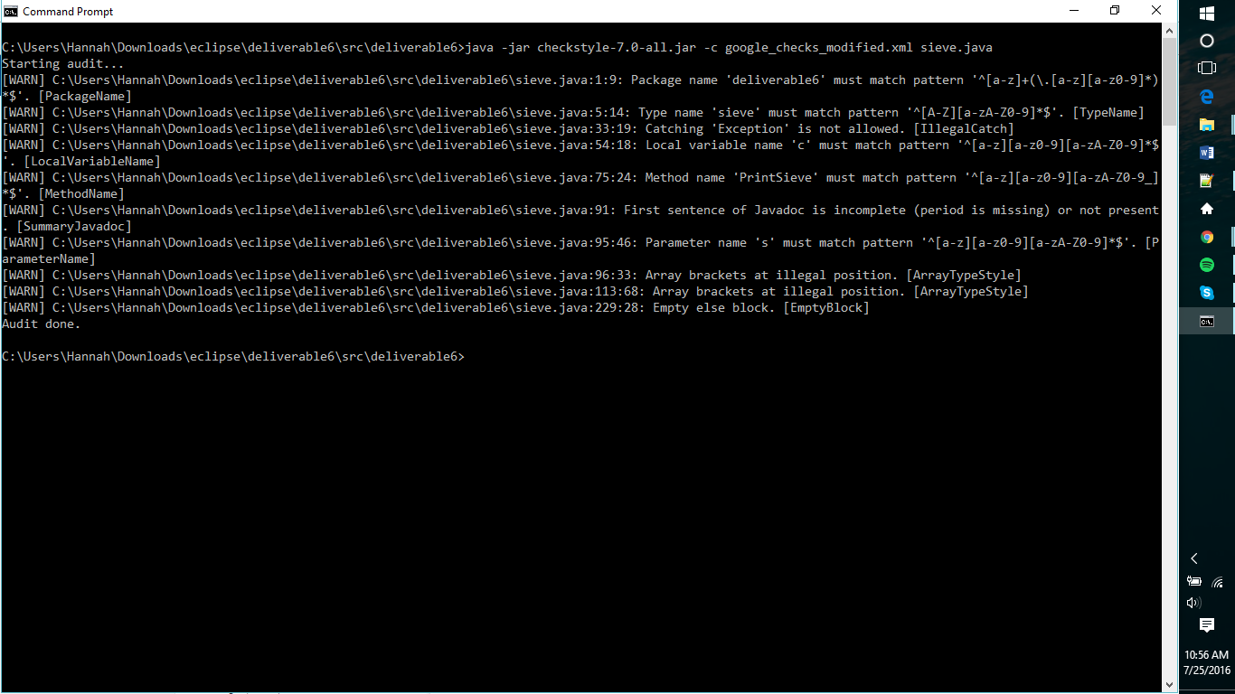

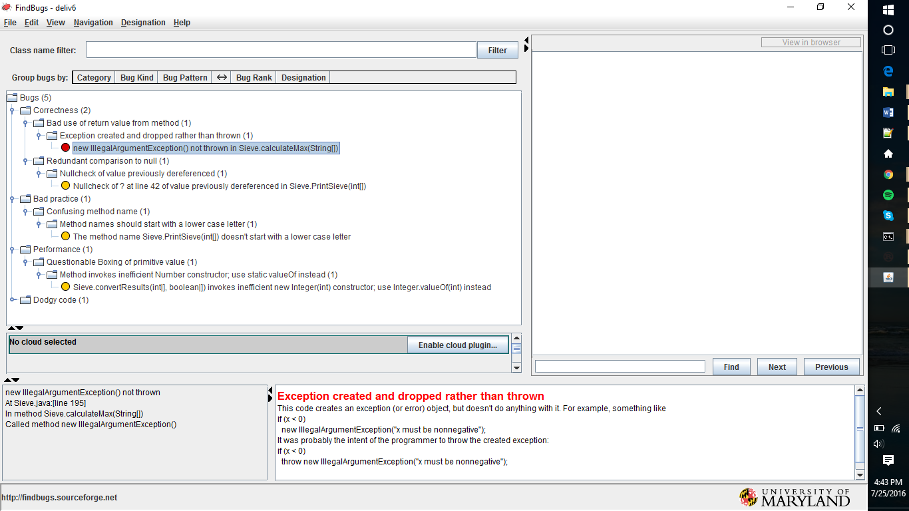

After refactoring:

