Graph: Number of Inputs VS Time

Blue Line: Insertion Sort
Green Line: Merge Sort
Red Line: Quick Sort
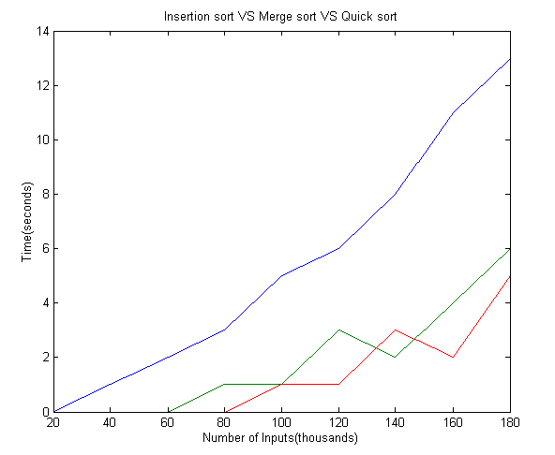

X-Axis: Number of Inputs (Thousands)
Y-Axis: Time (Seconds)

I use Matlab 6.0 for implementing the graph.

