JavaScript and DOM (Web API)
• Used to bring the worlds of HTML and CSS together with JavaScript
◦ In this course, will learn about:
▪ The DOM (what is it, how it’s created and how to access it)
▪ Modifying page content (updating and styling them)
▪ Browser events (how to hook into and respond to them)
▪ Performance (JS Event loop – better functional, efficient code)

DOM (Document Object Model) What is it?
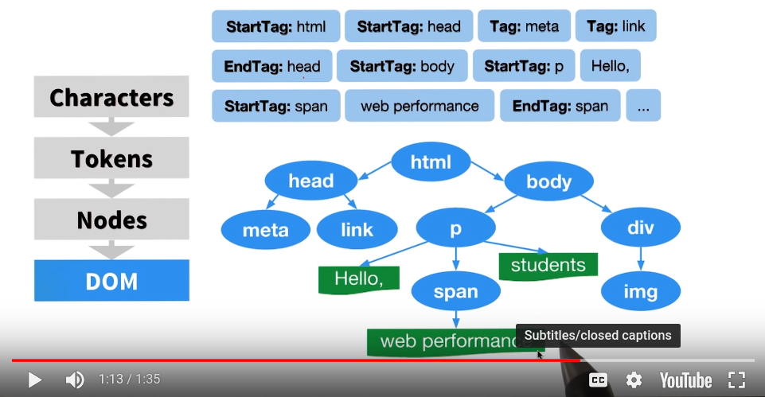

DOM is the tree structure that captures the contents and properties of the HTML and all the relationships between the nodes – the full parse representation of the HTML markup

1. HTML is received The browser receives a stream of HTML. The
2. Tags converted to tokens parsing process determines the different
3. Tokens converted to Nodes characters (the tokenization process) and
4. Nodes converted to the DOM converts them to tokens.

The DOM is a model (representation) of the relationship and attributes of the HTML document that was received.
• Can be accessed using the special object provided by browser (document)

Access full list of DOM specs: https://www.w3.org/standards/techs/dom#w3c_all
Some of the specifications that make up the DOM are:
• Core Specification
• Events Specification
• Style Specification
• Validation Specification
• Load and Save Specification

document Object of the DOM
- Is like any other JS object, has key:value pairs that one can accesse
- Some of the values are properties but some are methods
  - An important method to remember: document.getElementId()
    - Returns a single item (can pass it into a var to call later)
  - .getElementsByClassName() + .getElementsByTagName()
    - Return multiple elements
    - The two methods above has an extra s
    - Doesn’t return an array, but an HTML Collection

Recall Characters → Tags → Tokens → Nodes → DOM, but What are Nodes Exactly?
- Node with capital N is like a class
  - Is like the blueprint for a building
    - Contains data about the building (properties)
      - Color of the building, number of doors, number of windows
    - Contains a list of the buildings capabilities (methods)
      - Alarm system
      - Srinkler system
  - Another word we can use is interface (tells us properties and methods)
- node with lowercase n is like an object
  - Are the real objects built from the blueprint (interface)

Takeaway: Node interface is a blueprint for all the properties and methods that every real node has after it’s created.
https://developer.mozilla.org/en-US/docs/Web/API/Node

There are more specific interfaces that have their own properties and methods specific to just their nodes.

Element Interface
- Create elements https://developer.mozilla.org/en-US/docs/Web/API/Element
- Descendant of the Node Interface which means that it inherits all of the Node Interface’s properties and methods

Protip: $0 refers to the selected element on Developer’s Tools
- There is a .getElementsByClassName() in the Document Interface and the Element Interface

Select the DOM element with an ID of "sidebar"
const sidebarElement = document.getElementById('sidebar')

Searches the "sidebar" element for any elements with a class of "sub-heading" const subHeadingList = sidebarElement.getElementsByClassName('sub-heading')

Browser compatibility
- Almost every method on MDN has a Browser compatibility table that lists when each browser started supporting that specific method
- Very few methods are standardized across all browsers
- JS libraries such as jQuery helps mitigate these issues

Purposes of the jQuery Library
- Abstract away the differences between different browsers
- Write jQuery specific methods which would determine which browser it was running on and use the right code for that browser

Element Selecting Similar to How CSS Does It
querySelector Method under the Document Interface
- .querySelector() method to select elements just like in CSS

// find and return the element with an ID of "header"
document.querySelector('#header')

// find and return the first element with the class "header"
document.querySelector('.header')

// find and return the first <header> element
document.querySelector('header')

.querySelector() returns a SINGLE element
- For ID selector, makes sense to only return one element, but for class and tags will return the first item it finds

querySelectorAll() returns list of all elements given argument
- Does not return an array, rather a NodeList
- Can’t use .map() method to loop over but can use for loop or forEach

Use JavaScript & DOM Methods to:
- Create DOM elements
- Delete DOM elements
- Manipulate DOM elements
Review .getElementsById(), .querySelector(), Node and Element Interface
Use .innerHTML Property
- Used to get and set the HTML content of an element
- Returns a DOMString
Use .textContent Property
- Used to get and set the text content of an element
Look at the differences between .textContent and .innerText properties

Remember: Every element inherits properties/methods from the Element Interface
- Means that every element has an .innerHTML property
  - Represents the markup of the element’s content
  - Get the element’s (and all of its descendants) HTML content
  - Set the element’s HTML content
- .innerHTML returns the HTML content within the selected element
- .outerHTML represents the HTML element itself, as well as its children

If just want the text content, use the .textContent property
- Set the text content of an element and all its descendants
  - For example: card.textContent =
‘I will be the updated text for the card element!’
  - Passing text that contains HTML characters will not display as HTML
    - Need to use .innerHTML for that
- Return the text content of an element and all its descendants
  - For example: card.textContent

Differences Between .textContent and .innerText
- .textcontent sets/gets the text content of an element
- .innertext returns the text as it would be seen visually
  - If CSS is used to hide text, .innerText will not return that text
- Probably will use .textContent more often than .innerText

Add New Page Content with the DOM Using:
- .createElement()
  - Method is a part of the document object
  - Just creates the element, doesn’t actually add it to the DOM
  - For example: document.createElement(‘span’)
- .createTextNode()
  - Create new text nodes. Look at the below example on this:
const myPara = document.createElement('p'); const textOfParagraph = document.createTextNode('I am the text for the paragraph!');

myPara.appendChild(textOfParagraph); document.body.appendChild(myPara);
The code below will provide the exact same result using .textContent
const myPara = document.createElement('p');

myPara.textContent = 'I am the text for the paragraph!'; document.body.appendChild(myPara);
  - Instead of creating a new text node and appending it to the element, it’s faster and easier to update the element’s text with .textContent

- .appendChild()
  - Used to add an element to the page
  - Needs to be called on another element, not the document object and is passed the element to append (is appended as the last child)
  - Using .appendChild() method, it must be called on an existing element.
  - In the below example, the <span> element will appear in the DOM as a child of the <h1>...but it will appear at the end, after all text and any other elements that might be in the <h1>

const newSpan = document.createElement('span')

const mainHeading = document.querySelector('h1')

// add the <span> element as the last child element of the main heading
mainHeading.appendChild(newSpan)
  - By defintion, .appendChild() adds element as the last child of the parent element; moves element from current position to the new position

- .insertAdjacentHTML()
  - If want flexibility in where to add the child element, use this method
  - Needs to be called on a parent element
  - Two arguments: location of the HTML and the HTML text to be inserted
    - Four locations:
      - beforebegin: inserts the HTML text as a previous sibling
      - afterbegin: inserts the HTML text as the first child
      - beforend: inserts the HTML text as the last child
      - afterend: inserts the HTML text as a following sibling

<!-- beforebegin -->
<p>
<!-- afterbegin -->
Existing text/HTML content
<!-- beforeend -->
</p>
<!-- afterend →

Important Takeaways
- If element already exists in the DOM and this element is passed to .appendChild(), .appendChild() will move it rather than duplicating it
- An element's .textContent property is used more often than creating a text node with the .createTextNode() method
- The .insertAdjacentHTML() method's second argument has to be text, you can't pass an element

Remove Page Content

How to remove content from the page via .removeChild() and .remove() methods
and two new properties .firstElementChild and .parentElement

Use .removeChild() to remove a child element: opposite of .appendChild()
- Requires a parent element and the child element to be removed
- Drawback is that the .removeChild() requires access to parent to function

.firstElementChild property can be called on a parent element to access its first element and can use .parentElement property to refer to any child’s parent

const mainHeading = document.querySelector('h1')
mainHeading.parentElement.removeChild(mainHeading)

mainHeading variable calls .parentElement, so the focus is directed at the parent element. Then .removeChild() is called on the parent element. Finally, mainHeading itself is passed as the element that needs to be removed

Replace HTML Element with .replaceChild(newNode, oldNode)

Can remove the child element directly with the .remove() method
- Method can be called directly on the element to delete

When filling out a form and make a mistake, error message might pop up or one of the form fields might have a red border, these are style changes
How to Control Page Dialing with JavaScript and DOM Methods
- Style Property
- CSS Text Method
- classList Property
Review on CSS Specificity
Specificity is the means by which browsers decide which CSS property values are the most relevant to an element and therefore, will be applied. Basically, the closer the style rule is to an element, the more specific it is.

When using the .style property, you can only modify one CSS style at a time
- Calling .style will return a CSS style declaration
- .style.property syntax is perfect for setting one style at a time, but it’s not great for controlling multiple styles (use .style.cssText)

const mainHeading = document.querySelector('h1')

mainHeading.style.color = 'red'

.style.cssText Example
- Write CSS style just as you would in a stylehseet (font-size vs. fontSize)
- Will overwrite anything that’s already in the .style attribute

const heading = document.querySelector('h1')

heading.style.cssText = 'color: blue; background-color: grey; font-size: 3.5em'

Another way to set styles for an element is to use the .setAttribute() method
- Not just for styling page elements. Can use this method to set any attribute for an element e.g. give element an ID

const heading = document.querySelector(‘h1’)

heading.setAttribute(‘style’, ‘color: blue; background-color: grey;’)

Separation of Concerns
HTML should be HTML file, styling should be in CSS file and interactivity should be in a JavaScript file. Wrong to put page styling in your JavaScript file
- Use DOM to find class using JS; control the class attribute for an element

Accessing an Element’s Classes
- .className property
  - Returns a space-separated string of all of the element’s classes
  - Convert space-separated string into an array using JS method, .split()
  - Once have array of classes, can:
    - Can loop through using a for loop
    - Use .push() to add an item to the list
    - Use .pop() to remove an item from the list
  - If set value of .className property to a string, it will erase any classes that were originally in the element’s class attribute
- However, .className returns a string and makes it hard to add or remove individual classes, so use newer .classList property
  - Returns a DOMTokenList of all of the element’s classes
  - Popular used properties of the .classList property are:
    - .add() - to add a class to the list
    - .remove() - to remove a class from the list
    - .toggle() - to add the class if it doesn’t exist or remove it from the list if it does already exit
    - .contains() - returns boolean based on if class exists in list

Recommended to use the .classList property more than any other in this lesson
- Helps to keep your CSS styling out of your JavaScript code

