Connections

Due: Friday, July 12th at 9:00 am

Hubert Muchalski Ph.D.

# Before you get started…

It is okay, or even desirable, to collaborate with other students. The work that you submit, however, must be your own.[1] The answers can be typed or handwritten. All drawings of structures, reactions, and mechanisms must be drawn by hand using pen. If you choose to write everything by hand, make sure it is legible.

# Radical Chemistry in Foods and Consumer Products

1. Food additive E307 (alpha-tocopherol), commonly known as vitamin E and ascorbic acid (vitamin C) are considered essential vitamins in human diet. They are both considered antioxidants. It is recommended that vitamin E supplements are taken with fatty foods but there is no such recommendation to vitamin C. Draw structures of both molecules and propose explanation for the dietary recommendation mentioned above.
2. Polyunsaturated fatty acids (PUFAs) readily undergo autoxidation (peroxidation). Linoleic acid (omega-6 fatty acid) is 62 times more reactive than oleic acid because the intermediate carbon radical is stabilized by resonance. Draw all resonance contributors of the radical that forms upon abstraction of the bis-allylic hydrogen atom from linoleic acid. Also, explain the nomenclature convention that uses “omega-#” notion to name PUFAs
3. Most consumer products made of polymer materials (a.k.a. plastics) have triangular symbols that identify the plastic resin out of which the product is made and each has designated number and letter code. Draw the mechanism of formation of tetramer of polypropylene. What symbol and number are used to identify polypropylene? Give an example of consumer products made of polypropylene.

# Physics and Chemistry Interface

1. Why is the dipole moment of trichloromethane (1.08 D) is lower than dipole moment of dichloromethane (1.60 D)? Use drawing as part of your answer.
2. The two molecules shown below are constitutional isomers. However, despite same chemical composition they have drastically different boiling points, 153 °C and 216 °C, respectively. Using a drawing and no more than 5 sentences explain why compound B (butyramide) has higher boiling point.

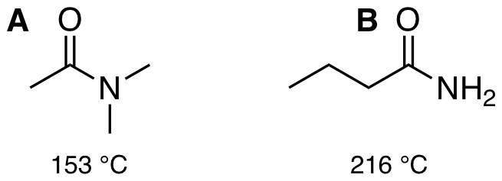

Amides boiling point

# Synthesis of Ethers in Kitchens and Laboratories

In a 2004 article, Vanderhaegen et al. (Journal of Agricultural and Food Chemistry 2004, 52(6), 1661-1668) describe the formation of furfuryl ethyl ether (FEE) in beer from two possible precursors, 2-furyl alcohol (FALC) and 2-furfuryl acetate (FAC), reacting with ethanol in an acid-catalyzed mechanism. They propose several interconnected routes leading to the ether functional group of FEE. Read the article ([link to PDF](http://login.hmlproxy.lib.csufresno.edu/login?url=http://dx.doi.org/10.1021/jf035412g)) and answer questions below.

1. Draw the three-step mechanism of formation of FEE from FAC.
2. The authors believe that the displacement by ethanol to produce furfuryl ethyl ether involves an SN2 type mechanism, as opposed to an SN1 mechanism. What reasons do they provide to support the hypothesized SN2 mechanism?
3. Beer is a complex mixture that contains a number of different substances. The concentrations of other nucleophiles in beer are low relative to that of ethanol. However, small amounts of products may form that affect the taste of beer due to their low flavor thresholds, meaning these substances can affect flavor at very low concentrations. These potential side reactions are represented in Figure 3 using a generalized nucleophile (Nuc). The authors cite one specific compound that might be produced in beer that has a roasted, coffee-like aroma. Draw the structure of this compound.

# Sharpless Asymmetric Dihydroxylation

*syn*-Dihydroxylation reaction carried out in presence of chiral ligand allows for asymmetric synthesis of diols. Look up the topic of Sharpless Asymmetric Dihydroxylation (SAD) and answer the following questions:

1. Draw the structures of ligands used in asymmetric dihydroxylation: (DHQ)2PHAL and (DHQD)2PHAL.
2. Draw a model that is used to predict which stereoisomer will be produced depending on the ligand used.
3. Nobel Laurate and the discoverer of the dihydroxylation reaction, prof. K. Barry Sharpless is blind on one eye. Investigate this fact and explain.

1. From the Syllabus: “Your work is expected to be the product of your own thinking, written and explained in your own words with no parts of the work copied from external sources such as books or websites, and done clearly enough in your own mind that you could explain the work from start to finish if asked.”