**AGGREGATION, COMPOSITION AND ASSOCIATION:**

Association is the relation between multiple objects. Aggregation and Composition are considered to be two types of association. If an object owns another object and if the owned object cannot exist without the owner then it is called association e.g. a human owns a heart. The heart cannot exist if the human do not exist. If an object owns another object and both objects can exist independently then it is referred as Composition e.g. a team and a player. A player will exist even if the team ends.

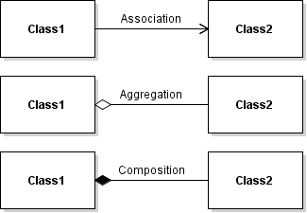

**JAVA CODE**

import java.util.*;

/**

*

*/

public class vechile {

/**

* Default constructor

*/

public vechile() {

}

/**

*

*/

public void speed;

/**

*

*/

public void color;

/**

*

*/

public void turnleft() {

// TODO implement here

}

/**

*

*/

public void turnright() {

// TODO implement here

}

}

