*database.xlsx* contains time-averaged surface water concentrations of I-129 at various locations, sourced from the studies listed in the “citations” sheet. Some studies presented only a single data point at a single location. Other studies took continuous measurements over a period of time; in this case, the time average, maximum, and minimum of these measurements are presented as a single entry in the database. A select few studies took 1-3 measurements at a single location, with the time between measurements on the order of years; for these studies, measurements are presented as separate entries in the database. The columns of this database are described below.

Description of columns in *database.xlsx*

* **region**: geographical region into which the value is grouped, for averaging in accompanying paper and in [1].  
  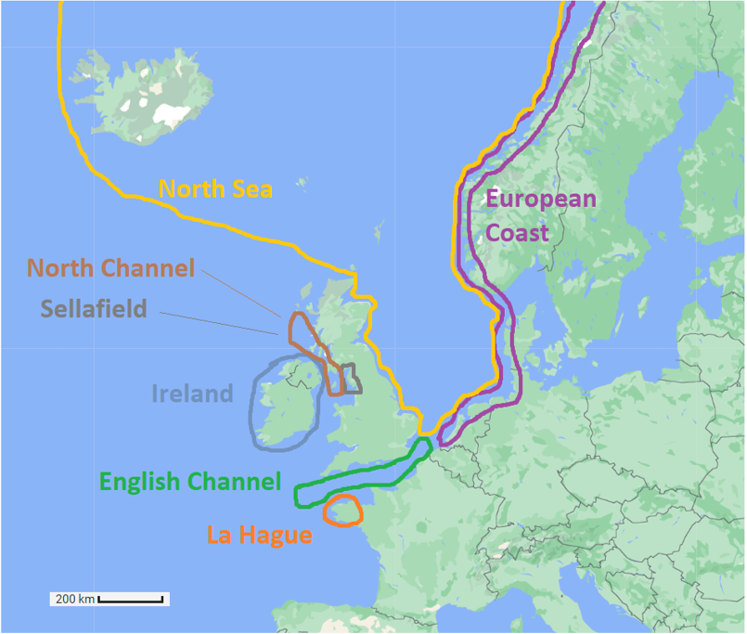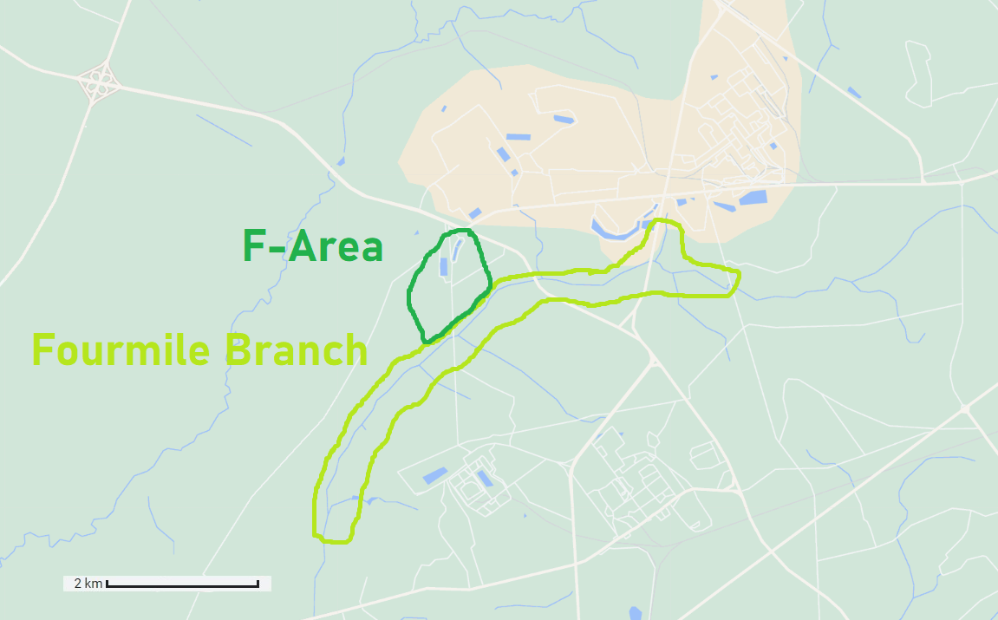
* **site**: The spent nuclear fuel reprocessing facilities which are relevant to this data point; that is, the facilities which have released I-129 effluents which have affected the I-129 surface water concentration at this point. The trajectory of I-129 effluents from La Hague and Sellafield is described in [2]. The possible entries in this field are:
  + La Hague (France)
  + Sellafield (UK)
  + Savannah River F-Area
  + Reference: reference point outside the direct influence of the above sites
* **location**: all locational information given about the data point in its original study
* **coordinates**: whether or not coordinates are available for this data point in its original study (yes/no)
* **start_date**: date at which data collection began (YYYY-MM-DD)
* **end_date**: date at which data collection ended (YYYY-MM-DD)
* **medium**: type of surface water measured (seawater, river water, lake water, …)
* **time_average_value**: average of all measurements reported at this location between *start date* and *end date*
* **maximum_value**: upper limit of measurements
* **minimum_value**: lower limit of measurements
* **n**: number of measurements between *start date* and *end date*.
* **units**: measurement units used in *time average*, *maximum*, and *minimum*.
* **citation**: original study in which data point was presented
* **Notes**: any other information which can help identify the data point in its original study, contextualize one or more of its attributes, or further describe it in any way

[1] Whiteaker, K. (2024). *Quantifying Iodine-129 Environmental Releases and Surface Water Concentrations at Nuclear Fuel Recycling Facilities* [Master’s thesis]. Massachusetts Institute of Technology.

[2] Raisbeck, G., F. Yiou, Z. Zhou, and L. Kilius, “129I from nuclear fuel reprocessing facilities at Sellafield (U.K.) and La Hague (France); potential as an oceanographie tracer,” Journal of Marine Systems, vol. 6, no. 5, pp. 561–570, 1995, issn: 0924-7963. doi: <https://doi.org/10.1016/0924-7963(95)00024-J>.

Category → Region

Site → Facility

Location → Location

Coordinates → Coordinates

start date → start_date

end date → end_date

Medium → medium

time average value → time_average_value

Maximum → maximum_value

Minimum → minimum_value

n → number_points

Units → units

Citation

Notes