Dashboard Wireframe Sign-Off Document
Skye Fundraising Intelligence Dashboard — Stakeholder Review & Approval

SO-001 · Skye Data Advisory · Project Sign-Off · March 15, 2026

Purpose & Instructions
This document presents the three dashboard wireframes produced by the Skye Data Advisory UX team for the Fundraising Intelligence Dashboard. Each wireframe represents one tab of the Tableau dashboard. Stakeholders are asked to review each tab against the checklist provided, note any requested changes in the comment log, and provide a formal signature authorizing development to proceed.
No development work should begin on any dashboard tab until this document has been signed off by the Business Owner (Development Director or equivalent). If revisions are required, the wireframe must be updated and re-reviewed before sign-off.
Review process:
- Review each wireframe image and its checklist below.
- Mark each checklist item as Approved, Approved with comments, or Revision required.
- Record any specific change requests in the Comment Log on the final page.
- Sign the approval block for each tab you are approving.
- Return the completed document to the Project Manager / DGO.
- If any tab requires revision, the UX team will update and reissue for re-review.

Project Context
Field | Value
Project Name | Skye Fundraising Intelligence Dashboard
Dashboard Platform | Tableau Public
Data Source | Snowflake → VW_FUNDRAISING_DASHBOARD → CSV Extract
Number of Tabs | 3 (Executive Overview, Campaign Performance, Donor Intelligence)
Design System | Skye Data Advisory Brand System v1.0
Wireframe Version | v1.0 — Initial UX Review
Prepared By | Skye Data Advisory UX Team
Review Requested | March 15, 2026
Sign-Off Deadline | [ INSERT DATE ]
Business Owner | [ INSERT NAME / ROLE ]

Tab 1 — Executive Overview
Tab Purpose
Provides leadership (Executive Director, Board, CFO) with a high-level view of fundraising health. Answers: How much did we raise? Are donors returning? Which channels are performing? What is our campaign ROI?
Key Components on This Tab
- 4 KPI Cards: Total Donations ($1.24M), Total Donors (3,847), Average Gift ($322), Repeat Donor Rate (68%)
- Donations Over Time: Monthly line chart with Women's History Month spike annotated in Mission Gold
- Donor Growth: Monthly bar chart with Retention Rate trend line overlay
- Revenue by Channel: Horizontal bar chart (Email, Direct, Social, Event)
- Campaign ROI Ranking: Horizontal bar chart sorted by ROI multiplier
- Insight Annotation Bar: Plain-language interpretation of key findings (bottom of tab)
- Global Filter Bar: Date Range, Campaign, Channel, Geography, Donor Segment
Wireframe Image — Tab 1
Review the wireframe below. This is the pre-development design. It does not contain live data.
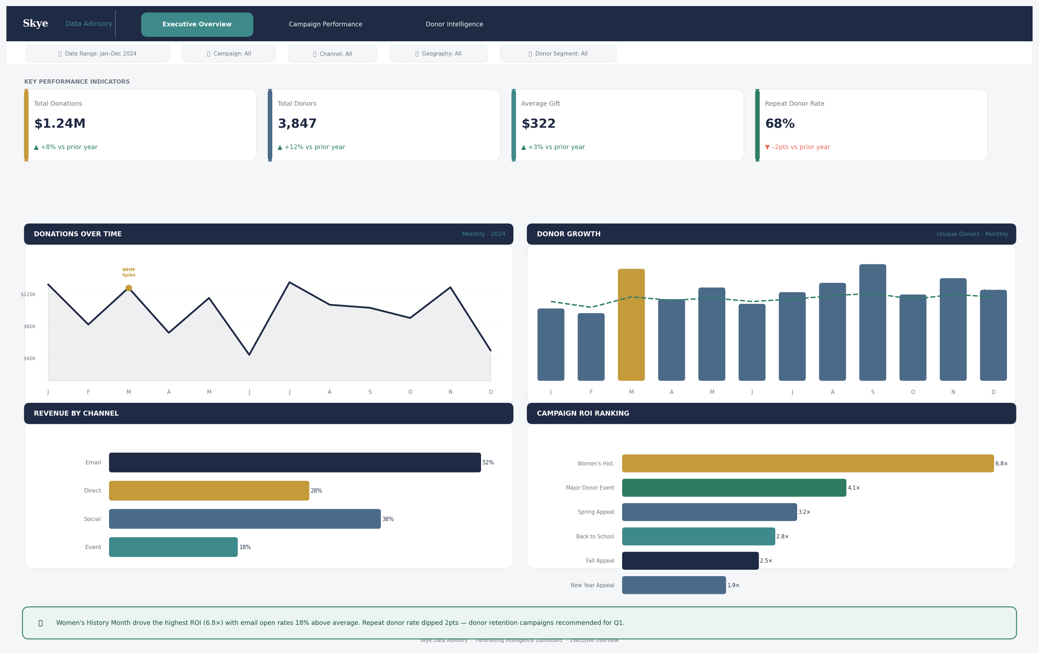
Figure 1: Executive Overview Tab Wireframe — v1.0

Tab 1 Review Checklist — Executive Overview
# | Review Item | Reviewer Response
1 | KPI cards display the correct four metrics for executive decision-making | ☐ Approved ☐ Approved with comments ☐ Revision required
2 | Metric labels and values align with the agreed data dictionary definitions | ☐ Approved ☐ Approved with comments ☐ Revision required
3 | Donations Over Time uses the correct time granularity (monthly) and date range (2024) | ☐ Approved ☐ Approved with comments ☐ Revision required
4 | The Women's History Month spike annotation is appropriate and correctly labeled | ☐ Approved ☐ Approved with comments ☐ Revision required
5 | Donor Growth chart correctly shows unique donors alongside retention rate | ☐ Approved ☐ Approved with comments ☐ Revision required
6 | Revenue by Channel includes all four approved channel types (Email, Social, Direct, Event) | ☐ Approved ☐ Approved with comments ☐ Revision required
7 | Campaign ROI ranking is sorted correctly and includes all major campaigns | ☐ Approved ☐ Approved with comments ☐ Revision required
8 | Color usage follows the Skye brand system (Navy baseline, Gold KPI highlight, Coral outliers) | ☐ Approved ☐ Approved with comments ☐ Revision required
9 | Insight annotation bar contains an appropriate example interpretation | ☐ Approved ☐ Approved with comments ☐ Revision required
10 | Filter bar includes all five required global filters | ☐ Approved ☐ Approved with comments ☐ Revision required
11 | The three-layer layout (KPIs → Trends → Diagnostics) is correctly implemented | ☐ Approved ☐ Approved with comments ☐ Revision required
12 | Tab is appropriate for the intended audience (Executive Director, Board, CFO) | ☐ Approved ☐ Approved with comments ☐ Revision required

Tab 1 Sign-Off
By signing below, the reviewer confirms that Tab 1 (Executive Overview) is approved for development, subject to any comments recorded in the Comment Log.
Signature | Printed Name / Role | Date
 | [ Name ] — [ Title ] | [ Date ]

Signature | Printed Name / Role | Date
 | Skye Data Advisory — DGO | [ Date ]

Tab 2 — Campaign Performance
Tab Purpose
Provides the fundraising and development team with a detailed view of campaign effectiveness. Answers: Which campaigns generated the most revenue? What is our email engagement funnel? Which campaigns have the best return on cost?
Key Components on This Tab
- 3 KPI Cards: Campaign Revenue ($1.24M), Best Campaign ROI (6.8×), Email Conversion (42%)
- Revenue by Campaign: Horizontal bar chart with Women's History Month highlighted in Gold
- Revenue by Channel: Grouped bar chart showing contribution of each channel
- Email Engagement Funnel: 4-stage funnel (Sent → Opened → Clicked → Donated) with percentages
- Cost vs. Net Revenue: Grouped bar chart comparing campaign spend to revenue per campaign
- Insight Annotation Bar: Highlights email channel dominance and major donor event cost warning
- All global filters apply to this tab
Wireframe Image — Tab 2
Review the wireframe below.
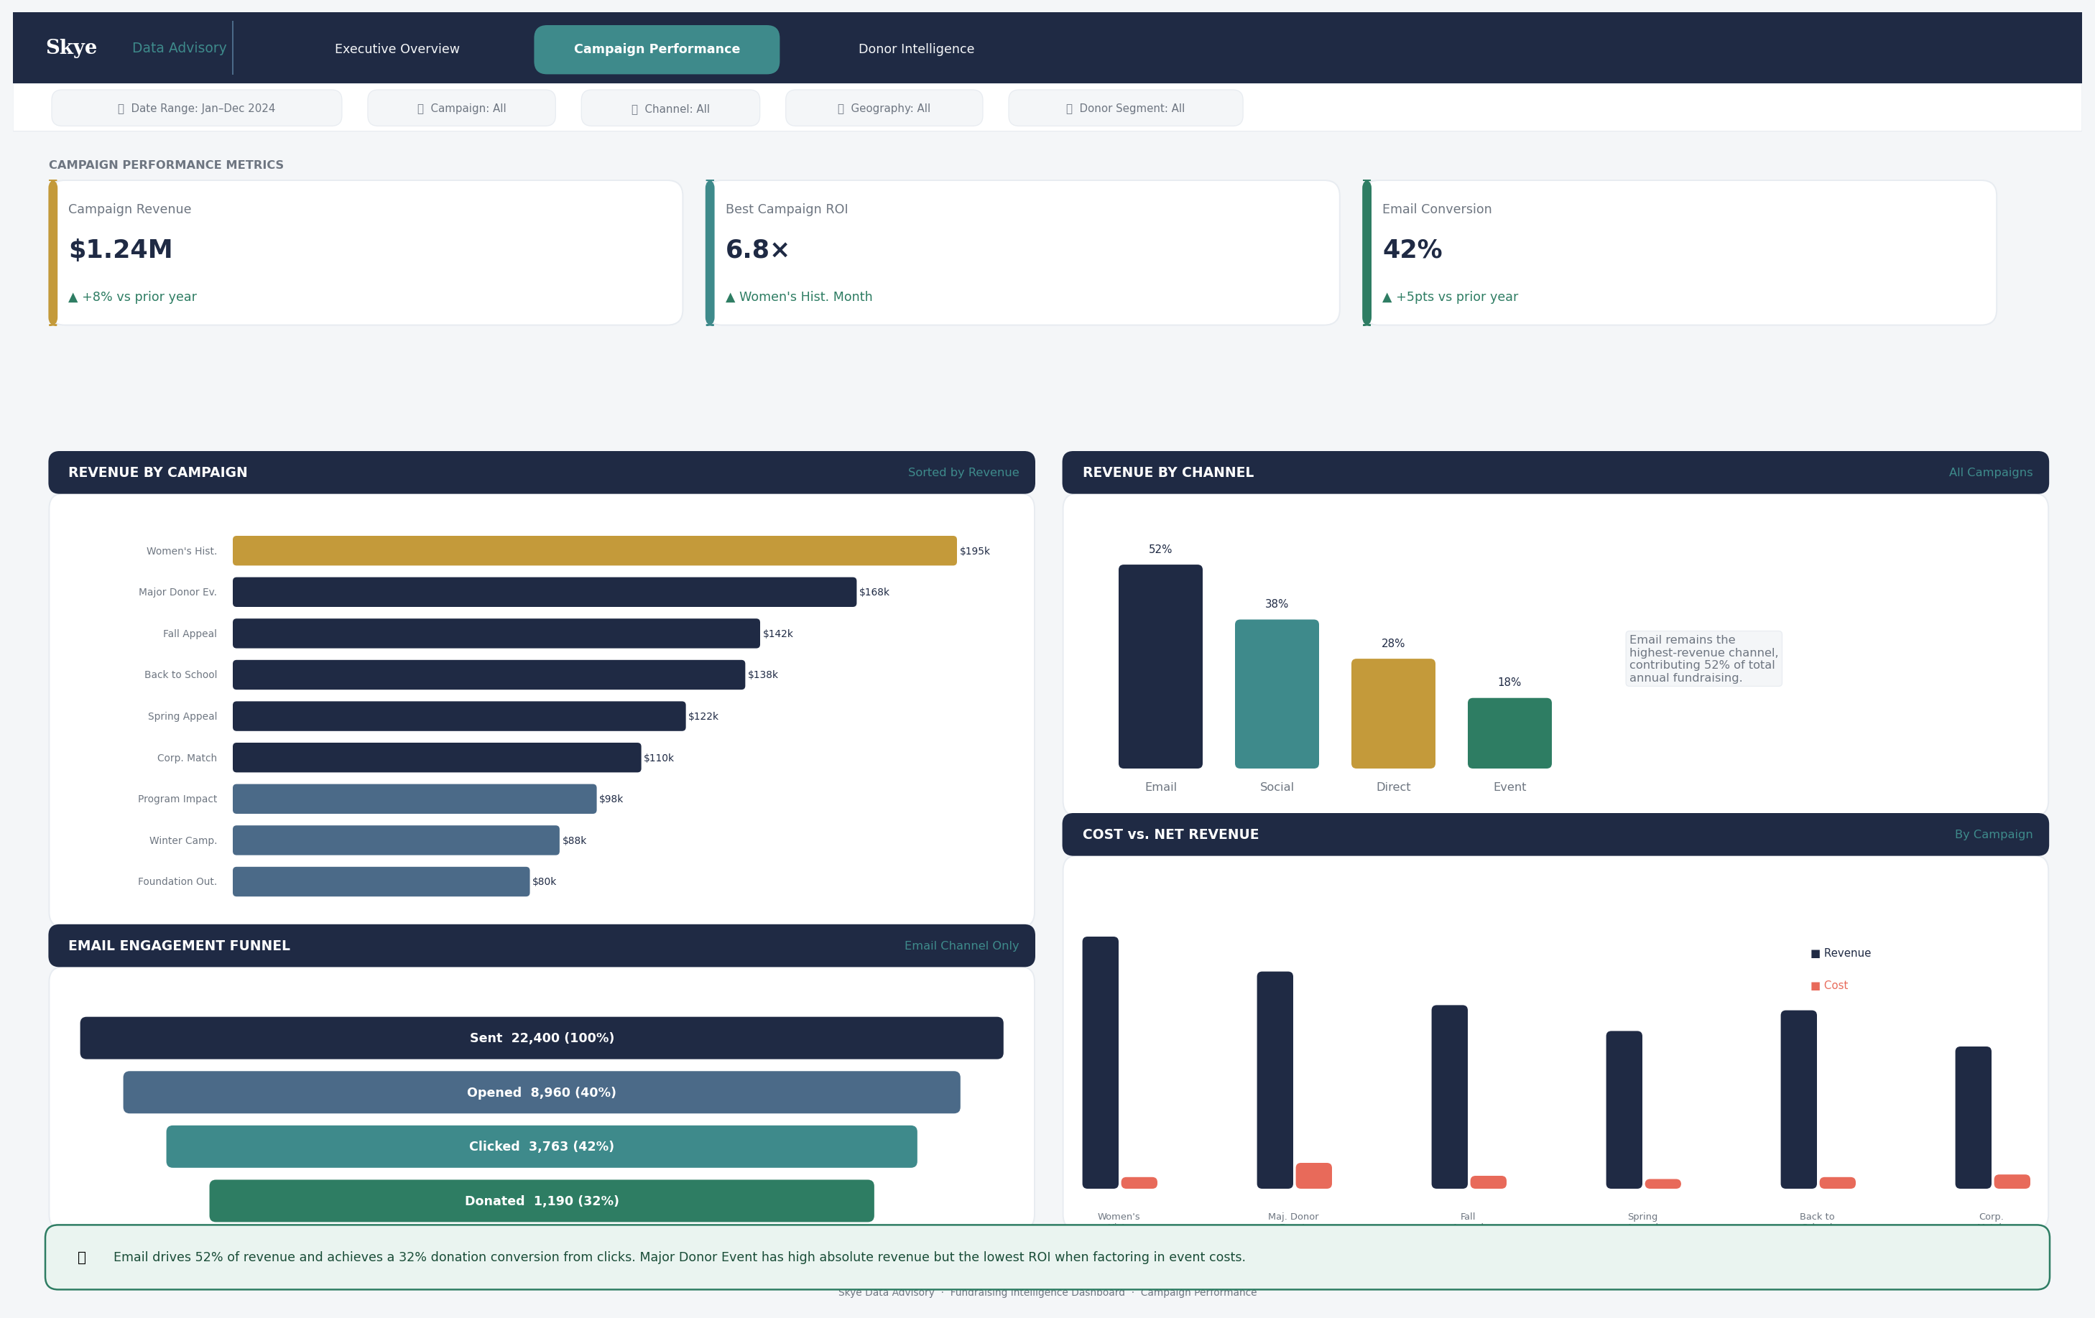
Figure 2: Campaign Performance Tab Wireframe — v1.0

Tab 2 Review Checklist — Campaign Performance
# | Review Item | Reviewer Response
1 | KPI cards reflect the correct three campaign-level metrics | ☐ Approved ☐ Approved with comments ☐ Revision required
2 | Revenue by Campaign includes all 12 campaigns and is sorted correctly | ☐ Approved ☐ Approved with comments ☐ Revision required
3 | Women's History Month is highlighted as the top performer in Mission Gold | ☐ Approved ☐ Approved with comments ☐ Revision required
4 | Revenue by Channel accurately represents the four channel types | ☐ Approved ☐ Approved with comments ☐ Revision required
5 | Email funnel shows four stages with correct stage labels (Sent, Opened, Clicked, Donated) | ☐ Approved ☐ Approved with comments ☐ Revision required
6 | Funnel stage colors progress correctly (Navy → Slate → Teal → Green) | ☐ Approved ☐ Approved with comments ☐ Revision required
7 | Cost vs. Revenue chart correctly pairs revenue (Navy) and cost (Coral) bars per campaign | ☐ Approved ☐ Approved with comments ☐ Revision required
8 | The insight bar correctly flags email channel dominance and the Major Donor Event cost observation | ☐ Approved ☐ Approved with comments ☐ Revision required
9 | Tab is appropriate for the intended audience (Development Director, Campaign Manager) | ☐ Approved ☐ Approved with comments ☐ Revision required
10 | All campaign names in the charts match the approved campaign list in the data dictionary | ☐ Approved ☐ Approved with comments ☐ Revision required
11 | ROI values shown are correctly calculated as (Revenue − Cost) / Cost | ☐ Approved ☐ Approved with comments ☐ Revision required

Tab 2 Sign-Off
By signing below, the reviewer confirms that Tab 2 (Campaign Performance) is approved for development, subject to any comments recorded in the Comment Log.
Signature | Printed Name / Role | Date
 | [ Name ] — [ Title ] | [ Date ]

Signature | Printed Name / Role | Date
 | Skye Data Advisory — DGO | [ Date ]

Tab 3 — Donor Intelligence
Tab Purpose
Provides the development team with insight into donor behavior, segment value, and geographic distribution. Answers: Who are our donors? What is their lifetime value? Are we retaining them? Where are they located? Are there anomalies requiring attention?
Key Components on This Tab
- 3 KPI Cards: Total Donors (3,847), Repeat Donor Rate (68%), Avg Lifetime Value ($4,820)
- Donor Segmentation: Stacked bar showing revenue contribution by General / Major / Recurring segments
- Segment Donuts: Three donut charts showing the revenue split for each segment
- Lifetime Giving Distribution: Histogram binned by giving level ($0–1k through $20k+)
- Geographic Donation Map: State-level filled dot map showing donation distribution
- Repeat vs. New Donor Trend: Monthly stacked bar with Signal Coral outlier flagged for September
- Legend showing Navy = Repeat Donors, Teal = New Donors, Coral = Outlier
- Insight bar warning about September outlier and major donor revenue concentration
Wireframe Image — Tab 3
Review the wireframe below.
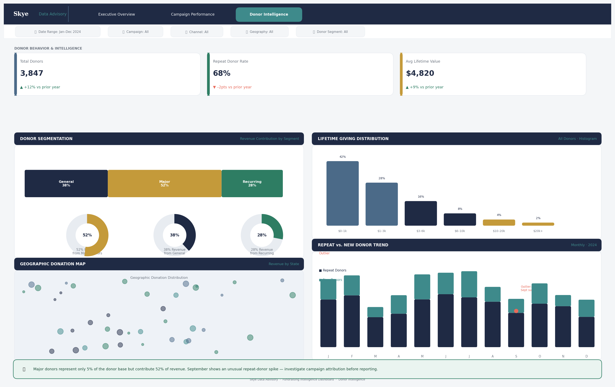
Figure 3: Donor Intelligence Tab Wireframe — v1.0

Tab 3 Review Checklist — Donor Intelligence
# | Review Item | Reviewer Response
1 | KPI cards display the correct three donor-level metrics | ☐ Approved ☐ Approved with comments ☐ Revision required
2 | Donor segmentation bar correctly shows General, Major, and Recurring segments | ☐ Approved ☐ Approved with comments ☐ Revision required
3 | Revenue percentages in the donut charts are directionally correct (Major = ~52%) | ☐ Approved ☐ Approved with comments ☐ Revision required
4 | Lifetime giving histogram uses appropriate bin ranges ($0–1k, $1–3k, $3–6k, $6–10k, $10–20k, $20k+) | ☐ Approved ☐ Approved with comments ☐ Revision required
5 | Geographic map shows state-level data only — no street addresses or city-level identifiers | ☐ Approved ☐ Approved with comments ☐ Revision required
6 | Signal Coral is used ONLY for the September outlier — not for any standard data series | ☐ Approved ☐ Approved with comments ☐ Revision required
7 | The September outlier is flagged with an appropriate annotation | ☐ Approved ☐ Approved with comments ☐ Revision required
8 | Repeat vs. New Donor trend shows both donor types and is easy to distinguish | ☐ Approved ☐ Approved with comments ☐ Revision required
9 | The insight bar correctly warns about major donor concentration and data investigation need | ☐ Approved ☐ Approved with comments ☐ Revision required
10 | Tab is appropriate for the intended audience (Development Director, Major Gifts Officer) | ☐ Approved ☐ Approved with comments ☐ Revision required
11 | No personally identifiable donor information is visible anywhere on this tab | ☐ Approved ☐ Approved with comments ☐ Revision required
12 | The outlier detection logic (Coral = > 2× window average) aligns with the QA test plan | ☐ Approved ☐ Approved with comments ☐ Revision required

Tab 3 Sign-Off
By signing below, the reviewer confirms that Tab 3 (Donor Intelligence) is approved for development, subject to any comments recorded in the Comment Log.
Signature | Printed Name / Role | Date
 | [ Name ] — [ Title ] | [ Date ]

Signature | Printed Name / Role | Date
 | Skye Data Advisory — DGO | [ Date ]

Overall Wireframe Approval
This overall sign-off confirms that all three tabs have been reviewed and approved (or approved with comments) and that the UX/development team is authorized to proceed with building the Tableau dashboard. Development must not begin until this block is signed.
Overall Decision
Deliverable | Decision | Initials
Tab 1 — Executive Overview | ☐ Approved ☐ Approved with changes ☐ Revision required
Tab 2 — Campaign Performance | ☐ Approved ☐ Approved with changes ☐ Revision required
Tab 3 — Donor Intelligence | ☐ Approved ☐ Approved with changes ☐ Revision required
Overall Authorization to Build | ☐ APPROVED TO PROCEED ☐ ON HOLD — revisions required

Overall Sign-Off
Signature | Printed Name / Role | Date
 | [ Name ] — [ Title ] | [ Date ]

Signature | Printed Name / Role | Date
 | [ Name ] — [ Title ] | [ Date ]

Signature | Printed Name / Role | Date
 | Skye Data Advisory — DGO | [ Date ]

Signature | Printed Name / Role | Date
 | Skye Data Advisory — UX | [ Date ]

Comment Log — Requested Changes
Use this table to record all revision requests. Each item must be assigned a priority, an owner, and a resolution status before development can proceed for the affected tab.
Comment # | Tab | Element | Requested Change | Priority | Owner | Status | Resolution Notes
C-001 | Tab # | [ Describe the element ] | [ Describe the requested change ] | High / Med / Low | UX Lead | Open / Resolved
C-002
C-003
C-004
C-005
C-006

Once all comments are marked Resolved and the overall sign-off block above is signed, this document should be saved to the project governance folder in Google Drive and shared with the DGO, Project Manager, and UX Lead.

