**Hands-on Workshop for Accessing, Processing, and Analyzing ECOSTRESS Data: Workshop Instructions**

**NOTE: You will not be able to complete the instructions below until after you have completed all the steps in the Pre-Workshop Instructions.**

**Search and Download ECOSTRESS Data Using Earthdata Search Client**

1. Go to <https://search.earthdata.nasa.gov/search>
   1. Click the  button in the upper right-hand corner to sign-in using your Earthdata Login account with Early Adopter access.
2. In the search engine, type the shortname of the product we are looking for (ECO3ETPTJPL) or simply search ‘ECOSTRESS’.
   1. under Matching Collections, find ECO3ETPTJPL v001 and click into it.
3. Spatial Subsetting
   1. Click the spatial subsetting icon  and select Point
   2. In the box in the upper left-hand corner  enter the US-CZ3 Flux Tower location: 37.0674, -119.1951 and hit enter.
4. Temporal Subsetting:
   1. Click the temporal subsetting icon 
      1. Set the start date to 2018-08-05 22:03:00
      2. Set the end date to 2018-08-05 22:04:00
5. Now that you have found the matching granule needed for the workshop, click  on the right side of the page.
6. Click  on the left side of the page after you have added the level 3 granule to your project.
7. Challenge: Now find the corresponding ECO1BGEO file and add it to your project
   1. hint: follow steps 2, 5-6
8. Once you have the ECOSTRESS_L3_ET_PT-JPL_00468_007_20180805T220314_0502_02.h5 and ECOSTRESS_L1B_GEO_00468_007_20180805T220314_0502_02.h5 files in your project, click  in the upper right-hand corner of the screen.
9. Click 
10. On the Data Access page, select ‘Stage for Delivery’ and click Continue (twice).
11. Submit the Request for ECOSTRESS Data.
    1. You will receive an email once your request is ready to be downloaded including links to the files.
12. For Additional information on using NASA Earthdata Search Client to access ECOSTRESS Data, check out the MASTER ECOSTRESS Quick Guide Earthdata Search _forEarlyAdopters.docx file provided in the workshop materials.
    1. how to search and download multiple ECOSTRESS data products from the same orbit
    2. How to subset ECOSTRESS data according to day or night retrievals

**How to use the ECOSTRESS Swath to Grid Conversion Script**

1. Go to <https://git.earthdata.nasa.gov/projects/LPDUR/repos/ecostress_swath2grid/browse>
2. Scroll down in the README to Procedures
   1. The python script and ECOSTRESS data should already be downloaded into your workshop directory and an ECOSTRESS Python Environment should already be set up on your laptop (see Pre-Workshop directions).
3. Using your preferred command line application (Terminal/Command Prompt/Cmder/anaconda prompt) navigate to your ECOSTRESS Workshop directory containing the materials that were provided in the Workshop.zip file.
   1. ex: cd C:/ECOSTRESS
4. Activate your ECOSTRESS python environment.
   1. windows: activate ecostress
   2. mac: source activate ecostress
5. Once you have set up your MacOS/Windows environment and it has been activated, run the script with the following in your Command Prompt/terminal window:
   1. python ECOSTRESS_swath2grid.py --proj <insert reprojection desired, Options: GEO and UTM> --dir <insert input directory with ECOSTRESS files here>
      1. GEO = Geographic lat/lon, EPSG code 4326
      2. UTM = Universal Transverse Mercator Zones (north/south) with WGS84 datum
      3. Ex: python ECOSTRESS_swath2grid.py --proj GEO --dir C:/ECOSTRESS/
6. Run the script again, this time adding an optional argument to only process specific science datasets (SDS) within the L3ETPTJPL file.
   1. you can do so by adding the optional argument --sds <insert SDS layer names desired> (comma separated with no spaces, see README for specific SDS layer names by product).
      1. Ex: python ECOSTRESS_swath2grid.py --proj UTM --dir C:\ECOSTRESS --sds ETinst,ETinstUncertainty
7. Navigate to your workshop directory in file explorer and verify that the output GeoTIFFs have been created.

**Working with ECOSTRESS Evapotranspiration Data in Python Tutorial**

1. Go to <https://git.earthdata.nasa.gov/projects/LPDUR/repos/tutorial-ecostress/browse>
2. Scroll through the README to Procedures.
   1. Again, we already have downloaded the data, Jupyter Notebook Tutorial, and Ameriflux tower data (csv) to our workshop directory.
3. The ecostress conda environment should still be activated in your command line app.
4. Start a Jupyter Notebook dashboard by typing the following into the command line:
   1. jupyter notebook
      1. This should open a new Jupyter dashboard in your web browser.
5. From the jupyter dashboard, click  to open the notebook.
6. Read through the introduction.
7. Find the first cell in section 1a. Import Packages and execute the cell by typing shift+enter.
8. continue to use shift+enter to continue through the tutorial.
9. Once you have completed the tutorial, be sure to check your output directory again to ensure that the output .png and GeoTIFF files have exported correctly.

**Techniques for Visualizing ECOSTRESS Data in QGIS**

**Interactive Color Map of ECOSTRESS ET**

1. Open **QGIS**
2. Go to the menu **HCMGIS -> BaseMap -> Google Satellite**
   1. A projected color image of the Earth should appear
   2. There are a variety of other base maps available in this menu
   3. This base map probably changed the project coordinate reference system to Web Pseudo-Mercator (EPSG:38G7)
3. Click on the button with the **EPSG** code in the bottom right corner of QGIS
   1. The **CRS** tab of the **Project Properties** dialog box should open
4. Set the CRS to **WGS84 (EPSG:4326)** so that coordinates are plain lat/lon
5. Drag and drop **ECOSTRESS_L3_ET_PT-JPL_00468_007_20180805T220314_0502_02_ETinst.tif** onto the QGIS map canvas
   1. A small black and white tile should appear over California and a new layer should appear in the layers panel
6. Right-click on the **ECOSTRESS_L3_ET_PT-JPL_00468_007_20180805T220314_0502_02_ETinst** layer that appeared in the layer panel and click **Zoom to Layer**
   1. The black and white tile should fill the screen now
7. Go to the menu **Project -> Properties**
   1. A dialog box should appear
8. Go to the **Default Styles** tab
9. Click on the **Edit symbol** button to the right of the **Color Ramp** drop-down box
   1. The button looks like a pencil on paper
   2. A dialog box of symbols should slide down
10. Click **Import / Export -> Import item**
11. Navigate to the **evapotranspiration.xml** file
12. Select the **evapotranspiration** color-ramp containing a gradient of beige, green, turquoise, and blue colors
13. Click **Import**
14. Click **close**
15. In **Color Ramp** drop-down box, select **evapotranspiration**
16. Click **OK**
17. Back in the main QGIS window, double-click the **ECOSTRESS_L3_ET_PT-JPL_00468_007_20180805T220314_0502_02_ETinst** layer
18. Go to the **Symbology** tab
19. In the **Render type** drop-down box, select **Singleband pseudocolor**
20. In the **Color ramp** drop-down menu, go to **All Color Ramps** and select **evapotranspiration**
21. Set the min value to 0 and the max value to 200
22. Go to the **Transparency** tab and set **Global opacity** to 75%
23. Click **OK**
24. The ET data should now be on the map in color
25. Drag and drop the **ameriflux_us_cz3.geojson** file onto the map
    1. A dot should appear on the map
26. Play with the symbology of the tower marker
27. Drag on the canvas to pan the map and use the mouse wheel to zoom in and out

Making Maps in QGIS

# Print Layout

You should have the ECOSTRESS evapotranspiration raster open from the first QGIS tutorial.

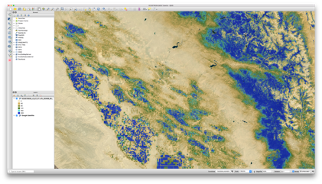

Zoom in to an interesting location on the map.

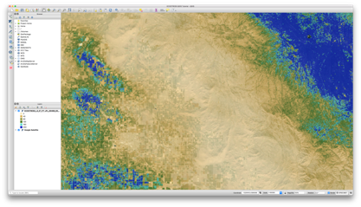

Go to the menu **Project -> New Print Layout**

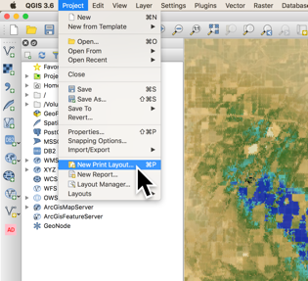

Type in the title for your map and click OK

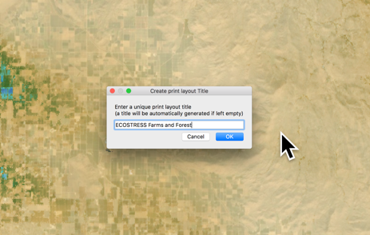

Click on the map tool once the print layout is open

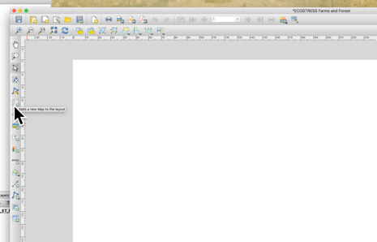

Drag a map rectangle onto the layout

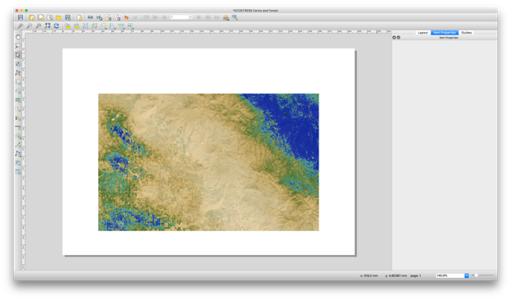

# Graticule

Follow this section if you wish to add a graticule

Expand the **Grids** section of the **Item Properties** panel and click **Modify Grid**

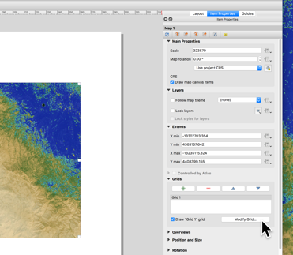

Next to **CRS**, click the **Change…** button

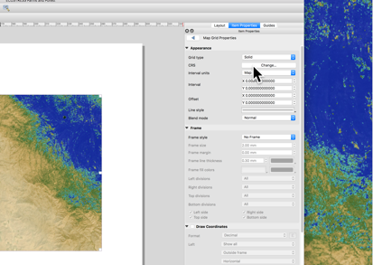

Select **WGS84/EPSG:4326** so that the graticule will display lat/lon

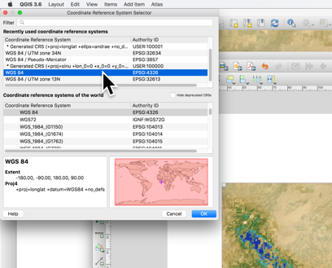

Set appropriate intervals, such as a tenth of a degree here

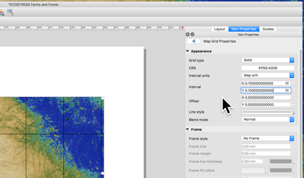

If you don’t wish to display grid-lines on top of the map, set **Grid type** to **Frame and annotations only**

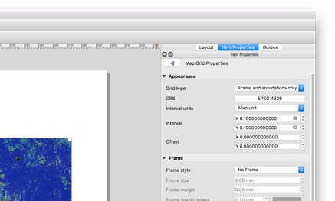

Select a frame style, such as **Exterior Ticks**

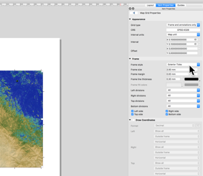

Check the **Draw Coordinates** box, set the format to **Decimal with suffix** and set **Coordinate precision** appropriate to your intervals, such as 1 for tenths of a degree

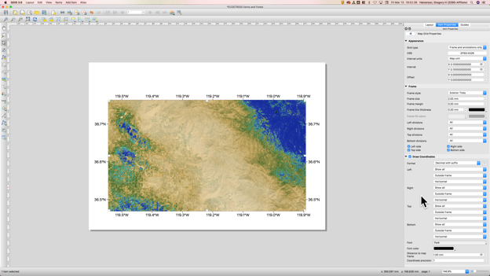

# Legend

Follow this section if you wish to draw a legend

Select the **Add Rectangle** tool

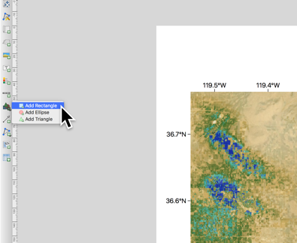

Draw out the rectangle for your legend and click on the **Style** button

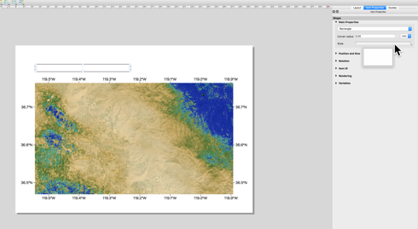

Under **Fill**, click on the **Simple Fill** item, then change **Symbol layer type** to **Gradient fill**

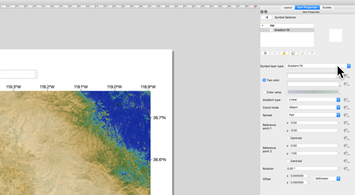

Change the color-ramp to **evapotranspiration**

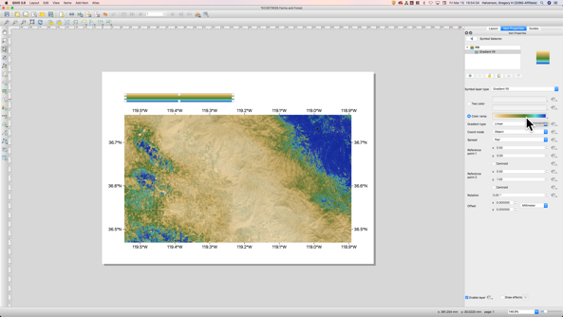

Swap the x and y values for the reference points to (0, 0.5) for reference point 1 and (1, 0.5) for reference point to so that the color-ramp displays from left to right

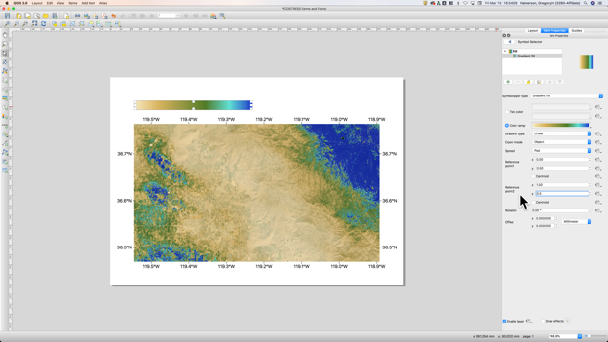

Select the labels tool to add labels to your map

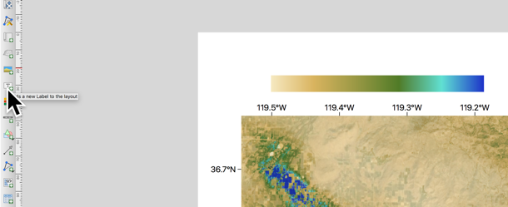

Drag out a rectangle for the minimum value to go with your legend, check **Render as HTML** to enable the **<sup>** tag for units, and type the minimum value **0 W m<sup>-2</sup>**

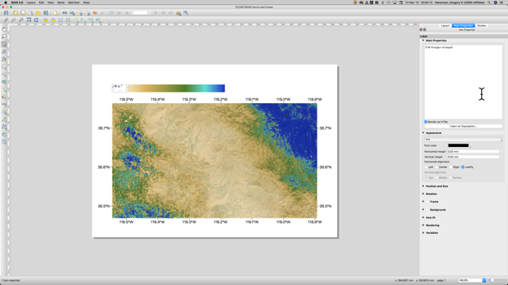

Under **Appearance** click the **Font** button and style as appropriate

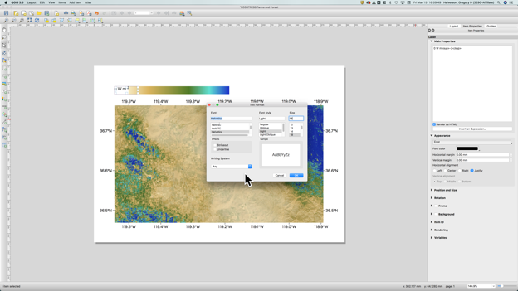

Copy and paste the label and edit it to the maximum value

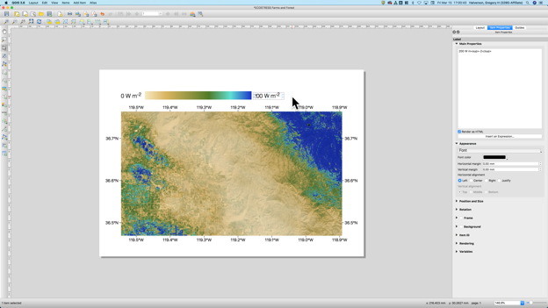

# Finishing Touches

Continue using the label tool to add a title and other important information to your map

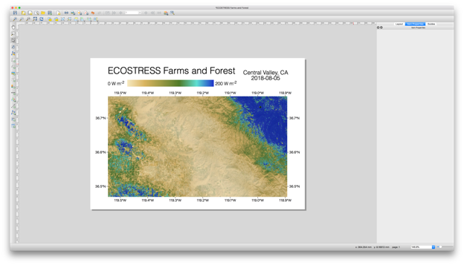

When you’ve finished your map, go to **Layout -> Export as Image** to save the map as a picture and make sure to save the map project as well

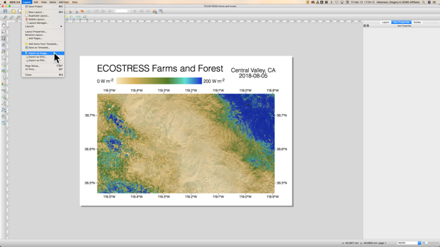

Upload your first map to the **my_first_img** channel on Slack and give the other students some likes

