Snow, soil, and elevation predominate over other factors in explaining variability in subalpine conifer forest structure

Hugh M. Worsham, Energy and Resources Group, U. C. Berkeley

Haruko M. Wainwright, Department of Nuclear Science and Engineering, Massachusetts Institute of Technology

Thomas L. Powell, Sewanee College

Nicola Falco, Lawrence Berkeley National Lab

Lara M. Kueppers, Energy and Resources Group, U.C. Berkeley, Lawrence Berkeley National Lab

October 27, 2023

# Abstract

A consensus suggests that abiotic constraints explain much of the variability in forest structure from scales ranging from hillslope to continent. At broad scales, climatic factors such as actual evapotranspiration (AET) and climatic water deficit (CWD) often emerge as the strongest constraints. However, at finer scales, such as that of a watershed or basin, synoptic climate may have less influence than other locally varying topographic and edaphic factors, or such factors may mediate synoptic climate in ways that trees must respond to physiologically. Here we present a novel analysis of abiotic constraints on a complement of conifer stand structural characteristics on a spatially continuous basis at the scale of a watershed. We use full-waveform LiDAR to quantify various aspects of stand structure across their full range of expression in an upper montane--subapline domain in the Rocky Mountains of Colorado. We evaluate covariability of these structural metrics with a suite of climate, topography, soil, geologic variables, incorporating end-members of the abiotic gradients along which forest stands grow. We report the relative importance of abiotic factors and describe the functional behavior of individual covariates, as well as interactions between explanatory factors. Our findings suggest that density is explained primarily by factors connected to snow input and soil water storage. Maximum canopy height, QMD, and BA are also primarily explained by snow and soil moisture factors, with elevation as a mediator and with inverse functional relationships to several explainers compared to density. Height skew, which describes the balance of larger and smaller age classes in a stand, is less well correlated with all factors. Quantifying the drivers of fine-scale heterogeneity in the structure of montane and subalpine forests is an essential preliminary for understanding how these systems will respond to synoptic environmental change, establishing a reference against which these responses can be measured, and for devising conservation and management strategies that promote forest resilience.

# 1. Introduction

Abiotic constraints are important for explaining variability in forest structure from scales ranging from hillslope to continent. At continental to global scales, climate factors, particularly those governing available moisture and atmospheric demand consistently emerge as the strongest constraints. However, at finer scales, such as that of a watershed or basin, synoptic climate appears to have less of an influence than other locally varying factors. At landscape (~ 10^3 to 10^6 m2) and watershed scales (~ 10^2 to 10^3 m2), topographic variation exerts local influences that decouple site microclimates from regional patterns (Dobrowski 2011; Adams et al. 2014; Barnard et al. 2017). Indeed, local environments can influence precipitation input (via orography, wind sheltering, rain shadow effects); surface and subsurface storage, which can lag precipitation input on timescales from months to decades; and radiation, which drives atmospheric demand. Further, variability in soil properties directly drives plant-available water (parent material, depth, e.g.). Together, these modify site energy and water balance in ways that trees must respond to physiologically.

From macro- and mega-scale studies, some general trends are apparent in the covariability of forest structure with abiotic factors. Stem diameter, basal, area, and growth rates tend to decline with elevation, with temperature as the key limiting control. The same properties also decline from valley to ridge positions, and from polar to equatorial exposures, perhaps as a result of these factors’ influence on water supply and deficit. However, smaller-scale studies have complicated this picture. Lydersen and North (2012) reported contrary findings in a Sierra Nevada mixed conifer forest, where upper slopes had both the highest quadratic mean diameter (QMD) and the tallest trees. Kane et al. (2015), furthermore, found that topography explained little variance in forest structure in a domain with a frequent fire return interval. Fricker et al. (2019) found found that climatic water deficit (CWD) and mean annual precipitation (MAP) explained the majority of variance in the distribution of maximum tree heights in a Sierra Nevada domain, though other factors, including a nonlinear elevational control, were also important.

While previous studies have identified general state-factor responses in forest structure and composition, to our knowledge, no study accounts for climate, topographic, edaphic, and influences on multiple stand structural properties together. The majority of gradient analyses use elevation, convergence, or landscape position as proxies for temperature and soil moisture (Stephenson (1998); Ng et al. 2020). A smaller subset of studies have deployed more complex metrics that combine factors such as elevation, hillslope position, aspect, and slope into quasi-independent climate-proxy variables. Urban et al. (2000) used elevation, slope aspect, topographic convergence, and soil depth to model a “physical template” describing the light, temperature, and soil moisture regime of a Sierra Nevada domain, and then examined the sensitivity of model-estimated forest stand basal area, fuel loading, and canopy depth to the topographic inputs. Underwood et al. (2010) used elevation, slope, aspect, solar radiation, and topographic wetness to divide a Sierra Nevada domain into “landscape management units” representing nine clusters of topographic variability, and examined variation in stem and species density across those units. Their effort relied on data collected *in situ* from 164 transects. Few studies directly address microclimatic heterogeneity in high-elevation complex terrain. Fewer still account for state-variable interactions, and none does the above on a spatially continuous basis, incorporating end-members on the radiative and moisture gradients along which forest stands grow.

While plot- and transect-based data can provide reliable estimates of aboveground forest structure and composition when scaled up to a stand, these data are by nature limited in spatial extent and do not represent the full range of state-factor variability that may constrain the distribution of vegetation across a landscape (Hurtt et al. (2004); Antonarakis et al. (2011), Lydersen and North (2012), Antonarakis et al. (2014)). Even within mature, close-canopied forests, characteristics such as stand density, age-class distribution, allometry, species composition, and species dominance can have wide variance. Efforts to scale these properties up to a watershed from plot observations (or plot-benchmarked models) alone can yield substantial error terms. Therefore, prior work may have failed to capture important dimensions of co-variability. Kane et al. (2015) and Bolstad et al. (2018) are the only studies we have identified that evaluate spatially continuous measures of topography and forest structure, although more results have been reported from tropical forests (e.g. Chadwick and Asner 2015, Jucker et al. 2018).

LiDAR integrated with field sampling holds promise for overcoming some of these limitations. Advances in active remote sensing, including in Light Detection and Ranging (LiDAR), have opened up new opportunities for characterizing forest structure on a continuous basis for a wide array of scientific and management applications (Mallet and Bretar (2009)). In particular, over the past five years a profusion of full-waveform LiDAR datasets from aerial and satellite platforms, and emerging open-source libraries for cleaning and processing the data, has enabled more accurate estimates of forest structure than those from discrete-return acquisitions (Zhou and Popescu (2019); Zhou et al. (2017)). Like discrete-return points, waveform data can be used to delineate individual canopy trees and to estimate individual-scale characteristics such as stem diameter, stem height, stem volume, and crown volume (Dalponte et al. (2011), Jucker et al. (2017)). Waveforms can also be processed to generate continuous estimates of forest structure parameters at the pixel-grid scale; these parameters include aboveground biomass, leaf-area index, total number density, and diameter-class distribution. While some researchers have eschewed individual tree object–based approaches because of the difficulty of characterizing subcanopy structure with dicrete-return data, a profusion of new algorithms aimed at waveform and hyper-dense point clouds has made it increasingly possible to achieve individual-based structure estimates. Using the full waveforms appears to improve the accuracy of both object-oriented and continuous-estimate methods over discrete-return estimates, particularly for characterizing mid-canopy and sub-canopy structure. Calibrating remote sensing models against *in situ* stem diameter and height measurements yields further accuracy improvements (Antonarakis et al. (2011); Jucker et al. (2017)).

Our primary objective in this study was to quantify relationships between forest structure and abiotic environmental drivers of stand structural development in subalpine forests broadly representative of low-diversity forests across the Southern Rocky Mountains.

We addressed the following questions:

1. Which topographic, climate, and substrate variables exert the strongest influence on conifer forest stand structure?
2. To what extent do feature interactions mediate these relationships?

To address these questions, we integrated a full-waveform LiDAR dataset acquired over Colorado’s East River watershed with field inventory measurements of 5000+ trees to quantify the spatial variability of forest canopy structure through the vertical profile, as well as stand structure and composition. We then used inferential modeling techniques to quantify the relative importance of state-factor controls on forest stand structure and composition, as estimated at a single point and time.

# 2. Methods

## 2.1. Study area

The domain for this project comprised upper montane-subalpine conifer forest stands in Colorado’s East River watershed (38°55’ N, 106°56’ W; Fig. 1). The East River is a headwater tributary of the Colorado River, the principal freshwater source for one in 10 people in the U.S. (U.S. Department of the Interior Bureau of Reclamation 2012). The 750 km2 catchment includes six major drainages with perennial snowmelt-fed streams. It also has significant topographic heterogeneity: 1420 m of elevational relief, multiple peaks extending above treeline, and pronounced gradients in slope, aspect, insolation, and hillslope position. Mean annual temperature measured at a SNOTEL site (736-Schofield) at 3261 m in the northern reach of the watershed is 1.8 º C, with maximum and minimum of 8.3 º C and –28.4 º C respectively. Mean annual precipitation is 1200 mm y–1, approximately 70 percent snow and 30 percent rain. Maximum air temperatures are depressed at high elevations and minimum air temperatures by cold air downwelling at low elevations. Precipitation is also strongly influenced by elevation, with snow accumulation generally increasing upgradient. The system is driven by seasonal temperature and precipitation regimes that impose important controls on vegetation phenology. Winter snows arrive as early as September, and storms may persist into early June at the highest elevations. Snowmelt typically begins in April and continues through June. A seasonal drydown occurs in late June and July, characterized by sparse rainfall and soil desiccation as evaporative demand rises with summer temperatures (Harte et al. 1995). In most years, this seasonal moisture deficit is partially mitigated by a July–August monsoon. The driest phase occurs over August–September and can drive severe soil moisture deficits in years when the monsoon fails, as it did in 2018. In addition to these broad patterns, the domain’s stark relief and topographic complexity coordinate to produce highly variable local climatic conditions. Soils are derived from varied, primarily sedimentary material intruded by igneous laccoliths. Heterogeneous soil composition and drainage potential drives substantial variability in plant available water. The dominant tree species are *P. engelmannii*, *A. lasiocarpa*, *P. contorta*, and *Populus tremuloides*, with occasional *P. menziesii* at mid-elevations and one known population of *Pinus longaeva* near treeline on one peak.

## 2.2 Full-waveform LiDAR

Between June 12 and 26, 2018, the NEON AOP surveyed approximately 330 km2 of the watershed (Chadwick et al. (2020); Fig. 1). The AOP collected LiDAR using an Optech Gemini discrete LiDAR sensor and waveform digitizer. The LiDAR sensor’s pulse repetition frequency varied between 33 and 100 kHz. Validation was conducted using *in situ* data at 437 sites representing a range of vegetative and built land cover types.

Discrete-return point density in the post-processed dataset ranged between 1 and 9 returns , which was insufficient for characterizing subcanopy structure. We therefore elected to reprocess the full waveforms, which had a nominal density between 1 and 4 pulses . We were able to exploit the higher information density of full-waveform pulses to develop more complete characterizations of stand and canopy structure than would have been possible with discrete returns alone.

First, we used a spectral deconvolution procedure to isolate the target-response signal from its interactions with the LiDAR system’s outgoing pulse, atmospheric scattering, and sensor-system noise. We used the Gold deconvolution algorithm implemented in the waveformlidar package in the R statistical computing environment (Zhou and Popescu (2019)), but refactored their implementation for parallel computing. The result of the algorithm approximates the true distribution of scattering objects along the outbound light pulse’s path.

The signal intensity of an outbound LiDAR pulse as a function of time is roughly Gaussian in shape. As the pulse interacts with physical objects along its path and is reflected back to the sensor, the returning backscatter cross-section can also be expressed approximately as a sum of Gaussian functions. Gaussian decomposition, therefore, allows one to characterize the components of the returning impulse (Harding 2005). We applied an adaptive Gaussian decomposition algorithm to fit one or more Gaussian models to the return pulse components based on Equation 1:

{#eq:eqn1}

where is the amplitude of waveform component , is the bin location of (measured as a point in time, ns), is the standard deviation of , and is a penalty parameter that minimizes model residual over a specified number of iterations. The algorithm (1) rescales the returns using the minimum intensity (typically around 200 (DN) for NEON data), (2) identifies potential peaks in the waveform, and (3) iteratively fits a model to each peak. It then selects the model that minimizes root mean square error between the raw waveform and fitted values, excluding models that produce physically meaningless parameters, such as a negative . Where multiple peaks exist, the algorithm fits a separate function to each and expresses the final fit as the sum of Gaussian functions. Fitting was accomplished using the function nlsLM in the R package minpack.lm.

The deconvolution and decomposition procedures were applied to the full set of waveforms in parallel on 256 cores on the University of California, Berkeley’s high-performance computing cluster. In total, we processed approximately 1.4*109 waveform returns. Of these, a negligible fraction (approximately 0.5 percent) either had no detectable peaks or represented backscatter records that could not be fit to a Gaussian function. Where peaks could not be identified, the waveforms were dropped from the set. Where they could not be estimated by a Gaussian, the characteristic components (e.g, amplitude, time to median energy) were estimated from the deconvolved returns directly, without curve fitting.

After processing, we used the geolocation matrices provided in the NEON dataset to geolocate the waveforms and extracted characteristic metrics from the fitted waveforms. These included the peaks’ location in three-dimensional space, their amplitude and width, front slope, and time to median intensity. We then used the R package lidR to discretize this information along with the geolocated waveform data (Jean-Romain 2022). We normalized the discretized points to the earth surface by differencing their z-values against a DEM derived from the discrete-return point cloud included in the NEON dataset. We then decimated the high-density returns, preserving all of the identified peaks to obtain a discretized point cloud of 5.72*109 points with an evenly distributed mean density of 15.3 points m-2 across the domain.

## 2.3 Field census

Between 2018 and 2022, we established 25 long-term forest monitoring plots in the East River and nearby drainages. The sites were stratified across six topographic gradients (Table 1). An initial set of 68 sites was preselected via Latin hypercube sampling on six topographic gradients derived from the USGS 1/3-arc second digital elevation model (DEM) ([TODO: cite]). The final 25 sites were selected from among that group after scouting and optimizing the distribution of the set along the topographic gradients (Fig. S1). At each site we installed a 40 m x 40 m plot, using slope corrections to approximate a projected flat-surface area of 1600 m2. To minimize edge effects, we located plots at least 100 m from forest edges, major compositional transitions, perennial streams, and ecotones.

We used a GNSS receiver (Trimble Geo 7X, Trimble, Inc.) to georeference all plot locations *in situ*. To establish absolute georeferencing we made a minimum of six measurements over multiple days at each plot corner and took the arithmetic mean of recorded coordinates, inversely weighted by reported horizontal uncertainty. Positioning data were post-processed in TerraSync (Trimble Inc.) with differential correction using the Continuously Operating Reference Stations (CORS) Network station SE01 (39.40035, -107.212101; NOAA 2020). Estimated planimetric accuracy of plot corner locations was 0.98 m.

Between 2018 and 2022 we conducted a field census of approximately 9000 trees in the 25 plots (Table 2). All trees of any species with a diameter at breast height (DBH, measured at 1.3 m above the ground) 1.0 cm were labeled with an aluminum tag. For each tagged tree, we recorded species and measured diameter at breast height (DBH) using a standard metric forestry diameter tape (for stems 7 cm DBH) or calipers ( 7 cm). We measured stem heights with a Nikon LaserPro II laser hypsometer (for stems 5 m in height) or a rigid metric tape measure ( 5 m). To maximize precision, hypsometer measurements were repeated on each tree until measurements converged within 0.5 m. Expected vertical accuracy on hypsometer measurements was 1.0 m.

Stems were then geolocated using either the GNSS receiver or by measuring the direction and distance from a geolocated reference tree with a digital compass and rigid metric tape. For those positioned with the GNSS, the receiver was positioned in contact with the side of each tree stem at 1.3 m. We enforced a maximum estimated horizontal precision threshold of 1.0 m before recording, and we recorded a minimum of 30 positional observations at a rate of 1 observation s-1 for each stem. In total, 5899 (89.4 percent) of the stems surveyed were positioned. Those without unique geolocations were less than 5 m in height and were fully suppressed beneath the canopy of another tree, such that it was extremely unlikely for tree crown segmentation to differentiate the suppressed tree from the dominant. For geotagged trees, mean planimetric accuracy was 1.01 m (s.d = 0.70 m).

Seventeen of the 25 plots lay within the overflight footprint of a 2018 NEON AOP acquisition (Kampe et al. 2009). We used the observations from this subset for training and validation of models developed in the next phase of analysis. The 17 focal plots contained 5828 observed trees, of which 5416 were living at the time of inventory.

Past management and disturbance influence forest structure as it manifests on the landscape at any point in time. The legacies of logging, fire, avalanche, and pest-pathogen infestation, which, among other events, are common to Colorado’s montane and subalpine forests, could obscure the relationship between forest vital rates, emergent structure, and underlying abiotic constraints. Logging related to the mining industry occurred in some parts of the watershed during the 19th and early 20th centuries, with a limited footprint enduring today. This said, the watershed includes large stands where little to no tree removal occurred, and stands with old trees and uneven age and size structure are well distributed. Further, prior studies have found strong associations between forest structure and abiotic factors under consideration here, even in the presence of major harvest and disturbance events (Urban et al. (2000), Lydersen and North (2012), Collins et al. 2015, Stephens et al. 2015, Kane et al. (2015)). We aimed to partially mitigate unobserved management and disturbance effects by siting inventory plots in stands where no recent harvest or major disturbance occurred in at least the last 40 years, based on (a) visual inspection for cut stumps and remnants and (b) stability of the Normalized Difference Vegetation Index over the Landsat record (1980-present).

## 2.4. Tree crowns and stand structure

Here we detail the procedure we followed to generate an individual tree crown (ITC) map and gridded estimates of conifer forest structure (as in Dalponte and Coomes (2016)). The former comprised an object-centric map of tree crowns in conifer forest stands, with each object describing the position, height, area, and stem diameter of a tree. The latter comprised a continuous map of forest structure metrics at 10m, 40m, 100m, and 1km grid scales. To generate these products, we integrated the discretized LiDAR and inventory data to optimize and validate an individual tree delineation (ITD) model, which we then applied to delineate trees in the watershed’s remaining forested area. As we detail below, this approach iterated through many permutations of possible parameters for seven ITD algorithms; computed performance metrics at each iteration; and then selected the best performing algorithm and parameter set to apply to out-of-sample data.

First, we extracted the discretized LiDAR data intersecting the boundaries of each field plot with a 3 m buffer on all sides. We then attempted tree segmentation on the discretized data using algorithm and parameter set , where is the th algorithm, is one of several parameters taking user-specified values required for the algorithm to proceed, and is a vector of values on that parameter (Table S1). After each delineation attempt, the automated matching procedure described in Eysn et al. (2015) and Pang et al. (2021) was applied to link detection results to reference observations from field inventory. We opted for an automated approach because (1) the computational scale of our method (up to 2800 delineation attempts per algorithm per site) made manual interpretation infeasible, and (2) doing so enabled us to enforce clear, objective rules for reproducibility. In early testing, we also evaluated bipartite matching strategies seeking to minimize the Euclidean and Mahalanobis distances between detected and reference trees (Hansen and Klopfer (2006)). We ultimately selected the Eysn et al. (2015) method based on superior inter-tree and inter-site matching performance.

The matching process began by selecting the tallest detected tree (“target”) and searching for candidates among reference trees satisfying Euclidean height (∆Z) and horizontal distance (∆XY) criteria specified in Table 3. The reference candidate with the least ∆XY was chosen as a tentative match to the target. The candidates were then queried a second time. If a candidate with greater ∆XY proved closer in height to the target, and its ∆XY was at most 2.5 m more than ∆XY of the tentative match, it was selected as the match. However, since an optimal match depends not only on the neighborhood of reference trees, but also on other nearby *detected* trees, the target was then compared against other detected neighbors. If another detected tree was closer in horizontal and vertical distance to the matched reference, the pairing was discarded. This process was repeated on all remaining detected trees in descending order of height, until all reference trees had been evaluated. Matches were then removed from the set, and the process was repeated until no further matches could be found under the search criteria.

For each run of on we tallied the extracted trees, true positives (TP, or successful matches) false positives (FP, or commission errors), and false negatives (FN, or omission errors). We used these values to compute the performance statistics in Table 4. The root mean squares (RMS) of all performance statistics were calculated across the 17 plots as unbiased estimators of the performance of each and parameter set .

We then selected the algorithm and parameter permutation that had yielded the maximum root mean square *F* score across all . *F* is a proportion representing the harmonic mean of precision (the proportion of all tree detections that were correctly matched) and recall (the proportion of all possible matches that were correctly matched). Perfect detection and match rates would yield an *F* score of 1.0, while failure would yield 0.0. It was selected as the optimization statistic over overall accuracy for its balanced sensitivity to both over- and under-detection.

Of the eight algorithms tested, LayerStacking Ayrey et al. (2017) yielded the highest *F* score across training and testing sets (Table 4, Table S2). The algorithm proceeds by first dividing the point cloud into stacked horizontal layers at 1-m intervals, starting at m above ground (Table 5). A series of clustering procedures is then applied to each layer. In the lowest three layers ( m a.g.), points are clustered through Density-Based Scanning (Ester et al. 1996); points within clusters are removed as non-tree low vegetation, while those lying outside clusters are retained as sparse returns from small tree boles. Next, a canopy height model (CHM) of resolution is computed from the point cloud. Tree tops are identified from the CHM using a local maximum filter (LMF) with a window of radius . Then, points in each layer undergo *k*-means clustering, using the local maxima as seeds, and a polygonal buffer of radius is placed around each resulting cluster. The polygons from each layer are then flattened and rasterized to create an intermediate “overlap map.” This abstraction quantifies the density of clusters, such that areas of high-density polygonal overlap represent individual trees. In conifer forests, this delineation can be improved with an additional parameter, , which enforces higher weighting for clusters near the canopy top, because these tend to be closer to a conifer’s center. A second LMF is applied to the overlap map, using a window of radius , and local maxima are taken to be tree centers. Additional smoothing of the local maxima, and filtering and merging of clusters, yields a set of points representing tree tops with embedded height and position information.

For the remainder of the LiDAR-surveyed domain, we subset the discretized waveforms over conifer forest by finding their intersection with conifer regions from a land-cover classification map derived from the NEON hyperspectral acquisition (Breckheimer 2021). We forced the LayerStacking algorithm with this subset of LiDAR data and the optimal parameter permutation to delineate all tree crowns in the watershed’s conifer stands. The result was a spatially continuous dataset of conifer tree objects describing their locations and heights. To estimate the stem diameters of each delineated object, we used an allometric function of stem height with coefficients derived from plot observations.

From the crown map, we computed continuous area-based structural metrics by summarizing object-level predictions at specified grid scales across the watershed (Fig S2). Structural metrics included total number density (TND), basal area (BA), quadratic mean diameter (QMD), diameter and height percentiles, and skewness of height, all computed at the level of a grid cell. TND (stems ha-1) was a sum of the number of trees over grid cell area. BA (m2) was computed as:

{#eq:eqn2}

and expressed as the fraction of land area occupied by tree stems. QMD was also computed as:

{#eq:eqn3}

where was the number of trees in the cell. Skewness of height was the third moment of the distribution of stem heights. Larger positive values signified a more positive skew, with a larger proportion of trees in smaller height classes than a normal distribution. More negative skew values signified a negative skew, with a larger proportion of trees in larger height classes.

## 2.5. Abiotic explanatory variables

### 2.5.1. Topography

We generated six topographic variables from the 1-m DEM produced in LiDAR processing (see Table 1 and Fig. S3). We prioritized factors with topoclimatic leverage, i.e., those whose variability has been shown to modify the radiation or moisture budget in trees’ local growing environments (Frey et al., 2016). Elevation (m) was computed at the 100 m pixel scale by aggregating the raw DEM. Slope angle (degrees) and aspect (degrees) were computed from the elevation product with the terrain method in the R package terra with 8 neighbors, using the method in Horn (1981). We further transformed the aspect product by folding values about the 25ºNE-205ºSW line. Translating them into into a scale whose maximum occurs on SW slopes and minimum on NE slopes yields a more ecologically relevant measure of aspect-constrained exposure. The fold line we selected represented the estimated angles of highest and lowest mean annual incident radiation in the domain, given the watershed’s latitude and slope orientation. Total heat load (unitless index) was calculated from folded aspect and slope angle using the method in McCune and Keon (2002). Topographic position index (TPI) is a morphometric measure that classifies a landscape into slope position classes, from ridgetop to toeslope. We computed TPI at each pixel as the difference between the elevation at the target point and the mean elevation within a neighborhood of 9 pixels (1000 m), normalized to the standard deviation of elevation in that window (Gallant and Wilson 2000; De Reu et al. (2013)). TPI values are more positive the higher a target point is than its neighborhood, and more negative the lower it is. Topographic Wetness Index (TWI) is a measure of the relative capacity of an area to accumulate water through surface or subsurface flow. We selected this metric as a proxy for relative soil moisture conditions. We used the implementation in the R package dynatopmodel, which calculates TWI ()) at each pixel as the log ratio between its upslope contributing area and slope angle (Quinn et al. 1995, Metcalfe et al. 2018).

### 2.5.2. Climate

To estimate relative spatial patterns of snow accumulation (m), we retrieved snow water equivalent (SWE) data produced by the Airborne Snow Observatory from flights on March 31; 2018, April 4, 2019; and April 21, 2022. The flights occurred before the onset of snowmelt in each season. The ASO SWE product was generated from observations of snow depth, spectral albedo, and radiative forcing from a coupled imaging spectrometer and terrestrial laser scanning system, combined with snow density modeled using iSnobal (Painter (2018)). We also produced an estimate of the relative velocity of snow disappearance (m day-1). In each flight year, we differenced the snow-on values and snow-free values from subsequent flights (May 24, 2018; June 10, 2019; and May 18, 2022, respectively), and divided by the day interval between paired flights. While the ASO data may not have captured peak snow depth or maximum snow-free extent in each season, averaging across three years of flights enabled us to approximate the spatial pattern of relative accumulation and disappearance across the basin. Because we were less interested in absolute accumulation values and more interested in variability across space, this seemed a justifiable decision.

We also used estimates of mean total annual actual evapotranspiration (AET) and climatic water deficit (CWD) generated through a run of the Basin Characterization Model (BCM) on the Upper Colorado Basin (Buto et al. 2017). The BCM output package is a set of gridded products that characterizes the water balance for a subject region at 270 m resolution. The model is forced with monthly data and has been widely used in ecological and management applications (Flint et al. 2013). From this dataset, AET is the depth of water (mm) evaporated from the surface or transpired by plants within each pixel. CWD is calculated as the difference between potential evapotranspiration (PET) and AET (mm), where PET is the total depth of water that can be evaporated or transpired given prevailing atmospheric conditions. Under non-limited moisture conditions, AET equals PET and CWD is 0; positive CWD values correspond to moisture deficit, or an excess of atmospheric demand relative to available water in the soil. AET and CWD in our study represent the arithmetic mean of the annual sums of their values from 1985 to 2012 (Buto et al. 2017).

### 2.5.3. Soil

To evaluate edaphic effects on forest structure and composition, continuous estimates of soil properties were derived from the U.S. Geological Survey SSURGO national soils database (Survey Soil Staff 2022). SSURGO hosts models of spatially continuous soil properties predicted via an ensemble of regression, classification, and machine-learning operations on observations from *in situ* soil samples and environmental predictor variables. Spatial and attribute data were retrieved from the Web Soil Survey using the R library FedData, using the keys for area symbols that intersect the study domain (‘CO654’, ‘CO660’, ‘CO661’, ‘CO662’). After joining the spatial and attribute tables, we aggregated horizon-scale data to generate a unique observation per component. For horizons within a given component, we calculated horizon depth–weighted means for available water capacity (AWC, ‘awc_r’) and hydraulic conductivity (K, ‘k_r’) in the top 100 cm of soil. We calculated the horizon depth–weighted mean of percent organic matter (OM, ‘om_r’) in the top 30 cm of soil. We calculated total soil depth as the maximum horizon depth per component. We took these variables to be independent estimates of soil constraints on tree growth, and the selected soil depths to be those in which the selected variables are likely exert the strongest biophysiological effect. Initial testing also included percent sand and clay, pH, k_sat_, and cation exchange capacity. These either had sparse observations across the domain or were highly correlated with one or more of the selected variables and were dropped from modeling. These component-scale estimates were aggregated again to the map unit scale by taking their mean values weighted by the proportion of each component represented in a map unit. The map unit associated data were then converted from vector to raster format using the rasterize function in the R package terra.

### 2.5.4. Geology

The underlying geological substrate was characterized by rasterizing the Colorado Geological Survey vector database “R-37: Geology and Mineral Resources of Gunnison County, Colorado” (Morgan 2020). The vector database had been created through digitization of the original sheets used to prepare the U.S. Geological Survey MI-16 Geologic Map of Colorado (Tweto 1979).

## 2.6. Inferential modeling

To evaluate our core research questions, we quantified the relationships between our spatially continuous stand structural metrics and underlying abiotic factors. All data were first (dis-)aggregated to the 100 m pixel scale and aligned to a uniform grid using bilinear interpolation for continuous variables and nearest-neighbor resampling for categorical variables. We fit both generalized additive models (GAM) and generalized boosted models (GBM) to characterise their associations. We fit separate models for each response variable.

In the GAM approach, we estimated each structural metric as the sum of nonlinear spline functions of the explanatory variables, using the gam implementation in the R package mcgv. The generalized additive approach allowed us to account for nonlinearities and to uncover variable interactions. We examined the main effects of each explanatory variable, along with two-way interactions between a subset of variables (Table S3). In the GBM approach, we predicted stand structure from the abiotic variables using the generalized boosting implementations in R’s caret and gbm libraries. This strategy yielded estimates of total variance explained by each model, as well as the relative influence of predictor variables. Relative influence describes the proportional contribution of a given variable to the model’s explanatory power. It is operationalized by tallying the number of times a variable is selected for splitting and then averaging this value over all decision trees weighted by the squared increase in deviance explained at each split. Variable influence is expressed relative to the other variables in the model.

We elected to use these two strategies in parallel because of complementary strengths of each. The GAM strategy provides insight into the functional shapes of response-explainer relationships, where the GBM is limited in this capacity. The GAM also quantifies the effect of interactions between variables, while the GBM obscures them. On the other hand, the GBM allows for comparison of feature importance, which can be difficult to attain with the GAM because of the inherent challenge in ranking coefficients on the functions on independent variables , since each function is effectively a sum of basis functions, , where *k* is arbitrary and coefficients are found for each . GBMs also tend to be more robust to multicollinearity and to autocorrelative structure, both of which appeared in our data. We assumed that convergence between models would give us greater confidence in the result, while divergence could provide points of departure for further investigation.

Finally, we expected the response and explanatory variables to exhibit spatially autocorrelative structure at multiple scales. We tested model residuals for Moran’s I to determine whether a latent spatially structured process could account for unexplained variance.

# 3. Results

## 3.1. LiDAR vs. field inventory

Comparing detected trees to field inventory, the optimal LayerStacking algorithm extracted 5,593 trees across the 17 plots (Table 4; see Table S2 for results for each LayerStacking parameter permutation). Of these, 57% were successfully matched to field trees. The RMS distance between matched trees was 2.48 m in the horizontal dimension and 1.42 m in the vertical dimension. Agreement between matched trees was strong across all size classes, while underdetection was most prevalent in trees below [TODO: GET NUMBER] m in height (Fig. 2).

As for the demographics of detected trees in training, median height was 7.9 m (s.d. 8.9 m), versus 6.7 m (s.d. 6.9 m) in the field inventory. Maximum canopy height, estimated at the 90th percentile, was more similar at 20.6 m versus 20.4 m in field inventory. We computed DBH for each detected tree using the fitted equation (s.e._a_=0.0209, s.e._b_=0.0070). QMD of modeled trees in the plots was 18.4 cm, versus 18.1 cm in the field inventory. We disaggregated 90th percentile height and QMD by site to evaluate performance in more detail (Fig. 3).

Applying the optimal LayerStacking algorithm and parameters to conifer forests across the full domain produced on the order of trees. The median height of modeled trees was 6.3 m (s.d. 6.8 m) and 90th percentile height was 18.3 m. QMD estimated with allometric coefficients was 18.8 cm. Frequency distributions of domain-wide height and diameter estimates appear in Fig. 4.

## 3.2 Factors associated with forest structure

Inferential modeling revealed three distinct patterns of relationship. (1) Density was explained primarily by factors connected to snow input and soil water storage. (2) Maximum canopy height, QMD, and BA were also primarily explained by snow and soil moisture factors, with elevation as a mediator and with inverse functional relationships to several explainers compared to density. (3) Height skew, which describes the balance of larger and smaller age classes in a stand, was less well correlated with all factors.

Below, we describe significant and influential explanatory relationships in GAM and the top five predictors in GBM for each model. We show the percentage of total deviance explained in each response by GAM and test RMSE, along with cross-validation and test RMSE for GBM in Table 6. Model results for explanatory variables were generally coherent between the two modeling strategies. The five most influential variables on each response in GBM were also significant (p < 0.01) and those that exerted the most leverage on the responses based on interpretation of partial-effects plots.

All response variables were strongly associated with SWE and ∆SWE, which broadly described the snow input component of the watershed’s climate (Fig. 5). Soil available water content and elevation were also high-influence predictors of stand structure. Density was more strongly associated with geologic substrate than were the other forest structural factors, which were in turn influenced more strongly by soil total depth and soil K, in the case of basal area. Geology was the least important predictor of height, QMD, and BA. Other individual climatic, topographic, or soil factors contributed less than 5 percent to variance reduction in any response, and at most 21.7%–41.4% of cumulative variance reduction in any response.

### 3.2.1 Climatic explainers of forest structure variability

SWE and ∆SWE were the most important predictors of density and were among the top five for all responses. The relationships for all responses were strongly nonlinear. Where ∆SWE was highest (suggesting more rapid snow disappearance), height, QMD, and basal area were lowest. Maxima in these measures of forest structure coincided with mean SWE and ∆SWE values (.50 m and 0.0050 m day -1, respectively). The reverse was true for both density and height skew, suggesting that denser stands and stands skewing toward smaller-statured trees occur in sites where snow accumulation is greatest but also disappearance is most rapid. The remaining two climate variables, CWD and AET, were among the least important predictors of any structural measure in GBM, and the covariance with structure in GAM was much less coherent than in SWE and ∆SWE.

### 3.2.2 Topography

Elevation exerted an approximately negative-exponential control on stand density across the gradient, but a non-monotonic effect on height, QMD, and basal area (Fig. 6). Maximum density was found at the lowest elevations (~ 2700 m), while maxima in height, QMD, and basal area co-occurred between 3000 m and 3300 m. Minima on these four variables occurred at the highest elevations (3600 m – 3800 m). Neither modeling strategy found a strong elevational influence on height skew. TPI was the only other topographic factor to emerge as a major predictor, and for height skew only. TPI exerted modest leverage on height skew, and the shape of the relationship suggested that more positively skewed stands occurred at lower elevations and more negatively skewed stands at TPI values around 1.0, coinciding with mid- to upper-slopes. Heat load and slope had minimal effects on any forest structural characteristic.

### 3.2.3 Soil

Available water content based on soil composition and structure had the greatest leverage on height and BA. The response in these factors was bimodal, with maxima around 0.10 and 0.18, which were approximately the mean and two standard deviations above the mean. Density, in contrast, increased overall with AWC but the relationship was also nonlinear. The total depth of soil showed opposite relationships with height skew (negative) and with height, QMD, and BA (positive), but the splines were tightly kinked along the support. Soil K and percent organic matter had less interpretable effects in the GAM, with high EDF and large amplitudes at low values but little meaningful trend over the splines. Together they accounted for less than 10% of variance in any response.

### 3.2.4 Geology

Geology emerged as one of the five most important predictors for density but was the least important for height, QMD, and basal area. Density was higher than average on the sand/shale Gothic formation and lower than average on claystone-shale, granodioritic laccoliths, the sand/silt Mesa Verde Formation, and mudstone/conglomerate Maroon Formation (Table 7). Coefficients on geologic substrates were mostly non-significant in GAM for other structural factors, though basal area was significantly higher on intrusive laccolith parent material and on the claystone-shale Wasatch formation.

### 3.2.5 Feature interactions

In the GAM strategy, we further evaluated two-way interactions between elevation and each of SWE, ∆SWE, AWC, and TPI. Interaction terms were significant across all five GAMs. In Fig. 7, we show interaction plots for elevation and the top predictor for each structural variable. The interactive effects were most pronounced for density and QMD. Highest stand density occurred at the interface of low elevation and rapid snow disappearance, while the lowest densities occurred at high elevations, regardless of melt rate, and where low elevation and slow melt coincided. As for QMD, the girthiest trees in the domain tended to occur where low elevation coincided with high soil AWC.

# 4. Discussion

We have described an analysis of abiotic correlates with several measures of forest stand structure based on discretization and tree-crown detection of full-waveform LiDAR. The study quantified the relative contribution of climatic, topographic, edaphic, and geologic factors to explaining stand structure, and further described the functional behavior of individual covariates, as well as interactions between explanatory factors. In section 4.1, we discuss the efficacy of the method for estimating stand structural characteristics. Then, in section 4.2, we evaluate the inferential results in the light of prior findings and biophysical processes.

### 4.1 Optimization of tree segmentation on discretized waveform LiDAR is appropriate for continuous estimation of forest structure

Our detection and match rates between field-observed and model-detected trees compared favorably with results from prior studies using the same automated matching procedure. In their benchmarking analysis of eight delineation algorithms, Eysn et al. (2015) reported a maximum RMS match rate of 36% and an extraction rate of 55% with 1.6 m ∆Z accuracy and 0.9 m ∆XY accuracy in a mixed-age conifer site, a substantial underdetection bias compared to our results. Pang et al. (2021) reported a match rate of 70% on an extraction rate of 103% across 10 sites of varying composition. However, their analysis used a minimum diameter threshold of 5 cm and minimum height of 4.2 m, where ours were 1.0 cm and 1.3 m, respectively. Ayrey et al. (2017) reported true-positive rates of 66%–69% and commission rates of 22–29% in their original application of the LayerStacking algorithm in dense uneven-aged conifer forest. In their case, they manually matched trees through visual observation and enforced a minimum DBH threshold of 10 cm. The strength of agreement in our study suggests that it is possible to map height, location, and DBH at the ITC level with sufficient accuracy using the ITD optimization strategy described here. Our results further support Dalponte and Coomes (2016) ’s conjecture that tree-centric approaches to quantifying forest characteristics are appropriate, and in some cases even advantageous compared to area-based approaches, because they allow for feature estimation at any (reasonable) spatial scale on fundamentally the same epistemological basis as a field inventory.

On average, the ITD model overestimated the number of trees in plots by 28 percent, largely because of overdetection in the middle height classes of lower density plots and underdetection in the lower height classes across sites. The higher extraction rate in our deployment of the LayerStacking algorithm suggests that we slightly overdetected trees, resulting in a high density bias and, potentially, a low QMD and BA bias, pointing to a need for further refinement of the delineation approach and/or a generalizable correction factor. The model overestimated median height by 1.2 m across plots, but overestimated maximum height by only 0.2 m. Using site-derived allometric coefficients produced a negligible overestimate of QMD (+ 0.3 cm) relative to field data. That we were able to extract and match a large proportion of true subcanopy trees with relatively low commission error underscores the advantage of full waveform over discrete point data Anderson et al. (2016).

One novel contribution of this analysis was our workflow for optimizing tree-crown detection. One of the critical challenges in large-scale tree mapping is justifying the selection of algorithm and optimal parameters for a particular site and vegetation type. We addressed this challenge by bringing to bear an approach with roots in the machine-learning domain. Our method allowed us to robustly train, test, and validate ITD procedures while preserving interpretability of model parameters. By programatically iterating through multiple algorithms and large permuted sets of parameters, we were able to objectively and empirically justify the ITD method applied in domain-wide prediction. We note that other algorithms are available, and others among those we tested may have performed better in other domains, but we suggest that our approach offers a model for reproducible tree detection for the discipline. A further contribution of our method is that it demonstrates the possibility of predicting individual-scale tree attributes over a large domain while training on only a small proportion its trees, provided the training samples are well distributed across environmental and structural gradients.

### 4.2 Abiotic constraints on stand structure

Forest stand structure can be thought of as an ensemble of emergent properties of ecosystem development manifest on a landscape. Studying such an ensemble at an arbitrary point in time carries inherent limitations, notably, in collapsing the legacies of past change, including disturbance history and individual life histories. Nevertheless, we start from the position that undertaking this sort of analysis is valuable (a) on its own as a contribution to the broader field of ecological gradient analysis, and (b) for improving understanding forest dynamics under novel climate forcings and anthropogenic land-use modification, in so far as it establishes a baseline against which to evaluate future change or provides a benchmark for mechanistic modeling of future scenarios.

Patterns of forest structure are necessarily scale-specific and depend on different covariates at different spatial scales (Wiens 1989). In this watershed-scale analysis, we found factors relating to soil water release (AWC), precipitation input (SWE, ∆SWE), and elevation to predominate as explainers across different measures of stand structure (59.7%--81.1% relative influence in GBM).

The importance of snow variables, SWE and ∆SWE, is consistent with findings that conifers in this region rely on stored winter precipitation and snowmelt pulses as their primary water source (Berkelhammer et al. 2020; Allen et al. 2019). Again, the relationships for density and for other structural factors were decoupled. Density was low and stable across low-to-median values on the SWE distribution, and increased toward the upper extreme. The other factors showed the opposite trend: high and stable at low-to-median SWE values and decreasing toward the upper extreme.

Because our statistical approaches described covariability, we were limited in our ability to infer causal direction in these relationships. It is likely that forest canopy structure and snow dynamics create amplifying and attenuating feedbacks. Tree and canopy structure modifies snow accumulation and ablation (Jost et al. 2007, Varhola et al. 2010, Schneider et al. 2019). Higher canopy density can increase interception, leading to lower surface accumulation than in adjacent gaps or unforested areas (Martin Dickerson-Lange et al. 2017; Dickerson-Lange et al. 2023; Sun et al. 2023). Intercepted snow can return to the atmosphere via sublimation or deposit on the surface through melt or mass release. Trees also influence snow redistribution by modifying wind patterns and intercepting wind-blown snow (Faria et al. 2000). Tree and stand effects on snow melt dynamics are variable. By shading snow from incoming shortwave radiation, trees can slow snowmelt; but as radiating bodies, they can increase melt rates, especially in the zone of influence surrounding individual tree boles (Lawler and Link 2011). The net effects depend in part on scale (Veatch et al. 2009; Bonner et al. 2022; Lundquist et al. 2013).

In the other direction, seasonal snowpack also influences tree growth and forest structure. Seasonal snowpack provides a reservoir that exceeds soil saturation and may delay soil drydown well into the growing season (Gleason et al. 2021; Bales et. al 2021). Local canopy influences on melt rate influence the size and duration of this reservoir, in turn modifying the quantity of moisture available to meet summer atmospheric demand. In some regions, particularly those with more arid climates, high peak SWE and longer snowpack duration enhance tree growth (Littell et al. 2008, Hu et al. 2010, Trujillo et al. 2012, Anderegg et al. 2013, Gleason et al. 2021). However, in more energy-limited systems, the opposite effect obtains, largely because of constraints on the growing season (Littell and Peterson 2005, Littell et al. 2008).

The stand density-SWE relationship uncovered in our study suggests that at the hectare-to-watershed scale higher stand density provides a net negative feedback to snowpack duration, such that snow disappears faster in areas of higher density, albeit with a diminishing effect at very high densities. It may also be the case that faster snow disappearance has led to lower-density stand development over the long term. On the other hand, height, QMD, and BA peaked in areas of below-average melt rate, suggesting that snowpack persistence may be advantageous for individual-tree productivity.

Soil AWC is a measure of the water available to plants per unit depth and is parameterized in the SSURGO data as the difference in volumetric water content at field capacity ( = 0.10 bar) and at the permanent wilting point ( = 15 bar). The associative trends diverged between AWC and density, on the one hand, and height, QMD, and BA, on the other. Density generally increased with AWC, with kinks in the middle range of AWC values. However, the distribution of other factors along AWC was non-linear, with a maximum plateau in the middle range of AWC values and declines at either extreme. This suggests a potential decoupling of stand-scale and individual-scale dynamics. While the number of trees seems to be able to continue increasing at ever higher levels of soil available water, there may be a preferential zone of soil moisture facilitating carbon assimilation for the individual.

As for topography, the inflection of height, QMD, and BA curves along the elevation gradient corresponded approximately to the dividing line between montane and subalpine zones, at around 3000–3200 m elevation. To a crude approximation, this suggests that there exists a zone of preference supporting maximum height and diameter growth occurring around this elevational range. This may have to do with cold-air pooling, where minimum temperatures are depressed at low elevations, in addition to the familiar adiabatic lapse with elevations, because of downwelling of cool air into regionally low areas. The interactive effect of elevation and ∆SWE’s on density suggest that this is a plausible interpretation: density was limited where low elevation and long snow residence time co-occurred. That is to say, it may be the case that where pooling cold air preserved snowpack, it also diminished stand development.

While we attempted to capture the influence of geological substrate on structural pattern, the categorical predictors did not account for many of the major lithologic constraints on tree growth, namely water access. There is evidence that large trees root into decomposing saprolite at the soil-bedrock interface, and can root even deeper into fractured bedrock as deep as 20 m. Where this subsurface reservoir exists, it can provide a substantial subsidy during seasonal and secular dry periods, offering trees an advantage over those without access to such a subsidy ([TODO:CITE]). Moreover, water storage below the soil layer depends heavily on lithologic properties not represented in our simple categorical feature. And other geological properties govern downgradient subsurface flow, which we also did not parameterize in our model. Getting a better grasp on these properties could improve our analysis.

### 4.2.1 Water and energy limitation

At broad scales (1012--1014 m2), gradient analyses have consistently found temperature and moisture to be strong explainers of such emergent properties as canopy structure and carbon density (Veblen 1986, Hessberg et al. 2007, Holden and Jolly 2011). However, Stephenson (1990, 1998) and Urban (2000) find that, while simple to measure or index, temperature and moisture on their own may offer unstable approximations of plant-available water and energy. The asynchrony of peak precipitation input and peak atmospheric demand in domains such as the high-elevation watershed considered here can lead to seasonal bias in estimates of water/energy availability or limitation. The interdependence of these factors may also obscure more meaningful vegetation-environment interactions: temperature and moisture tend to covary closely along elevational and latitudinal gradients, but temperature also partially drives atmospheric demand and influences stomatal regulation, contributing both positive and negative feedbacks to plant-available moisture (Peters et al. 2018). These interactions may particularly pronounced at smaller scales, where local topoclimatic variability modifies synoptic temperature and moisture regimes (Dobrowski 2011; Adams et al. 2014; Barnard et al. 2017). More appropriate measures, in their view, are AET and CWD, axes that capture the energy and water available to facilitate transpiration and C assimilation, plus unmet atmospheric demand. Because AET has been well correlated with net primary production (negatively, for CWD) (Rosenzweig 1968; Lieth 1975; Fritts 1976; Webb et. al 1983) and CWD with canopy height (Fricker et al. 2019), we expected AET and CWD to have the strongest associations with the five measures of forest structure. We further expected these strong climatic signals to be amplified or modulated by other local topographic and substrate properties, given these factors' importance for ecosystem development at the micro-scale (100:106 m2) (Delcourt 1982).

Our results did not accord with these expectations, raising questions about water and energy limitation in this high-elevation forested system. We initially assumed that because our domain spanned a 1300 m elevational gradient above 2700 m, we would see evidence of a water-energy (W-E) thresholding effect. It is generally thought that above the W-E threshold, plant growth should be more sensitive to variability in radiation, since PET rarely exceeds AET, and the growing season is short (Hartl-Meier et al., 2014; Roebroek et al., 2020; Sánchez-Salguero et al., 2017; Stephenson, 1998; van der Maaten-Theunissen et al., 2013). We thought stands on the lower end of our elevation range might be sensitive to factors governing water deficit, but that factors governing the radiation budget (AET, heat load, e.g.) would predominate across the majority of the watershed.

Instead, soil AWC, SWE, and ∆SWE were the dominant signals across the elevational range. Although several studies have identified discontinuities in tree responses to drought and to temperature across elevation gradients, the estimated elevational threshold is extremely uncertain, reported from 800 m to 3200 m (Hartl-Meier et al., 2014; Salzer et al., 2014; van der Maaten-Theunissen et al., 2013). Pinning the threshold to temperature is also uncertain, ranging at least from 8.4 º C (Dudney et al. 2023) to 30 º C (Gantois 2022). This might lead to the conclusion that despite its high elevation, ours is not an essentially energy-limited system, and variability in snow accumulation, melt rate, and available water dictate the spatial pattern of forest structure more so than variability in radiative factors. However, this conclusion seems unlikely because of prior evidence of strong spring and summer energy limitation in this watershed (Chen et al. 2021).

An alternate interpretation is that the W-E limitation threshold may not map tightly to an elevational or temperature threshold. Rather, in keeping with Stephenson and Urban, water-energy limitation may be more of a function of (potentially asynchronous) patterns of moisture availability and radiative forcing, which could have a more mosaic expression on the landscape than a simple temperature threshould might suggest. This expression could easily be missed using spatially discontinuous plot- or gradient-based observations.

A third interpretation, importantly, acknowledge some uncertainty in the extent to which SWE and ∆SWE act as independent constraints on forest structure, rather than integrators of other topoclimatic drivers. SWE and ∆SWE proxy both winter precipitation input and also net energy balance. The positive correlation between SWE and elevation (R=0.58; Fig. S4) points to the influence of radiation on this value. In our study design, it was not possible to quantitatively disentangle the interactive effects of water and energy balance on SWE and ∆SWE, and it is likely that these factors' influence on forest structure has as much to do with their constraints on growing season as with moisture subsidy.

# Conclusions

This paper, to our knowledge, is the first to evaluate a complement of conifer stand structural characteristics on a spatially continuous basis at the scale of a full watershed, incorporating end-members on abiotic gradients along which forest stands grow.

Quantifying the drivers of fine-scale heterogeneity in the structure, composition, and function of montane and subalpine forests is important for several reasons. First, understanding the factors that shape landscape vegetation patterns remains a foundational question in ecology and conservation (Waring and Running 1998, Turner and Gardner 2015). Second, as in most systems that face the imminent prospect of novel drought and disturbance regimes, there is a need for reference data against which scientists and managers can observe change (Millar et al. 2007). Third, understanding the drivers of heterogeneity is essential for forecasting how mountain forests will respond to regional environmental change, and for devising conservation and management strategies that promote forest resilience. Finally, there is a need for both data and inferential analyses that can be used to initialize and benchmark terrestrial ecosystem models used to predict vegetation and flux responses to perturbations (Antonarakis et al. 2011, Antonarakis et al. 2014)

One upshot of our results is straightforward: that evaluating forest structure and its state-factor covariates using spatially continuous data reveals novel and, to a certain degree, unanticipated inferences about their relationships. It may indeed be the case that plot and transect data miss important dimensions of variability in vegetation and environmental gradients, though it will be important to evaluate this claim in other subalpine mixed-conifer domains to verify that these relationships generalize beyond a single watershed.

# Acknowledgements

This work was funded by the U.S. Department of Energy Watershed Function Scientific Focus Area at Lawrence Berkeley National Lab, by the U.S. Department of Energy Environmental System Science (Project [TODO: #######] “Integrating tree hydraulic trait, forest stand structure, and topographic controls on ecohydrologic function in a Rocky Mountain subalpine watershed”), the Energy and Resources Group, UC Berkeley (Berkeley, CA, USA), and the Rocky Mountain Biological Lab (RMBL, Gothic, CO, USA). The authors would additionally like to thank RMBL for assistance with field site access, research permitting, and GNSS data acquisition. We also thank Hilary Henry, Sophia Bagshaw, Sarah Hettema, Jessica Katz, and Asa Elliott for field assistance, and Maggi Kelly, Dennis Baldocchi, Marcos Longo, and Ian Breckheimer for productive discussions. We are grateful to the anonymous reviewers for their constructive suggestions.

# Figures and Tables

## Figure 1

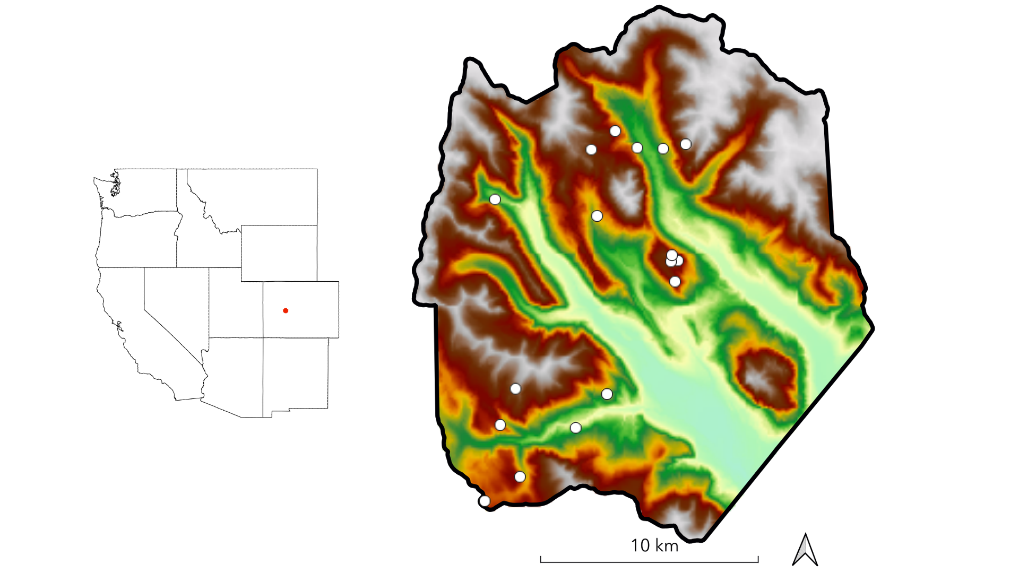

**Figure 1.** The study domain spans the footprint of a June 2018 NEON AOP acquisition in the East River watershed in western Colorado. Dots indicate the locations of 0.16 ha conifer forest inventory plots. Shading is by elevation.

**Table 1.** Response (RE) and explanatory (EX) variables used in this study’s statistical analyses. Variables listed in the “Topography” category were also used in the sampling procedure to stratify inventory plots.

| Type | Category | Variable | Description | Units | Source |
| --- | --- | --- | --- | --- | --- |
| RE | Forest structure | Total number density | Total number of ITC objects per grid cell | stems ha⁻¹ | NEON LiDAR |
| RE | Forest structure | QMD | Quadratic mean of stem diameters of objects per grid cell | cm | NEON LiDAR |
| RE | Forest structure | Basal area | Sum of cross-sectional areas of stems per hectare | m² | NEON LiDAR |
| RE | Forest structure | 90th percentile height | Estimated maximum canopy height per grid cell | m | NEON LiDAR |
| RE | Forest structure | Height skew | Third moment of height distribution per grid cell | NA | NEON LiDAR |
| EX | Topography | Elevation | Elevation above sea level | m | NEON LiDAR |
| EX | Topography | Slope | dz/dxy computed in a 30 m window | degrees | NEON LiDAR |
| EX | Topography | Folded aspect | Index of cardinal aspect adjusted for higher incident radiation on SW slopes | index | NEON LiDAR |
| EX | Topography | Heat load | Potential heat load calculated according to Eq. 3 in McCune and Keon (2002) | index | NEON LiDAR |
| EX | Topography | TPI | Index of hillslope position (summit, shoulder, backslope, footslope, and toeslope) computed in 1000 m window | index | NEON LiDAR |
| EX | Topography | TWI | Terrain-driven ratio of upslope water supply to local drainage expressed as afunction of local slope and upslope contributing area per unit contour length, computed on a 100 m pixel scale | index | NEON LiDAR |
| EX | Climate | AET | Actual evapotranspiration: depth of water (mm) evaporated from the surface or transpired by plants per grid cell | m | BCM (Budo et al. 2017) |
| EX | Climate | CWD | Climatic water deficit: difference between potential evapotranspiration (PET) and AET, where PET is the total depth of water that can be evaporated or transpired given prevailing atmospheric conditions | m day⁻¹ | BCM (Budo et al. 2017) |
| EX | Climate | SWE | Snow water equivalent derived by forcing iSnobal with 50 m snow depth data from eight Airborne Snow Observatory flights | mm | ASO |
| EX | Climate | ∆SWE | Relative velocity of snow disappearance; difference between winter SWE and summer SWE divided by days between flights averaged over three flight-years | mm | ASO |
| EX | Soil | Available water capacity | Amount of plant-available water that can be stored in a unit of soil depth | mm | SSURGO |
| EX | Soil | Organic matter | Amount of decomposed plant and animal residue expressed as a weight percentage of the less than 2 mm soil material | % mass | SSURGO |
| EX | Soil | k | Amount of water that moves vertically through a unit area of soil per unit time under unit hydraulic gradient | µm sec⁻¹ | SSURGO |
| EX | Soil | Total depth | Sum of horizon depths in a soil component | cm | SSURGO |
| EX | Geology | Lithologic substrate | Distribution of rock formations | NA | Colorado Geological Survey |

**Table 2.** Measurements taken in field inventory with their units and a summary of methods.

| Measurement | Units | Method |
| --- | --- | --- |
| Species | NA | Visual identification |
| Stem height | m | Nikon Forestry Pro II hypsometer or metric tape |
| DBH | cm | Diameter tape or calipers |
| Stem geolocation | decimal degrees | decimal degrees |
| Crown illumination | unitless index | Trimble GEO-7X GNSS unit |
| Canopy position | unitless index | Visual determination |
| Life status | NA | Visual determination |
| Health status | NA | Visual inspection for death |
| Species | NA | Visual inspection for infection, damage, decay, browning, or wilting |

**Table 3.** Tree height (∆Z) and horizontal (∆XY) distance criteria for candidate searching in the matching procedure (Eysn et al. 2015).

| Tree height (Z) | ∆Z criterion | ∆Y criterion |
| --- | --- | --- |
| Z ≤ 10 m | ∆Z < 3 m | ∆XY < 3 m |
| 10 m < Z ≤ 15 m | ∆Z < 3 m | ∆XY < 4 m |
| 15 m < Z ≤ 25 m | ∆Z < 4 m | ∆XY < 5 m |
| Z > 25 m | ∆Z < 4 m | ∆XY < 5 m |

**Table 4.** Summary statistics for the best-performing runs of six individual tree delineation (ITD) algorithms. Parameters and values for each run appear in Table S1. Root mean squares were computed for results across the 17 training plots. **NOTE: THIS NEEDS TO BE UPDATED WITH A BETTER VERSION FROM DATA IN SAVIO. SAVIO’S BEEN DOWN SINCE 10/22**

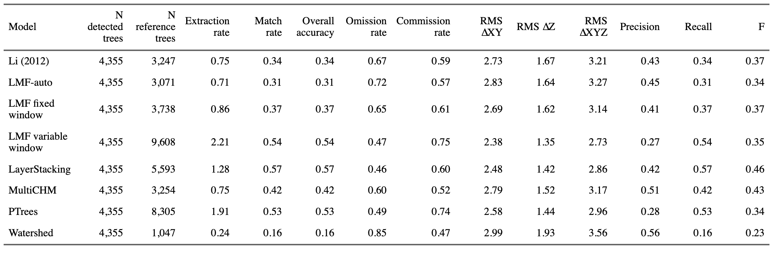

**Table 5.** User-specified parameters () applied in the LayerStacking algorithm with the optimal values found in training.

| ID | Parameter | Description | Optimal value |
| --- | --- | --- | --- |
| λ₁ | `start` | Starting height above ground at which layer divisions begin | 0.5 |
| λ₂ | `resolution` | Resolution of the CHM | 0.5 |
| λ₃ | `window1` | Window radius for the first local maximum filter for detecting tree tops | 1.2 |
| λ₄ | `buffer` | Size of the buffer enforced around each point to create a polygonal cluster | 0.5 |
| λ₅ | `hardwood` | Logical switch, where False adds weight to clusters to account for mid-canopy density in conifer stands | 0 |
| λ₆ | `window2` | Window radius for the second local maximum filter for detecting tree tops | 2 |
| λ₇ | `hmin` | Minimum height threshold, below which a new tree cannot be initiated | 1.3 |

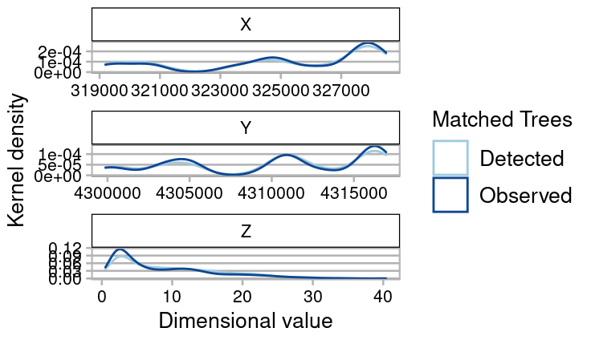 **Figure 2.** Kernel density estimate of the distributions of field-observed (dark blue) and model-detected (light blue) trees across the 17 training sites. The closer the lines are for a given dimensional value, the stronger the agreement at that value. **NOTE: THIS NEEDS TO BE UPDATED WITH A BETTER VERSION STORED ON SAVIO. THE OTHER VERSION INCLUDES LINES FOR UNMATCHED OBSERVED TREES. SAVIO’S BEEN DOWN SINCE 10/22**

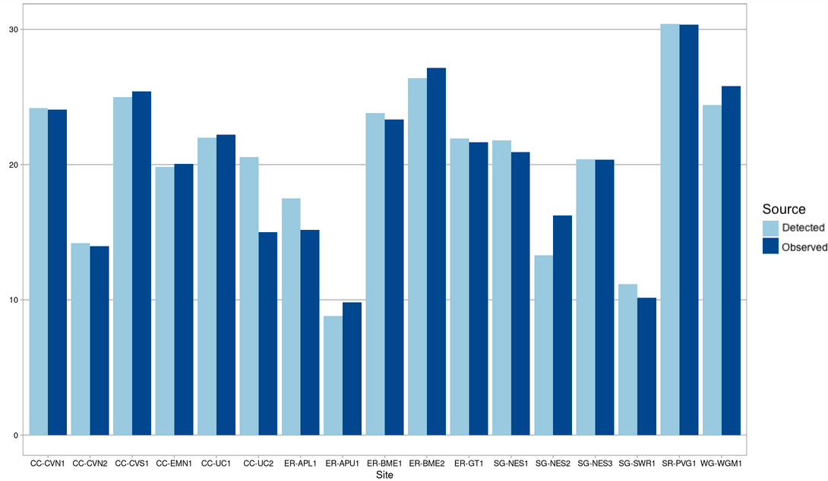 **Figure 3.** Bar-graph comparison of height between matched trees across the 17 training sites. Light shading corresponds to detected trees, while dark shading corresponds to field-observed trees. **NOTE: THIS NEEDS TO BE UPDATED WITH A BETTER VERSION STORED ON SAVIO. THE OTHER VERSION INCLUDES STACKED BARS FOR UNMATCHED OBSERVED TREES. SAVIO’S BEEN DOWN SINCE 10/21**

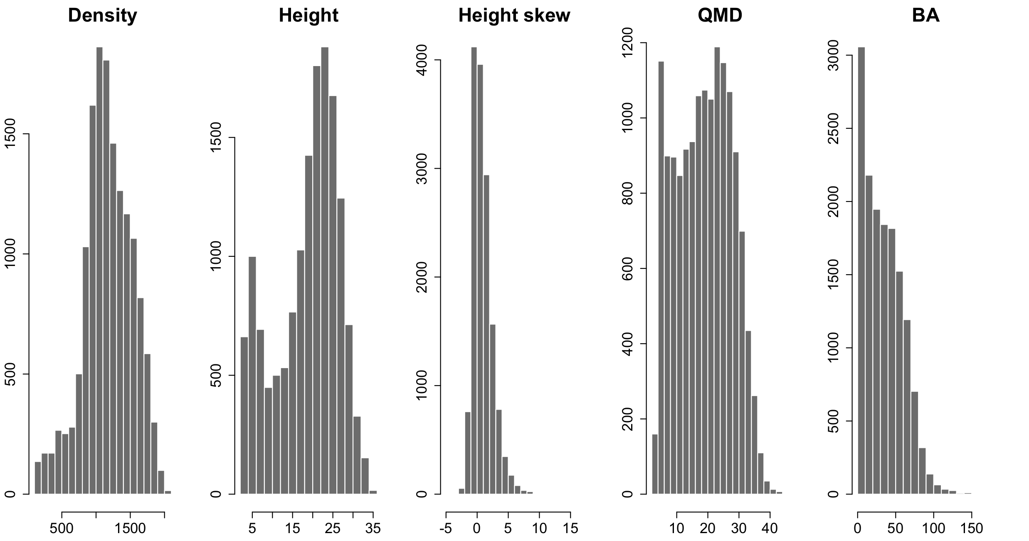

**Figure 4.** Frequency distribution of structural values for predicted trees across the full forested domain.

**Table 7.** Percent of total variance explained (TVE) and validation RMSE for GAM. Out-of-bag RMSE and validation RMSE for GBM.

| Response | GBM CV error | GBM test error | GAM % TDE | GAM test error |
| --- | --- | --- | --- | --- |
| Height 90p | 5.36 | 5.40 | 0.56 | 4.97 |
| Basal area | 17.52 | 18.19 | 0.55 | 17.53 |
| QMD | 5.78 | 5.85 | 0.60 | 5.38 |
| Height skew | 1.19 | 1.22 | 0.51 | 1.18 |
| Density | 299.76 | 310.30 | 0.35 | 280.78 |

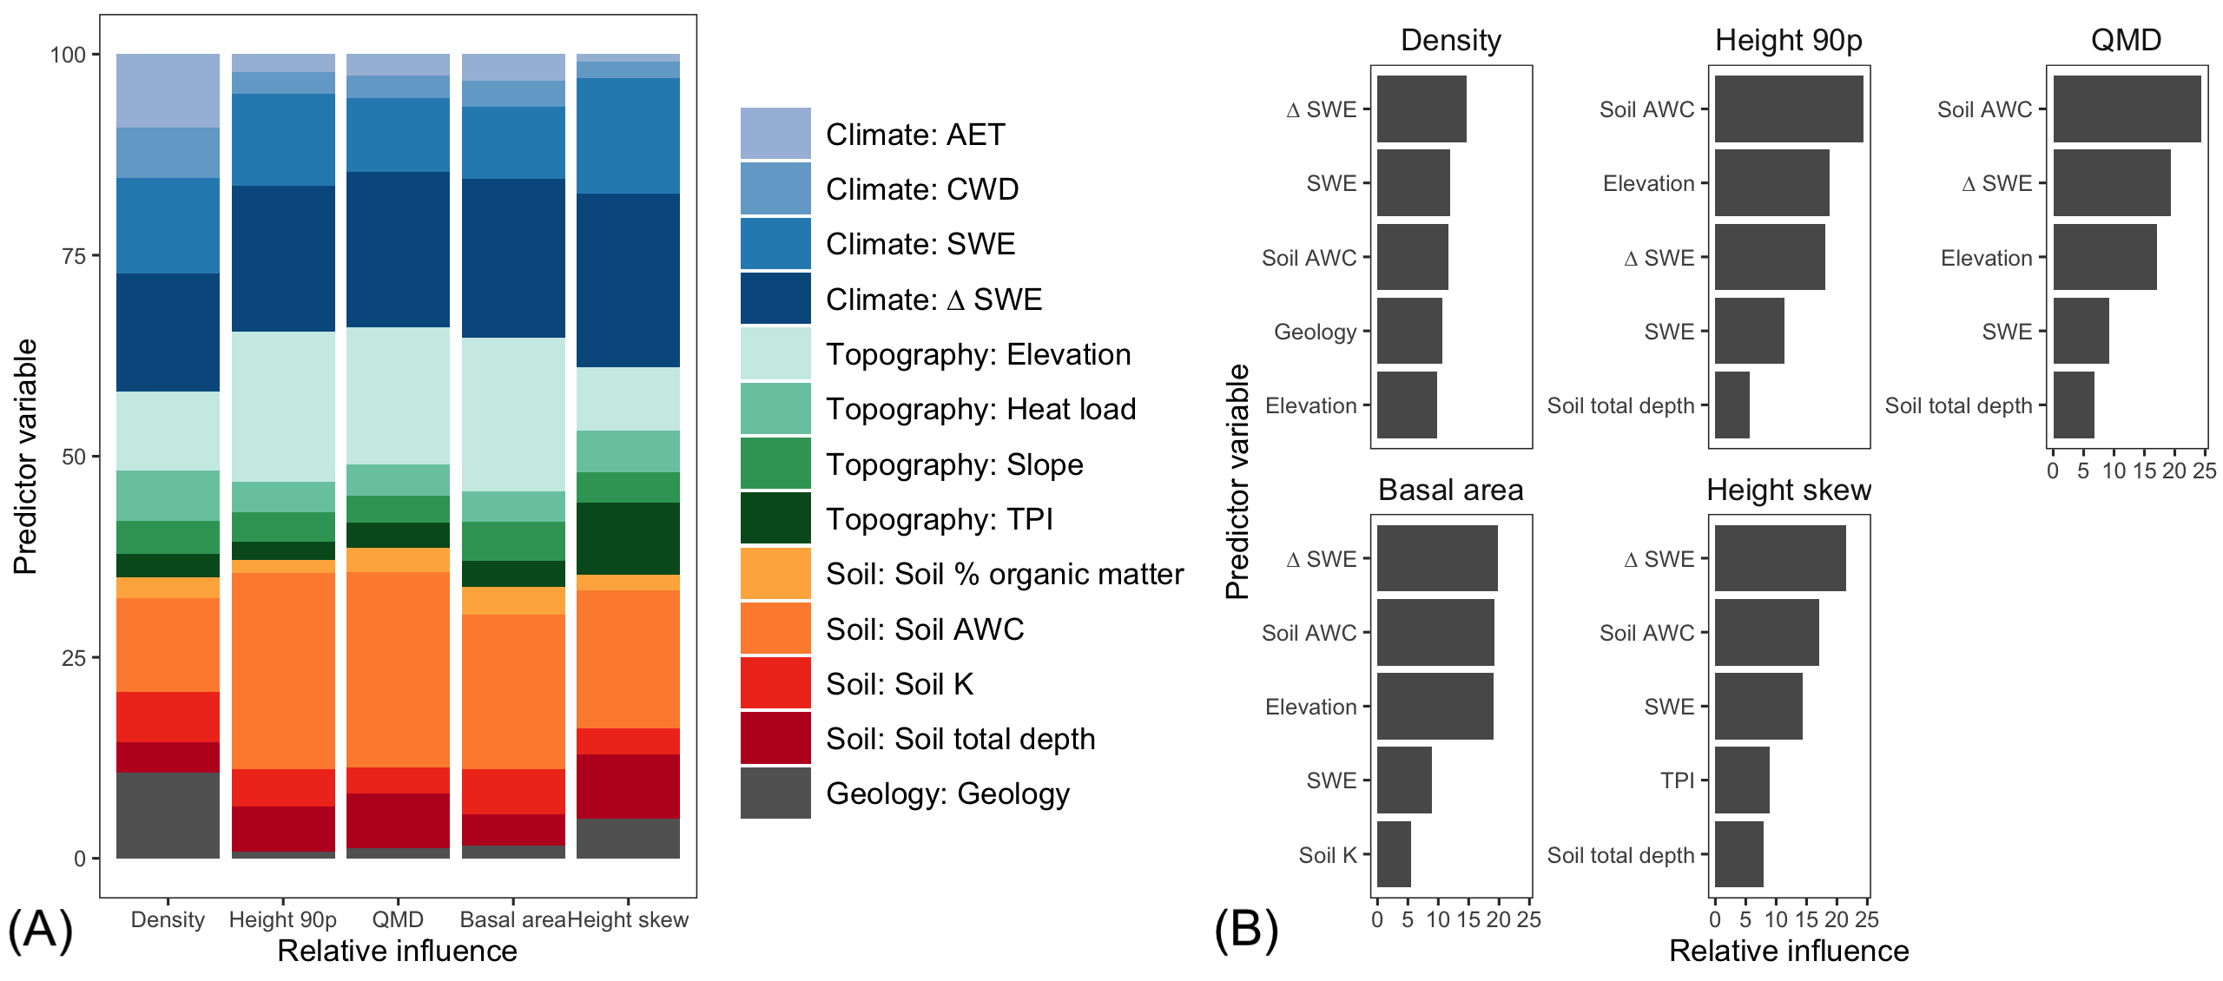 **Figure 5.** Relative variable influence in GBM for all predictor variables (A) and for the five most influential variables for each response (B). In (A), variable categories are clustered by color ramp (climate=blue, soil=red-orange, topography=green, geology=grey) Shading within groups is arbitrary. Readers are referred to the digital version of the paper for color interpretation. In (B), predictors are ranked in order of their relative contribution to variance explained, averaged over all splits.

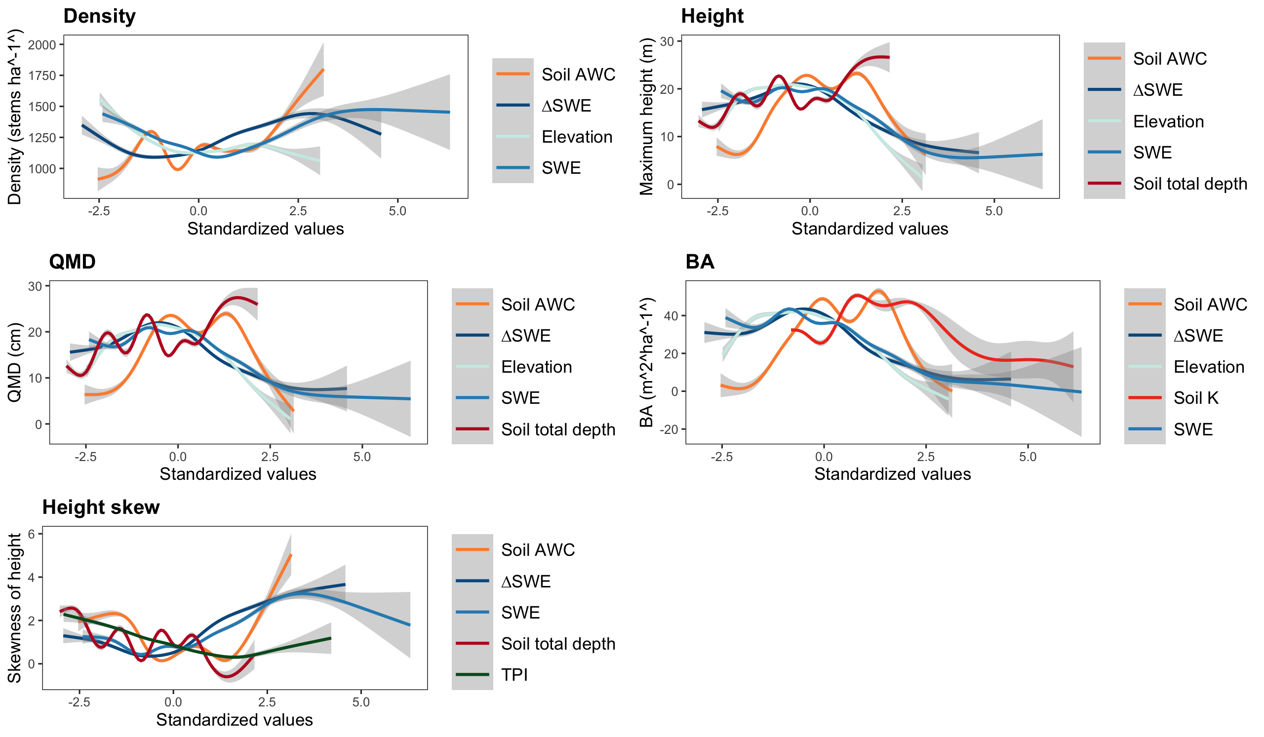

**Figure 6.** Partial effects plots from GAM on the five forest structure responses for the five most important variables identified for each response through GBM. All relationships presented here were significant in GAM. Note that the figure for Density shows only four variables. The fifth most important explainer for density was geology, which is not well displayed in this format. Geology is discussed in 3.3

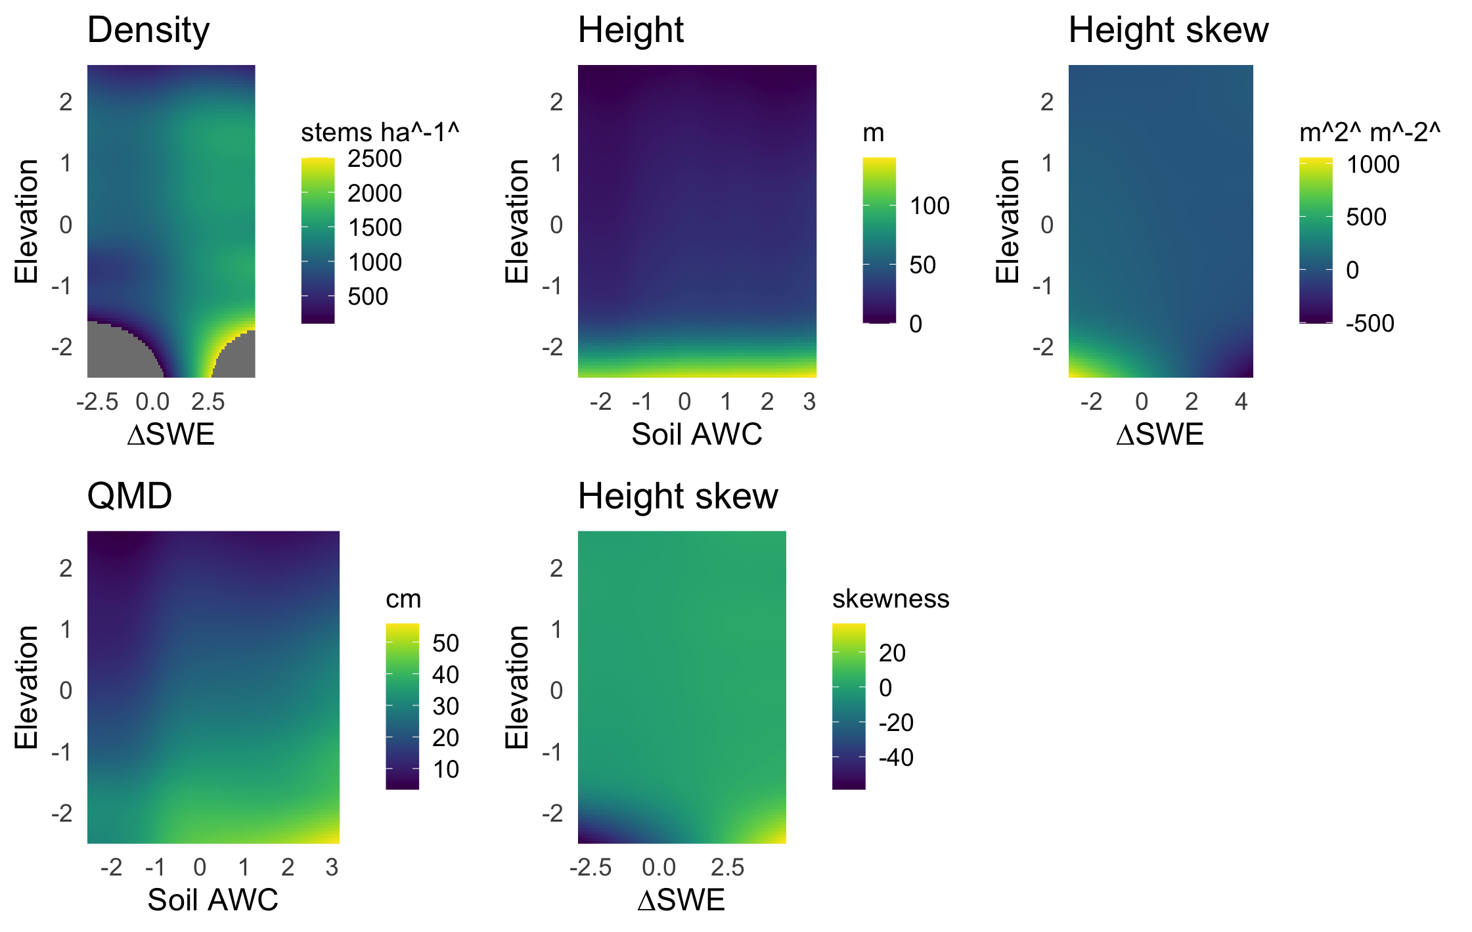 **Figure 7.** Variable interaction plots demonstrate the strong, nonlinear elevational control on density (A), maximum height (B), QMD (C), and BA (D). Interaction plots show the two strongest explainers of each response variable. The influence of elevation is mediated by SWE, slope angle, soil AWC, and soil organic matter, respectively.

# Supplementary Information

**Figure S1.** Distributions of inventory plots along six topographic gradients.

**Table S1.** Algorithms, parameters, and vectors of values applied on those parameters in ITD training and validation.

|  |  |  |  |  |
| --- | --- | --- | --- | --- |
|  | Algorithm | Parameter | Description | Tested values |
| 1 | Li (2012) | dt1 | Threshold 1. Refer to p. 79 in Li et al. (2012) | 0.5, 1.0, 1.5, 2.0 |
|  |  | dt2 | Threshold 2. Refer to p. 79 in Li et al. (2012) | 0.5, 1.0, 1.5, 2.0 |
|  |  | hmin | Minimum height threshold in m, below which a new tree cannot be initiated | 1.3 |
|  |  | R | Search radius. Refer to p. 79 in Li et al. (2012) | 0, 1, 2 |
|  |  | Zu | Height switch for dt1 and dt2. Use dt1 unless point height > Zu; then use dt2 | 14, 15, 16 |
| 2 | LMF-auto (Jean-Romain et al. *in prep*) | NA | LMF-auto is parameterless by design | NA |
| 3 | LMF fixed-window (Popescu and Wynne 2004) | ws | Window size: side length or diameter of the moving window used to detect the local maxima | The sequence 0.2:10.0 incrementing by 0.2 |
|  |  | shape | Shape of the window, either circular or square | circular, square |
|  |  | hmin | Minimum height threshold in m, below which a new tree cannot be initiated | 1.3 |
| 4 | LMF variable-window (Popescu and Wynne 2004) | b0 | First coefficient, β_0 on the function for computing variable-window size: | 0.5, 1.0, 1.5, 2.0, 2.5 |
|  |  | b1 | Second coefficient β_1 on the variable window size function | 0.02, 0.04, 0.06, 0.08, 0.10, 0.12, 0.14, 0.16 |
|  |  | c0 | Third coefficient β_2 on the variable window size function | 1, 2, 3, 4, 5 |
|  |  | shape | Shape of the window, either circular or square | circular, square |
|  |  | hmin | Minimum height threshold in m, below which a new tree cannot be initiated | 1.3 |
| 5 | LayerStacking (Ayrey 2017) | start | the starting height above ground at which layer divisions begin | 0.5 |
|  |  | resolution | Resolution of the CHM | 0.5, 1 |
|  |  | window1 | window radius for the first local maximum filter for detecting tree tops | 1, 2, 3 |
|  |  | buffer | size of the buffer enforced around each point to create a polygonal cluster | 1, 2, 3 |
|  |  | hardwood | logical switch, where False adds weight to clusters to account for mid-canopy density in conifer stands | F |
|  |  | window2 | window radius for the second local maximum filter for detecting tree tops | 0.2, 0.4, 0.6, 0.8 |
|  |  | hmin | Minimum height threshold in m, below which a new tree cannot be initiated | 1.3 |
| 6 | MultiCHM (Eysn 2015) | resolution | Resolution of the CHM | 0.5, 1 |
|  |  | layer_thickness | The eliminating layer in the original paper is defined as a layer of `layer_thickness` m below the current CHM. Refer to Eysn 2015 p. 1728). | 0.25, 0.5 |
|  |  | dist_2d | 2D threshold for delineating a tree from local maximum. A tree is created if no other detected tree lies within this distance | 0.1, 0.25, 0.5, 1, 2 |
|  |  | dist_3d | 3D threshold for delineating a tree from local maximum. A tree is created if no other detected tree lies within this distance | 0.5, 1, 3, 5 |
| 7 | PTrees (Vega 2014) | k | Number of nearest neighbors to use in search. Refer to Vega (2014). | Forward and reverse permutations of: {5, 6, 7, 8, 10, 12, 15, 20, 25, 30, 40, 60, 80, 100} |
|  |  | hmin | Minimum height of a detected tree. Addition not in the original paper included to reduce oversegmentation. | 1.3 |
| 8 | Inverted watershed (Koch et al. 2006) | resolution | Resolution of the CHM | 0.5, 1, 1.5, 2 |
|  |  | th_tree | Minimum height threshold in m, below which a new tree cannot be initiated | 1.3 |
|  |  | subcircle_size | radius of circles used to rasterize the point cloud to CHM | 0.1, 0.2, 0.3, 0.4, 0.5, 0.6, 0.7, 0.8 |
|  |  | kernel_size | Size of kernel to smoothe CHM before applying watershed algorithm | 3, 5, 9, 15 |
|  |  | tolerance | Minimum Z distance between a tree candidate's highest point and the point where it contacts another tree. If Z distance < tolerance, the object is merged with its highest neighbor. | 1 |
|  |  | ext | Search radius in pixels for neighboring trees | 1 |

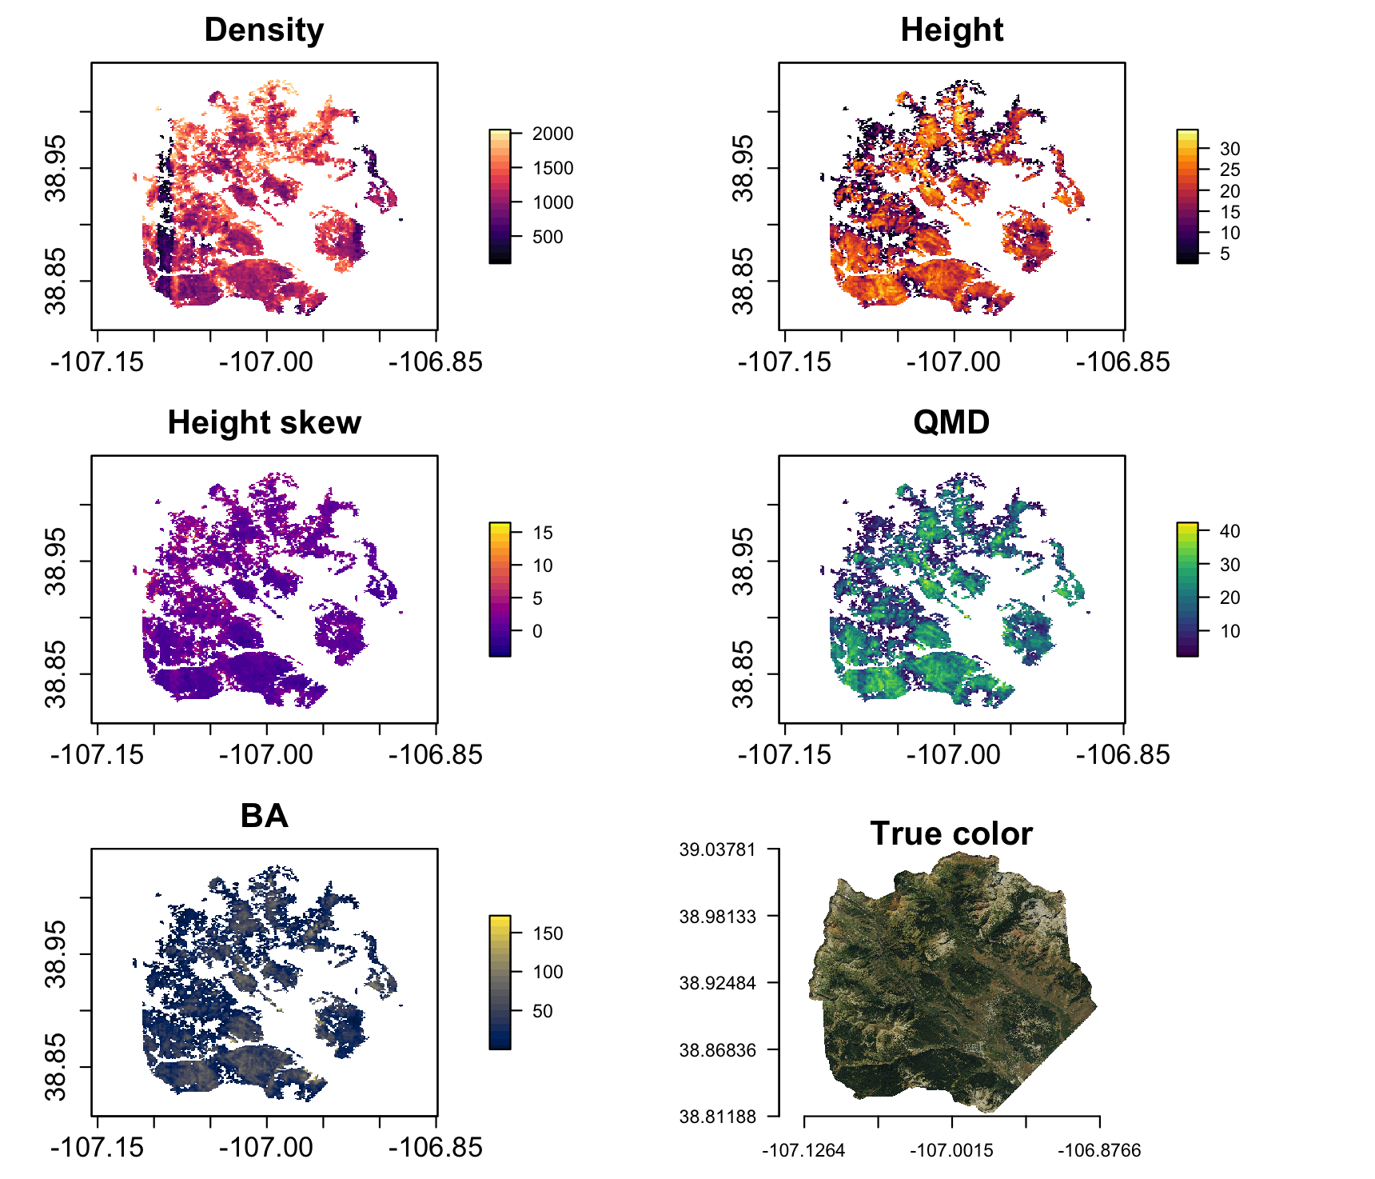

**Figure S2.** Raster images of forest structure variables with a true-color RGB composite produced from the USDA NRCS National Aerial Imaging Program imagery acquired in 2019 (bottom right). Forest struture metrics are masked to areas with conifer forest cover exceeding 100 stems ha-1 in density.

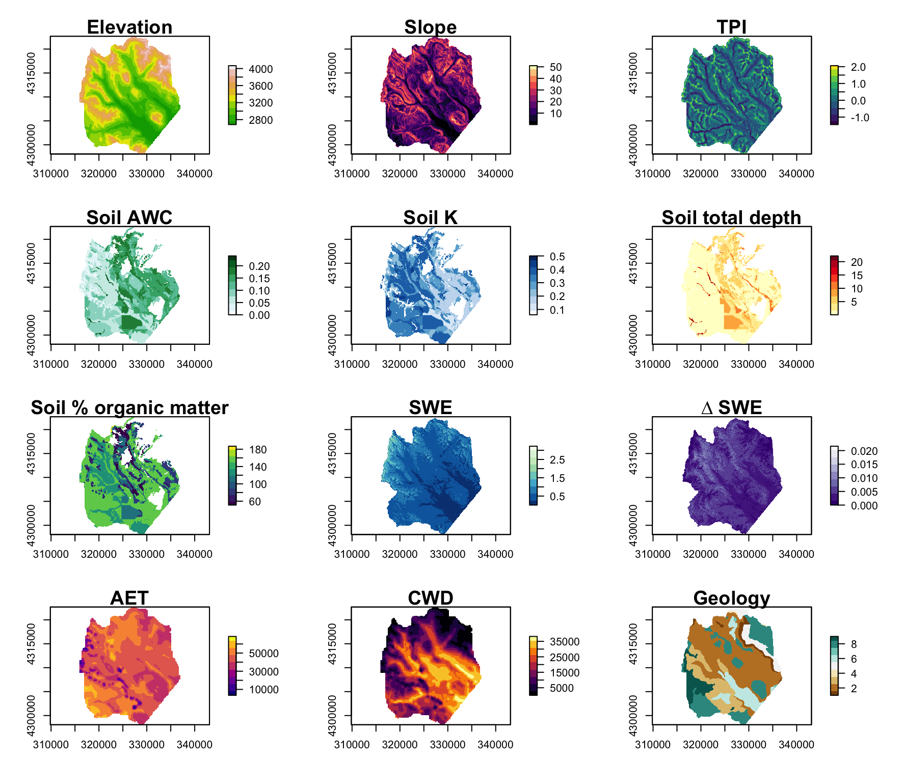 **Figure S3.** Raster images of abiotic explanatory variables. For geology, the numeric scale [1-9] corresponds denotes the following lithologic groups: [1] Dakota Sandstone, [2] Mancos Shale, [3] Mesa Verde Formation (Sand/Silt/Coal), [4] Gothic Formation (Sand/Shale), [5] Maroon Formation (Red Sand/Mud/Conglomerate), [6] Glacial Drift, [7] Landslide Deposits, [8] Middle-Tertiary Granodioritic Laccoliths, [9] Wasatch Formation (Claystone-Shale).

**Figure S4.**

# References

Anderson, K., Hancock, S., Disney, M., Gaston, K.J., 2016. Is waveform worth it? A comparison of LiDAR approaches for vegetation and landscape characterization. Remote Sensing in Ecology and Conservation 2, 5–15. <https://doi.org/10.1002/rse2.8>

Antonarakis, A.S., Munger, J.W., Moorcroft, P.R., 2014. Imaging spectroscopy- and lidar-derived estimates of canopy composition and structure to improve predictions of forest carbon fluxes and ecosystem dynamics. Geophysical Research Letters 41, 2535–2542. <https://doi.org/10.1002/2013GL058373.>

Antonarakis, A.S., Saatchi, S.S., Chazdon, R.L., Moorcroft, P.R., 2011. Using Lidar and Radar measurements to constrain predictions of forest ecosystem structure and function. Ecological Applications 21, 1120–1137. <https://doi.org/10.1890/10-0274.1>

Ayrey, E., Fraver, S., Kershaw, J.A., Kenefic, L.S., Hayes, D., Weiskittel, A.R., Roth, B.E., 2017. Layer Stacking: A Novel Algorithm for Individual Forest Tree Segmentation from LiDAR Point Clouds. Canadian Journal of Remote Sensing 43, 16–27. <https://doi.org/10.1080/07038992.2017.1252907>

Bolstad, P.V., Elliott, K.J., Miniat, C.F., 2018. Forests, shrubs, and terrain: Top‐down and bottom‐up controls on forest structure. Ecosphere 9. <https://doi.org/10.1002/ecs2.2185>

Chadwick, K.D., Brodrick, P.G., Grant, K., Goulden, T., Henderson, A., Falco, N., Wainwright, H., Williams, K.H., Bill, M., Breckheimer, I., Brodie, E.L., Steltzer, H., Williams, C.F.R., Blonder, B., Chen, J., Dafflon, B., Damerow, J., Hancher, M., Khurram, A., Lamb, J., Lawrence, C.R., McCormick, M., Musinsky, J., Pierce, S., Polussa, A., Hastings Porro, M., Scott, A., Singh, H.W., Sorensen, P.O., Varadharajan, C., Whitney, B., Maher, K., 2020. Integrating airborne remote sensing and field campaigns for ecology and Earth system science. Methods in Ecology and Evolution 11, 1492–1508. <https://doi.org/10.1111/2041-210X.13463>

Dalponte, M., Bruzzone, L., Gianelle, D., 2011. A system for the estimation of single-tree stem diameter and volume using multireturn LIDAR data. IEEE Transactions on Geoscience and Remote Sensing 49, 2479–2490. <https://doi.org/10.1109/TGRS.2011.2107744>

Dalponte, M., Coomes, D.A., 2016. Tree-centric mapping of forest carbon density from airborne laser scanning and hyperspectral data. Methods in Ecology and Evolution 7, 1236–1245. <https://doi.org/10.1111/2041-210X.12575>

De Reu, J., Bourgeois, J., Bats, M., Zwertvaegher, A., Gelorini, V., De Smedt, P., Chu, W., Antrop, M., De Maeyer, P., Finke, P., Van Meirvenne, M., Verniers, J., Crombé, P., 2013. Application of the topographic position index to heterogeneous landscapes. Geomorphology 186, 39–49. <https://doi.org/10.1016/j.geomorph.2012.12.015>

Eysn, L., Hollaus, M., Lindberg, E., Berger, F., Monnet, J.-M., Dalponte, M., Kobal, M., Pellegrini, M., Lingua, E., Mongus, D., Pfeifer, N., 2015. A Benchmark of Lidar-Based Single Tree Detection Methods Using Heterogeneous Forest Data from the Alpine Space. Forests 6, 1721–1747. <https://doi.org/10.3390/f6051721>

Fricker, G.A., Synes, N.W., Serra-Diaz, J.M., North, M.P., Davis, F.W., Franklin, J., 2019. More than climate? Predictors of tree canopy height vary with scale in complex terrain, Sierra Nevada, CA (USA). Forest Ecology and Management 434, 142–153. <https://doi.org/10.1016/j.foreco.2018.12.006>

Hansen, B.B., Klopfer, S.O., 2006. Optimal Full Matching and Related Designs via Network Flows. Journal of Computational and Graphical Statistics 15, 609–627. <https://doi.org/10.1198/106186006X137047>

Hurtt, G.C., Dubayah, R., Drake, J., Moorcroft, P.R., Pacala, S.W., Blair, J.B., Fearon, M.G., 2004. Beyond potential vegetation: Combining lidar data and a height-structured model for carbon studies. Ecological Applications 14, 873–883. <https://doi.org/10.1890/02-5317>

Jucker, T., Caspersen, J., Chave, J., Antin, C., Barbier, N., Bongers, F., Dalponte, M., Ewijk, K.Y. van, Forrester, D.I., Haeni, M., Higgins, S.I., Holdaway, R.J., Iida, Y., Lorimer, C., Marshall, P.L., Momo, S., Moncrieff, G.R., Ploton, P., Poorter, L., Rahman, K.A., Schlund, M., Sonké, B., Sterck, F.J., Trugman, A.T., Usoltsev, V.A., Vanderwel, M.C., Waldner, P., Wedeux, B.M.M., Wirth, C., Wöll, H., Woods, M., Xiang, W., Zimmermann, N.E., Coomes, D.A., 2017. Allometric equations for integrating remote sensing imagery into forest monitoring programmes. Global Change Biology 23, 177–190. <https://doi.org/10.1111/gcb.13388>

Kane, V.R., Lutz, J.A., Alina Cansler, C., Povak, N.A., Churchill, D.J., Smith, D.F., Kane, J.T., North, M.P., 2015. Water balance and topography predict fire and forest structure patterns. Forest Ecology and Management 338, 1–13. <https://doi.org/10.1016/j.foreco.2014.10.038>

Lydersen, J., North, M., 2012. Topographic Variation in Structure of Mixed-Conifer Forests Under an Active-Fire Regime. Ecosystems 15, 1134–1146. <https://doi.org/10.1007/s10021-012-9573-8>

Mallet, C., Bretar, F., 2009. Full-waveform topographic lidar: State-of-the-art. ISPRS Journal of Photogrammetry and Remote Sensing 64, 1–16. <https://doi.org/10.1016/j.isprsjprs.2008.09.007>

McCune, B., Keon, D., 2002. Equations for potential annual direct incident radiation and heat load. Journal of Vegetation Science 13, 603–606. <https://doi.org/10.1111/j.1654-1103.2002.tb02087.x>

Painter, T., 2018. ASO L4 lidar snow water equivalent 50m UTM grid, version 1. <https://doi.org/10.5067/M4TUH28NHL4Z>

Pang, Y., Wang, W., Du, L., Zhang, Z., Liang, X., Li, Y., Wang, Z., 2021. Nyström-based spectral clustering using airborne LiDAR point cloud data for individual tree segmentation. International Journal of Digital Earth 14, 1452–1476. <https://doi.org/10.1080/17538947.2021.1943018>

Stephenson, N., 1998. Actual evapotranspiration and deficit: Biologically meaningful correlates of vegetation distribution across spatial scales. Journal of Biogeography 25, 855–870. <https://doi.org/10.1046/j.1365-2699.1998.00233.x>

Underwood, E.C., Viers, J.H., Quinn, J.F., North, M., 2010. Using topography to meet wildlife and fuels treatment objectives in fire-suppressed landscapes. Environmental Management 46, 809–819. <https://doi.org/10.1007/s00267-010-9556-5>

Urban, D.L., Miller, C., Halpin, P.N., Stephenson, N.L., 2000. Forest gradient response in Sierran landscapes: The physical template. Landscape Ecology 15, 603–620. <https://doi.org/10.1023/A:1008183331604>

Zhou, T., Popescu, S., 2019. Waveformlidar: An R package for waveform LiDAR processing and analysis. Remote Sensing 11, 1–19. <https://doi.org/10.3390/rs11212552>

Zhou, T., Popescu, S.C., Krause, K., Sheridan, R.D., Putman, E., 2017. Gold – A novel deconvolution algorithm with optimization for waveform LiDAR processing. ISPRS Journal of Photogrammetry and Remote Sensing 129, 131–150. <https://doi.org/10.1016/j.isprsjprs.2017.04.021>