State-factor controls on subalpine forest structure

Hugh M. Worsham, Energy and Resources Group, U. C. Berkeley

Haruko M. Wainwright, Massachusetts Institute of Technology

Thomas L. Powell, Sewanee College

Nicola Falco, Lawrence Berkeley National Lab

Lara M. Kueppers, Energy and Resources Group, U.C. Berkeley, Lawrence Berkeley National Lab

March 05, 2023

Abstract goes here.

# 1. Introduction

One strain of thinking in ecology holds that ecosystem development is a function of five state factors: topography, parent material, climate, organisms, and time (Amundson and Jenny, 1997; Jenny, 1961). Forest stand structure and composition are two emergent properties of ecosystem development that can be evaluated in terms of continuous variables observed at a given point in time.

## 1.1 Variability in forest structure and composition

### 1.1.1 Forest structure and topography

Topographic properties such as elevation, slope, hillslope position, curvature, and aspect substantially influence local microclimate and soil moisture variability (Dobrowski 2011).

### 1.1.2. Forest composition and topography

In subalpine forests of the southern Rocky Mountains (SRM), some clear topography-driven controls on species occurrence exist. Engelmann spruce (*Picea engelmannii*) and subalpine fir (*Abies lasiocarpa*) tend to co-occur in high densities throughout the subalpine zone (~2700–-3000 m a.s.l.) and only sparsely in the upper montane zone (~1850–2900 m a.s.l.).

We addressed the following questions:

1. To what extent are tree stem height and diameter distributions, total number density, and basal area influenced by the elevation, slope, hillslope position, solar radiation, aspect, and topographic wetness of a site?
2. To what extent are species distributions influenced by the same topographic factors?
3. How do the specified topographic factors interact to mediate these relationships?

To address these questions, we integrated a full-waveform LiDAR dataset acquired over Colorado’s East River watershed with [a species classification map derived from imaging spectrometry and] field inventory measurements of 7000+ trees to quantify the spatial variability of forest canopy structure through the vertical profile, as well as stand structure and composition. We then used inferential modeling techniques to quantify the relative importance of state-factor controls on forest stand structure and composition, as estimated at a single point and time.

# 2. Data and methods

## 2.1. Study area

The domain for this project comprised montane-subalpine conifer forest stands in Colorado’s East River watershed (38°55’ N, 106°56’ W; Fig. 1). The East River is a headwater tributary of the Colorado River, the principal freshwater source for one in 10 people in the U.S. (U.S. Department of the Interior Bureau of Reclamation 2012).

## 2.2 Math

We applied an adaptive Gaussian decomposition algorithm to fit one or more Gaussian models to the return pulse components based on Equation 2:

(2) where is the amplitude of waveform component , is the bin location of (measured as a point in time, ns), is the standard deviation of , and is a penalty parameter that minimizes model residual over a specified number of iterations.

## Code

Fitting was accomplished using the nlsLM in the R package minpack.lm.

# 3. Results

## 3.1 Field census

In the 17 sites situated within the NEON LiDAR coverage area, we made observations of 5828 trees, of which 5416 were living at the time of observation. Median height across all species was 5.6 m (s.d. 7.2 m). The large standard deviation suggests a long tail of large-statured trees, consistent with the characteristically negative exponential shape of height frequency distribution curves. Quadratic mean diameter across all species was 18.1 cm. Summary statistics per species and per site appear in Tables 4 and 5, respectively. Diameter distributions across plots and by species appear in Fig. 3.

4163 trees were geotagged with a GPS unit. Another 680 were geolocated by measuring the direction and distance from a geolocated reference tree. In total, 5899 of the 7361 (89.4 percent) of stems surveyed received geotags. Those without geolocations were either dead or less than 3 m in height and fully suppressed beneath the canopy of another tree, so that it was extremely unlikely for tree crown segmentation to differentiate the suppressed tree from the dominant. For geotagged trees, mean horizontal precision as recorded by the GPS unit was 1.01 m (s.d = 0.70 m).

# Conclusions

# References

Amundson, R., Jenny, H., 1997. On a State Factor Model of Ecosystems. BioScience 47, 536–543. <https://doi.org/10.2307/1313122>

Bolstad, P.V., Elliott, K.J., Miniat, C.F., 2018. Forests, shrubs, and terrain: Top‐down and bottom‐up controls on forest structure. Ecosphere 9. <https://doi.org/10.1002/ecs2.2185>

Dalponte, M., Coomes, D.A., 2016. Tree-centric mapping of forest carbon density from airborne laser scanning and hyperspectral data. Methods in Ecology and Evolution 7, 1236–1245. <https://doi.org/10.1111/2041-210X.12575>

Jenny, H., 1961. Derivation of State Factor Equations of Soils and Ecosystems. Soil Science Society of America Journal 25, 385–388. <https://doi.org/10.2136/sssaj1961.03615995002500050023x>

Kane, V.R., Lutz, J.A., Alina Cansler, C., Povak, N.A., Churchill, D.J., Smith, D.F., Kane, J.T., North, M.P., 2015. Water balance and topography predict fire and forest structure patterns. Forest Ecology and Management 338, 1–13. <https://doi.org/10.1016/j.foreco.2014.10.038>

Lookingbill, T., Urban, D., 2004. An empirical approach towards improved spatial estimates of soil moisture for vegetation analysis. Landscape Ecology 19, 417–433. <https://doi.org/10.1023/B:LAND.0000030451.29571.8b>

Lydersen, J., North, M., 2012. Topographic Variation in Structure of Mixed-Conifer Forests Under an Active-Fire Regime. Ecosystems 15, 1134–1146. <https://doi.org/10.1007/s10021-012-9573-8>

McNab, W.H., 1993. A topographic index to quantify the effect of mesoscale landform on site productivity. Canadian Journal of Forest Research 23, 1100–1107. <https://doi.org/10.1139/x93-140>

# Figures and Tables

## Figure

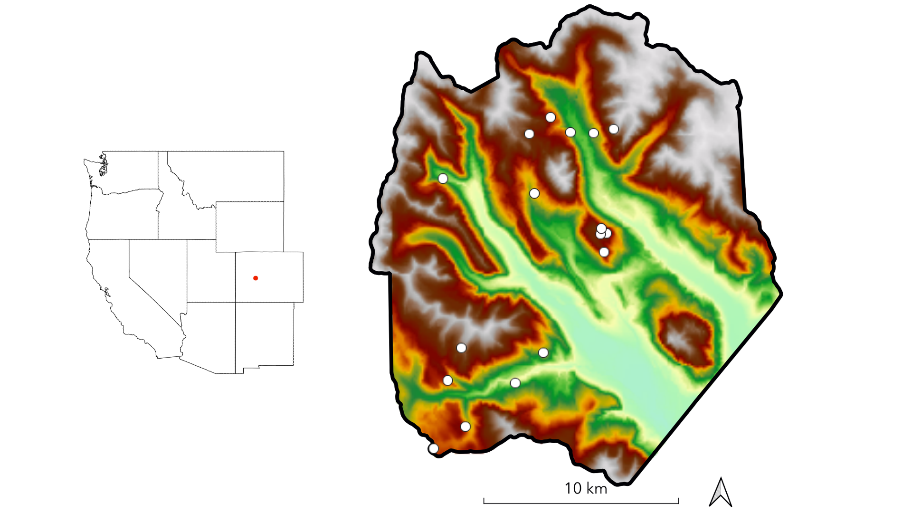

**Figure 1.** The study domain spans the footprint of a June 2018 NEON AOP acquisition in the East River watershed in western Colorado. Dots indicate the locations of 0.16 ha conifer forest inventory plots. Shading is by elevation.

# Table

**Table 1.** Description and units of topographic variables used for field plot selection.

|  |  |  |
| --- | --- | --- |
| Variable | Description | Units |
| Elevation | Elevation above sea level | m |
| Slope | dy/dx computed in a 30 m window | degrees |
| Folded aspect | Index of cardinal aspect adjusted for higher incident radiation on SW slopes | unitless index |
| Heat load | Potential heat load calculated according to Eq. 3 in McCune and Keon (2002) | unitless index |
| Topographic position index | Index of hillslope position (summit, shoulder, backslope, footslope, and toeslope) computed in 1000 m window | unitless index |
| Topographic wetness index | Terrain-driven balance of upslope water supply and local drainage (a function of local slope and upslope contributing area per unit contour length) | unitless index |

# Code block

kable(full_unq_inv %>%  
 group_by(Sp_Code) %>%  
 summarise('N'=n(),  
 'Median height (m)'=round(median(Height_Avg_M, na.rm=T),0),  
 'Median DBH (cm)'=round(median(DBH_Avg_CM, na.rm=T),1),  
 'Stem Density (stems ha^-1)'=round(n()/2.72,0),  
 'Basal area (m^2 ha^-1)'=round(sum(pi*(DBH_Avg_CM/2)^2, na.rm=T)/2.72*(10^-4),1)))