**Edaphic and topographic factors explain subalpine forest structure variability more than climate alone**

Hugh M. Worsham, Energy and Resources Group, U. C. Berkeley

Haruko M. Wainwright, Department of Nuclear Science and Engineering, Massachusetts Institute of Technology

Thomas L. Powell, Sewanee College

Nicola Falco, Lawrence Berkeley National Lab

Lara M. Kueppers, Energy and Resources Group, U.C. Berkeley, Lawrence Berkeley National Lab

October 20, 2023

Abstract

# 1 1. Introduction

Abiotic constraints are important for explaining variability in forest structure from scales ranging from hillslope to continent. At continental to global scales, climate factors (namely, the orthogonal vectors of actual evapotranspiration AET and climatic water deficit (CWD; the difference between potential and actual ET)) consistently emerge as the strongest constraints. However, at finer scales, such as that of a watershed or basin, synoptic climate appears to have less of an influence than other locally varying factors. At landscape (~ 10^3 to 10^6 m2) and watershed scales (~ 10^2 to 10^3 m2), microtopographic variation exerts local influences that decouple site microclimates from regional climate. Indeed, local environments can influence precipitation input (via orography, wind sheltering, rain shadow effects); surface and subsurface storage, which can lag precipitation input on timescales from months to decades; and radiation, which drives atmospheric demand. Further, variability in soil properties directly drives plant-available water (parent material, depth, e.g.). Together, these modify site energy and water balance in ways that trees must respond to physiologically.

A consensus exists on general trends in forest structure and composition and covariance with state factors. Stem diameter, basal, area, and growth rates tend to decline with elevation, with temperature as the key limiting control. The same properties also decline from valley to ridge positions, and from polar to equatorial exposures, perhaps as a result of these factors’ influence on water supply and deficit. However, Lydersen and North (2012) reported contrary findings in a Sierra Nevada mixed conifer forest, where upper slopes had both the highest quadratic mean diameter (QMD) and the tallest trees. Kane et al. (2015), furthermore, found that topography explained little variance in forest structure in a domain with a frequent fire return interval. Fricker et al. (2019) found responses in maximum tree height to topographic, edaphic, lithologic, and climate factors at landscape/watershed scale, including nonlinear elevational control on maximum tree height. They also found that CWD and mean annual precipitation (CWD and MAP) explained the most variance in maximum tree height distribution.

While previous studies have identified general state-factor responses in forest structure and composition, to our knowledge, no study accounts for topographic, edaphic, lithologic, and climate influences on multiple stand structural and compositional properties together. Few studies directly address microclimatic heterogeneity in high-elevation complex terrain, and none account for state-variable interactions. None does the above on a spatially continuous basis, incorporating end-members on the radiative and moisture gradients along which forest stands grow.

The majority of gradient analyses use elevation, convergence, or landscape position as proxies for temperature and soil moisture (Stephenson 1998; Ng et al. 2020). A smaller subset of studies have deployed more complex metrics that combine factors such as elevation, hillslope position, aspect, and slope into quasi-independent climate-proxy variables. Urban and colleagues (2000) used elevation, slope aspect, topographic convergence, and soil depth to model a “physical template” describing the light, temperature, and soil moisture regime of a Sierra Nevada domain, and then examined the sensitivity of model-estimated forest stand basal area, fuel loading, and canopy depth to the topographic inputs. Underwood and colleagues (2010) used elevation, slope, aspect, solar radiation, and topographic wetness to divide a Sierra Nevada domain into “landscape management units” representing nine clusters of topographic variability, and examined variation in stem and species density across those units. Their effort relied on data collected *in situ* from 164 transects.

While plot- and transect-based data can provide reliable estimates of aboveground forest structure and composition when scaled up to a stand, these data are by nature limited in spatial extent and do not represent the full range of state-factor variability that may constrain the distribution of vegetation across a landscape (Hurtt et al. 2004, Antonarakis et al. 2011, Lydersen and North (2012), Antonarakis et al. 2014). Even within mature, close-canopied forests, characteristics such as stand density, age-class distribution, allometry, species composition, and species dominance can have wide variance. Efforts to scale these properties up to a watershed from plot observations (or plot-benchmarked models) alone can yield substantial error terms. Therefore, prior work may have failed to capture important dimensions of co-variability. Kane et al. (2015) and Bolstad et al. (2018) are the only studies we have identified that evaluate spatially continuous measures of topography and forest structure, although more results have been reported from tropical forests (e.g. Chadwick and Asner 2015, Jucker et al. 2018).

LiDAR integrated with field sampling [and hyperspectral remote sensing] holds promise for overcoming some of these limitations. Advances in active remote sensing, including in Light Detection and Ranging (LiDAR), have opened up new opportunities for characterizing forest structure on a continuous basis for a wide array of scientific and management applications (Mallet and Bretar 2009). In particular, over the past five years a profusion of full waveform LiDAR datasets from aerial and satellite platforms, and emerging open-source libraries for cleaning and processing the data, has enabled more accurate estimates of forest structure than those from discrete-return acquisitions (Zhou and Popescu 2017). Like discrete-return points, waveform data can be used to delineate individual canopy trees and to estimate individual-scale characteristics such as stem diameter, stem height, stem volume, and crown volume (Dalponte et al. 2011, Jucker et al. 2017). Waveforms can also be processed to generate continuous estimates of forest structure parameters at the pixel-grid scale; these parameters include aboveground biomass, leaf-area index, total number density, and diameter-class distribution. While some researchers have eschewed individual tree object–based approaches because of the difficulty of characterizing subcanopy structure with dicrete-return data, a profusion of new algorithms aimed at waveform and hyper-dense point clouds has made it increasingly possible to achieve individual-based structure estimates. Using the full waveforms appears to improve the accuracy of both object-oriented and continuous-estimate methods over discrete-return estimates, particularly for characterizing mid-canopy and sub-canopy structure. Integrating waveforms with imaging spectrometry and calibrating remote sensing against *in situ* stem diameter and height measurements yields further accuracy improvements (Antonarakis et al. 2011, Jucker et al. 2017).

Our primary objective in this study was to quantify relationships between forest structure and abiotic environmental drivers of stand structural development in subalpine forests broadly representative of low-diversity forests across the Southern Rocky Mountains.

We addressed the following questions:

1. Which topographic, climate, and substrate variables exert the strongest influence on conifer forest stand structure?
2. To what extent do feature interactions mediate these relationships?

To address these questions, we integrated a full-waveform LiDAR dataset acquired over Colorado’s East River watershed with [a species classification map derived from imaging spectrometry and] field inventory measurements of 7000+ trees to quantify the spatial variability of forest canopy structure through the vertical profile, as well as stand structure and composition. We then used inferential modeling techniques to quantify the relative importance of state-factor controls on forest stand structure and composition, as estimated at a single point and time.

# 2 2. Methods

## 2.1 2.1. Study area

The domain for this project comprised upper montane-subalpine conifer forest stands in Colorado’s East River watershed (38°55’ N, 106°56’ W; Fig. 1). The East River is a headwater tributary of the Colorado River, the principal freshwater source for one in 10 people in the U.S. (U.S. Department of the Interior Bureau of Reclamation 2012). The 750 km2 catchment includes six major drainages with perennial snowmelt-fed streams. It also has significant topographic heterogeneity: 1420 m of elevational relief, multiple peaks extending above treeline, and pronounced gradients in slope, aspect, insolation, and hillslope position. Mean annual temperature measured at a SNOTEL site (736-Schofield) at 3261 m in the northern reach of the watershed is 1.8 º C, with maximum and minimum of 8.3 º C and –28.4 º C respectively. Mean annual precipitation is 1200 mm y–1, approximately 70 percent snow and 30 percent rain. Maximum air temperatures are depressed by wind at high elevations and minimum air temperatures by cold air downwelling at low elevations. Precipitation is also strongly influenced by elevation, with snow accumulation generally increasing upgradient. The system is driven by seasonal temperature and precipitation regimes that impose important controls on vegetation phenology. Winter snows arrive as early as September, and storms may persist into early June at the highest elevations. Snowmelt typically begins in April and continues through June. A seasonal drydown occurs in late June and July, characterized by sparse rainfall and soil desiccation as evaporative demand rises with summer temperatures (Harte et al. 1995). In most years, this seasonal moisture deficit is partially mitigated by a July–August monsoon. The driest phase occurs over August–September and can drive severe soil moisture deficits in years when the monsoon fails, as it did in 2018. In addition to these broad patterns, the domain’s stark relief and topographic complexity coordinate to produce highly variable local climatic conditions. Soils are derived from varied, primarily sedimentary material intruded by igneous laccoliths. Mancos shale is the dominant bedrock. Heterogeneous soil composition and drainage potential drives substantial variability in plant available water. The dominant tree species are *P. engelmannii*, *A. lasiocarpa*, *P. contorta*, and *Populus tremuloides*, with occasional *P. menziesii* at mid-elevations and one known population of *Pinus longaeva* near treeline on one summit.

## 2.2 2.2 Full-waveform LiDAR

Between June 12 and 26, 2018, the NEON AOP surveyed approximately 330 km2 of the watershed (Chadwick et al. 2020; Fig. 1). The AOP collected LiDAR using an Optech Gemini discrete LiDAR sensor and waveform digitizer. The LiDAR sensor’s pulse repetition frequency varied between 33 and 100 kHz. Validation was conducted using *in situ* data at 437 sites representing a range of vegetative and built land cover types.

Discrete-return point density in the post-processed dataset ranged between 1 and 9 returns , which was insufficient for characterizing subcanopy structure. We therefore elected to reprocess the full waveforms, which had a nominal density between 1 and 4 pulses . We were able to exploit the higher information density of full-waveform pulses to develop more complete characterizations of stand and canopy structure than would have been possible with discrete returns alone.

First, we used a spectral deconvolution procedure to isolate the target-response signal from its interactions with the LiDAR system’s outgoing pulse, atmospheric scattering, and sensor-system noise. We used the Gold deconvolution algorithm implemented in the waveformlidar package in the R statistical computing environment (Zhou et al. 2017), but refactored their implementation for parallel computing. The result of the algorithm approximates the true distribution of scattering objects along the outbound light pulse’s path.

The signal intensity of an outbound LiDAR pulse as a function of time is roughly Gaussian in shape. As the pulse interacts with physical objects along its path and is reflected back to the sensor, the returning backscatter cross-section can also be expressed approximately as a sum of Gaussian functions. Gaussian decomposition, therefore, allows one to characterize the components of the returning impulse (Harding 2005). We applied an adaptive Gaussian decomposition algorithm to fit one or more Gaussian models to the return pulse components based on Equation 1:

where is the amplitude of waveform component , is the bin location of (measured as a point in time, ns), is the standard deviation of , and is a penalty parameter that minimizes model residual over a specified number of iterations. The algorithm (1) rescales the returns using the minimum intensity (typically around 200 (DN) for NEON data), (2) identifies potential peaks in the waveform, and (3) iteratively fits a model to each peak. It then selects the model that minimizes root mean square error between the raw waveform and fitted values, excluding models that produce physically meaningless parameters, such as a negative . Where multiple peaks exist, the algorithm fits a separate function to each and expresses the final fit as the sum of Gaussian functions. Fitting was accomplished using the function nlsLM in the R package minpack.lm.

The deconvolution and decomposition procedures were applied to the full set of waveforms in parallel on 256 cores on the University of California, Berkeley’s high-performance computing cluster. In total, we processed approximately 1.4*109 waveform returns. Of these, a negligible fraction (approximately 0.5 percent) either had no detectable peaks or represented backscatter records that could not be fit to a Gaussian function (Fig. S1). Where peaks could not be identified, the waveforms were dropped from the set. Where they could not be estimated by a Gaussian, the characteristic components (e.g, amplitude, time to median energy) were estimated from the deconvolved returns directly, without curve fitting.

After processing, we used the geolocation matrices provided in the NEON dataset to geolocate the waveforms and extracted characteristic metrics from the fitted waveforms. These included the peaks’ location in three-dimensional space, their amplitude and width, front slope, and time to median intensity. We then used the R package lidR to discretize this information along with the geolocated waveform data. We normalized the discretized points to the earth surface by differencing their z-values against a DEM derived from the discrete-return point cloud included in the NEON dataset. We then decimated the high-density returns, preserving all of the identified peaks to obtain a discretized point cloud of points with an evenly distributed mean density of 15.3 points m-2 across the domain.

## 2.3 2.3 Field census

Between 2018 and 2022, we established 25 long-term forest monitoring plots in the East River and nearby drainages. The sites were stratified across six topographic gradients (Table 1). An initial set of 68 sites was preselected via Latin hypercube sampling on six topographic gradients derived from the USGS 1/3-arc second digital elevation model (DEM) ([TODO: cite]). The final 25 sites were selected from among that group after scouting and optimizing the distribution of the set along the topographic gradients (Fig. S2). At each site we installed a 40 m x 40 m plot, using slope corrections to approximate a projected flat-surface area of 1600 m2. To minimize edge effects, we located plots at least 100 m from forest edges, major compositional transitions, perennial streams, and ecotones.

We used a GNSS receiver (Trimble Geo 7X, Trimble, Inc.) to georeference all plot locations *in situ*. To establish absolute georeferencing we made a minimum of six measurements over multiple days at each plot corner and took the arithmetic mean of recorded coordinates, inversely weighted by reported horizontal uncertainty. Positioning data were post-processed in TerraSync (Trimble Inc.) with differential correction using the Continuously Operating Reference Stations (CORS) Network station SE01 (39.40035, -107.212101; NOAA 2020). Estimated planimetric accuracy of plot corner locations was 0.98 m.

Between 2018 and 2022 we conducted a field census of approximately 9000 trees in the 25 plots. All trees of any species with a diameter at breast height (DBH, measured at 1.3 m above the ground) 1.0 cm were labeled with an aluminum tag. For each tagged tree, we recorded species and measured diameter at breast height (DBH) using a standard metric forestry diameter tape (for stems 7 cm DBH) or calipers ( 7 cm). We measured stem heights with a Nikon LaserPro II laser hypsometer (for stems 5 m in height) or a rigid metric tape measure ( 5 m). To maximize precision, hypsometer measurements were repeated on each tree until measurements converged within 0.5 m. Expected vertical accuracy on hypsometer measurements was 1.0 m.

Stems were then geolocated using either the GNSS receiver or by measuring the direction and distance from a geolocated reference tree with a digital compass and rigid metric tape. For those positioned with the GNSS, the receiver was positioned in contact with the side of each tree stem at 1.3 m. We enforced a maximum estimated horizontal precision threshold of 1.0 m before recording, and we recorded a minimum of 30 positional observations at a rate of 1 observation s-1 for each stem. In total, 5899 (89.4 percent) of the stems surveyed were positioned. Those without unique geolocations were less than 5 m in height and were fully suppressed beneath the canopy of another tree, such that it was extremely unlikely for tree crown segmentation to differentiate the suppressed tree from the dominant. For geotagged trees, mean planimetric accuracy was 1.01 m (s.d = 0.70 m).

Seventeen of the 25 plots lay within the overflight footprint of a 2018 NEON AOP acquisition (Kampe et al. 2009). We used the observations from this subset for training and validation of models developed in the next phase of analysis. The 17 focal plots included 5828 observed trees, of which 5416 were living at the time of inventory. Median height across all species was [5.6] m (s.d. 7.2 m; Table 4 and Table 5). The large standard deviation resulted from a long tail of large-statured trees, consistent with the characteristically negative exponential shape of height frequency distribution curves. Quadratic mean diameter (Fig. 3) across all species was 18.1 cm, and mean basal area was [TODO: GET VALUE] (s.d. [TODO: GET VALUE]). Median density was [TODO: GET VALUE] trees per hectare (s.d. [TODO: GET VALUE]).

Past management and disturbance influence forest structure as it manifests on the landscape at any point in time. The legacies of logging, fire, avalanche, and pest-pathogen infestation, which, among other events, are common to Colorado’s subalpine forests, could obscure the relationship between forest vital rates, emergent structure, and underlying abiotic constraints. Logging related to the mining industry occurred in some parts of the watershed during the 19th and early 20th centuries, with a limited footprint enduring today. This said, the watershed includes large stands where little to no tree removal occurred, and stands with old trees and uneven age and size structure are well distributed. Further, prior studies have found strong associations between forest structure and factors including water-balance and soil, even in the presence of major harvest and disturbance events (Urban et al. 2000, Lyderson and North 2012, Collins et al. 2015, Stephens et al. 2015, Kane et al. 2015). We aimed to further mitigate unobserved management and disturbance effects by siting inventory plots in stands where no recent harvest or major disturbance occurred in at least the last 40 years, based on (a) visual inspection for cut stumps and remnants and (b) stability of the Normalized Difference Vegetation Index over the Landsat record (1980-present).

## 2.4 2.4. Tree crowns and stand structure

Here we detail the procedure we followed to generate an individual tree crown (ITC) map and gridded estimates of conifer forest structure (as in Dalponte and Coomes (2016)). The former comprised an object-centric map of tree crowns in conifer forest stands, with each object describing the position, height, area, and stem diameter of a tree. The latter comprised a continuous map of forest structure metrics at 10m, 40m, 100m, and 1km grid scales. To generate these products, we integrated the discretized LiDAR and inventory data to optimize and validate an individual tree delineation (ITD) model, which we then applied to delineate trees in the watershed’s remaining forested area. As we detail below, this approach iterated through many combinations of possible parameters for seven ITD algorithms; computed performance metrics at each iteration; and then selected the best performing algorithm and parameter set to apply to out-of-sample data.

First, we extracted the discretized LiDAR data intersecting the boundaries of each field plot with a 3 m buffer on all sides. We then attempted tree segmentation on the discretized data using algorithm and parameter set , where is the th algorithm, is one of several parameters taking user-specified values required for the algorithm to proceed, and is a vector of values on that parameter (Table X; Supplementary Material Table 2). After each delineation attempt, the automated matching procedure described in Eysn et al. (2015) and Pang et al. (2021) was applied to link detection results to reference observations from field inventory. We opted for an automated approach because (1) the computational scale of our method (up to 2800 delineation attempts per algorithm per site) made manual interpretation infeasible, and (2) doing so enabled us to enforce clear, objective rules for reproducibility. In early testing, we also evaluated bipartite matching strategies seeking to minimize the Euclidean and Mahalanobis distances between detected and reference trees [TODO: CITE]. We ultimately selected the Eysn (2015) approach based on superior inter-tree and inter-site matching performance.

The matching process began by selecting the tallest detected tree (“target”) and searching for candidates among reference trees satisfying Euclidean height (∆Z) and horizontal distance (∆XY) criteria specified in Table [X]. The reference candidate with the least ∆XY was chosen as a tentative match to the target. The candidates were then queried a second time. If a candidate with greater ∆XY proved closer in height to the target, and its ∆XY was at most 2.5 m more than ∆XY of the tentative match, it was selected as the match. However, since an optimal match depends not only on the neighborhood of reference trees, but also on other nearby *detected* trees, the target was then compared against other detected neighbors. If another detected tree was closer in horizontal and vertical distance to the matched reference, the pairing was discarded. This process was repeated on all remaining detected trees in descending order of height, until all reference trees had been evaluated. Matches were then removed from the set, and the process was repeated until no further matches could be found under the search criteria.

For each run of on we tallied the extracted trees, true positives (TP, or successful matches) false positives (FP, or commission errors), and false negatives (FN, or omission errors). We used these values to compute performance statistics in Table [X]. The root mean squares of all performance statistics were computed across the 17 plots as unbiased estimators of the performance of each and parameter set .

We then selected the algorithm and parameter combination that had yielded the maximum root mean square *F* score across all . *F* is a proportion representing the harmonic mean of precision (the proportion of all tree detections that were correctly matched) and recall (the proportion of all possible matches that were correctly matched). Perfect detection and match rates would yield an *F* score of 1.0, while failure would yield 0.0. It was selected as the optimization statistic over overall accuracy for its balanced sensitivity to both over- and under-detection.

Of the eight algorithms tested, LayerStacking (Ayrey et al. 2017) yielded the highest *F* score across training and testing sets (Table 4). The algorithm proceeds by first dividing the point cloud into stacked horizontal layers at 1-m intervals, starting at m above ground (a.g.) (Table 5). A series of clustering procedures is then applied to each layer. In the lowest three layers ( m a.g.), points are clustered through Density-Based Scanning (Ester et al. 1996); points within clusters are removed as non-tree low vegetation, while those lying outside clusters are retained as sparse returns from small tree boles. Next, a canopy height model (CHM) of resolution is computed from the point cloud. Tree tops are identified from the CHM using a local maximum filter (LMF) with a window of radius . Then, points in each layer undergo *k*-means clustering, using the local maxima as seeds, and a polygonal buffer of radius is placed around each resulting cluster. The polygons from each layer are then flattened and rasterized to create an intermediate “overlap map.” This abstraction quantifies the density of clusters, such that areas of high-density polygonal overlap represent individual trees. In conifer forests, this delineation can be improved with an additional parameter, , which enforces higher weighting for clusters near the canopy top, because these tend to be closer to a conifer’s center. A second LMF is applied to the overlap map, using a window of radius , and local maxima are taken to be tree centers. Additional smoothing of the local maxima, and filtering and merging of clusters, yields a set of points representing tree tops with embedded height and position information.

For the remainder of the LiDAR-surveyed domain, we subset the discretized waveforms over conifer forest by finding their intersection with conifer regions from a land-cover classification map derived from the NEON hyperspectral acquisition (Breckheimer 2021). We forced the LayerStacking algorithm with this subset of LiDAR data and the optimal parameter combination to delineate all tree crowns in the watershed’s conifer stands. The result was a spatially continuous dataset of conifer tree objects describing their locations and heights. To estimate the stem diameters of each delineated object, we used an allometric function of stem height with coefficients derived from plot observations. [TODO: write functional form].

From the crown map, we computed continuous area-based structural metrics by summarizing object-level predictions at specified grid scales across the watershed. Structural metrics included total number density, basal area, quadratic mean diameter (QMD), diameter and height percentiles, and skewness of height. Total number density (stems ha-1) was a sum of the number of trees contained in the footprint of each grid cell. Basal area (m2) was computed in each grid cell as

and expressed as the fraction of land area occupied by tree stems. QMD was also computed independently for each grid cell as

, {#eq:eqn3}

where was the number of trees in the cell. Skewness of height was the third moment of the distribution of stem heights in a grid cell. Larger positive values indicate a more positive skew, with a larger proportion of trees in smaller height classes than a normal distribution. More negative skew values indicate a negative skew, with a larger proportion of trees in larger height classes.

## 2.5 2.5. Abiotic explanatory variables

### 2.5.1 2.5.1. Topography

We generated six topographic variables from the 1-m DEM produced in LiDAR processing (see Table 1). We prioritized factors with topoclimatic leverage, i.e., those whose variability has been shown to modify the radiation or moisture budget in trees’ local growing environments (Frey et al., 2016). Elevation (m) was computed at the 100 m pixel scale by aggregating the raw DEM. Slope angle (degrees) and aspect (degrees) were computed from the elevation product with the terrain method in the R package terra with 8 neighbors, using the method in Horn (1981). We further transformed the aspect product by folding values about the 25ºNE-205ºSW line. Translating them into into a scale whose maximum occurs on SW slopes and minimum on NE slopes yields a more ecologically relevant measure of aspect-constrained exposure. The fold line we selected represented the estimated angles of highest and lowest mean annual incident radiation in the domain, given the watershed’s latitude and slope orientation. Total heat load (unitless index) was calculated from folded aspect and slope angle using the method in McCune and Keon (2002). Topographic position index (TPI) is a morphometric measure that classifies a landscape into slope position classes, from ridgetop to toeslope. We computed TPI at each pixel as the difference between the elevation at the target point and the mean elevation within a neighborhood of 9 pixels (1000 m), normalized to the standard deviation of elevation in that window (Gallant and Wilson 2000; De Reu et al. 2014). TPI values are more positive the higher a target point is than its neighborhood, and more negative the lower it is. Topographic Wetness Index (TWI) is a measure of the relative capacity of an area to accumulate water through surface or subsurface flow. We selected this metric as a proxy for relative soil moisture conditions. We used the implementation in the R package dynatopmodel, which calculates TWI ()) at each pixel as the log ratio between its upslope contributing area and slope angle (Quinn et al. 1995, Metcalfe et al. 2018).

### 2.5.2 2.5.2. Climate

To estimate relative spatial patterns of snow accumulation, we retrieved snow water equivalent (SWE) data generated by the Airborne Snow Observatory from flights on March 31, 2018, April 4, 2019, and April 21, 2022. The flights occurred before the onset of snowmelt in each season. The ASO SWE product was generated from observations of snow depth, spectral albedo, and radiative forcing from a coupled imaging spectrometer and terrestrial laser scanning system, combined with snow density modeled using iSnobal. While the data may not have captured peak snow depth in each season, by averaging across three years we were able to approximate the spatial pattern of relative accumulation across the basin. Because we were less interested in absolute accumulation values and more interested in variability across space, this seemed a justifiable decision.

We also used estimates of mean total annual actual evapotranspiration (AET) and climatic water deficit (CWD) generated through a run of the Basin Characterization Model (BCM) on the Upper Colorado Basin (Buto et al. 2017). The BCM output package is a set of gridded products that characterizes the water balance for a subject region at 270 m resolution. The model is forced with monthly timestep data and has been widely used in ecological and management applications (Flint et al. 2013). From this dataset, AET is the depth of water (mm) evaporated from the surface or transpired by plants within each pixel. CWD is calculated as the difference between potential evapotranspiration (PET) and AET, where PET is the total depth of water that can be evaporated or transpired given prevailing atmospheric conditions. Under non-limited moisture conditions, AET equals PET and CWD is 0; positive CWD values indicate a moisture deficit, or an excess of evaporative demand relative to available water in the soil. AET and CWD in our study represent the average of the annual sums of their values from 1985 to 2012 (Buto et al. 2017).

### 2.5.3 2.5.3. Soil

To evaluate edaphic effects on forest structure and composition, continuous estimates of soil properties were derived from the U.S. Geological Survey SSURGO database (Survey Soil Staff 2022). Spatially continuous soil properties are predictively modeled using an ensemble of regression, classification, and machine-learning operations on observations from in situ soil samples and a wide array of environmental predictor variables. Spatial and attribute data were retrieved from the Web Soil Survey using the keys for area symbols that intersected the study domain (‘CO654’, ‘CO660’, ‘CO661’, ‘CO662’). After joining the spatial and attribute tables, we aggregated horizon-scale data to generate a unique observation per component. For horizons within a given component, we calculated horizon depth–weighted means for the following variables in the top 100 cm of soil: available water capacity (awc_r) saturated hydraulic conductivity (k_sat), and soil pH (‘ph1to1h2o_r’). We calculated the horizon depth–weighted mean of percent organic matter (‘om_r’) in the top 30 cm of soil. We took these variables to be the most biologically relevant independent estimators of soil constraints on tree growth, and the selected soil depths as those in which the selected variables had the strongest leverage on tree growth. Initial testing also included percent sand, k, and cation exchange capacity, which either had sparse observations across the domain or were highly correlated with one or more of the other variables, so they were dropped. We calculated total soil depth as the maximum horizon depth per component. These component-scale estimates were aggregated again to the map unit scale by taking the mean value weighted by the proportion of each component represented in a map unit. The map unit associated data were then converted from vector to raster using the rasterize function in the R package terra.

### 2.5.4 2.5.4. Geology

The underlying lithologic substrate was characterized by rasterizing the Colorado Geological Survey database R-37: Geology and Mineral Resources of Gunnison County, Colorado (Morgan 2020). The vector database was created by digitizing the original sheets used to prepare the U.S. Geological Survey MI-16 Geologic Map of Colorado (Tweto 1979).

## 2.6 2.6. Inferential modeling

To evaluate our core research questions, we quantified the relationships between stand structural metrics and underlying abiotic factors. All data were first (dis-)aggregated to the 100 m pixel scale and aligned to a uniform grid using bilinear interpolation for continuous variables and nearest-neighbor resampling for categorical variables. We fit both generalized additive models (GAM) and generalized boosted models (GBM) to characterise the relationships among the explanatory and response variables.

In the GAM approach, we estimated each structural metric as the sum of nonlinear spline functions of the explanatory variables. We used the ‘gam’ implementation in the R package ‘mcgv.’ The generalized additive approach allowed us to account for nonlinearities and to uncover variable interactions. We examined the main effects of each explanatory variable, along with two-way interactions between a subset of them.

In the GBM approach, we predicted stand structure from the abiotic variables using the R packages ‘caret’ and ‘gbm.’ The strategy yields an estimate of total variance explained by the model as well as the relative influence of predictor variables. Relative influence describes the proportional contribution of a given variable to the model’s explanatory power. It is operationalized GBM by tallying the number of times a variable is selected for splitting, and then taking its average over all decision trees, weighted by the squared increase in deviance explained by the model at each split. Variable influence is expressed relative to the other variables in the model. We elected to use these two strategies in parallel because of complementary strengths of each. The GAM strategy provides insight into the functional forms of response-explainer relationships, where the GBM does not. It also quantifies the effect of interactions between variables, while the GBM obscures them. On the other hand, GBM allows a comparison of feature importance that can be challenging to attain with GAMs because of the inherent difficulty in ranking coefficients on different functional forms. GBMs also tend to be more robust to multicollinearity and to autocorrelative structure, both of which appeared in our data. We assumed that convergence between models would give us greater confidence in the result, while divergence could provide points of departure for further investigation.

We expected the response and explanatory variables to exhibit spatially autocorrelative structure at multiple scales. We tested model residuals for spatial autocorrelation to determine whether a latent spatially structured variable might account for unexplained variance.

# 3 3. Results

## 3.1 3.1. LiDAR vs. field inventory

Comparing detected trees to field inventory, the optimal LayerStacking algorithm extracted 5,593 trees across the 17 plots (Table 4). Of these, 57% were successfully matched to field trees. The root mean square distance between matched trees was 2.48 m in the horizontal dimension, and 1.42 m in the vertical dimension. Agreement between trees of all size classes was strong (Fig. 4).

As for the demographics of detected trees, median height was 7.9 m (s.d. 8.9 m), versus 6.7 m in the field inventory. Maximum canopy height, estimated as the 90th percentile of height, was more similar, at 20.6 m versus 20.4 m in field inventory. We computed DBH for each detected tree using the fitted equation (a_s.e._=0.0209, b_s.e._=0.0070). QMD of modeled trees in the plots was 18.4 cm, versus 18.1 cm in the field inventory. We disaggregated quadratic mean diameter by site to compare performance of diameter estimation across sites (Fig. 5).

Applying the optimal LayerStacking algorithm and parameters to areas of conifer forest across the full domain produced on the order of trees. The median height of modeled trees was [7.1] m (s.d. 6.9 m) and 90th percentile height was 18.3 m. Estimated quadratic mean diameter using allometric coefficients was 14.6 cm. The frequency distribution of heights and diameters of modeled trees appears in Fig. 6.

We summarized tree-scale data to a 100 m grid to generate stand structural metrics. Images of the final raster data products appear in Fig. 7. Images of the state-factor datasets appear in Fig. 8.

3.2 Abiotic factors associated with forest structure - % variance explained for each GAM - total variance explained for each GBM - GAMS

- Decoupling of density and other structural metrics  
TOPOGRAPHY  
- Elevation  
 - Negative control on density  
 - Non-monotonic / nonlinear influence on diameter, height, basal area  
 - Not much influence at all on height skew   
- Aspect  
 - Little influence (significant only at 0.05), slope close to 0   
- TWI  
 - Similar unimodal peak near low TWI values for diameter, height, BA,  
 - Density increases with topographic wetness  
- TPI   
 - Density declines with increasing TPI (higher ridges)  
 - BA, diam, height all have a maximum at mid-ranges of TPI (mid-slopes), though the effect magnitude is smaller  
  
SOIL  
- AWC  
 - AWC had greatest leverage on height, QMD, and BA - bimodal, maximum at values just above and just below mean; lower response at tails  
 - Density generally increased with AWC  
- Density declined with soil total depth, but height, QMD, BA increased  
- K, Ksat and OM had less interpretable effects: no trend over the spline, but high effective degrees of freedom  
  
CLIMATE  
- SWE  
 - Generally declines  
- Delta SWE  
 - Relative velocity of snowmelt  
 - Where delta SWE is highest (suggesting faster snow disappearance), height, QMD, BA lowest  
- CWD  
 - height, ba, diam asymptotic , plateau near mean CWD  
 - density behaves differently with a unimodal minimum near mean CWD  
- AET  
 - relationships with all response to AET was less coherent than CWD  
  
- Height skew showed little relationship with any abiotic factor  
- Strongest were related to moisture:  
 - Increased with TWI  
 - Increased with SWE (more SWE, more positive skew = larger proportion of smaller trees)  
 - Lower delta SWE associated with more negative skew values (longer snow residence time = higher proportion of larger-statured trees)  
  
GEOLOGY  
- Density: significant positive effect in Mancos shale and glacial material   
- Not a strong explainer in GBM  
  
FEATURE INTERACTIONS  
-

* FIGURES
  + Partial effects plots for top 5 explainers

## 3.2 3.4 Relationships between stand structural metrics and state factors

Elevation dictated much of the spatial pattern of variability in forest structure, though its influence was mediated by other state factors. Elevation exerted a strong nonlinear control on stand density, 90th percentile height, quadratic mean diameter, and basal area. Fig. 9 shows interactions between the two dominant topographic explainers for each of the response variables. - [TODO: Table of model coefficients] - Stand density was at a maximum at 2800 m, on ridgetops and at southwest-facing aspects. - Stand density decreased with SWE - SWE mediated the elevational control on density, such that areas of low elevation and high SWE hosted the least dense stands, while areas of high elevation and low SWE hosted less dense stands than high elevation areas with high SWE - The elevation-slope interaction had the strongest influence on the upper range of stand height (measured by the 90th percentile of height per pixel), with highest densities occuring on moderate slopes at low-to mid-elevations. Extreme steep and shallow slopes produced stands of lower overall height, though this effect was less pronounced at the extremes of elevation - For QMD the influence of elevation was mediated strongly by soil AWC, which had an approximately bimodal nonlinear fit, with maxima around [TODO: rescale and report maxima] - For basal area, the interaction between elevation and percent organic matter exerted the most influence - Other topographic factors had smaller effects [TODO: report coefficients and curve d.f.] - Fig. 9 [TODO: plot partial-effects for all 4 response variables] - [TODO: report geology effects]

# 4 Discussion

### 4.0.1 Optimization of tree segmentation on waveform LiDAR is appropriate for continuous estimation of forest structure

The match rate between field-observed and model-identified trees of XX percent compared favorably with results from prior studies using the same automated matching procedure. In their benchmark of available delineation algorithms, Eysn (2015), for example, reported a RMS match rate of 36% alongside a 55% extraction rate, 1.6 m ∆Z accuracy, and 0.9 m ∆XY accuracy, in a mixed-age conifer site, a substantial underdetection bias compared to our results. Pang et al. (2020) reported a match rate of 70% on an extraction rate of 103% across 10 sites of varying composition. However their analysis used a minimum diameter threshold of 5 cm and minimum height of 4.2 m, where ours were 1.0 cm and 1.3 m, respectively.

The higher extraction rate from the LayerStacking algorithm suggests that we overdetected trees, resulting in a high density bias and, potentially, a low diameter bias.

The strength of agreement between field-identified and modeled trees at the inventory plots suggests that it is possible to map height, location, and DBH at the ITC level accurately using the ITD optimization strategy described here. That we were able to extract and match a large proportion of true subcanopy trees with relatively low commission error underscores the advantage of full waveform over discrete point data. This is an important result because it demonstrates the possibility of predicting individual-scale tree attributes over a large domain while training on only a small proportion its trees, provided the training samples are well distributed across environmental gradients.

On average, the ITD model underestimated the number of trees in plots by 6 percent (s.d = 68 percent) [TODO: check; these are from an old run], largely because of significant overdetection in the middle height classes of lower density plots and underdetection in the lower height classes across sites. The model slightly overestimated median height across plots. Using site-derived allometric coefficients yielded underestimation of quadratic mean diameter.

### 4.0.2 Stand structure

The nonlinearity of the elevational constraint on stand density, height, and DBH contrasts with prior findings of these structural measures’ declining with elevation. The inference that taller and larger-diameter trees occur at topographic positions nearer to ridges than to toeslopes is consistent with Lydersen and North’s (2012) findings.

One interpretation of these results is straightforward: that evaluating forest structure and its state-factor covariates using spatially continuous data reveals novel and, to a certain degree, unanticipated inferences about their relationships. It may indeed be the case that plot and transect data miss important dimensions of variability in vegetation and environmental gradients, though it will be important to evaluate this claim in other subalpine mixed-conifer domains, to verify that these relationships are not specific to one drainage.

A second interpretation inquires into the biophysical factors that may be driving these relationships. The inflection of the elevation:forest structure curves corresponds approximately to the dividing line between montane and subalpine zones, at around 27000–2900 m elevation. To a crude approximation, this suggests that there exists a zone of preferable conditions supporting stand density, basal area, and height growth occurring around this elevational range.

* We might think of this preferable zone as sitting at the intersection of two axes of control on stand development: water limitation and temperature limitation
* Stephenson (1990, 1998) suggests thinking of moisture supply and demand as orthogonal vectors driving vegetation dynamics
* Urban et al. interpret this in the context of range limitations for conifer species in the Sierra Nevada
* The orthogonal vectors framework may also be instructive for considering controls on structure
* The zone of preference can be thought to sit between a low-elevation constraint of water limitation (droughtiness) and a high-elevation constraint of temperature limitation (coolness).
* Both low elevation sites and high elevation sites may experience temperature limitation
  + Minimum temperature is the growth limiter
  + Low-elevation sites in the watershed experience low minima because of inversions that cause cold-air pooling
  + Low elevation sites are further constrained by water limitation during the growing season, with warmer temperatures driving higher evaporative demand and earlier snowmelt
* Of course, tree species respond differentially to these constraints due to differences in assemblages of functional traits… [TODO: how to interpret that, without compositional data?]

# 5 Conclusions

* [TODO: most of this section]
* Gaps we addressed
* How we addressed them
* Summary of major findings and their relation to literature
* Significance:
* Quantifying the drivers of fine-scale heterogeneity in the structure, composition, and function of montane and subalpine forests is important for several reasons. First, understanding the factors that shape landscape vegetation patterns remains a foundational question in ecology and conservation (Waring and Running 1998, Turner and Gardner 2015). Second, as in most systems that face the imminent prospect of novel drought and disturbance regimes, there is a need for reference data against which scientists and managers can observe change (Millar et al. 2007). Third, understanding the drivers of heterogeneity is essential for forecasting how mountain forests will respond to regional environmental change, and for devising conservation and management strategies that promote forest resilience. Finally, there is a need for both data and inferential analyses that can be used to initialize and benchmark terrestrial ecosystem models used to predict vegetation and flux responses to perturbations (Antonarakis et al. 2011, Antonarakis et al. 2014)

# 6 Acknowledgements

# 7 Figures and Tables

## 7.1 Figure 1

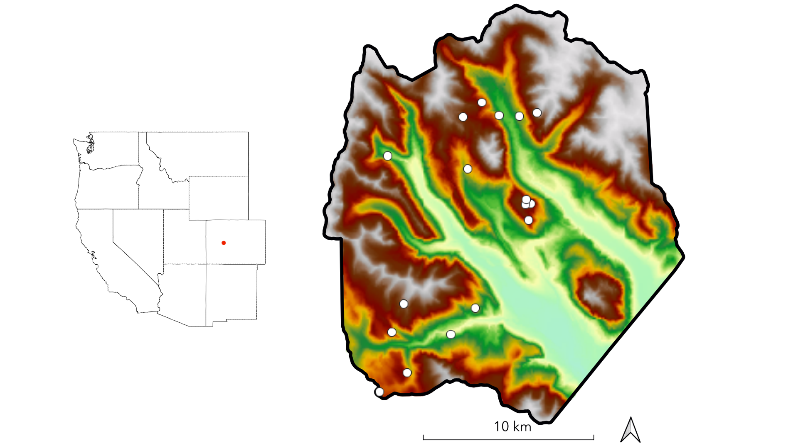 **Figure 1.** The study domain spans the footprint of a June 2018 NEON AOP acquisition in the East River watershed in western Colorado. Dots indicate the locations of 0.16 ha conifer forest inventory plots. Shading is by elevation.

## 7.2 Table 1

**Table 1.** Response (RE) and explanatory (EX) variables used in this study’s statistical analyses. Variables listed in the “Topography” category were also used in the sampling procedure to stratify inventory plots.

| Type | Category | Variable | Description | Units | Source |
| --- | --- | --- | --- | --- | --- |
| RE | Forest structure | Total number density | Total number of ITC objects per grid cell | stems ha^-1 | NEON LiDAR |
| RE | Forest structure | QMD | Quadratic mean of stem diameters of objects per grid cell | cm | NEON LiDAR |
| RE | Forest structure | Basal area | Sum of cross-sectional areas of stems per hectare | m^2 | NEON LiDAR |
| RE | Forest structure | 90th percentile height | Estimated maximum canopy height per grid cell | m | NEON LiDAR |
| RE | Forest structure | Height skew | Third moment of height distribution per grid cell | NA | NEON LiDAR |
| EX | Topography | Elevation | Elevation above sea level | m | NEON LiDAR |
| EX | Topography | Slope | dz/dxy computed in a 30 m window | degrees | NEON LiDAR |
| EX | Topography | Folded aspect | Index of cardinal aspect adjusted for higher incident radiation on SW slopes | index | NEON LiDAR |
| EX | Topography | Heat load | Potential heat load calculated according to Eq. 3 in McCune and Keon (2002) | index | NEON LiDAR |
| EX | Topography | TPI | Index of hillslope position (summit, shoulder, backslope, footslope, and toeslope) computed in 1000 m window | index | NEON LiDAR |
| EX | Topography | TWI | Terrain-driven ratio of upslope water supply to local drainage expressed as afunction of local slope and upslope contributing area per unit contour length, computed on a 100 m pixel scale | index | NEON LiDAR |
| EX | Climate | AET | Actual evapotranspiration: depth of water (mm) evaporated from the surface or transpired by plants per grid cell | m | BCM (Budo et al. 2017) |
| EX | Climate | CWD | Climatic water deficit: difference between potential evapotranspiration (PET) and AET, where PET is the total depth of water that can be evaporated or transpired given prevailing atmospheric conditions | m day^-1 | BCM (Budo et al. 2017) |
| EX | Climate | SWE | Snow water equivalent derived by forcing iSnobal with 50 m snow depth data from eight Airborne Snow Observatory flights | mm | ASO |
| EX | Climate | ∆SWE | Relative velocity of snow disappearance; difference between winter SWE and summer SWE divided by days between flights averaged over three flight-years | mm | ASO |
| EX | Soil | Available water capacity | Amount of plant-available water that can be stored in a unit of soil depth | mm | SSURGO |
| EX | Soil | Organic matter | Amount of decomposed plant and animal residue expressed as a weight percentage of the less than 2 mm soil material | % mass | SSURGO |
| EX | Soil | k | Amount of water that moves vertically through a unit area of soil per unit time under unit hydraulic gradient | μm sec^-1 | SSURGO |
| EX | Soil | Total depth | Sum of horizon depths in a soil component | cm | SSURGO |
| EX | Geology | Lithologic substrate | Distribution of rock formations | NA | Colorado Geological Survey |

## 7.3 Table 2

**Table 2.** Measurements taken in field inventory with their units and a summary of methods.

| Measurement | Units | Method |
| --- | --- | --- |
| Species | NA | Visual identification |
| Stem height | m | Nikon Forestry Pro II hypsometer, metric tape |
| DBH | cm | Diameter tape, calipers |
| Stem geolocation | decimal degrees | Trimble GEO-7X GPS unit held against stem |
| Crown illumination | unitless index | Visual determination |
| Beetle damage | unitless index | Visual inspection for boreholes, sap, red/grey needles |
| Life status | NA | Visual inspection for living/dead status |
| Health status | NA | Visual inspection for signs of infection, decay, browning, wilting |

## 7.4 Table 4

**Table 4.** Summary statistics for the best-performing runs of six individual tree delineation (ITD) algorithms. Parameters and values for each run appear in Supplementary Material. Averages and standard deviations were taken for results across plots.

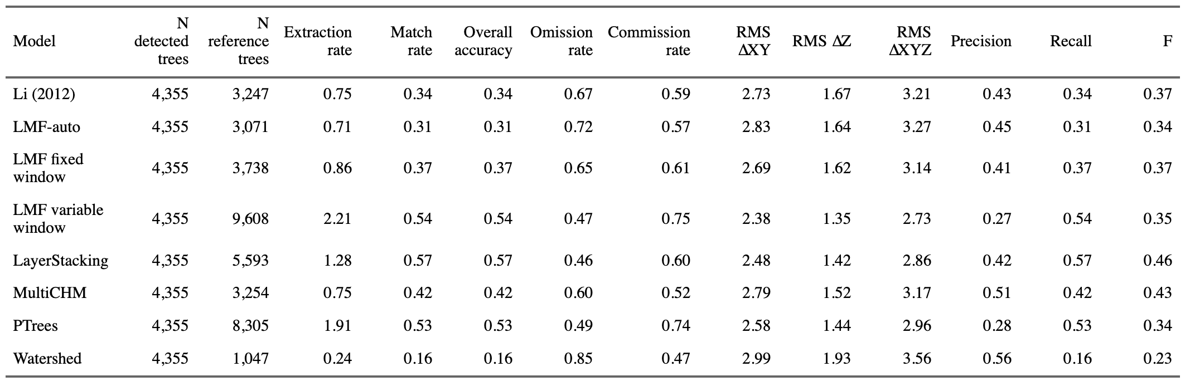

## 7.5 Table 5

Table 5. User-specified parameters () applied in the LayerStacking algorithm with the optimal values found in training.

| ID | Parameter | Description | Optimal value |
| --- | --- | --- | --- |
|  | start | the starting height above ground at which layer divisions begin | 0.5 |
|  | resolution | the resolution of the CHM | 0.5 |
|  | window1 | window radius for the first local maximum filter for detecting tree tops | 1.2 |
|  | buffer | size of the buffer enforced around each point to create a polygonal cluster | 0.5 |
|  | hardwood | logical switch, where False adds weight to clusters to account for mid-canopy density in conifer stands | F |
|  | window2 | window radius for the second local maximum filter for detecting tree tops | 2.0 |
|  | hmin | minimum height threshold, below which a new tree cannot be initiated | 1.3 |

## 7.6 Figure 3

**Figure 3.** Diameter and height distributions of trees measured in inventory plots across all sites (A), and by species (B, C).

## 7.7 Figure 4

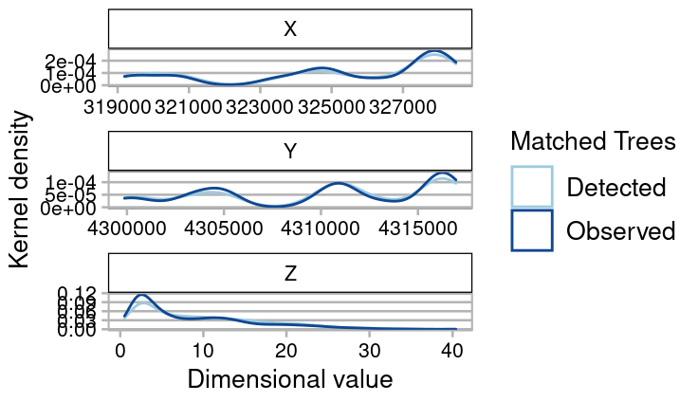 **Figure 4.** Total number of trees measured in plots (“Observed”—dark blue) and detected in segmentation of the ALS point cloud (“Predicted”—light blue), by height class, in 1 m increments.

## 7.8 Figure 5

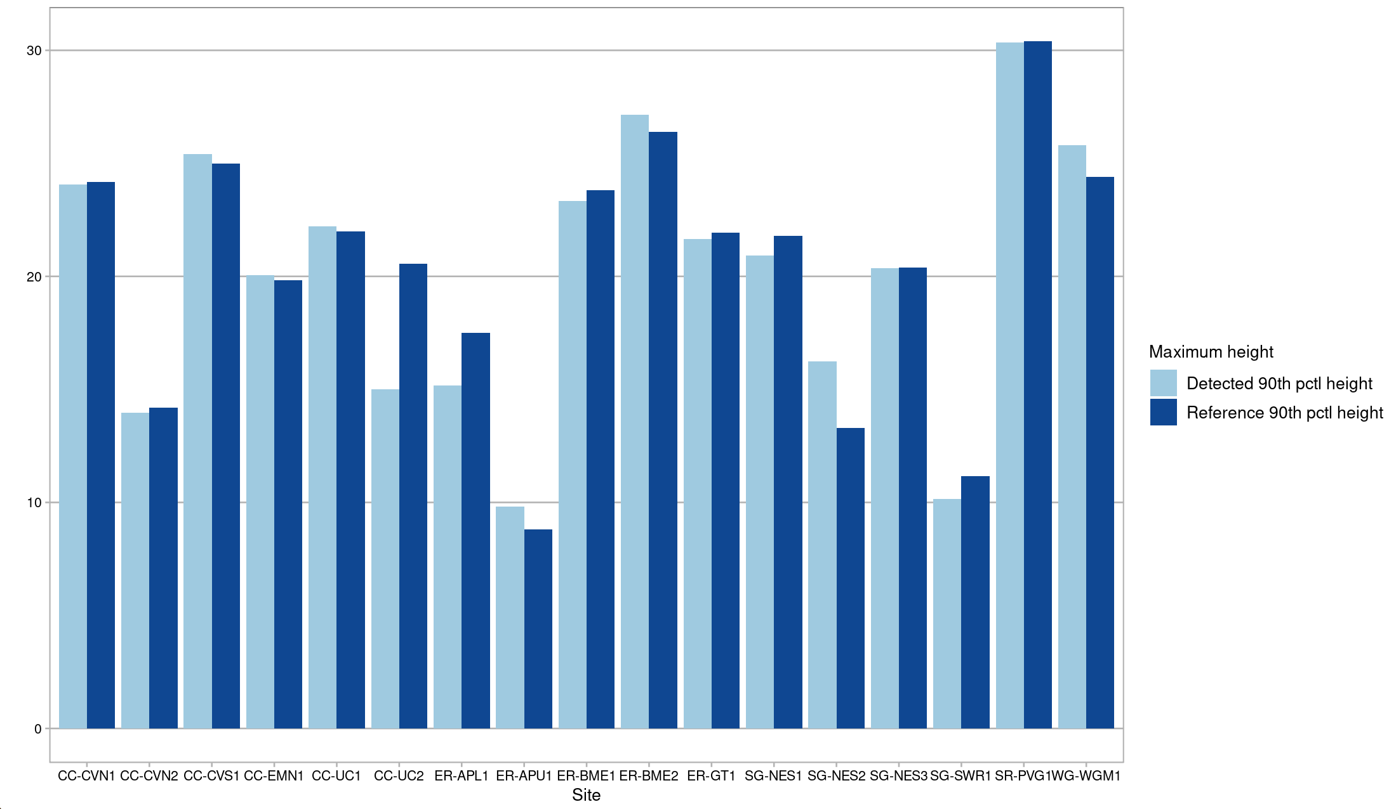

## 7.9 Figure 6

[TODO - frequency distribution of heights and diameters of modeled trees]

## 7.10 Figure 7

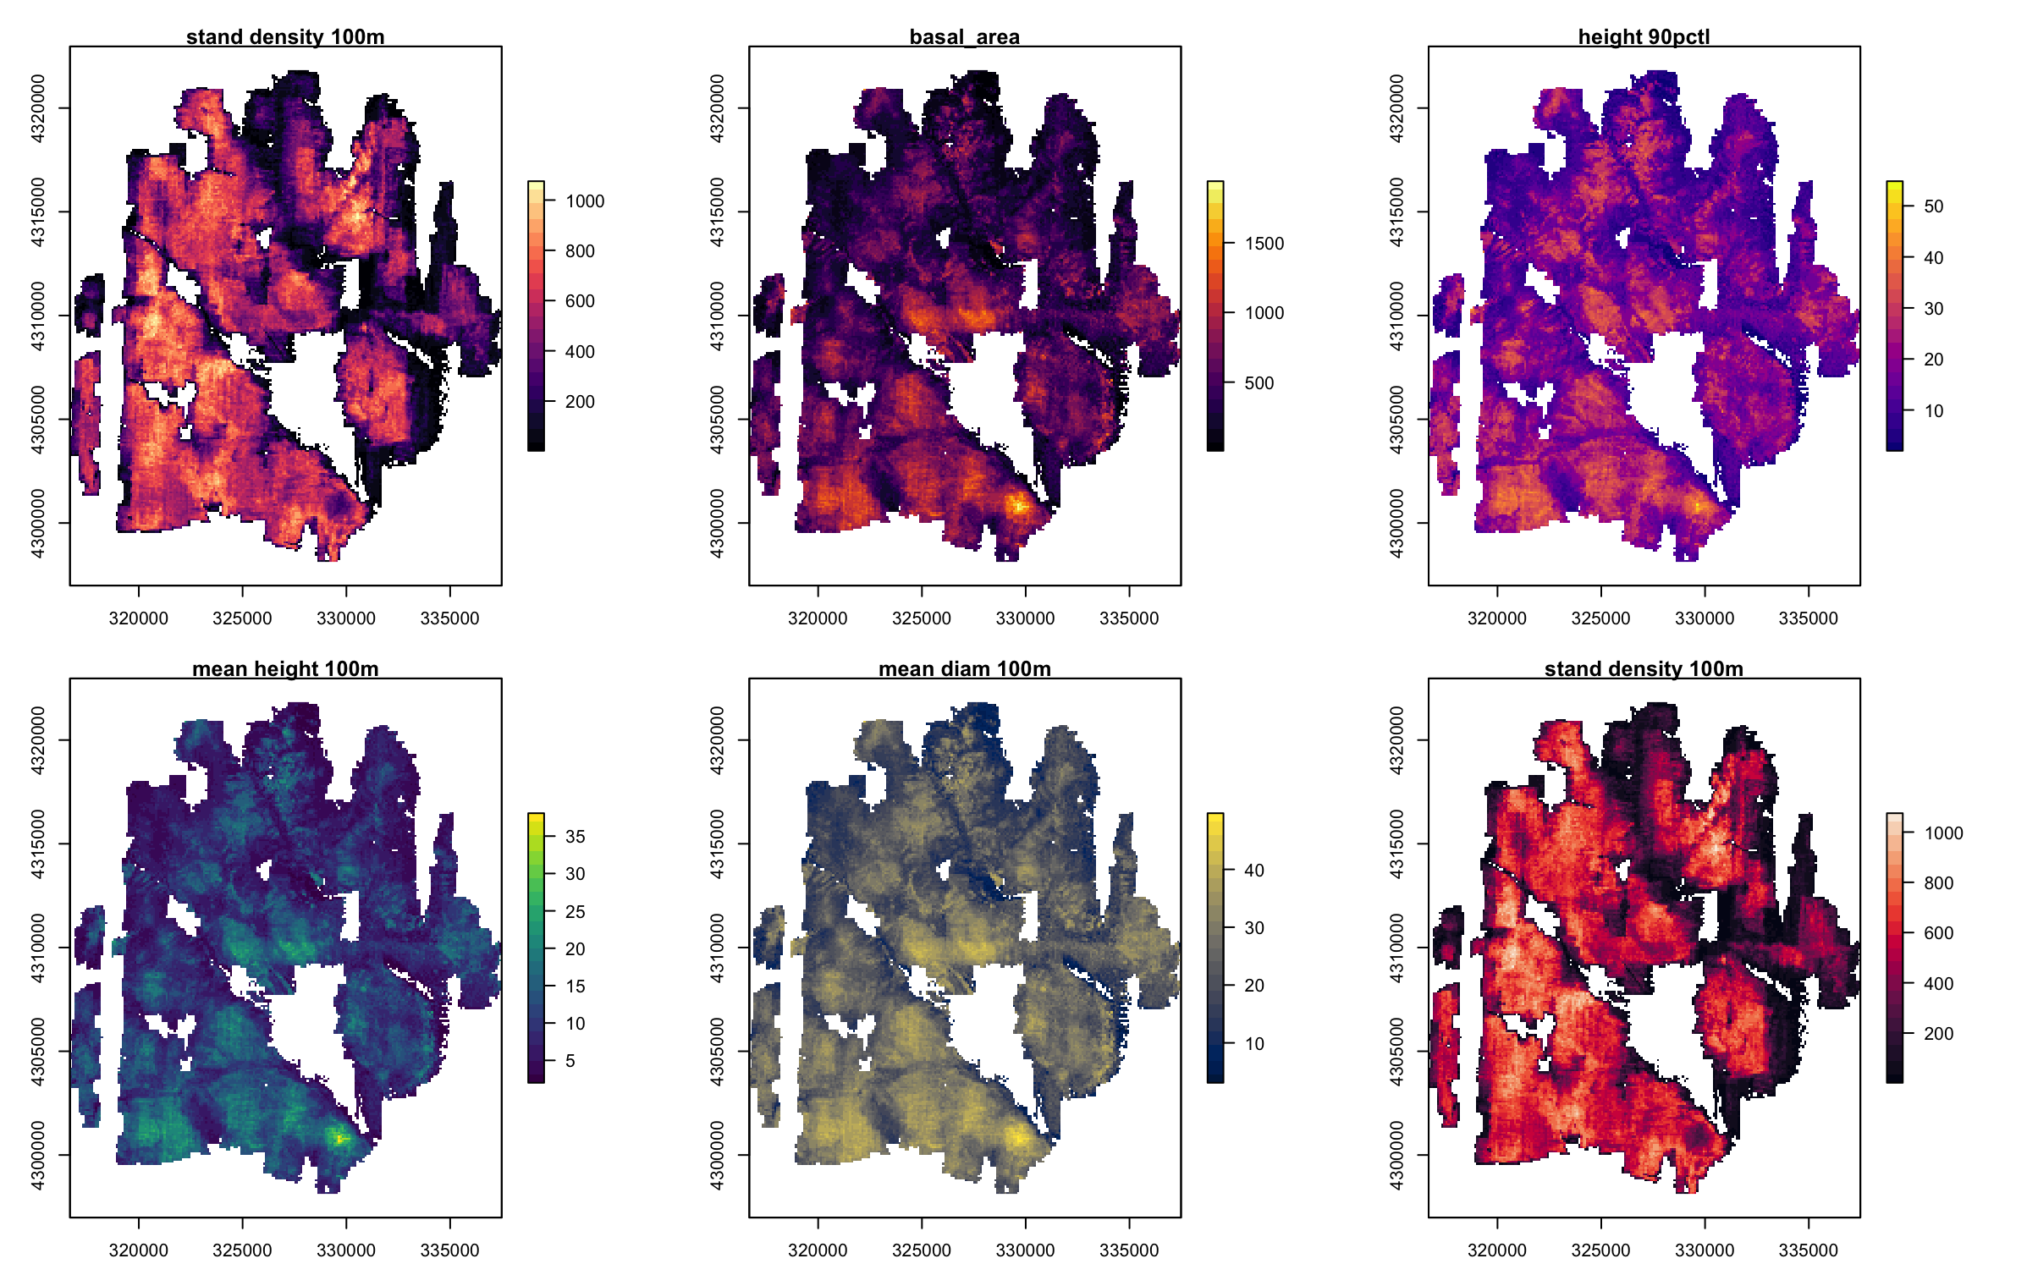 **Figure 7.** Maps of forest structure metrics at 100 m grid resolution.

## 7.11 Figure 8

[TODO - state factor maps]

## 7.12 Table 4. Summary statistics by species for trees observed in field census.

| Sp_Code | N | Median height (m) | Median DBH (cm) | Stem Density (stems ha^-1) | Basal area (m^2 ha^-1) |
| --- | --- | --- | --- | --- | --- |
| ABLA | 3464 | 4 | 5.6 | 1274 | 17.8 |
| PICO | 676 | 12 | 13.8 | 249 | 6.2 |
| PIEN | 1574 | 8 | 11.7 | 579 | 25.9 |
| POTR | 37 | 5 | 8.2 | 14 | 0.1 |

## 7.13 Table 5. Summary statistics by plot for trees observed in field census.

| Site_Name | N | N species | Median height (m) | Median DBH (cm) | Stem Density | Basal area (m^2 ha^-1) |
| --- | --- | --- | --- | --- | --- | --- |
| CC-CVN1 | 224 | 2 | 5 | 9.8 | 1400 | 49.0 |
| CC-CVN2 | 526 | 3 | 12 | 12.2 | 3288 | 47.5 |
| CC-CVS1 | 326 | 2 | 2 | 2.5 | 2038 | 34.1 |
| CC-EMN1 | 294 | 2 | 5 | 8.9 | 1838 | 61.8 |
| CC-UC1 | 199 | 2 | 7 | 11.7 | 1244 | 49.3 |
| CC-UC2 | 335 | 2 | 6 | 9.1 | 2094 | 53.0 |
| ER-APL1 | 494 | 2 | 4 | 5.9 | 3088 | 65.7 |
| ER-APU1 | 471 | 2 | 3 | 4.9 | 2944 | 27.1 |
| ER-BME1 | 197 | 2 | 10 | 15.3 | 1231 | 62.3 |
| ER-BME2 | 220 | 2 | 9 | 11.9 | 1375 | 54.5 |
| ER-GT1 | 278 | 2 | 6 | 8.2 | 1738 | 46.1 |
| SG-NES1 | 478 | 3 | 3 | 5.2 | 2988 | 54.3 |
| SG-NES2 | 488 | 3 | 4 | 5.8 | 3050 | 43.1 |
| SG-NES3 | 399 | 3 | 4 | 5.9 | 2494 | 44.9 |
| SG-SWR1 | 287 | 4 | 5 | 9.1 | 1794 | 30.7 |
| SR-PVG1 | 66 | 2 | 23 | 32.7 | 412 | 40.8 |
| WG-WGM1 | 209 | 2 | 7 | 10.5 | 1306 | 50.2 |
| XX-CAR3 | 260 | 4 | 8 | 10.7 | 1625 | 34.6 |

## 7.14 Figure 9

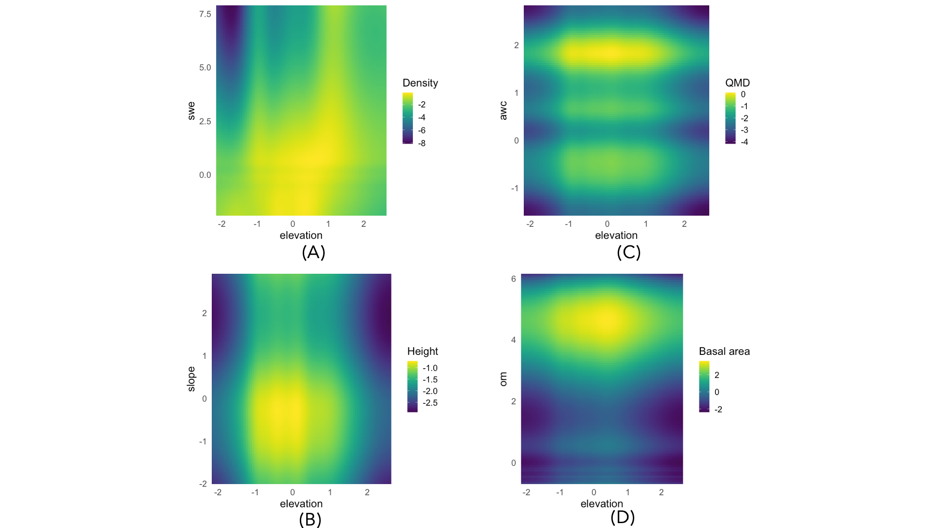 **Figure 9.** Variable interaction plots demonstrate the strong, nonlinear elevational control on density (A), 90th percentile height (B), QMD (C), and basal area (D). Interaction plots show the two strongest explainers of each response variable. The influence of elevation is mediated by SWE, slope angle, soil AWC, and soil organic matter, respectively.

## 7.15 Figure 10

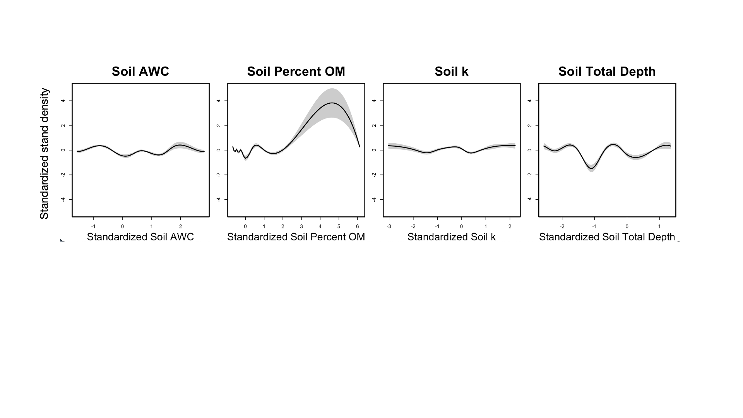 **Figure 10.** Stand density increased with soil organic matter and was at minimum with soil total depth = 50 cm, but other soil properties had little correlation with stand density.

# 8 Supplementary Information

## 8.1 Table S1

**Table S1.** Six topographic variables used to stratify forest inventory plots

## 8.2 Figure S1

**Figure S1.** A problematic waveform

**Figure S2.** Distribution of inventory plots along gradients

# References

Dalponte, M., Coomes, D.A., 2016. Tree-centric mapping of forest carbon density from airborne laser scanning and hyperspectral data. Methods in Ecology and Evolution 7, 1236–1245. <https://doi.org/10.1111/2041-210X.12575>

Lydersen, J., North, M., 2012. Topographic Variation in Structure of Mixed-Conifer Forests Under an Active-Fire Regime. Ecosystems 15, 1134–1146. <https://doi.org/10.1007/s10021-012-9573-8>