

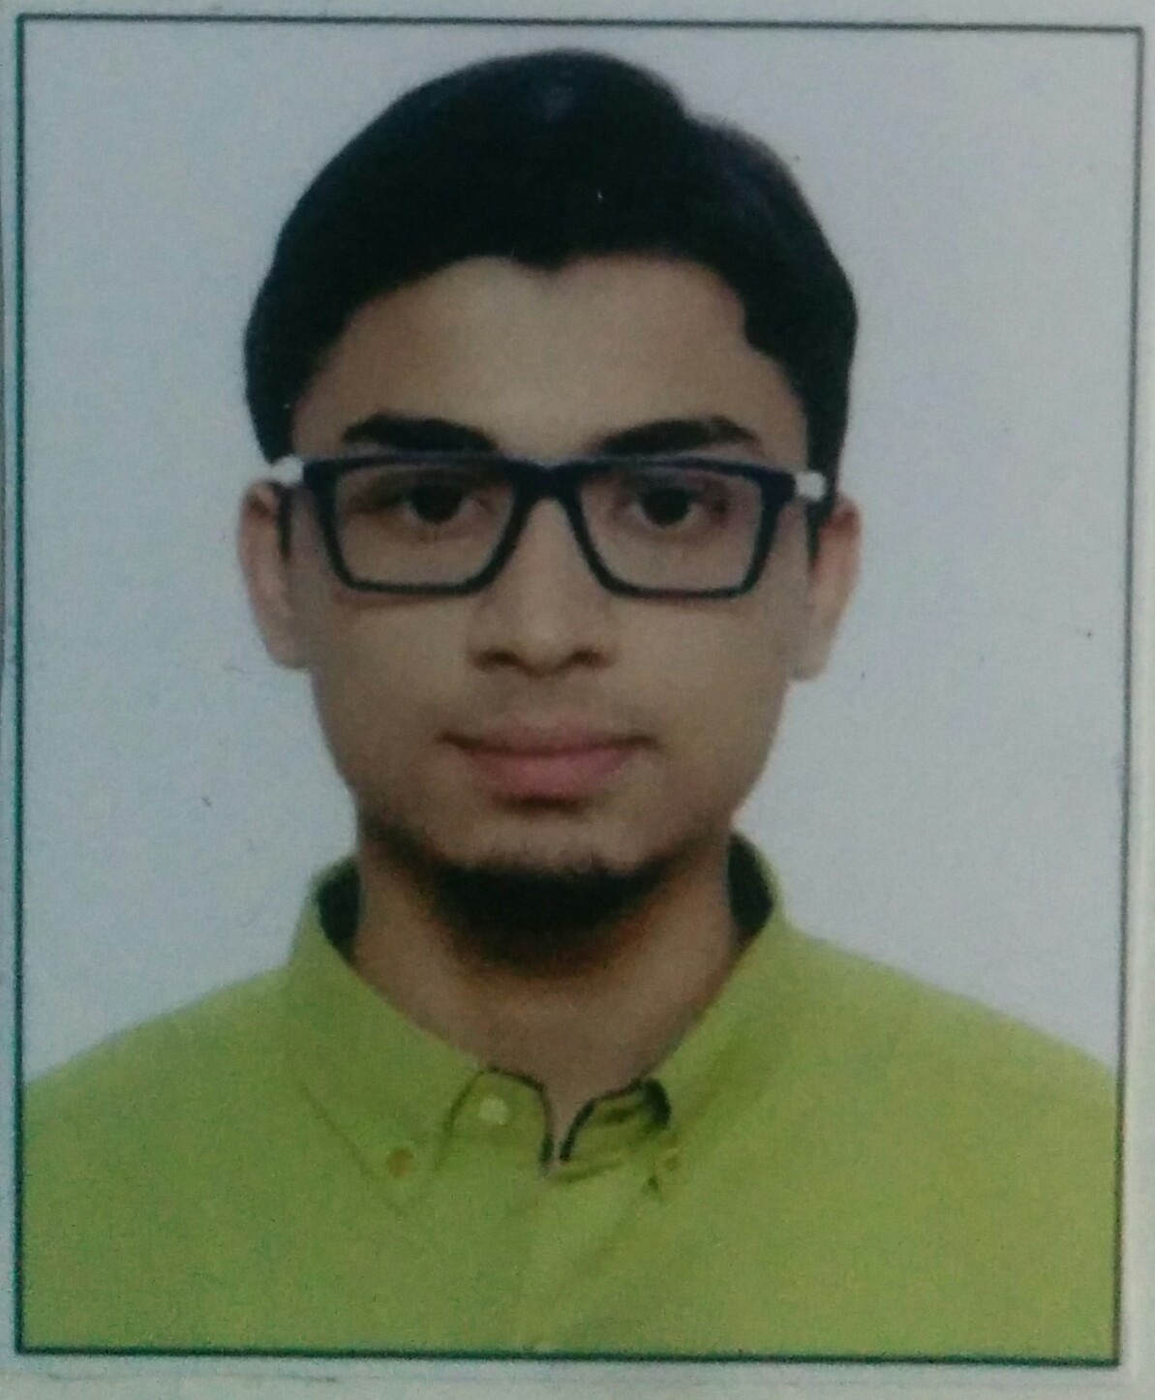

***(Fill in Block Letters Only)***

**Full Name : Surname First Name Middle Name**

**Father’s Occupation :**

**Permanent Address :**

**Nationality : DOB (DD -MM-YYYY) :**

**Contact Nos. :**

**(Max two)**

**Year Gap : In Degree Before Degree :**

**Email ID :**

**Personal Information**

MIRZA HAMZA YUNUS

SERVICE

1103/A, MALKANI TOWER,

BANDIVALI HILL ROAD,

JOGESHWARI WEST

MUMBAI 400102

22-04-1995

INDIAN

8097064686 9869400565

0

**hamzamirza95@gmail.com**

0

**Remarks (if any):**

**(*For Office Use Only*)**

**Branch : Enrolment No.:**

**Attach Photo Copies of Required Documents on A4 Size Paper Only -**

**(1) SSC Certificate**

**(2) HSC Marksheet / Certificate**

**(3) Diploma Final Year Marksheet**

**(4) BE All Sem Marksheet 1. Sem-I 5. Sem-V**

**(5) Photo ID 2. Sem-II 6. Sem-VI**

**3. Sem-III 7. Sem-VII**

**4. Sem-IV 8. Sem-VIII**

**Verified by Staff Co-ordinator :**

|  |  |  |  |  |  |  |
| --- | --- | --- | --- | --- | --- | --- |
| **Qualification** | **Name of the**  **School / College** | **Board** | **Month & Year**  **of Passing** | **Marks Obtained** | **Total Marks** | **Agg %** |
| **S.S.C.** | HMPS | MSBSHSE | March-11 | 487 | 550 | **88.54** |
| **H.S.C.** | Rizvi College of Arts Science and Commerce | MSBSHSE | Feb-13 | 428 | 600 | **71.33** |

**Educational Qualification**

|  |  |  |  |  |  |  |  |  |  |  |
| --- | --- | --- | --- | --- | --- | --- | --- | --- | --- | --- |
| **Semester** | | **Month & Yr of Passing** | | **No. of K.T’s** | **Credits (C)** | **(CxG)** | **S.G.P.I.** | **S.G.P.I. (Yearwise)** | **C.G.P.I.** | **C.G.P.I (Yearwise)** |
| **1st SEM** | | **DEC-13** | | **0** | **27** | **190.50** | **7.06** |  |  |  |
| **2nd SEM** | | **MAY-14** | | **0** | **27** | **211.50** | **7.83** |  |  |
| **3rd SEM** | | **DEC-14** | | **0** | **28** | **195** | **6.96** |  |  |  |
| **4th SEM** | | **MAY-15** | | **0** | **28** | **206** | **7.36** |  |  |
| **5th SEM** | | **DEC-15** | | **0** | **24** | **192** | **8.00** |  |  |  |
| **6th SEM** | |  | |  |  |  |  |  |  |
| **7th SEM** | |  | |  |  |  |  |  |  |  |
| **8th SEM** | |  | |  |  |  |  |  |  |
| **SEM-V SEM-VI SEM-VII SEM-VIII**  **Agg.C.G.P.I. till last Semester:** | | | | | | | | | | |
|  |  | |  | | | | | | | |
|  |  | |  | | | | | | | |

**Present Status**

**Hobbies**

Java, Python, HTML, CSS, Django framework, Android, Web Application, Java Script, Linux Shell, SQL, Networking

**Computer Skills**

**Extra-Curricular Activities**

Swimming, Basketball, Coding, Reading novels and magazines, Debating, Community Service

**Inplant Training / Project Work if any**

**I hereby declare that the above-furnished details of my bio-data are true to the best of my knowledge and belief.**

**NOTE: Once selected in a company through the TPO cell, you will not be given another chance unless all other students of similar category are placed.**

**Place:**

**Date: (Signature of Candidate)**