* **Title:** MUSIC: Make Utility Simple In Image Classification
* **Abstract:**
* **Introduction:**
* **Related work:**

# Editing Models with Task Arithmetic

* 1. Training a model is the backbone of Machine learning because all the decisions will be done on its basis. Once training is done we retrain it according to our needs and feedback. This process is very costly due to following factors:
  2. Time and capital is effected most on retraining as we need to perform that process again so more time is utilized due to which more money is exhausted. We only have trained model instead of training data so we need to collect it again so need resources to do it.
  3. Fine tuning was introduced to address this problem but it requires labeled data so we need more efficient solution, here comes the solution of editing models with task arithmetic operations using task vectors. Task vector is weights in direction (Positive / Negative) which help the model to perform better.
  4. For example if we want to mitigate undesirable behaviors then we can change behaviors of model by negating as task vector similarly if we can to make model to learn new thing then we can do it by adding task vector. This performs well target tasks or even also improves performance and also efficient to compute as compared to fine tuning.

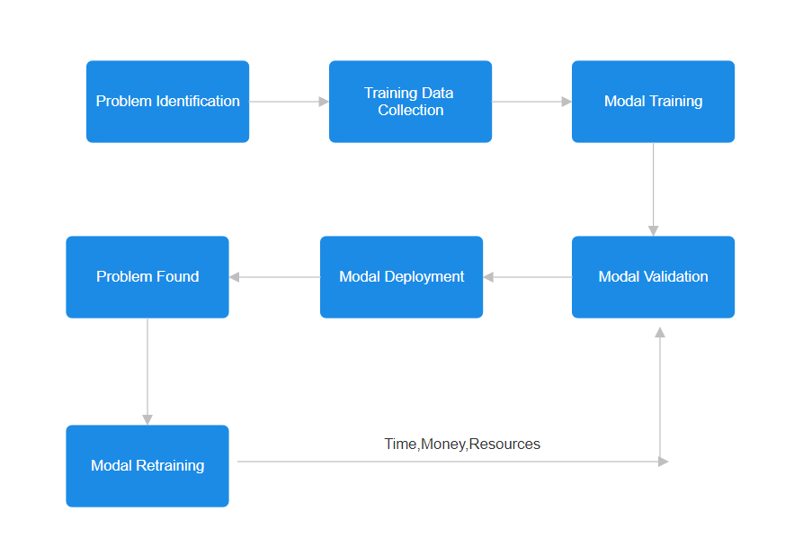

1. **LANGUAGE MODELS ARE HOMER SIMPSON! Safety Re-Alignment of Fine-tuned Language Models through Task Arithmetic**
   1. The introduction tells about the advances and growth of LLMs, which have demonstrated satisfaction in different tasks. However, the fine-tuning process, which is meant to improve the model functionality in defined areas, usually results in compromise of safety. The authors cite earlier works that explain how fine-tuning can argue indirectly make the models unsafe. Here comes the concept of RESTA, whose aim is to reinstate safety without paying a heavy price in performance appeal.
   2. The RESTA Method can be defined in either terms – simplicity and effectiveness. The primary activity consists of a safety vector being added in an elemental manner, to the model parameters. In addition to the authors also came up with a method called Drop and REscale (DARE) which assists in eliminating the extra parameters that were captured during the fine-tuning to increase the efficiency of the safety vectors.
   3. The authors made evaluations of RESTA on two ways of fine-tuning parameters called the parameter efficient fine-tuning PEFT and the full fine-tuning FullFT. It was observed that these two approaches compromised the safety of the models when used on several tasks, including those with harmless datasets. In order to evaluate the performance of RESTA, the authors created a safety evaluation benchmark known as CATQA, which contains 550 dangerous questions that have been divided into 11 groups, each of 5 sub-categories. Such a benchmark was purposefully developed in order to include all the abusive cases specified by OpenAI and Meta’s usage regulations.
   4. As it turned out, the results of the evaluations were promising. The authors noted that the fine-tuned models had a great decrease in the unsafety scores after applying RESTA. When for instance, the Llama-2 model was tested on CATQA, the unsafety score reduced from 33.57% to 12.17% in PEFT while in FullFT, the figure reduced from 22.16% to 4.34%. These results shows that RESTA enhances safety without compromising the performance of the model in a variety of tasks.
2. **Task Arithmetic in the Tangent Space: Improved Editing of Pre-Trained Models**
   1. Task arithmetic refers to the ability to perform arithmetic operations on the weights of a model to get desired outcomes for multiple tasks. This is cost-effective and scalable approach to edit pre-trained models directly in weight space. By changing the weights associated with different tasks, researchers can enhance a model's performance on those tasks or even negate certain tasks, leading to a phenomenon known as task forgetting. The authors highlight that traditional model editing methods often involve costly joint fine-tuning across multiple tasks, which can degrade the model's pre-training performance or zero-shot accuracy. Task arithmetic offers a promising alternative by allowing for more efficient adjustments to the model's weights.
   2. One of the most important contributions of the paper is a proposal to linearizing models in order to enhance weight disentanglement. The authors show that fine-tuning a model in its tangent space can amplify the disentanglement of weights and thus effectively improve performances across benchmark arithmetic tasks. Finally, the authors presented empirical results that linearizing models can bring 5.8 points of accuracy in task addition and 13.1 points less in task negation on various vision-language benchmarks.
   3. Experiment indicated that fine-tuning in the tangent space significantly improved the arithmetic benchmark for most tasks compared to the pre-trained models.

* **Design and Implementation:**

For the validity of our hypothesis we used MNIST dataset (Images of handwritten digits), that contain 60,000 images as training data and 10,000 images as testing data. Images are classified into classes from 0-9. First of all we did we observed data and performed normalization in pre processing. We split 1000 images, each from class 3, 4 and 7 wit 57,000 images remaining in training dataset. Separated images are saved in 3 different files on the basis of class. After this step we trained the model on SimpleNN with epochs of 50 as it is performing best on 50 epochs and batch size of 128. We achieved Train Loss: 0.0180, Train Acc: 0.9946, Test Loss: 0.2459, Test Acc: 0.9649.

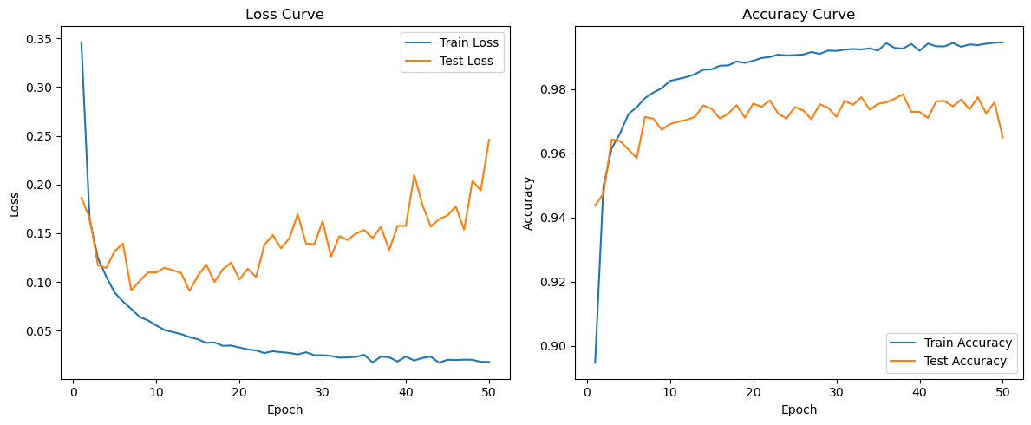

­­Further for fine tuning we used the concept from real world. Let’s suppose you are a student and your professor assigned you a task to learn 30 topics till tomorrow, Will you be able to learn it? Yes you can but your performance will be compromised. Now if you are asked to learn 10 topics in a day and total 30 topics in 3 days. Now your response will be much better as compared to first case.

Here we used the same concept in our training. Instead of fine tuning our model on all three classes on a single run, we separately fine tuned the model on each class. As a result ou model performed better when we separately fine tuned model.

* **Evaluation:**
* **Conclusion:**
* **References:**