NTI – Data Analysis Final Project
Movies Metadata: Cleaning, Analysis & Power BI Dashboard

Team Members
# | Name | ID
1 | Hamza Osama Mostafa Mohmoud | 692400384
2 | Ahmed Mohamed Ahmed Rageb | 692400371
3 | Mohamed Hesham Attia | 692400356

Data Overview

Files delivered
File | Description
movies_metadata_cleaned (2).csv | Intermediate file — first cleaning pass, 45,430 rows × 25 columns
New analysis.py | Python cleaning & transformation script (10 stages)
movies_metadata_final.csv | Final analysis-ready dataset, 45,346 rows × 27 columns
movies_metadata_final.xlsx | Same final data in Excel format for manual review
Project.pbix | Power BI report built on the final dataset

Shape of the final dataset
Metric | Value
Rows (movies) | 45,346
Columns | 27 (25 original + profit + roi)
Release years covered | 1888 – 2020
Rows with usable budget & revenue | 5,307 (≈ 11.7%)
Dominant original language | English (32,184 films, ≈ 71%)
Average runtime | 97.2 minutes
Average vote score | 5.62 / 10

Key column groups
- Identity: title, original_title, imdb_id, id, original_language.
- Time: release_date, release_year — the backbone of every trend analysis.
- Content: genres, overview, tagline, collection_name, runtime.
- Commercial: budget, revenue and the two derived measures profit and roi.
- Audience: popularity, vote_average, vote_count.
- Production: production_companies, production_countries, spoken_languages.

Data Cleaning & Transformation

# | Stage | What was done
1 | Duplicates | drop_duplicates on the movie id, keeping the first occurrence
2 | Dates | release_date parsed with to_datetime(errors='coerce'); release_year re-derived and any year outside 1888–2026 set to NaN
3 | Text | Whitespace stripped from all text columns; original_language lower-cased; status normalised to Title case
4 | Missing text | overview → 'No overview', tagline → 'No tagline', status and original_language → 'Unknown'
5 | Numeric sanity | Negative budget, revenue and vote_count set to NaN
6 | Derived columns | profit = revenue − budget (only when both exist); roi = revenue / budget (only when budget > 0)
7 | Impossible values | runtime ≤ 0 or > 600 minutes set to NaN; vote_average outside 0–10 set to NaN
8 | Unusable rows | Rows without a title or a valid release_date dropped (84 rows removed)
9 | Data types | release_year and vote_count cast to Int64; budget and revenue cast to Float64 (nullable types)
10 | Export | Final frame written to CSV and XLSX

Effect of the cleaning
Issue | Before | After
Rows | 45,430 | 45,346
Missing release_date | 84 | 0
runtime = 0 (false zeros) | 1,558 | 0 — converted to NaN
Missing status | 81 | 0
Derived business measures | none | profit, roi

Known limitations
- Placeholder text ('No overview', 'No tagline') hides missing values behind a string; for text mining these should be restored to null.
- About 51 title + release_year pairs still repeat — most are legitimate remakes, but a small number may be genuine duplicates with different ids.
- Budget and revenue are missing for roughly 80% of the catalogue, so all financial findings describe the commercially reported subset, not the whole industry.

Business Questions & Analysis

Q1 — How has production volume changed over time?
Output accelerates sharply: 3,471 films in the 1970s, 5,675 in the 1990s, 11,195 in the 2000s and 12,793 in the 2010s. More than half the catalogue was released after 2000.

Q2 — Which genres dominate the catalogue?
Drama is the largest genre (4,994 films), then Comedy (3,620) and Documentary (2,711); the most common pairings are Drama|Romance (1,300) and Comedy|Drama (1,133). Volume does not follow profitability — see Q4.

Q3 — Does a bigger budget guarantee a bigger return?
Across the 5,307 films with reliable finances the correlation between budget and revenue is 0.73 — strong, but not deterministic. Budget buys revenue, not efficiency: median ROI is 2.07× against a mean of 9.07×, and 29.6% of financed films lost money.

Q4 — Which genres return the most profit per film?
Genre group | Average profit per film | Films
Comedy | Romance | $65.7M | 125
Comedy | $43.1M | 318
Comedy | Drama | Romance | $41.8M | 115
Drama | $28.0M | 377
Drama | Romance | $24.7M | 184

Q5 — What are the highest-grossing and highest-ROI titles?
Title | Year | Budget | Profit / ROI
Avatar | 2009 | $237M | $2.55B profit
Star Wars: The Force Awakens | 2015 | $245M | $1.82B profit
Titanic | 1997 | $200M | $1.65B profit
Alice in Wonderland | 1951 | $3M | 190.7× ROI
Snow White and the Seven Dwarfs | 1937 | $1.5M | 124.2× ROI

Q6 — Do audiences reward the same films the box office does?
No. The highest-rated titles with at least 1,000 votes are The Godfather (8.5), The Shawshank Redemption (8.5) and Your Name. (8.5) — none appear among the top earners. Acclaim and commercial scale are independent dimensions, so the dashboard treats rating and profit as separate axes.

Dashboard

Layout and visuals
Visual | Fields used | Purpose
KPI card | Total Profit | Headline profitability of the filtered selection
KPI card | Average ROI | Return efficiency, independent of scale
KPI card | Total Revenue | Overall commercial size of the selection
Line chart | Profit by release_year | Long-run profitability trend of the industry
Donut chart | Profit by genres | Share of total profit contributed by each genre
Clustered bar chart | Vote average by genres | Audience quality ranking per genre
Line + stacked column | Profit, vote_average, vote_count | Tests whether popularity and acclaim track profit
Column chart | Vote average by title | Top-rated individual films
Slicer | release_year | Time-window filter for the whole page
Slicer | status | Restricts to Released titles when needed

Interaction design
- The two slicers (release_year, status) drive the entire page — selecting a decade updates every card and chart at once.
- Clicking a genre in the donut cross-filters the trend, rating and title visuals, so genre-specific behaviour can be read without leaving the page.
- KPI cards sit at the top so the headline numbers are read first, with the detail visuals below them.

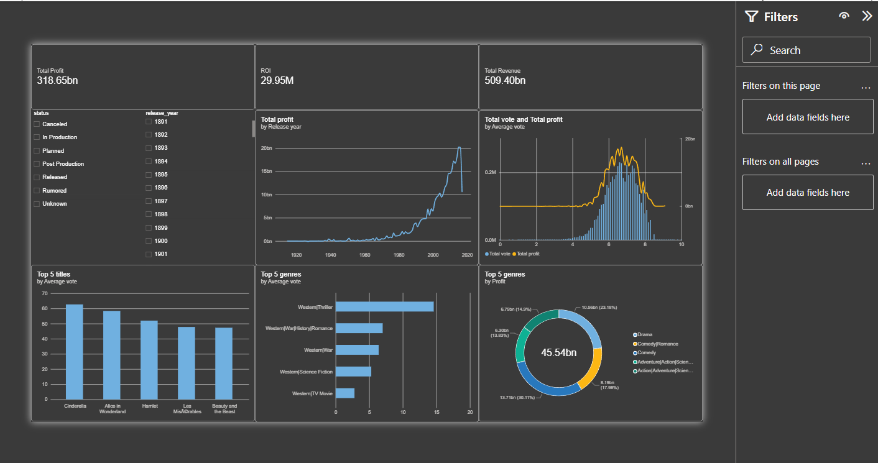

Key Findings & Recommendations

Key findings
- Volume has exploded: 24,000 of the 45,346 films — more than half the catalogue — were released after 2000, so historical averages are dominated by recent output.
- Budget explains revenue but not success: correlation of 0.73 between budget and revenue, yet nearly 3 out of 10 financed films still lose money.
- ROI favours the small: median ROI is 2.07× against a mean of 9.07×; the highest multipliers (Rocky, Snow White, The Devil Inside) all came from budgets of $1–3M.
- Comedy and romance combinations deliver the best average profit per film, while Drama dominates in count but not in return.
- Ratings and revenue are decoupled: the top-rated films (The Godfather, The Shawshank Redemption, Your Name.) are absent from the top-earning list entirely.
- The market is concentrated: the United States accounts for 17,836 films and English for 71% of the catalogue; MGM, Warner Bros. and Paramount lead production counts.
- Data coverage is the main constraint: only 11.7% of rows carry usable financial data, which limits every monetary conclusion.

Recommendations
- Build portfolios around mid- and low-budget comedy/drama titles for ROI, and reserve high budgets for franchise properties where scale is proven.
- Do not use audience rating as a revenue forecast — track the two metrics separately, as the dashboard does.
- Treat pre-2000 averages with care in any benchmark; filter by decade before comparing performance.
- Improve financial data capture at source: enriching budget and revenue coverage would be the single highest-value upgrade to this analysis.
- Restore placeholder text values to true nulls before any NLP work on overview or tagline.
- Review the 51 repeated title + year pairs to confirm they are remakes rather than duplicate records.

Conclusion
This project took a large, inconsistent public film catalogue and turned it into a reliable analytical asset. A single reproducible Python script removed duplicate records, repaired dates, normalised text, eliminated impossible values such as zero runtimes and negative budgets, and added the two derived measures — profit and ROI — that the business questions actually depend on. The result is a dataset of 45,346 films and 27 columns with no missing release dates, no false zeros and correctly typed numeric fields.
On top of that foundation, six business questions were answered and then made explorable in a Power BI dashboard where KPI cards, a profit trend line, genre breakdowns and rating comparisons all respond to the same year and status filters. The analysis shows a film industry where output has multiplied since 2000, where budget predicts revenue but not efficiency, where the strongest returns come from modest productions, and where critical acclaim and commercial success rarely land on the same title.
The main limitation is coverage rather than quality: financial figures exist for roughly one film in nine, so profitability conclusions describe the reported subset rather than the entire catalogue. Extending financial coverage, restoring placeholder text to nulls and resolving the remaining possible duplicates are the natural next steps, together with adding a cast-and-crew dimension so that talent can be linked to performance.
Overall, the deliverables — the cleaning script, the final dataset, the Power BI report and this document — form a complete, reproducible analytics workflow from raw data to decision-ready insight.

