Modeling S&P Composite using GARCH model

Yueqi Liu, Haining Zhang

Yueqi.liu@uconn.edu, haining.zhang@uconn.edu

2017/12/4

# Introduction

The volatility of this S&P 500 stock index returns can be seen as a measurement of the risk for investment and provides essential information for the investors to make the correct decisions.

The S&P Composite data set is collected by Yale Department of Economics (https://www.quandl.com/data/YALE/SPCOMP-S-P-Composite). This data set consists of monthly stock price, dividends, and earnings data and the consumer price index (to allow conversion to real values), etc, all starting January 1871. We delete NA values in first 10 years and get the data over the period Jan, 1881 through Dec, 2016. Time series plot for all 9 variables shows as follows.

In this dataset, CPI is the Consumer Price Index; Dividend is a distribution of a portion of a company’s earnings; Earnings is an after-tax net income of the company; Long interest Rates refer to government bonds maturing in ten years; Real Price are adjusted for general price level changes over time; Cyclically Adjusted PE. Ratio is defined as price divided by the average of ten years of earnings, adjusted for inflation.

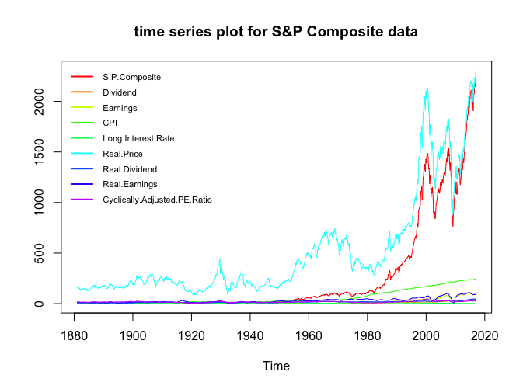

Following is the part of the dataset:

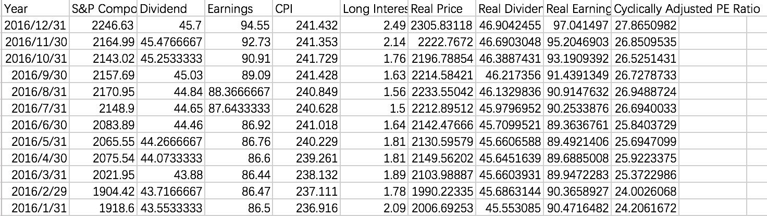

# Goal of Analysis

In order to follow the bond market, it is important to learn about the S&P Composite index of stocks because the volatility of this S&P Composite stock index returns can be seen as a measurement of the risk for investment and provides essential information for the investors to make the correct decisions.

The S&P Composite measures the value of stocks of the 500 largest corporations by market capitalization listed on the New York Stock Exchange or Nasdaq Composite. Standard & Poor's intention is to have a price that provides a quick look at the stock market and economy. Also, the S&P Composite is considered as an effective representation for the economy due to its inclusion of 500 companies, which covers all areas of the United States and across all industries. Through financial time series analysis, we can access, visualize and analyze historic time-series data.

In this case, we used the GARCH-M model including ARMA, GARCH model and linear regression with several extraneous predictors as following, which can be used to forecast the S&P Composite Stock Index Returns in the following years.

$$\left\{\begin{aligned}X_{t}=β^{'}z_{t}+y_{t}^{*} \left(1\right) \\ ϕ\left(B\right)y_{t}^{*}=θ\left(B\right)y_{t} \left(2\right) \\ \begin{matrix}{ y}_{t}=σ_{t}ε_{t} \left(3\right) \\ σ_{t}^{2}=α_{0}+\sum_{j=1}^{m}{α_{j}y_{t-j}^{2}}+\sum_{j=1}^{s}{β_{j}σ_{t-j}^{2}}\end{matrix}\left(4\right)\end{aligned}\right.$$

where $β^{'}z_{t}$ is a function of exogenous predictors.

# Comprehensive Data Analysis.

## Linear Regression.

Firstly, we fit a full linear regression model with Dividend, Earnings, Real Dividend, Real Earnings, CPI (Consumer Price Index), Long Interest Rate, Real Price and Cyclically Adjusted PE Ratio and obtain regression residuals.

## Residuals:  
## Min 1Q Median 3Q Max   
## -84.312 -18.255 -2.383 20.032 73.674   
##   
## Coefficients:  
## Estimate Std. Error t value Pr(>|t|)   
## (Intercept) 157.412098 4.405286 35.733 < 2e-16 ***  
## Dividend 30.566873 0.757761 40.338 < 2e-16 ***  
## Earnings 4.050867 0.292287 13.859 < 2e-16 ***  
## CPI -0.757145 0.047086 -16.080 < 2e-16 ***  
## Long.Interest.Rate -4.489523 0.469905 -9.554 < 2e-16 ***  
## Real.Price 0.708420 0.007627 92.885 < 2e-16 ***  
## Real.Dividend -18.037391 0.533901 -33.784 < 2e-16 ***  
## Real.Earnings -1.682304 0.230640 -7.294 4.68e-13 ***  
## Cyclically.Adjusted.PE.Ratio -5.829591 0.243546 -23.936 < 2e-16 ***  
## ---  
## Signif. codes: 0 '***' 0.001 '**' 0.01 '*' 0.05 '.' 0.1 ' ' 1  
##   
## Residual standard error: 29.15 on 1623 degrees of freedom  
## Multiple R-squared: 0.9963, Adjusted R-squared: 0.9963   
## F-statistic: 5.532e+04 on 8 and 1623 DF, p-value: < 2.2e-16

We also draw correlation plot for all variables and find most variables have significant high positive correlations (>0.8) with S&P Composite. So use these variables to fit a regression model is reasonable.

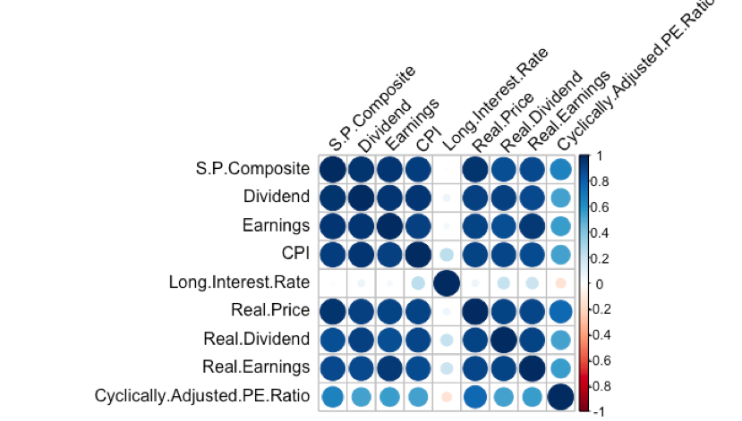

Obviously, there are collinearity between dividend and real dividend, earnings and real earnings. Therefore, we turn to obtain the VIF values of these variables.

VIF values:

## Dividend Earnings   
## 90.630964 88.901893   
## CPI Long.Interest.Rate   
## 20.931561 2.375851   
## Real.Price Real.Dividend   
## 29.378285 32.956594   
## Real.Earnings Cyclically.Adjusted.PE.Ratio   
## 54.280547 5.004143

So, after drop two variables Dividend and Earnings who have larger VIF, we go on to fit the reduced model as following (let $Z_{1t}$, $Z_{2t}$, $Z_{3t},$ $Z_{4t}$, $Z_{5t}$):

## Call:  
## lm(formula = S.P.Composite ~ ., data = data3)  
##   
## Residuals:  
## Min 1Q Median 3Q Max   
## -147.12 -51.71 -7.44 55.64 375.45   
##   
## Coefficients:  
## Estimate Std. Error t value Pr(>|t|)   
## (Intercept) 184.89841 10.71348 17.26 < 2e-16 ***  
## CPI 2.36787 0.08186 28.93 < 2e-16 ***  
## Long.Interest.Rate -32.39503 0.90167 -35.93 < 2e-16 ***  
## Real.Price 0.86657 0.01890 45.86 < 2e-16 ***  
## Real.Dividend -10.79104 0.69952 -15.43 < 2e-16 ***  
## Real.Earnings 0.85080 0.22568 3.77 0.000169 *

## Cyclically.Adjusted.PE.Ratio -13.61284 0.58071 -23.44 < 2e-16 ***  
## ---  
## Signif. codes: 0 '***' 0.001 '**' 0.01 '*' 0.05 '.' 0.1 ' ' 1  
##   
## Residual standard error: 74.28 on 1625 degrees of freedom  
## Multiple R-squared: 0.9762, Adjusted R-squared: 0.9762   
## F-statistic: 1.113e+04 on 6 and 1625 DF, p-value: < 2.2e-16

Therefore, (1) can be:

$X_{t}=184.89841+2.3679Z_{1t}-32.395{Z_{2t}+0.8666Z_{3t}-10.7910Z_{4t}+0.8508Z_{5t}+y}_{t}^{*}$

Next, we need to fit the ARMA+GARCH model to the residuals ($y_{t}^{*}$) of this linear regression. Before fitting this final model, it is necessary to check the time series plot of $y_{t}^{*}$ as well as ACF and PACF plots of both $y_{t}^{*}$ and $y_{t}^{*2}$. The plots are as following:

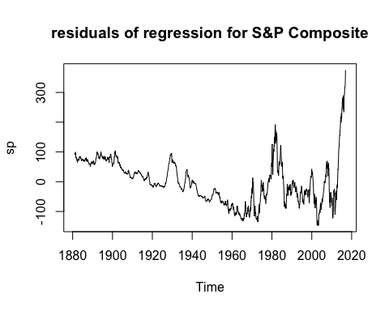

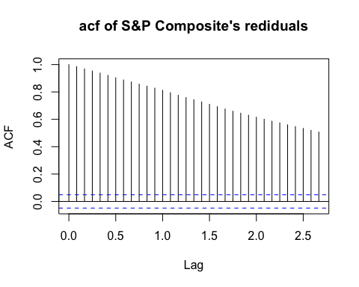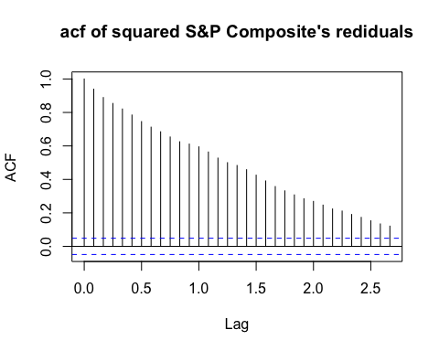

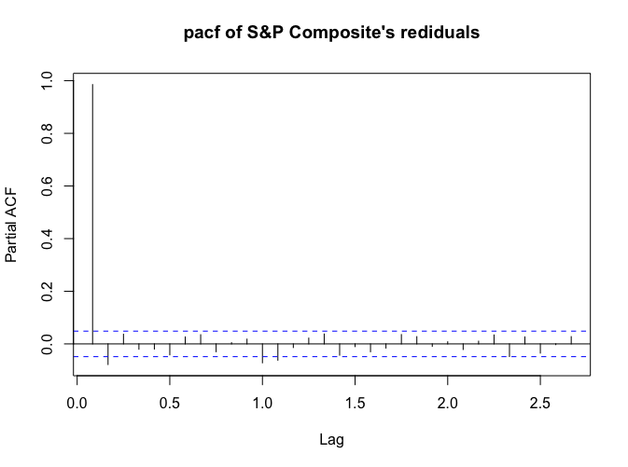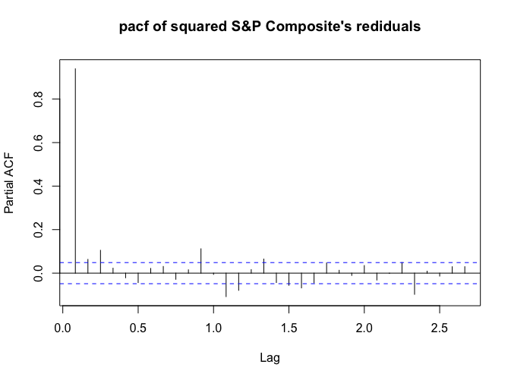

From the plots, we find obvious trend in the time series plot of the $y_{t}^{*}$. Also, the ACF and PACF plots are not good enough.

In addition, we need to use the Augmented Dickey-Fuller Test and Phillips-Perron test to check the stationarity of the $y_{t}^{*}$ and $y_{t}^{*2}$ as following:.

##   
## Augmented Dickey-Fuller Test  
##   
## data: sp  
## Dickey-Fuller = -0.89051, Lag order = 11, p-value = 0.9535  
## alternative hypothesis: stationary

## Phillips-Perron Unit Root Test  
##   
## data: sp  
## Dickey-Fuller Z(alpha) = 0.10731, Truncation lag parameter = 8,  
## p-value = 0.99  
## alternative hypothesis: stationary

##   
## Augmented Dickey-Fuller Test  
##   
## data: sp^2  
## Dickey-Fuller = 5.9939, Lag order = 11, p-value = 0.99  
## alternative hypothesis: stationary

##   
## Phillips-Perron Unit Root Test  
##   
## data: sp^2  
## Dickey-Fuller Z(alpha) = 57.284, Truncation lag parameter = 8,  
## p-value = 0.99  
## alternative hypothesis: stationary

From all p-values we obtained above, we can conclude that the residuals $y_{t}^{*}$ and its square are non-stationary. So, in order to remove the trend, we try to do difference of the $y_{t}^{*}$ and mark it as ‘sp_d’.

Following are the ACF and PACF plots of both ‘sp_d’ and the squre of the ‘sp_d’:

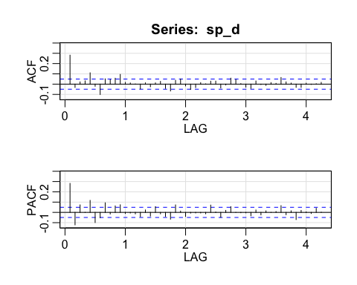

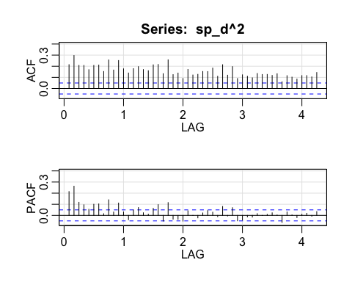

From these plots, we find that the ACF and PACF of ‘sp_d’ have some patterns and decay into blue dotted lines with the lag values increasing. In addition, the ACF and PACF plots of the square of ‘sp_d’ have obvious patterns. Therefore, these all results show that we need to fit ARMA+GARCH model to the dataset.

It is also necessary to check the stationarity again. From the ADF test and PP test following, we can reject the null hypothesis (non-stationary) and conclude that the series are stationary.

##   
## Augmented Dickey-Fuller Test  
##   
## data: sp_d  
## Dickey-Fuller = -9.6165, Lag order = 11, p-value = 0.01  
## alternative hypothesis: stationary

## Warning in pp.test(sp_d): p-value smaller than printed p-value

##   
## Phillips-Perron Unit Root Test  
##   
## data: sp_d  
## Dickey-Fuller Z(alpha) = -1120.5, Truncation lag parameter = 8,  
## p-value = 0.01  
## alternative hypothesis: stationary

## ARMA Model.

Before fitting the ARMA+GARCH model by garchfit {fGarch}, we are supposed to decide a best order for the ARMA model. So, we set loops to choose a model with the smallest BIC automatically. At last, we decide to use MA(1), whose BIC is 4.148424, to fit ‘sp_d’ as the ARMA part of the final model we will fit next.

## p q BIC  
## 2 0 1 4.148424

Moreover, we also want to decide the order for the GARCH part. Due to the patterns showed in the ACF and PACF plots for the residuals ($σ_{t}ε_{t}$) of the ARMA model, we decide to use GARCH(1, 1) in the GARCH part.

##   
## Call:  
## arima(x = sp_d, order = c(0, 0, 1), method = "CSS")  
##   
## Coefficients:  
## ma1 intercept  
## 0.3510 0.1737  
## s.e. 0.0253 0.2650  
##   
## sigma^2 estimated as 62.76: part log likelihood = -5689.94

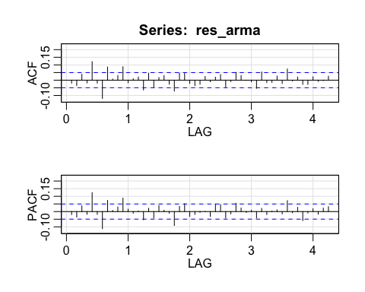

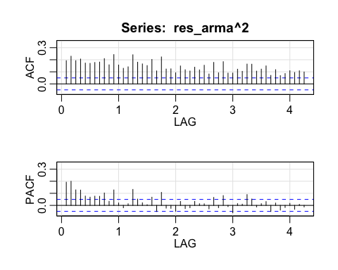

## ARMA+GARCH Model.

Finally, we use the garchFit {fGarch} to fit the final model to the ‘sp_d’ as following:

Model 1: We assume that the distribution of $ε_{t}$ is standard normal.

From the result, we can see that the Jarque-Bera test and Shapiro-Wilk test can show that the normal assumption is not suitable. The skewness and excess kurtosis exist in the model distribution assumption because the p-value is small enough.

And we also use the LM Arch test to do the diagnostic of the model. The LM Arch test (p-value=0.9763>0.05) shows that the $ε_{t}$ is uncorrelated, which conforms to the assumption of the GARCH-type model.

So this model is not a good fit for the data.

## Title:  
## GARCH Modelling   
##   
## Call:  
## garchFit(formula = ~arma(0, 1) + garch(1, 1), data = sp_d, trace = FALSE)   
##   
## Conditional Distribution:  
## norm   
##   
## Coefficient(s):  
## mu ma1 omega alpha1 beta1   
## -0.242206 0.354688 0.056163 0.162626 0.857883   
##   
## Std. Errors:  
## based on Hessian   
##   
## Error Analysis:  
## Estimate Std. Error t value Pr(>|t|)   
## mu -0.24221 0.08889 -2.725 0.00643 **   
## ma1 0.35469 0.02386 14.864 < 2e-16 ***  
## omega 0.05616 0.01183 4.746 2.07e-06 ***  
## alpha1 0.16263 0.02022 8.044 8.88e-16 ***  
## beta1 0.85788 0.01435 59.776 < 2e-16 ***  
## ---  
## Signif. codes: 0 '***' 0.001 '**' 0.01 '*' 0.05 '.' 0.1 ' ' 1  
##   
##   
##   
## Standardised Residuals Tests:  
## Statistic p-Value   
## Jarque-Bera Test R Chi^2 177.3047 0   
## Shapiro-Wilk Test R W 0.9877136 1.540478e-10  
## Ljung-Box Test R Q(10) 52.58574 8.887877e-08  
## Ljung-Box Test R Q(15) 56.4072 1.034172e-06  
## Ljung-Box Test R Q(20) 57.88576 1.50502e-05   
## Ljung-Box Test R^2 Q(10) 4.152994 0.9401813   
## Ljung-Box Test R^2 Q(15) 5.422665 0.9879026   
## Ljung-Box Test R^2 Q(20) 8.028445 0.9916779   
## LM Arch Test R TR^2 4.348687 0.9762913   
##   
## Information Criterion Statistics:  
## AIC BIC SIC HQIC   
## 5.902742 5.919287 5.902724 5.908880

So we try to use to use non normal conditional distribution: standard t distribution and skewed t distribution.

Model 2: Assume that the distribution of $ε_{t}$ is standard Student’s t with 5 d.f, mean=0 and SD=1. We can see the estimations of the model parameters are all significant for standard t distribution.

The Ljung-Box statistics indicate quite significant autocorrelations in standardized residuals since p-values are below 0.05, and no autocorrelations in squared standardized residuals. However, since this model is not fitted to the raw data, we use the LM Arch test to do the diagnostic of the model. The LM Arch test (p-value=0.9823>0.05) shows that the residuals are uncorrelated, which conforms to the assumption of the GARCH-type model. So we still conclude that the model does not exhibit significant lack of fit.

##   
## Title:  
## GARCH Modelling   
##   
## Call:  
## garchFit(formula = ~arma(0, 1) + garch(1, 1), data = sp_d, cond.dist = "std",   
## trace = FALSE)   
##   
## Mean and Variance Equation:  
## data ~ arma(0, 1) + garch(1, 1)  
## <environment: 0x7fbcb3068df0>  
## [data = sp_d]  
##   
## Conditional Distribution:  
## std   
##   
## Coefficient(s):  
## mu ma1 omega alpha1 beta1 shape   
## -0.208595 0.340602 0.042987 0.155234 0.865298 7.127081   
##   
## Std. Errors:  
## based on Hessian   
##   
## Error Analysis:  
## Estimate Std. Error t value Pr(>|t|)   
## mu -0.20859 0.08391 -2.486 0.0129 *   
## ma1 0.34060 0.02317 14.697 < 2e-16 ***  
## omega 0.04299 0.01775 2.422 0.0154 *   
## alpha1 0.15523 0.02308 6.725 1.76e-11 ***  
## beta1 0.86530 0.01643 52.662 < 2e-16 ***  
## shape 7.12708 1.17928 6.044 1.51e-09 ***  
## ---  
## Signif. codes: 0 '***' 0.001 '**' 0.01 '*' 0.05 '.' 0.1 ' ' 1  
##   
## Log Likelihood:  
## -4777.167 normalized: -2.92898   
##   
##   
## Standardised Residuals Tests:  
## Statistic p-Value   
## Jarque-Bera Test R Chi^2 193.0316 0   
## Shapiro-Wilk Test R W 0.987196 7.828725e-11  
## Ljung-Box Test R Q(10) 54.21589 4.423043e-08  
## Ljung-Box Test R Q(15) 57.98403 5.582691e-07  
## Ljung-Box Test R Q(20) 59.37682 8.88872e-06   
## Ljung-Box Test R^2 Q(10) 3.872842 0.952901   
## Ljung-Box Test R^2 Q(15) 5.004112 0.9920915   
## Ljung-Box Test R^2 Q(20) 7.926538 0.9923427   
## LM Arch Test R TR^2 4.059584 0.982337   
##   
## Information Criterion Statistics:  
## AIC BIC SIC HQIC   
## 5.865318 5.885172 5.865291 5.872684

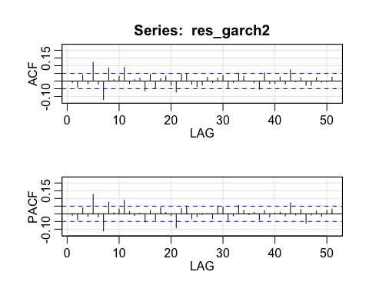

Model 3: Assume that the distribution of $ε_{t}$ is skew-standard Student’s t with 5 d.f, mean=0 and SD=1. The Ljung-Box statistics indicate quite significant autocorrelations in standardized residuals since p-values are below 0.05, and no autocorrelations in squared standardized residuals. However, since this model is not fitted to the raw data, we use the LM Arch test to do the diagnostic of the model. The LM Arch test (p-value=0.9825>0.05) shows that the $ε_{t}$ is uncorrelated, which conforms to the assumption of the GARCH-type model.

##   
## Title:  
## GARCH Modelling   
##   
## Call:  
## garchFit(formula = ~arma(0, 1) + garch(1, 1), data = sp_d, cond.dist = "sstd",   
## trace = FALSE)   
##   
## Mean and Variance Equation:  
## data ~ arma(0, 1) + garch(1, 1)  
## <environment: 0x7fbcb17b54a0>  
## [data = sp_d]  
##   
## Conditional Distribution:  
## sstd   
##   
## Coefficient(s):  
## mu ma1 omega alpha1 beta1 skew   
## -0.196536 0.341319 0.042294 0.154148 0.865940 1.016825   
## shape   
## 7.179054   
##   
## Std. Errors:  
## based on Hessian   
##   
## Error Analysis:  
## Estimate Std. Error t value Pr(>|t|)   
## mu -0.19654 0.08799 -2.234 0.0255 *   
## ma1 0.34132 0.02324 14.687 < 2e-16 ***  
## omega 0.04229 0.01887 2.242 0.0250 *   
## alpha1 0.15415 0.02297 6.711 1.93e-11 ***  
## beta1 0.86594 0.01640 52.811 < 2e-16 ***  
## skew 1.01682 0.03652 27.842 < 2e-16 ***  
## shape 7.17905 1.19810 5.992 2.07e-09 ***  
## ---  
## Signif. codes: 0 '***' 0.001 '**' 0.01 '*' 0.05 '.' 0.1 ' ' 1  
##   
## Log Likelihood:  
## -4777.059 normalized: -2.928914   
##   
##   
## Standardised Residuals Tests:  
## Statistic p-Value   
## Jarque-Bera Test R Chi^2 194.646 0   
## Shapiro-Wilk Test R W 0.9871448 7.32846e-11   
## Ljung-Box Test R Q(10) 54.40046 4.086138e-08  
## Ljung-Box Test R Q(15) 58.17188 5.185822e-07  
## Ljung-Box Test R Q(20) 59.5596 8.330052e-06  
## Ljung-Box Test R^2 Q(10) 3.860603 0.9534164   
## Ljung-Box Test R^2 Q(15) 4.982057 0.9922772   
## Ljung-Box Test R^2 Q(20) 7.935103 0.9922885   
## LM Arch Test R TR^2 4.048839 0.9825389   
##   
## Information Criterion Statistics:  
## AIC BIC SIC HQIC   
## 5.866413 5.889575 5.866376 5.875005

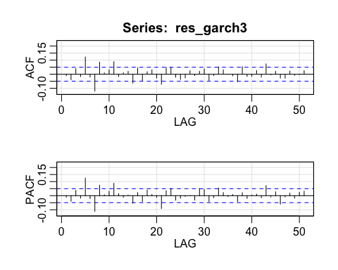

Finally, we compare these three models using the information criterion statistics including AIC and BIC and log-likelihood criterion. We find that the model 2 whose conditional distribution is standard t is the best because the smallest AIC, BIC and larger log-likelihood .

Therefore, we obtain the final best model as following:

$$\left\{\begin{aligned}X_{t}=184.8984+2.3679z_{1t}-32.395z_{2t}+0.8666z_{3t}-10.791z_{4t} \\ +0.8508z_{5t} +y_{t}^{*} \\ y_{t}^{*}=(1+0.3406B){(y}_{t}-0.20859) \\ \begin{matrix}{ y}_{t}=σ_{t}ε_{t} \\ σ_{t}^{2}=0.0430+0.1552y_{t-1}^{2}+0.8653σ_{t-1}^{2}\end{matrix} \end{aligned}\right.$$

# Forecasting.

Finally, we use our final GARCH-M model to forecast the S&P Composite Index from January 2017 to June 2017 as following:

2274.243, 2310.593, 2333.384, 2329.704, 2352.646, 2380.969.

Also, we compare the real observed S&P Composite Index data with our forecasting values. Their overlay time-series plot is as following:

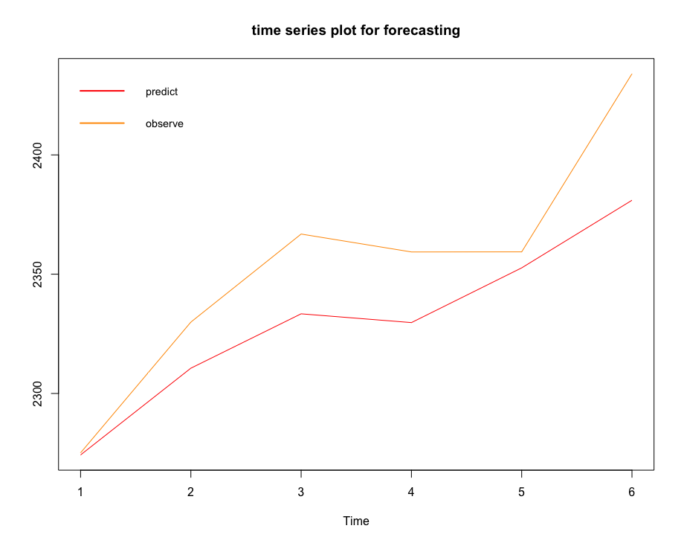

# Discussion of Results and Summary.

In this case, we firstly did the variable selection in order to obtain a good-fit regression model. Then, using the difference of the residuals of this regression model, we fit the MA(1)+ GARCH(1,1) model as following:

$$\left\{\begin{aligned}X_{t}=184.8984+2.3679z_{1t}-32.395z_{2t}+0.8666z_{3t}-10.791z_{4t} \\ +0.8508z_{5t} +y_{t}^{*} \\ y_{t}^{*}=(1+0.3406B){(y}_{t}-0.20859) \\ \begin{matrix}{ y}_{t}=σ_{t}ε_{t} \\ σ_{t}^{2}=0.0430+0.1552y_{t-1}^{2}+0.8653σ_{t-1}^{2}\end{matrix} \end{aligned}\right.$$

With the final fitted model, we predicted the S&P Composite values from 01/2017 to 06/2017. From the plot in Part 4, we can see that the prediction is approximately same with the observed data. So, the model performs well.

In the next step, we can try more complex model such as APARCH, TGARCH and EGARCH, etc.

# Reference

[1] <https://www.investopedia.com/ask/answers/040215/what-does-sp-500-index-measure-and-how-it-calculated.asp>

[2] <https://stats.stackexchange.com/questions/202526/garch-diagnostics-autocorrelation-in-standardized-residuals-but-not-in-their-sq>

[3] Modeling S&P 500 STOCK INDEX using ARMA-ASYMMETRIC POWER ARCH models, Jia Zhou, Chanli He[June 2009]