DTS =0 tool sẽ chạy linear trails,DTS =1 differential trails.
Bước 1: Tải và chuẩn bị mã nguồn(Tải 2 cái 1 cái sẽ là ascon gốc và 1 cái sẽ chỉnh lại cho ascon cải tiến
git clone https://gitlab.science.ru.nl/selhirch/ascontrailtool.git ascon
git clone https://gitlab.science.ru.nl/selhirch/ascontrailtool.git ascon2
git clone https://gitlab.science.ru.nl/selhirch/ascontrailtool.git ascon3
git clone https://gitlab.science.ru.nl/selhirch/ascontrailtool.git ascon4
ls
Thư mục sẽ có:
ascon/
ascon2/
ascon3/
ascon4/
Bước 2: Cấu hình config.h
Compile Ascon gốc
Vào thư mục:
cd ascon
cd reference/C++/src (mấy file cần sử ở trong này hết nếu cần thì cd vào đây)
ls
Mở config:
nano config.h
Mở file src/config.h và chỉnh sửa dòng 9:
#define DTS 0 // 0 cho linear trails, 1 cho differential trails
Bước 3: Biên dịch chương trình
Tải mấy chương trình và công cụ để dành cho biên dịch thành công:
sudo apt install make
sudo apt install make-guile
sudo apt install build-essential
sudo apt install g++-9
Mở file Makefile
nano makefile
Tìm dòng này
-std=c++0x
Đổi thành
-std=c++17
Mở file main.cpp
nano src/main.cpp
Tìm dòng
#include <execution>
Xóa dòng đó hoặc comment đổi thành:
// #include <execution>
make -B # Biên dịch lại toàn bộ
Bước 4: Tạo trail cores 2 vòng
# Ví dụ: Tạo linear trail cores 2 vòng với wrev(a)+w(b) ≤ 20
./bin/AsconTrailTool generate

Bước 5: Mở rộng trail cores
# Mở rộng về phía trước (forward)
./bin/AsconTrailTool extendWW forward 28

# Mở rộng về phía sau (backward)
./bin/AsconTrailTool extendWW backward 28

Bước 6: Lọc trail cores theo trọng số
./bin/AsconTrailTool filter <input_file> <output_file> <min_weight> <max_weight>

Bước 7: Hiển thị trail cores
./bin/AsconTrailTool display <input_file>

Bước 8: Mở rộng trail cores
# Mở rộng về phía trước (forward)
./bin/AsconTrailTool extendWW forward 28

# Mở rộng về phía sau (backward)
./bin/AsconTrailTool extendWW backward 28

Bước 9: Lọc trail cores theo trọng số
./bin/AsconTrailTool filter <input_file> <output_file> <min_weight> <max_weight>

Bước 10: Hiển thị trail cores
./bin/AsconTrailTool display <input_file>

Thuật toán Ascon AEAD gốc
- Đánh giá không gian vệt vi sai (Differential Trail Space – DTS)
- Thiết lập forward – DTS
Sinh trail core 2 vòng:
nano src/config.h
#define DTS 1
static const int limitWeight = 39;
static const int weightedWeights = 21; // 2w_rev(a) + w(b) < 40
make -B
./bin/AsconTrailTool generate
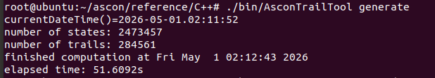
Kết quả thu được 284561 vệt vi sai 2 vòng có weight nhỏ hơn hoặc bằng 39.
Mở rộng lên 3 vòng:
./bin/AsconTrailTool extendWW forward 40
Kết quả mở rộng 3 vòng:
wc -l DTS-2RTrailCoresUpToWeight39_2w0+w1-forwUpTo40
Sau khi mở rộng lên 3 vòng thì số vệt có weight nhỏ hơn hoặc bằng 40 chỉ còn 2 vệt.
- Thiết lập backward – DTS
Bên cạnh forward extension, nhóm nghiên cứu tiếp tục khảo sát theo hướng backward extension nhằm đánh giá khả năng tồn tại của các vệt vi sai khi mở rộng ngược về phía đầu vào..
Sinh trail core 2 vòng:
nano src/config.h
#define DTS 1
static const int limitWeight = 40;
static const int weightedWeights = 12; // w_rev(a) + 2w(b) <= 40
make -B
./bin/AsconTrailTool generate
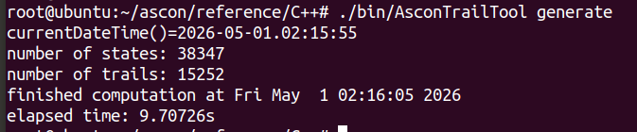
Mở rộng lên 3 vòng:
./bin/AsconTrailTool extendWW backward 40
Kết quả mở rộng 3 vòng:
wc -l DTS-2RTrailCoresUpToWeight40_w0+2w1-backUpTo40
- Đánh giá không gian vệt tuyến tính (Linear Trail Space – LTS)
- Thiết lập forward – LTS
Sinh trail core 2 vòng:
nano src/config.h
#define DTS 0
static const int limitWeight = 26;
static const int weightedWeights = 21;
make -B
./bin/AsconTrailTool generate
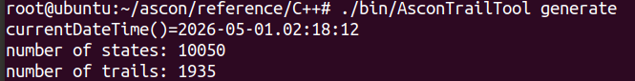
Mở rộng lên 3 vòng:
./bin/AsconTrailTool extendWW forward 28
Kết quả mở rộng 3 vòng:
wc -l LTS-2RTrailCoresUpToWeight26_2w0+w1-forwUpTo28
- Thiết lập backward – LTS
Sinh trail core 2 vòng:
nano src/config.h
#define DTS 0
static const int limitWeight = 28;
static const int weightedWeights = 12; // w_rev(a) + 2w(b) <= 28
make -B
./bin/AsconTrailTool generate
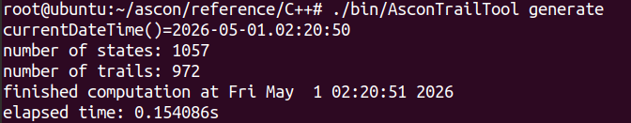
Mở rộng lên 3 vòng:
./bin/AsconTrailTool extendWW backward 28
Kết quả mở rộng 3 vòng:
wc -l LTS-2RTrailCoresUpToWeight28_w0+2w1-backUpTo28

Thuật toán Ascon AEAD cải tiến trên tầng tuyến tính mới và S-box Ascon2
- Đánh giá không gian vệt vi sai (Differential Trail Space – DTS)
- Thiết lập forward – DTS
Sinh trail core 2 vòng:
nano src/config.h
#define DTS 1
static const int limitWeight = 49;
static const int weightedWeights = 21; // 2w_rev(a) + w(b) < 50
make -B
./bin/AsconTrailTool generate
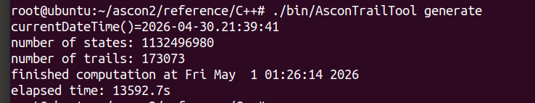
Mở rộng lên 3 vòng:
./bin/AsconTrailTool extendWW forward 50
Kết quả mở rộng 3 vòng:
wc -l DTS-2RTrailCoresUpToWeight49_2w0+w1-forwUpTo50
- Thiết lập backward – DTS
Bên cạnh forward extension, nhóm nghiên cứu tiếp tục khảo sát theo hướng backward extension nhằm đánh giá khả năng tồn tại của các vệt vi sai khi mở rộng ngược về phía đầu vào.
Sinh trail core 2 vòng:
nano src/config.h
#define DTS 1
static const int limitWeight = 50;
static const int weightedWeights = 12; // w_rev(a) + 2w(b) <= 50
make -B
./bin/AsconTrailTool generate
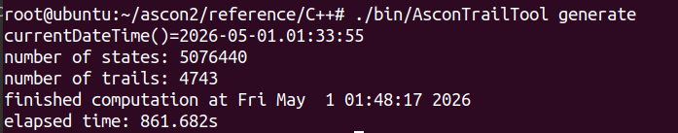
Mở rộng lên 3 vòng:
./bin/AsconTrailTool extendWW backward 50
Kết quả mở rộng 3 vòng:
wc -l DTS-2RTrailCoresUpToWeight50_w0+2w1-backUpTo50
- Đánh giá không gian vệt tuyến tính (Linear Trail Space – LTS)
- Thiết lập forward – LTS
Sinh trail core 2 vòng:
nano src/config.h
#define DTS 0
static const int limitWeight = 46;
static const int weightedWeights = 21;
make -B
./bin/AsconTrailTool generate
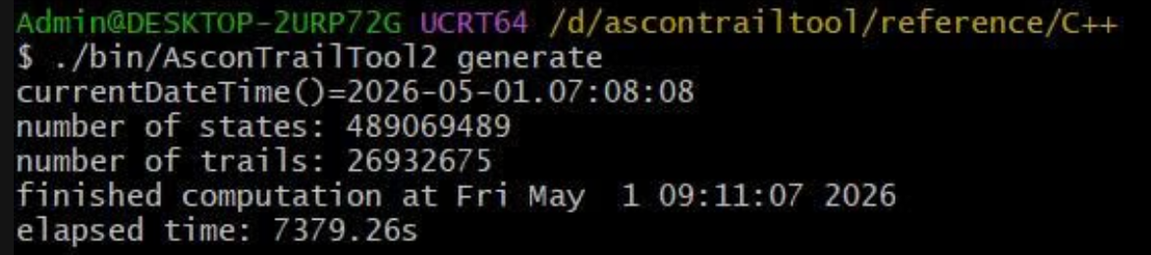
Mở rộng lên 3 vòng:
./bin/AsconTrailTool extendWW forward 48
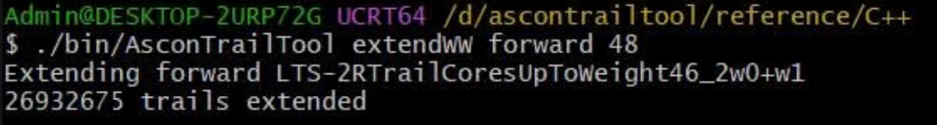
Kết quả mở rộng 3 vòng:
wc -l LTS-2RTrailCoresUpToWeight46_2w0+w1-forwUpTo48
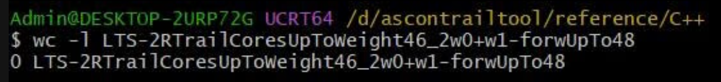
- Thiết lập backward – LTS
Sinh trail core 2 vòng:
nano src/config.h
#define DTS 0
static const int limitWeight = 48;
static const int weightedWeights = 12; // w_rev(a) + 2w(b) <= 48
make -B
./bin/AsconTrailTool generate
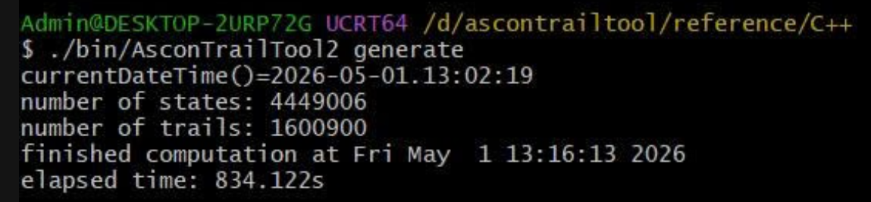
Mở rộng lên 3 vòng:
./bin/AsconTrailTool extendWW backward 48
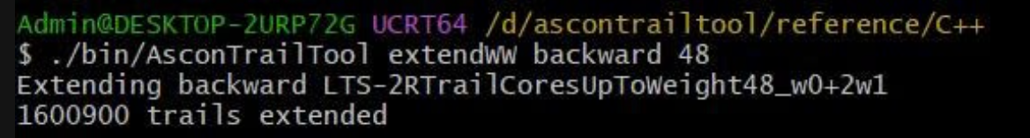
Kết quả mở rộng 3 vòng:
wc – l LTS-2RTrailCoresUpToWeight48_w0+2w1-backUpTo48
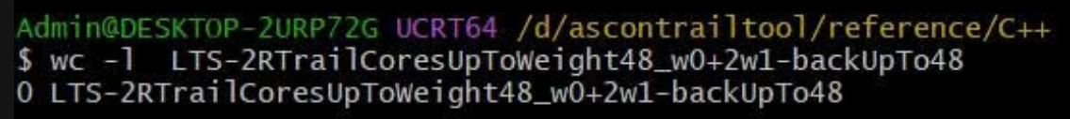

Thuật toán Ascon AEAD cải tiến trên tầng tuyến tính mới và S-box Ascon3
- Đánh giá không gian vệt vi sai (Differential Trail Space – DTS)
- Thiết lập forward – DTS
Sinh trail core 2 vòng:
nano src/config.h
#define DTS 1
static const int limitWeight = 50;
static const int weightedWeights = 21; // 2w_rev(a) + w(b) < 50
make -B
./bin/AsconTrailTool generate
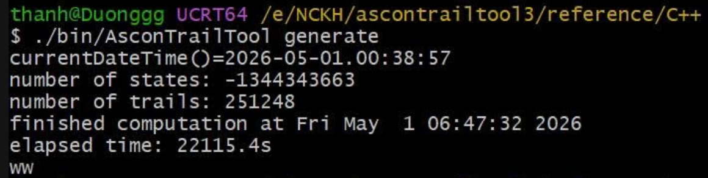
Mở rộng lên 3 vòng:
./bin/AsconTrailTool extendWW forward 51
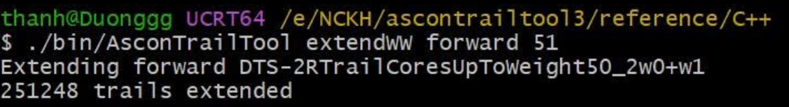
Kết quả mở rộng 3 vòng:
wc – l DTS-2RtrailCoresUpToWeight50_2w0+w1-forwUpTo51
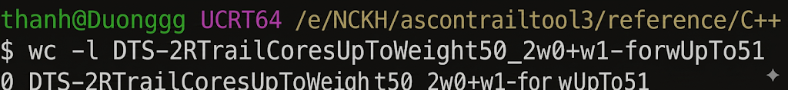
- Thiết lập backward – DTS
Bên cạnh forward extension, nhóm nghiên cứu tiếp tục khảo sát theo hướng backward extension nhằm đánh giá khả năng tồn tại của các vệt vi sai khi mở rộng ngược về phía đầu vào..
Sinh trail core 2 vòng:
nano src/config.h
#define DTS 1
static const int limitWeight = 51;
static const int weightedWeights = 12; // w_rev(a) + 2w(b) <= 51
make -B
./bin/AsconTrailTool generate
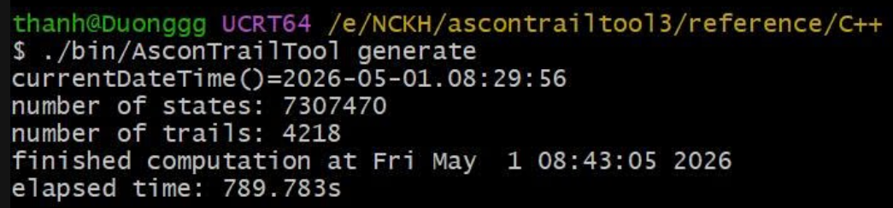
Mở rộng lên 3 vòng:
./bin/AsconTrailTool extendWW backward 51
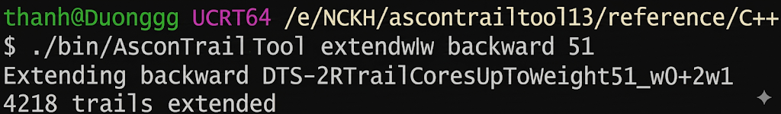
Kết quả mở rộng 3 vòng:
wc – l DTS-2RtrailCoresUpToWeight51_w0+2w1-backUpTo51
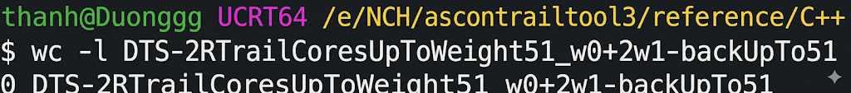
- Đánh giá không gian vệt tuyến tính (Linear Trail Space – LTS)
- Thiết lập forward – LTS
Sinh trail core 2 vòng:
nano src/config.h
#define DTS 0
static const int limitWeight = 46;
static const int weightedWeights = 21;
make -B
./bin/AsconTrailTool generate
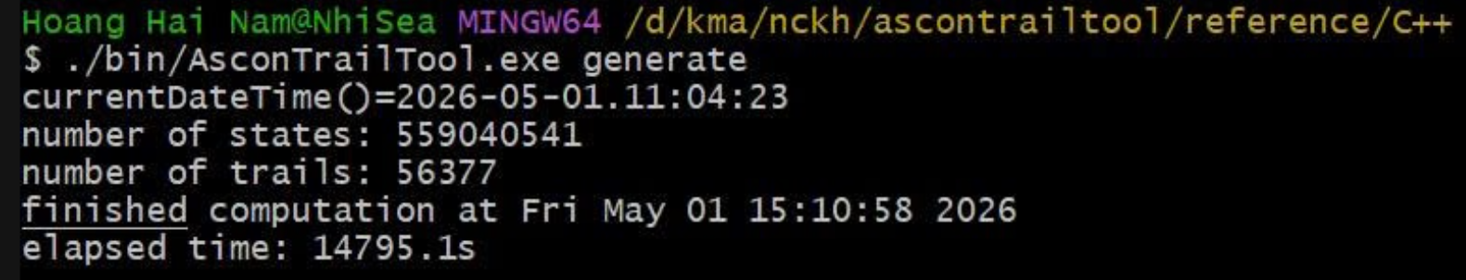
Mở rộng lên 3 vòng:
./bin/AsconTrailTool extendWW forward 48
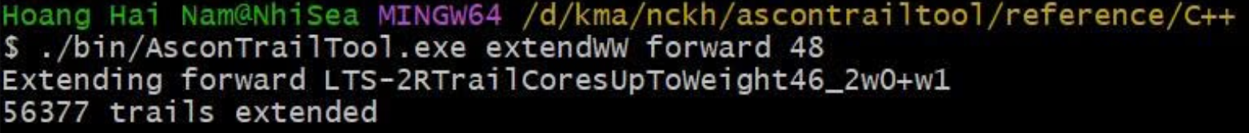
Kết quả mở rộng 3 vòng:
wc -l LTS-2RtrailCoresUpToWeight46_2w0+w1-forwUpTo48
- Thiết lập backward – LTS
Sinh trail core 2 vòng:
nano src/config.h
#define DTS 0
static const int limitWeight = 48;
static const int weightedWeights = 12; // w_rev(a) + 2w(b) <= 48
make -B
./bin/AsconTrailTool generate
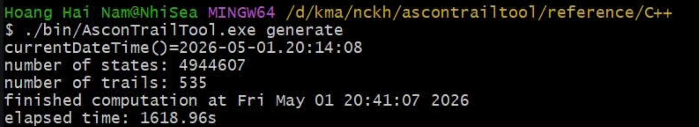
Mở rộng lên 3 vòng:
./bin/AsconTrailTool extendWW backward 48
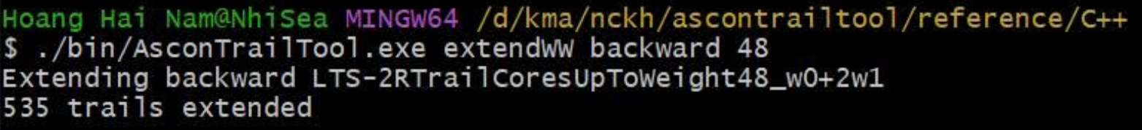
Kết quả mở rộng 3 vòng:
wc -l LTS-2RtrailCoresUpToWeight48_w0+2w1-backUpTo48

Cái dưới này mình để đọc hiểu chỗ nào cần thay thôi nha: Thay file: asconColScore.cpp, trailExtension.cpp , config.h(sửa 1 xíu)
File code đầu vào cho ascontrail: Mấy cái DDT với LAT là thay cho file code .py tính đầu vào, còn trong bảng là lấy để thay luôn vào trong code cần để thay cho Sbox mới
Ascon gốc:
Ascon2
uint64_t biggerThanTwo(State &s) {
return
(s.getRow(0) & s.getRow(3)) ^ // x0x3
(s.getRow(2) & s.getRow(3)) ^ // x2x3

(s.getRow(1) & s.getRow(4)) ^ // x1x4
(s.getRow(3) & s.getRow(4)) ^ // x3x4

(s.getRow(0) & s.getRow(2)) ^ // x0x2
(s.getRow(0) & s.getRow(4)) ^ // x0x4

(s.getRow(0) & s.getRow(1)) ^ // x0x1
(s.getRow(1) & s.getRow(3)) ^ // x1x3

(s.getRow(1) & s.getRow(2)) ^ // x1x2
(s.getRow(2) & s.getRow(4)); // x2x4
}
uint64_t biggerThanThree(State &s) {
return
(s.getRow(0) & s.getRow(3) & s.getRow(2)) ^ // x0 x3 x2
(s.getRow(1) & s.getRow(4) & s.getRow(3)) ^ // x1 x4 x3
(s.getRow(0) & s.getRow(2) & s.getRow(4)) ^ // x0 x2 x4
(s.getRow(0) & s.getRow(1) & s.getRow(3)) ^ // x0 x1 x3
(s.getRow(1) & s.getRow(2) & s.getRow(4)); // x1 x2 x4
}
uint64_t biggerThanTwoLTS(State &s) {
return
(s.getRow(0) & s.getRow(3)) ^
(s.getRow(2) & s.getRow(3)) ^
(s.getRow(1) & s.getRow(4)) ^
(s.getRow(3) & s.getRow(4)) ^
(s.getRow(0) & s.getRow(2));
}

DDT = [
[32,0,0,0,0,0,0,0,0,0,0,0,0,0,0,0,0,0,0,0,0,0,0,0,0,0,0,0,0,0,0,0],
[0,0,0,0,0,4,0,0,0,0,0,0,4,0,4,4,0,0,0,0,0,4,0,4,0,4,0,0,0,4,0,0],
[0,4,0,0,0,0,4,0,0,4,0,0,4,0,0,0,0,4,0,0,4,0,0,4,0,0,0,0,4,0,0,0],
[0,0,4,0,0,0,4,0,4,0,0,0,0,4,0,0,4,0,0,0,4,0,4,0,0,0,0,4,0,0,0,0],
[0,0,0,4,0,0,0,4,4,0,0,4,0,0,0,0,4,0,4,4,0,0,0,0,0,0,4,0,0,0,0,0],
[0,0,0,0,4,0,0,0,0,0,4,4,0,0,0,4,0,0,0,4,0,0,0,0,4,4,0,0,0,0,4,0],
[0,0,2,2,0,2,2,2,0,0,2,2,2,0,0,2,0,2,2,0,0,0,2,2,0,0,0,2,0,0,2,2],
[0,0,4,0,0,0,0,0,4,0,4,0,0,4,0,0,0,0,0,4,0,0,4,0,4,0,0,0,0,0,4,0],
[0,2,0,2,2,0,2,0,2,0,2,0,2,0,2,2,0,0,2,0,2,0,2,0,2,0,2,0,0,2,0,2],
[0,0,0,0,0,4,0,0,0,0,0,0,4,4,4,0,0,0,0,0,4,4,4,0,0,0,0,4,0,0,0,0],
[0,0,0,4,0,0,0,4,0,0,0,4,0,0,4,0,0,0,4,0,0,4,0,0,0,4,0,0,0,4,0,0],
[0,0,2,0,2,2,2,0,2,2,0,2,2,0,2,0,2,0,2,0,0,2,0,0,2,0,0,0,2,0,2,2],
[0,2,2,0,2,0,0,2,2,0,0,2,2,2,0,2,0,2,0,0,0,2,2,0,0,2,2,0,2,0,0,2],
[0,4,0,0,0,0,4,4,0,4,0,0,0,0,0,0,4,4,4,0,0,0,0,0,0,0,4,0,0,0,0,0],
[0,0,0,0,4,0,0,0,0,4,4,0,0,0,0,4,0,4,0,0,0,0,0,4,4,0,0,0,4,0,0,0],
[0,2,0,2,0,2,2,0,2,2,0,2,0,2,0,2,0,2,0,2,0,2,0,0,2,0,0,2,0,2,0,2],
[0,2,0,0,0,0,2,2,0,2,0,0,2,0,0,0,2,2,2,0,2,2,0,2,0,0,2,2,2,2,0,2],
[0,4,0,0,4,4,0,4,0,0,0,4,0,0,4,0,0,0,0,0,0,0,0,4,0,0,0,0,0,4,0,0],
[0,4,4,4,0,0,0,0,0,0,0,0,4,4,4,0,4,0,0,0,0,0,0,0,0,0,0,4,0,0,0,0],
[0,0,2,0,0,0,2,0,2,0,2,0,0,2,0,0,2,2,0,2,2,0,2,0,2,0,2,2,2,0,2,2],
[0,0,0,0,0,2,0,0,0,0,0,0,2,2,2,2,0,0,0,0,2,2,2,2,2,2,0,2,2,2,2,2],
[0,0,0,4,4,4,0,0,4,0,4,0,0,4,0,0,0,0,0,0,0,0,0,0,0,4,0,0,0,0,4,0],
[0,4,4,0,0,4,0,0,0,4,4,0,0,0,0,4,0,0,0,0,4,0,0,0,0,0,0,0,4,0,0,0],
[0,0,0,0,2,0,0,0,0,2,2,2,0,0,0,2,0,2,2,2,0,0,0,2,2,2,2,0,2,2,2,2],
[0,0,4,4,4,0,4,4,0,4,0,0,0,0,0,0,0,0,0,4,0,0,0,0,0,0,4,0,0,0,0,0],
[0,0,0,2,0,0,0,2,2,0,0,2,0,0,2,0,2,0,2,2,0,2,2,0,0,2,2,2,0,2,2,2],
[0,0,2,0,0,0,2,0,2,0,2,0,0,2,0,0,2,2,0,2,2,0,2,0,2,0,2,2,2,0,2,2],
[0,2,0,0,0,0,2,2,0,2,0,0,2,0,0,0,2,2,2,0,2,2,0,2,0,0,2,2,2,2,0,2],
[0,0,0,0,0,2,0,0,0,0,0,0,2,2,2,2,0,0,0,0,2,2,2,2,2,2,0,2,2,2,2,2],
[0,0,0,0,2,0,0,0,0,2,2,2,0,0,0,2,0,2,2,2,0,0,0,2,2,2,2,0,2,2,2,2],
[0,0,0,2,0,0,0,2,2,0,0,2,0,0,2,0,2,0,2,2,0,2,2,0,0,2,2,2,0,2,2,2],
[0,2,2,2,2,2,0,0,0,0,0,0,0,0,0,0,2,2,2,2,2,2,2,2,2,2,0,0,0,0,0,2]
]

# =========================
# LAT (PASTE FULL 32 ROWS)
# =========================

LAT = [
[32,0,0,0,0,0,0,0,0,0,0,0,0,0,0,0,0,0,0,0,0,0,0,0,0,0,0,0,0,0,0,0],
[0,0,0,0,0,16,8,0,0,0,0,0,0,8,0,8,8,8,0,0,0,0,8,8,0,8,8,0,8,8,0,8],
[0,16,0,0,0,0,0,8,8,0,0,0,8,0,0,0,0,0,8,8,8,0,8,8,0,0,0,8,8,0,8,8],
[0,0,16,0,0,0,8,0,0,0,8,8,0,0,0,0,8,0,8,0,8,0,0,0,8,8,8,8,0,8,0,8],
[0,0,0,16,0,0,0,0,8,0,0,0,0,0,8,8,8,0,0,8,0,8,0,8,8,0,8,0,8,0,8,8],
[0,0,0,0,16,0,0,0,0,8,0,8,8,0,0,0,0,8,0,8,8,8,0,0,0,8,0,8,0,8,8,8],
[0,0,0,0,0,0,8,8,8,0,0,0,8,8,0,8,8,8,8,8,8,0,0,0,0,8,8,8,0,8,8,0],
[0,0,0,0,0,16,0,0,0,0,8,8,0,8,0,8,0,8,8,0,8,0,8,8,8,0,0,8,8,0,0,0],
[0,0,0,0,0,0,8,8,8,0,8,8,8,0,0,0,8,0,0,8,0,0,8,8,8,8,8,0,8,8,8,0],
[0,0,0,16,0,0,8,0,8,0,0,0,0,8,8,0,0,8,0,8,0,8,8,0,8,8,0,0,0,8,8,0],
[0,16,0,0,0,0,0,8,0,0,0,0,8,0,8,8,8,0,8,0,8,8,8,0,8,0,8,8,0,0,0,0],
[0,0,0,0,0,0,8,0,8,0,8,8,0,0,8,8,0,0,8,8,8,8,0,8,0,8,0,8,8,8,8,0],
[0,0,0,0,0,0,8,0,0,8,0,8,8,8,0,8,8,0,0,8,8,8,8,8,0,0,8,8,8,0,8,0],
[0,0,0,0,16,0,0,8,8,8,0,8,0,0,0,0,0,8,8,0,0,8,8,8,0,8,0,0,8,8,0,0],
[0,0,16,0,0,0,8,0,0,8,8,0,8,0,0,0,8,8,8,8,0,8,0,0,8,0,8,0,0,0,8,0],
[0,0,0,0,0,0,0,0,8,8,0,8,8,0,8,8,8,8,0,0,8,0,0,8,8,8,8,8,8,8,0,0],
[0,16,0,0,0,0,0,8,8,0,8,8,8,8,0,8,0,8,0,8,0,0,0,0,8,0,0,0,0,0,8,8],
[0,0,0,0,0,0,8,8,0,0,0,0,8,8,8,0,0,8,8,0,8,8,0,8,8,8,0,8,8,8,0,8],
[0,0,0,0,0,0,0,0,8,0,8,8,0,8,8,0,8,8,8,8,8,8,8,0,0,0,8,8,0,0,8,8],
[0,0,16,0,0,0,8,8,0,0,8,8,8,0,8,8,0,0,0,0,0,8,8,0,0,8,0,0,0,8,0,8],
[0,0,0,0,0,16,8,8,8,8,0,8,0,8,0,8,8,0,8,0,0,8,0,0,0,0,8,0,0,0,0,8],
[0,0,0,0,0,0,0,0,0,8,8,0,8,8,0,8,0,0,8,8,0,8,8,8,8,8,0,0,8,8,8,8],
[0,0,0,0,0,0,8,8,8,8,8,0,0,0,0,0,8,8,0,0,8,8,8,8,8,0,8,8,8,0,0,8],
[0,0,0,0,16,0,8,0,8,8,0,8,8,8,8,0,0,0,0,0,8,0,8,0,8,0,0,8,0,0,0,8],
[0,0,0,0,0,0,0,8,0,8,0,8,0,0,8,8,8,8,8,8,0,0,8,0,8,8,8,0,0,8,8,8],
[0,0,0,16,0,0,8,0,8,8,8,0,8,0,8,8,0,8,8,0,0,0,0,8,0,0,0,0,8,0,0,8],
[0,16,0,0,0,0,0,8,0,0,8,8,8,8,8,0,8,8,0,0,0,8,0,8,0,0,8,0,8,0,0,0],
[0,0,0,0,0,16,0,8,8,8,8,0,0,8,0,8,0,0,0,0,8,8,0,0,8,8,0,8,0,8,0,0],
[0,0,0,0,16,0,8,8,0,8,0,8,0,8,8,0,0,0,8,8,0,0,0,8,8,0,0,0,8,0,8,0],
[0,0,0,16,0,0,0,0,8,8,8,0,8,8,8,0,8,0,8,0,0,0,8,0,0,8,8,0,0,8,0,0],
[0,0,16,0,0,0,8,8,0,8,8,0,0,0,8,8,0,8,0,8,8,0,8,0,0,0,0,8,0,0,8,0],
[0,0,0,0,0,0,0,8,0,8,8,0,0,8,8,0,8,0,0,8,8,0,0,8,0,8,8,8,8,8,8,8]
]

Ascon 3
uint64_t biggerThanTwo(State &stateAtB) {
// x0x1 + x0x2 + x0x3 + x1x2 + x1x4 + x2x3 + x2x4 + x3x4

return (stateAtB.getRow(0) & stateAtB.getRow(1)) ^
(stateAtB.getRow(0) & stateAtB.getRow(2)) ^
(stateAtB.getRow(0) & stateAtB.getRow(3)) ^
(stateAtB.getRow(1) & stateAtB.getRow(2)) ^
(stateAtB.getRow(1) & stateAtB.getRow(4)) ^
(stateAtB.getRow(2) & stateAtB.getRow(3)) ^
(stateAtB.getRow(2) & stateAtB.getRow(4)) ^
(stateAtB.getRow(3) & stateAtB.getRow(4));
}
uint64_t biggerThanThree(State &stateAtB) {
// ASCON-3: no cubic terms in ANF
return 0;
}
uint64_t biggerThanTwoLTS(State &stateAtB) {
// lightweight approximation (faster pruning)

return (stateAtB.getRow(1) & stateAtB.getRow(3)) ^
(stateAtB.getRow(3) & stateAtB.getRow(4)) ^
(stateAtB.getRow(0) & stateAtB.getRow(1)) ^
(stateAtB.getRow(2) & stateAtB.getRow(4));
}
DDT = [
[32,0,0,0,0,0,0,0,0,0,0,0,0,0,0,0,0,0,0,0,0,0,0,0,0,0,0,0,0,0,0,0],
[0,0,0,0,0,0,0,0,4,0,0,0,0,0,4,0,4,0,0,4,0,4,0,0,0,4,4,0,0,4,0,0],
[0,0,0,0,0,0,0,0,0,4,0,4,0,0,0,0,0,4,0,4,0,0,0,4,0,4,0,0,4,0,4,0],
[0,0,0,0,0,0,0,0,0,0,0,0,0,4,0,4,0,0,0,0,4,0,4,4,0,4,0,4,0,4,0,0],
[0,0,0,0,0,0,0,4,0,0,0,0,4,0,0,0,4,0,4,0,4,0,0,4,0,0,4,0,4,0,0,0],
[0,0,0,0,0,0,4,0,0,0,4,0,0,0,0,0,4,0,0,4,4,0,0,0,4,0,0,4,0,0,4,0],
[0,0,2,0,2,2,2,0,2,2,0,2,2,0,2,0,2,0,2,0,0,2,0,0,2,0,0,0,2,0,2,2],
[0,0,0,2,2,2,0,2,2,2,2,0,2,2,0,0,2,2,0,0,2,0,0,0,0,2,0,0,0,2,2,2],
[0,2,0,2,0,2,2,0,2,2,0,2,0,2,0,2,0,2,0,2,0,2,0,0,2,0,0,2,0,2,0,2],
[0,2,2,2,0,0,0,0,0,2,2,2,2,2,2,0,2,0,0,0,0,0,0,2,2,2,2,2,0,0,0,2],
[0,2,0,0,2,2,2,2,0,0,2,2,0,2,2,0,2,0,0,2,0,0,2,2,0,0,0,0,2,2,0,2],
[0,2,2,0,2,0,0,2,2,0,0,2,2,2,0,2,0,2,0,0,0,2,2,0,0,2,2,0,2,0,0,2],
[0,2,0,2,2,0,2,0,2,0,2,0,2,0,2,2,0,0,2,0,2,0,2,0,2,0,2,0,0,2,0,2],
[0,0,2,2,2,0,2,2,0,2,0,0,0,2,2,2,0,0,0,2,2,2,0,2,0,0,2,0,0,0,2,2],
[0,2,2,0,0,2,0,2,2,2,2,0,0,0,2,2,0,0,2,2,2,0,0,0,0,2,0,2,2,0,0,2],
[0,0,2,2,0,2,2,2,0,0,2,2,2,0,0,2,0,2,2,0,0,0,2,2,0,0,0,2,0,0,2,2],
[0,0,0,0,0,4,4,0,0,4,0,0,0,0,4,0,4,0,4,0,0,0,0,0,4,0,0,0,0,0,4,0],
[0,2,2,0,2,0,0,2,2,0,0,2,2,2,0,2,0,2,0,0,0,2,2,0,0,2,2,0,2,0,0,2],
[0,2,0,2,2,0,2,0,2,0,2,0,2,0,2,2,0,0,2,0,2,0,2,0,2,0,2,0,0,2,0,2],
[0,4,0,0,0,0,0,0,4,4,0,0,0,4,0,0,0,0,0,4,0,4,0,0,4,0,0,0,0,4,0,0],
[0,0,0,0,4,0,0,0,0,0,4,0,4,0,4,0,0,0,4,0,4,0,4,0,0,0,4,0,0,0,0,0],
[0,2,0,2,0,2,2,0,2,2,0,2,0,2,0,2,0,2,0,2,0,2,0,0,2,0,0,2,0,2,0,2],
[0,0,2,2,0,2,2,2,0,0,2,2,2,0,0,2,0,2,2,0,0,0,2,2,0,0,0,2,0,0,2,2],
[0,0,0,4,0,0,0,4,0,0,4,0,0,0,0,4,0,4,0,0,0,0,4,4,0,0,0,4,0,0,0,0],
[0,0,2,0,2,2,2,0,2,2,0,2,2,0,2,0,2,0,2,0,0,2,0,0,2,0,0,0,2,0,2,2],
[0,0,4,0,0,0,0,4,0,0,0,4,0,4,0,0,0,4,0,0,0,4,0,0,0,4,0,0,4,0,0,0],
[0,4,0,0,4,0,0,0,4,0,0,0,0,0,4,0,0,0,0,0,4,0,0,0,4,0,4,0,0,4,0,0],
[0,0,0,4,0,4,4,0,0,0,4,0,0,0,0,0,0,0,4,0,0,0,0,4,0,0,0,4,0,0,4,0],
[0,0,4,0,4,0,0,4,0,0,0,0,4,0,0,0,0,0,0,0,0,0,4,0,0,4,4,0,4,0,0,0],
[0,4,0,4,0,0,0,0,0,0,0,0,0,4,0,4,0,4,0,4,0,0,0,0,0,0,0,4,0,4,0,0],
[0,0,4,0,0,4,0,0,0,4,0,4,0,0,0,0,4,0,0,0,0,4,0,0,0,0,0,0,4,0,4,0],
[0,2,2,2,2,2,0,0,0,0,0,0,0,0,0,0,2,2,2,2,2,2,2,2,2,2,0,0,0,0,0,2]
]
LAT = [
[32,0,0,0,0,0,0,0,0,0,0,0,0,0,0,0,0,0,0,0,0,0,0,0,0,0,0,0,0,0,0,0],
[0,0,0,0,0,16,8,0,0,0,0,0,0,8,0,8,8,8,0,0,0,0,8,8,0,8,8,0,8,8,0,8],
[0,16,0,0,0,0,0,8,8,0,0,0,8,0,0,0,0,0,8,8,8,0,8,8,0,0,0,8,8,0,8,8],
[0,0,16,0,0,0,8,0,0,0,8,8,0,0,0,0,8,0,8,0,8,0,0,0,8,8,8,8,0,8,0,8],
[0,0,0,16,0,0,0,0,8,0,0,0,0,0,8,8,8,0,0,8,0,8,0,8,8,0,8,0,8,0,8,8],
[0,0,0,0,16,0,0,0,0,8,0,8,8,0,0,0,0,8,0,8,8,8,0,0,0,8,0,8,0,8,8,8],
[0,0,0,0,0,0,8,8,8,0,0,0,8,8,0,8,8,8,8,8,8,0,0,0,0,8,8,8,0,8,8,0],
[0,0,0,0,0,16,0,0,0,0,8,8,0,8,0,8,0,8,8,0,8,0,8,8,8,0,0,8,8,0,0,0],
[0,0,0,0,0,0,8,8,8,0,8,8,8,0,0,0,8,0,0,8,0,0,8,8,8,8,8,0,8,8,8,0],
[0,0,0,16,0,0,8,0,8,0,0,0,0,8,8,0,0,8,0,8,0,8,8,0,8,8,0,0,0,8,8,0],
[0,16,0,0,0,0,0,8,0,0,0,0,8,0,8,8,8,0,8,0,8,8,8,0,8,0,8,8,0,0,0,0],
[0,0,0,0,0,0,8,0,8,0,8,8,0,0,8,8,0,0,8,8,8,8,0,8,0,8,0,8,8,8,8,0],
[0,0,0,0,0,0,8,0,0,8,0,8,8,8,0,8,8,0,0,8,8,8,8,8,0,0,8,8,8,0,8,0],
[0,0,0,0,16,0,0,8,8,8,0,8,0,0,0,0,0,8,8,0,0,8,8,8,0,8,0,0,8,8,0,0],
[0,0,16,0,0,0,8,0,0,8,8,0,8,0,0,0,8,8,8,8,0,8,0,0,8,0,8,0,0,0,8,0],
[0,0,0,0,0,0,0,0,8,8,0,8,8,0,8,8,8,8,0,0,8,0,0,8,8,8,8,8,8,8,0,0],
[0,16,0,0,0,0,0,8,8,0,8,8,8,8,0,8,0,8,0,8,0,0,0,0,8,0,0,0,0,0,8,8],
[0,0,0,0,0,0,8,8,0,0,0,0,8,8,8,0,0,8,8,0,8,8,0,8,8,8,0,8,8,8,0,8],
[0,0,0,0,0,0,0,0,8,0,8,8,0,8,8,0,8,8,8,8,8,8,8,0,0,0,8,8,0,0,8,8],
[0,0,16,0,0,0,8,8,0,0,8,8,8,0,8,8,0,0,0,0,0,8,8,0,0,8,0,0,0,8,0,8],
[0,0,0,0,0,16,8,8,8,8,0,8,0,8,0,8,8,0,8,0,0,8,0,0,0,0,8,0,0,0,0,8],
[0,0,0,0,0,0,0,0,0,8,8,0,8,8,0,8,0,0,8,8,0,8,8,8,8,8,0,0,8,8,8,8],
[0,0,0,0,0,0,8,8,8,8,8,0,0,0,0,0,8,8,0,0,8,8,8,8,8,0,8,8,8,0,0,8],
[0,0,0,0,16,0,8,0,8,8,0,8,8,8,8,0,0,0,0,0,8,0,8,0,8,0,0,8,0,0,0,8],
[0,0,0,0,0,0,0,8,0,8,0,8,0,0,8,8,8,8,8,8,0,0,8,0,8,8,8,0,0,8,8,8],
[0,0,0,16,0,0,8,0,8,8,8,0,8,0,8,8,0,8,8,0,0,0,0,8,0,0,0,0,8,0,0,8],
[0,16,0,0,0,0,0,8,0,0,8,8,8,8,8,0,8,8,0,0,0,8,0,8,0,0,8,0,8,0,0,0],
[0,0,0,0,0,16,0,8,8,8,8,0,0,8,0,8,0,0,0,0,8,8,0,0,8,8,0,8,0,8,0,0],
[0,0,0,0,16,0,8,8,0,8,0,8,0,8,8,0,0,0,8,8,0,0,0,8,8,0,0,0,8,0,8,0],
[0,0,0,16,0,0,0,0,8,8,8,0,8,8,8,0,8,0,8,0,0,0,8,0,0,8,8,0,0,8,0,0],
[0,0,16,0,0,0,8,8,0,8,8,0,0,0,8,8,0,8,0,8,8,0,8,0,0,0,0,8,0,0,8,0],
[0,0,0,0,0,0,0,8,0,8,8,0,0,8,8,0,8,0,0,8,8,0,0,8,0,8,8,8,8,8,8,8]
]

Câu hỏi: Hướng dẫn LT và CT cách tính chỗ những file cần sửa
asconColScore.cpp
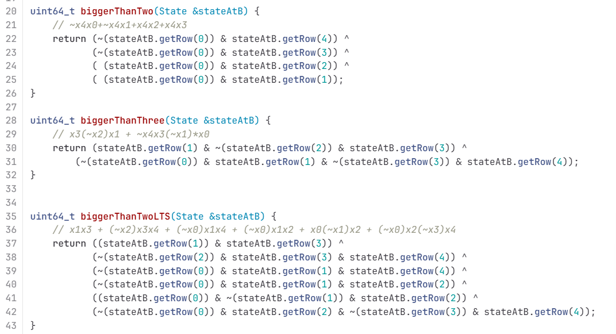
Đoạn code này thì được tính bằng code---Cái này cũng có trong code của cỗ exten… rồi nhưng mà viết lại cho dễ nhìn(code này đã kiểm chứng test thử bằng ascon gốc và ra kết quả giống)
Trong paper về Ascon, weight được định nghĩa như sau:
- Differential weight
$$w_{r}(b,a)=-{log⁡}_{2}DP(b,a)$$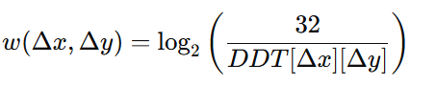
- Linear weight
$$w_{c}(a,b)=-{log⁡}_{2}C^{2}(a,b)$$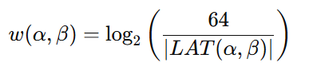
Nói đơn giản:
- Differential: weight = $-{log⁡}_{2}(\text{probability})$
- Linear: weight = $-{log⁡}_{2}({\text{correlation}}^{2})$
PS C:\Users\Acer\PEIGEN> & C:/Users/Acer/AppData/Local/Microsoft/WindowsApps/python3.11.exe "c:/Desktop/MS Visio/Downloads/tinhdauvaohoasconColScore1.py"
wr (DTS weightListPerInput)
[0, 3, 3, 4, 3, 3, 4, 4, 3, 3, 3, 3, 4, 3, 4, 4, 3, 4, 3, 4, 3, 3, 3, 4, 4, 4, 3, 4, 4, 4, 4, 4]
lấy từng giá trị DDT > 0 trong dòng
tính weight
chọn weight nhỏ nhất
Ví dụ như là xem dòng 01: có mỗi số 4(nếu dòng có thêm số 8 thì log₂(32/8)=2 => lấy 2 vì tính ra nó nhỏ nhất)=> log₂(32/4)=3
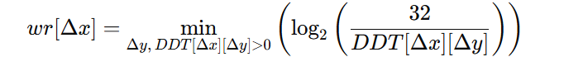
wc (LTS weightListPerInput)
[0, 2, 2, 4, 2, 4, 4, 4, 2, 4, 4, 4, 4, 4, 4, 4, 2, 4, 4, 4, 4, 4, 4, 4, 4, 4, 4, 4, 4, 4, 4, 4]
Để tính wc cho một hàng của LAT:
- Lấy tất cả giá trị trong dòng $LAT(α,β)$.
- Bỏ các giá trị bằng 0.
- Với mỗi giá trị khác 0, tính rồi tìm ra cái giá trị nhỏ nhất và lấy
Ví dụ dòng 01: có giá trị 6 và 8
w=log2​(32^2/16^2)=2; w=log2​(64/8)=3 => lấy giá trị 2
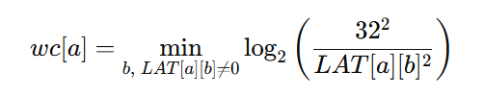
wrev_dts (minRevWeightPerOutput) (cái này thì tương tự mà theo cột)
[0, 3, 3, 3, 3, 3, 3, 3, 3, 3, 3, 3, 3, 3, 3, 3, 3, 3, 3, 3, 3, 3, 3, 3, 3, 3, 3, 3, 3, 3, 3, 4]
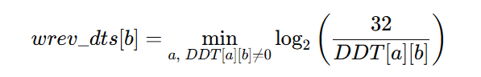
wrev_lts (minRevWeightPerOutput)(cái này thì tương tự theo cột)
[0, 2, 2, 4, 2, 2, 4, 2, 2, 2, 2, 4, 4, 4, 2, 2, 2, 4, 2, 2, 2, 4, 4, 2, 4, 2, 4, 2, 2, 2, 2, 4]
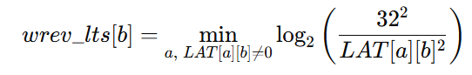
và thay số vào những chỗ này
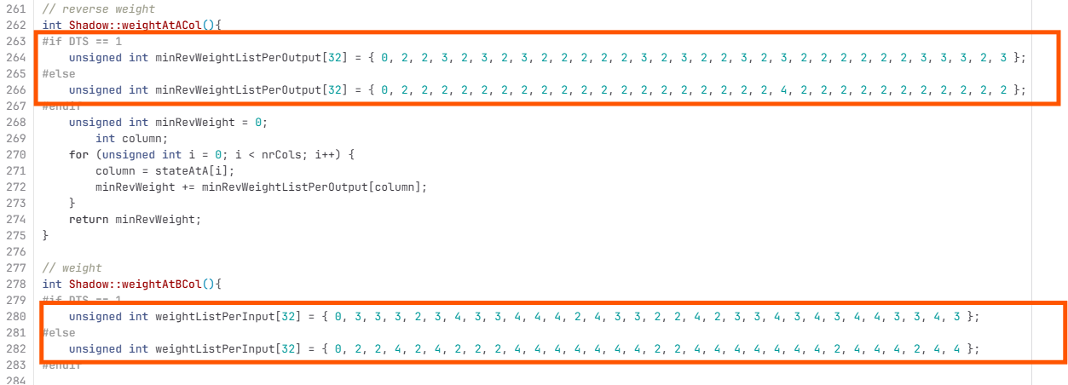
Tiếp theo là sửa file: trailExtension.cpp(chỉ thay số chữ tên chữ vẫn giữ nguyên)_sửa 12 chỗ theo thứ tự file code: DTS=1 là nó đã tính cho bảng DDT còn DTS = 0 nó tính cho bảng LAT
Ví dụ cần thay mấy cái chỗ có số này. Cách tính thì tui sẽ tính và ghi lại sau. Hoặc mọi người tìm hiểu rồi ghi lại giúp t, tại cái tính này chỉ dựa vào bảng chỉ cần nhìn rồi tính 1 tí thôi là hiểu. Mấy cái số liệu trên kia cũng thế.
PS C:\Users\Acer\PEIGEN> & C:/Users/Acer/AppData/Local/Microsoft/WindowsApps/python3.11.exe "c:/Desktop/MS Visio/Downloads/tinhchoascontrail1.py"
S-box (hex): ['0x0', '0x10', '0x1', '0x19', '0x2', '0x16', '0x13', '0xf', '0x4', '0x15', '0xd', '0x14', '0x7', '0x12', '0x1e', '0x3', '0x8', '0x1c', '0xb', '0x17', '0x1a', '0xa', '0x9', '0x11', '0xe', '0x1b', '0x5', '0x18', '0x1d', '0xc', '0x6', '0x1f']
DDT/LAT OK

==================================================================
// DTS=1 (DIFFERENTIAL)
==================================================================
// Input = 0 1 2 3 4 5 6 7 8 9 10 11 12 13 14 15 16 17 18 19 20 21 22 23 24 25 26 27 28 29 30 31
weightListPerInput = { 0, 3, 3, 4, 3, 3, 4, 4, 3, 3, 3, 3, 4, 3, 4, 4, 3, 4, 3, 4, 3, 3, 3, 4, 4, 4, 3, 4, 4, 4, 4, 4 }; => Giống cái tính code trên

Cái này thì xem số ở các dòng ở đâu thì lấy số của số cột: ví dụ dòng 01:
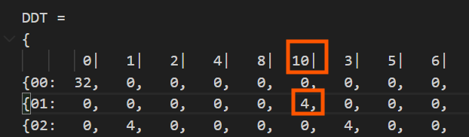
directOutputListPerInput = {
{0x00},
{0x10, 0x11, 0x14, 0x15, 0x18, 0x19, 0x1C, 0x1D},
{0x01, 0x03, 0x09, 0x0B, 0x11, 0x13, 0x19, 0x1B},
{0x02, 0x03, 0x04, 0x05, 0x0A, 0x0B, 0x0C, 0x0D, 0x10, 0x11, 0x16, 0x17, 0x18, 0x19, 0x1E, 0x1F},
{0x02, 0x03, 0x06, 0x07, 0x12, 0x13, 0x16, 0x17},
{0x02, 0x06, 0x0A, 0x0E, 0x12, 0x16, 0x1A, 0x1E},
{0x01, 0x03, 0x04, 0x06, 0x08, 0x0A, 0x0D, 0x0F, 0x11, 0x13, 0x14, 0x16, 0x18, 0x1A, 0x1D, 0x1F},
{0x01, 0x03, 0x05, 0x07, 0x09, 0x0B, 0x0D, 0x0F, 0x11, 0x13, 0x15, 0x17, 0x19, 0x1B, 0x1D, 0x1F},
{0x04, 0x05, 0x06, 0x07, 0x0C, 0x0D, 0x0E, 0x0F},
{0x10, 0x11, 0x12, 0x13, 0x14, 0x15, 0x16, 0x17},
{0x04, 0x05, 0x0C, 0x0D, 0x14, 0x15, 0x1C, 0x1D},
{0x01, 0x05, 0x08, 0x0C, 0x10, 0x14, 0x19, 0x1D},
{0x02, 0x03, 0x06, 0x07, 0x08, 0x09, 0x0C, 0x0D, 0x10, 0x11, 0x14, 0x15, 0x1A, 0x1B, 0x1E, 0x1F},
{0x01, 0x02, 0x04, 0x07, 0x11, 0x12, 0x14, 0x17},
{0x02, 0x03, 0x06, 0x07, 0x0A, 0x0B, 0x0E, 0x0F, 0x12, 0x13, 0x16, 0x17, 0x1A, 0x1B, 0x1E, 0x1F},
{0x02, 0x03, 0x06, 0x07, 0x0A, 0x0B, 0x0E, 0x0F, 0x12, 0x13, 0x16, 0x17, 0x1A, 0x1B, 0x1E, 0x1F},
{0x08, 0x0A, 0x0C, 0x0E, 0x18, 0x1A, 0x1C, 0x1E},
{0x01, 0x02, 0x05, 0x06, 0x08, 0x0B, 0x0C, 0x0F, 0x11, 0x12, 0x15, 0x16, 0x18, 0x1B, 0x1C, 0x1F},
{0x01, 0x03, 0x05, 0x07, 0x09, 0x0B, 0x0D, 0x0F},
{0x10, 0x11, 0x12, 0x13, 0x14, 0x15, 0x16, 0x17, 0x18, 0x19, 0x1A, 0x1B, 0x1C, 0x1D, 0x1E, 0x1F},
{0x08, 0x09, 0x0A, 0x0B, 0x18, 0x19, 0x1A, 0x1B},
{0x04, 0x06, 0x08, 0x0A, 0x10, 0x12, 0x1C, 0x1E},
{0x01, 0x02, 0x09, 0x0A, 0x10, 0x13, 0x18, 0x1B},
{0x01, 0x03, 0x05, 0x07, 0x09, 0x0B, 0x0D, 0x0F, 0x11, 0x13, 0x15, 0x17, 0x19, 0x1B, 0x1D, 0x1F},
{0x01, 0x03, 0x04, 0x06, 0x09, 0x0B, 0x0C, 0x0E, 0x10, 0x12, 0x15, 0x17, 0x18, 0x1A, 0x1D, 0x1F},
{0x08, 0x09, 0x0A, 0x0B, 0x0C, 0x0D, 0x0E, 0x0F, 0x18, 0x19, 0x1A, 0x1B, 0x1C, 0x1D, 0x1E, 0x1F},
{0x02, 0x03, 0x04, 0x05, 0x08, 0x09, 0x0E, 0x0F},
{0x10, 0x11, 0x12, 0x13, 0x14, 0x15, 0x16, 0x17, 0x18, 0x19, 0x1A, 0x1B, 0x1C, 0x1D, 0x1E, 0x1F},
{0x04, 0x05, 0x06, 0x07, 0x0C, 0x0D, 0x0E, 0x0F, 0x14, 0x15, 0x16, 0x17, 0x1C, 0x1D, 0x1E, 0x1F},
{0x08, 0x09, 0x0A, 0x0B, 0x0C, 0x0D, 0x0E, 0x0F, 0x18, 0x19, 0x1A, 0x1B, 0x1C, 0x1D, 0x1E, 0x1F},
{0x04, 0x05, 0x06, 0x07, 0x0C, 0x0D, 0x0E, 0x0F, 0x14, 0x15, 0x16, 0x17, 0x1C, 0x1D, 0x1E, 0x1F},
{0x01, 0x02, 0x04, 0x07, 0x08, 0x0B, 0x0D, 0x0E, 0x10, 0x13, 0x15, 0x16, 0x19, 0x1A, 0x1C, 0x1F},
};

Chưa hiểu cái này lắm
affinePerInput = {
AffineSpaceOfColumns(0x00, {}), // 0x00
AffineSpaceOfColumns(0x10, {0x08, 0x04, 0x01}), // 0x01
AffineSpaceOfColumns(0x01, {0x10, 0x08, 0x02}), // 0x02
AffineSpaceOfColumns(0x02, {0x12, 0x08, 0x06, 0x01}), // 0x03
AffineSpaceOfColumns(0x02, {0x10, 0x04, 0x01}), // 0x04
AffineSpaceOfColumns(0x02, {0x10, 0x08, 0x04}), // 0x05
AffineSpaceOfColumns(0x01, {0x10, 0x09, 0x05, 0x02}), // 0x06
AffineSpaceOfColumns(0x01, {0x10, 0x08, 0x04, 0x02}), // 0x07
AffineSpaceOfColumns(0x04, {0x08, 0x02, 0x01}), // 0x08
AffineSpaceOfColumns(0x10, {0x04, 0x02, 0x01}), // 0x09
AffineSpaceOfColumns(0x04, {0x10, 0x08, 0x01}), // 0x0a
AffineSpaceOfColumns(0x01, {0x11, 0x09, 0x04}), // 0x0b
AffineSpaceOfColumns(0x02, {0x12, 0x0A, 0x04, 0x01}), // 0x0c
AffineSpaceOfColumns(0x01, {0x10, 0x05, 0x03}), // 0x0d
AffineSpaceOfColumns(0x02, {0x10, 0x08, 0x04, 0x01}), // 0x0e
AffineSpaceOfColumns(0x02, {0x10, 0x08, 0x04, 0x01}), // 0x0f
AffineSpaceOfColumns(0x08, {0x10, 0x04, 0x02}), // 0x10
AffineSpaceOfColumns(0x01, {0x10, 0x09, 0x04, 0x03}), // 0x11
AffineSpaceOfColumns(0x01, {0x08, 0x04, 0x02}), // 0x12
AffineSpaceOfColumns(0x10, {0x08, 0x04, 0x02, 0x01}), // 0x13
AffineSpaceOfColumns(0x08, {0x10, 0x02, 0x01}), // 0x14
AffineSpaceOfColumns(0x04, {0x14, 0x0C, 0x02}), // 0x15
AffineSpaceOfColumns(0x01, {0x11, 0x08, 0x03}), // 0x16
AffineSpaceOfColumns(0x01, {0x10, 0x08, 0x04, 0x02}), // 0x17
AffineSpaceOfColumns(0x01, {0x11, 0x08, 0x05, 0x02}), // 0x18
AffineSpaceOfColumns(0x08, {0x10, 0x04, 0x02, 0x01}), // 0x19
AffineSpaceOfColumns(0x02, {0x0A, 0x06, 0x01}), // 0x1a
AffineSpaceOfColumns(0x10, {0x08, 0x04, 0x02, 0x01}), // 0x1b
AffineSpaceOfColumns(0x04, {0x10, 0x08, 0x02, 0x01}), // 0x1c
AffineSpaceOfColumns(0x08, {0x10, 0x04, 0x02, 0x01}), // 0x1d
AffineSpaceOfColumns(0x04, {0x10, 0x08, 0x02, 0x01}), // 0x1e
AffineSpaceOfColumns(0x01, {0x11, 0x09, 0x05, 0x03}), // 0x1f
};

// (ordered by weight then value)
reverseOutputListPerInput = {
{}, // 0x00
{0x02, 0x0B, 0x0D, 0x12, 0x16, 0x06, 0x07, 0x11, 0x17, 0x18, 0x1F}, // 0x01
{0x04, 0x05, 0x0D, 0x16, 0x1A, 0x03, 0x0C, 0x0E, 0x0F, 0x11, 0x1F}, // 0x02
{0x02, 0x04, 0x12, 0x1A, 0x03, 0x06, 0x07, 0x0C, 0x0E, 0x0F, 0x17, 0x18}, // 0x03
{0x08, 0x0A, 0x0D, 0x15, 0x1A, 0x03, 0x06, 0x18, 0x1C, 0x1E, 0x1F}, // 0x04
{0x08, 0x0A, 0x0B, 0x12, 0x1A, 0x03, 0x07, 0x11, 0x17, 0x1C, 0x1E}, // 0x05
{0x04, 0x05, 0x08, 0x15, 0x06, 0x0C, 0x0E, 0x0F, 0x11, 0x18, 0x1C, 0x1E}, // 0x06
{0x04, 0x08, 0x0D, 0x12, 0x07, 0x0C, 0x0E, 0x0F, 0x17, 0x1C, 0x1E, 0x1F}, // 0x07
{0x0B, 0x10, 0x14, 0x15, 0x1A, 0x06, 0x0C, 0x11, 0x19, 0x1D, 0x1F}, // 0x08
{0x02, 0x12, 0x14, 0x16, 0x1A, 0x07, 0x0C, 0x17, 0x18, 0x19, 0x1D}, // 0x09
{0x05, 0x10, 0x14, 0x15, 0x16, 0x03, 0x06, 0x0E, 0x0F, 0x19, 0x1D}, // 0x0a
{0x02, 0x12, 0x14, 0x03, 0x07, 0x0E, 0x0F, 0x11, 0x17, 0x18, 0x19, 0x1D, 0x1F}, // 0x0b
{0x08, 0x0A, 0x0B, 0x10, 0x03, 0x0C, 0x11, 0x18, 0x19, 0x1C, 0x1D, 0x1E}, // 0x0c
{0x08, 0x0A, 0x12, 0x03, 0x06, 0x07, 0x0C, 0x17, 0x19, 0x1C, 0x1D, 0x1E, 0x1F}, // 0x0d
{0x05, 0x08, 0x10, 0x1A, 0x0E, 0x0F, 0x18, 0x19, 0x1C, 0x1D, 0x1E, 0x1F}, // 0x0e
{0x08, 0x12, 0x1A, 0x06, 0x07, 0x0E, 0x0F, 0x11, 0x17, 0x19, 0x1C, 0x1D, 0x1E}, // 0x0f
{0x01, 0x09, 0x0B, 0x15, 0x16, 0x03, 0x0C, 0x13, 0x18, 0x1B, 0x1F}, // 0x10
{0x01, 0x02, 0x09, 0x0D, 0x03, 0x06, 0x07, 0x0C, 0x11, 0x13, 0x17, 0x1B}, // 0x11
{0x04, 0x05, 0x09, 0x0D, 0x15, 0x0E, 0x0F, 0x11, 0x13, 0x18, 0x1B}, // 0x12
{0x02, 0x04, 0x09, 0x16, 0x06, 0x07, 0x0E, 0x0F, 0x13, 0x17, 0x1B, 0x1F}, // 0x13
{0x01, 0x09, 0x0A, 0x0B, 0x0D, 0x06, 0x0C, 0x13, 0x1B, 0x1C, 0x1E}, // 0x14
{0x01, 0x09, 0x0A, 0x07, 0x0C, 0x11, 0x13, 0x17, 0x18, 0x1B, 0x1C, 0x1E, 0x1F}, // 0x15
{0x04, 0x05, 0x09, 0x03, 0x06, 0x0E, 0x0F, 0x11, 0x13, 0x1B, 0x1C, 0x1E, 0x1F}, // 0x16
{0x04, 0x09, 0x0D, 0x03, 0x07, 0x0E, 0x0F, 0x13, 0x17, 0x18, 0x1B, 0x1C, 0x1E}, // 0x17
{0x01, 0x10, 0x14, 0x16, 0x03, 0x06, 0x11, 0x13, 0x18, 0x19, 0x1B, 0x1D}, // 0x18
{0x01, 0x02, 0x0B, 0x14, 0x03, 0x07, 0x13, 0x17, 0x19, 0x1B, 0x1D, 0x1F}, // 0x19
{0x05, 0x10, 0x14, 0x06, 0x0C, 0x0E, 0x0F, 0x13, 0x18, 0x19, 0x1B, 0x1D, 0x1F}, // 0x1a
{0x02, 0x14, 0x16, 0x07, 0x0C, 0x0E, 0x0F, 0x11, 0x13, 0x17, 0x19, 0x1B, 0x1D}, // 0x1b
{0x01, 0x0A, 0x10, 0x15, 0x11, 0x13, 0x19, 0x1B, 0x1C, 0x1D, 0x1E, 0x1F}, // 0x1c
{0x01, 0x0A, 0x0B, 0x06, 0x07, 0x13, 0x17, 0x18, 0x19, 0x1B, 0x1C, 0x1D, 0x1E}, // 0x1d
{0x05, 0x10, 0x15, 0x03, 0x0C, 0x0E, 0x0F, 0x13, 0x19, 0x1B, 0x1C, 0x1D, 0x1E}, // 0x1e
{0x03, 0x06, 0x07, 0x0C, 0x0E, 0x0F, 0x11, 0x13, 0x17, 0x18, 0x19, 0x1B, 0x1C, 0x1D, 0x1E, 0x1F}, // 0x1f
};

weightReverseOutputListPerInput = {
{}, // 0x00
{3, 3, 3, 3, 3, 4, 4, 4, 4, 4, 4}, // 0x01
{3, 3, 3, 3, 3, 4, 4, 4, 4, 4, 4}, // 0x02
{3, 3, 3, 3, 4, 4, 4, 4, 4, 4, 4, 4}, // 0x03
{3, 3, 3, 3, 3, 4, 4, 4, 4, 4, 4}, // 0x04
{3, 3, 3, 3, 3, 4, 4, 4, 4, 4, 4}, // 0x05
{3, 3, 3, 3, 4, 4, 4, 4, 4, 4, 4, 4}, // 0x06
{3, 3, 3, 3, 4, 4, 4, 4, 4, 4, 4, 4}, // 0x07
{3, 3, 3, 3, 3, 4, 4, 4, 4, 4, 4}, // 0x08
{3, 3, 3, 3, 3, 4, 4, 4, 4, 4, 4}, // 0x09
{3, 3, 3, 3, 3, 4, 4, 4, 4, 4, 4}, // 0x0a
{3, 3, 3, 4, 4, 4, 4, 4, 4, 4, 4, 4, 4}, // 0x0b
{3, 3, 3, 3, 4, 4, 4, 4, 4, 4, 4, 4}, // 0x0c
{3, 3, 3, 4, 4, 4, 4, 4, 4, 4, 4, 4, 4}, // 0x0d
{3, 3, 3, 3, 4, 4, 4, 4, 4, 4, 4, 4}, // 0x0e
{3, 3, 3, 4, 4, 4, 4, 4, 4, 4, 4, 4, 4}, // 0x0f
{3, 3, 3, 3, 3, 4, 4, 4, 4, 4, 4}, // 0x10
{3, 3, 3, 3, 4, 4, 4, 4, 4, 4, 4, 4}, // 0x11
{3, 3, 3, 3, 3, 4, 4, 4, 4, 4, 4}, // 0x12
{3, 3, 3, 3, 4, 4, 4, 4, 4, 4, 4, 4}, // 0x13
{3, 3, 3, 3, 3, 4, 4, 4, 4, 4, 4}, // 0x14
{3, 3, 3, 4, 4, 4, 4, 4, 4, 4, 4, 4, 4}, // 0x15
{3, 3, 3, 4, 4, 4, 4, 4, 4, 4, 4, 4, 4}, // 0x16
{3, 3, 3, 4, 4, 4, 4, 4, 4, 4, 4, 4, 4}, // 0x17
{3, 3, 3, 3, 4, 4, 4, 4, 4, 4, 4, 4}, // 0x18
{3, 3, 3, 3, 4, 4, 4, 4, 4, 4, 4, 4}, // 0x19
{3, 3, 3, 4, 4, 4, 4, 4, 4, 4, 4, 4, 4}, // 0x1a
{3, 3, 3, 4, 4, 4, 4, 4, 4, 4, 4, 4, 4}, // 0x1b
{3, 3, 3, 3, 4, 4, 4, 4, 4, 4, 4, 4}, // 0x1c
{3, 3, 3, 4, 4, 4, 4, 4, 4, 4, 4, 4, 4}, // 0x1d
{3, 3, 3, 4, 4, 4, 4, 4, 4, 4, 4, 4, 4}, // 0x1e
{4, 4, 4, 4, 4, 4, 4, 4, 4, 4, 4, 4, 4, 4, 4, 4}, // 0x1f
};

// Output = 0 1 2 3 4 5 6 7 8 9 10 11 12 13 14 15 16 17 18 19 20 21 22 23 24 25 26 27 28 29 30 31
minRevWeightListPerOutput = { 0, 3, 3, 3, 3, 3, 3, 3, 3, 3, 3, 3, 3, 3, 3, 3, 3, 3, 3, 3, 3, 3, 3, 3, 3, 3, 3, 3, 3, 3, 3, 4 };(giống cái code trên wrev_dts)

// --- Thống kê ---
// Weight distribution (diff/lin): {3: 15, 4: 16}
// minRevWeight range : 3 – 4

==================================================================
// DTS=0 (LINEAR)
==================================================================
// Input = 0 1 2 3 4 5 6 7 8 9 10 11 12 13 14 15 16 17 18 19 20 21 22 23 24 25 26 27 28 29 30 31
weightListPerInput = { 0, 2, 2, 4, 2, 4, 4, 4, 2, 4, 4, 4, 4, 4, 4, 4, 2, 4, 4, 4, 4, 4, 4, 4, 4, 4, 4, 4, 4, 4, 4, 4 }; (giống cái wc code trên)

directOutputListPerInput = {
{0x00},
{0x02, 0x07, 0x0A, 0x0F},
{0x04, 0x0E, 0x14, 0x1E},
{0x01, 0x03, 0x04, 0x06, 0x09, 0x0B, 0x0C, 0x0E, 0x11, 0x13, 0x14, 0x16, 0x19, 0x1B, 0x1C, 0x1E},
{0x08, 0x09, 0x1C, 0x1D},
{0x02, 0x03, 0x06, 0x07, 0x0A, 0x0B, 0x0E, 0x0F, 0x12, 0x13, 0x16, 0x17, 0x1A, 0x1B, 0x1E, 0x1F},
{0x02, 0x03, 0x06, 0x07, 0x08, 0x09, 0x0C, 0x0D, 0x12, 0x13, 0x16, 0x17, 0x18, 0x19, 0x1C, 0x1D},
{0x01, 0x03, 0x04, 0x06, 0x08, 0x0A, 0x0D, 0x0F, 0x11, 0x13, 0x14, 0x16, 0x18, 0x1A, 0x1D, 0x1F},
{0x10, 0x12, 0x19, 0x1B},
{0x10, 0x11, 0x12, 0x13, 0x14, 0x15, 0x16, 0x17, 0x18, 0x19, 0x1A, 0x1B, 0x1C, 0x1D, 0x1E, 0x1F},
{0x04, 0x05, 0x06, 0x07, 0x0C, 0x0D, 0x0E, 0x0F, 0x14, 0x15, 0x16, 0x17, 0x1C, 0x1D, 0x1E, 0x1F},
{0x01, 0x03, 0x05, 0x07, 0x09, 0x0B, 0x0D, 0x0F, 0x10, 0x12, 0x14, 0x16, 0x18, 0x1A, 0x1C, 0x1E},
{0x04, 0x05, 0x06, 0x07, 0x0C, 0x0D, 0x0E, 0x0F, 0x10, 0x11, 0x12, 0x13, 0x18, 0x19, 0x1A, 0x1B},
{0x02, 0x03, 0x04, 0x05, 0x0A, 0x0B, 0x0C, 0x0D, 0x12, 0x13, 0x14, 0x15, 0x1A, 0x1B, 0x1C, 0x1D},
{0x02, 0x03, 0x06, 0x07, 0x08, 0x09, 0x0C, 0x0D, 0x10, 0x11, 0x14, 0x15, 0x1A, 0x1B, 0x1E, 0x1F},
{0x01, 0x03, 0x04, 0x06, 0x08, 0x0A, 0x0D, 0x0F, 0x11, 0x13, 0x14, 0x16, 0x18, 0x1A, 0x1D, 0x1F},
{0x01, 0x05, 0x13, 0x17},
{0x02, 0x03, 0x06, 0x07, 0x0A, 0x0B, 0x0E, 0x0F, 0x10, 0x11, 0x14, 0x15, 0x18, 0x19, 0x1C, 0x1D},
{0x01, 0x03, 0x05, 0x07, 0x09, 0x0B, 0x0D, 0x0F, 0x11, 0x13, 0x15, 0x17, 0x19, 0x1B, 0x1D, 0x1F},
{0x02, 0x03, 0x04, 0x05, 0x0A, 0x0B, 0x0C, 0x0D, 0x10, 0x11, 0x16, 0x17, 0x18, 0x19, 0x1E, 0x1F},
{0x08, 0x09, 0x0A, 0x0B, 0x0C, 0x0D, 0x0E, 0x0F, 0x18, 0x19, 0x1A, 0x1B, 0x1C, 0x1D, 0x1E, 0x1F},
{0x08, 0x09, 0x0A, 0x0B, 0x0C, 0x0D, 0x0E, 0x0F, 0x10, 0x11, 0x12, 0x13, 0x14, 0x15, 0x16, 0x17},
{0x01, 0x02, 0x05, 0x06, 0x09, 0x0A, 0x0D, 0x0E, 0x11, 0x12, 0x15, 0x16, 0x19, 0x1A, 0x1D, 0x1E},
{0x02, 0x03, 0x04, 0x05, 0x0A, 0x0B, 0x0C, 0x0D, 0x10, 0x11, 0x16, 0x17, 0x18, 0x19, 0x1E, 0x1F},
{0x01, 0x03, 0x05, 0x07, 0x08, 0x0A, 0x0C, 0x0E, 0x11, 0x13, 0x15, 0x17, 0x18, 0x1A, 0x1C, 0x1E},
{0x01, 0x02, 0x05, 0x06, 0x08, 0x0B, 0x0C, 0x0F, 0x11, 0x12, 0x15, 0x16, 0x18, 0x1B, 0x1C, 0x1F},
{0x04, 0x05, 0x06, 0x07, 0x08, 0x09, 0x0A, 0x0B, 0x14, 0x15, 0x16, 0x17, 0x18, 0x19, 0x1A, 0x1B},
{0x01, 0x02, 0x05, 0x06, 0x08, 0x0B, 0x0C, 0x0F, 0x11, 0x12, 0x15, 0x16, 0x18, 0x1B, 0x1C, 0x1F},
{0x01, 0x03, 0x04, 0x06, 0x09, 0x0B, 0x0C, 0x0E, 0x10, 0x12, 0x15, 0x17, 0x18, 0x1A, 0x1D, 0x1F},
{0x01, 0x03, 0x04, 0x06, 0x09, 0x0B, 0x0C, 0x0E, 0x10, 0x12, 0x15, 0x17, 0x18, 0x1A, 0x1D, 0x1F},
{0x02, 0x03, 0x06, 0x07, 0x08, 0x09, 0x0C, 0x0D, 0x10, 0x11, 0x14, 0x15, 0x1A, 0x1B, 0x1E, 0x1F},
{0x01, 0x02, 0x04, 0x07, 0x08, 0x0B, 0x0D, 0x0E, 0x10, 0x13, 0x15, 0x16, 0x19, 0x1A, 0x1C, 0x1F},
};

affinePerInput = {
AffineSpaceOfColumns(0x00, {}), // 0x00
AffineSpaceOfColumns(0x02, {0x08, 0x05}), // 0x01
AffineSpaceOfColumns(0x04, {0x10, 0x0A}), // 0x02
AffineSpaceOfColumns(0x01, {0x10, 0x08, 0x05, 0x02}), // 0x03
AffineSpaceOfColumns(0x08, {0x14, 0x01}), // 0x04
AffineSpaceOfColumns(0x02, {0x10, 0x08, 0x04, 0x01}), // 0x05
AffineSpaceOfColumns(0x02, {0x10, 0x0A, 0x04, 0x01}), // 0x06
AffineSpaceOfColumns(0x01, {0x10, 0x09, 0x05, 0x02}), // 0x07
AffineSpaceOfColumns(0x10, {0x09, 0x02}), // 0x08
AffineSpaceOfColumns(0x10, {0x08, 0x04, 0x02, 0x01}), // 0x09
AffineSpaceOfColumns(0x04, {0x10, 0x08, 0x02, 0x01}), // 0x0a
AffineSpaceOfColumns(0x01, {0x11, 0x08, 0x04, 0x02}), // 0x0b
AffineSpaceOfColumns(0x04, {0x14, 0x08, 0x02, 0x01}), // 0x0c
AffineSpaceOfColumns(0x02, {0x10, 0x08, 0x06, 0x01}), // 0x0d
AffineSpaceOfColumns(0x02, {0x12, 0x0A, 0x04, 0x01}), // 0x0e
AffineSpaceOfColumns(0x01, {0x10, 0x09, 0x05, 0x02}), // 0x0f
AffineSpaceOfColumns(0x01, {0x12, 0x04}), // 0x10
AffineSpaceOfColumns(0x02, {0x12, 0x08, 0x04, 0x01}), // 0x11
AffineSpaceOfColumns(0x01, {0x10, 0x08, 0x04, 0x02}), // 0x12
AffineSpaceOfColumns(0x02, {0x12, 0x08, 0x06, 0x01}), // 0x13
AffineSpaceOfColumns(0x08, {0x10, 0x04, 0x02, 0x01}), // 0x14
AffineSpaceOfColumns(0x08, {0x18, 0x04, 0x02, 0x01}), // 0x15
AffineSpaceOfColumns(0x01, {0x10, 0x08, 0x04, 0x03}), // 0x16
AffineSpaceOfColumns(0x02, {0x12, 0x08, 0x06, 0x01}), // 0x17
AffineSpaceOfColumns(0x01, {0x10, 0x09, 0x04, 0x02}), // 0x18
AffineSpaceOfColumns(0x01, {0x10, 0x09, 0x04, 0x03}), // 0x19
AffineSpaceOfColumns(0x04, {0x10, 0x0C, 0x02, 0x01}), // 0x1a
AffineSpaceOfColumns(0x01, {0x10, 0x09, 0x04, 0x03}), // 0x1b
AffineSpaceOfColumns(0x01, {0x11, 0x08, 0x05, 0x02}), // 0x1c
AffineSpaceOfColumns(0x01, {0x11, 0x08, 0x05, 0x02}), // 0x1d
AffineSpaceOfColumns(0x02, {0x12, 0x0A, 0x04, 0x01}), // 0x1e
AffineSpaceOfColumns(0x01, {0x11, 0x09, 0x05, 0x03}), // 0x1f
};

// (ordered by weight then value)
reverseOutputListPerInput = {
{}, // 0x00
{0x10, 0x03, 0x07, 0x0B, 0x0F, 0x12, 0x16, 0x18, 0x19, 0x1B, 0x1C, 0x1D, 0x1F}, // 0x01
{0x01, 0x05, 0x06, 0x0D, 0x0E, 0x11, 0x13, 0x16, 0x17, 0x19, 0x1B, 0x1E, 0x1F}, // 0x02
{0x03, 0x05, 0x06, 0x07, 0x0B, 0x0D, 0x0E, 0x0F, 0x11, 0x12, 0x13, 0x17, 0x18, 0x1C, 0x1D, 0x1E}, // 0x03
{0x02, 0x03, 0x07, 0x0A, 0x0C, 0x0D, 0x0F, 0x13, 0x17, 0x1A, 0x1C, 0x1D, 0x1F}, // 0x04
{0x10, 0x0A, 0x0B, 0x0C, 0x0D, 0x12, 0x13, 0x16, 0x17, 0x18, 0x19, 0x1A, 0x1B}, // 0x05
{0x03, 0x05, 0x06, 0x07, 0x0A, 0x0C, 0x0E, 0x0F, 0x11, 0x16, 0x19, 0x1A, 0x1B, 0x1C, 0x1D, 0x1E}, // 0x06
{0x01, 0x05, 0x06, 0x0A, 0x0B, 0x0C, 0x0E, 0x11, 0x12, 0x18, 0x1A, 0x1E, 0x1F}, // 0x07
{0x04, 0x06, 0x07, 0x0E, 0x0F, 0x14, 0x15, 0x18, 0x19, 0x1A, 0x1B, 0x1E, 0x1F}, // 0x08
{0x04, 0x03, 0x06, 0x0B, 0x0E, 0x12, 0x14, 0x15, 0x16, 0x1A, 0x1C, 0x1D, 0x1E}, // 0x09
{0x01, 0x05, 0x07, 0x0D, 0x0F, 0x11, 0x13, 0x14, 0x15, 0x16, 0x17, 0x18, 0x1A}, // 0x0a
{0x03, 0x05, 0x0B, 0x0D, 0x11, 0x12, 0x13, 0x14, 0x15, 0x17, 0x19, 0x1A, 0x1B, 0x1C, 0x1D, 0x1F}, // 0x0b
{0x03, 0x06, 0x0A, 0x0C, 0x0D, 0x0E, 0x13, 0x14, 0x15, 0x17, 0x18, 0x19, 0x1B, 0x1C, 0x1D, 0x1E}, // 0x0c
{0x06, 0x07, 0x0A, 0x0B, 0x0C, 0x0D, 0x0E, 0x0F, 0x12, 0x13, 0x14, 0x15, 0x16, 0x17, 0x1E, 0x1F}, // 0x0d
{0x02, 0x03, 0x05, 0x0A, 0x0C, 0x11, 0x14, 0x15, 0x16, 0x18, 0x1C, 0x1D, 0x1F}, // 0x0e
{0x01, 0x05, 0x07, 0x0A, 0x0B, 0x0C, 0x0F, 0x11, 0x12, 0x14, 0x15, 0x19, 0x1B}, // 0x0f
{0x08, 0x09, 0x0B, 0x0C, 0x0E, 0x11, 0x13, 0x15, 0x17, 0x1C, 0x1D, 0x1E, 0x1F}, // 0x10
{0x03, 0x07, 0x09, 0x0C, 0x0E, 0x0F, 0x11, 0x12, 0x13, 0x15, 0x16, 0x17, 0x18, 0x19, 0x1B, 0x1E}, // 0x11
{0x08, 0x05, 0x06, 0x09, 0x0B, 0x0C, 0x0D, 0x15, 0x16, 0x19, 0x1B, 0x1C, 0x1D}, // 0x12
{0x10, 0x03, 0x05, 0x06, 0x07, 0x09, 0x0C, 0x0D, 0x0F, 0x12, 0x15, 0x18, 0x1F}, // 0x13
{0x02, 0x03, 0x07, 0x09, 0x0A, 0x0B, 0x0D, 0x0E, 0x0F, 0x11, 0x15, 0x1A, 0x1E}, // 0x14
{0x09, 0x0A, 0x0D, 0x0E, 0x11, 0x12, 0x15, 0x16, 0x18, 0x19, 0x1A, 0x1B, 0x1C, 0x1D, 0x1E, 0x1F}, // 0x15
{0x03, 0x05, 0x06, 0x07, 0x09, 0x0A, 0x0B, 0x0F, 0x13, 0x15, 0x16, 0x17, 0x19, 0x1A, 0x1B, 0x1F}, // 0x16
{0x10, 0x05, 0x06, 0x09, 0x0A, 0x12, 0x13, 0x15, 0x17, 0x18, 0x1A, 0x1C, 0x1D}, // 0x17
{0x06, 0x07, 0x09, 0x0B, 0x0C, 0x0F, 0x11, 0x13, 0x14, 0x17, 0x18, 0x19, 0x1A, 0x1B, 0x1C, 0x1D}, // 0x18
{0x08, 0x03, 0x06, 0x09, 0x0C, 0x11, 0x12, 0x13, 0x14, 0x16, 0x17, 0x1A, 0x1F}, // 0x19
{0x05, 0x07, 0x09, 0x0B, 0x0C, 0x0D, 0x0E, 0x0F, 0x14, 0x16, 0x18, 0x1A, 0x1C, 0x1D, 0x1E, 0x1F}, // 0x1a
{0x08, 0x03, 0x05, 0x09, 0x0C, 0x0D, 0x0E, 0x12, 0x14, 0x19, 0x1A, 0x1B, 0x1E}, // 0x1b
{0x04, 0x03, 0x06, 0x09, 0x0A, 0x0B, 0x0D, 0x11, 0x14, 0x18, 0x19, 0x1B, 0x1F}, // 0x1c
{0x04, 0x06, 0x07, 0x09, 0x0A, 0x0D, 0x0F, 0x11, 0x12, 0x14, 0x16, 0x1C, 0x1D}, // 0x1d
{0x02, 0x03, 0x05, 0x09, 0x0A, 0x0B, 0x0E, 0x13, 0x14, 0x16, 0x17, 0x18, 0x1E}, // 0x1e
{0x05, 0x07, 0x09, 0x0A, 0x0E, 0x0F, 0x12, 0x13, 0x14, 0x17, 0x19, 0x1B, 0x1C, 0x1D, 0x1E, 0x1F}, // 0x1f
};

weightReverseOutputListPerInput = {
{}, // 0x00
{2, 4, 4, 4, 4, 4, 4, 4, 4, 4, 4, 4, 4}, // 0x01
{2, 4, 4, 4, 4, 4, 4, 4, 4, 4, 4, 4, 4}, // 0x02
{4, 4, 4, 4, 4, 4, 4, 4, 4, 4, 4, 4, 4, 4, 4, 4}, // 0x03
{2, 4, 4, 4, 4, 4, 4, 4, 4, 4, 4, 4, 4}, // 0x04
{2, 4, 4, 4, 4, 4, 4, 4, 4, 4, 4, 4, 4}, // 0x05
{4, 4, 4, 4, 4, 4, 4, 4, 4, 4, 4, 4, 4, 4, 4, 4}, // 0x06
{2, 4, 4, 4, 4, 4, 4, 4, 4, 4, 4, 4, 4}, // 0x07
{2, 4, 4, 4, 4, 4, 4, 4, 4, 4, 4, 4, 4}, // 0x08
{2, 4, 4, 4, 4, 4, 4, 4, 4, 4, 4, 4, 4}, // 0x09
{2, 4, 4, 4, 4, 4, 4, 4, 4, 4, 4, 4, 4}, // 0x0a
{4, 4, 4, 4, 4, 4, 4, 4, 4, 4, 4, 4, 4, 4, 4, 4}, // 0x0b
{4, 4, 4, 4, 4, 4, 4, 4, 4, 4, 4, 4, 4, 4, 4, 4}, // 0x0c
{4, 4, 4, 4, 4, 4, 4, 4, 4, 4, 4, 4, 4, 4, 4, 4}, // 0x0d
{2, 4, 4, 4, 4, 4, 4, 4, 4, 4, 4, 4, 4}, // 0x0e
{2, 4, 4, 4, 4, 4, 4, 4, 4, 4, 4, 4, 4}, // 0x0f
{2, 4, 4, 4, 4, 4, 4, 4, 4, 4, 4, 4, 4}, // 0x10
{4, 4, 4, 4, 4, 4, 4, 4, 4, 4, 4, 4, 4, 4, 4, 4}, // 0x11
{2, 4, 4, 4, 4, 4, 4, 4, 4, 4, 4, 4, 4}, // 0x12
{2, 4, 4, 4, 4, 4, 4, 4, 4, 4, 4, 4, 4}, // 0x13
{2, 4, 4, 4, 4, 4, 4, 4, 4, 4, 4, 4, 4}, // 0x14
{4, 4, 4, 4, 4, 4, 4, 4, 4, 4, 4, 4, 4, 4, 4, 4}, // 0x15
{4, 4, 4, 4, 4, 4, 4, 4, 4, 4, 4, 4, 4, 4, 4, 4}, // 0x16
{2, 4, 4, 4, 4, 4, 4, 4, 4, 4, 4, 4, 4}, // 0x17
{4, 4, 4, 4, 4, 4, 4, 4, 4, 4, 4, 4, 4, 4, 4, 4}, // 0x18
{2, 4, 4, 4, 4, 4, 4, 4, 4, 4, 4, 4, 4}, // 0x19
{4, 4, 4, 4, 4, 4, 4, 4, 4, 4, 4, 4, 4, 4, 4, 4}, // 0x1a
{2, 4, 4, 4, 4, 4, 4, 4, 4, 4, 4, 4, 4}, // 0x1b
{2, 4, 4, 4, 4, 4, 4, 4, 4, 4, 4, 4, 4}, // 0x1c
{2, 4, 4, 4, 4, 4, 4, 4, 4, 4, 4, 4, 4}, // 0x1d
{2, 4, 4, 4, 4, 4, 4, 4, 4, 4, 4, 4, 4}, // 0x1e
{4, 4, 4, 4, 4, 4, 4, 4, 4, 4, 4, 4, 4, 4, 4, 4}, // 0x1f
};

// Output = 0 1 2 3 4 5 6 7 8 9 10 11 12 13 14 15 16 17 18 19 20 21 22 23 24 25 26 27 28 29 30 31
minRevWeightListPerOutput = { 0, 2, 2, 4, 2, 2, 4, 2, 2, 2, 2, 4, 4, 4, 2, 2, 2, 4, 2, 2, 2, 4, 4, 2, 4, 2, 4, 2, 2, 2, 2, 4 }; Giống cái code trên

// --- Thống kê ---
// Weight distribution (diff/lin): {2: 5, 4: 26}
// minRevWeight range : 2 – 4
PS C:\Users\Acer\PEIGEN>

config.h (có thể đổi vài chỗ này để đỡ nhầm tên
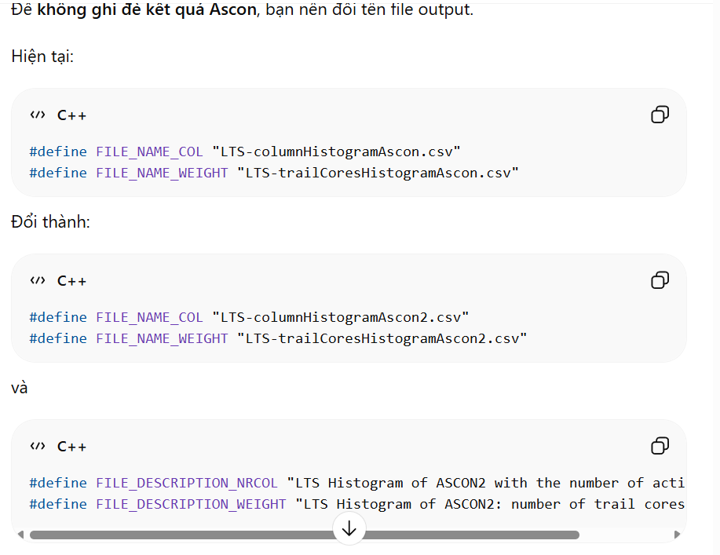
Thế chắc là có asconColScore.cpp, trailExtension.cpp , config.h(sửa 1 tí) mấy file này phải sửa

