DTS =0 tool sẽ chạy linear trails,DTS =1 differential trails.
Bước 1: Tải và chuẩn bị mã nguồn(Tải 2 cái 1 cái sẽ là ascon gốc và 1 cái sẽ chỉnh lại cho ascon cải tiến
git clone https://gitlab.science.ru.nl/selhirch/ascontrailtool.git ascon
git clone https://gitlab.science.ru.nl/selhirch/ascontrailtool.git ascon2
git clone https://gitlab.science.ru.nl/selhirch/ascontrailtool.git ascon3

ls
Thư mục sẽ có:
ascon/
ascon2/
ascon3/
Bước 2: Cấu hình config.h
Compile Ascon gốc
Vào thư mục:
cd ascon
cd reference/C++/src (mấy file cần sử ở trong này hết nếu cần thì cd vào đây)
ls
Mở config:
nano config.h
Mở file src/config.h và chỉnh sửa dòng 9:
#define DTS 0 // 0 cho linear trails, 1 cho differential trails
Bước 3: Biên dịch chương trình
Tải mấy chương trình và công cụ để dành cho biên dịch thành công:
sudo apt install make
sudo apt install make-guile
sudo apt install build-essential
sudo apt install g++-9
Mở file Makefile
nano makefile
Tìm dòng này
-std=c++0x
Đổi thành
-std=c++17
Mở file main.cpp
nano src/main.cpp
Tìm dòng
#include <execution>
Xóa dòng đó hoặc comment đổi thành:
// #include <execution>
make -B # Biên dịch lại toàn bộ
Bước 4: Tạo trail cores 2 vòng
# Ví dụ: Tạo linear trail cores 2 vòng với wrev(a)+w(b) ≤ 20
./bin/AsconTrailTool generate

Bước 5: Mở rộng trail cores
# Mở rộng về phía trước (forward)
./bin/AsconTrailTool extendWW forward 28

# Mở rộng về phía sau (backward)
./bin/AsconTrailTool extendWW backward 28

Bước 6: Lọc trail cores theo trọng số
./bin/AsconTrailTool filter <input_file> <output_file> <min_weight> <max_weight>

Bước 7: Hiển thị trail cores
./bin/AsconTrailTool display <input_file>

Bước 8: Mở rộng trail cores
# Mở rộng về phía trước (forward)
./bin/AsconTrailTool extendWW forward 28

# Mở rộng về phía sau (backward)
./bin/AsconTrailTool extendWW backward 28

Bước 9: Lọc trail cores theo trọng số
./bin/AsconTrailTool filter <input_file> <output_file> <min_weight> <max_weight>

Bước 10: Hiển thị trail cores
./bin/AsconTrailTool display <input_file>

Sinh trail core 2 vòng (chuẩn bị forward) differential – DTS
nano src/config.h
#define DTS 1
static const int limitWeight = 39;
static const int weightedWeights = 21; // 2w_rev(a) + w(b) <= 39
make -B
./bin/AsconTrailTool generate
Ascon gốc:
root@ubuntu:~/ascon/reference/C++# ./bin/AsconTrailTool generate
currentDateTime()=2026-04-25.04:53:38
number of states: 2473457
number of trails: 284561
finished computation at Sat Apr 25 04:54:34 2026
elapsed time: 55.6523s
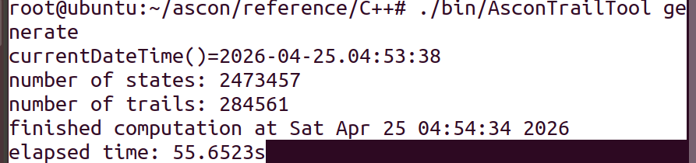
Ascon2
root@ubuntu:~/ascon2/reference/C++# ./bin/AsconTrailTool generate
currentDateTime()=2026-04-25.07:06:53
number of states: 7053282
number of trails: 2250
finished computation at Sat Apr 25 07:08:14 2026
elapsed time: 81.4147s
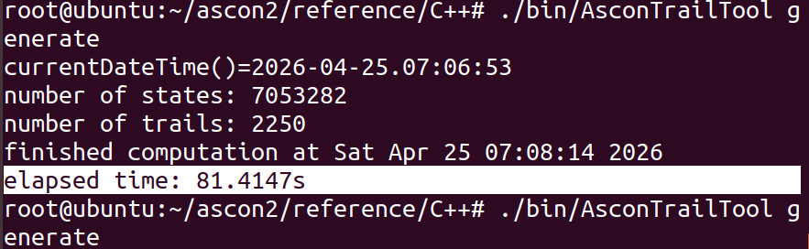
Ascon3
root@ubuntu:~/ascon3/reference/C++# ./bin/AsconTrailTool generate
currentDateTime()=2026-04-25.09:10:15
number of states: 9069030
number of trails: 3307
finished computation at Sat Apr 25 09:11:53 2026
elapsed time: 98.2111s
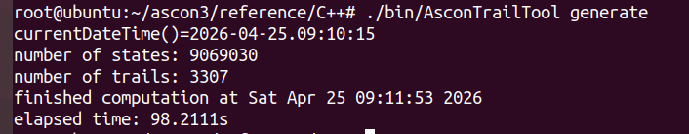
- Mở rộng lên 3 vòng:
# Forward: ghép thêm 1 vòng phía trước
./bin/AsconTrailTool extendWW forward 40
Ascon gốc
root@ubuntu:~/ascon/reference/C++# ./bin/AsconTrailTool extendWW forward 40
Extending forward DTS-2RTrailCoresUpToWeight39_2w0+w1
284561 trails extended
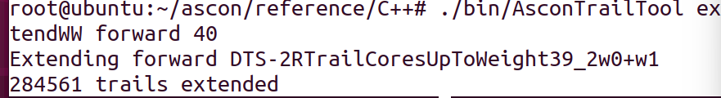
Ascon2 1phút
root@ubuntu:~/ascon2/reference/C++# ./bin/AsconTrailTool extendWW forward 40
Extending forward DTS-2RTrailCoresUpToWeight39_2w0+w1
2250 trails extended
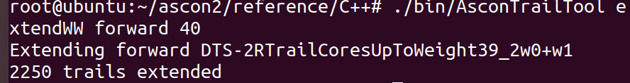
Ascon3 1.4s
root@ubuntu:~/ascon3/reference/C++# ./bin/AsconTrailTool extendWW forward 40
Extending forward DTS-2RTrailCoresUpToWeight39_2w0+w1
3307 trails extended
./bin/AsconTrailTool extend forward \
DTS-2RTrailCoresUpToWeight39_2w0+w1-forwUpTo40 \
52 true
Ascon gốc:
root@ubuntu:~/ascon/reference/C++# ./bin/AsconTrailTool extend forward \
> DTS-2RTrailCoresUpToWeight39_2w0+w1-forwUpTo40 \
> 52 true
forward extension of DTS-2RTrailCoresUpToWeight39_2w0+w1-forwUpTo40 up to 52
2 trails extended
root@ubuntu:~/ascon/reference/C++#
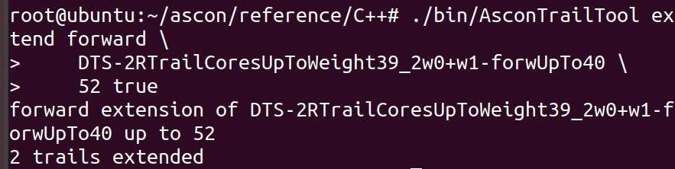
Ascon2: 23s
root@ubuntu:~/ascon2/reference/C++# ./bin/AsconTrailTool extend forward DTS-2RTrailCoresUpToWeight39_2w0+w1-forwUpTo40 52 true
101924 trails extended
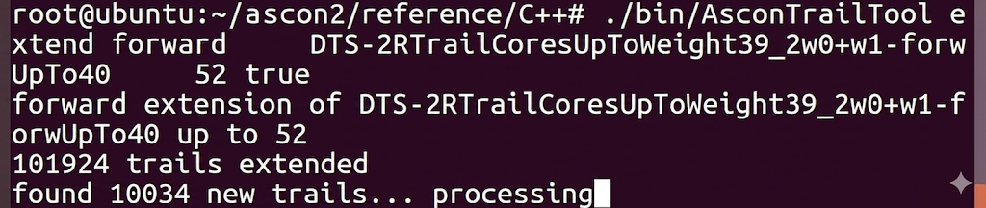
Ascon3: (Đoạn này chưa tính được lâu quá)

— Sinh trail core 2 vòng (chuẩn bị backward)
nano src/config.h
#define DTS 1
static const int limitWeight = 40;
static const int weightedWeights = 12; // w_rev(a) + 2w(b) <= 40
make -B
./bin/AsconTrailTool generate
Ascon gốc:
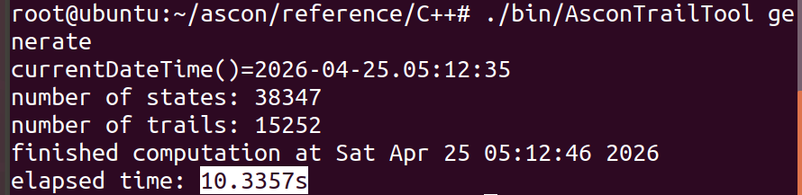
root@ubuntu:~/ascon/reference/C++# ./bin/AsconTrailTool generate
currentDateTime()=2026-04-25.05:12:35
number of states: 38347
number of trails: 15252
finished computation at Sat Apr 25 05:12:46 2026
elapsed time: 10.3357s
Ascon2
root@ubuntu:~/ascon2/reference/C++# ./bin/AsconTrailTool generate
currentDateTime()=2026-04-25.07:51:45
number of states: 84830
number of trails: 154
finished computation at Sat Apr 25 07:52:00 2026
elapsed time: 15.389s
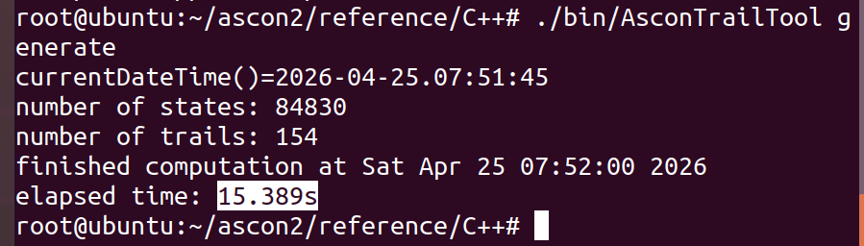
Ascon3
root@ubuntu:~/ascon3/reference/C++# ./bin/AsconTrailTool generate
currentDateTime()=2026-04-25.09:31:27
number of states: 103689
number of trails: 164
finished computation at Sat Apr 25 09:31:47 2026
elapsed time: 19.9662s
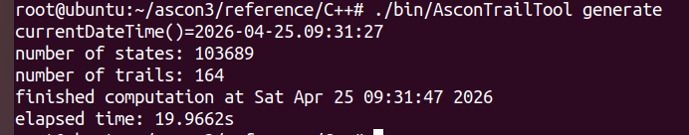
- Mở rộng lên 3 vòng:
# Backward: ghép thêm 1 vòng phía sau
./bin/AsconTrailTool extendWW backward 40
Ascon gốc:
root@ubuntu:~/ascon/reference/C++# ./bin/AsconTrailTool extendWW backward 40
Extending backward DTS-2RTrailCoresUpToWeight40_w0+2w1
15252 trails extended
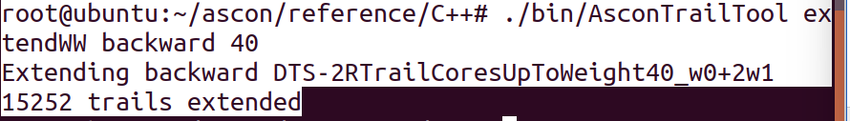
Ascon2: 1s
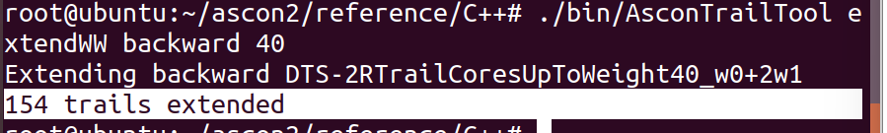
root@ubuntu:~/ascon2/reference/C++# ./bin/AsconTrailTool extendWW backward 40
Extending backward DTS-2RTrailCoresUpToWeight40_w0+2w1
154 trails extended
Ascon3 1s
root@ubuntu:~/ascon3/reference/C++# ./bin/AsconTrailTool extendWW backward 40
Extending backward DTS-2RTrailCoresUpToWeight40_w0+2w1
164 trails extended
./bin/AsconTrailTool extend backward \
DTS-2RTrailCoresUpToWeight40_w0+2w1-backUpTo40 \
52 true
Ascon gốc:
root@ubuntu:~/ascon/reference/C++# ./bin/AsconTrailTool extend backward \
> DTS-2RTrailCoresUpToWeight40_w0+2w1-backUpTo40 \
> 52 true
backward extension of DTS-2RTrailCoresUpToWeight40_w0+2w1-backUpTo40 with envelope up to 52
0 trails extended
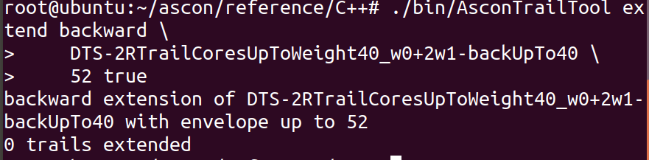
Ascon2: 1s
root@ubuntu:~/ascon2/reference/C++# ./bin/AsconTrailTool extend backward \
> DTS-2RTrailCoresUpToWeight40_w0+2w1-backUpTo40 \
> 52 true
backward extension of DTS-2RTrailCoresUpToWeight40_w0+2w1-backUpTo40 with envelope up to 52
0 trails extended
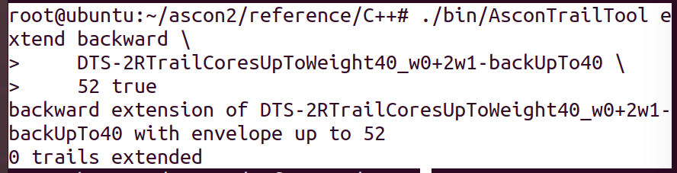
Ascon3: 1s
root@ubuntu:~/ascon3/reference/C++# ./bin/AsconTrailTool extend backward \
> DTS-2RTrailCoresUpToWeight40_w0+2w1-backUpTo40 \
> 52 true
backward extension of DTS-2RTrailCoresUpToWeight40_w0+2w1-backUpTo40 with envelope up to 52
0 trails extended
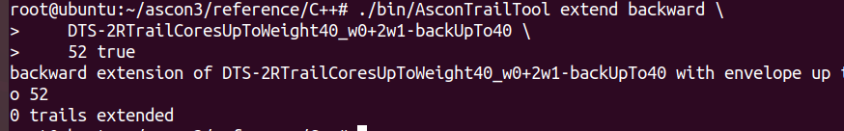

- Sinh trail core 2 vòng (chuẩn bị forward)---- LAT
nano src/config.h
#define DTS 0
static const int limitWeight = 26;
static const int weightedWeights = 21;
make -B
./bin/AsconTrailTool generate
Ascon gốc:
root@ubuntu:~/ascon/reference/C++# ./bin/AsconTrailTool generate
currentDateTime()=2026-04-25.05:26:19
number of states: 10050
number of trails: 1935
finished computation at Sat Apr 25 05:26:20 2026
elapsed time: 0.180926s
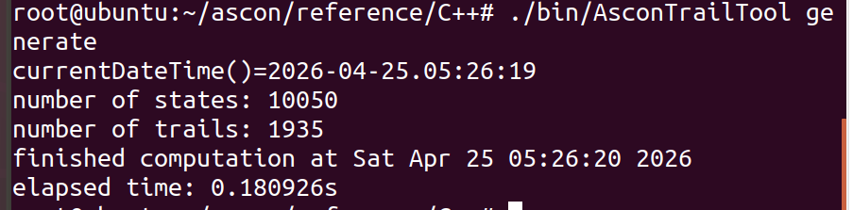
Ascon2:
root@ubuntu:~/ascon2/reference/C++# ./bin/AsconTrailTool generate
currentDateTime()=2026-04-25.08:06:36
number of states: 10282
number of trails: 10282
finished computation at Sat Apr 25 08:06:36 2026
elapsed time: 0.196316s
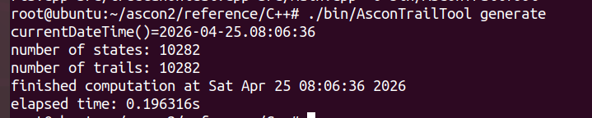
Ascon3:
root@ubuntu:~/ascon3/reference/C++# ./bin/AsconTrailTool generate
currentDateTime()=2026-04-25.09:36:18
number of states: 10686
number of trails: 10686
finished computation at Sat Apr 25 09:36:18 2026
elapsed time: 0.19793s
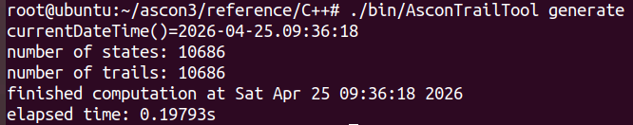
- Mở rộng lên 3 vòng:
# Forward: ghép thêm 1 vòng phía trước
./bin/AsconTrailTool extendWW forward 28
Ascon gốc:
root@ubuntu:~/ascon/reference/C++# ./bin/AsconTrailTool extendWW forward 28
Extending forward LTS-2RTrailCoresUpToWeight26_2w0+w1
1935 trails extended
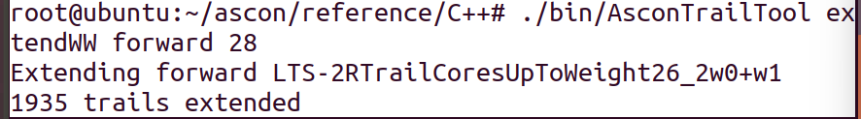
Ascon2: Vòng 2 yếu hơn r( Vòng này tính lớn quá ch tính dc)(Đoạn này chưa tính được lâu quá)

Ascon3:(Đoạn này chưa tính được lâu quá)

Ascon gốc:
./bin/AsconTrailTool extend forward \
LTS-2RTrailCoresUpToWeight26_2w0+w1-forwUpTo28 \
46 true

root@ubuntu:~/ascon/reference/C++# ./bin/AsconTrailTool extend forward \
> LTS-2RTrailCoresUpToWeight26_2w0+w1-forwUpTo28 \
> 46 true
forward extension of LTS-2RTrailCoresUpToWeight26_2w0+w1-forwUpTo28 up to 46
1 trails extended
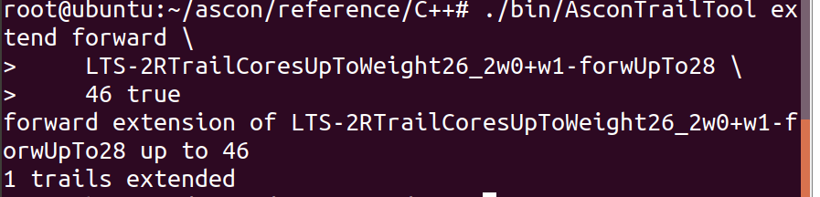
Ascon2:Vòng 2 yếu hơn r( Vòng này tính lớn quá ch tính dc)(cái trên ch tính đc nên (Đoạn này chưa tính được lâu quá)
Ascon3: (cái trên ch tính đc nên (Đoạn này chưa tính được lâu quá)

— Sinh trail core 2 vòng (chuẩn bị backward)
nano src/config.h
#define DTS 0
static const int limitWeight = 28;
static const int weightedWeights = 12; // w_rev(a) + 2w(b) <= 40
make -B
./bin/AsconTrailTool generate
Ascon gốc:
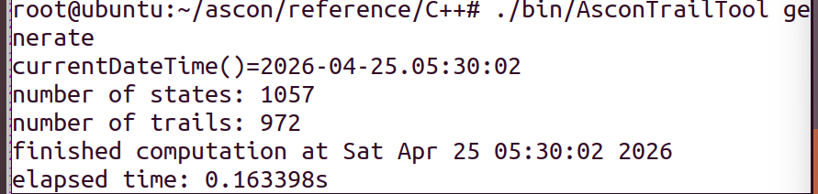
root@ubuntu:~/ascon/reference/C++# ./bin/AsconTrailTool generate
currentDateTime()=2026-04-25.05:30:02
number of states: 1057
number of trails: 972
finished computation at Sat Apr 25 05:30:02 2026
elapsed time: 0.163398s
Ascon2:
root@ubuntu:~/ascon2/reference/C++# ./bin/AsconTrailTool generate
currentDateTime()=2026-04-25.08:28:17
number of states: 1080
number of trails: 1080
finished computation at Sat Apr 25 08:28:17 2026
elapsed time: 0.182449s
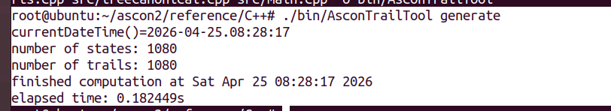
Ascon3:
root@ubuntu:~/ascon3/reference/C++# ./bin/AsconTrailTool generate
currentDateTime()=2026-04-25.09:46:17
number of states: 1108
number of trails: 1108
finished computation at Sat Apr 25 09:46:17 2026
elapsed time: 0.182036s
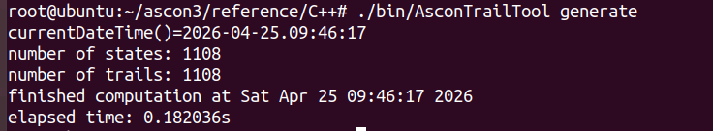
- Mở rộng lên 3 vòng:
# Backward: ghép thêm 1 vòng phía sau
./bin/AsconTrailTool extendWW backward 28
Ascon gốc
root@ubuntu:~/ascon/reference/C++# ./bin/AsconTrailTool extendWW backward 28
Extending backward LTS-2RTrailCoresUpToWeight28_w0+2w1
972 trails extended
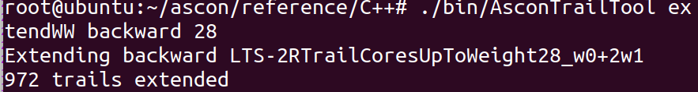
Ascon2: 2.5s
root@ubuntu:~/ascon2/reference/C++# ./bin/AsconTrailTool extendWW backward 28
Extending backward LTS-2RTrailCoresUpToWeight28_w0+2w1
1080 trails extended
Ascon3: 3s
root@ubuntu:~/ascon3/reference/C++# ./bin/AsconTrailTool extendWW backward 28
Extending backward LTS-2RTrailCoresUpToWeight28_w0+2w1
1108 trails extended
./bin/AsconTrailTool extend backward \
LTS-2RTrailCoresUpToWeight28_w0+2w1-backUpTo28 \
46 true
Ascon gốc:
root@ubuntu:~/ascon/reference/C++# ./bin/AsconTrailTool extend backward \
> LTS-2RTrailCoresUpToWeight28_w0+2w1-backUpTo28 \
> 46 true
backward extension of LTS-2RTrailCoresUpToWeight28_w0+2w1-backUpTo28 with envelope up to 46
0 trails extended
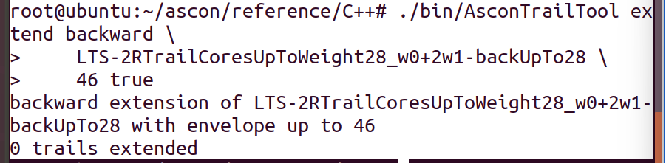
Ascon2: 3 phút
root@ubuntu:~/ascon2/reference/C++# ./bin/AsconTrailTool extend backward \
> LTS-2RTrailCoresUpToWeight28_w0+2w1-backUpTo28 \
> 46 true
backward extension of LTS-2RTrailCoresUpToWeight28_w0+2w1-backUpTo28 with envelope up to 46
10 trails extended
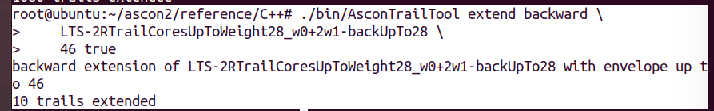
Ascon3: 3 phút
root@ubuntu:~/ascon3/reference/C++# ./bin/AsconTrailTool extend backward LTS-2RTrailCoresUpToWeight28_w0+2w1-backUpTo28 46 true
backward extension of LTS-2RTrailCoresUpToWeight28_w0+2w1-backUpTo28 with envelope up to 46
7 trails extended
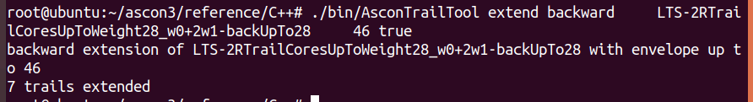

Thay file: asconColScore.cpp, trailExtension.cpp , config.h(sửa 1 xíu)
File code đầu vào cho ascontrail: Mấy cái DDT với LAT là thay cho file code .py tính đầu vào, còn trong bảng là lấy để thay luôn vào trong code cần để thay cho Sbox mới
Ascon gốc:
Ascon2
uint64_t biggerThanTwo(State &s) {
return
(s.getRow(0) & s.getRow(3)) ^ // x0x3
(s.getRow(2) & s.getRow(3)) ^ // x2x3

(s.getRow(1) & s.getRow(4)) ^ // x1x4
(s.getRow(3) & s.getRow(4)) ^ // x3x4

(s.getRow(0) & s.getRow(2)) ^ // x0x2
(s.getRow(0) & s.getRow(4)) ^ // x0x4

(s.getRow(0) & s.getRow(1)) ^ // x0x1
(s.getRow(1) & s.getRow(3)) ^ // x1x3

(s.getRow(1) & s.getRow(2)) ^ // x1x2
(s.getRow(2) & s.getRow(4)); // x2x4
}
uint64_t biggerThanThree(State &s) {
return
(s.getRow(0) & s.getRow(3) & s.getRow(2)) ^ // x0 x3 x2
(s.getRow(1) & s.getRow(4) & s.getRow(3)) ^ // x1 x4 x3
(s.getRow(0) & s.getRow(2) & s.getRow(4)) ^ // x0 x2 x4
(s.getRow(0) & s.getRow(1) & s.getRow(3)) ^ // x0 x1 x3
(s.getRow(1) & s.getRow(2) & s.getRow(4)); // x1 x2 x4
}
uint64_t biggerThanTwoLTS(State &s) {
return
(s.getRow(0) & s.getRow(3)) ^
(s.getRow(2) & s.getRow(3)) ^
(s.getRow(1) & s.getRow(4)) ^
(s.getRow(3) & s.getRow(4)) ^
(s.getRow(0) & s.getRow(2));
}

DDT = [
[32,0,0,0,0,0,0,0,0,0,0,0,0,0,0,0,0,0,0,0,0,0,0,0,0,0,0,0,0,0,0,0],
[0,0,0,0,0,4,0,0,0,0,0,0,4,0,4,4,0,0,0,0,0,4,0,4,0,4,0,0,0,4,0,0],
[0,4,0,0,0,0,4,0,0,4,0,0,4,0,0,0,0,4,0,0,4,0,0,4,0,0,0,0,4,0,0,0],
[0,0,4,0,0,0,4,0,4,0,0,0,0,4,0,0,4,0,0,0,4,0,4,0,0,0,0,4,0,0,0,0],
[0,0,0,4,0,0,0,4,4,0,0,4,0,0,0,0,4,0,4,4,0,0,0,0,0,0,4,0,0,0,0,0],
[0,0,0,0,4,0,0,0,0,0,4,4,0,0,0,4,0,0,0,4,0,0,0,0,4,4,0,0,0,0,4,0],
[0,0,2,2,0,2,2,2,0,0,2,2,2,0,0,2,0,2,2,0,0,0,2,2,0,0,0,2,0,0,2,2],
[0,0,4,0,0,0,0,0,4,0,4,0,0,4,0,0,0,0,0,4,0,0,4,0,4,0,0,0,0,0,4,0],
[0,2,0,2,2,0,2,0,2,0,2,0,2,0,2,2,0,0,2,0,2,0,2,0,2,0,2,0,0,2,0,2],
[0,0,0,0,0,4,0,0,0,0,0,0,4,4,4,0,0,0,0,0,4,4,4,0,0,0,0,4,0,0,0,0],
[0,0,0,4,0,0,0,4,0,0,0,4,0,0,4,0,0,0,4,0,0,4,0,0,0,4,0,0,0,4,0,0],
[0,0,2,0,2,2,2,0,2,2,0,2,2,0,2,0,2,0,2,0,0,2,0,0,2,0,0,0,2,0,2,2],
[0,2,2,0,2,0,0,2,2,0,0,2,2,2,0,2,0,2,0,0,0,2,2,0,0,2,2,0,2,0,0,2],
[0,4,0,0,0,0,4,4,0,4,0,0,0,0,0,0,4,4,4,0,0,0,0,0,0,0,4,0,0,0,0,0],
[0,0,0,0,4,0,0,0,0,4,4,0,0,0,0,4,0,4,0,0,0,0,0,4,4,0,0,0,4,0,0,0],
[0,2,0,2,0,2,2,0,2,2,0,2,0,2,0,2,0,2,0,2,0,2,0,0,2,0,0,2,0,2,0,2],
[0,2,0,0,0,0,2,2,0,2,0,0,2,0,0,0,2,2,2,0,2,2,0,2,0,0,2,2,2,2,0,2],
[0,4,0,0,4,4,0,4,0,0,0,4,0,0,4,0,0,0,0,0,0,0,0,4,0,0,0,0,0,4,0,0],
[0,4,4,4,0,0,0,0,0,0,0,0,4,4,4,0,4,0,0,0,0,0,0,0,0,0,0,4,0,0,0,0],
[0,0,2,0,0,0,2,0,2,0,2,0,0,2,0,0,2,2,0,2,2,0,2,0,2,0,2,2,2,0,2,2],
[0,0,0,0,0,2,0,0,0,0,0,0,2,2,2,2,0,0,0,0,2,2,2,2,2,2,0,2,2,2,2,2],
[0,0,0,4,4,4,0,0,4,0,4,0,0,4,0,0,0,0,0,0,0,0,0,0,0,4,0,0,0,0,4,0],
[0,4,4,0,0,4,0,0,0,4,4,0,0,0,0,4,0,0,0,0,4,0,0,0,0,0,0,0,4,0,0,0],
[0,0,0,0,2,0,0,0,0,2,2,2,0,0,0,2,0,2,2,2,0,0,0,2,2,2,2,0,2,2,2,2],
[0,0,4,4,4,0,4,4,0,4,0,0,0,0,0,0,0,0,0,4,0,0,0,0,0,0,4,0,0,0,0,0],
[0,0,0,2,0,0,0,2,2,0,0,2,0,0,2,0,2,0,2,2,0,2,2,0,0,2,2,2,0,2,2,2],
[0,0,2,0,0,0,2,0,2,0,2,0,0,2,0,0,2,2,0,2,2,0,2,0,2,0,2,2,2,0,2,2],
[0,2,0,0,0,0,2,2,0,2,0,0,2,0,0,0,2,2,2,0,2,2,0,2,0,0,2,2,2,2,0,2],
[0,0,0,0,0,2,0,0,0,0,0,0,2,2,2,2,0,0,0,0,2,2,2,2,2,2,0,2,2,2,2,2],
[0,0,0,0,2,0,0,0,0,2,2,2,0,0,0,2,0,2,2,2,0,0,0,2,2,2,2,0,2,2,2,2],
[0,0,0,2,0,0,0,2,2,0,0,2,0,0,2,0,2,0,2,2,0,2,2,0,0,2,2,2,0,2,2,2],
[0,2,2,2,2,2,0,0,0,0,0,0,0,0,0,0,2,2,2,2,2,2,2,2,2,2,0,0,0,0,0,2]
]

# =========================
# LAT (PASTE FULL 32 ROWS)
# =========================

LAT = [
[32,0,0,0,0,0,0,0,0,0,0,0,0,0,0,0,0,0,0,0,0,0,0,0,0,0,0,0,0,0,0,0],
[0,0,0,0,0,16,8,0,0,0,0,0,0,8,0,8,8,8,0,0,0,0,8,8,0,8,8,0,8,8,0,8],
[0,16,0,0,0,0,0,8,8,0,0,0,8,0,0,0,0,0,8,8,8,0,8,8,0,0,0,8,8,0,8,8],
[0,0,16,0,0,0,8,0,0,0,8,8,0,0,0,0,8,0,8,0,8,0,0,0,8,8,8,8,0,8,0,8],
[0,0,0,16,0,0,0,0,8,0,0,0,0,0,8,8,8,0,0,8,0,8,0,8,8,0,8,0,8,0,8,8],
[0,0,0,0,16,0,0,0,0,8,0,8,8,0,0,0,0,8,0,8,8,8,0,0,0,8,0,8,0,8,8,8],
[0,0,0,0,0,0,8,8,8,0,0,0,8,8,0,8,8,8,8,8,8,0,0,0,0,8,8,8,0,8,8,0],
[0,0,0,0,0,16,0,0,0,0,8,8,0,8,0,8,0,8,8,0,8,0,8,8,8,0,0,8,8,0,0,0],
[0,0,0,0,0,0,8,8,8,0,8,8,8,0,0,0,8,0,0,8,0,0,8,8,8,8,8,0,8,8,8,0],
[0,0,0,16,0,0,8,0,8,0,0,0,0,8,8,0,0,8,0,8,0,8,8,0,8,8,0,0,0,8,8,0],
[0,16,0,0,0,0,0,8,0,0,0,0,8,0,8,8,8,0,8,0,8,8,8,0,8,0,8,8,0,0,0,0],
[0,0,0,0,0,0,8,0,8,0,8,8,0,0,8,8,0,0,8,8,8,8,0,8,0,8,0,8,8,8,8,0],
[0,0,0,0,0,0,8,0,0,8,0,8,8,8,0,8,8,0,0,8,8,8,8,8,0,0,8,8,8,0,8,0],
[0,0,0,0,16,0,0,8,8,8,0,8,0,0,0,0,0,8,8,0,0,8,8,8,0,8,0,0,8,8,0,0],
[0,0,16,0,0,0,8,0,0,8,8,0,8,0,0,0,8,8,8,8,0,8,0,0,8,0,8,0,0,0,8,0],
[0,0,0,0,0,0,0,0,8,8,0,8,8,0,8,8,8,8,0,0,8,0,0,8,8,8,8,8,8,8,0,0],
[0,16,0,0,0,0,0,8,8,0,8,8,8,8,0,8,0,8,0,8,0,0,0,0,8,0,0,0,0,0,8,8],
[0,0,0,0,0,0,8,8,0,0,0,0,8,8,8,0,0,8,8,0,8,8,0,8,8,8,0,8,8,8,0,8],
[0,0,0,0,0,0,0,0,8,0,8,8,0,8,8,0,8,8,8,8,8,8,8,0,0,0,8,8,0,0,8,8],
[0,0,16,0,0,0,8,8,0,0,8,8,8,0,8,8,0,0,0,0,0,8,8,0,0,8,0,0,0,8,0,8],
[0,0,0,0,0,16,8,8,8,8,0,8,0,8,0,8,8,0,8,0,0,8,0,0,0,0,8,0,0,0,0,8],
[0,0,0,0,0,0,0,0,0,8,8,0,8,8,0,8,0,0,8,8,0,8,8,8,8,8,0,0,8,8,8,8],
[0,0,0,0,0,0,8,8,8,8,8,0,0,0,0,0,8,8,0,0,8,8,8,8,8,0,8,8,8,0,0,8],
[0,0,0,0,16,0,8,0,8,8,0,8,8,8,8,0,0,0,0,0,8,0,8,0,8,0,0,8,0,0,0,8],
[0,0,0,0,0,0,0,8,0,8,0,8,0,0,8,8,8,8,8,8,0,0,8,0,8,8,8,0,0,8,8,8],
[0,0,0,16,0,0,8,0,8,8,8,0,8,0,8,8,0,8,8,0,0,0,0,8,0,0,0,0,8,0,0,8],
[0,16,0,0,0,0,0,8,0,0,8,8,8,8,8,0,8,8,0,0,0,8,0,8,0,0,8,0,8,0,0,0],
[0,0,0,0,0,16,0,8,8,8,8,0,0,8,0,8,0,0,0,0,8,8,0,0,8,8,0,8,0,8,0,0],
[0,0,0,0,16,0,8,8,0,8,0,8,0,8,8,0,0,0,8,8,0,0,0,8,8,0,0,0,8,0,8,0],
[0,0,0,16,0,0,0,0,8,8,8,0,8,8,8,0,8,0,8,0,0,0,8,0,0,8,8,0,0,8,0,0],
[0,0,16,0,0,0,8,8,0,8,8,0,0,0,8,8,0,8,0,8,8,0,8,0,0,0,0,8,0,0,8,0],
[0,0,0,0,0,0,0,8,0,8,8,0,0,8,8,0,8,0,0,8,8,0,0,8,0,8,8,8,8,8,8,8]
]

Ascon 3
uint64_t biggerThanTwo(State &stateAtB) {
// x0x1 + x0x2 + x0x3 + x1x2 + x1x4 + x2x3 + x2x4 + x3x4

return (stateAtB.getRow(0) & stateAtB.getRow(1)) ^
(stateAtB.getRow(0) & stateAtB.getRow(2)) ^
(stateAtB.getRow(0) & stateAtB.getRow(3)) ^
(stateAtB.getRow(1) & stateAtB.getRow(2)) ^
(stateAtB.getRow(1) & stateAtB.getRow(4)) ^
(stateAtB.getRow(2) & stateAtB.getRow(3)) ^
(stateAtB.getRow(2) & stateAtB.getRow(4)) ^
(stateAtB.getRow(3) & stateAtB.getRow(4));
}
uint64_t biggerThanThree(State &stateAtB) {
// ASCON-3: no cubic terms in ANF
return 0;
}
uint64_t biggerThanTwoLTS(State &stateAtB) {
// lightweight approximation (faster pruning)

return (stateAtB.getRow(1) & stateAtB.getRow(3)) ^
(stateAtB.getRow(3) & stateAtB.getRow(4)) ^
(stateAtB.getRow(0) & stateAtB.getRow(1)) ^
(stateAtB.getRow(2) & stateAtB.getRow(4));
}
DDT = [
[32,0,0,0,0,0,0,0,0,0,0,0,0,0,0,0,0,0,0,0,0,0,0,0,0,0,0,0,0,0,0,0],
[0,0,0,0,0,0,0,0,4,0,0,0,0,0,4,0,4,0,0,4,0,4,0,0,0,4,4,0,0,4,0,0],
[0,0,0,0,0,0,0,0,0,4,0,4,0,0,0,0,0,4,0,4,0,0,0,4,0,4,0,0,4,0,4,0],
[0,0,0,0,0,0,0,0,0,0,0,0,0,4,0,4,0,0,0,0,4,0,4,4,0,4,0,4,0,4,0,0],
[0,0,0,0,0,0,0,4,0,0,0,0,4,0,0,0,4,0,4,0,4,0,0,4,0,0,4,0,4,0,0,0],
[0,0,0,0,0,0,4,0,0,0,4,0,0,0,0,0,4,0,0,4,4,0,0,0,4,0,0,4,0,0,4,0],
[0,0,2,0,2,2,2,0,2,2,0,2,2,0,2,0,2,0,2,0,0,2,0,0,2,0,0,0,2,0,2,2],
[0,0,0,2,2,2,0,2,2,2,2,0,2,2,0,0,2,2,0,0,2,0,0,0,0,2,0,0,0,2,2,2],
[0,2,0,2,0,2,2,0,2,2,0,2,0,2,0,2,0,2,0,2,0,2,0,0,2,0,0,2,0,2,0,2],
[0,2,2,2,0,0,0,0,0,2,2,2,2,2,2,0,2,0,0,0,0,0,0,2,2,2,2,2,0,0,0,2],
[0,2,0,0,2,2,2,2,0,0,2,2,0,2,2,0,2,0,0,2,0,0,2,2,0,0,0,0,2,2,0,2],
[0,2,2,0,2,0,0,2,2,0,0,2,2,2,0,2,0,2,0,0,0,2,2,0,0,2,2,0,2,0,0,2],
[0,2,0,2,2,0,2,0,2,0,2,0,2,0,2,2,0,0,2,0,2,0,2,0,2,0,2,0,0,2,0,2],
[0,0,2,2,2,0,2,2,0,2,0,0,0,2,2,2,0,0,0,2,2,2,0,2,0,0,2,0,0,0,2,2],
[0,2,2,0,0,2,0,2,2,2,2,0,0,0,2,2,0,0,2,2,2,0,0,0,0,2,0,2,2,0,0,2],
[0,0,2,2,0,2,2,2,0,0,2,2,2,0,0,2,0,2,2,0,0,0,2,2,0,0,0,2,0,0,2,2],
[0,0,0,0,0,4,4,0,0,4,0,0,0,0,4,0,4,0,4,0,0,0,0,0,4,0,0,0,0,0,4,0],
[0,2,2,0,2,0,0,2,2,0,0,2,2,2,0,2,0,2,0,0,0,2,2,0,0,2,2,0,2,0,0,2],
[0,2,0,2,2,0,2,0,2,0,2,0,2,0,2,2,0,0,2,0,2,0,2,0,2,0,2,0,0,2,0,2],
[0,4,0,0,0,0,0,0,4,4,0,0,0,4,0,0,0,0,0,4,0,4,0,0,4,0,0,0,0,4,0,0],
[0,0,0,0,4,0,0,0,0,0,4,0,4,0,4,0,0,0,4,0,4,0,4,0,0,0,4,0,0,0,0,0],
[0,2,0,2,0,2,2,0,2,2,0,2,0,2,0,2,0,2,0,2,0,2,0,0,2,0,0,2,0,2,0,2],
[0,0,2,2,0,2,2,2,0,0,2,2,2,0,0,2,0,2,2,0,0,0,2,2,0,0,0,2,0,0,2,2],
[0,0,0,4,0,0,0,4,0,0,4,0,0,0,0,4,0,4,0,0,0,0,4,4,0,0,0,4,0,0,0,0],
[0,0,2,0,2,2,2,0,2,2,0,2,2,0,2,0,2,0,2,0,0,2,0,0,2,0,0,0,2,0,2,2],
[0,0,4,0,0,0,0,4,0,0,0,4,0,4,0,0,0,4,0,0,0,4,0,0,0,4,0,0,4,0,0,0],
[0,4,0,0,4,0,0,0,4,0,0,0,0,0,4,0,0,0,0,0,4,0,0,0,4,0,4,0,0,4,0,0],
[0,0,0,4,0,4,4,0,0,0,4,0,0,0,0,0,0,0,4,0,0,0,0,4,0,0,0,4,0,0,4,0],
[0,0,4,0,4,0,0,4,0,0,0,0,4,0,0,0,0,0,0,0,0,0,4,0,0,4,4,0,4,0,0,0],
[0,4,0,4,0,0,0,0,0,0,0,0,0,4,0,4,0,4,0,4,0,0,0,0,0,0,0,4,0,4,0,0],
[0,0,4,0,0,4,0,0,0,4,0,4,0,0,0,0,4,0,0,0,0,4,0,0,0,0,0,0,4,0,4,0],
[0,2,2,2,2,2,0,0,0,0,0,0,0,0,0,0,2,2,2,2,2,2,2,2,2,2,0,0,0,0,0,2]
]
LAT = [
[32,0,0,0,0,0,0,0,0,0,0,0,0,0,0,0,0,0,0,0,0,0,0,0,0,0,0,0,0,0,0,0],
[0,0,0,0,0,16,8,0,0,0,0,0,0,8,0,8,8,8,0,0,0,0,8,8,0,8,8,0,8,8,0,8],
[0,16,0,0,0,0,0,8,8,0,0,0,8,0,0,0,0,0,8,8,8,0,8,8,0,0,0,8,8,0,8,8],
[0,0,16,0,0,0,8,0,0,0,8,8,0,0,0,0,8,0,8,0,8,0,0,0,8,8,8,8,0,8,0,8],
[0,0,0,16,0,0,0,0,8,0,0,0,0,0,8,8,8,0,0,8,0,8,0,8,8,0,8,0,8,0,8,8],
[0,0,0,0,16,0,0,0,0,8,0,8,8,0,0,0,0,8,0,8,8,8,0,0,0,8,0,8,0,8,8,8],
[0,0,0,0,0,0,8,8,8,0,0,0,8,8,0,8,8,8,8,8,8,0,0,0,0,8,8,8,0,8,8,0],
[0,0,0,0,0,16,0,0,0,0,8,8,0,8,0,8,0,8,8,0,8,0,8,8,8,0,0,8,8,0,0,0],
[0,0,0,0,0,0,8,8,8,0,8,8,8,0,0,0,8,0,0,8,0,0,8,8,8,8,8,0,8,8,8,0],
[0,0,0,16,0,0,8,0,8,0,0,0,0,8,8,0,0,8,0,8,0,8,8,0,8,8,0,0,0,8,8,0],
[0,16,0,0,0,0,0,8,0,0,0,0,8,0,8,8,8,0,8,0,8,8,8,0,8,0,8,8,0,0,0,0],
[0,0,0,0,0,0,8,0,8,0,8,8,0,0,8,8,0,0,8,8,8,8,0,8,0,8,0,8,8,8,8,0],
[0,0,0,0,0,0,8,0,0,8,0,8,8,8,0,8,8,0,0,8,8,8,8,8,0,0,8,8,8,0,8,0],
[0,0,0,0,16,0,0,8,8,8,0,8,0,0,0,0,0,8,8,0,0,8,8,8,0,8,0,0,8,8,0,0],
[0,0,16,0,0,0,8,0,0,8,8,0,8,0,0,0,8,8,8,8,0,8,0,0,8,0,8,0,0,0,8,0],
[0,0,0,0,0,0,0,0,8,8,0,8,8,0,8,8,8,8,0,0,8,0,0,8,8,8,8,8,8,8,0,0],
[0,16,0,0,0,0,0,8,8,0,8,8,8,8,0,8,0,8,0,8,0,0,0,0,8,0,0,0,0,0,8,8],
[0,0,0,0,0,0,8,8,0,0,0,0,8,8,8,0,0,8,8,0,8,8,0,8,8,8,0,8,8,8,0,8],
[0,0,0,0,0,0,0,0,8,0,8,8,0,8,8,0,8,8,8,8,8,8,8,0,0,0,8,8,0,0,8,8],
[0,0,16,0,0,0,8,8,0,0,8,8,8,0,8,8,0,0,0,0,0,8,8,0,0,8,0,0,0,8,0,8],
[0,0,0,0,0,16,8,8,8,8,0,8,0,8,0,8,8,0,8,0,0,8,0,0,0,0,8,0,0,0,0,8],
[0,0,0,0,0,0,0,0,0,8,8,0,8,8,0,8,0,0,8,8,0,8,8,8,8,8,0,0,8,8,8,8],
[0,0,0,0,0,0,8,8,8,8,8,0,0,0,0,0,8,8,0,0,8,8,8,8,8,0,8,8,8,0,0,8],
[0,0,0,0,16,0,8,0,8,8,0,8,8,8,8,0,0,0,0,0,8,0,8,0,8,0,0,8,0,0,0,8],
[0,0,0,0,0,0,0,8,0,8,0,8,0,0,8,8,8,8,8,8,0,0,8,0,8,8,8,0,0,8,8,8],
[0,0,0,16,0,0,8,0,8,8,8,0,8,0,8,8,0,8,8,0,0,0,0,8,0,0,0,0,8,0,0,8],
[0,16,0,0,0,0,0,8,0,0,8,8,8,8,8,0,8,8,0,0,0,8,0,8,0,0,8,0,8,0,0,0],
[0,0,0,0,0,16,0,8,8,8,8,0,0,8,0,8,0,0,0,0,8,8,0,0,8,8,0,8,0,8,0,0],
[0,0,0,0,16,0,8,8,0,8,0,8,0,8,8,0,0,0,8,8,0,0,0,8,8,0,0,0,8,0,8,0],
[0,0,0,16,0,0,0,0,8,8,8,0,8,8,8,0,8,0,8,0,0,0,8,0,0,8,8,0,0,8,0,0],
[0,0,16,0,0,0,8,8,0,8,8,0,0,0,8,8,0,8,0,8,8,0,8,0,0,0,0,8,0,0,8,0],
[0,0,0,0,0,0,0,8,0,8,8,0,0,8,8,0,8,0,0,8,8,0,0,8,0,8,8,8,8,8,8,8]
]

Câu hỏi: Hướng dẫn LT và CT cách tính chỗ những file cần sửa
asconColScore.cpp
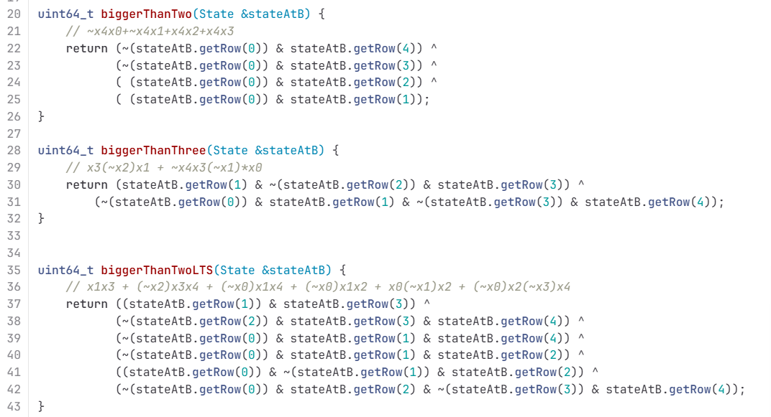
Đoạn code này thì được tính bằng code---Cái này cũng có trong code của cỗ exten… rồi nhưng mà viết lại cho dễ nhìn(code này đã kiểm chứng test thử bằng ascon gốc và ra kết quả giống)
Trong paper về Ascon, weight được định nghĩa như sau:
- Differential weight
$$w_{r}(b,a)=-{log⁡}_{2}DP(b,a)$$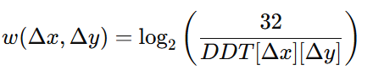
- Linear weight
$$w_{c}(a,b)=-{log⁡}_{2}C^{2}(a,b)$$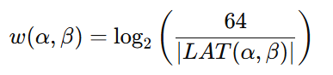
Nói đơn giản:
- Differential: weight = $-{log⁡}_{2}(\text{probability})$
- Linear: weight = $-{log⁡}_{2}({\text{correlation}}^{2})$
PS C:\Users\Acer\PEIGEN> & C:/Users/Acer/AppData/Local/Microsoft/WindowsApps/python3.11.exe "c:/Desktop/MS Visio/Downloads/tinhdauvaohoasconColScore1.py"
wr (DTS weightListPerInput)
[0, 3, 3, 4, 3, 3, 4, 4, 3, 3, 3, 3, 4, 3, 4, 4, 3, 4, 3, 4, 3, 3, 3, 4, 4, 4, 3, 4, 4, 4, 4, 4]
lấy từng giá trị DDT > 0 trong dòng
tính weight
chọn weight nhỏ nhất
Ví dụ như là xem dòng 01: có mỗi số 4(nếu dòng có thêm số 8 thì log₂(32/8)=2 => lấy 2 vì tính ra nó nhỏ nhất)=> log₂(32/4)=3
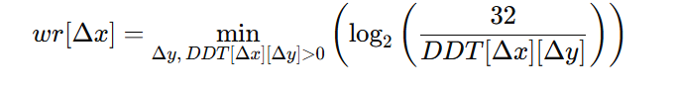
wc (LTS weightListPerInput)
[0, 2, 2, 4, 2, 4, 4, 4, 2, 4, 4, 4, 4, 4, 4, 4, 2, 4, 4, 4, 4, 4, 4, 4, 4, 4, 4, 4, 4, 4, 4, 4]
Để tính wc cho một hàng của LAT:
- Lấy tất cả giá trị trong dòng $LAT(α,β)$.
- Bỏ các giá trị bằng 0.
- Với mỗi giá trị khác 0, tính rồi tìm ra cái giá trị nhỏ nhất và lấy
Ví dụ dòng 01: có giá trị 6 và 8
w=log2​(32^2/16^2)=2; w=log2​(64/8)=3 => lấy giá trị 2
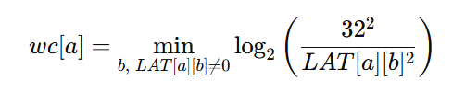
wrev_dts (minRevWeightPerOutput) (cái này thì tương tự mà theo cột)
[0, 3, 3, 3, 3, 3, 3, 3, 3, 3, 3, 3, 3, 3, 3, 3, 3, 3, 3, 3, 3, 3, 3, 3, 3, 3, 3, 3, 3, 3, 3, 4]
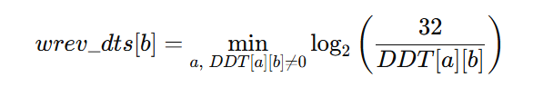
wrev_lts (minRevWeightPerOutput)(cái này thì tương tự theo cột)
[0, 2, 2, 4, 2, 2, 4, 2, 2, 2, 2, 4, 4, 4, 2, 2, 2, 4, 2, 2, 2, 4, 4, 2, 4, 2, 4, 2, 2, 2, 2, 4]
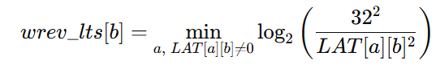
và thay số vào những chỗ này
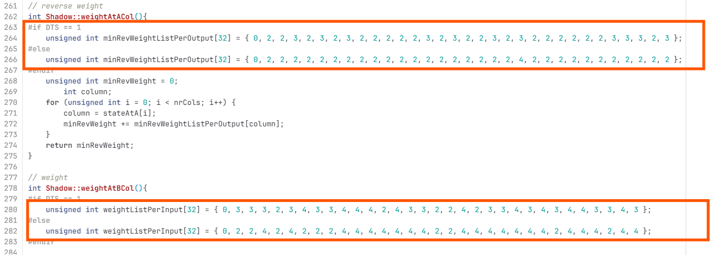
Tiếp theo là sửa file: trailExtension.cpp(chỉ thay số chữ tên chữ vẫn giữ nguyên)_sửa 12 chỗ theo thứ tự file code: DTS=1 là nó đã tính cho bảng DDT còn DTS = 0 nó tính cho bảng LAT
Ví dụ cần thay mấy cái chỗ có số này. Cách tính thì tui sẽ tính và ghi lại sau. Hoặc mọi người tìm hiểu rồi ghi lại giúp t, tại cái tính này chỉ dựa vào bảng chỉ cần nhìn rồi tính 1 tí thôi là hiểu. Mấy cái số liệu trên kia cũng thế.
PS C:\Users\Acer\PEIGEN> & C:/Users/Acer/AppData/Local/Microsoft/WindowsApps/python3.11.exe "c:/Desktop/MS Visio/Downloads/tinhchoascontrail1.py"
S-box (hex): ['0x0', '0x10', '0x1', '0x19', '0x2', '0x16', '0x13', '0xf', '0x4', '0x15', '0xd', '0x14', '0x7', '0x12', '0x1e', '0x3', '0x8', '0x1c', '0xb', '0x17', '0x1a', '0xa', '0x9', '0x11', '0xe', '0x1b', '0x5', '0x18', '0x1d', '0xc', '0x6', '0x1f']
DDT/LAT OK

==================================================================
// DTS=1 (DIFFERENTIAL)
==================================================================
// Input = 0 1 2 3 4 5 6 7 8 9 10 11 12 13 14 15 16 17 18 19 20 21 22 23 24 25 26 27 28 29 30 31
weightListPerInput = { 0, 3, 3, 4, 3, 3, 4, 4, 3, 3, 3, 3, 4, 3, 4, 4, 3, 4, 3, 4, 3, 3, 3, 4, 4, 4, 3, 4, 4, 4, 4, 4 }; => Giống cái tính code trên

Cái này thì xem số ở các dòng ở đâu thì lấy số của số cột: ví dụ dòng 01:
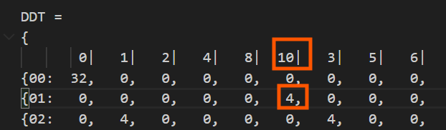
directOutputListPerInput = {
{0x00},
{0x10, 0x11, 0x14, 0x15, 0x18, 0x19, 0x1C, 0x1D},
{0x01, 0x03, 0x09, 0x0B, 0x11, 0x13, 0x19, 0x1B},
{0x02, 0x03, 0x04, 0x05, 0x0A, 0x0B, 0x0C, 0x0D, 0x10, 0x11, 0x16, 0x17, 0x18, 0x19, 0x1E, 0x1F},
{0x02, 0x03, 0x06, 0x07, 0x12, 0x13, 0x16, 0x17},
{0x02, 0x06, 0x0A, 0x0E, 0x12, 0x16, 0x1A, 0x1E},
{0x01, 0x03, 0x04, 0x06, 0x08, 0x0A, 0x0D, 0x0F, 0x11, 0x13, 0x14, 0x16, 0x18, 0x1A, 0x1D, 0x1F},
{0x01, 0x03, 0x05, 0x07, 0x09, 0x0B, 0x0D, 0x0F, 0x11, 0x13, 0x15, 0x17, 0x19, 0x1B, 0x1D, 0x1F},
{0x04, 0x05, 0x06, 0x07, 0x0C, 0x0D, 0x0E, 0x0F},
{0x10, 0x11, 0x12, 0x13, 0x14, 0x15, 0x16, 0x17},
{0x04, 0x05, 0x0C, 0x0D, 0x14, 0x15, 0x1C, 0x1D},
{0x01, 0x05, 0x08, 0x0C, 0x10, 0x14, 0x19, 0x1D},
{0x02, 0x03, 0x06, 0x07, 0x08, 0x09, 0x0C, 0x0D, 0x10, 0x11, 0x14, 0x15, 0x1A, 0x1B, 0x1E, 0x1F},
{0x01, 0x02, 0x04, 0x07, 0x11, 0x12, 0x14, 0x17},
{0x02, 0x03, 0x06, 0x07, 0x0A, 0x0B, 0x0E, 0x0F, 0x12, 0x13, 0x16, 0x17, 0x1A, 0x1B, 0x1E, 0x1F},
{0x02, 0x03, 0x06, 0x07, 0x0A, 0x0B, 0x0E, 0x0F, 0x12, 0x13, 0x16, 0x17, 0x1A, 0x1B, 0x1E, 0x1F},
{0x08, 0x0A, 0x0C, 0x0E, 0x18, 0x1A, 0x1C, 0x1E},
{0x01, 0x02, 0x05, 0x06, 0x08, 0x0B, 0x0C, 0x0F, 0x11, 0x12, 0x15, 0x16, 0x18, 0x1B, 0x1C, 0x1F},
{0x01, 0x03, 0x05, 0x07, 0x09, 0x0B, 0x0D, 0x0F},
{0x10, 0x11, 0x12, 0x13, 0x14, 0x15, 0x16, 0x17, 0x18, 0x19, 0x1A, 0x1B, 0x1C, 0x1D, 0x1E, 0x1F},
{0x08, 0x09, 0x0A, 0x0B, 0x18, 0x19, 0x1A, 0x1B},
{0x04, 0x06, 0x08, 0x0A, 0x10, 0x12, 0x1C, 0x1E},
{0x01, 0x02, 0x09, 0x0A, 0x10, 0x13, 0x18, 0x1B},
{0x01, 0x03, 0x05, 0x07, 0x09, 0x0B, 0x0D, 0x0F, 0x11, 0x13, 0x15, 0x17, 0x19, 0x1B, 0x1D, 0x1F},
{0x01, 0x03, 0x04, 0x06, 0x09, 0x0B, 0x0C, 0x0E, 0x10, 0x12, 0x15, 0x17, 0x18, 0x1A, 0x1D, 0x1F},
{0x08, 0x09, 0x0A, 0x0B, 0x0C, 0x0D, 0x0E, 0x0F, 0x18, 0x19, 0x1A, 0x1B, 0x1C, 0x1D, 0x1E, 0x1F},
{0x02, 0x03, 0x04, 0x05, 0x08, 0x09, 0x0E, 0x0F},
{0x10, 0x11, 0x12, 0x13, 0x14, 0x15, 0x16, 0x17, 0x18, 0x19, 0x1A, 0x1B, 0x1C, 0x1D, 0x1E, 0x1F},
{0x04, 0x05, 0x06, 0x07, 0x0C, 0x0D, 0x0E, 0x0F, 0x14, 0x15, 0x16, 0x17, 0x1C, 0x1D, 0x1E, 0x1F},
{0x08, 0x09, 0x0A, 0x0B, 0x0C, 0x0D, 0x0E, 0x0F, 0x18, 0x19, 0x1A, 0x1B, 0x1C, 0x1D, 0x1E, 0x1F},
{0x04, 0x05, 0x06, 0x07, 0x0C, 0x0D, 0x0E, 0x0F, 0x14, 0x15, 0x16, 0x17, 0x1C, 0x1D, 0x1E, 0x1F},
{0x01, 0x02, 0x04, 0x07, 0x08, 0x0B, 0x0D, 0x0E, 0x10, 0x13, 0x15, 0x16, 0x19, 0x1A, 0x1C, 0x1F},
};

Chưa hiểu cái này lắm
affinePerInput = {
AffineSpaceOfColumns(0x00, {}), // 0x00
AffineSpaceOfColumns(0x10, {0x08, 0x04, 0x01}), // 0x01
AffineSpaceOfColumns(0x01, {0x10, 0x08, 0x02}), // 0x02
AffineSpaceOfColumns(0x02, {0x12, 0x08, 0x06, 0x01}), // 0x03
AffineSpaceOfColumns(0x02, {0x10, 0x04, 0x01}), // 0x04
AffineSpaceOfColumns(0x02, {0x10, 0x08, 0x04}), // 0x05
AffineSpaceOfColumns(0x01, {0x10, 0x09, 0x05, 0x02}), // 0x06
AffineSpaceOfColumns(0x01, {0x10, 0x08, 0x04, 0x02}), // 0x07
AffineSpaceOfColumns(0x04, {0x08, 0x02, 0x01}), // 0x08
AffineSpaceOfColumns(0x10, {0x04, 0x02, 0x01}), // 0x09
AffineSpaceOfColumns(0x04, {0x10, 0x08, 0x01}), // 0x0a
AffineSpaceOfColumns(0x01, {0x11, 0x09, 0x04}), // 0x0b
AffineSpaceOfColumns(0x02, {0x12, 0x0A, 0x04, 0x01}), // 0x0c
AffineSpaceOfColumns(0x01, {0x10, 0x05, 0x03}), // 0x0d
AffineSpaceOfColumns(0x02, {0x10, 0x08, 0x04, 0x01}), // 0x0e
AffineSpaceOfColumns(0x02, {0x10, 0x08, 0x04, 0x01}), // 0x0f
AffineSpaceOfColumns(0x08, {0x10, 0x04, 0x02}), // 0x10
AffineSpaceOfColumns(0x01, {0x10, 0x09, 0x04, 0x03}), // 0x11
AffineSpaceOfColumns(0x01, {0x08, 0x04, 0x02}), // 0x12
AffineSpaceOfColumns(0x10, {0x08, 0x04, 0x02, 0x01}), // 0x13
AffineSpaceOfColumns(0x08, {0x10, 0x02, 0x01}), // 0x14
AffineSpaceOfColumns(0x04, {0x14, 0x0C, 0x02}), // 0x15
AffineSpaceOfColumns(0x01, {0x11, 0x08, 0x03}), // 0x16
AffineSpaceOfColumns(0x01, {0x10, 0x08, 0x04, 0x02}), // 0x17
AffineSpaceOfColumns(0x01, {0x11, 0x08, 0x05, 0x02}), // 0x18
AffineSpaceOfColumns(0x08, {0x10, 0x04, 0x02, 0x01}), // 0x19
AffineSpaceOfColumns(0x02, {0x0A, 0x06, 0x01}), // 0x1a
AffineSpaceOfColumns(0x10, {0x08, 0x04, 0x02, 0x01}), // 0x1b
AffineSpaceOfColumns(0x04, {0x10, 0x08, 0x02, 0x01}), // 0x1c
AffineSpaceOfColumns(0x08, {0x10, 0x04, 0x02, 0x01}), // 0x1d
AffineSpaceOfColumns(0x04, {0x10, 0x08, 0x02, 0x01}), // 0x1e
AffineSpaceOfColumns(0x01, {0x11, 0x09, 0x05, 0x03}), // 0x1f
};

// (ordered by weight then value)
reverseOutputListPerInput = {
{}, // 0x00
{0x02, 0x0B, 0x0D, 0x12, 0x16, 0x06, 0x07, 0x11, 0x17, 0x18, 0x1F}, // 0x01
{0x04, 0x05, 0x0D, 0x16, 0x1A, 0x03, 0x0C, 0x0E, 0x0F, 0x11, 0x1F}, // 0x02
{0x02, 0x04, 0x12, 0x1A, 0x03, 0x06, 0x07, 0x0C, 0x0E, 0x0F, 0x17, 0x18}, // 0x03
{0x08, 0x0A, 0x0D, 0x15, 0x1A, 0x03, 0x06, 0x18, 0x1C, 0x1E, 0x1F}, // 0x04
{0x08, 0x0A, 0x0B, 0x12, 0x1A, 0x03, 0x07, 0x11, 0x17, 0x1C, 0x1E}, // 0x05
{0x04, 0x05, 0x08, 0x15, 0x06, 0x0C, 0x0E, 0x0F, 0x11, 0x18, 0x1C, 0x1E}, // 0x06
{0x04, 0x08, 0x0D, 0x12, 0x07, 0x0C, 0x0E, 0x0F, 0x17, 0x1C, 0x1E, 0x1F}, // 0x07
{0x0B, 0x10, 0x14, 0x15, 0x1A, 0x06, 0x0C, 0x11, 0x19, 0x1D, 0x1F}, // 0x08
{0x02, 0x12, 0x14, 0x16, 0x1A, 0x07, 0x0C, 0x17, 0x18, 0x19, 0x1D}, // 0x09
{0x05, 0x10, 0x14, 0x15, 0x16, 0x03, 0x06, 0x0E, 0x0F, 0x19, 0x1D}, // 0x0a
{0x02, 0x12, 0x14, 0x03, 0x07, 0x0E, 0x0F, 0x11, 0x17, 0x18, 0x19, 0x1D, 0x1F}, // 0x0b
{0x08, 0x0A, 0x0B, 0x10, 0x03, 0x0C, 0x11, 0x18, 0x19, 0x1C, 0x1D, 0x1E}, // 0x0c
{0x08, 0x0A, 0x12, 0x03, 0x06, 0x07, 0x0C, 0x17, 0x19, 0x1C, 0x1D, 0x1E, 0x1F}, // 0x0d
{0x05, 0x08, 0x10, 0x1A, 0x0E, 0x0F, 0x18, 0x19, 0x1C, 0x1D, 0x1E, 0x1F}, // 0x0e
{0x08, 0x12, 0x1A, 0x06, 0x07, 0x0E, 0x0F, 0x11, 0x17, 0x19, 0x1C, 0x1D, 0x1E}, // 0x0f
{0x01, 0x09, 0x0B, 0x15, 0x16, 0x03, 0x0C, 0x13, 0x18, 0x1B, 0x1F}, // 0x10
{0x01, 0x02, 0x09, 0x0D, 0x03, 0x06, 0x07, 0x0C, 0x11, 0x13, 0x17, 0x1B}, // 0x11
{0x04, 0x05, 0x09, 0x0D, 0x15, 0x0E, 0x0F, 0x11, 0x13, 0x18, 0x1B}, // 0x12
{0x02, 0x04, 0x09, 0x16, 0x06, 0x07, 0x0E, 0x0F, 0x13, 0x17, 0x1B, 0x1F}, // 0x13
{0x01, 0x09, 0x0A, 0x0B, 0x0D, 0x06, 0x0C, 0x13, 0x1B, 0x1C, 0x1E}, // 0x14
{0x01, 0x09, 0x0A, 0x07, 0x0C, 0x11, 0x13, 0x17, 0x18, 0x1B, 0x1C, 0x1E, 0x1F}, // 0x15
{0x04, 0x05, 0x09, 0x03, 0x06, 0x0E, 0x0F, 0x11, 0x13, 0x1B, 0x1C, 0x1E, 0x1F}, // 0x16
{0x04, 0x09, 0x0D, 0x03, 0x07, 0x0E, 0x0F, 0x13, 0x17, 0x18, 0x1B, 0x1C, 0x1E}, // 0x17
{0x01, 0x10, 0x14, 0x16, 0x03, 0x06, 0x11, 0x13, 0x18, 0x19, 0x1B, 0x1D}, // 0x18
{0x01, 0x02, 0x0B, 0x14, 0x03, 0x07, 0x13, 0x17, 0x19, 0x1B, 0x1D, 0x1F}, // 0x19
{0x05, 0x10, 0x14, 0x06, 0x0C, 0x0E, 0x0F, 0x13, 0x18, 0x19, 0x1B, 0x1D, 0x1F}, // 0x1a
{0x02, 0x14, 0x16, 0x07, 0x0C, 0x0E, 0x0F, 0x11, 0x13, 0x17, 0x19, 0x1B, 0x1D}, // 0x1b
{0x01, 0x0A, 0x10, 0x15, 0x11, 0x13, 0x19, 0x1B, 0x1C, 0x1D, 0x1E, 0x1F}, // 0x1c
{0x01, 0x0A, 0x0B, 0x06, 0x07, 0x13, 0x17, 0x18, 0x19, 0x1B, 0x1C, 0x1D, 0x1E}, // 0x1d
{0x05, 0x10, 0x15, 0x03, 0x0C, 0x0E, 0x0F, 0x13, 0x19, 0x1B, 0x1C, 0x1D, 0x1E}, // 0x1e
{0x03, 0x06, 0x07, 0x0C, 0x0E, 0x0F, 0x11, 0x13, 0x17, 0x18, 0x19, 0x1B, 0x1C, 0x1D, 0x1E, 0x1F}, // 0x1f
};

weightReverseOutputListPerInput = {
{}, // 0x00
{3, 3, 3, 3, 3, 4, 4, 4, 4, 4, 4}, // 0x01
{3, 3, 3, 3, 3, 4, 4, 4, 4, 4, 4}, // 0x02
{3, 3, 3, 3, 4, 4, 4, 4, 4, 4, 4, 4}, // 0x03
{3, 3, 3, 3, 3, 4, 4, 4, 4, 4, 4}, // 0x04
{3, 3, 3, 3, 3, 4, 4, 4, 4, 4, 4}, // 0x05
{3, 3, 3, 3, 4, 4, 4, 4, 4, 4, 4, 4}, // 0x06
{3, 3, 3, 3, 4, 4, 4, 4, 4, 4, 4, 4}, // 0x07
{3, 3, 3, 3, 3, 4, 4, 4, 4, 4, 4}, // 0x08
{3, 3, 3, 3, 3, 4, 4, 4, 4, 4, 4}, // 0x09
{3, 3, 3, 3, 3, 4, 4, 4, 4, 4, 4}, // 0x0a
{3, 3, 3, 4, 4, 4, 4, 4, 4, 4, 4, 4, 4}, // 0x0b
{3, 3, 3, 3, 4, 4, 4, 4, 4, 4, 4, 4}, // 0x0c
{3, 3, 3, 4, 4, 4, 4, 4, 4, 4, 4, 4, 4}, // 0x0d
{3, 3, 3, 3, 4, 4, 4, 4, 4, 4, 4, 4}, // 0x0e
{3, 3, 3, 4, 4, 4, 4, 4, 4, 4, 4, 4, 4}, // 0x0f
{3, 3, 3, 3, 3, 4, 4, 4, 4, 4, 4}, // 0x10
{3, 3, 3, 3, 4, 4, 4, 4, 4, 4, 4, 4}, // 0x11
{3, 3, 3, 3, 3, 4, 4, 4, 4, 4, 4}, // 0x12
{3, 3, 3, 3, 4, 4, 4, 4, 4, 4, 4, 4}, // 0x13
{3, 3, 3, 3, 3, 4, 4, 4, 4, 4, 4}, // 0x14
{3, 3, 3, 4, 4, 4, 4, 4, 4, 4, 4, 4, 4}, // 0x15
{3, 3, 3, 4, 4, 4, 4, 4, 4, 4, 4, 4, 4}, // 0x16
{3, 3, 3, 4, 4, 4, 4, 4, 4, 4, 4, 4, 4}, // 0x17
{3, 3, 3, 3, 4, 4, 4, 4, 4, 4, 4, 4}, // 0x18
{3, 3, 3, 3, 4, 4, 4, 4, 4, 4, 4, 4}, // 0x19
{3, 3, 3, 4, 4, 4, 4, 4, 4, 4, 4, 4, 4}, // 0x1a
{3, 3, 3, 4, 4, 4, 4, 4, 4, 4, 4, 4, 4}, // 0x1b
{3, 3, 3, 3, 4, 4, 4, 4, 4, 4, 4, 4}, // 0x1c
{3, 3, 3, 4, 4, 4, 4, 4, 4, 4, 4, 4, 4}, // 0x1d
{3, 3, 3, 4, 4, 4, 4, 4, 4, 4, 4, 4, 4}, // 0x1e
{4, 4, 4, 4, 4, 4, 4, 4, 4, 4, 4, 4, 4, 4, 4, 4}, // 0x1f
};

// Output = 0 1 2 3 4 5 6 7 8 9 10 11 12 13 14 15 16 17 18 19 20 21 22 23 24 25 26 27 28 29 30 31
minRevWeightListPerOutput = { 0, 3, 3, 3, 3, 3, 3, 3, 3, 3, 3, 3, 3, 3, 3, 3, 3, 3, 3, 3, 3, 3, 3, 3, 3, 3, 3, 3, 3, 3, 3, 4 };(giống cái code trên wrev_dts)

// --- Thống kê ---
// Weight distribution (diff/lin): {3: 15, 4: 16}
// minRevWeight range : 3 – 4

==================================================================
// DTS=0 (LINEAR)
==================================================================
// Input = 0 1 2 3 4 5 6 7 8 9 10 11 12 13 14 15 16 17 18 19 20 21 22 23 24 25 26 27 28 29 30 31
weightListPerInput = { 0, 2, 2, 4, 2, 4, 4, 4, 2, 4, 4, 4, 4, 4, 4, 4, 2, 4, 4, 4, 4, 4, 4, 4, 4, 4, 4, 4, 4, 4, 4, 4 }; (giống cái wc code trên)

directOutputListPerInput = {
{0x00},
{0x02, 0x07, 0x0A, 0x0F},
{0x04, 0x0E, 0x14, 0x1E},
{0x01, 0x03, 0x04, 0x06, 0x09, 0x0B, 0x0C, 0x0E, 0x11, 0x13, 0x14, 0x16, 0x19, 0x1B, 0x1C, 0x1E},
{0x08, 0x09, 0x1C, 0x1D},
{0x02, 0x03, 0x06, 0x07, 0x0A, 0x0B, 0x0E, 0x0F, 0x12, 0x13, 0x16, 0x17, 0x1A, 0x1B, 0x1E, 0x1F},
{0x02, 0x03, 0x06, 0x07, 0x08, 0x09, 0x0C, 0x0D, 0x12, 0x13, 0x16, 0x17, 0x18, 0x19, 0x1C, 0x1D},
{0x01, 0x03, 0x04, 0x06, 0x08, 0x0A, 0x0D, 0x0F, 0x11, 0x13, 0x14, 0x16, 0x18, 0x1A, 0x1D, 0x1F},
{0x10, 0x12, 0x19, 0x1B},
{0x10, 0x11, 0x12, 0x13, 0x14, 0x15, 0x16, 0x17, 0x18, 0x19, 0x1A, 0x1B, 0x1C, 0x1D, 0x1E, 0x1F},
{0x04, 0x05, 0x06, 0x07, 0x0C, 0x0D, 0x0E, 0x0F, 0x14, 0x15, 0x16, 0x17, 0x1C, 0x1D, 0x1E, 0x1F},
{0x01, 0x03, 0x05, 0x07, 0x09, 0x0B, 0x0D, 0x0F, 0x10, 0x12, 0x14, 0x16, 0x18, 0x1A, 0x1C, 0x1E},
{0x04, 0x05, 0x06, 0x07, 0x0C, 0x0D, 0x0E, 0x0F, 0x10, 0x11, 0x12, 0x13, 0x18, 0x19, 0x1A, 0x1B},
{0x02, 0x03, 0x04, 0x05, 0x0A, 0x0B, 0x0C, 0x0D, 0x12, 0x13, 0x14, 0x15, 0x1A, 0x1B, 0x1C, 0x1D},
{0x02, 0x03, 0x06, 0x07, 0x08, 0x09, 0x0C, 0x0D, 0x10, 0x11, 0x14, 0x15, 0x1A, 0x1B, 0x1E, 0x1F},
{0x01, 0x03, 0x04, 0x06, 0x08, 0x0A, 0x0D, 0x0F, 0x11, 0x13, 0x14, 0x16, 0x18, 0x1A, 0x1D, 0x1F},
{0x01, 0x05, 0x13, 0x17},
{0x02, 0x03, 0x06, 0x07, 0x0A, 0x0B, 0x0E, 0x0F, 0x10, 0x11, 0x14, 0x15, 0x18, 0x19, 0x1C, 0x1D},
{0x01, 0x03, 0x05, 0x07, 0x09, 0x0B, 0x0D, 0x0F, 0x11, 0x13, 0x15, 0x17, 0x19, 0x1B, 0x1D, 0x1F},
{0x02, 0x03, 0x04, 0x05, 0x0A, 0x0B, 0x0C, 0x0D, 0x10, 0x11, 0x16, 0x17, 0x18, 0x19, 0x1E, 0x1F},
{0x08, 0x09, 0x0A, 0x0B, 0x0C, 0x0D, 0x0E, 0x0F, 0x18, 0x19, 0x1A, 0x1B, 0x1C, 0x1D, 0x1E, 0x1F},
{0x08, 0x09, 0x0A, 0x0B, 0x0C, 0x0D, 0x0E, 0x0F, 0x10, 0x11, 0x12, 0x13, 0x14, 0x15, 0x16, 0x17},
{0x01, 0x02, 0x05, 0x06, 0x09, 0x0A, 0x0D, 0x0E, 0x11, 0x12, 0x15, 0x16, 0x19, 0x1A, 0x1D, 0x1E},
{0x02, 0x03, 0x04, 0x05, 0x0A, 0x0B, 0x0C, 0x0D, 0x10, 0x11, 0x16, 0x17, 0x18, 0x19, 0x1E, 0x1F},
{0x01, 0x03, 0x05, 0x07, 0x08, 0x0A, 0x0C, 0x0E, 0x11, 0x13, 0x15, 0x17, 0x18, 0x1A, 0x1C, 0x1E},
{0x01, 0x02, 0x05, 0x06, 0x08, 0x0B, 0x0C, 0x0F, 0x11, 0x12, 0x15, 0x16, 0x18, 0x1B, 0x1C, 0x1F},
{0x04, 0x05, 0x06, 0x07, 0x08, 0x09, 0x0A, 0x0B, 0x14, 0x15, 0x16, 0x17, 0x18, 0x19, 0x1A, 0x1B},
{0x01, 0x02, 0x05, 0x06, 0x08, 0x0B, 0x0C, 0x0F, 0x11, 0x12, 0x15, 0x16, 0x18, 0x1B, 0x1C, 0x1F},
{0x01, 0x03, 0x04, 0x06, 0x09, 0x0B, 0x0C, 0x0E, 0x10, 0x12, 0x15, 0x17, 0x18, 0x1A, 0x1D, 0x1F},
{0x01, 0x03, 0x04, 0x06, 0x09, 0x0B, 0x0C, 0x0E, 0x10, 0x12, 0x15, 0x17, 0x18, 0x1A, 0x1D, 0x1F},
{0x02, 0x03, 0x06, 0x07, 0x08, 0x09, 0x0C, 0x0D, 0x10, 0x11, 0x14, 0x15, 0x1A, 0x1B, 0x1E, 0x1F},
{0x01, 0x02, 0x04, 0x07, 0x08, 0x0B, 0x0D, 0x0E, 0x10, 0x13, 0x15, 0x16, 0x19, 0x1A, 0x1C, 0x1F},
};

affinePerInput = {
AffineSpaceOfColumns(0x00, {}), // 0x00
AffineSpaceOfColumns(0x02, {0x08, 0x05}), // 0x01
AffineSpaceOfColumns(0x04, {0x10, 0x0A}), // 0x02
AffineSpaceOfColumns(0x01, {0x10, 0x08, 0x05, 0x02}), // 0x03
AffineSpaceOfColumns(0x08, {0x14, 0x01}), // 0x04
AffineSpaceOfColumns(0x02, {0x10, 0x08, 0x04, 0x01}), // 0x05
AffineSpaceOfColumns(0x02, {0x10, 0x0A, 0x04, 0x01}), // 0x06
AffineSpaceOfColumns(0x01, {0x10, 0x09, 0x05, 0x02}), // 0x07
AffineSpaceOfColumns(0x10, {0x09, 0x02}), // 0x08
AffineSpaceOfColumns(0x10, {0x08, 0x04, 0x02, 0x01}), // 0x09
AffineSpaceOfColumns(0x04, {0x10, 0x08, 0x02, 0x01}), // 0x0a
AffineSpaceOfColumns(0x01, {0x11, 0x08, 0x04, 0x02}), // 0x0b
AffineSpaceOfColumns(0x04, {0x14, 0x08, 0x02, 0x01}), // 0x0c
AffineSpaceOfColumns(0x02, {0x10, 0x08, 0x06, 0x01}), // 0x0d
AffineSpaceOfColumns(0x02, {0x12, 0x0A, 0x04, 0x01}), // 0x0e
AffineSpaceOfColumns(0x01, {0x10, 0x09, 0x05, 0x02}), // 0x0f
AffineSpaceOfColumns(0x01, {0x12, 0x04}), // 0x10
AffineSpaceOfColumns(0x02, {0x12, 0x08, 0x04, 0x01}), // 0x11
AffineSpaceOfColumns(0x01, {0x10, 0x08, 0x04, 0x02}), // 0x12
AffineSpaceOfColumns(0x02, {0x12, 0x08, 0x06, 0x01}), // 0x13
AffineSpaceOfColumns(0x08, {0x10, 0x04, 0x02, 0x01}), // 0x14
AffineSpaceOfColumns(0x08, {0x18, 0x04, 0x02, 0x01}), // 0x15
AffineSpaceOfColumns(0x01, {0x10, 0x08, 0x04, 0x03}), // 0x16
AffineSpaceOfColumns(0x02, {0x12, 0x08, 0x06, 0x01}), // 0x17
AffineSpaceOfColumns(0x01, {0x10, 0x09, 0x04, 0x02}), // 0x18
AffineSpaceOfColumns(0x01, {0x10, 0x09, 0x04, 0x03}), // 0x19
AffineSpaceOfColumns(0x04, {0x10, 0x0C, 0x02, 0x01}), // 0x1a
AffineSpaceOfColumns(0x01, {0x10, 0x09, 0x04, 0x03}), // 0x1b
AffineSpaceOfColumns(0x01, {0x11, 0x08, 0x05, 0x02}), // 0x1c
AffineSpaceOfColumns(0x01, {0x11, 0x08, 0x05, 0x02}), // 0x1d
AffineSpaceOfColumns(0x02, {0x12, 0x0A, 0x04, 0x01}), // 0x1e
AffineSpaceOfColumns(0x01, {0x11, 0x09, 0x05, 0x03}), // 0x1f
};

// (ordered by weight then value)
reverseOutputListPerInput = {
{}, // 0x00
{0x10, 0x03, 0x07, 0x0B, 0x0F, 0x12, 0x16, 0x18, 0x19, 0x1B, 0x1C, 0x1D, 0x1F}, // 0x01
{0x01, 0x05, 0x06, 0x0D, 0x0E, 0x11, 0x13, 0x16, 0x17, 0x19, 0x1B, 0x1E, 0x1F}, // 0x02
{0x03, 0x05, 0x06, 0x07, 0x0B, 0x0D, 0x0E, 0x0F, 0x11, 0x12, 0x13, 0x17, 0x18, 0x1C, 0x1D, 0x1E}, // 0x03
{0x02, 0x03, 0x07, 0x0A, 0x0C, 0x0D, 0x0F, 0x13, 0x17, 0x1A, 0x1C, 0x1D, 0x1F}, // 0x04
{0x10, 0x0A, 0x0B, 0x0C, 0x0D, 0x12, 0x13, 0x16, 0x17, 0x18, 0x19, 0x1A, 0x1B}, // 0x05
{0x03, 0x05, 0x06, 0x07, 0x0A, 0x0C, 0x0E, 0x0F, 0x11, 0x16, 0x19, 0x1A, 0x1B, 0x1C, 0x1D, 0x1E}, // 0x06
{0x01, 0x05, 0x06, 0x0A, 0x0B, 0x0C, 0x0E, 0x11, 0x12, 0x18, 0x1A, 0x1E, 0x1F}, // 0x07
{0x04, 0x06, 0x07, 0x0E, 0x0F, 0x14, 0x15, 0x18, 0x19, 0x1A, 0x1B, 0x1E, 0x1F}, // 0x08
{0x04, 0x03, 0x06, 0x0B, 0x0E, 0x12, 0x14, 0x15, 0x16, 0x1A, 0x1C, 0x1D, 0x1E}, // 0x09
{0x01, 0x05, 0x07, 0x0D, 0x0F, 0x11, 0x13, 0x14, 0x15, 0x16, 0x17, 0x18, 0x1A}, // 0x0a
{0x03, 0x05, 0x0B, 0x0D, 0x11, 0x12, 0x13, 0x14, 0x15, 0x17, 0x19, 0x1A, 0x1B, 0x1C, 0x1D, 0x1F}, // 0x0b
{0x03, 0x06, 0x0A, 0x0C, 0x0D, 0x0E, 0x13, 0x14, 0x15, 0x17, 0x18, 0x19, 0x1B, 0x1C, 0x1D, 0x1E}, // 0x0c
{0x06, 0x07, 0x0A, 0x0B, 0x0C, 0x0D, 0x0E, 0x0F, 0x12, 0x13, 0x14, 0x15, 0x16, 0x17, 0x1E, 0x1F}, // 0x0d
{0x02, 0x03, 0x05, 0x0A, 0x0C, 0x11, 0x14, 0x15, 0x16, 0x18, 0x1C, 0x1D, 0x1F}, // 0x0e
{0x01, 0x05, 0x07, 0x0A, 0x0B, 0x0C, 0x0F, 0x11, 0x12, 0x14, 0x15, 0x19, 0x1B}, // 0x0f
{0x08, 0x09, 0x0B, 0x0C, 0x0E, 0x11, 0x13, 0x15, 0x17, 0x1C, 0x1D, 0x1E, 0x1F}, // 0x10
{0x03, 0x07, 0x09, 0x0C, 0x0E, 0x0F, 0x11, 0x12, 0x13, 0x15, 0x16, 0x17, 0x18, 0x19, 0x1B, 0x1E}, // 0x11
{0x08, 0x05, 0x06, 0x09, 0x0B, 0x0C, 0x0D, 0x15, 0x16, 0x19, 0x1B, 0x1C, 0x1D}, // 0x12
{0x10, 0x03, 0x05, 0x06, 0x07, 0x09, 0x0C, 0x0D, 0x0F, 0x12, 0x15, 0x18, 0x1F}, // 0x13
{0x02, 0x03, 0x07, 0x09, 0x0A, 0x0B, 0x0D, 0x0E, 0x0F, 0x11, 0x15, 0x1A, 0x1E}, // 0x14
{0x09, 0x0A, 0x0D, 0x0E, 0x11, 0x12, 0x15, 0x16, 0x18, 0x19, 0x1A, 0x1B, 0x1C, 0x1D, 0x1E, 0x1F}, // 0x15
{0x03, 0x05, 0x06, 0x07, 0x09, 0x0A, 0x0B, 0x0F, 0x13, 0x15, 0x16, 0x17, 0x19, 0x1A, 0x1B, 0x1F}, // 0x16
{0x10, 0x05, 0x06, 0x09, 0x0A, 0x12, 0x13, 0x15, 0x17, 0x18, 0x1A, 0x1C, 0x1D}, // 0x17
{0x06, 0x07, 0x09, 0x0B, 0x0C, 0x0F, 0x11, 0x13, 0x14, 0x17, 0x18, 0x19, 0x1A, 0x1B, 0x1C, 0x1D}, // 0x18
{0x08, 0x03, 0x06, 0x09, 0x0C, 0x11, 0x12, 0x13, 0x14, 0x16, 0x17, 0x1A, 0x1F}, // 0x19
{0x05, 0x07, 0x09, 0x0B, 0x0C, 0x0D, 0x0E, 0x0F, 0x14, 0x16, 0x18, 0x1A, 0x1C, 0x1D, 0x1E, 0x1F}, // 0x1a
{0x08, 0x03, 0x05, 0x09, 0x0C, 0x0D, 0x0E, 0x12, 0x14, 0x19, 0x1A, 0x1B, 0x1E}, // 0x1b
{0x04, 0x03, 0x06, 0x09, 0x0A, 0x0B, 0x0D, 0x11, 0x14, 0x18, 0x19, 0x1B, 0x1F}, // 0x1c
{0x04, 0x06, 0x07, 0x09, 0x0A, 0x0D, 0x0F, 0x11, 0x12, 0x14, 0x16, 0x1C, 0x1D}, // 0x1d
{0x02, 0x03, 0x05, 0x09, 0x0A, 0x0B, 0x0E, 0x13, 0x14, 0x16, 0x17, 0x18, 0x1E}, // 0x1e
{0x05, 0x07, 0x09, 0x0A, 0x0E, 0x0F, 0x12, 0x13, 0x14, 0x17, 0x19, 0x1B, 0x1C, 0x1D, 0x1E, 0x1F}, // 0x1f
};

weightReverseOutputListPerInput = {
{}, // 0x00
{2, 4, 4, 4, 4, 4, 4, 4, 4, 4, 4, 4, 4}, // 0x01
{2, 4, 4, 4, 4, 4, 4, 4, 4, 4, 4, 4, 4}, // 0x02
{4, 4, 4, 4, 4, 4, 4, 4, 4, 4, 4, 4, 4, 4, 4, 4}, // 0x03
{2, 4, 4, 4, 4, 4, 4, 4, 4, 4, 4, 4, 4}, // 0x04
{2, 4, 4, 4, 4, 4, 4, 4, 4, 4, 4, 4, 4}, // 0x05
{4, 4, 4, 4, 4, 4, 4, 4, 4, 4, 4, 4, 4, 4, 4, 4}, // 0x06
{2, 4, 4, 4, 4, 4, 4, 4, 4, 4, 4, 4, 4}, // 0x07
{2, 4, 4, 4, 4, 4, 4, 4, 4, 4, 4, 4, 4}, // 0x08
{2, 4, 4, 4, 4, 4, 4, 4, 4, 4, 4, 4, 4}, // 0x09
{2, 4, 4, 4, 4, 4, 4, 4, 4, 4, 4, 4, 4}, // 0x0a
{4, 4, 4, 4, 4, 4, 4, 4, 4, 4, 4, 4, 4, 4, 4, 4}, // 0x0b
{4, 4, 4, 4, 4, 4, 4, 4, 4, 4, 4, 4, 4, 4, 4, 4}, // 0x0c
{4, 4, 4, 4, 4, 4, 4, 4, 4, 4, 4, 4, 4, 4, 4, 4}, // 0x0d
{2, 4, 4, 4, 4, 4, 4, 4, 4, 4, 4, 4, 4}, // 0x0e
{2, 4, 4, 4, 4, 4, 4, 4, 4, 4, 4, 4, 4}, // 0x0f
{2, 4, 4, 4, 4, 4, 4, 4, 4, 4, 4, 4, 4}, // 0x10
{4, 4, 4, 4, 4, 4, 4, 4, 4, 4, 4, 4, 4, 4, 4, 4}, // 0x11
{2, 4, 4, 4, 4, 4, 4, 4, 4, 4, 4, 4, 4}, // 0x12
{2, 4, 4, 4, 4, 4, 4, 4, 4, 4, 4, 4, 4}, // 0x13
{2, 4, 4, 4, 4, 4, 4, 4, 4, 4, 4, 4, 4}, // 0x14
{4, 4, 4, 4, 4, 4, 4, 4, 4, 4, 4, 4, 4, 4, 4, 4}, // 0x15
{4, 4, 4, 4, 4, 4, 4, 4, 4, 4, 4, 4, 4, 4, 4, 4}, // 0x16
{2, 4, 4, 4, 4, 4, 4, 4, 4, 4, 4, 4, 4}, // 0x17
{4, 4, 4, 4, 4, 4, 4, 4, 4, 4, 4, 4, 4, 4, 4, 4}, // 0x18
{2, 4, 4, 4, 4, 4, 4, 4, 4, 4, 4, 4, 4}, // 0x19
{4, 4, 4, 4, 4, 4, 4, 4, 4, 4, 4, 4, 4, 4, 4, 4}, // 0x1a
{2, 4, 4, 4, 4, 4, 4, 4, 4, 4, 4, 4, 4}, // 0x1b
{2, 4, 4, 4, 4, 4, 4, 4, 4, 4, 4, 4, 4}, // 0x1c
{2, 4, 4, 4, 4, 4, 4, 4, 4, 4, 4, 4, 4}, // 0x1d
{2, 4, 4, 4, 4, 4, 4, 4, 4, 4, 4, 4, 4}, // 0x1e
{4, 4, 4, 4, 4, 4, 4, 4, 4, 4, 4, 4, 4, 4, 4, 4}, // 0x1f
};

// Output = 0 1 2 3 4 5 6 7 8 9 10 11 12 13 14 15 16 17 18 19 20 21 22 23 24 25 26 27 28 29 30 31
minRevWeightListPerOutput = { 0, 2, 2, 4, 2, 2, 4, 2, 2, 2, 2, 4, 4, 4, 2, 2, 2, 4, 2, 2, 2, 4, 4, 2, 4, 2, 4, 2, 2, 2, 2, 4 }; Giống cái code trên

// --- Thống kê ---
// Weight distribution (diff/lin): {2: 5, 4: 26}
// minRevWeight range : 2 – 4
PS C:\Users\Acer\PEIGEN>

config.h (có thể đổi vài chỗ này để đỡ nhầm tên
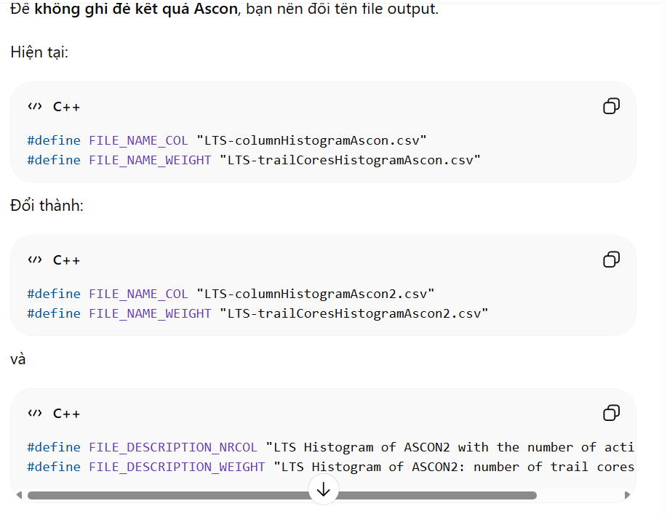
Thế chắc là có asconColScore.cpp, trailExtension.cpp , config.h(sửa 1 tí) mấy file này phải sửa

