

**REPUBLIC OF CAMEROON**

**Peace-Work-Fatherland**

**MINISTER OF HIGHER EDUCATION**

**FACULTY OF ENGINEERING**

**AND TECHNOLOGY**

**REPUBLIQUE DU CAMEROON**

**PAIX-Travail-Patrie**

**MINISTRE DE L’ENSEIGNEMENT SUPERIEUR**

**FACULTE D’INGINERIE**

**ET TECHGNOLOGIE**

**CEF440:**

**INTERNET AND MOBILE PROGRAMMING**

**UI Design of Ways**

**Presented by:**

**HEUYA NDJANSEB KEVIN KENNEDY FE20A049**

**YUVEN BRENDARD WIYFOFE FE20A124**

**LEKEAKA DELAND ACHANKENG FE20A056**

**INSTRUCTOR**: **Dr. NKEMENI VALERY**

**March 2023**

**CONTENT**

**User Design**

**→ Short Delay Page**

**→ Login**

**→ Registration**

**→ Dashboard**

**→ User Personal Information**

**→ Booking a Ride**

**→ Setting Location**

**→ Choosing a Ride**

**→ Confirming the Ride and Pick-Up Location**

**→ Payment Page Information**

1. **Short Delay Page**

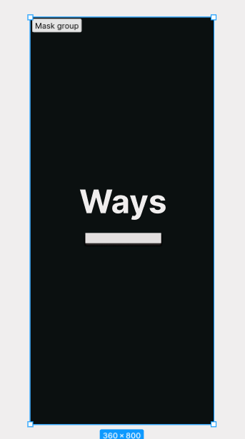

The delay page is the page that appears when ever the app is started. This page contain the name of our app.

Apart from making the app more attractive, the importance of this page is to make our user remember our app in order to promote it to their friends and families. This will make a free source of advertisement because it have been proven that a recommendation from a friends or family members have more values.

**2. Log In and Registration**

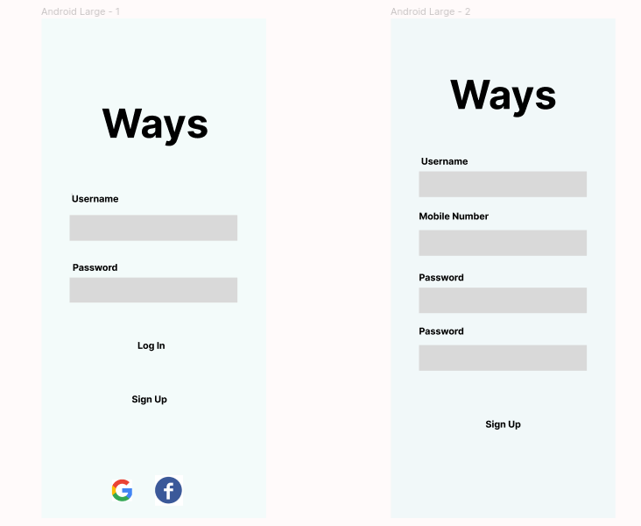

For new user to get access to our app, he/she must first of all sign-up.

When the app is lunch on a device for the first time, the sign-in page is loaded which requires the user to input his log-in details and have the possibility to log-in with google or facebook accounts.

In case the User is new, he can click the sign-up button and fill in the information needed.

**3. Dashboard and Personal Information**

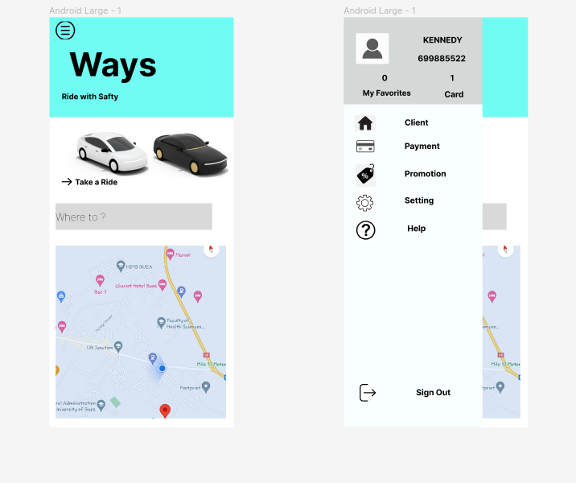

The Dashboard of our app is going to contain the current location of the user and he/she can view his position on the map. The user also have an option of booking a ride with the option of inputting his/her destination.

On the right top corner of our app is a menu button which help our user to navigate easily around the app. This menu contain user personal information such as Payment, client home location, promotion, setting and help with an option to sign out.

**4. Booking a Ride**

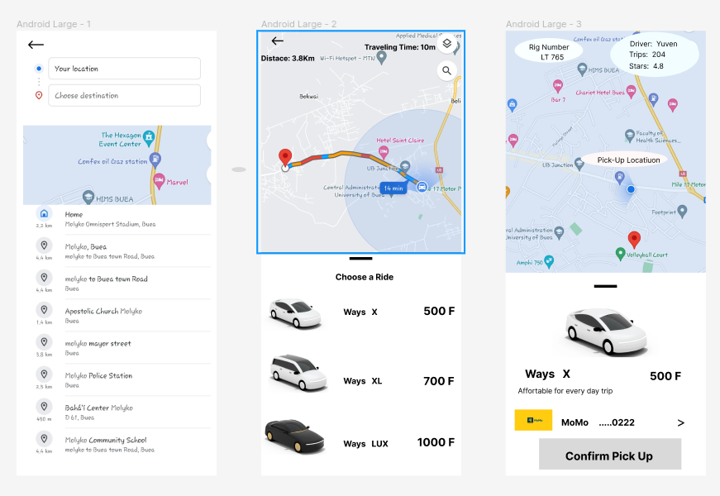

When a User want to take a ride, he/she is directed to this page where he can input his location. While inputting the location, the user receive suggestion from the app (This is done with Google API)

When a location is entered, the user is redirected to another page where he can view the path to his destination. Our select the Shortest path to arrive fast at the destination. Then the user have to make choice on the type of car depending on his wealth.

After the choice is made, must confirm the ride by paying for his ride. Then a notification is sent to the driver.

**5. Payment Method**

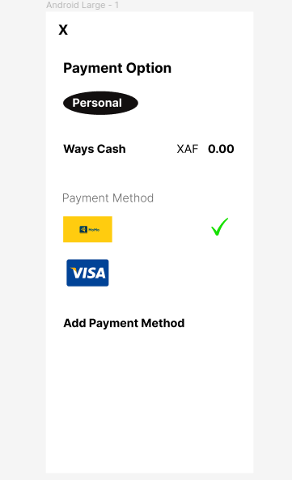

This page contain the financial status of the user where he can view his account balance. He also have the possibility to add new payments account (momo or bank card).