Arjun Big Data Training: Spark Scala Mobile: +91 9900355621

1) Identify whether the following functions are pure and explain?
(Note: Please try to answer this yourself first before running them in the Scala shell)
a. def add(x: Int, y: Int): Int = {

x + y
}

Sol:- 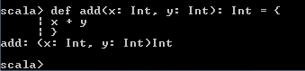

It is adding two integer values.

b. var x = 33

def changeStuff: Unit = {
x = x + 10
}

Sol:-
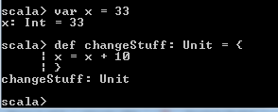

c. def fullName(firstName: String, lastName: String): String = {

s"$firstName $lastName"
}
fullName(“Scala”, “Spark”)

sol:- 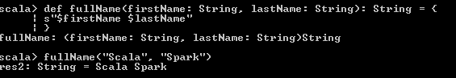

d. def loco: Unit = {

println("toma 4loco!")
}
loco

sol:-
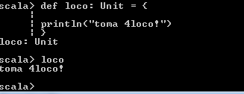
2) What does the following code snippets print and justify your answer?

a. def building = {

"tall"
}
println(building)

sol:-
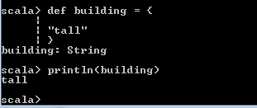
Building we have given value as “tall” so println has given same value.

b. def crazy(number: Int) = {

number + 3
}
println(crazy("book"))

sol:-
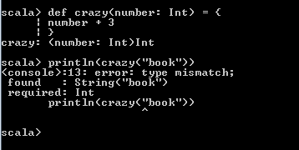

Here we have defined crazy as integer but while printing we r asking string value so,error has countered like “Type Mismatch”

c. def singSong(times: Int): Int = {

s"I'm going to sing ${times.toString} times"
}
println(singSong(5))

sol:-
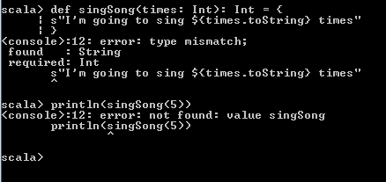

singSong has defined as integer datatype but we have allocated string so first execution has been failed with type miss match error
and second execution we are asking print sing song(5) this is not correct so it’s telling error like not found.

d. def fullName(first: String, last: String = "balvin"): String = {

s"$first $last"
}
println(fullName("j"))

sol:-
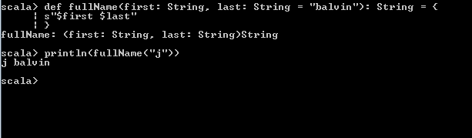

Full name has defined string and also given last name as balvin while printing first name has given “j” and last name is taken from def so output is given “j balvin”

e. def mathFun(x: Int, y: Int = 99): Int = {

x * y
}
println(mathFun(4, 5))

sol:-
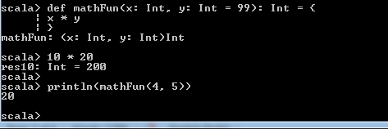
f. def theBest(category: String, thing: String): String = {

s"The best type of $category is $thing"
}
println(theBest(thing = "Squirtle", category = "Pokemon"))

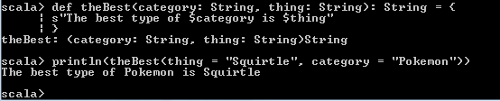

3) Implement Scala code to find the maximum among the three numbers using the match expression.
Sol:-
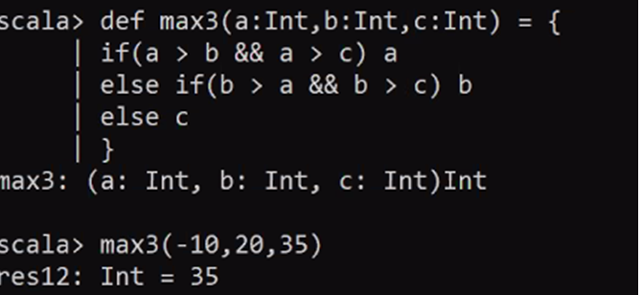

4) Create a Scala function that sums up 10 numbers starting from the number passed as parameter and returns the same.

5) Create a function named “getAgeCategory” which classifies the age based on the following rules and returns a category.

age < 10 - kid
age between 10 and 20 – teen
age between 20 and 60 – adult
age greater than 60 – old age

