Arjun Big Data Training: Spark Scala Mobile: +91 9900355621

Anonymous and higher order functions
1) What does the following code snippets print and explain?

(Note: Please try to answer these yourself first before running them in the Scala shell)

a.
def triple(x: Int): Int = x * 3

val tripleCopy: (Int) => Int = triple
println(tripleCopy(5)

Sol:- “println(tripleCopy(5))” should be declared properly as mentioned, if we are not declared it’s throwing an error while execution

b. def m(x: Int, y: Int): Int = {

if (x > y) x else y
}
val max: (Int, Int) => Int = m
println(max(88, 99))

Sol:-First defining the method and assigning value to m and while printing it’s checking the which one is max
o/p is :- 99

c. var fullName = (first: String, last: String) => {

s"$first $last"
}
println(fullName("bob", "loblaw"))

Sol:-defining method first and last as string and passing the param while printing what ever name has given it’s displaying the output.

o/p is:-bob loblaw

d. val hi = () => "howdy!"

println(hi())

Sol:-hi as string function and it’s allocated string value as ‘howdy!’....So, while printing it’s giving same assigned value.
o/p is:- howdy!

e. def play(thing: String): String = {

s"Let's play with $thing"
}
def funify(thing: String, f: String => String): String = {
f(thing) + " and have fun"
}
println(funify("cats", play))

sol:-defined play -thing as string and assigned to param and second definition is funify and clubbing two strings .

o/p is:-Lets play with cats and have fun

2) Implement the following in Scala,

a) Define a function named "toUpper" which accepts a String as input parameter that is then formatted to upper case as output.
Sol:-
val m = Map(1 -> “scala” , 2 -> “spark” , 3 -> “Hadoop” , 4 ->”bigdata”)
val m1 = m.map(t => (t._1,t._2.toUpperCase))

o/p is:-

b) Define another function named "toLower" which accepts a String as input parameter and formats the input to lower case as output.

Sol:-o/p is
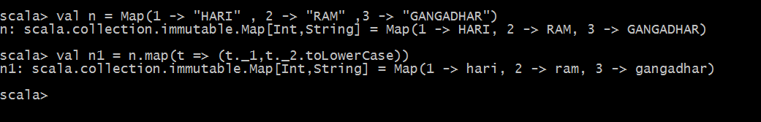

c) Define another function named "formatNames" which also has an input String called "name". This function however has another parameter which accepts functions with an input of type String and also outputs a String. This particular function will be used to apply the given format to the "name" input.

You can use the test inputs for say, "Scala", "Spark", and "BigData", and make sure that the output is as shown below.
SCALA
spark
BIGDATA

Sol:-o/p is

