Arjun Big Data Training: Spark Scala Mobile: +91 9900355621

Collections – List and its higher order methods
1) What does the following code snippets print and explain?

(Note: Please try to answer these yourself first before running them in the Scala shell)
a. val people = List("lebron", "messi", "ke$ha")
println(people.size)

sol:-List method is used for list of people and also size =>what was the exact count of people has defined in the list
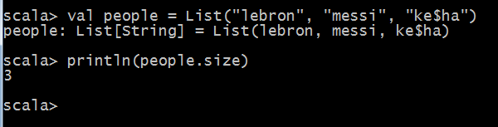

b. val future = List("soon", "i'll", "be", "60 years old")

println(future.tail)

Sol:-it excludes the tail value in the future list

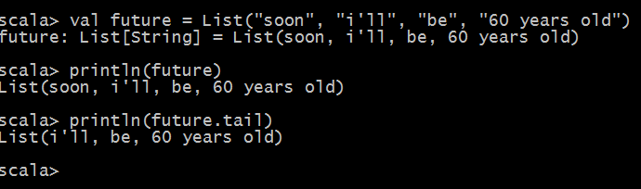

c. val spanish = List("como", "j", "balvin", "va")

println(s"${spanish(1)} ${spanish(2)} bobo")

Sol:- Spanish object ->list method first value as starts from zero and result as expected.
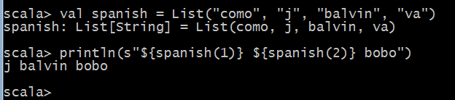

d. val numbers = List(11, 22, 33)

var total = 0
for (i <- numbers) {
total += i
}
println(total)

Sol:-we are defining values in the numbers object =>list ,then applying for loop to count all the numbers.

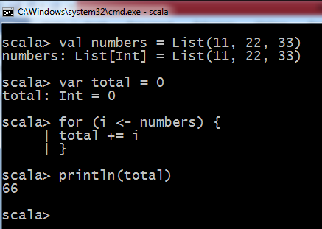

e. val odds = List(3, 5, 7)

var result = 1
odds.foreach( (num: Int) => result *= num )
println(result)

Sol:-odds object has assigned three values and define for loop condition => result = result * num
Ex:-1=1*3,3=3*5,15=15*7

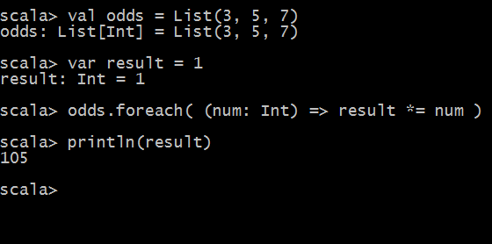

f. val singers = List("shakira", "nicky jam")

var result = singers.map( (s: String) => s"$s is cool" )
println(result)

Sol:-SINGERS OBJECT HAVING TWO STRINGS first and second result printing as expected results below

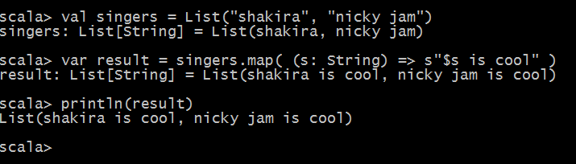

g. val stringNums = List("4", "10", "13")

println {
stringNums.map( (n: String) => n.toInt )
}

Sol:-Object name has defined stringNames and it has three values in list method.

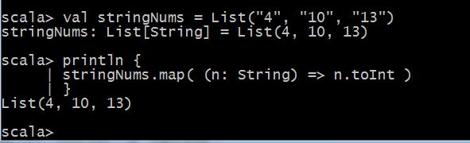
2) Derive a new list by applying cube on every element in the following list,

val eleList = List(23,99,147,555)

sol:-
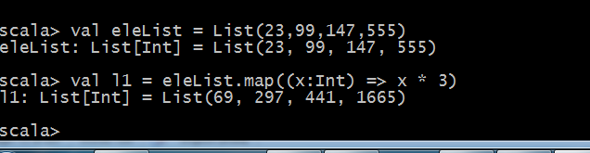

3) Find the longest string in the following list (use only higher order methods on List),

val names = List(“tuco”,”jesse”,”hank”,”gustavo”)
Sol:-
var names = List("tuco", "jesse", "hank", "gustavo")

println {
names.reduceLeft { (s1: String, s2: String) =>
if (s1.length > s2.length) s1 else s2
}
}

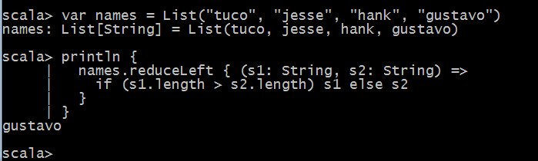

4) Concatenate the strings in the following list using the higher order methods on List,

val countries = List(“India”,”Brazil”,”Argentina”,”Colombia”)

Sol:-

val countries = List(“India”,”Brazil”,”Argentina”,”Colombia”)

println {
countries.reduceLeft[String] { (c1: String, c2: String) =>
s"$c1, $c2"
}
}

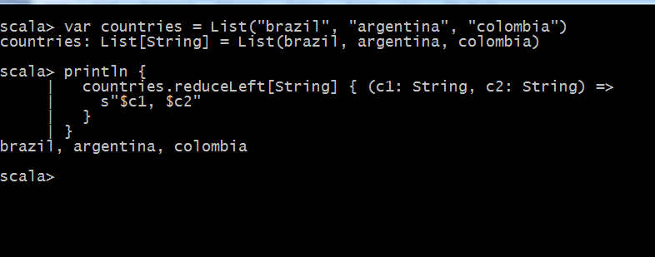

5) Return a list that uppercases all of the letters in the following list,

val me = List(“I”,”am”,”quiet”)
Sol:-

println {
me.map { (word: String) =>
word.toUpperCase
}
}

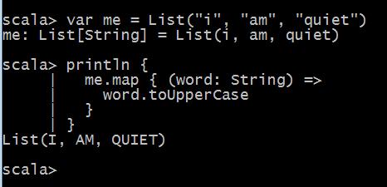

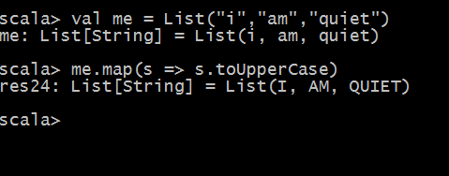

6) Sum all of the even numbers in the following list,

val numList = List.range(1,8)

Sol:-

println {
whatever.foldLeft(0) { (memo: Int, num: Int) =>
if (num % 2 == 0) memo + num else memo
}
}

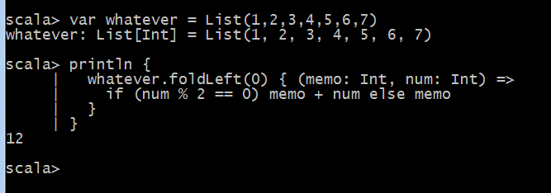

7) Concatenate all the words in the following list that start with the letter “b”. Separate each word with a space.

val rrr = List(“ant”,”beer”,”battered”,”cool”,”burger”)

Sol:-
rrr.filter { (w: String) =>
w.take(1) == "b"
}.reduceLeft { (a: String, b: String) =>
s"$a $b"
}
o/p:-
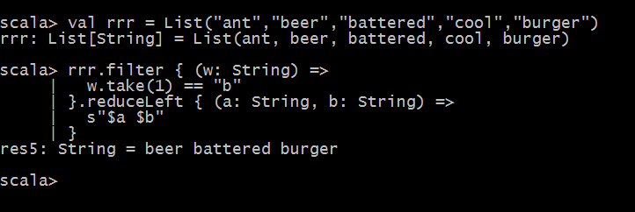

8) Consider a list of strings say List(“scala”,”spark”,”functional”,”immutability”,”wonderful”). Now generate a list of uppercase strings as output for those which contain a character ‘l’ and whose length is greater than 7.

Sol:-
Val s = List(“scala”,”spark”,”functional”,”immutability”,”wonderful”)

s.filter { (w: String) =>
w.take(1) == "b"
}.reduce { (a: String, b: String) =>
s"$a $b"
}

