L&D Training Effectiveness Report - Technical Leadership & Communication
Course Leadership_06_2026
Audience: L&D Manager | Evidence: Blocked | Status: Draft

Executive summary
Evidence gaps block a final effectiveness conclusion.
The selected scope contains 1 course(s), 0 completed course(s), and 8 trainee-course records. Overall attendance is 47.9%, completion is 0%, pass rate is 0%, and average score is N/A/10. Total training hours are 34.5 and scaled cost is 4.8. Final effectiveness conclusion is blocked because required evidence is incomplete or course status is not completed.
Final conclusion is blocked until required evidence is resolved.

Performance scorecard
Metric | Value | Target | Status | Meaning
Attendance | 47.9% | Target >= 85% | Risk | Learner attendance across validated sessions.
Completion | 0% | Target >= 90% | Risk | Completion is based on attendance >= 70%, separate from pass rate.
Pass rate | 0% | Target >= 80% | Risk | Assessment achievement against course pass threshold.
Avg score | N/A/10 | Threshold 6.5 | Tracked | Average assessment score from validated records.
Satisfaction | 4.8/5 | Target >= 4.0 | Good | Combined trainer and content feedback rating.
Training hours | 34.5 | Tracked | Tracked | Total attended training hours.
Cost | 4.8 | Scaled cost | Tracked | Scaled cost signal for relative comparison.
ROI proxy | N/A | Relative KPI | Tracked | Proxy metric using post-training performance delta and scaled cost.

Visual analytics
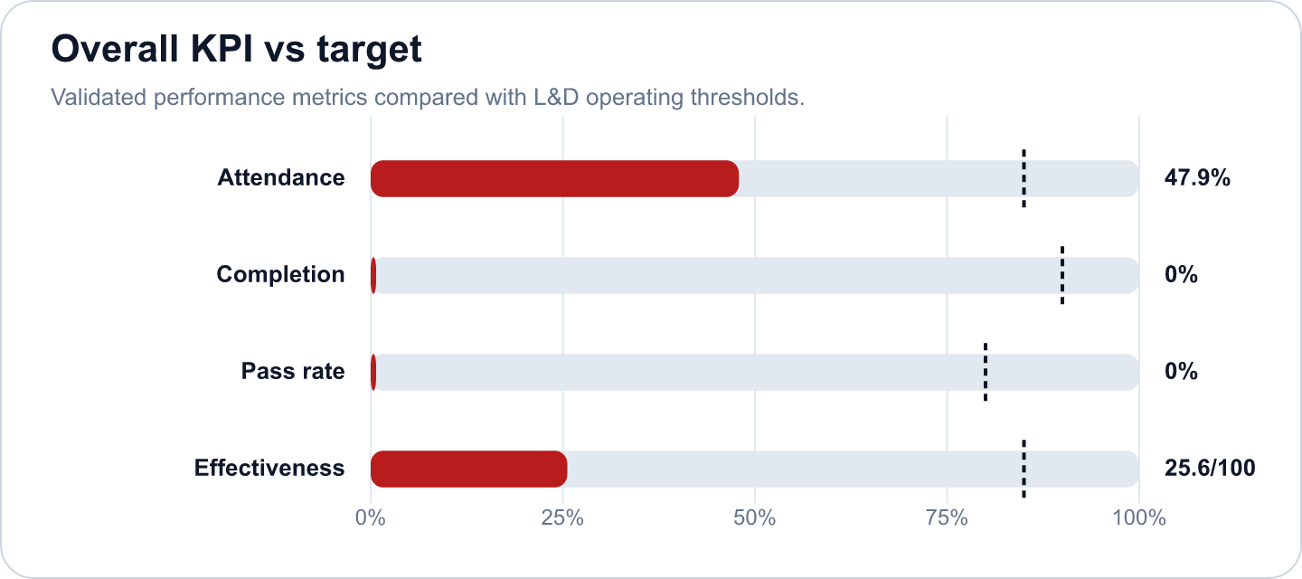
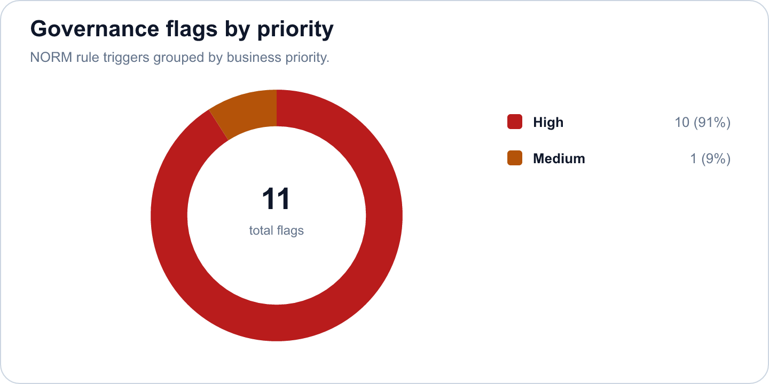

Key findings
- Strong completion outcome at 0% (Risk)
Evidence: Completion is calculated as attendance >= 70%; pass rate is tracked separately at 0%.
Implication: Learners are completing the required session exposure, and assessment achievement is also healthy.
- Overall effectiveness score is 25.58 (Risk)
Evidence: Attendance 47.9%, pass rate 0%, average score N/A/10.
Implication: The selected scope is classified as Not reportable.
- Technical Leadership & Communication has an effectiveness score of 25.58 in the selected scope. (Good)
Evidence: Supported by validated metrics, evidence gate, and L&D NORM checks.
Implication: Use this signal to prioritize follow-up actions and stakeholder communication.
- 1 course group contained learners who need support based on score or attendance policy. (Monitor)
Evidence: Supported by validated metrics, evidence gate, and L&D NORM checks.
Implication: Use this signal to prioritize follow-up actions and stakeholder communication.
- 10 high-priority L&D NORM flags were triggered. (Monitor)
Evidence: Supported by validated metrics, evidence gate, and L&D NORM checks.
Implication: Use this signal to prioritize follow-up actions and stakeholder communication.
- Evidence status is BLOCKED; conclusions must be limited to validated metrics. (Monitor)
Evidence: Supported by validated metrics, evidence gate, and L&D NORM checks.
Implication: Use this signal to prioritize follow-up actions and stakeholder communication.

Recommendations and owners
Priority | Owner | Action | Expected outcome
Medium | Team Manager + L&D | Flag course for content review; notify L&D manager | Improve training effectiveness and repeatability.
High | L&D Manager | Mark as Incomplete; recommend re-enrollment in next cohort | Improve training effectiveness and repeatability.
High | L&D Manager | Block final conclusion; flag data incomplete | Improve training effectiveness and repeatability.
High | L&D Manager | Do not publish a final effectiveness conclusion until blocked evidence items are resolved. | Improve training effectiveness and repeatability.
Low | L&D Manager | Use this output as a preliminary readiness report and assign owners to missing evidence items. | Improve training effectiveness and repeatability.
Low | Team Manager + L&D | Open a course content review with the L&D manager and confirm the improvement owner. | Improve training effectiveness and repeatability.

Course performance
Course | Learners | Attendance | Completion | Pass rate | Score | Effectiveness
Technical Leadership & Communication | 8 | 47.9% | 0% | 0% | N/A/10 | 25.58

Readiness and evidence
Final conclusion: Blocked
Missing evidence: 1; warnings: 1
Check | Status | Detail
Source availability and required columns | Ready | Required sheets and columns were mapped from Teams, OneDrive, Forms, KPI, Rules and Template sources.
Course status | Blocked | 1 selected course(s) are not completed.
Attendance completeness | Warning | Expected attendance rows are trainee count x total sessions. Late is retained for metrics as partial attendance.
Assessment completeness | Ready | Completed courses require one valid assessment and pass-status row per trainee.
Feedback completeness | Ready | NORM-14 requires at least 60% feedback response rate for valid analysis.
Row-level data quality | Ready | Duplicate rows and numeric ranges were checked before metric generation.
Consistency: course ID and pass-status logic | Ready | Cross-source course IDs and pass-status logic were checked against the selected course catalog.

Governance and access
Classification: Not reportable
Sensitive details: Visible; raw appendix: Allowed
Rule | Priority | Message | Action
NORM-01 | High | Pass rate is below 70%. | Flag course for content review; notify L&D manager
NORM-03 | Medium | Attendance rate is below 75%. | Send reminder to absentees; flag to direct manager
NORM-05 | High | Trainee has zero score or missing assessment. | Mark as Incomplete; recommend re-enrollment in next cohort
NORM-05 | High | Trainee has zero score or missing assessment. | Mark as Incomplete; recommend re-enrollment in next cohort
NORM-05 | High | Trainee has zero score or missing assessment. | Mark as Incomplete; recommend re-enrollment in next cohort
NORM-05 | High | Trainee has zero score or missing assessment. | Mark as Incomplete; recommend re-enrollment in next cohort
NORM-05 | High | Trainee has zero score or missing assessment. | Mark as Incomplete; recommend re-enrollment in next cohort
NORM-05 | High | Trainee has zero score or missing assessment. | Mark as Incomplete; recommend re-enrollment in next cohort

Appendix
- Report ID: rpt_1431f506-b94c-4a3a-894b-808dcdcd2f35
- Dataset ID: ds_72a9e696d23d6e55
- Metrics snapshot ID: mx_2fbb0278-a059-4cd9-85d5-e2d215dd4bd3
- Evidence decision ID: ev_486ddbee-59a9-4b72-b89a-706857bca16c
- Governance view ID: gv_7ba8df8b-a01e-4272-b1a3-63dd8818830b
- Role view: L&D Manager
- Sensitive details: visible
Deterministic fallback used. OPENAI_API_KEY is not configured or LD_REPORTING_USE_LLM=false.

