L&D Training Effectiveness Report - ai agent
Course ai agent | Type full
Audience: L&D Manager | Evidence: Passed | Status: Finalized

Executive summary
Training effectiveness is strong with validated evidence.
The selected scope contains 1 course(s), 1 completed course(s), and 13 trainee-course records. Overall attendance is 90.4%, completion is 100%, pass rate is 92.3%, and average score is 7.88/10. Total training hours are 188 and scaled cost is 9.6. Overall effectiveness classification is Risk. Management interpretation: The training program for the AI Agent & LLM Application Development course has achieved a high completion rate of 100% and a solid attendance rate of 90.4%. However, the overall effectiveness classification is marked as Risk due to the presence of at least one trainee who requires additional support, as indicated by the norm flags.
Final conclusion is allowed. Overall classification is Risk.

Performance scorecard
Metric | Value | Target | Status | Meaning
Attendance | 90.4% | Target >= 85% | Good | Learner attendance across validated sessions.
Completion | 100% | Target >= 90% | Excellent | Completion is based on attendance >= 70%, separate from pass rate.
Pass rate | 92.3% | Target >= 80% | Good | Assessment achievement against course pass threshold.
Avg score | 7.88/10 | Threshold 6.5 | Excellent | Average assessment score from validated records.
Satisfaction | 4.73/5 | Target >= 4.0 | Good | Combined trainer and content feedback rating.
Training hours | 188 | Tracked | Tracked | Total attended training hours.
Cost | 9.6 | Scaled cost | Tracked | Scaled cost signal for relative comparison.
ROI proxy | 0.042 | Relative KPI | Monitor | Proxy metric using post-training performance delta and scaled cost.

Visual analytics
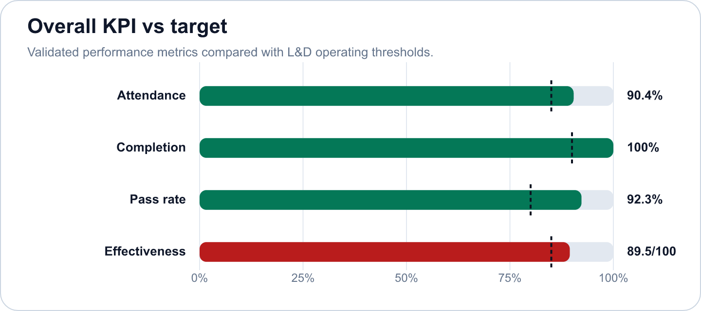
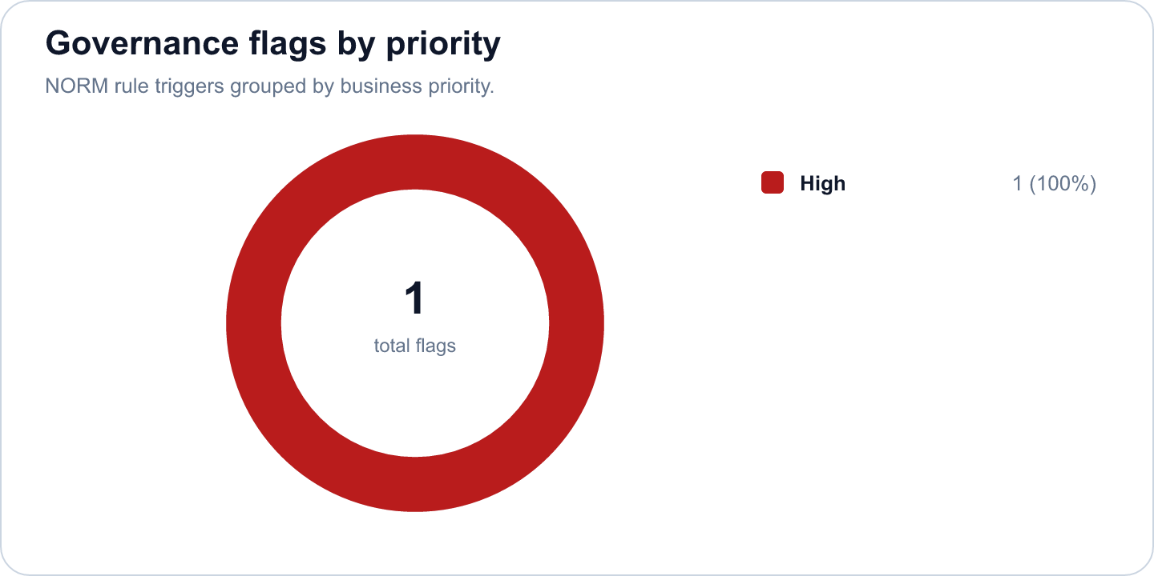

Key findings
- Strong completion outcome at 100% (Excellent)
Evidence: Completion is calculated as attendance >= 70%; pass rate is tracked separately at 92.3%.
Implication: Learners are completing the required session exposure, and assessment achievement is also healthy.
- Overall effectiveness score is 89.47 (Risk)
Evidence: Attendance 90.4%, pass rate 92.3%, average score 7.88/10.
Implication: The selected scope is classified as Risk.
- AI Agent & LLM Application Development has an effectiveness score of 89.47 in the selected scope. (Good)
Evidence: Supported by validated metrics, evidence gate, and L&D NORM checks.
Implication: Use this signal to prioritize follow-up actions and stakeholder communication.
- 2 outstanding trainees met the star learner rule: score >= 9.0 and full attendance. (Good)
Evidence: Supported by validated metrics, evidence gate, and L&D NORM checks.
Implication: Use this signal to prioritize follow-up actions and stakeholder communication.
- 1 high-priority L&D NORM flag was triggered. (Monitor)
Evidence: Supported by validated metrics, evidence gate, and L&D NORM checks.
Implication: Use this signal to prioritize follow-up actions and stakeholder communication.
- The course had a total of 13 trainees, with a pass rate of 92.3% and an average score of 7.88 out of 10. (Good)
Evidence: Supported by validated metrics, evidence gate, and L&D NORM checks.
Implication: Use this signal to prioritize follow-up actions and stakeholder communication.

Recommendations and owners
Priority | Owner | Action | Expected outcome
High | L&D Manager | Flag for coaching; assign buddy or practice resources | Improve learner recovery and reduce support-needed cases.
High | L&D Manager | Assign a coaching owner, buddy support, and targeted practice resources for the flagged learner. | Improve learner recovery and reduce support-needed cases.
Medium | L&D Manager | Additionally, a review of the course content may be beneficial to ensure it meets the diverse needs of all trainees. | Improve training effectiveness and repeatability.

Course performance
Course | Learners | Attendance | Completion | Pass rate | Score | Effectiveness
AI Agent & LLM Application Development | 13 | 90.4% | 100% | 92.3% | 7.88/10 | 89.47

Readiness and evidence
Final conclusion: Allowed
Missing evidence: 0; warnings: 0
Check | Status | Detail
Source availability and required columns | Ready | Required sheets and columns were mapped from Teams, OneDrive, Forms, KPI, Rules and Template sources.
Course status | Ready | All selected courses are completed.
Attendance completeness | Ready | Expected attendance rows are trainee count x total sessions. Late is retained for metrics as partial attendance.
Assessment completeness | Ready | Completed courses require one valid assessment and pass-status row per trainee.
Feedback completeness | Ready | NORM-14 requires at least 60% feedback response rate for valid analysis.
Row-level data quality | Ready | Duplicate rows and numeric ranges were checked before metric generation.
Consistency: course ID and pass-status logic | Ready | Cross-source course IDs and pass-status logic were checked against the selected course catalog.

Governance and access
Classification: Risk
Sensitive details: Visible; raw appendix: Allowed
Rule | Priority | Message | Action
NORM-07 | High | Trainee needs 1:1 support. | Flag for coaching; assign buddy or practice resources

Appendix
- Report ID: rpt_1426465f-ac06-47a8-939b-4b058d242aed
- Dataset ID: ds_571ce047a32c42ae
- Metrics snapshot ID: mx_19cedc15-a7fe-44f9-957a-2865597a4ebe
- Evidence decision ID: ev_49aa71d7-8530-4d5f-8828-92db7dec7f44
- Governance view ID: gv_91ae813b-5f39-4d28-b2b2-22c35da85a1a
- Role view: L&D Manager
- Sensitive details: visible
OpenAI gpt-4o-mini enriched narrative fields. Numeric metrics remain deterministic.

