L&D Training Effectiveness Report - AI Agent & LLM Application Development
Course AI Agent & LLM Application Development
Audience: L&D Manager | Evidence: Passed | Status: Draft

Executive summary
Training effectiveness is strong with validated evidence.
The selected scope contains 1 course(s), 1 completed course(s), and 13 trainee-course records. Overall attendance is 90.4%, completion is 100%, pass rate is 92.3%, and average score is 7.88/10. Total training hours are 188 and scaled cost is 9.6. Overall effectiveness classification is Risk.
Final conclusion is allowed. Overall classification is Risk.

Performance scorecard
Metric | Value | Target | Status | Meaning
Attendance | 90.4% | Target >= 85% | Good | Learner attendance across validated sessions.
Completion | 100% | Target >= 90% | Excellent | Completion is based on attendance >= 70%, separate from pass rate.
Pass rate | 92.3% | Target >= 80% | Good | Assessment achievement against course pass threshold.
Avg score | 7.88/10 | Threshold 6.5 | Excellent | Average assessment score from validated records.
Satisfaction | 4.73/5 | Target >= 4.0 | Good | Combined trainer and content feedback rating.
Training hours | 188 | Tracked | Tracked | Total attended training hours.
Cost | 9.6 | Scaled cost | Tracked | Scaled cost signal for relative comparison.
ROI proxy | 0.042 | Relative KPI | Monitor | Proxy metric using post-training performance delta and scaled cost.

Visual analytics
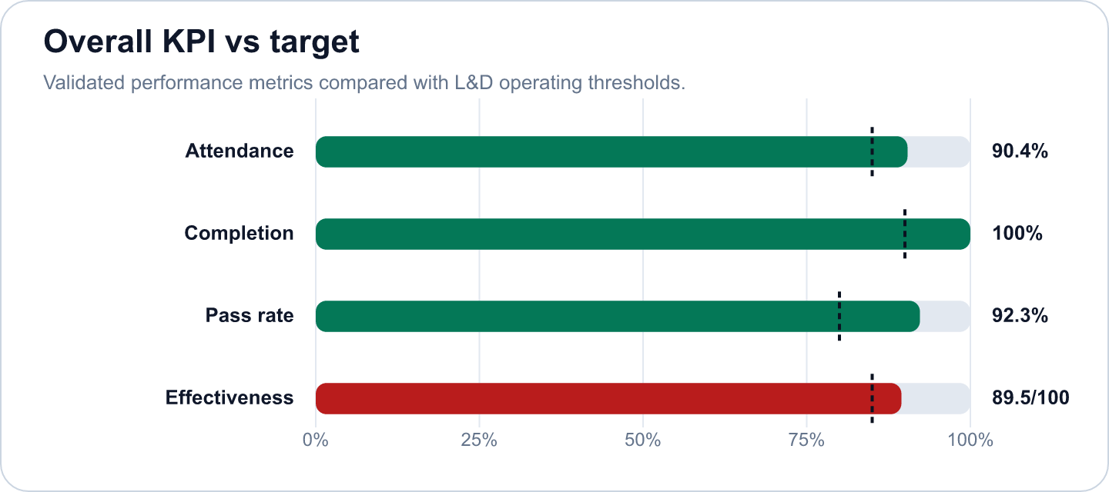
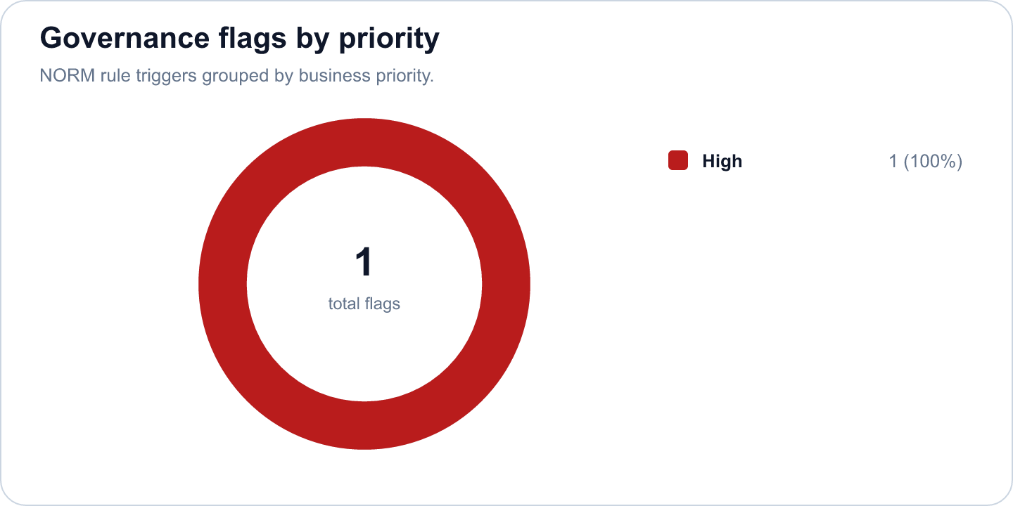

Key findings
- Strong completion outcome at 100% (Excellent)
Evidence: Completion is calculated as attendance >= 70%; pass rate is tracked separately at 92.3%.
Implication: Learners are completing the required session exposure, and assessment achievement is also healthy.
- Overall effectiveness score is 89.47 (Risk)
Evidence: Attendance 90.4%, pass rate 92.3%, average score 7.88/10.
Implication: The selected scope is classified as Risk.
- AI Agent & LLM Application Development has an effectiveness score of 89.47 in the selected scope. (Good)
Evidence: Supported by validated metrics, evidence gate, and L&D NORM checks.
Implication: Use this signal to prioritize follow-up actions and stakeholder communication.
- 2 outstanding trainees met the star learner rule: score >= 9.0 and full attendance. (Good)
Evidence: Supported by validated metrics, evidence gate, and L&D NORM checks.
Implication: Use this signal to prioritize follow-up actions and stakeholder communication.
- 1 course group contained learners who need support based on score or attendance policy. (Monitor)
Evidence: Supported by validated metrics, evidence gate, and L&D NORM checks.
Implication: Use this signal to prioritize follow-up actions and stakeholder communication.
- 1 high-priority L&D NORM flag was triggered. (Monitor)
Evidence: Supported by validated metrics, evidence gate, and L&D NORM checks.
Implication: Use this signal to prioritize follow-up actions and stakeholder communication.

Recommendations and owners
Priority | Owner | Action | Expected outcome
High | L&D Manager | Flag for coaching; assign buddy or practice resources | Maintain AI Agent & LLM Application Development average score at or above the 6.5/10 target (current 7.88/10) in the next cohort.
High | L&D Manager | Assign a coaching owner, buddy support, and targeted practice resources for the flagged learner. | Maintain AI Agent & LLM Application Development average score at or above the 6.5/10 target (current 7.88/10) in the next cohort.
High | Team Manager + L&D | Assign a coaching owner for support-needed learners and review attendance issues with direct managers. | Maintain AI Agent & LLM Application Development attendance at or above the 85% target (current 90.4%) in the next cohort.

Course performance
Course | Learners | Attendance | Completion | Pass rate | Score | Effectiveness
AI Agent & LLM Application Development | 13 | 90.4% | 100% | 92.3% | 7.88/10 | 89.47

Readiness and evidence
Final conclusion: Allowed
Missing evidence: 0; warnings: 0
Check | Status | Detail
Source availability and required columns | Ready | Required sheets and columns were mapped from Teams, OneDrive, Forms, KPI, Rules and Template sources.
Course status | Ready | All selected courses are completed.
Attendance completeness | Ready | Expected attendance rows are trainee count x total sessions. Late is retained for metrics as partial attendance.
Assessment completeness | Ready | Completed courses require one valid assessment and pass-status row per trainee.
Feedback completeness | Ready | NORM-14 requires at least 60% feedback response rate for valid analysis.
Row-level data quality | Ready | Duplicate rows and numeric ranges were checked before metric generation.
Consistency: course ID and pass-status logic | Ready | Cross-source course IDs and pass-status logic were checked against the selected course catalog.

Governance and access
Classification: Risk
Sensitive details: Visible; raw appendix: Allowed
Rule | Priority | Message | Action
NORM-07 | High | Trainee needs 1:1 support. | Flag for coaching; assign buddy or practice resources

Appendix
- Report ID: rpt_833ad6db-719e-4bd8-becc-9e4ed7d87fad
- Dataset ID: ds_8c0b07933ec22cd4
- Metrics snapshot ID: mx_789f5b65-04ac-45d6-95ad-89e0fc72d5a9
- Evidence decision ID: ev_256e7bd2-0af6-4e8b-8b64-a7d04a2ea004
- Governance view ID: gv_ef628e29-3e36-4ae0-a7d5-2d3e0ad50b5c
- Role view: L&D Manager
- Sensitive details: visible
Deterministic fallback used. OPENAI_API_KEY is not configured or LD_REPORTING_USE_LLM=false.

