L&D Training Effectiveness Report - AWS Cloud Architecture & Services
Course CloudAWS_03_2026 | Type full
Audience: L&D Manager | Evidence: Passed | Status: Draft

Executive summary
Training effectiveness is strong with validated evidence.
The selected scope contains 1 course(s), 1 completed course(s), and 12 trainee-course records. Overall attendance is 93.3%, completion is 100%, pass rate is 83.3%, and average score is 7.32/10. Total training hours are 224 and scaled cost is 11. Overall effectiveness classification is Risk. Management interpretation: The training program for the AWS Cloud Architecture & Services course has achieved a high attendance rate of 93.3% and a completion rate of 100%. However, the pass rate of 83.3% indicates that a portion of trainees did not meet the expected performance threshold, classifying the overall effectiveness as Risk. The average score of 7.32/10 and a feedback rating of 4.71/5 suggest that while trainees found value in the course, there are areas for improvement, particularly for those requiring additional support.
Final conclusion is allowed. Overall classification is Risk.

Performance scorecard
Metric | Value | Target | Status | Meaning
Attendance | 93.3% | Target >= 85% | Good | Learner attendance across validated sessions.
Completion | 100% | Target >= 90% | Excellent | Completion is based on attendance >= 70%, separate from pass rate.
Pass rate | 83.3% | Target >= 80% | Good | Assessment achievement against course pass threshold.
Avg score | 7.32/10 | Threshold 6.5 | Good | Average assessment score from validated records.
Satisfaction | 4.71/5 | Target >= 4.0 | Good | Combined trainer and content feedback rating.
Training hours | 224 | Tracked | Tracked | Total attended training hours.
Cost | 11 | Scaled cost | Tracked | Scaled cost signal for relative comparison.
ROI proxy | 0.024 | Relative KPI | Monitor | Proxy metric using post-training performance delta and scaled cost.

Visual analytics
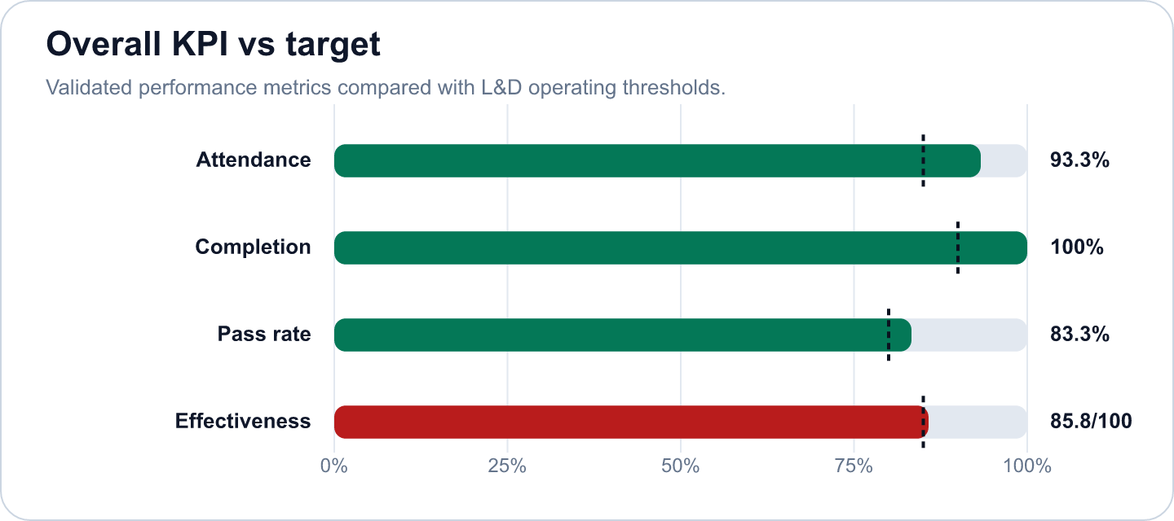
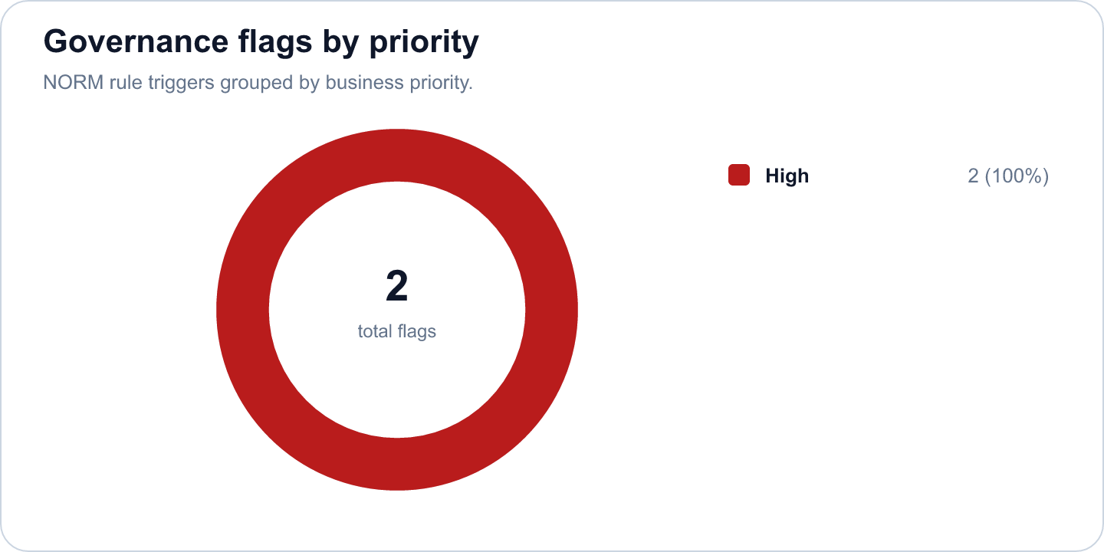

Key findings
- Strong completion outcome at 100% (Excellent)
Evidence: Completion is calculated as attendance >= 70%; pass rate is tracked separately at 83.3%.
Implication: Learners are completing the required session exposure, and assessment achievement is also healthy.
- Overall effectiveness score is 85.76 (Risk)
Evidence: Attendance 93.3%, pass rate 83.3%, average score 7.32/10.
Implication: The selected scope is classified as Risk.
- AWS Cloud Architecture & Services has an effectiveness score of 85.76 in the selected scope. (Good)
Evidence: Supported by validated metrics, evidence gate, and L&D NORM checks.
Implication: Use this signal to prioritize follow-up actions and stakeholder communication.
- 2 outstanding trainees met the star learner rule: score >= 9.0 and full attendance. (Good)
Evidence: Supported by validated metrics, evidence gate, and L&D NORM checks.
Implication: Use this signal to prioritize follow-up actions and stakeholder communication.
- 2 high-priority L&D NORM flags were triggered. (Monitor)
Evidence: Supported by validated metrics, evidence gate, and L&D NORM checks.
Implication: Use this signal to prioritize follow-up actions and stakeholder communication.
- The total training hours amounted to 224, with a scaled cost of 11, resulting in a low ROI proxy of 0.024. (Good)
Evidence: Supported by validated metrics, evidence gate, and L&D NORM checks.
Implication: Use this signal to prioritize follow-up actions and stakeholder communication.

Recommendations and owners
Priority | Owner | Action | Expected outcome
High | L&D Manager | Flag for coaching; assign buddy or practice resources | Improve learner recovery and reduce support-needed cases.
High | L&D Manager | Assign a coaching owner, buddy support, and targeted practice resources for the flagged learner. | Improve learner recovery and reduce support-needed cases.
High | L&D Manager | Additionally, a review of course content and delivery methods should be conducted to address the areas where trainees struggled, ensuring that future cohorts achieve higher pass rates and overall effectiveness. | Improve training effectiveness and repeatability.

Course performance
Course | Learners | Attendance | Completion | Pass rate | Score | Effectiveness
AWS Cloud Architecture & Services | 12 | 93.3% | 100% | 83.3% | 7.32/10 | 85.76

Readiness and evidence
Final conclusion: Allowed
Missing evidence: 0; warnings: 0
Check | Status | Detail
Source availability and required columns | Ready | Required sheets and columns were mapped from Teams, OneDrive, Forms, KPI, Rules and Template sources.
Course status | Ready | All selected courses are completed.
Attendance completeness | Ready | Expected attendance rows are trainee count x total sessions. Late is retained for metrics as partial attendance.
Assessment completeness | Ready | Completed courses require one valid assessment and pass-status row per trainee.
Feedback completeness | Ready | NORM-14 requires at least 60% feedback response rate for valid analysis.
Row-level data quality | Ready | Duplicate rows and numeric ranges were checked before metric generation.
Consistency: course ID and pass-status logic | Ready | Cross-source course IDs and pass-status logic were checked against the selected course catalog.

Governance and access
Classification: Risk
Sensitive details: Visible; raw appendix: Allowed
Rule | Priority | Message | Action
NORM-07 | High | Trainee needs 1:1 support. | Flag for coaching; assign buddy or practice resources
NORM-07 | High | Trainee needs 1:1 support. | Flag for coaching; assign buddy or practice resources

Appendix
- Report ID: rpt_098e16b2-9aa6-4aa9-b1e3-4ba601bf27ea
- Dataset ID: ds_cea4a2b3994d2052
- Metrics snapshot ID: mx_07df58ac-f6ee-4bc0-95c9-b9211933ca97
- Evidence decision ID: ev_4dcb8798-1da9-4fb5-b534-66c48241e53b
- Governance view ID: gv_277cea64-fc12-433e-954c-2c579bd224dd
- Role view: L&D Manager
- Sensitive details: visible
OpenAI gpt-4o-mini enriched narrative fields. Numeric metrics remain deterministic.

