L&D Training Effectiveness Report - AWS Cloud Architecture & Services
Course CloudAWS_03_2026 | Type full
Audience: L&D Manager | Evidence: Passed | Status: Draft

Executive summary
Training effectiveness is strong with validated evidence.
The selected scope contains 1 course(s), 1 completed course(s), and 12 trainee-course records. Overall attendance is 93.3%, completion is 100%, pass rate is 83.3%, and average score is 7.32/10. Total training hours are 224 and scaled cost is 11. Overall effectiveness classification is Risk. Management interpretation: The training course 'AWS Cloud Architecture & Services' has been completed with a high attendance rate of 93.3% and a completion rate of 100%. However, the overall pass rate of 83.3% indicates that a portion of trainees did not meet the expected performance standards, leading to a classification of Risk for overall effectiveness.
Final conclusion is allowed. Overall classification is Risk.

Performance scorecard
Metric | Value | Target | Status | Meaning
Attendance | 93.3% | Target >= 85% | Good | Learner attendance across validated sessions.
Completion | 100% | Target >= 90% | Excellent | Completion is based on attendance >= 70%, separate from pass rate.
Pass rate | 83.3% | Target >= 80% | Good | Assessment achievement against course pass threshold.
Avg score | 7.32/10 | Threshold 6.5 | Good | Average assessment score from validated records.
Satisfaction | 4.71/5 | Target >= 4.0 | Good | Combined trainer and content feedback rating.
Training hours | 224 | Tracked | Tracked | Total attended training hours.
Cost | 11 | Scaled cost | Tracked | Scaled cost signal for relative comparison.
ROI proxy | 0.024 | Relative KPI | Monitor | Proxy metric using post-training performance delta and scaled cost.

Visual analytics
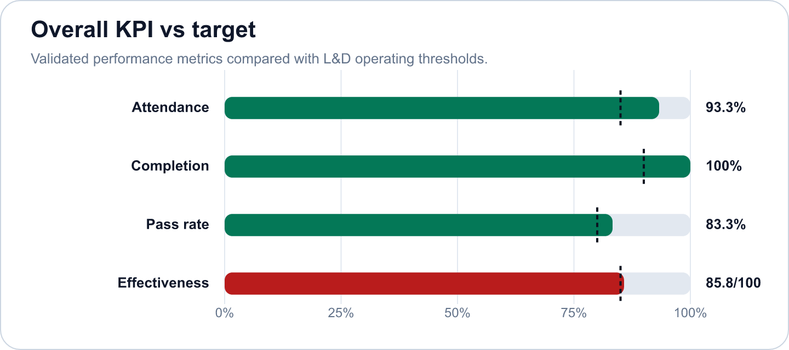
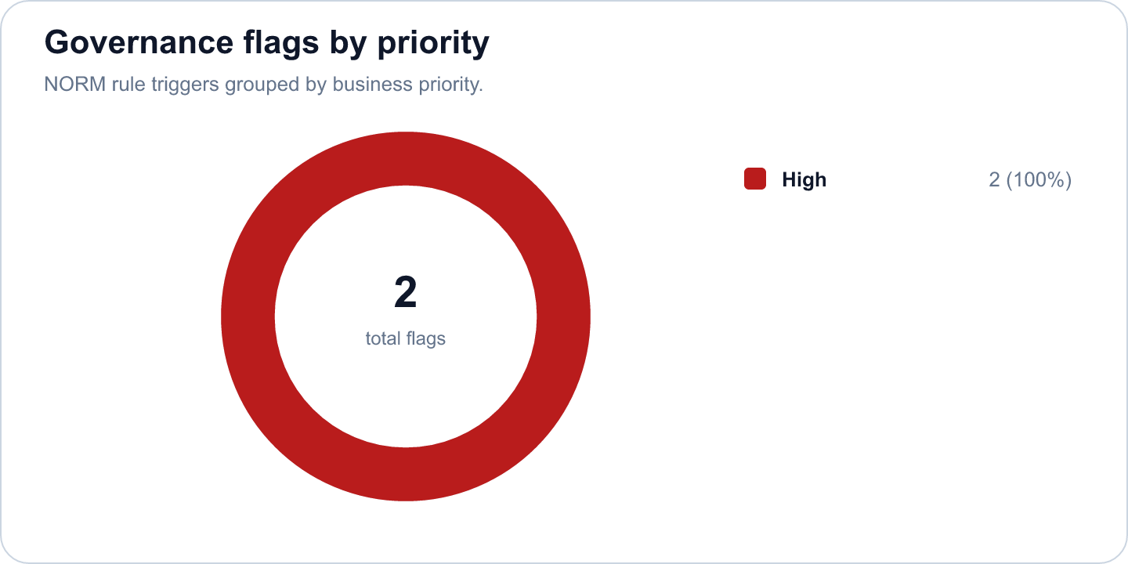

Key findings
- Strong completion outcome at 100% (Excellent)
Evidence: Completion is calculated as attendance >= 70%; pass rate is tracked separately at 83.3%.
Implication: Learners are completing the required session exposure, and assessment achievement is also healthy.
- Overall effectiveness score is 85.76 (Risk)
Evidence: Attendance 93.3%, pass rate 83.3%, average score 7.32/10.
Implication: The selected scope is classified as Risk.
- AWS Cloud Architecture & Services has an effectiveness score of 85.76 in the selected scope. (Good)
Evidence: Supported by validated metrics, evidence gate, and L&D NORM checks.
Implication: Use this signal to prioritize follow-up actions and stakeholder communication.
- 2 outstanding trainees met the star learner rule: score >= 9.0 and full attendance. (Good)
Evidence: Supported by validated metrics, evidence gate, and L&D NORM checks.
Implication: Use this signal to prioritize follow-up actions and stakeholder communication.
- 2 high-priority L&D NORM flags were triggered. (Monitor)
Evidence: Supported by validated metrics, evidence gate, and L&D NORM checks.
Implication: Use this signal to prioritize follow-up actions and stakeholder communication.
- The average score of 7.32 out of 10 and a feedback rating of 4.71 out of 5 suggest that while trainees found v (Good)
Evidence: Supported by validated metrics, evidence gate, and L&D NORM checks.
Implication: Use this signal to prioritize follow-up actions and stakeholder communication.

Recommendations and owners
Priority | Owner | Action | Expected outcome
High | L&D Manager | Flag for coaching; assign buddy or practice resources | Improve learner recovery and reduce support-needed cases.
High | L&D Manager | Assign a coaching owner, buddy support, and targeted practice resources for the flagged learner. | Improve learner recovery and reduce support-needed cases.
Medium | L&D Manager | Additionally, a review of course content may be warranted to address the performance gaps indicated by the pass rate. | Improve training effectiveness and repeatability.

Course performance
Course | Learners | Attendance | Completion | Pass rate | Score | Effectiveness
AWS Cloud Architecture & Services | 12 | 93.3% | 100% | 83.3% | 7.32/10 | 85.76

Readiness and evidence
Final conclusion: Allowed
Missing evidence: 0; warnings: 0
Check | Status | Detail
Source availability and required columns | Ready | Required sheets and columns were mapped from Teams, OneDrive, Forms, KPI, Rules and Template sources.
Course status | Ready | All selected courses are completed.
Attendance completeness | Ready | Expected attendance rows are trainee count x total sessions. Late is retained for metrics as partial attendance.
Assessment completeness | Ready | Completed courses require one valid assessment and pass-status row per trainee.
Feedback completeness | Ready | NORM-14 requires at least 60% feedback response rate for valid analysis.
Row-level data quality | Ready | Duplicate rows and numeric ranges were checked before metric generation.
Consistency: course ID and pass-status logic | Ready | Cross-source course IDs and pass-status logic were checked against the selected course catalog.

Governance and access
Classification: Risk
Sensitive details: Visible; raw appendix: Allowed
Rule | Priority | Message | Action
NORM-07 | High | Trainee needs 1:1 support. | Flag for coaching; assign buddy or practice resources
NORM-07 | High | Trainee needs 1:1 support. | Flag for coaching; assign buddy or practice resources

Appendix
- Report ID: rpt_6b88eb81-539e-4f83-9a4b-b897ae0710c4
- Dataset ID: ds_c2fe0a0ca11171e0
- Metrics snapshot ID: mx_1b0d51ee-8f44-4095-80af-94fcbeb8d910
- Evidence decision ID: ev_bbb63090-f7d7-4435-b135-c7e434747679
- Governance view ID: gv_1521e668-3471-4da6-b67c-19aeba6cf3d8
- Role view: L&D Manager
- Sensitive details: visible
OpenAI gpt-4o-mini enriched narrative fields. Numeric metrics remain deterministic.

