L&D Training Effectiveness Report - DevOps Fundamentals: CI/CD, K8s, Monitoring
Course DevOps_02_2026 | Type full
Audience: L&D Manager | Evidence: Passed | Status: Draft

Executive summary
Training effectiveness is strong with validated evidence.
The selected scope contains 1 course(s), 1 completed course(s), and 10 trainee-course records. Overall attendance is 96%, completion is 100%, pass rate is 100%, and average score is 7.89/10. Total training hours are 216 and scaled cost is 15. Overall effectiveness classification is Effective. Management interpretation: The training course 'DevOps Fundamentals: CI/CD, K8s, Monitoring' has demonstrated high effectiveness with a completion rate of 100%, a pass rate of 100%, and an average score of 7.89 out of 10. The overall attendance rate stands at 96%, indicating strong engagement among participants. The course has also received a favorable feedback rating of 4.6 out of 5, suggesting that trainees found the content valuable.
Final conclusion is allowed. Overall classification is Effective.

Performance scorecard
Metric | Value | Target | Status | Meaning
Attendance | 96% | Target >= 85% | Good | Learner attendance across validated sessions.
Completion | 100% | Target >= 90% | Excellent | Completion is based on attendance >= 70%, separate from pass rate.
Pass rate | 100% | Target >= 80% | Excellent | Assessment achievement against course pass threshold.
Avg score | 7.89/10 | Threshold 6.5 | Excellent | Average assessment score from validated records.
Satisfaction | 4.6/5 | Target >= 4.0 | Good | Combined trainer and content feedback rating.
Training hours | 216 | Tracked | Tracked | Total attended training hours.
Cost | 15 | Scaled cost | Tracked | Scaled cost signal for relative comparison.
ROI proxy | 0.0207 | Relative KPI | Monitor | Proxy metric using post-training performance delta and scaled cost.

Visual analytics
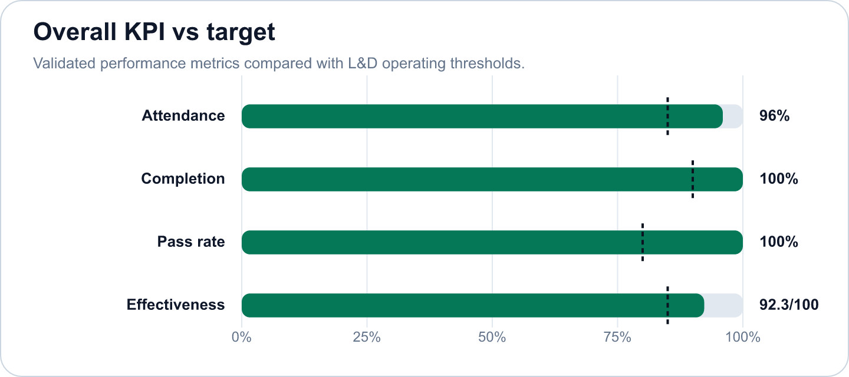

Key findings
- Strong completion outcome at 100% (Excellent)
Evidence: Completion is calculated as attendance >= 70%; pass rate is tracked separately at 100%.
Implication: Learners are completing the required session exposure, and assessment achievement is also healthy.
- Overall effectiveness score is 92.28 (Good)
Evidence: Attendance 96%, pass rate 100%, average score 7.89/10.
Implication: The selected scope is classified as Effective.
- DevOps Fundamentals: CI/CD, K8s, Monitoring has an effectiveness score of 92.28 in the selected scope. (Good)
Evidence: Supported by validated metrics, evidence gate, and L&D NORM checks.
Implication: Use this signal to prioritize follow-up actions and stakeholder communication.
- The course's effectiveness classification is rated as Effective, supported by the metrics of high attendance, (Monitor)
Evidence: Supported by validated metrics, evidence gate, and L&D NORM checks.
Implication: Use this signal to prioritize follow-up actions and stakeholder communication.
- The total training hours amounted to 216, with a scaled cost of 15, resulting in a ROI proxy of 0.0207. (Good)
Evidence: Supported by validated metrics, evidence gate, and L&D NORM checks.
Implication: Use this signal to prioritize follow-up actions and stakeholder communication.
- These metrics indicate that the course was not only well-attended but also successfully met its learning objec (Good)
Evidence: Supported by validated metrics, evidence gate, and L&D NORM checks.
Implication: Use this signal to prioritize follow-up actions and stakeholder communication.

Recommendations and owners
Priority | Owner | Action | Expected outcome
Medium | L&D Manager | Maintain the current delivery model and reuse top-performing materials for future cohorts. | Improve training effectiveness and repeatability.

Course performance
Course | Learners | Attendance | Completion | Pass rate | Score | Effectiveness
DevOps Fundamentals: CI/CD, K8s, Monitoring | 10 | 96% | 100% | 100% | 7.89/10 | 92.28

Readiness and evidence
Final conclusion: Allowed
Missing evidence: 0; warnings: 0
Check | Status | Detail
Source availability and required columns | Ready | Required sheets and columns were mapped from Teams, OneDrive, Forms, KPI, Rules and Template sources.
Course status | Ready | All selected courses are completed.
Attendance completeness | Ready | Expected attendance rows are trainee count x total sessions. Late is retained for metrics as partial attendance.
Assessment completeness | Ready | Completed courses require one valid assessment and pass-status row per trainee.
Feedback completeness | Ready | NORM-14 requires at least 60% feedback response rate for valid analysis.
Row-level data quality | Ready | Duplicate rows and numeric ranges were checked before metric generation.
Consistency: course ID and pass-status logic | Ready | Cross-source course IDs and pass-status logic were checked against the selected course catalog.

Governance and access
Classification: Effective
Sensitive details: Visible; raw appendix: Allowed
Rule | Priority | Message | Action
No NORM flags | N/A | No governance flags triggered. | Continue monitoring.

Appendix
- Report ID: rpt_a0aa5219-a417-4448-b177-0eefa182fdbc
- Dataset ID: ds_ae16fa7c76d5b778
- Metrics snapshot ID: mx_3dad5124-df2e-4d64-a82c-b63e490afd37
- Evidence decision ID: ev_8704f820-8d2e-45c7-a12a-4f53c7ccb1a7
- Governance view ID: gv_b23244c4-6390-4452-b3c9-5bd69a486225
- Role view: L&D Manager
- Sensitive details: visible
OpenAI gpt-4o-mini enriched narrative fields. Numeric metrics remain deterministic.

