L&D Training Effectiveness Report - DevOps Fundamentals: CI/CD, K8s, Monitoring
Course DevOps_02_2026 | Type full
Audience: L&D Manager | Evidence: Passed | Status: Draft

Executive summary
Training effectiveness is strong with validated evidence.
The selected scope contains 1 course(s), 1 completed course(s), and 10 trainee-course records. Overall attendance is 96%, completion is 100%, pass rate is 100%, and average score is 7.89/10. Total training hours are 216 and scaled cost is 15. Overall effectiveness classification is Effective. Management interpretation: The training course 'DevOps Fundamentals: CI/CD, K8s, Monitoring' has demonstrated strong performance metrics, with a completion rate of 100%, a pass rate of 100%, and an average score of 7.89 out of 10. The overall attendance rate stands at 96%, indicating high engagement among trainees. The effectiveness classification is rated as Effective, suggesting that the training met its intended objectives.
Final conclusion is allowed. Overall classification is Effective.

Performance scorecard
Metric | Value | Target | Status | Meaning
Attendance | 96% | Target >= 85% | Good | Learner attendance across validated sessions.
Completion | 100% | Target >= 90% | Excellent | Completion is based on attendance >= 70%, separate from pass rate.
Pass rate | 100% | Target >= 80% | Excellent | Assessment achievement against course pass threshold.
Avg score | 7.89/10 | Threshold 6.5 | Excellent | Average assessment score from validated records.
Satisfaction | 4.6/5 | Target >= 4.0 | Good | Combined trainer and content feedback rating.
Training hours | 216 | Tracked | Tracked | Total attended training hours.
Cost | 15 | Scaled cost | Tracked | Scaled cost signal for relative comparison.
ROI proxy | 0.0207 | Relative KPI | Monitor | Proxy metric using post-training performance delta and scaled cost.

Visual analytics
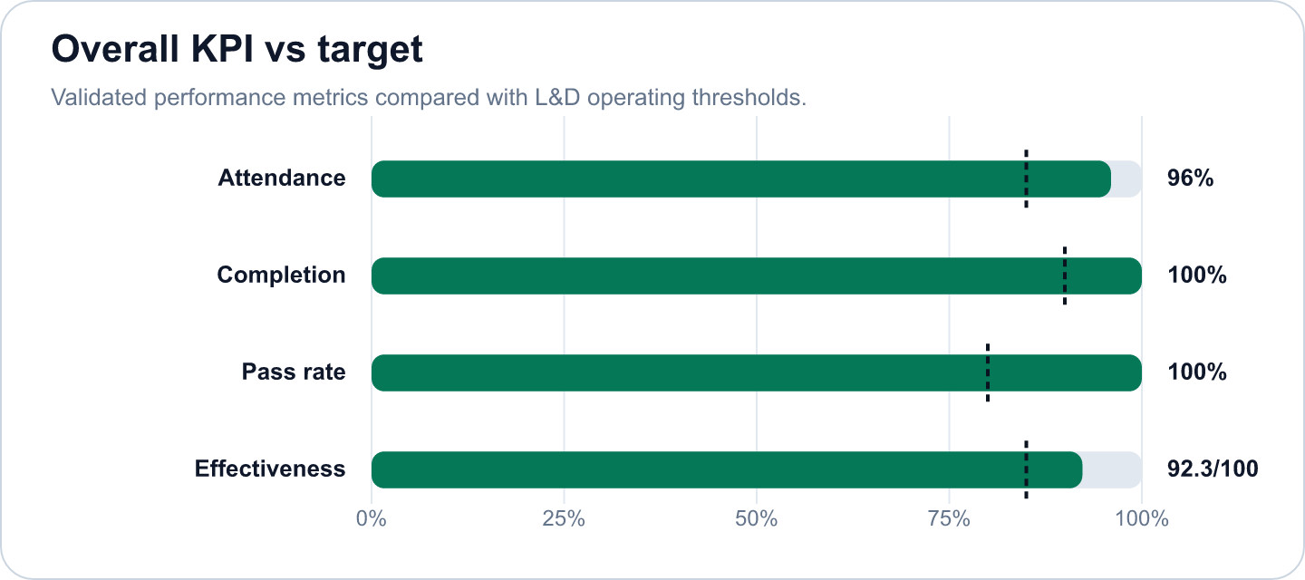

Key findings
- Strong completion outcome at 100% (Excellent)
Evidence: Completion is calculated as attendance >= 70%; pass rate is tracked separately at 100%.
Implication: Learners are completing the required session exposure, and assessment achievement is also healthy.
- Overall effectiveness score is 92.28 (Good)
Evidence: Attendance 96%, pass rate 100%, average score 7.89/10.
Implication: The selected scope is classified as Effective.
- DevOps Fundamentals: CI/CD, K8s, Monitoring has an effectiveness score of 92.28 in the selected scope. (Good)
Evidence: Supported by validated metrics, evidence gate, and L&D NORM checks.
Implication: Use this signal to prioritize follow-up actions and stakeholder communication.
- The course successfully engaged all 10 trainees, achieving full completion and pass rates. (Good)
Evidence: Supported by validated metrics, evidence gate, and L&D NORM checks.
Implication: Use this signal to prioritize follow-up actions and stakeholder communication.
- The average feedback rating of 4.6 out of 5 reflects positive trainee perceptions of the course content and de (Good)
Evidence: Supported by validated metrics, evidence gate, and L&D NORM checks.
Implication: Use this signal to prioritize follow-up actions and stakeholder communication.
- The total training hours amounted to 216, with a scaled cost of 15, resulting in an effectiveness score of 92. (Good)
Evidence: Supported by validated metrics, evidence gate, and L&D NORM checks.
Implication: Use this signal to prioritize follow-up actions and stakeholder communication.

Recommendations and owners
Priority | Owner | Action | Expected outcome
Medium | L&D Manager | Maintain the current delivery model and reuse top-performing materials for future cohorts. | Improve training effectiveness and repeatability.
Medium | L&D Manager | To maintain and enhance the effectiveness of future training initiatives, it is recommended to continue leveraging successful course elements identified in this program. | Improve training effectiveness and repeatability.
High | L&D Manager | Additionally, consider implementing advanced training techniques or supplementary resources to further elevate trainee performance and engagement, particularly for those who may benefit from additional support. | Improve learner recovery and reduce support-needed cases.

Course performance
Course | Learners | Attendance | Completion | Pass rate | Score | Effectiveness
DevOps Fundamentals: CI/CD, K8s, Monitoring | 10 | 96% | 100% | 100% | 7.89/10 | 92.28

Readiness and evidence
Final conclusion: Allowed
Missing evidence: 0; warnings: 0
Check | Status | Detail
Source availability and required columns | Ready | Required sheets and columns were mapped from Teams, OneDrive, Forms, KPI, Rules and Template sources.
Course status | Ready | All selected courses are completed.
Attendance completeness | Ready | Expected attendance rows are trainee count x total sessions. Late is retained for metrics as partial attendance.
Assessment completeness | Ready | Completed courses require one valid assessment and pass-status row per trainee.
Feedback completeness | Ready | NORM-14 requires at least 60% feedback response rate for valid analysis.
Row-level data quality | Ready | Duplicate rows and numeric ranges were checked before metric generation.
Consistency: course ID and pass-status logic | Ready | Cross-source course IDs and pass-status logic were checked against the selected course catalog.

Governance and access
Classification: Effective
Sensitive details: Visible; raw appendix: Allowed
Rule | Priority | Message | Action
No NORM flags | N/A | No governance flags triggered. | Continue monitoring.

Appendix
- Report ID: rpt_b7f84b2b-2429-46a0-b7c2-143fd0fe7170
- Dataset ID: ds_dfde9e57c5cd5ab0
- Metrics snapshot ID: mx_2b986bb4-e0d7-41fe-ba73-0b4d6b4da316
- Evidence decision ID: ev_902e6610-1b30-4c53-8246-c2ac6873dd25
- Governance view ID: gv_eb455253-a9c1-4c5f-86e8-103ac7d80184
- Role view: L&D Manager
- Sensitive details: visible
OpenAI gpt-4o-mini enriched narrative fields. Numeric metrics remain deterministic.

