L&D Training Effectiveness Report - DevOps
Course DevOps | Type full
Audience: L&D Manager | Evidence: Passed | Status: Draft

Executive summary
Training effectiveness is strong with validated evidence.
The selected scope contains 1 course(s), 1 completed course(s), and 10 trainee-course records. Overall attendance is 96%, completion is 100%, pass rate is 100%, and average score is 7.89/10. Total training hours are 216 and scaled cost is 15. Overall effectiveness classification is Effective. Management interpretation: The training program for the DevOps course has demonstrated high effectiveness, with all trainees successfully completing the course and achieving a perfect pass rate. The overall attendance rate is commendable at 96%, indicating strong engagement. The average score of 7.89 out of 10 reflects solid understanding of the material, while the feedback rating of 4.6 out of 5 suggests high satisfaction among participants.
Final conclusion is allowed. Overall classification is Effective.

Performance scorecard
Metric | Value | Target | Status | Meaning
Attendance | 96% | Target >= 85% | Good | Learner attendance across validated sessions.
Completion | 100% | Target >= 90% | Excellent | Completion is based on attendance >= 70%, separate from pass rate.
Pass rate | 100% | Target >= 80% | Excellent | Assessment achievement against course pass threshold.
Avg score | 7.89/10 | Threshold 6.5 | Excellent | Average assessment score from validated records.
Satisfaction | 4.6/5 | Target >= 4.0 | Good | Combined trainer and content feedback rating.
Training hours | 216 | Tracked | Tracked | Total attended training hours.
Cost | 15 | Scaled cost | Tracked | Scaled cost signal for relative comparison.
ROI proxy | 0.0207 | Relative KPI | Monitor | Proxy metric using post-training performance delta and scaled cost.

Visual analytics
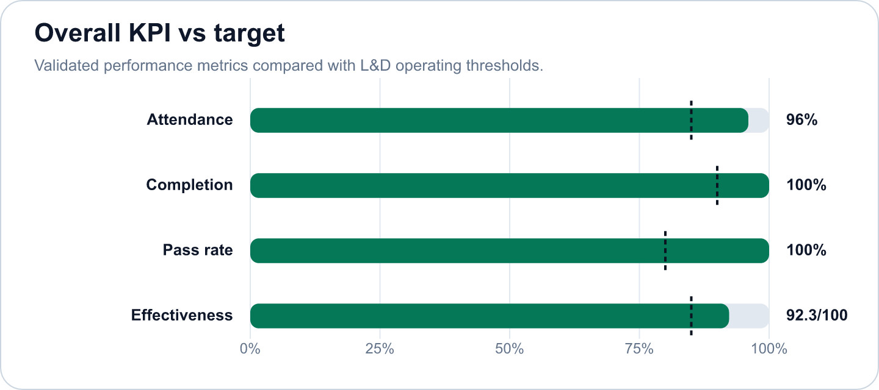

Key findings
- Strong completion outcome at 100% (Excellent)
Evidence: Completion is calculated as attendance >= 70%; pass rate is tracked separately at 100%.
Implication: Learners are completing the required session exposure, and assessment achievement is also healthy.
- Overall effectiveness score is 92.28 (Good)
Evidence: Attendance 96%, pass rate 100%, average score 7.89/10.
Implication: The selected scope is classified as Effective.
- DevOps Fundamentals: CI/CD, K8s, Monitoring has an effectiveness score of 92.28 in the selected scope. (Good)
Evidence: Supported by validated metrics, evidence gate, and L&D NORM checks.
Implication: Use this signal to prioritize follow-up actions and stakeholder communication.
- The course has successfully met all key performance indicators, including a 100% completion rate and a 100% pa (Good)
Evidence: Supported by validated metrics, evidence gate, and L&D NORM checks.
Implication: Use this signal to prioritize follow-up actions and stakeholder communication.
- The total training hours of 216 and a scaled cost of 15 indicate efficient resource utilization. (Good)
Evidence: Supported by validated metrics, evidence gate, and L&D NORM checks.
Implication: Use this signal to prioritize follow-up actions and stakeholder communication.
- The effectiveness score of 92.28 further underscores the program's success in delivering valuable training. (Good)
Evidence: Supported by validated metrics, evidence gate, and L&D NORM checks.
Implication: Use this signal to prioritize follow-up actions and stakeholder communication.

Recommendations and owners
Priority | Owner | Action | Expected outcome
Medium | L&D Manager | Maintain the current delivery model and reuse top-performing materials for future cohorts. | Improve training effectiveness and repeatability.
Medium | L&D Manager | To maintain and enhance the effectiveness of the training program, it is recommended to continue monitoring trainee feedback and performance metrics. | Improve training effectiveness and repeatability.
Medium | L&D Manager | Consider implementing advanced training techniques or supplementary resources to further elevate the average score and ensure sustained engagement. | Improve training effectiveness and repeatability.
High | L&D Manager | Additionally, exploring opportunities for mentorship roles for high-performing trainees may foster a culture of continuous learning. | Improve training effectiveness and repeatability.

Course performance
Course | Learners | Attendance | Completion | Pass rate | Score | Effectiveness
DevOps Fundamentals: CI/CD, K8s, Monitoring | 10 | 96% | 100% | 100% | 7.89/10 | 92.28

Readiness and evidence
Final conclusion: Allowed
Missing evidence: 0; warnings: 0
Check | Status | Detail
Source availability and required columns | Ready | Required sheets and columns were mapped from Teams, OneDrive, Forms, KPI, Rules and Template sources.
Course status | Ready | All selected courses are completed.
Attendance completeness | Ready | Expected attendance rows are trainee count x total sessions. Late is retained for metrics as partial attendance.
Assessment completeness | Ready | Completed courses require one valid assessment and pass-status row per trainee.
Feedback completeness | Ready | NORM-14 requires at least 60% feedback response rate for valid analysis.
Row-level data quality | Ready | Duplicate rows and numeric ranges were checked before metric generation.
Consistency: course ID and pass-status logic | Ready | Cross-source course IDs and pass-status logic were checked against the selected course catalog.

Governance and access
Classification: Effective
Sensitive details: Visible; raw appendix: Allowed
Rule | Priority | Message | Action
No NORM flags | N/A | No governance flags triggered. | Continue monitoring.

Appendix
- Report ID: rpt_bde40149-4d39-4b1b-8653-cb46f723265e
- Dataset ID: ds_9c553631964df03b
- Metrics snapshot ID: mx_4148e173-eb2d-4ae5-9a94-21c1aff69676
- Evidence decision ID: ev_0bbf9c18-bf8e-4f22-8634-0987b5bdd5c5
- Governance view ID: gv_949ca669-1c21-41ad-b036-2fce2c687820
- Role view: L&D Manager
- Sensitive details: visible
OpenAI gpt-4o-mini enriched narrative fields. Numeric metrics remain deterministic.

