



DEPARTMENT OF
CYBER SECURITY
Air University, Islamabad

COMPUTER ORGANIZATION AND ASEEMBLY LANGUAGE
PROJECT DOCUMENTATION
PROCESSOR DESIGN FOR EMBEDDED CALCULATOR

Group Members:
- Hussain Ali – 232095
- Sardar Ahmad Ali – 232147

Abstract
This project focuses on designing a processor architecture to perform fundamental arithmetic and logical operations for a basic calculator. The processor’s architecture includes the Control Unit (CU), Arithmetic Logic Unit (ALU), Registers, and Memory Interface. It is capable of performing operations like addition, subtraction, multiplication, division, and basic logical operations (AND, OR). The final implementation includes assembly language code and simulation results, showcasing the system’s ability to handle calculations efficiently. This report documents the entire process from design to final implementation.

1. Introduction

Problem Statement
Embedded systems are designed to perform specific tasks efficiently. This project involves creating a processor for a calculator, capable of executing basic arithmetic and logical operations while maintaining simplicity, cost-effectiveness, and power efficiency. The processor is composed of the following core components:
- Control Unit (CU): Coordinates and controls the execution of instructions.
- Arithmetic Logic Unit (ALU): Performs arithmetic operations (add, subtract, multiply, divide) and logical operations (AND, OR).
- Registers: Temporary storage locations for holding operands and results.
- Memory Unit: Includes RAM for program/data storage and ROM for fixed logic storage.
- Input/Output (I/O) Units: Facilitate communication with external devices such as keypads and displays.
The processor follows a structured architecture with well-defined instruction sets to execute simple operations. Block diagrams and data path diagrams are provided to illustrate the design, data flow, and interactions between components.

Objective
- Develop a processor architecture for a basic calculator.
- Implement the processor using assembly language.
- Simulate and test the design to verify functionality.

2. Design Phase

2.1 Block Diagram
The block diagram represents the overall structure of the processor, including key components and their interconnections.
Components:
- CPU (Central Processing Unit): Contains ALU, Control Unit, and Registers.
- Input/Output Devices: Facilitate user interaction.
- Memory Unit: Composed of RAM and ROM for storing data and instructions.
Description:
- The ALU performs arithmetic and logical operations.
- The Control Unit generates control signals to orchestrate component interactions.
- Registers store temporary data, results, and instructions.
- Memory stores instructions (program) and temporary or permanent data.
- I/O Units provide data input and display outputs.
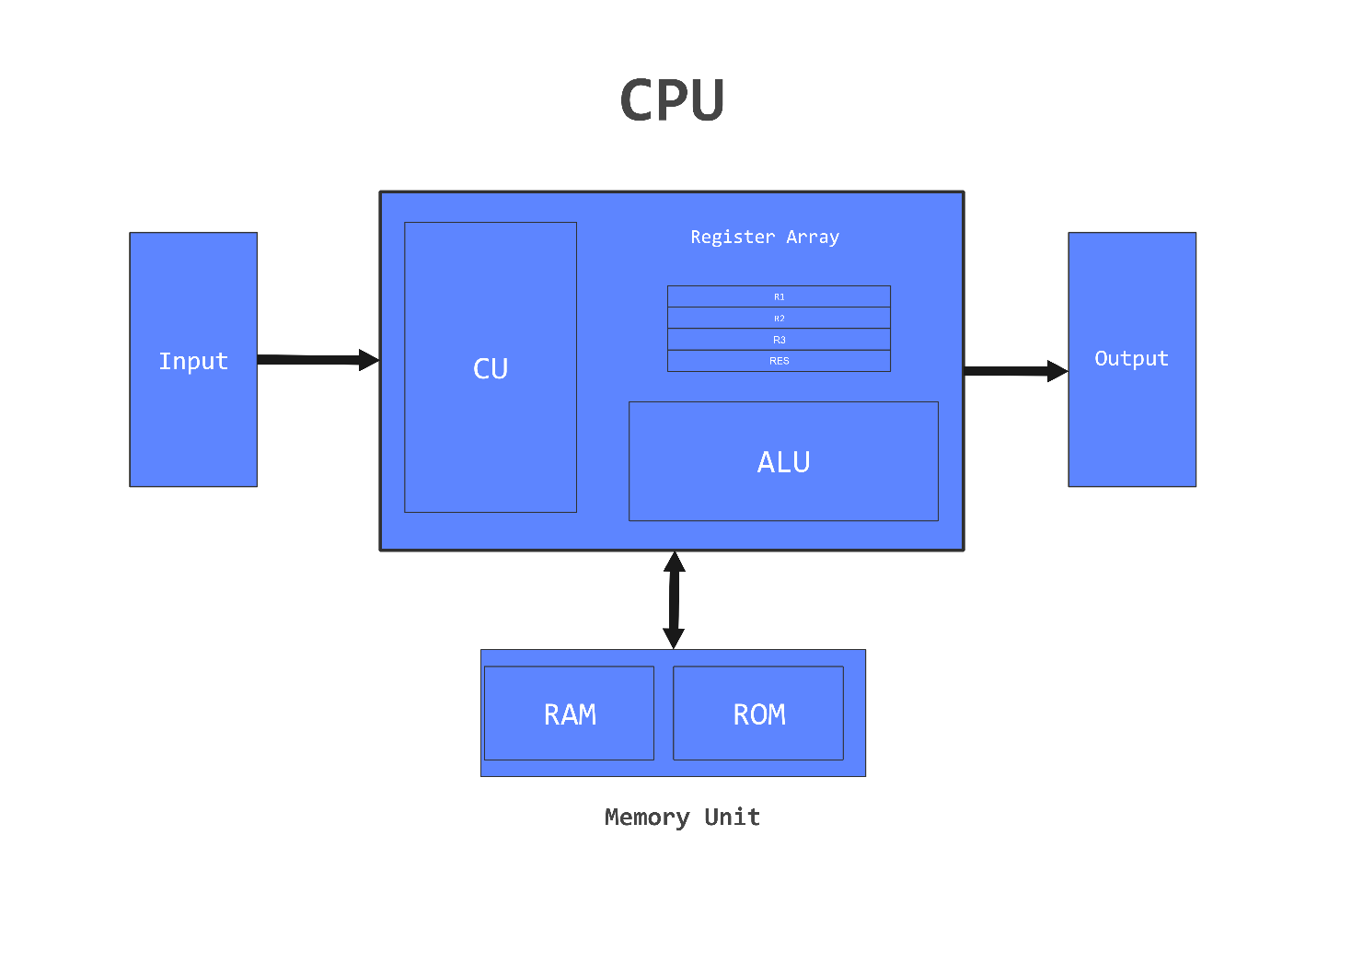

2.2 Bus Architecture
The bus architecture enables communication between the CPU and its components. The following diagram depicts the connection of each component to the respective buses:
Buses and Connectivity:
- Data Bus (Bidirectional): Transfers data between CPU components, memory, and I/O.
- Address Bus (Unidirectional): Carries memory addresses from the CPU to memory or I/O devices.
- Control Bus (Unidirectional): Sends control signals to manage read/write operations and data flow.
Connections:
- Registers to ALU: Connected via the Data Bus for transferring operands and results.
- ALU to Memory Unit: Connected through the Data Bus for reading and writing data.
- CU to All Components: Sends control signals via the Control Bus to orchestrate execution.
- Memory Unit: Connected to the Address Bus for locating data/instructions.
- Input/Output to CPU: Transfers user input and displays output via the Data Bus.
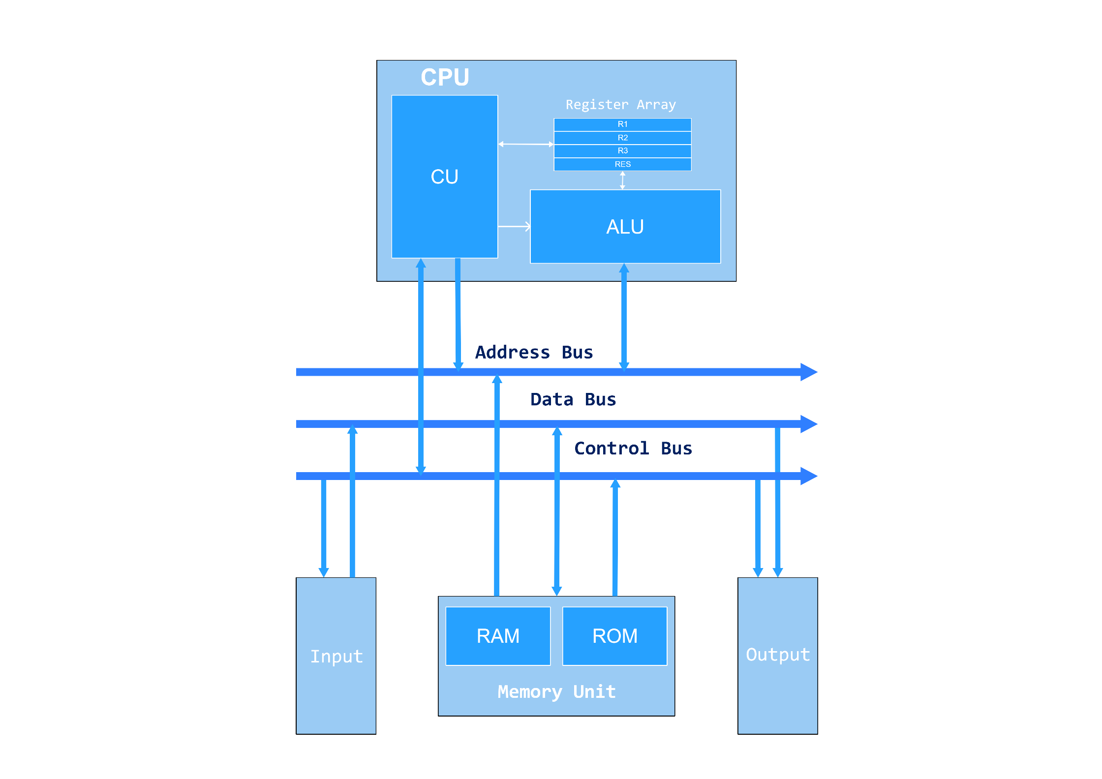

2.3 Data Path Diagram
The data path diagram shows how data flows between components within the processor and highlights the use of buses for communication. It includes:
- Data Buses: Carry data between registers, ALU, memory, and I/O devices.
- Control Signals: Generated by the Control Unit to coordinate operations.
- Address Buses: Used to specify memory locations.
Details of Data Flow:
- Input to Registers: Input data (e.g., from a keypad) is loaded into general-purpose registers via the data bus.
- Registers to ALU: The ALU fetches operands from registers to perform operations (e.g., addition, subtraction).
- ALU to Registers: The ALU sends the result back to the registers.
- Registers to Memory: Data can be stored into the memory (RAM).
- Memory to CPU: The CPU fetches instructions and data from memory using the address and data buses.
- CPU to Output: Final results are sent to the output devices (e.g., display unit).
Bus Types and Directionality:
- Data Bus: Bidirectional (registers ↔ ALU ↔ memory ↔ I/O).
- Control Bus: Unidirectional (Control Unit → other components).
- Address Bus: Unidirectional (CPU → memory).
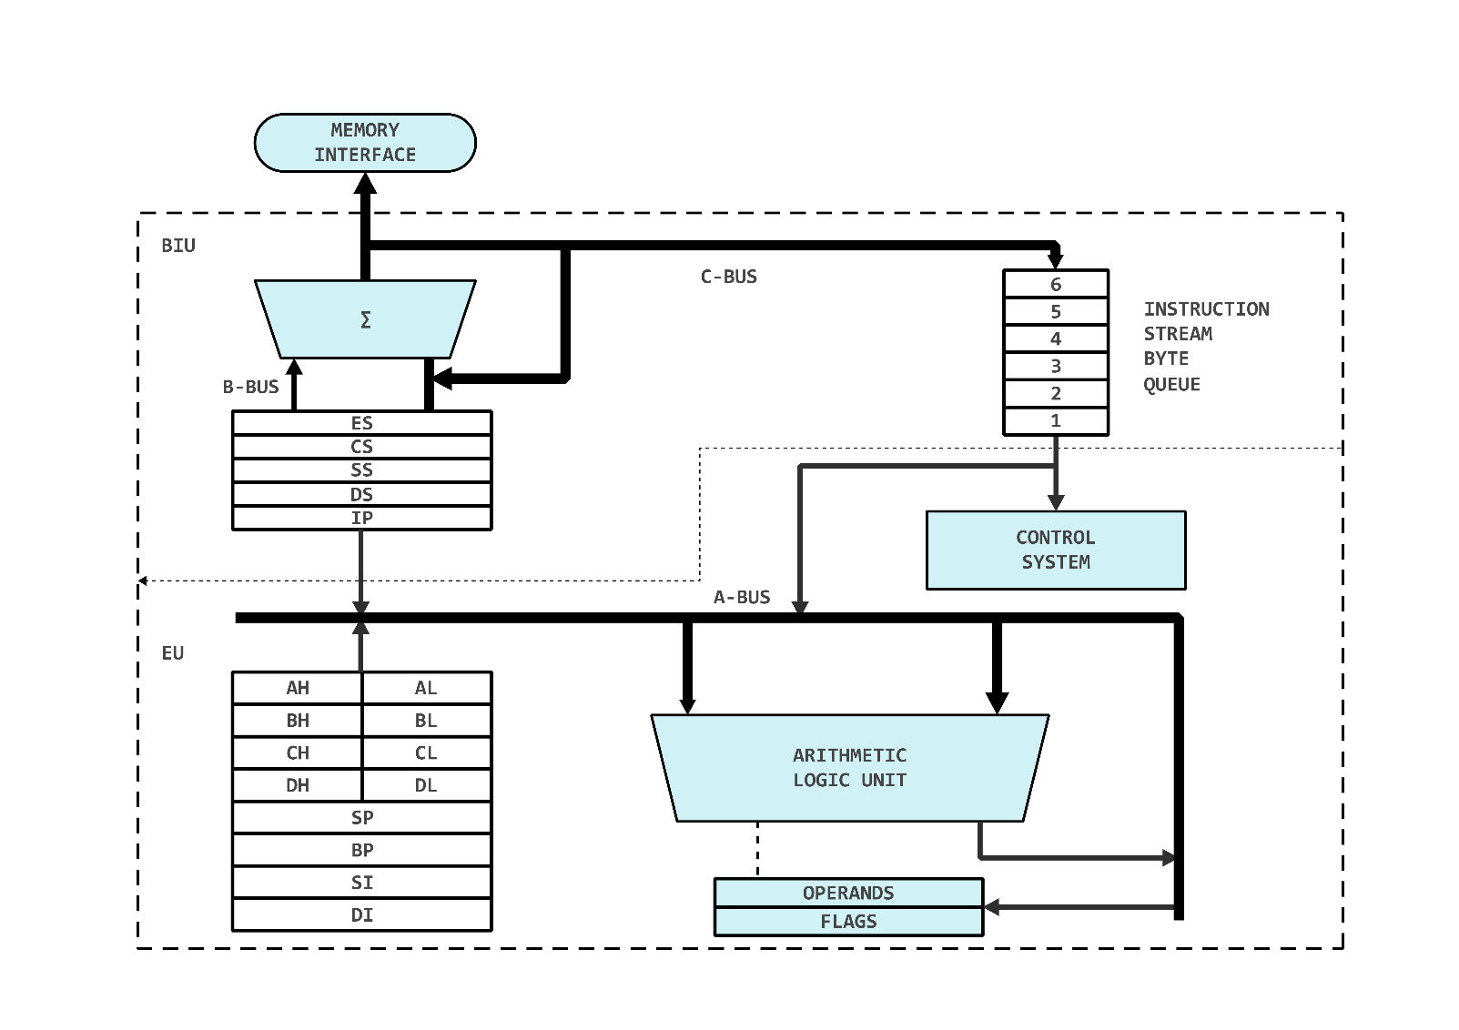

2.4 Instruction Set
The processor supports a set of instructions to perform basic arithmetic, logical, and control operations.
Opcode | Instruction | Description
LOAD | Load | Load data from memory to register.
STORE | Store | Store data from register to memory.
ADD | Add | Perform addition of two registers.
SUB | Subtract | Perform subtraction of two registers.
MUL | Multiply | Perform multiplication of two registers.
DIV | Divide | Perform division of two registers.
AND | AND-Gate | Perform logical AND operation.
OR | OR-Gate | Perform logical OR operation.
EXIT | Exit | Stop program execution.

Example Instruction Execution:
- ADD R1, R2, R3 → Adds values from registers R1 and R2 and stores the result in register R3.
- STORE R1, MEM[100] → Stores the value of register R1 into memory location 100.

3. Implementation Phase

3.1 Assembly Code
A comprehensive assembly language program was written to implement the processor’s functionalities. The code is structured as follows:

Program Structure
- Input numbers and operation code.
- Perform the operation based on the opcode.
- Output the result.
- Handle invalid operations.

Code Snippet
; Calculator Assembly Code
; Instructions: LOAD, STORE, ADD, SUB, MUL, DIV, AND, OR, EXIT

; Data segment
.data
NUM1 DW 0 ; First number
NUM2 DW 0 ; Second number
RESULT DW 0 ; Result storage
OPCODE DB 0 ; Operation code
DIV_ZERO_MSG DB "Error: Division by zero", 0
INVALID_MSG DB "Error: Invalid operation", 0
PROMPT_MSG DB "Enter numbers and operation code", 0

; Code segment
.code
START:
; Display prompt
MOV DX, OFFSET PROMPT_MSG
CALL PrintString

; Load first number into R1
CALL ReadInt ; Read input
MOV NUM1, AX ; Store in NUM1
LOAD R1, NUM1

; Load second number into R2
CALL ReadInt ; Read input
MOV NUM2, AX ; Store in NUM2
LOAD R2, NUM2

; Load operation code into R3
CALL ReadInt ; Read input for opcode
MOV OPCODE, AL ; Store in OPCODE
LOAD R3, OPCODE

; Check operation code and perform the operation
CMP R3, 1 ; Check if ADD operation
JE ADD_OPERATION
CMP R3, 2 ; Check if SUB operation
JE SUB_OPERATION
CMP R3, 3 ; Check if MUL operation
JE MUL_OPERATION
CMP R3, 4 ; Check if DIV operation
JE DIV_OPERATION
CMP R3, 5 ; Check if AND operation
JE AND_OPERATION
CMP R3, 6 ; Check if OR operation
JE OR_OPERATION
CMP R3, 99 ; Check if EXIT operation
JE EXIT_PROGRAM

; Default case: Invalid operation
JMP INVALID_OPERATION

ADD_OPERATION:
ADD R4, R1, R2 ; Perform addition
STORE R4, RESULT ; Store the result
JMP DISPLAY_RESULT

SUB_OPERATION:
SUB R4, R1, R2 ; Perform subtraction
STORE R4, RESULT ; Store the result
JMP DISPLAY_RESULT

MUL_OPERATION:
MUL R4, R1, R2 ; Perform multiplication
STORE R4, RESULT ; Store the result
JMP DISPLAY_RESULT

DIV_OPERATION:
CMP R2, 0 ; Check for division by zero
JE DIVISION_BY_ZERO
DIV R4, R1, R2 ; Perform division
STORE R4, RESULT ; Store the result
JMP DISPLAY_RESULT

DIVISION_BY_ZERO:
MOV DX, OFFSET DIV_ZERO_MSG
CALL PrintString
JMP END

AND_OPERATION:
AND R4, R1, R2 ; Perform logical AND
STORE R4, RESULT ; Store the result
JMP DISPLAY_RESULT

OR_OPERATION:
OR R4, R1, R2 ; Perform logical OR
STORE R4, RESULT ; Store the result
JMP DISPLAY_RESULT

EXIT_PROGRAM:
EXIT ; End the program

INVALID_OPERATION:
MOV DX, OFFSET INVALID_MSG
CALL PrintString ; Display error message
JMP END

DISPLAY_RESULT:
; Display result
MOV DX, OFFSET "Result: "
CALL PrintString
MOV AX, RESULT
CALL PrintInt ; Print the result
JMP END

END:
; Program end marker
HALT

; Auxiliary procedures
PrintString PROC
; Prints the string at DS:DX
; Implementation depends on system; use INT 21h for DOS or syscall
RET
PrintInt PROC
; Prints the integer in AX
; Implementation depends on system
RET
ReadInt PROC
; Reads an integer into AX
; Implementation depends on system
RET

3.2 Testing
The program was tested for all supported operations, including edge cases like division by zero and invalid opcodes. Simulations validated the processor’s ability to execute instructions correctly and efficiently.

4. Results and Analysis

4.1 Functionality Testing
- Arithmetic operations (ADD, SUB, MUL, DIV) produced accurate results for all test cases.
- Logical operations (AND, OR) were verified with various input combinations.
- The program correctly identified and handled invalid operations.

4.2 Simulation
The design was simulated using MASM in Visual Studio, ensuring compatibility and performance. The results confirmed the correctness of the processor’s operation.
test.asm:
;**************************************************************************
; Program Name: Embedded Calculator Processor Simulation
; Author: Hussain Ali
; Description:
; This program simulates a basic embedded processor capable of performing
; arithmetic (ADD, SUB, MUL, DIV) and logical (AND, OR) operations. The user
; inputs two numbers and selects an operation using an opcode. The program
; calculates and displays the result. It handles division by zero and invalid
; opcodes gracefully.
;**************************************************************************
.386 ; Specifies the target processor (80386 or later).
.model flat, stdcall ; Defines flat memory model and standard calling convention.
.stack 4096 ; Reserves 4 KB of stack space.
include Irvine32.inc ; Includes Irvine32 library for basic I/O functions.
.data
welcomeMsg db "Embedded Calculator Processor Simulation", 0
; Welcome message displayed at the start of the program.
menu db "Supported Operations: ADD(1), SUB(2), MUL(3), DIV(4), AND(5), OR(6), EXIT(99)", 0
; Menu displaying available operations and corresponding opcodes.
firstNumPrompt db "Enter the first number: ", 0
; Prompt to enter the first number.
secondNumPrompt db "Enter the second number: ", 0
; Prompt to enter the second number.
opcodePrompt db "Enter the operation code (1-ADD, 2-SUB, 3-MUL, 4-DIV, 5-AND, 6-OR, 99-EXIT): ", 0
; Prompt to enter the operation code.
resultMsg db "Result: ", 0
; Message prefix for displaying the result.
divZeroError db "Error: Division by zero.", 0
; Error message for division by zero.
invalidOpcode db "Error: Invalid opcode.", 0
; Error message for invalid operation codes.
exitMsg db "Processor simulation terminated. Goodbye!", 0
; Exit message displayed when the program ends.
num1 dd 0 ; Variable to store the first number (32-bit integer).
num2 dd 0 ; Variable to store the second number (32-bit integer).
opcode db 0 ; Variable to store the operation code (8-bit integer).
result dd 0 ; Variable to store the result of the operation (32-bit integer).
.code
main PROC
start:
; Display Welcome Message
mov edx, OFFSET welcomeMsg ; Load the address of the welcome message into EDX.
call WriteString ; Print the welcome message.
call Crlf ; Print a newline.
processorLoop:
; Display Menu
mov edx, OFFSET menu ; Load the address of the menu into EDX.
call WriteString ; Print the menu.
call Crlf ; Print a newline.
; Read First Number
mov edx, OFFSET firstNumPrompt ; Load the address of the first number prompt.
call WriteString ; Print the first number prompt.
call ReadInt ; Read the first number from the user.
mov num1, eax ; Store the input in num1.
; Read Second Number
mov edx, OFFSET secondNumPrompt ; Load the address of the second number prompt.
call WriteString ; Print the second number prompt.
call ReadInt ; Read the second number from the user.
mov num2, eax ; Store the input in num2.
; Read Opcode
mov edx, OFFSET opcodePrompt ; Load the address of the opcode prompt.
call WriteString ; Print the opcode prompt.
call ReadInt ; Read the opcode from the user.
mov opcode, al ; Store the input in opcode.
; Process Operation
cmp opcode, 1 ; Compare opcode with 1 (ADD).
JE ADD_OPERATION ; If equal, jump to ADD_OPERATION.
cmp opcode, 2 ; Compare opcode with 2 (SUB).
JE SUB_OPERATION ; If equal, jump to SUB_OPERATION.
cmp opcode, 3 ; Compare opcode with 3 (MUL).
JE MUL_OPERATION ; If equal, jump to MUL_OPERATION.
cmp opcode, 4 ; Compare opcode with 4 (DIV).
JE DIV_OPERATION ; If equal, jump to DIV_OPERATION.
cmp opcode, 5 ; Compare opcode with 5 (AND).
JE AND_OPERATION ; If equal, jump to AND_OPERATION.
cmp opcode, 6 ; Compare opcode with 6 (OR).
JE OR_OPERATION ; If equal, jump to OR_OPERATION.
cmp opcode, 99 ; Compare opcode with 99 (EXIT).
JE EXIT_PROCESSOR ; If equal, jump to EXIT_PROCESSOR.
; Invalid Opcode Handler
mov edx, OFFSET invalidOpcode ; Load the address of the invalid opcode message.
call WriteString ; Print the error message.
call Crlf ; Print a newline.
JMP processorLoop ; Restart the loop.
ADD_OPERATION:
mov eax, num1 ; Load num1 into EAX.
add eax, num2 ; Add num2 to EAX.
mov result, eax ; Store the result in the result variable.
JMP DISPLAY_RESULT ; Jump to DISPLAY_RESULT.
SUB_OPERATION:
mov eax, num1 ; Load num1 into EAX.
sub eax, num2 ; Subtract num2 from EAX.
mov result, eax ; Store the result in the result variable.
JMP DISPLAY_RESULT ; Jump to DISPLAY_RESULT.
MUL_OPERATION:
mov eax, num1 ; Load num1 into EAX.
imul num2 ; Multiply EAX by num2.
mov result, eax ; Store the result in the result variable.
JMP DISPLAY_RESULT ; Jump to DISPLAY_RESULT.
DIV_OPERATION:
cmp num2, 0 ; Check if num2 is zero.
JE DIV_ZERO_ERROR ; If zero, jump to DIV_ZERO_ERROR.
mov eax, num1 ; Load num1 into EAX.
cdq ; Sign-extend EAX into EDX:EAX.
idiv num2 ; Divide EDX:EAX by num2.
mov result, eax ; Store the quotient in the result variable.
JMP DISPLAY_RESULT ; Jump to DISPLAY_RESULT.
DIV_ZERO_ERROR:
mov edx, OFFSET divZeroError ; Load the address of the division error message.
call WriteString ; Print the error message.
call Crlf ; Print a newline.
JMP processorLoop ; Restart the loop.
AND_OPERATION:
mov eax, num1 ; Load num1 into EAX.
and eax, num2 ; Perform a bitwise AND with num2.
mov result, eax ; Store the result in the result variable.
JMP DISPLAY_RESULT ; Jump to DISPLAY_RESULT.
OR_OPERATION:
mov eax, num1 ; Load num1 into EAX.
or eax, num2 ; Perform a bitwise OR with num2.
mov result, eax ; Store the result in the result variable.
JMP DISPLAY_RESULT ; Jump to DISPLAY_RESULT.
DISPLAY_RESULT:
mov edx, OFFSET resultMsg ; Load the address of the result message.
call WriteString ; Print the result message.
call PrintSignedInt ; Call custom procedure to print the result.
call Crlf ; Print a newline.
JMP processorLoop ; Restart the loop.
EXIT_PROCESSOR:
mov edx, OFFSET exitMsg ; Load the address of the exit message.
call WriteString ; Print the exit message.
call Crlf ; Print a newline.
exit ; Terminate the program.
; Custom Procedure to Print Signed Integer Without + Sign
PrintSignedInt PROC
mov eax, result ; Load the result into EAX.
cmp eax, 0 ; Check if the result is non-negative.
JGE skipPlusSign ; If non-negative, skip the plus sign.
call WriteInt ; Print the signed integer (includes '-').
ret ; Return from the procedure.
skipPlusSign:
mov eax, result ; Reload the result into EAX.
call WriteDec ; Print the unsigned integer (no '+').
ret ; Return from the procedure.
PrintSignedInt ENDP
main ENDP
END main

4.3 Summary of Test Cases
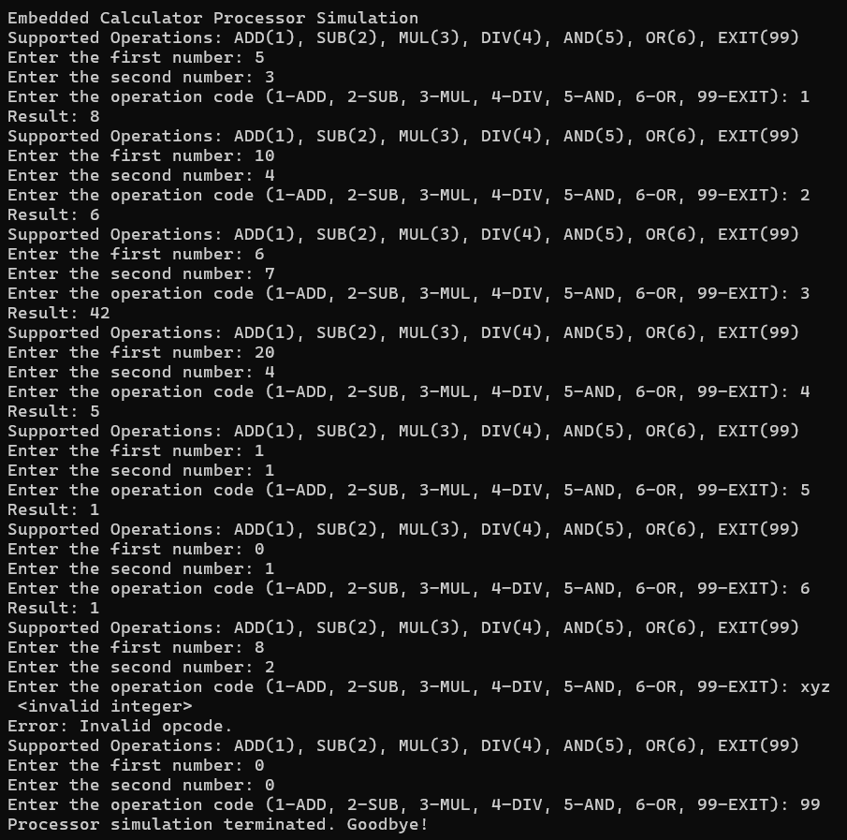

The following table summarizes the test cases used during the testing phase:
Test Case | Inputs | Expected Output | Actual Output | Status
Addition | NUM1=5, NUM2=3, ADD | RESULT=8 | RESULT=8 | Pass
Subtraction | NUM1=10, NUM2=4, SUB | RESULT=6 | RESULT=6 | Pass
Multiplication | NUM1=6, NUM2=7, MUL | RESULT=42 | RESULT=42 | Pass
Division | NUM1=20, NUM2=4, DIV | RESULT=5 | RESULT=5 | Pass
Logical AND | NUM1=1, NUM2=1, AND | RESULT=1 | RESULT=1 | Pass
Logical OR | NUM1=0, NUM2=1, OR | RESULT=1 | RESULT=1 | Pass
Invalid Operation | NUM1=8, NUM2=2, XYZ | "Invalid Operation" | "Invalid Operation" | Pass
The above results indicate that the processor and assembly code function as expected, covering a range of operations and edge cases.

5. Conclusion
This project successfully demonstrates the design and implementation of a processor for a basic calculator. The architecture efficiently handles arithmetic and logical operations, meeting the project’s objectives. The assembly language implementation and simulations validate the feasibility of this design for embedded systems.
While the current design fulfills the primary requirements, there are potential areas for improvement:
- Advanced Operations:
  - Incorporating additional functionalities like trigonometric, exponential, and modular operations to extend the processor’s utility.
- Enhanced Error Handling:
  - Implementing more sophisticated error detection and correction mechanisms, such as handling invalid inputs more robustly.

- Optimization:
  - Reducing execution time and improving resource utilization by refining the instruction pipeline and memory access.
- Hardware-Level Simulation:
  - Developing Verilog or VHDL simulations to represent the processor at a hardware description level.
  - Testing on FPGA platforms to evaluate real-world performance and scalability.
- User Interface:
  - Enhancing I/O interfacing by integrating graphical displays for better user experience.
These enhancements can make the processor more versatile and pave the way for implementing it in larger embedded systems or real-time applications.

6. References
- EdrawMax Block Diagram Guide
- 8086 Microprocessor Data Path
- Verilog Tutorials
- MASM Documentation

