

DATA STRUCTURES

SEMESTER PROJECT

Group Members:
- Syed Jazib Ali Rizvi – 232145
- Hussain Ali – 232095
- Muhammad Abdullah Haroon – 232992

Project Report
Project Title: Competition Scheduler
Course: CS216 Semester Project
Tools and Technology: C++/CLI with Windows Forms, Visual Studio

Introduction
Cybersecurity hackathons often require efficient management of team scheduling and match results for "Capture the Flag" (CTF) events. This project aims to develop a software solution that automates the process of organizing, scheduling, and managing matches in such events. The software provides an intuitive interface for users to manage the tournament seamlessly, ensuring smooth progression from initial matches to the final round.

Objectives
- Design a robust competition scheduler for managing 16 teams.
- Automate the creation of matches and progression of rounds.
- Provide a user-friendly interface for scheduling and tracking matches.
- Simulate match results using randomized logic.
- Incorporate efficient data structures such as Binary Search Trees (BSTs) for rank-based operations.

System Features

Core Features

Team Management:
- Add and store information for 16 teams.
- Rank teams in ascending order for fair match scheduling.

Match Scheduling:
- Schedule 15 matches, progressing from Round 1 to the Final.
- Assign specific dates and times to each match.
- Matches are auto-scheduled with realistic time intervals.

Round Progression:
- Divide teams into groups (8 for Round 1, 4 for Round 2, 2 for Semi-Finals, and 1 for the Final).
- Automatically transition winners to the next round.

Match Simulation:
- Simulate match results randomly.
- Update match status and declare winners.

User Interface (UI):
- A WinForms-based GUI for ease of use.
- Display schedules, match results, and logs dynamically.

Logs and Reports:
- Real-time logging for all events (e.g., match results, round progression).
- Final report generation.

Implementation Details

Modules and Design

Team Module:
- Class to store team attributes (e.g., name, rank, and performance).

Match Module:
- Class to handle match details, including participating teams, scheduled date/time, status, and results.

Scheduler Module:
- Core logic for:
- Dividing teams into groups.
- Scheduling matches for each round.
- Simulating results and updating winners.

GUI Module:
- Interactive forms for:
- Adding teams.
- Displaying match schedules.
- Simulating matches and advancing rounds.
- Generating tournament reports.

Algorithm Highlights
- Match Scheduling: Matches are scheduled sequentially, starting from the current date, with 2:00 PM as the first match time. Subsequent matches increment the date by one day.
- Round Transition: Winners are auto-calculated and stored, ensuring fair progression.
- Simulation Logic: Randomized winner selection ensures unbiased results.

System Design Document

Overall Flow of the Program
- User inputs team details.
- Teams are ranked and grouped for the first round.
- Matches are scheduled sequentially with date and time increments.
- Winners are determined through simulation for each round.
- Final match decides the tournament winner.

Major Components
- Input: Team data entry and manual start for simulations.
- Processing: Scheduling matches and simulating results.
- Output: Display of schedules, logs, and final results.

Classes Overview
- Team: Handles team attributes like name and rank.
- Match: Manages match details, including participating teams, date/time, and results.
- Scheduler: Implements tournament logic, including match scheduling, round progression, and simulations.

Data Structures
- Vector: Stores teams and matches.
- Queue: Groups teams for each round.
- Binary Search Tree (BST): (Future) For efficient rank-based operations.

Sample Screens (GUI)

Main Dashboard:
- Buttons for adding teams, viewing schedules, and starting simulations.
- Log display for real-time updates.
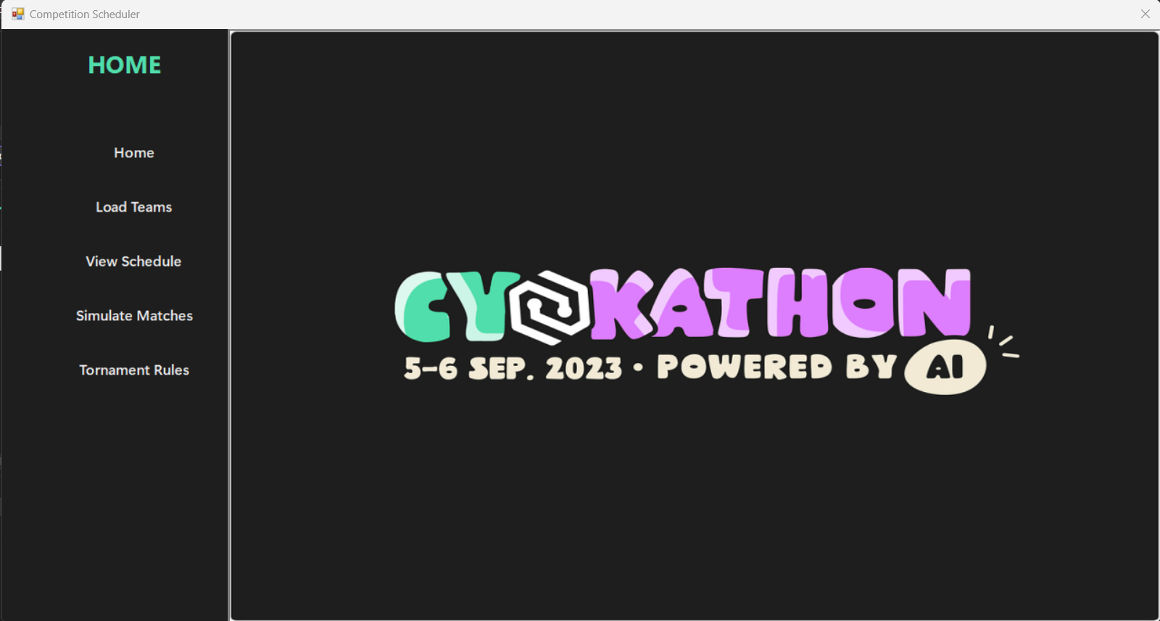

Team Entry Screen:
- Form for entering team details (e.g., name and rank).
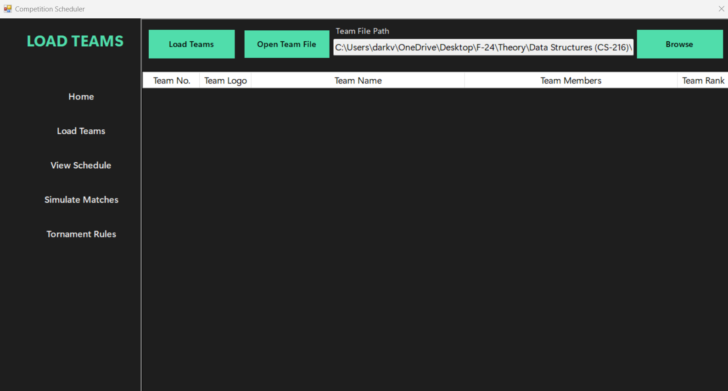

Schedule Display:
- Table showing match schedules with date, time, and participating teams.
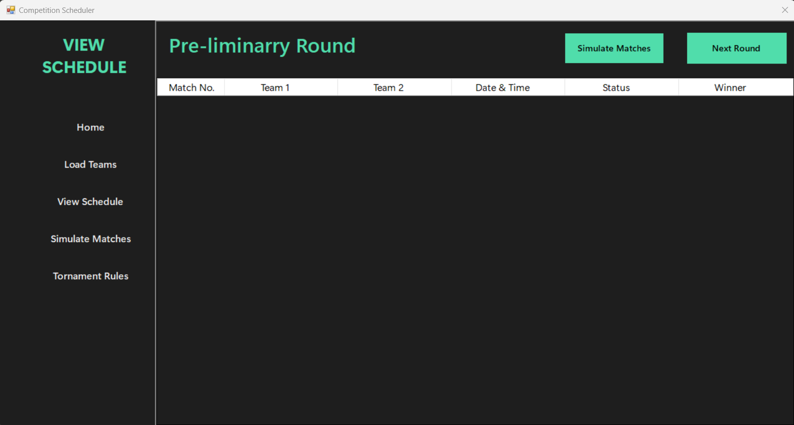

Simulation Screen:
- Button to simulate matches.
- Dynamic update of results and winners.
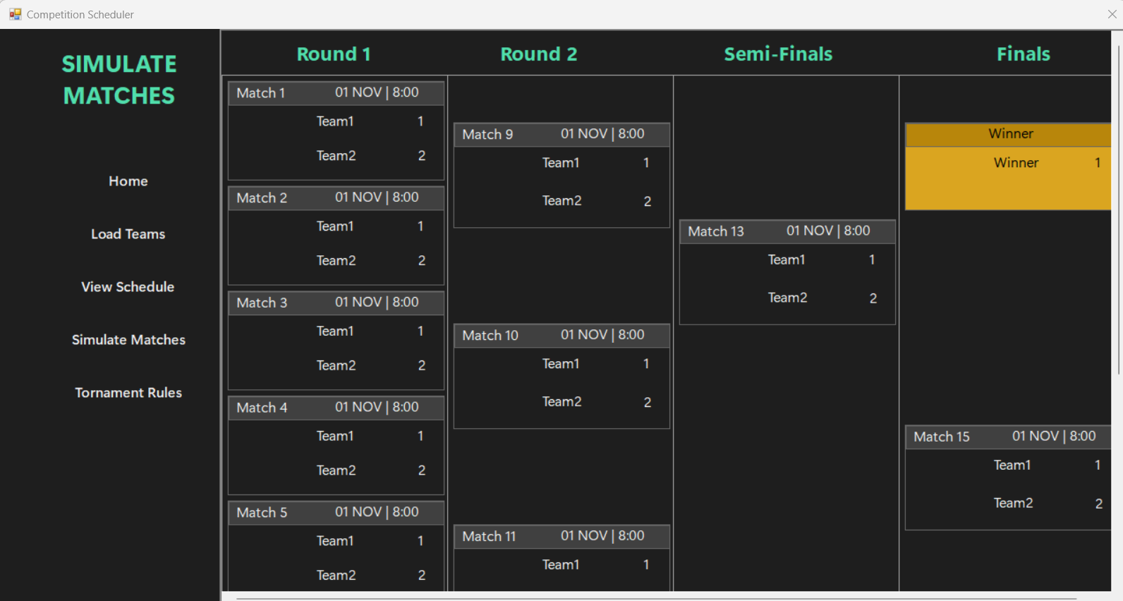

Challenges and Solutions
- Challenge: Handling date and time increments for scheduling.
  - Solution: Utilized C++ time libraries for seamless date handling.
- Challenge: Efficiently managing dynamic team data.
  - Solution: Leveraged STL containers (e.g., vector, queue) for flexible data handling.
- Challenge: Ensuring a user-friendly GUI.
  - Solution: Incorporated intuitive controls and real-time feedback in the WinForms interface.

Conclusion
The Competition Scheduler successfully meets the objectives of automating team and match management for CTF hackathons. The intuitive GUI, combined with robust backend logic, ensures a seamless user experience. This project demonstrates the practical application of data structures and software engineering principles in solving real-world problems.

Future Enhancements
- Add support for larger tournaments with more teams.
- Integrate cloud storage for persistent data.
- Provide a leaderboard for team rankings across multiple events.
- Include customizable scheduling options.

