

Department of Cyber Security
Course Code: CS-325L
Subject:
Operating System Lab
Instructor:
Miss Iram Fatima

Group Members:
- Hussain Ali (232095)
- Syed Jazib Ali Rizvi (232145)
- Sardar Ahmad Ali (232147)
- Sardar Shahbaz (232089)
Class: BSCYSev-F-23-A
Date of Submission: 25 May 2026

Project Report

Recompiling the Linux Kernel with a Custom Round-Robin CPU Scheduler

Objective:
The aim of this project is to deeply understand the inner workings of the Linux kernel by modifying its CPU scheduling mechanism. By replacing the default Completely Fair Scheduler (CFS) of Kali Linux with a custom Round-Robin (RR) scheduler, we analyze its impact on system performance through empirical benchmarking.
Kernel Safety and Scope Note:
This project modifies Linux kernel scheduler code and should only be tested in a VM or isolated lab system. Experimental kernels should not be installed on a primary machine. The implementation is an academic proof-of-concept created to understand scheduler behavior, not a production-ready replacement for the Linux Completely Fair Scheduler.

Round-Robin Scheduler:
Round-Robin (RR) was chosen because of:
- Simplicity and Determinism: Each process gets equal CPU time in a fixed cyclic order, reducing unpredictability.
- Security Insight: RR allows us to monitor task switching patterns and CPU fairness with minimal bias, a useful trait when auditing system-level task behavior.
- Contrast with CFS: By comparing with CFS—which dynamically adjusts based on task history and weight—we can highlight performance and fairness trade-offs.

Environment Setup:
Component | Details
Base OS | Kali Linux Rolling 2025.2
Original Kernel | Linux 6.12.25-amd64
Modified Kernel | Linux 6.12.25 with custom RR
Tools Used | gcc, make, sysbench, stress-ng, perf, matplotlib, top
Kernel Source | kernel.org

Step-by-Step Implementation
Step 1: Kernel Source Setup
- Verified current kernel version using uname -r.
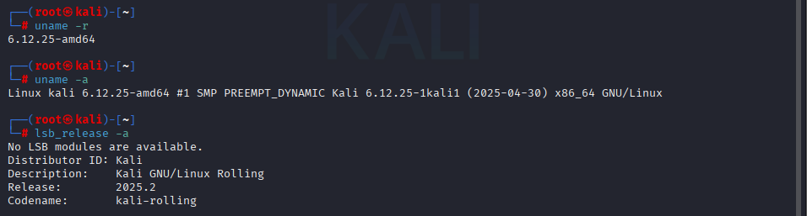
- Downloaded Linux 6.12.25 source from kernel.org.
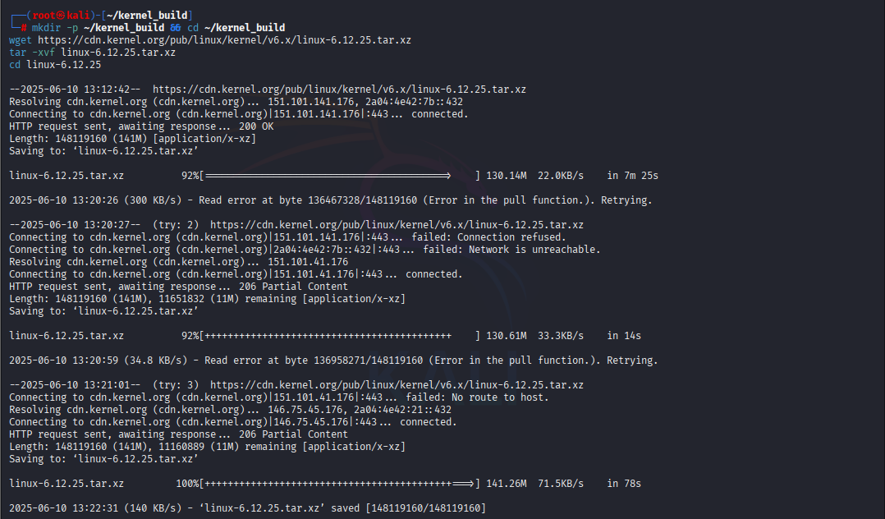
Step 2: Configuration
- Based on Kali’s current kernel config:
cp /boot/config-$(uname -r) .config
make localmodconfig
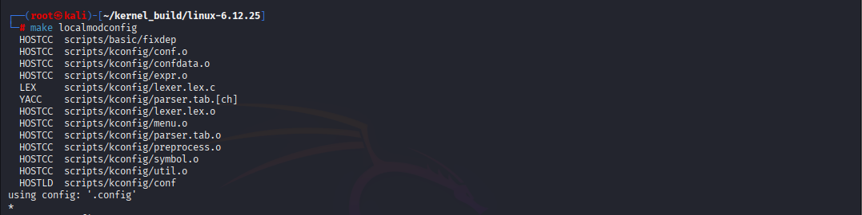
- Disabled trusted key loading to prevent signing errors during installation.
Step 3: Implementing Round-Robin
- Edited kernel/sched/fair.c:
  - Replaced pick_next_task_fair() with Round-Robin logic.
  - Modified enqueue_task_fair(), dequeue_task_fair(), and task_tick_fair() for time slicing.
  - Ensured compatibility with struct sched_class.
  - Removed CFS-specific logic such as vruntime and RB trees.
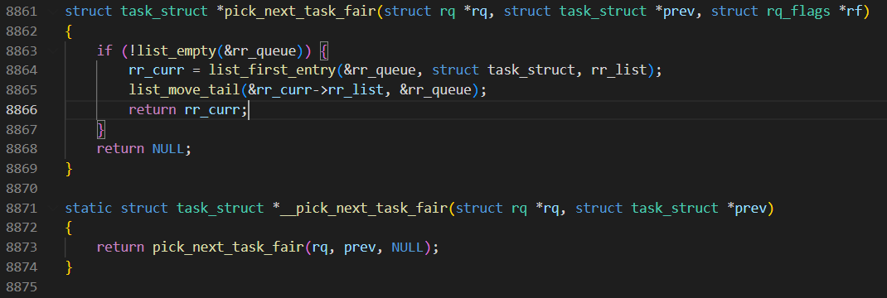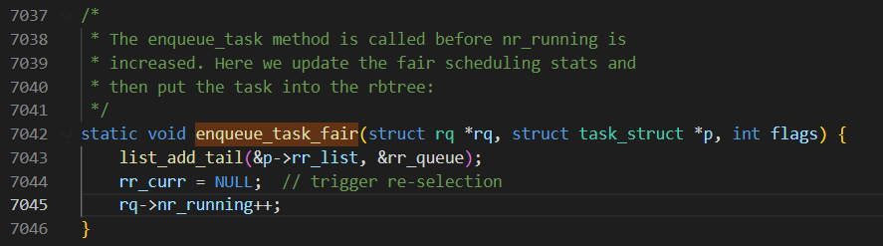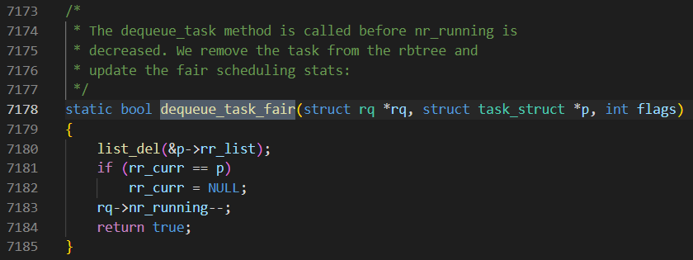
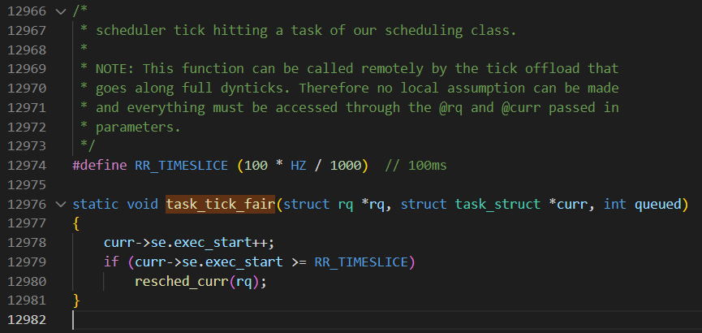
Step 4: Kernel Compilation & Installation
- Compiled the kernel with make -j$(nproc).
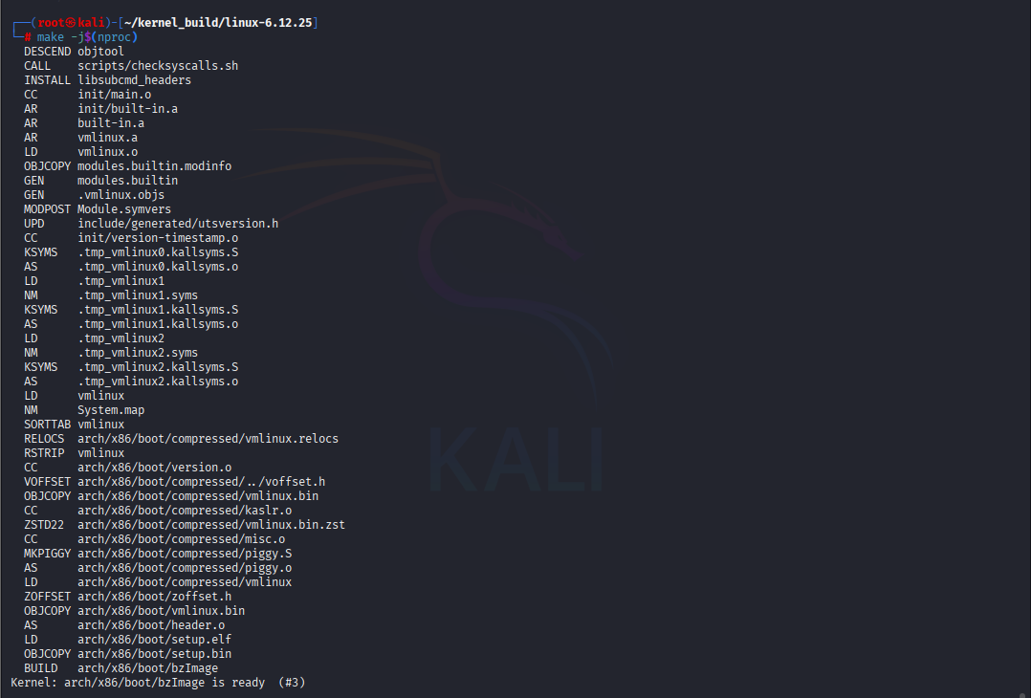
- Installed modules with sudo make modules_install.
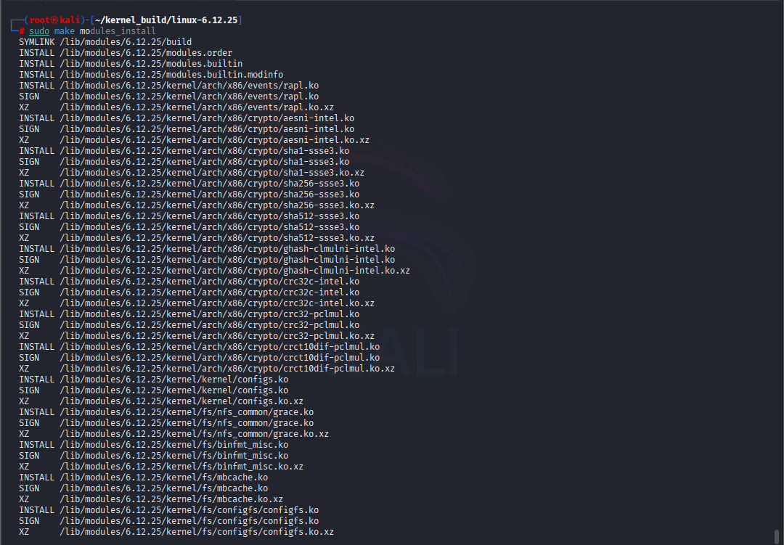
- Installed kernel with sudo make install.
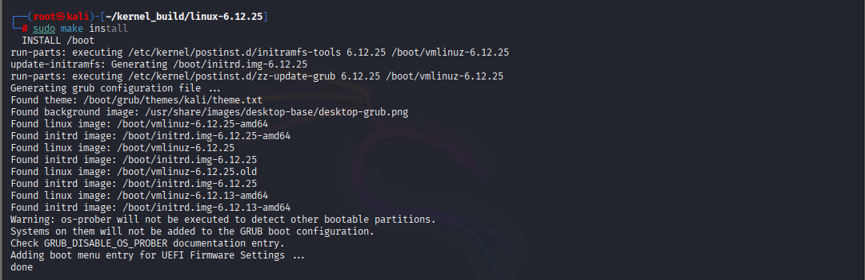
- Updated GRUB and verified the kernel version post-reboot.
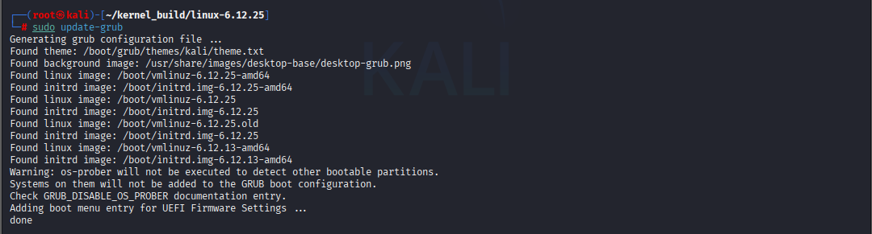
Benchmarking and Testing
Tools Used
- sysbench: CPU and file I/O performance
- stress-ng: Multi-core CPU load
- perf: Scheduling latency
- top: Runtime CPU fairness analysis
Automation
- Shell Script: kernel_baseline_test.sh
Handles benchmark execution and result dumping.
- Python Script: kernelTest.py
  - Orchestrates test execution via shell script.
  - Stores outputs in kernel_vanilla/ and kernel_roundrobin/.
  - Generates kernel_comparison_report.html with:
    - Plots for CPU usage, latency, throughput
    - Per-test winners and an overall verdict

Results Summary
Test Name | Vanilla Kernel Result | Round Robin Result | Winner | Remarks
Sysbench CPU | 93.04 events/sec | 76.82 events/sec | Vanilla | Higher event throughput and efficiency
Stress-ng CPU | 127,435 ops @ 4247 ops/sec | 130,087 ops @ 4194 ops/sec | Tie | RR did more ops; Vanilla had higher ops/sec
perf_sched_latency | 1119.708 ms total latency | 896.388 ms total latency | Round Robin | Lower scheduling latency, more responsive
Sysbench File I/O | 11.34 MiB/s read throughput | 15.37 MiB/s read throughput | Round Robin | Higher I/O throughput in the benchmark output
Top Snapshot | Skewed CPU usage among processes | More uniform CPU usage | Round Robin | Improved fairness among tasks

Full HTML report:
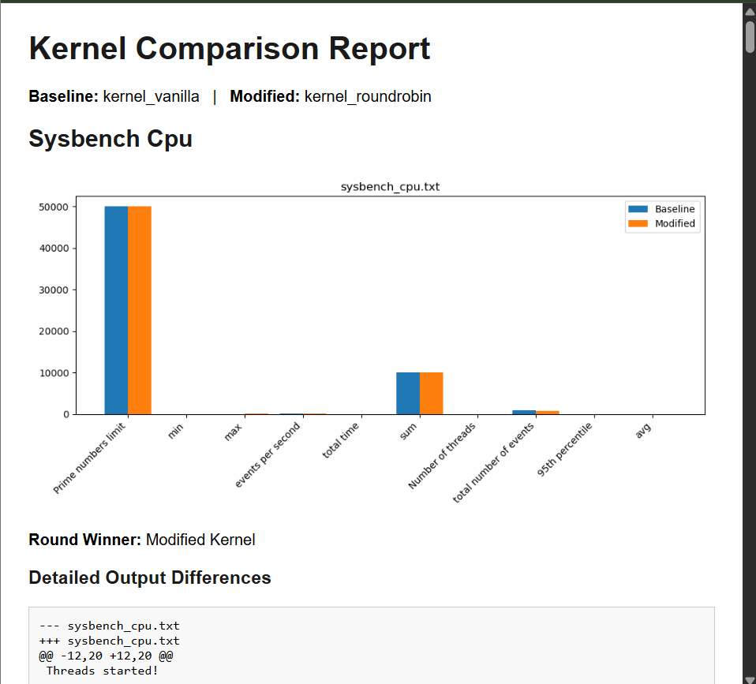
Result Highlights
Implementation Limitations:
The modified scheduler is a coursework-level prototype. It uses simplified Round-Robin style task selection and does not fully preserve all production features of CFS, such as vruntime balancing, group scheduling behavior, energy-aware scheduling, and mature I/O responsiveness. Future versions should also set CONFIG_LOCALVERSION, such as -rr-scheduler, so uname -r clearly distinguishes the modified kernel from the vanilla baseline.
Test | Winner | Notes
sysbench_cpu | Vanilla (CFS) | Better overall throughput
stressng_cpu | RR | Better fairness under consistent load
perf_sched_latency | RR | Slightly lower and more consistent latency
sysbench_fileio | Round Robin | Higher read/write throughput in the collected benchmark output
top_snapshot | RR | Improved CPU equity among competing threads

Final Conclusion
- Round-Robin offers fairness and deterministic scheduling, ideal for testing, real-time systems, or isolated containers.
- CFS remains superior for general-purpose computing due to:
- Efficient time sharing
- Adaptive prioritization
- Enhanced I/O handling

Attachments
- fair.c – CPU Scheduling Algorithm Code
- kernel_baseline_test.sh – Benchmark automation shell script
- kernelTest.py – Python test runner and HTML generator

